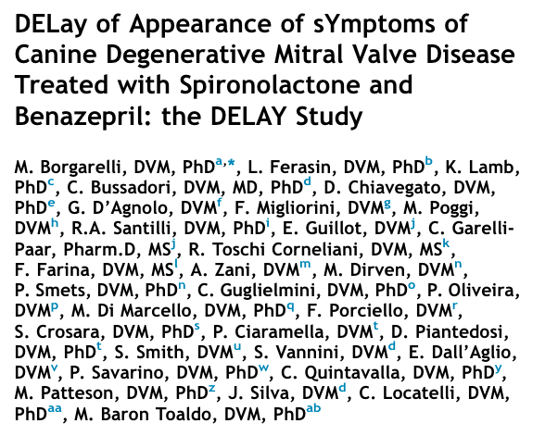
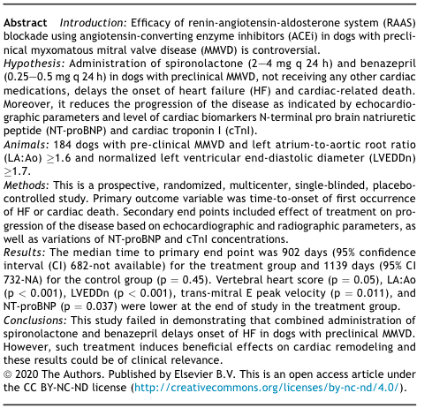
Introduction:
- Studies have not shown that enalapril, an angiotensin-converting enzyme inhibitor (ACEi) is effective in delaying the onset of heart failure despite its clinical efficacy documented for dogs in heart failure
- This may be due to inefficient aldosterone secretion suppression (a.k.a. aldosterone breakthrough, ABT), especially with long term ACEi usage
- High aldosterone contributes to heart disease in humans: promotes cardiac fibrosis and hypertrophy, enhances inflammatory cell function
- Seems to occur in ~ 30% of dogs preclinical for MMVD taking an ACEi
- Hypothesis: adding spironolactone, a mineralocorticoid receptor antagonist, to an ACEi could delay the progression of heart disease by providing more RAAS suppression
- Primary end point: first occurrence of heart failure or cardiac death
- Secondary end point: echocardiographic and radiographic parameters, NT-proBNP, cTnI concentrations

Conclusion:
- No significant difference between the groups in reaching the primary end point
  - Control (1139 days) > placebo (1045 days) > treatment (902)
  - Spironolactone [2-4 mg/kg PO q 24h] + Enalapril [o.25-0.5 mg.kg PO q 24h] did not delay the onset of heart failure in this population
- Cardiac remodeling occurred in the treatment group based upon significant differences in these parameters:
  - Lower HR
Previous studies have shown these are negative predictive parameters of outcome
  - Lower La:Ao
  - Lower LEVDDn
  - Lower E peak velocity of mitral valve inflow
  - Lower vertebral heart score
  - Lower NT-proBNP, biomarker of stretch
- Effective RAAS suppression was documented in the treatment group through urinary aldosterone concentration measurements
- RAAS is activated in preclinical MMVD as the disease progresses (based upon U A:C results)

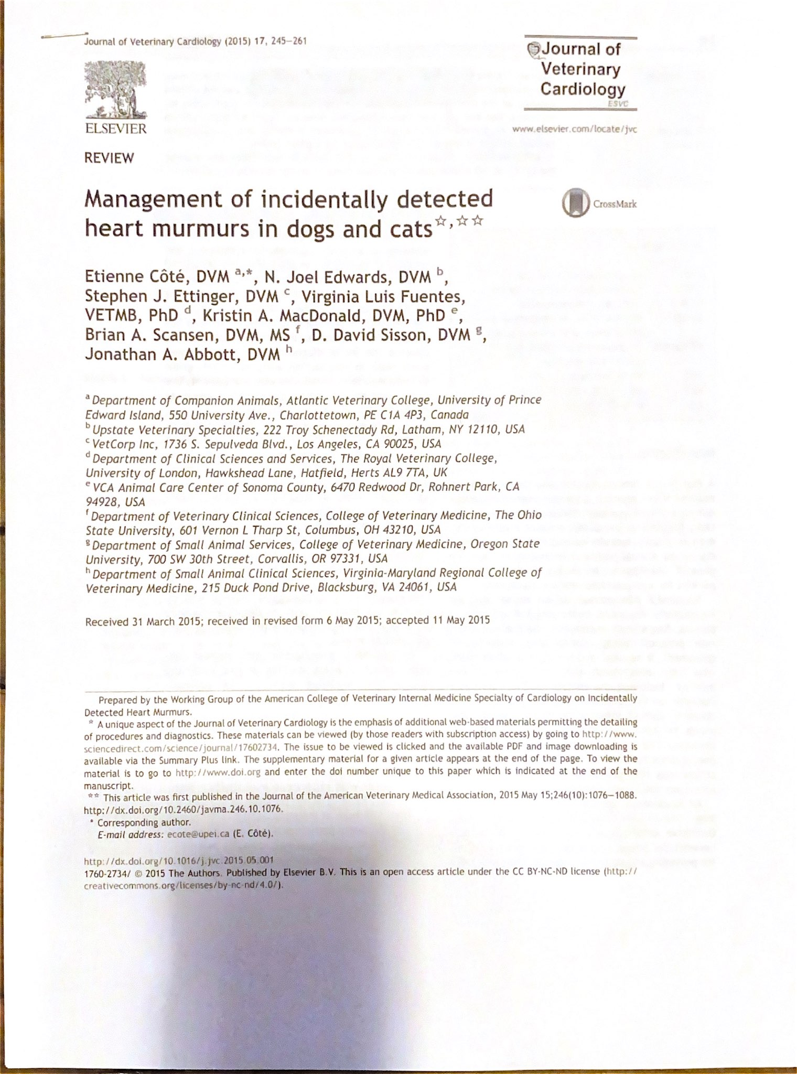
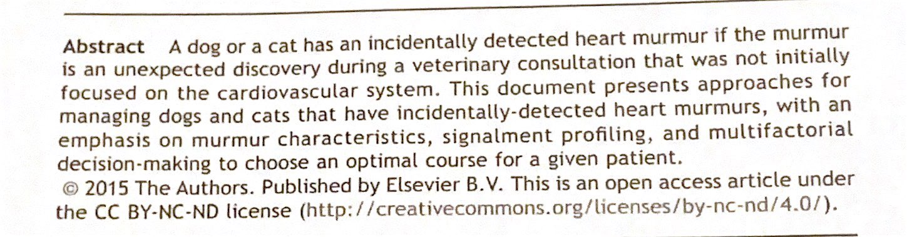

Summary:
- Incidental heart murmurs are detected with relative frequency during routine PEs, pre-anesthetic PEs, and work-ups for other systemic illnesses
- Defining murmurs
  - Nonpathological
    - Functional: no structural heart disease; other physiologic explanation (i.e. anemia)
    - Innocent: no structural heart disease; no other physiologic explanation
  - Pathological: structural cardiovascular lesion is present
    - Continuous and Diastolic murmurs are always pathological
- Recommend further investigation always for murmurs that are/which: continuous, diastolic, obscure the 2nd (or both) heart sounds, occur with a transient abnormal heart sounds (i.e. split S2), radiates to the carotid region, left apical systolic (over the mitral valve), right hemithorax PMI, young dog w/ systolic>/= 3/6
- Murmurs between grades 1/6-3/6 do not have inherent characteristics that dictate whether they are pathological or nonpathological for both dogs and cats
- Consider usage of biomarkers as diagnostics

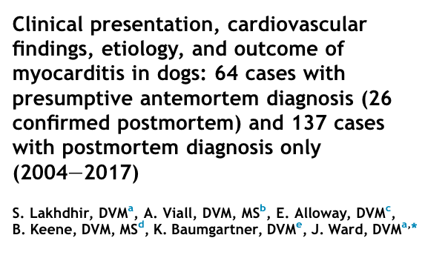
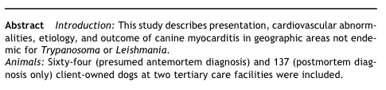
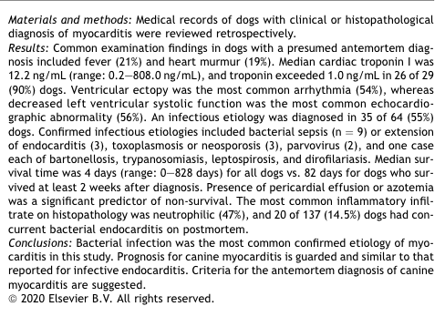
Introduction:
- Myocarditis is a non-specific inflammatory myocardial disease with many causes
  - Infectious: trypanosomiasis, leishmaniasis, parvovirus, toxoplasmosis, neosporosis, borreliosis, ehrlichiosis, leptospirosis, bartonellosisi, other viral, bacterial, fungal, algal
  - Non-infectious: pharmacologic drugs/toxins, immune-mediated conditions, trauma, heat stroke, shock, idiopathic
- Definitive diagnosis: histopathology; antemortem diagnosis would require endomyocardial biopsy—therefore dx is often presumed antemortem, as these biopsies are not performed in vet med

Conclusion:
- Most common presenting complaint: lethargy (70% of dogs), then hyporexia (69%)
  - Others: weakness (36%), vomiting +/- diarrhea (31%), tachypnea (28%)
  - Less common: exercise intolerance (17%), cough (17%), syncope (16%), CNS abnormalities (16%), lameness/orthopedic pain (11%), panting (9%), PU/PD (2%)
- <19% prevalence on PE of: heart murmur, femoral pulse abnormalities, lymphadenopathy, joint abnormalities, pale MM, prolonged CRT, extra heart sounds, dyspnea/tachypnea, muffled heart sounds
- Bloodwork: thrombocytopenia (57%), neutrophilia (52%), elevated ALT (67%), elevated ALP (54%), hypocalcemia (54%) and hypoalbuminemia (45%), azotemia (24%)
- Mean cardiac troponin: 12.2 ng/mL (normal < 0.2 ng/mL)
- ECG: VPCs (54%), vtach (33%), both (13%)
- Infectious etiology identified in 55%, so ABx were the most common treatment: doxycycline, beta-lactams, enrofloxacin, clindamycin, metronidazole
  - Unknown cause in 28% of cases
- MST was 4 days among the 64% of dogs who died (majority were euthanized); of these, 73% died related to myocarditis
  - 42% survived < 2 wk MST 2 d
  - 58% survived > 2 wk MST 82 d
- Dogs with non-infectious etiologies were more likely to have ventricular ectopy than infectious etiology dogs were
  - Not predictive of etiology on univariate analysis
- Dogs with infectious had larger LV (LVIDD and LVIDS)
  - Not predictive of etiology on univariate analysis
- Positively associated with survival: infectious disease testing, treatment with ABx, treatment with Doxycycline, and treatment with sotalol on univariate analysis
- Negatively associated with survival: intact, anemia, thrombocytopenia, Neutrophilia, azotemia, hypoalbuminemia, hypermagnesemia, total hypocalcemia, pericardial effusion, heteroechogeneity on echo, sepsis
  - Pericardial effusion remained significant on multivariate analysis
- Prognosis: poor to grave overall

