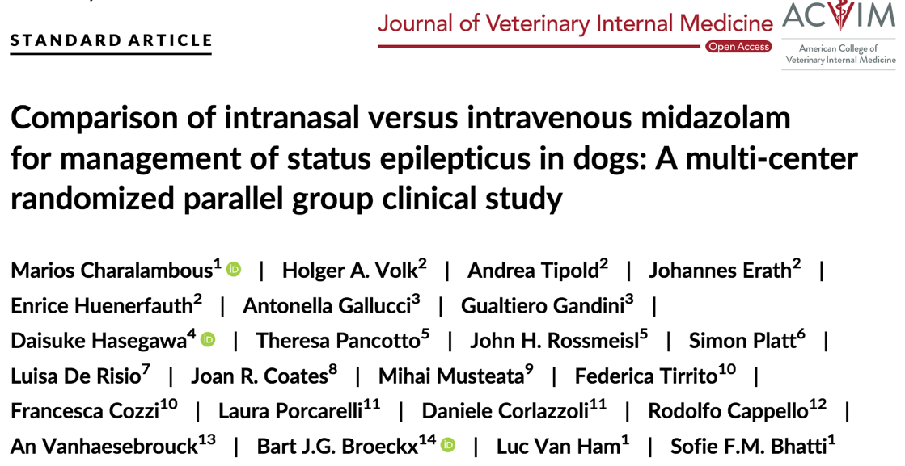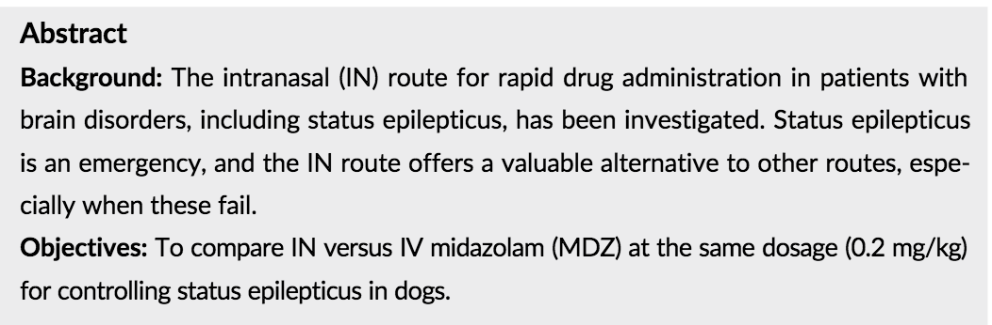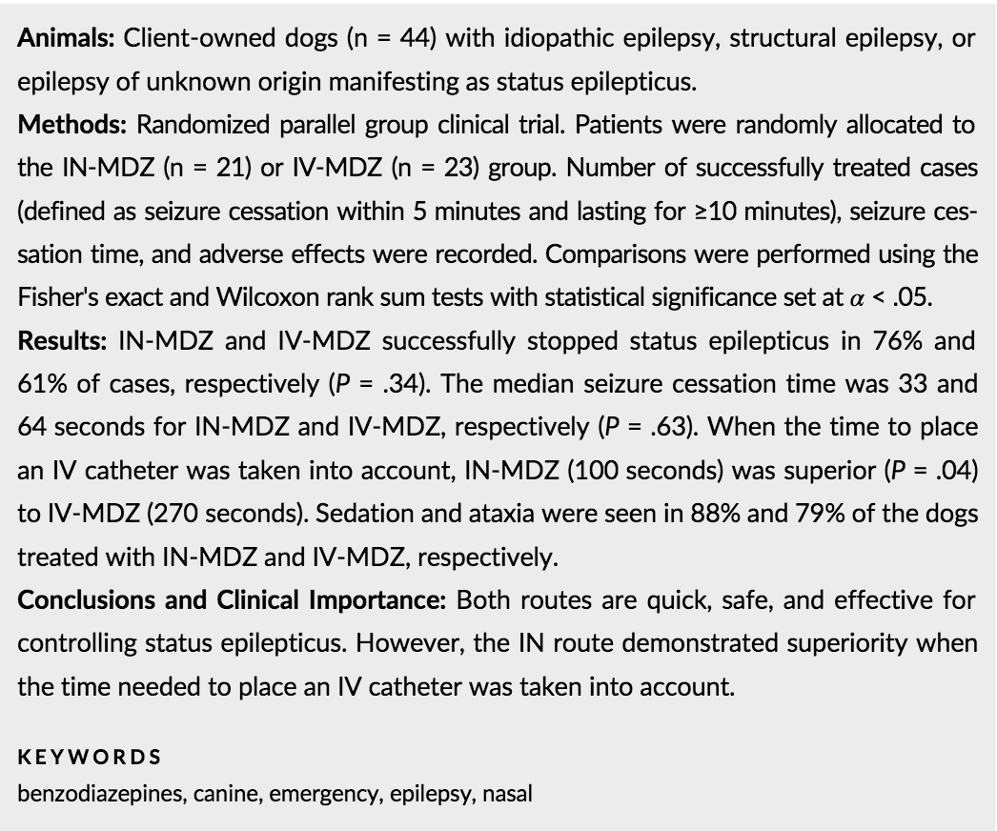

Introduction:
- SE requires rapid and effective delivery of anti-seizure meds.
- Intranasal route can circumvent blood brain barrier and anatomical and physiological properties of nasal cavity may make it ideal to deliver drugs to brain
- Benzodiazepines are common first-line management, like midazolam examined IN,IV, or IM
- Midazolam water-soluble, so safe if IV access not available
- IN midaz shown to be superior to rectal diazepam.
- Goal of study is to compare intranasal administration versus IV administration of midazolam

Materials/methods
- Randomized parallel group clinical trial
- Forty-nine dogs initially were included but 5 were excluded because they were diagnosed with reactive seizures caused by intoxication.
- IN midaz 21, IV midaz 23 (0.2mg/kg IV)
- Idiopathic epilepsy, structural epilepsy, or epilepsy of unknown origin with SE
- Cases were considered successful if “seizure cessation time” was <5 minutes after drug administration and the “seizure relapse time” was >10 minutes.

Results
- Status epilepticus was terminated within 5 minutes by IN-MDZ (n = 21) and IV-MDZ (n = 23) in 76% and 61% of cases, respectively. This difference was not statistically significant (P= .34).
- Seizure cessation time was not significantly different (IN-MDZ [median, 33 seconds] compared to IV-MDZ [median, 64.5 seconds];P= .63).
- However, when the time to place an IV catheter and prepare the medication also was considered (ie, total seizure cessation time), IN-MDZ (median, 100 seconds) was superior (P= .04) to IV-MDZ (median, 270 seconds).
- For dogs with idiopathic epilepsy, status epilepticus was terminated in 83% and 69% of the cases by IN-MDZ and IV-MDZ, respectively (P= .64).
- The seizure cessation time also was not significantly different (IN-MDZ [median, 27 seconds] compared to IV-MDZ [median, 78 seconds];P= .07). However, by adding the time needed to place an IV catheter and prepare the medication (total seizure cessation time), IN-MDZ (median, 66 seconds) was superior (P=.02) to IV-MDZ (median, 314 seconds).
- In 21% of the successful IV-MDZcases, an IV catheter already had been placed before trial initiation

Discussion
- Both IN and IV safe and effective
- IN considered superior when considering time needed to place IV catheter
- In humans, compare IN midaz to IV diaz showed IV diaz faster without accounting IV catheter time placement
- The underlying cause of the seizures could play a role in the response of the affected dogs to MDZ. Epileptic seizures related to meningo encephalitis of unknown origin, and focal epileptic seizures are negative prognostic fac-tors for status epilepticus in dogs
- The waiting period of at least 5 minutes before administering MDZ was crucial in our study because, otherwise, it could be argued that the epileptic seizures ceased because they might have been self-limiting (ie, inclusion of non-status epilepticus cases) and not a consequence of the MDZ administration

