JVIM Oct-Dec 2020
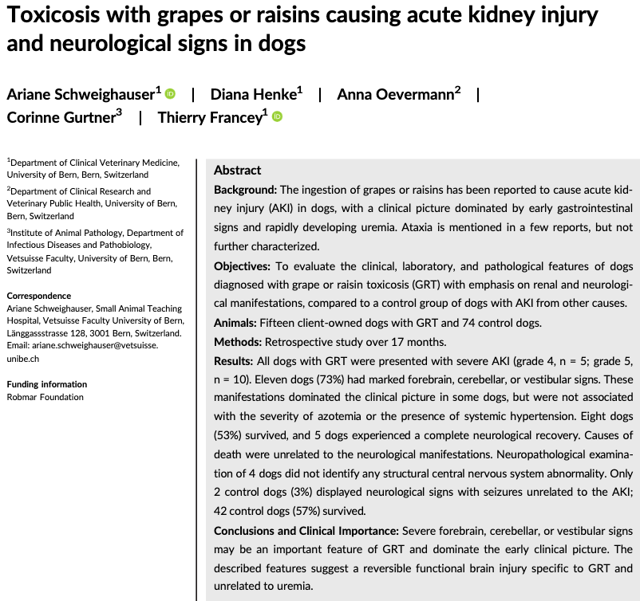
Intro
- Mechanism of toxicity unknown
  - Hypothesis: Mycotoxin contamination, heavy metals/pesticide contamination, excessive vitamin D, tannin intolerance or excessive ingestion of monosaccharides, hypovolemic shock or renal ischemia
- Toxic dose reported: 19.6g/kg grapes, 2.8g/kg raisins
- Cx: vomiting (81% w/in24h, 100% w/in 48h), other signs of acute uremia (anorexia, lethargy, D+, abd pain, 49% has oliguria/anuria)
- Seizures and ataxia reported in 23% of dogs, median onset 2 days, associated w/ negative outcome
- GOALS: Evaluate outcome of dogs w/ GRT compared to those w/ AKI of other origins and evaluate for possible risk factors associated w/ developing neuro signs
Results
- 89 dogs met criteria (Cr >1.7mg/dL for at least 24h; incr in Cr >0.3mg/dL during 1st 48h; persistent oligo-anuria [UOP<1mL/kg/h over 6h] after volume replacement; evidence of tubular injury based on renal glucosuria or granular cast of UA)
  - 17% had GRT-AKI and 83% had other-AKI
- GRT-AKI 11/15 dogs had neurological signs: change in LOC, kyphosis, pleurothotonus, head tilt, generalized tremor, ataxia, tetraparesis, hypermetric gai, decr menace, anisocoria, positional ventral strabismus, decr nasal sensation, decr segmental reflexes, seizure (1 dog)
  - Localization multifocal intracranial: Forebrain (thalamus) and/or cerebellum
  - Neuro signs worsened in 6/11 dogs then regressed over 2-20 days
- Hemodialysis: 12/15 (80%) of GRT-AKI and 46/74 (62%) in other-AKI
- Outcome: 8/15 (53%) in GRT-AKI survived to discharge; 42/74 (57%) in other-AKI survived to discharge
- Histopath GRT-AKI: Acute renal tubular necrosis = consistent w/ grape toxicity
Discussion
- Possible causes of neuro involvement: severe uremia, systemic hypertension, electrolyte changes, adverse drug effects, structural damage ot CNS w/ hemorrhage/thrombosis
- Uremic encephalopathy
  - Multifactorial
    - Accumulation of protein degradation products(e.g. guanidine and methylguanidine) act as uremic neurotoxins
    - Malfunction of intermediary metabolism
    - Hormonal disturbances
    - Imbalance b/w excitatory and inhibitory NTMs
    - Renal 2ry hyperparathyroidism contribute in people – Elevated [Ca2+] in the brain d/t altered PTH-sensitive Ca2+ transport Incr Ca2+ may incr neuroexcitation and contribute to signs
- GRT-AKI dog had significantly elevated Ca (total only, not ionized)
- Neuro signs in GRT-AKI unlikely d/t uremic encephalopathy b/c no histopath changes found
- Dialysis-related DDS, AlOH toxicity, systemic hypertension considered less likely

Bottomline: In GRT dogs w/ severe oligoanuric AKI, neuro signs are prevalent (>75%) and is usually multifocal intracranial (forebrain +/- cerebellum), with overall survival of 53%

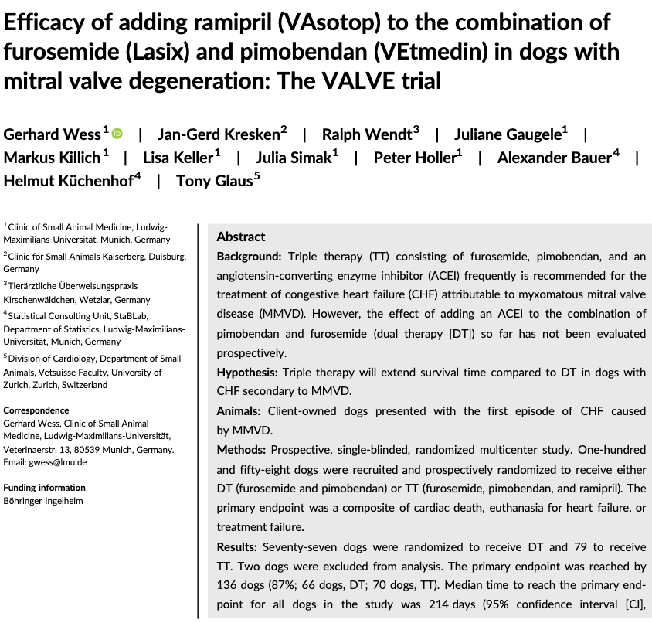
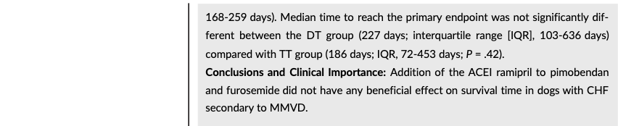
Intro
- Unclear if pimo/Lasix superior to ACEi/lasix
- Ramipril
  - Prodrug metabolized to active metabolite ramiprilat
  - Excreted by the kidneys; t 1/2 prolonged by heart, liver, and kidney failure
  - Benefits of ACEi in CHF: Decr peripheral + pulmonary vascular resistance, decr MAP + RAP + PCWP with no change in HR, may incr CO/SV and exercise tolerance
- STUDY GOAL: Evaluate if ACEi (ramipril) to pimo/Lasix has a +ve effect to mortality
Discussion:
- Survival time in this study comparable to QUEST study
  - QUEST study: Randomized pimo vs benazepril in additional to Lasix in MMVD and CHF
  - Median time to endpoint sig. longer in pimo group (267d) than benazepril (140d) dual therapy w/ pimo/Lasix superior to lasix/ACEi
- IMPROVE + COVE studies (short-term trials) included dogs w/ DVM + MMVD and had shown short-term benefits in DCM compared to MMVD in CHF class + pulmonary edema scores
- LIVE + BENCH study groups (long-term trials) confirmed prolonged survival times in dogs receiving ACEi + Lasix
  - BENCH study 1999 Effect of benazepril on survival times + Cx of MMVD dogs with CHF -- Benazepril extended lifespan (2.7x longer), reduced risk of worsening CHF, improve exercise tolerance and global clinical condition at day 28
    - Not all dogs in CHF = not all received diuretics
  - LIVE study 1998 Effects of enalapril on survival of dogs w/ CHF (DMVD or DCM): Enalapril + lasix was beneficial to Lasix alone
- In people, mostly recommend sx for valve repair/replacement so sparse data for use of medical tx (ACEi, ARBs) – mainly recc ACEi if systemic hypertension is present
Bottomline: VALVE trial = Triple therapy (as recommended by ACVIM guidelines) did not have a significant effect on survival time in dogs w/ CHF caused by MMVD.

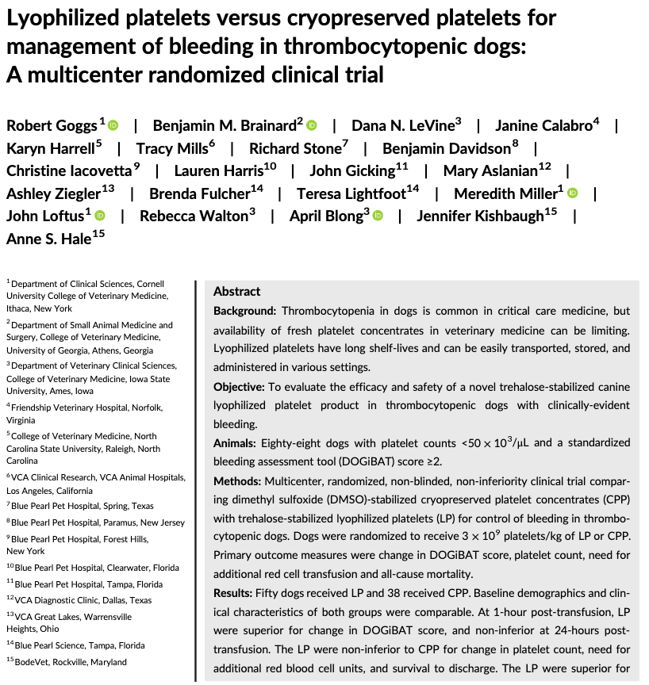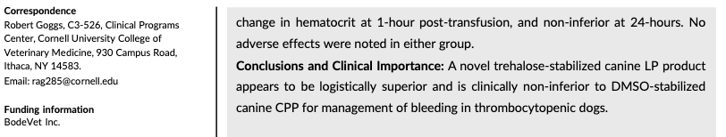
Intro
- Thrombocytopenia prevalence 5-7% and most common indication for plt transfusion
- Causes of thrombocytopenia: ITP, DIC, bone marrow disorder, neoplasia, rickettsial dz (anaplasma, ehrlichiosis); trauma huge in people
- Human guidelines for plt transfusion: Plt count <50 x10³uL undergoing sx/liver bx and those w/ active bleeding and plt count <30x10³uL
- STUDY GOAL: Compare the safety and efficacy of canine cryopreserved plt concentrates (CPP) vs trehalose-stabilized lyophilized (freeze-dried) plt (LP)
Results
- 88 dogs total: 50 LP and 38 CPP
- No diff in change in plt count pre- and post-transfusion b/w 2 groups and LP was non-inferior to CPP at both time points
- No diff in DOGiBAT scores, pRBC transfusion requirement, case fatality rate, clinically relevant adverse effects, BMBT or PT/PTT b/w groups
Discussion
- LP products has logistical benefit: stored at room-temp and doesn’t require thawing, has a longer shelf life (24m), and can be prepared rapidly (~15 min prep + rehydration and 30 min administration)
Bottomline: StablePlate Rx is non inferior to DMSO-stabilized frozen platelet for management of thrombocytopenia in dog, and may be logistically superior

