JVIM May 2021

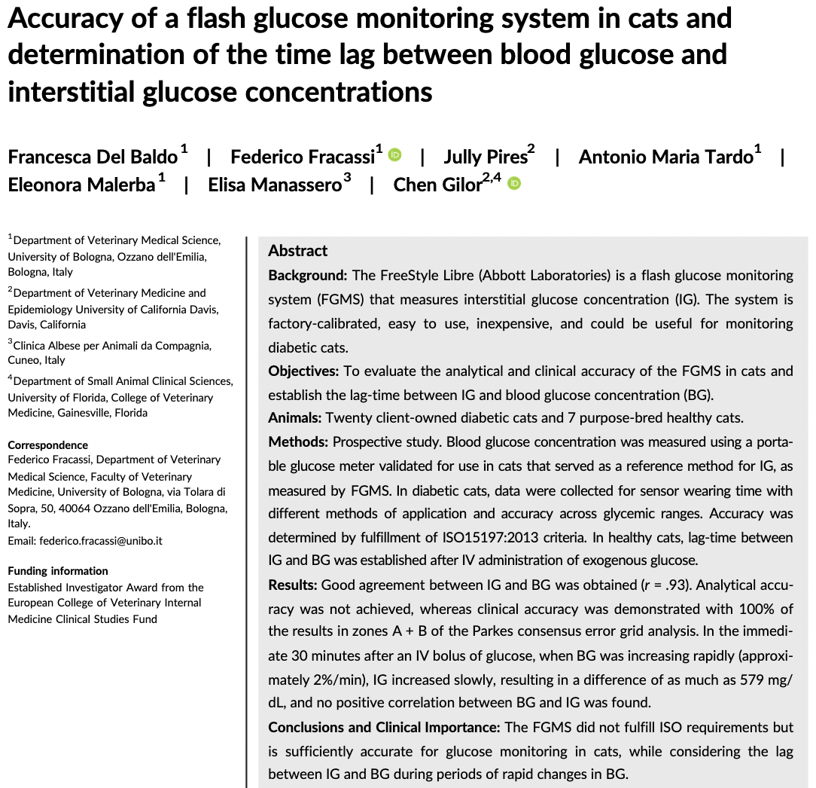
- Prospective evaluation evaluating blood glucose concentration (measured by glucometer) vs interstitial sugar (measured by FreeStyle Libre) in diabetic and healthy cats
- CGMS measure interstitial glucose concentration and has a lag-time of few minutes compared to BG changes
- Bottom line: Did not fulfill ISO requirements but clinically accurate enough to be used
- Relevant findings:
  - Although designed for 14-day wearing period, most kept on for 5.5 days
  - 18% had skin rx (erythema, mild crusting, abrasion, mild pruritus, discomfort)
  - Lag time between IG and BG was 30 minutes following IV dextrose bolus
  - Lag time potentially more profound in diabetic cat d/t chronic mild interstitial dehydration decreased microcirculation in SQ tissue = lower equilibration b/w BG and IG
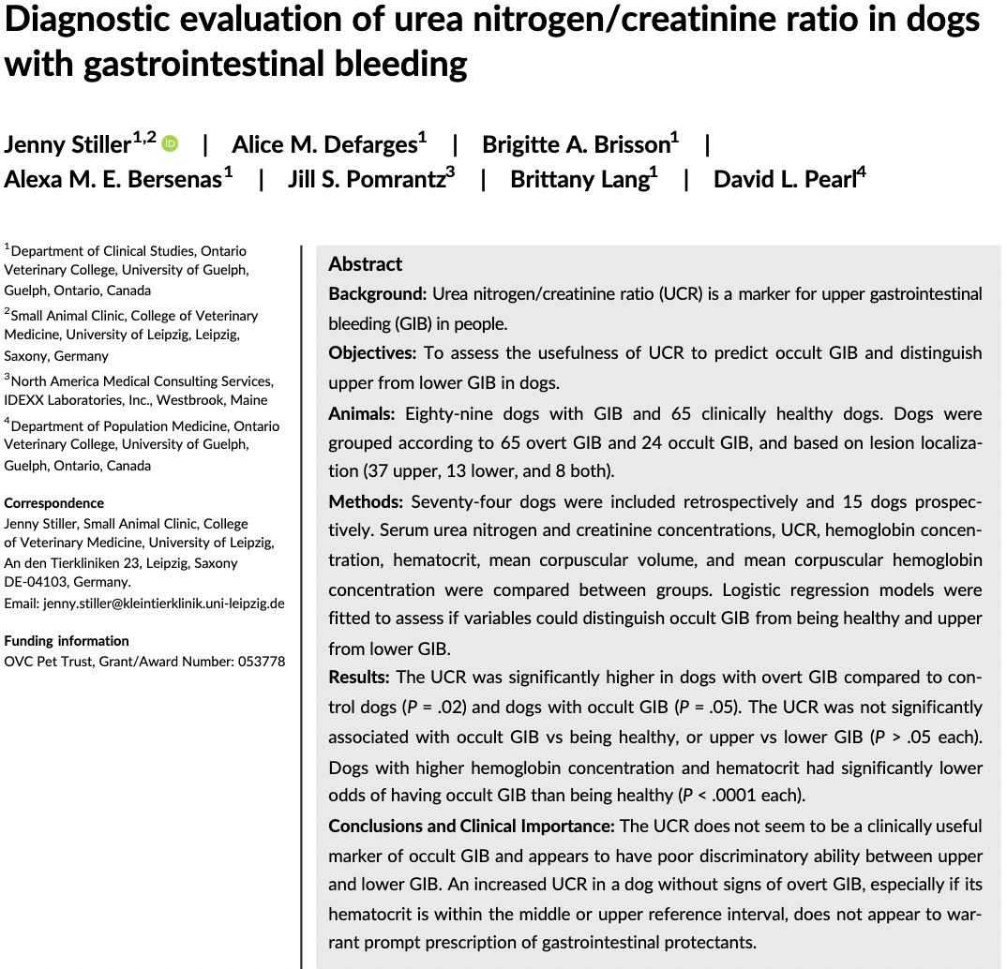
- GIB categorized into upper vs lower based on location orad or aborad to the ligament of Treitz (duodenojejunal junction)
- BUN:Cr ratio (UCR) used in people to ddx upper (high) from lower (low) GIB in people
  - Theory #1: An increased in BUN w/ GIB d/t increased hepatic ureagenesis after metabolism of blood proteins in the GIT
  - Theory #2: Prerenal azotemia from blood loss and subsequent hypovolemia incr serum BUN w/o and increase in Cr
- Enrolled around 89 dogs that were undergoing a VCE study; 65 dogs w/ overt FIB and 24 w/ occult GIB
- Conclusion: UCR not significantly associated w/ type of GIB (occult vs overt) or location of GIB
  - BUN lower in dogs w/ occult bleed compared to both control or overt bleed
  - Can’t r/o GIB based on BUN or UCR
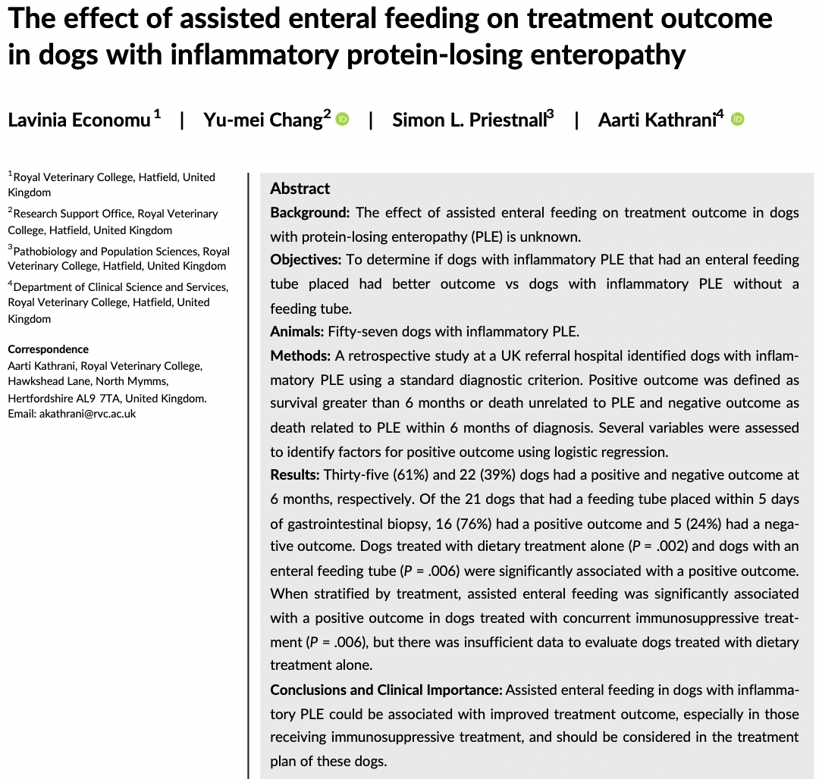
- Anorexia and hyporexia occurs in 50% of dogs w/ PLE d/t chronic enteropathy and lymphangiectasia
  - At risk of malnutrition – associated w/ immunosuppression (incr risk of bacterial translocation), delayed wound healing, loss of muscle mass, increased in-hospital mortality and longer LOH
- Retrospective study evaluating dogs w/ PLE and assisted enteral feeding
  - Assisted enteral feeding = NG, E, G, or J-tube placed w/in 5 days of GI biopsy
- Results:
  - All dogs were hypoalbuminemic
  - Majority of them had low B12
  - 61% had positive outcome (i.e. survived >6 months or had death unrelated to PLE); overall MST 996 days
    - 70% of dogs w/ -ve outcome were hyporexic
  - 37% dogs had assisted feeding, majority of them were anorexic
  - MST of assisted feeding was higher (559 days vs 282 days)
- Dogs that received dietary tx alone had better outcome than those who received immunosuppressant thought related to increased mucosal healing (extrapolated from people)

