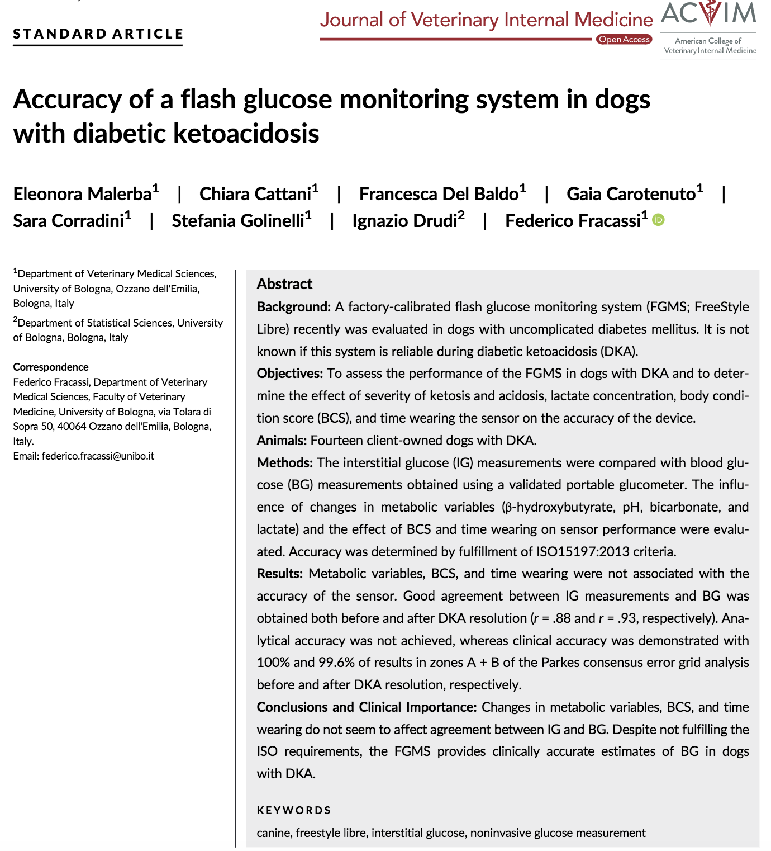

Introduction:
- DKA triad of hyperglycemia, ketosis, and acidosis
- Currently usually BG measured with portable blood glucose meter, but limitations include need for frequent blood draws leading to either iatrogenic anemia or placement of second or central catheter for blood sampling, increasing risk of catheter related complications including infection and phlebitis.
- Also leads to patient stress, owner expense, workload of clinicians and staff; as well as monitoring only every 1-2 hours at most
- Growing interest in interstitial glucose concentration, which reflects circulating BG concentrations.
- 1st generation system offered only retrospective analysis, glucose concentrations displayed after disconnecting sensor and uploading the data
- 2nd generation system allowed real-time display, but needed blood collection to calibrate 2-3 times a day
- A novel factory-calibrated flash glucose monitoring system (FGMS, FreeStyleLibre, Abbott, UK) has been licensed for use in people (CE mark, August 2014).
  - The system consists of a small, round, disposable, water-resistant sensor, which continuously measures glucose in the interstitial fluid through a small (5 mm long×0.4 mm wide) filament inserted SC.
  - The FGMS generates information every minute, and the readings are automatically stored in 15-minute intervals for up to 14 days.
  - Interstitial glucose concentrations are displayed when the sensor is wirelessly scanned (or “flashed”) with a reader device on demand. The reader device then will display the past 8 hours of glucose information, including current glucose, a trend graph, and a trend arrow that indicates the direction of the patient's current glucose concentration with respect to the previous results.
- This has been evaluated in diabetic dogs without DKA, but not in dogs with DKA
- Aim of study to assess performance of FGMS in dogs during DKA and after its resolution, comparing IG measurements with BG concentrations and determine effect of BCS, lactate concentration, severity of ketosis, and acidosis on accuracy of device

Material and Methods
- DKA diagnosed as at least 2 clinical signs of DKA (PU/PD, V+,anorexia), BG >250mg/dL, blood B-hydroxybuterate >3.8mmol/L, venous pH <7.3 or bicarb <15.
- Dogs treated with IV CRI regular insulin and considered resolved when BH < 1.0mmol/L and venous pH >7.3, bicarb >15mEq/L or both
- FGMS sensor placed on clipped/clean area dorsal part of neck
  - Sensor has 1 hour initialization
  - Readings between 20-500 mg/dL, beyond that is read as “LO” or “HI”
- IG measurements compared with BG concentration obtained within 10 seconds with PBGM
- Recorded BCS at admission
- Blood gas analysis q8-12 until DKA resolved, then one more 24 hours later to confirm metabolic balance maintained
- Ketone test strip q4 hours to test BHB with same blood used for PBGM
- At discharge, sensor removed and area of skin evaluated for signs of adverse effects

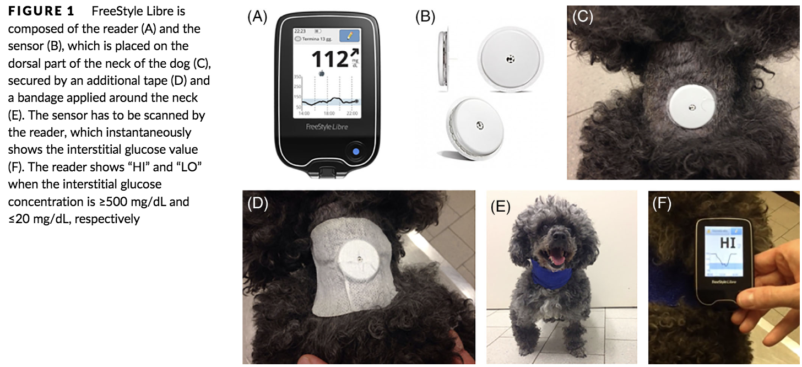

Results:
- 14 dogs
  - Two BCS 3, five BCS 4, three BCS 5, two BCS 7, one BCS 8, one BCS 9
- Application painless and easy to perform, well tolerated by all dogs
- Data collected 3-14 days, median 5.5 days
  - No relevant adverse effects during use, only 1 showed mild erythema on removal
- Total 485 paired glucose measurements, 229 during DKA, 256 after resolution
- I did not understand their stats and the way they decided to table their data……
- 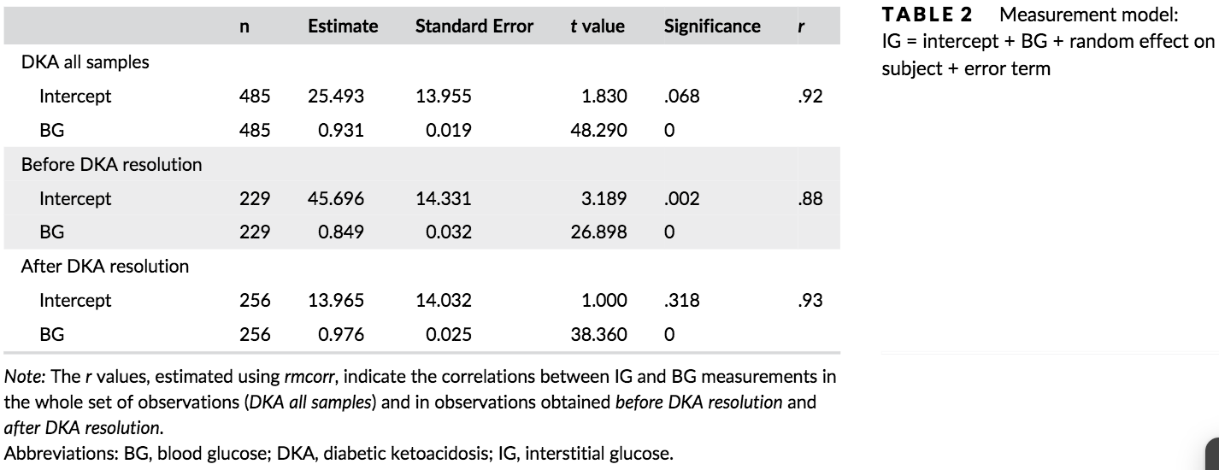
- This table apparently shows: good correlations between IG and BG measurements were obtained using rmcorr for all samples (r=.91) as well as before (r= .88) and after DKA resolution (r= .93; Table 2)
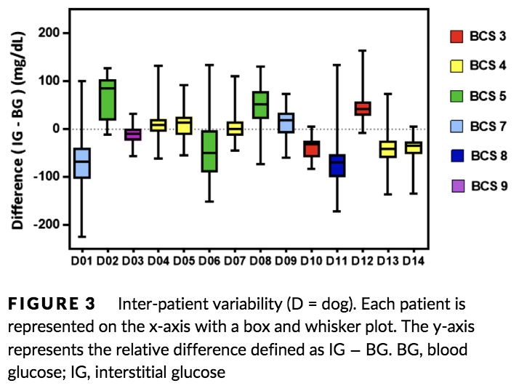
- Correlation between FreeStlye Libre IG and BG before and after DKA were r=0.88 and r=0.93
- Percentage results within +/- 15mg/dL at BG <100 and >100 were low with DKA (0% and 43.8%), and not much better after DKA resolution (42.9% and 53.6%) (Does not meet ISO analytical standards)

Discussion
- Does not fulfill analytical ISO 2013 accuracy requirements, but acceptable clinical accuracy
- DKA mortality in past decade has decreased from 26-30% to 5-7%
  - Death due to underlying medical disorder that precipitated DKA, client financial constraints, or both, rather than due to metabolic complications of DKA
- FreeStyle Libre wired enzyme factory-calibrated sensor wear time up to 14 days without additional calibration
  - Wide range glucose concentration, numerous readings in 24 hour period, display 8 hour previous history
- BCS, time wearing, lactate concentration, and severity of ketosis and acidosis did not effect accuracy of FGMS
- Another prospective vet study looked at performance of continuous GMS (CGMS Gold, Medtronic Mimimed) and effects on hydration, BCS, measure of perfusion (doppler BP, temperature difference), and severity of ketosis showed only weak association between hydration and accuracy, with accuracy in more hydrated patients.
  - Limitation of that device was cost of sensor, initial cost of device, and blood calibration every 8-12 hours, and data only available retrospectively after downloading onto personal computer
- Another CGMS (Guardian REAL-Time CGMS by Medtronic) provided IG concentration in real time, onscreen data recording over 24 hour, left in place up to 72 hours, but still needed BG calibration twice daily
- ISO analytical standards require comparison of BG meter with results of standard reference method. But standard is blood to blood. No standard for blood to different compartment. So ISO criteria may not hold up because there’s no standard of interstitial fluid
- Figure 3 showed significant inter-patient variability, so recommend checking BG if value on FGMS unexpected or low.
- Limitations
  - PBGM known in human patients to be lower than actual BG, which difference increases as hyperglycemia worsens. Therefore average difference between BG and IG could be better or worse depending on reference glucose measurement chosen
  - Limited number of hypoglycemic data points
  - Skin/SQ adipose tissue thickness not evaluated in this study. In people, decreased thickness of SQ (closer to muscle) may have inaccurate glucose results as muscle glucose lower than adipose tissue and blood
  - Sensor used in one location, did not test other locations
  - I think limitation is also sample size, its 14 patients with only 1 -5 in each BCS category.

