JVIM Jan 2021

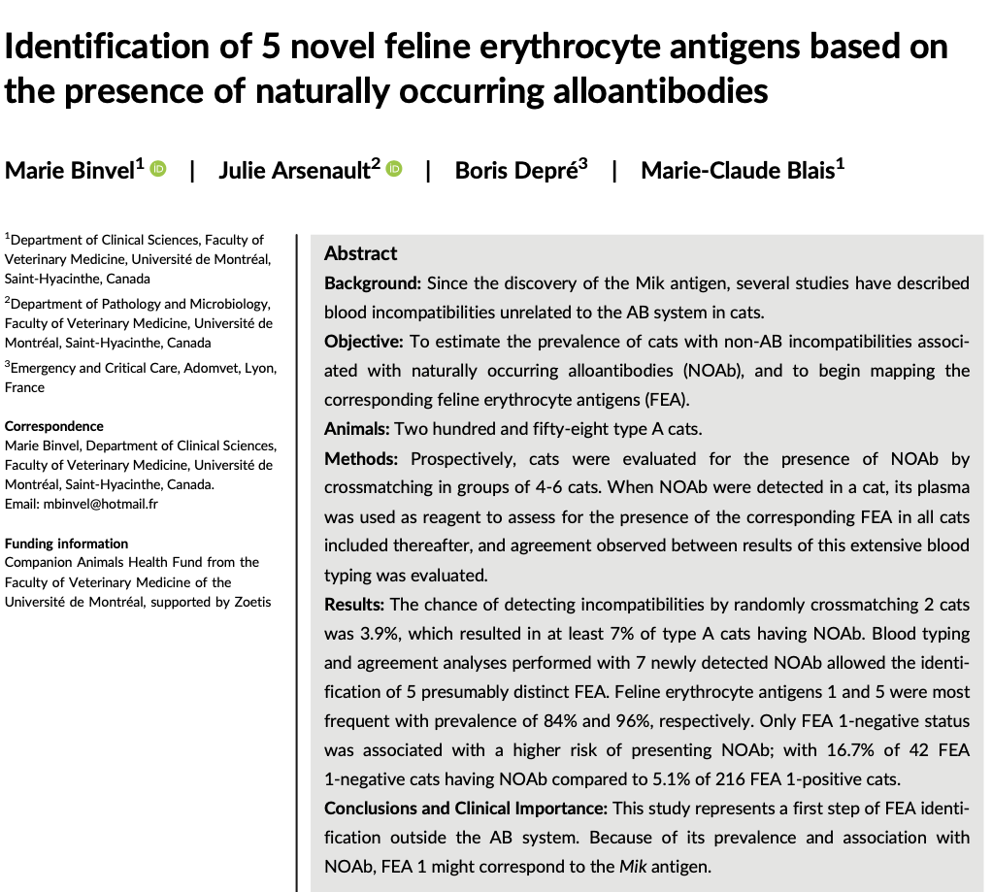
- Cats have naturally occurring anti-A and anti-B alloantibodies untyped transfusion can lead to severe acute hemolytic transfusion reaction, especially in type B cats receiving type A blood
- Mik negative cats were only found in type A cats, some of them have NOAb anti-Mik transfusion reaction can still occur in typed-matched transfusion
- Other studies have subsequently reported presence of NOAb outside of the AB system 0-29% transfusion-naïve cats showing at least 1 non-Ab related incompatibility
  - They focused on efficacy of transfusion (PCV incr) and safety of transfusion (i.e. occurrence of transfusion rx), rather than investigating this unknown antigen
- This study evaluated the chance of detecting non-AB incompatible blood types and to evaluate these NOAb
- 3.9% overall incompatible crossmatches in type A transfusion naïve cats
- Found 5 new feline erythrocyte antigen (FEA) types: 1-5
  - FEA 1 most likely to have NOAb maybe this is Mik?
  - FEA 1 and 5 were the most common
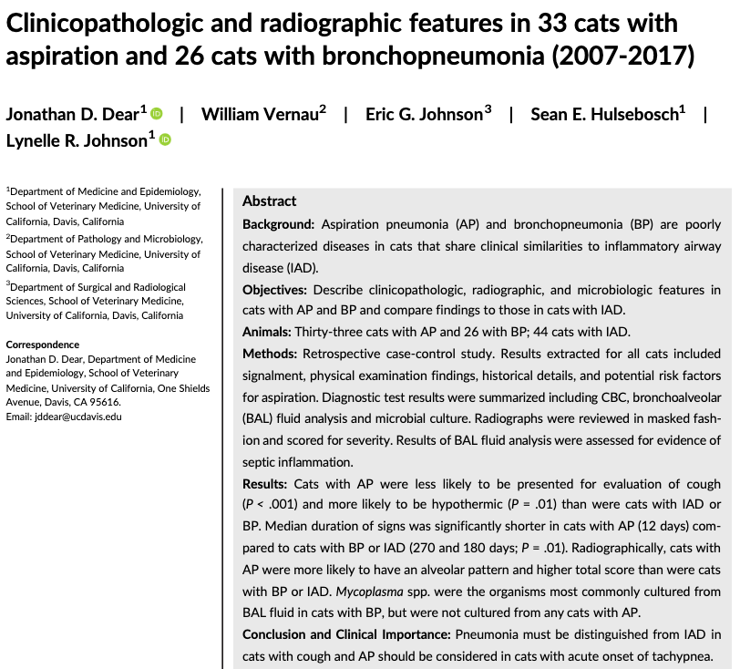
- GOAL: To characterize clinicopathologic features, radiographic findings and BAL fluid cytology + culture results in cats with confirmed BP and AP, using inflammatory airway disease (IAD) as control group
- Retrospective study over 10 years. Enrolled cats w/ “pneumonia”, “AP” or “BP” as diagnosis, then subdivided into AP vs BP based on detection of risk factors
  - AP = hx of concurrent dz or dz predisposing to aspiration and radiographs showing cranioventral pulmonary pattern
  - BP = dx of septic inflammation or clinically relevant bacterial or mycoplasma culture on airway sampling
- Most common AP risk factor was GI dz (esophageal dz in 60%, acute/chronic vomiting), recent anesthesia
- AP cats more likely to have acute hx of dz, median duration of Cx <2 weeks, more likely to be hypothermic, less likely to cough, more likely to have hx of tachypnea, more likely to have alveolar pattern
- BP cars more likely to have Cx 6-9 months, tend to have more severe bronchial pattern in addition to alveolar pattern
- Mycoplasma was most commonly cultured from BP cats, but not found in AP cats
- Overall, aerobic g-ve more commonly seen compared to aerobic g+ve organisms
  - Most common Pasteurella and Streptococcus respectively
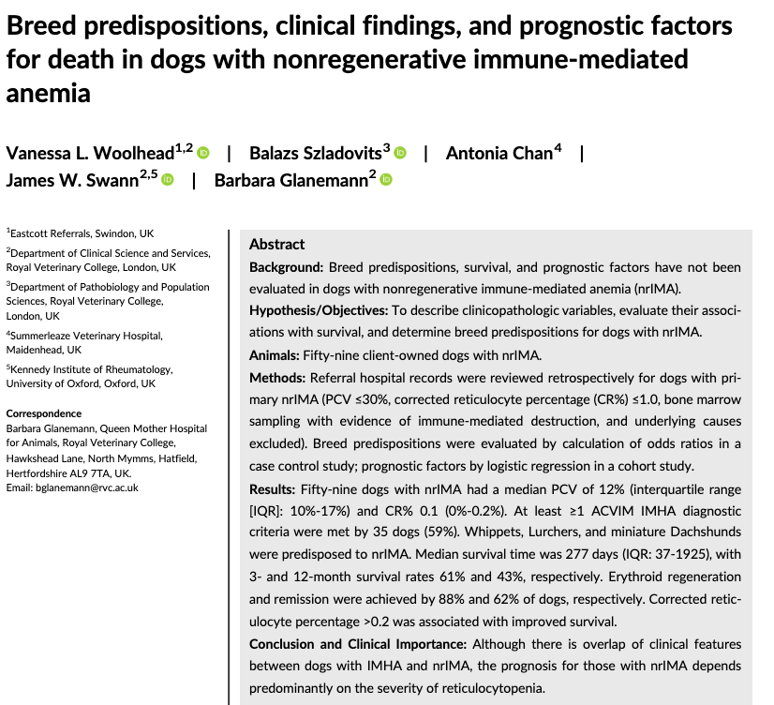
- 30-55% of IMHA dogs remain nonregenerative w/ corrected reticulocyte % (CR%) < 1, d/t destruction of erythroid progenitors by phagocytes in bone marrow (rubiphagocytosis)
- Dogs can have nonregenerative anemia +/- peripheral erythroid destruction or hemolysis precursor-targeted immune mediated anemia (PIMA)
  - They respond to immunosuppressive tx just as IMHA
- Previous negative prognostic indicator in nrIMA/PIMMA was development of thromboembolic event or presence of BM erythroid hyperplasia w/ concurrent neutropenia and thrombocytopenia
- Investigate clinicopathologic variables, association with survival and breed predispositions with nonregenerative immune-mediated anemia (nrIMA)
- Most common Cx: lethargy, weakness/syncope, inappetence, weight loss, PU/PD, pica
- Over 60% fulfilled >1 ACVIM IMHA dx criteria (hyperbilirubinemia or peripheral RBC destruction)
- Breeds: Whippets, Lurchers, mini dachshunds
- Most developed a regenerative response w/in 1 month
- Survival: 61% 3-months, 43% 6-months; CR% >0.2 associated w/ better survival
  - Survival in IMHA dependent on bilirubin, not regenerative response

