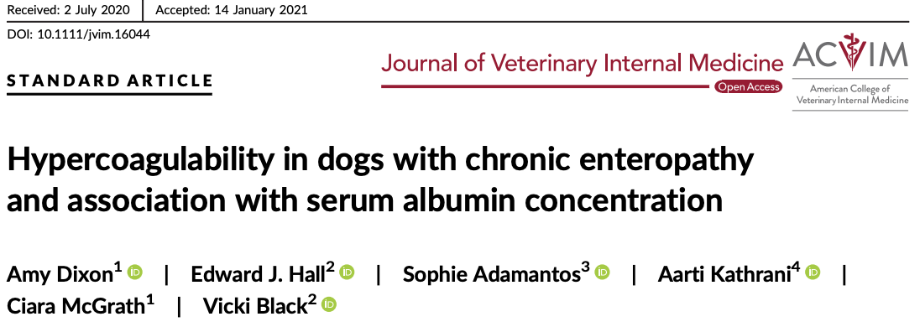
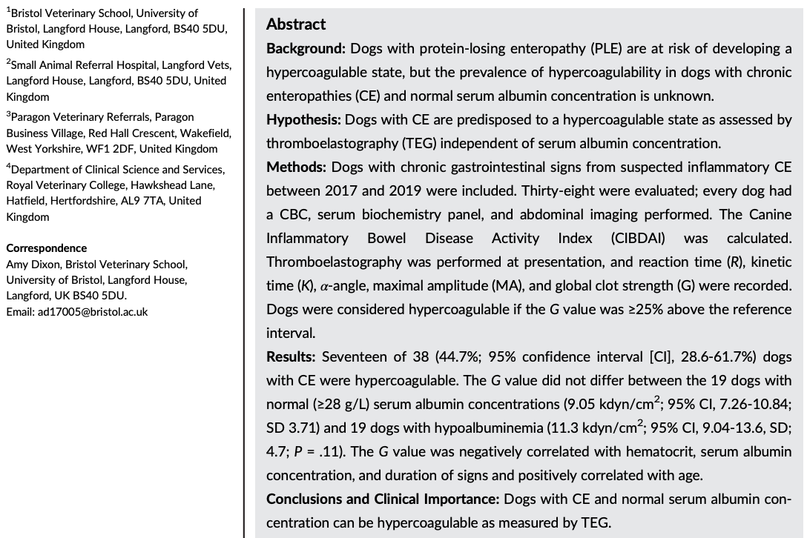
- PLE is associated with hypercoagulable state (loss of AT III) and may lead to thromboembolism
- In PLE, failure to resolve hypoalbuminemia in dogs w/ PLE is negatively associated w/ prognosis
- In previous studies, degree of hypercoagulability wasn’t associated w/ severity of hypoalbuminemia – hypercoagulability in PLE maybe multifactorial (GI inflammation?)
- OBJECTIVE: To investigate the prevalence of hypercoagulability (assessed by kaolin-activated TEG) in dogs w/ chronic enteropathy (CE) w/ normal serum albumin compared to those who are hypoalbuminemic.
- Patient population: Client owned dogs presenting to Bristol vets over 15 months with chronic (>2w) GI signs (D and/or vomiting, decr appetite); excluded if received steroids or NSAIDs in 2w prior
- Primary CE dx based on exclusion of infectious enteropathies (neg fecal culture, parasitology, or tx’d with panacur x 5 days) and excluded extra-GI dz (serum biochem, AUS/CT normal)
- Results:
  - 58% of hypoalbuminemic and 31.5% of normoalbuminemic dogs were hypercoagulable
  - Dogs w/ hypercoagulable TEG had shorter duration of Cx maybe more severe inflammatory process
  - G value was negatively correlated w/ HCT, serum album, and duration of signs but +vely correlated w/ age
  - Study was underpowered to detect difference in hypercoagulability using serum albumin cut off of 2.8 g/dL

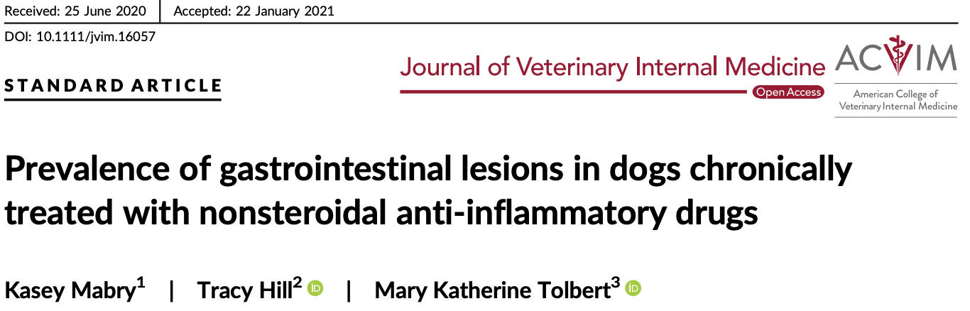
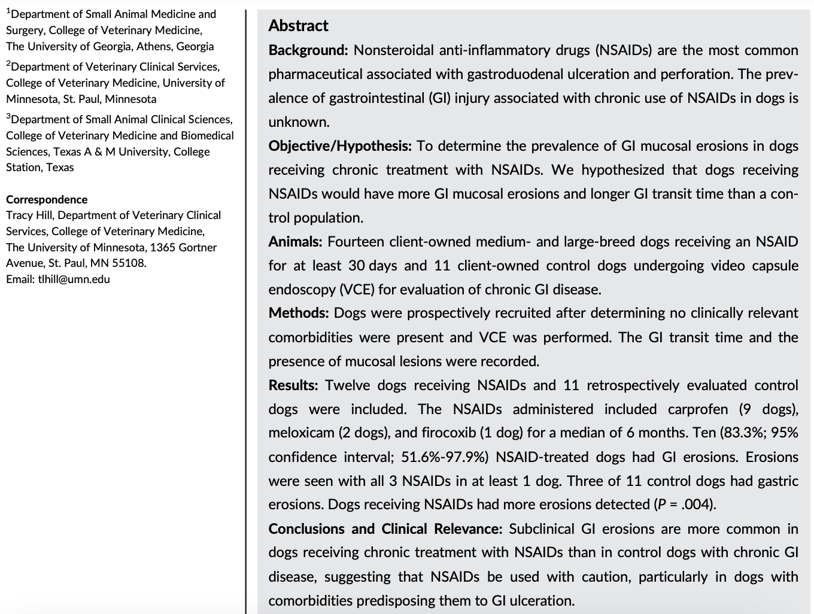
- Gastroduodenal perforation has NOT been reported in dogs receiving NSAIDs at therapeutic dose
- Previous studies looking at NSAID-Gi ulceration do not perform pre-tx endoscopy or VCE therefore cannot r/o pre-existing subclinical GI erosions
- OBJECTIVE: To investigate prevalence of GI mucosal ulceration in dogs receiving chronic NSAIDs
- 12 sample and 11 study dogs receiving 30d of NSAID underwent video capsule endoscopy (VCE); excluded if received H2RA, PPI, sucralfate, Mg- or AlOH, steroids w/in 30d
- 10/12 (83.3%) study dogs and 3/11 (27%) control dogs had stomach/SI/both erosion- none had clinical signs
- Suggest subclinical chronic GI dz is more common in dogs receiving chronic NSAID

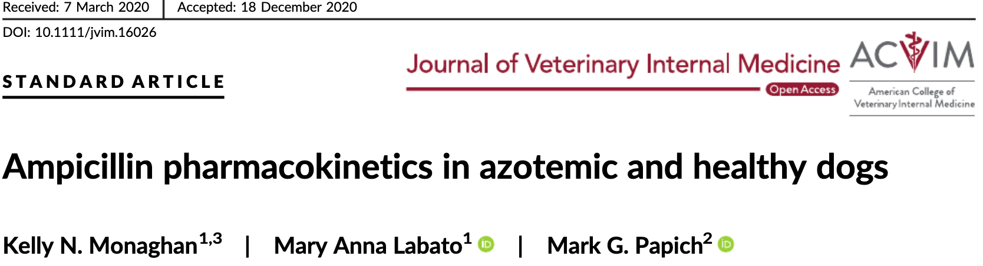
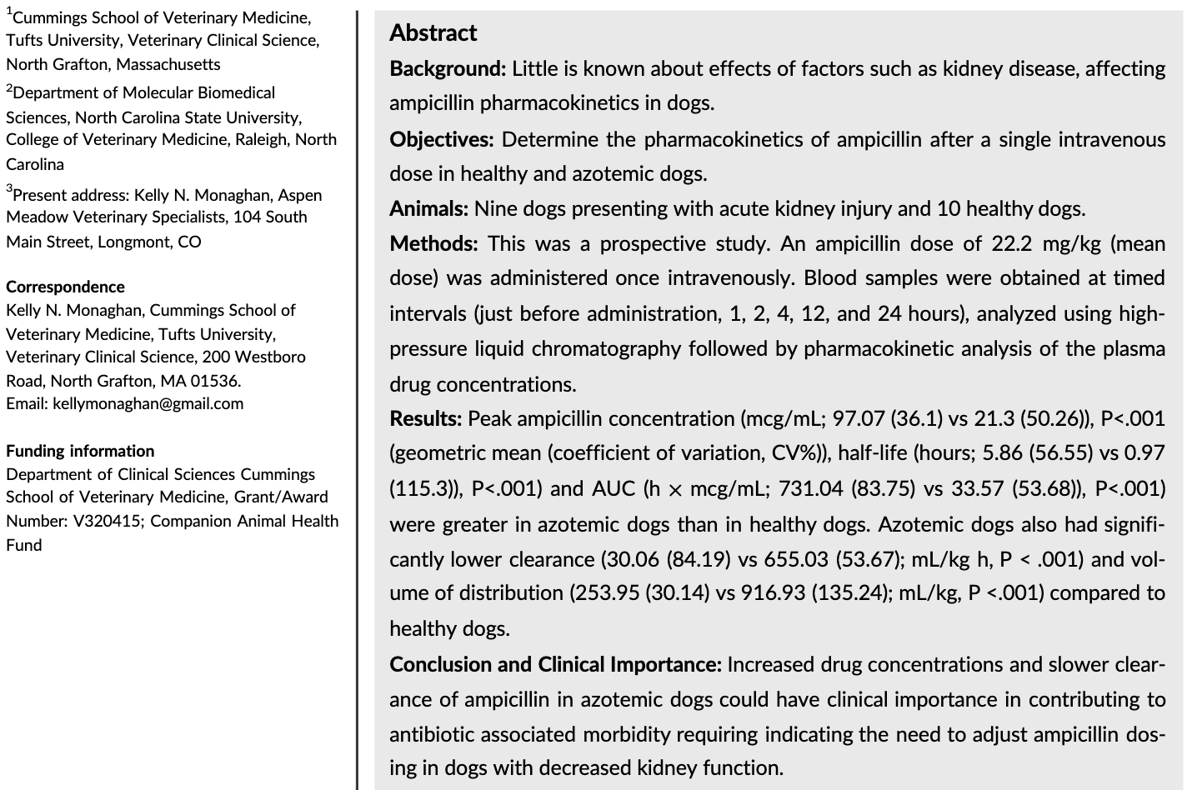
- Aminopenicillins: Excreted by kidneys via renal tubular secretion and partially via GFR, concentrated in urine, high index of safety in pets
- OBJECTIVE: To determine plasma clearance after a single IV dose in healthy dogs compared to azotemic dogs
- 9 azotemic dogs (severe azotemia = Cr >4 mg/dL) and 10 healthy dogs
  - Excluded Dogs <4.5kg, HCT <30%, and Alb <1.5 g/dL
- Gave them 22 mg/kg IV one dose – then checked bloods at 1,2,4,12, and 24h after administration
- Azotemic dogs had lower clearance and lower Vd
- Azotemic group achieving higher max plasma concentration than in healthy dogs AND they maintained measurable plasma concentration of ampicillin for the full 24h period
- Limitations: ONE dose only – not multiple dosing

