JAVMA Article for April 2020
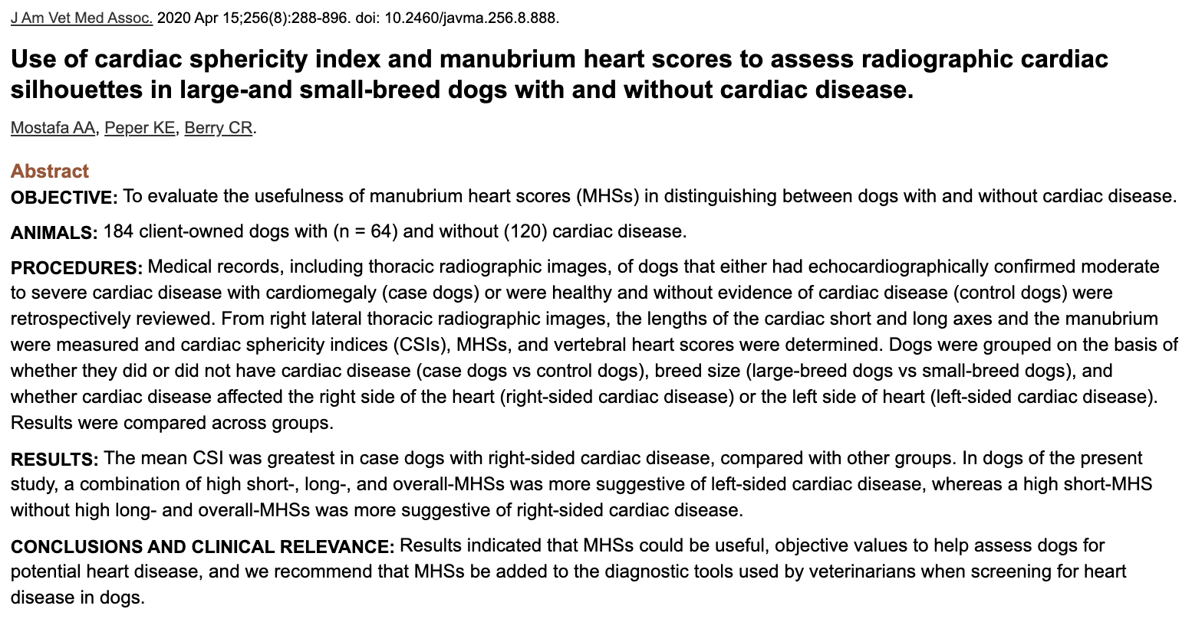
- VHS shortcomings: affected by interobserver variability, individual variation b/w dogs, disparities in breed thoracic confirmation and vertebral characteristics, congenital anomalies, shortened vertebral segments or IVDD narrowing
- Manubrium heart score (MHS) relies on length of manubrium, which strongly correlates w/ the cardiac axes
  - Previously assessed in healthy small and large breed dogs and “normal” MHS was established
- Enrolled normal (64) dogs and with heart disease (120) retrospectively
  - Excluded those w/ pericardial effusion and vertebral anomalies or deformed manubria
- Right lateral thoracic radiographs
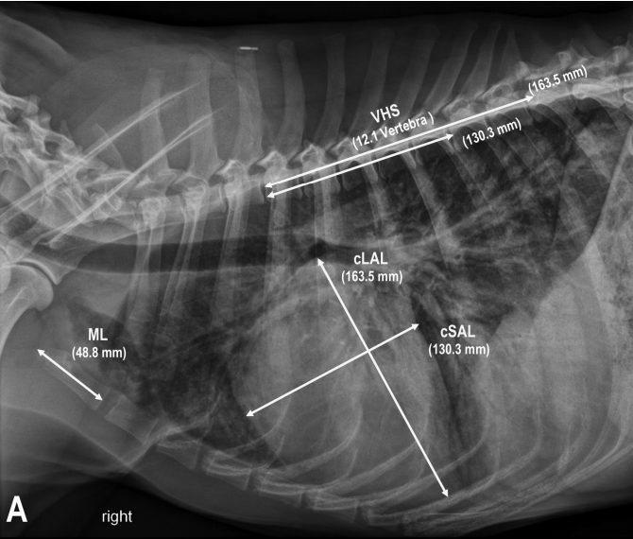
(GSD with DCM) MHS=6.1, VHS= 12.1, CSI 80%
- Overall-MHS= (cLAL+cSAL)/ ML
  - cLAL=Cardiac long-axis length
  - cSAL= cardiac short-axis length
  - ML = manubrium length
  - Short-MHS: cSAL:ML ratio
  - Long-MHS: cLAL:ML ratio
- CSL = cSAL:cLAL ratio (to objectively evaluate the roundness of the cardiac silhouette)
- Results
  - Large breed dogs: Higher CSI in right-sided enlargement and higher MHS in left-sided enlargement
  - Small breed dog: Higher CSI in right-sided enlargement, higher VHS in left-sided enlargement, no difference in MHS
- A combination of high short-, long- and overall-MHS = suggestive of left-sided disease
  - Large breed: short-MHS > 2.2, long-MHS >2.8 and overall-MHS >5
  - Small breed: short-MHS > 2.5, llong-MHS > 3 and overall-MHS > 5
- High short-MHS without high long- and overall-MHS = suggestive of right sided disease
  - Large breed: CSI > 78% and short-MHS > 2.2
  - Small breed: CSI >83% and short-MHS > 2.5
- Can consider using MHS in additional to VHS. Echo is still the gold standard.

