Apr 4 - May 16 2019 Lit Review
J Vet Radiology and Ultrasound
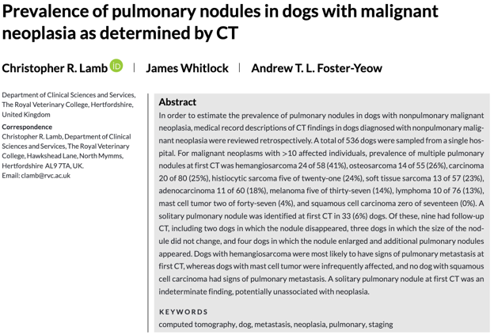
- X-ray prevalance of nodules: thyroid carcinoma 63%, TCC 26-36%, HSA 19-52%, OSA 17%, mammary carcinoma 15%
- CT prevalence of nodules: HSA > OSA > Carcinoma > histiocytic sarcoma > STS > adnocarcinoma > melanoma > lymphoma> MCT
- HAS most likely to have mets at 1st CT
- No dogs with squamous cell carcionmas had mets
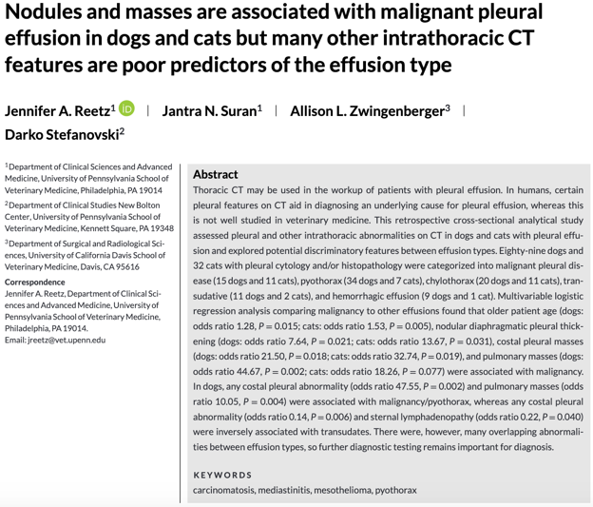

JAAHA

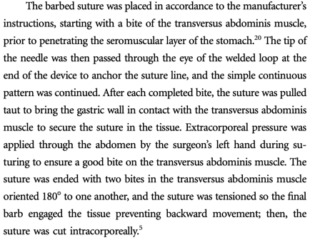
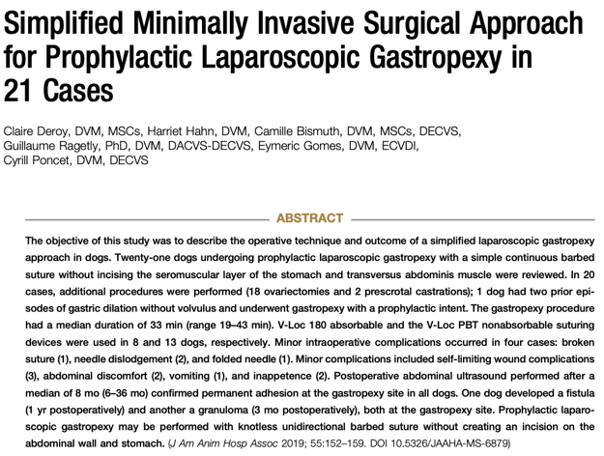

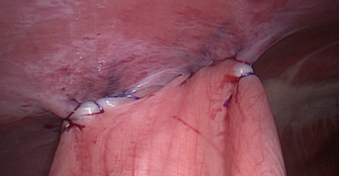
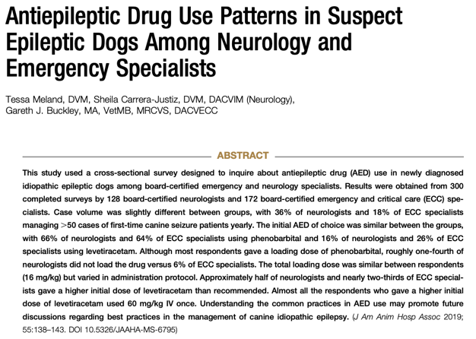

- Majority of neurologist + criticalists used pheno, 2nd most common was levetiracetam
  - If using pheno, 82% neurologist used a loading dose
  - If using Keppra, 52% neurologist used a 60mg/kg IV dose
- No one really uses zonisamide or KBr anymore
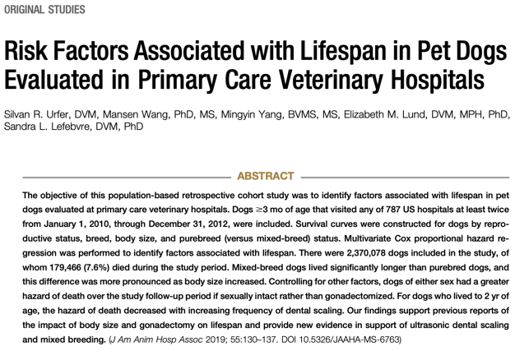
- Body size was a more important predictor of lifespan than purebred status
- Spayed females had the longest life expectancy (30w longer than intact female)
- “When comparing two dogs, all other factors being equal, a difference of one dental cleaning per year is associated with a nearly 20% decreased risk for death”
