Crit Care Clinics: Feb 2018

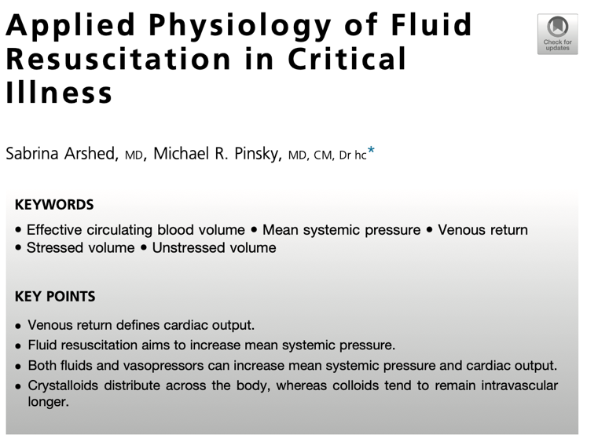
Introduction:
- Not all causes of hypotension benefit from the administration of IVF
- The “best” type of fluid used for resuscitation is controversial
- Fluid therapy should be goal directed and individually tailored to each patient’s needs

Summary:
- Goal of fluid therapy is to increase the MAP and improve venous return
- Increasing MAP is only beneficial if MAP>right atrial (RA) pressure
  - If RA pressure rises, venous return decreases
- MAP only starts to increase when blood volume> unstressed vascular volume
  - Unstressed vascular volume: volume contained by vessels WITHOUT causing vessel stretch (approx. 60-70% blood volume)
    - MAP=0
    - Varies based on vascular tone and distribution towards/away from high capacitance vessels
  - Stressed vascular volume: Volume in excess of unstressed vascular volume that contributes to vessel stretch (approximately 30-40% blood volume)
  - Vascular compliance= MAP/(stressed vascular volume- unstressed vascular volume)
- Types of shock
  - Cardiogenic shock
    - Causes:
      - Heart failure of any etiology (myocardial, valve disease,
    - Pathophys
      - SBP <90mmHg and hypoperfusion caused by arterial hypotension, increased cardiac filling pressure, increase venous pressure. Often causes pulmonary edema
    - Treatment/role of fluids:
      - Inotropic agents
        - Trade off of improved perfusion with increased ATP demand
      - Conservative fluid therapy to improve coronary perfusion
      - Avoid vasopressors- associated with poor outcome
  - Obstructive Shock
    - Causes
      - PCE tamponade, pneumothorax, massive PTE
    - Pathophys
      - Impaired ventricular filling or ejection causing decreased CO
    - Treatment/Role of fluids:
      - Fluid therapy often contraindicated in massive PTE as it causes further dilation of RV
  - Hemorrhagic (hypovolemic) Shock
    - Causes:
      - Traumatic injury
    - Pathophys
      - Loss of blood volume and/or trauma induced coagulopathy (10-34% of patients)
    - Treatment/Role of fluids:
      - Fluids indicated to restore volume
      - Crystalloids may cause interstitial edema, abdominal compartment syndrome
      - Blood products especially if rapid hemorrhagic losses- Consider 1:1 plasma: blood
  - Distributive Shock
    - Causes
      - Sepsis, trauma, perioperative state
    - Pathophys
      - Vasoplegia, impaired blood flow distribution causing increased unstressed vascular volume
    - Treatment/Role of Fluids
      - Aggressive fluid resuscitation if early
- Fluids
  - Balance between intracellular and extracellular (intravascular and interstitial)
    - Balance between oncotic and hydrostatic pressures. The glycocalyx has also become more known/important recently
  - Crystalloids:
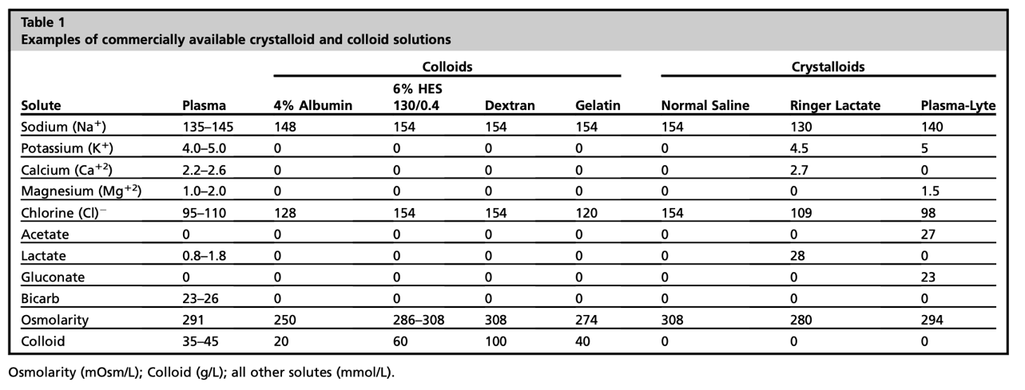
    - Tend to distribute into the intracellular spaces more than colloids
    - Studies have demonstrated improved outcomes when using balanced fluids (p-lyte, LRS) vs normal (0.9%) saline
      - 0.9% saline has supraphysiologic concentrations of Na and Cl and is acidifying
    - Aggressive resuscitation can lead to extravasation into the interstitial space- especially in cases of vasoplegia/glycocalyx damage
      - Study of crystalloids vs albumin showed improved outcomes with albumin in septic shock
  - Colloids
    - Tend to stay intravascular due to high molecular weight compounds that increase oncotic pressures.
    - In America, Albumin is the most commonly used colloid followed by hydroxylethyl starch (HES)
      - HES use banned in the UK due to association with AKI in septic patients
    - Studies
      - Saline vs Albumin Fluid Evaluation (SAFE) trial: compared 4% albumin with 0.9% saline
        - No difference in 28 day all-cause mortality
        - Relative risk of death increased when albumin used in TBI
        - Improved outcomes when albumin used in sepsis/septic shock
      - ALBOIS Study: compared albumin with normal saline
        - Septic shock patients were the only group that had better outcomes with albumin
      - Crystalloid vs Hydroxyethyl Starch Trial (CHEST): compared 6% HES to 0.9% saline
        - No difference in 90 day all-cause mortality
        - HES group had double the amount of adverse events (skin rash, pruritus, AKI)

Crit Care Clinics April 2020
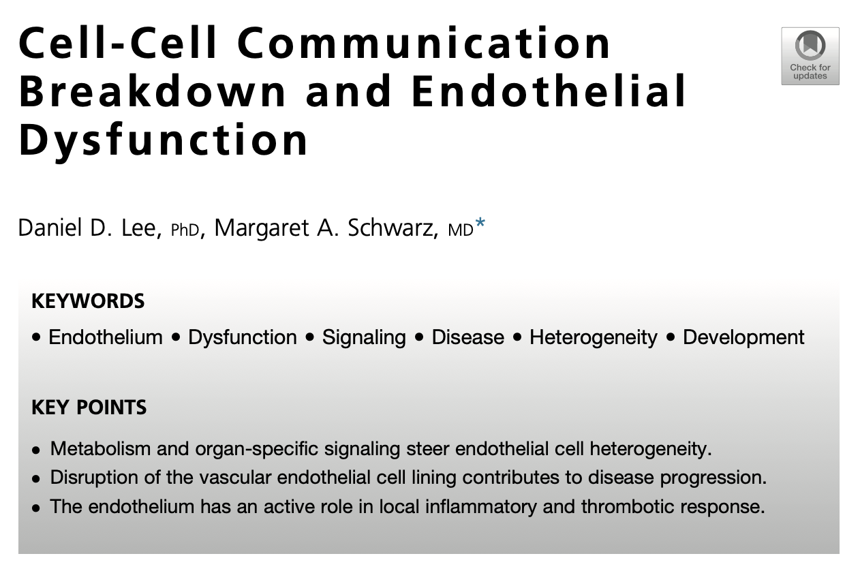

Intro:
- Vascular system is made up of specialized endothelial cells (EC)
- Endothelial cell growth and differentiation are guided by vascular endothelial growth factor (VEGF) in response to different environmental factors associated with different tissues.

Normal endothelial development
- Development of vascular endothelium occurs via a 4-step process
  - Steps 1 and 2 occur normally in every developing vessel. Steps 3 and 4 usually occur as compensatory mechanisms
- Vasculogenesis
    - Vasculature grows from primitive embryonic splanchnic mesoderm via differentiation of the endothelial progenitor cells into either hemangioblasts OR differentiated EC
    - Fate largely determined by transcription factors that are secrete from local tissue
- Angiogenesis
    - Remodeling of emerging vessels from existing vasculature
      - Sprouting: migration, proliferation and 3-D organization of EC into tubes
      - Non-sprouting: division and remodeling of existing vessels
- Arteriogenesis
    - Collateral artery growth in response to local ischemia
- Lymphoangiogenesis
    - Growth of lymphatic vessels from existing ones
- Endothelial cells are phenotypically heterogenous depending on the tissue location
  - Classical markers of endothelial lining
    - Hemangioblast
    - Neonatal angioblast
    - Adult endothelial progenitor cells
    - Matured endothelium
  - Endothelium dynamically responds to signaling from surrounding cells.
Endothelium Function
- ECs regulate the transport of fluids and circulating solutes
  - Paracellular transport
    - Mediated by:
      - Tight junctions (TJs) (zonulae occludens)
        - Fewer numbers in ECs used only for transport (capillaries/venules)
        - Sites of potential plasma proteins and leukocyte extravasation
      - Adherens junctions (AJs)
        - Protein complexes that link cytoskeleton of one EC to the adjacent EC via adhesion protein called vascular endotheial (VE) cadherin
  - Transcellular vesicle-based pathways
    - Relies on vesicle-based mechanisms
      - Endocytosis
      - Fusion
      - Vesiculo-vacuolar
- Response to vascular injury
  - Intact, “normal” EC contain Tissue Factor
    - Tissue factor is released and initiates clotting cascade when celluar injury occurs
  - Once wound repaired, ECs release fibrinolytic molecules (TPA, Urokinase-type PA and platelet cleaving metalloproteases) to degrade clot and cause vessesl recanalization
- Regulation of vessel contractile forces
  - Vasodilatory substances/promotors
    - Release of nitric oxide (NO)
    - Examples include: histamine, acetylcholine, bradykinin, thrombin, growth factors, endothelial L-arginine
  - Vasoconstrictor substances
    - Examples include: catecholamines, melatonin, vasopressin, serotonin, adenosine diphosphate, prostacyclin
Endothelial Development and Cell-cell communication
- Extracellular cues sensed by receptors and either cause functional or proliferative-migratory changes
- Cell-cell communication occurs via:
  - Endocrine
  - Neurotransmitter
  - Paracrine
  - Autocrine
- Ligands bind to receptors and are classified into these categories:
  - G protein coupled-
  - Ion channel-linked- cause open channel conformation and passage of ions
  - Enzyme-linked- activate intracellular enzymes
- Mural cells
  - Consist of pericytes and vascular smooth muscle cells (vSMC)
    - Ratio dependent on tissue type
- Monocyte/Macrophage- endothelium
  - Macrophages are the source of secreted factors needed for blood vessel growth
  - Controversial evidence that macs transdifferentiate into endothelial progenitors
- Endothelial-to-Mesenchymal Transition
  - Mature endothelium acquires characteristics of mesenchymal tissue
    - Important in human adult cardiovascular disease pathogenesis
Endothelial Dysfunction in disease processes
- Natural aging process
  - Reduced regeneration capacity of cells due to cell cycle arrest in G1
  - Increasingly prone to apoptosis with age
- ROS damage
  - Deleterious to DNA transcription and redox sensitive signaling pathways
  - ROS inflammation inhibition of NO-dependent vasorelaxation further organ damage
- Microthrombi
  - Usually from exocytosis of VWF multimers and platelet activation
  - Causes localized tissue inflammation
- Tumor growth
  - Previously quiescent ECs are recruited to promote neoplastic growth

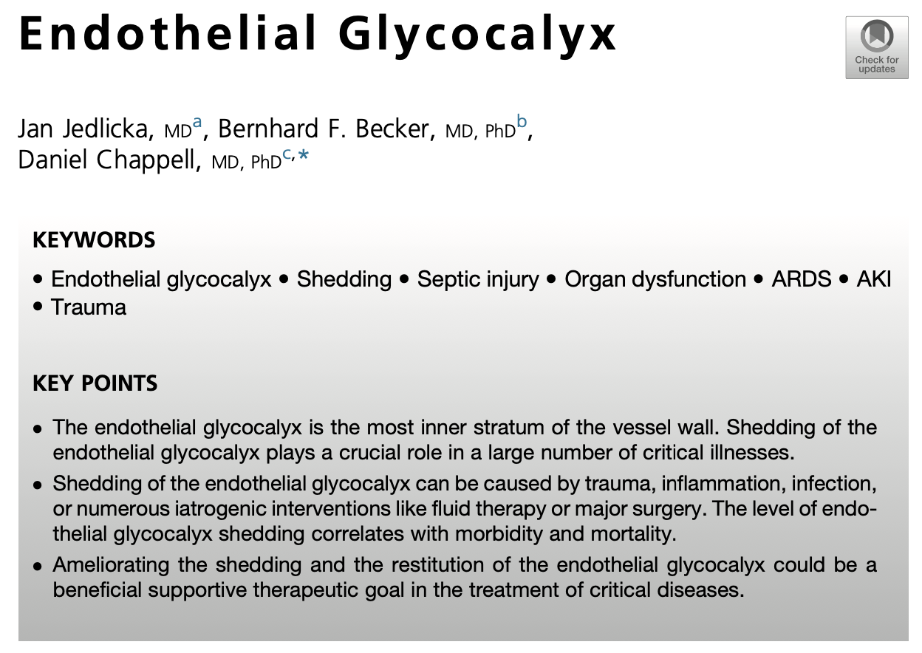
Introduction:
- Endothelial glycocalyx (EG) made up of proteoglycans, glycosaminoglycans and forms the luminal layer of the blood vessel
- EG interacts with circulating plasma proteins (albumin) to form the endothelial surface layer (ESL)
  - Promotes organ perfusion via maintaining vascular barrier and microcirculation
- Degradation of EG is associated with worsening outcomes
  - Damage associated with hypertension, diabetes, hyperglycemia, hypernatremia
- Despite physiologic importance, no evidence that the therapeutic goal of restitution of the EG improves survival
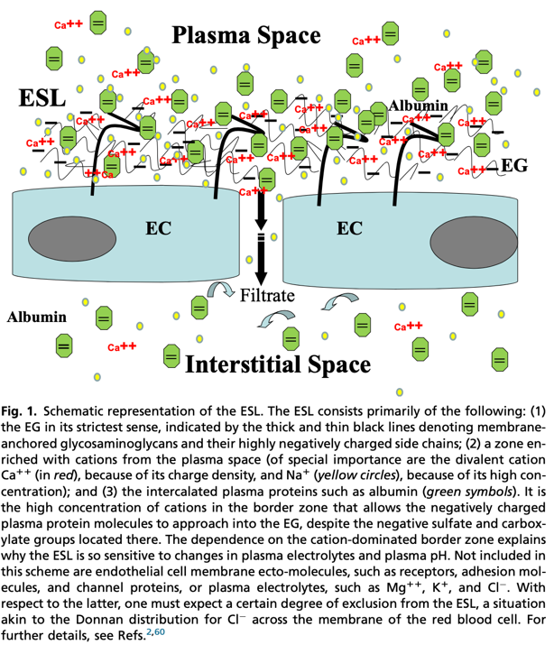
Function and Structure of Vessel Wall
- 4 different layers
- Vasta et nervi private (tunica adventitia)
- Tunica media
  - Mostly myocytes
  - Most prominent in arteries and larger veins (provides their inherent vascular tone)
- Tunica intima (membrana elastica interna)
  - Endothelial cells connected via tight junctions
  - Kidney/liver vessels contain fenestrae and gaps in some segments
- Endothelial glycocalyx
  - Generally 0.2-2um thick depending on the location
  - MAIN COMPONENT OF THE VASCULAR BARRIER- maintains vascular oncotic pressure
  - Negatively charged and composed of:
    - Proteoglycans (syndecans, glypicans)
    - Sulfated glycosaminioglycans (heparans, chondroitin, dermatan, keratan sulfates)
    - Hyaluronic acid (connected via CD44)
    - Plasma proteins (albumin)
    - Positively charged ions (Ca++, Na+)
    - Adhesion molecules (ICAM/VCAM), VWF, Antithrombin, Tissue factor pathway inhibitor, NO-synthase (NOS)

EG in Specific disease processes
  - Many possible underlying disease processes that causes dysfunction of the alveolo-capillary barrier with the same common final pathway (via destruction of the EG)
- Acute respiratory distress syndrome (ARDS)
  - Tumor necrosis factor- a (TNF-a) and other inflammatory mediators (IL-6, IL-8) cause release of heparan sulfate from the EG
    - Immunomodulation can decrease the release/production of these products
      - Neferine- little evidence for clinical application
      - Hydrocortisone- no proven survival benefit in ARDS
  - Syndecan 1 expression allows for reconstitution of the EG via plasma products.
- Trauma
  - Increased levels of syndecan-1 and thrombomodulin correlated with severity of organ dysfunction
  - Hyperfibrinolysis caused by increased TPA activity and decreased plasminogen activator
  - CRASH-2 trial showed survival benefit in patients receiving TXA
    - No change in syndecan-1 levels (decreases hyperfibrinolysis but does not alter the EG)
- Hypervolemia
  - Occurs in 67% of septic shock patients resuscitated with crystalloids alone
  - Causes worsening of interstitial edema and tissue hypoxia worsening EG destruction
  - Experimental ANP infusion without volume administration lead to increased syndecan-1 levels and degradation of EG
    - Volume overload atrial naturetic peptide (ANP) secretion increased EG permeability increased interstitial edema
- Ischemia/Reperfusion (I/R)
  - Marked elevations in syndecan-1 noted following ischemic injury
  - Immunomodulation (hydrocortisone, antithrombin III) can decrease the amount of EG degradation
    - Blockade of cytokine serine protease synthesis, stabilization of mast cells
  - Preconditioning with sevoflurane has been shown to decrease severity of I/R
- Hypernatremia
  - Hypernatremia common in ICU patients
    - 7-16% present with hypernatremia, 25% will develop while in ICU
  - Hypernatremia hyperosmolarity fluid shift from intravascular extravascular (development of interstitial edema)
  - Na has direct toxic effects on the EG
    - Experimentally, highest levels of syndecan-1 and hyaluronic acid noted in groups resuscitated with hypertonic saline
    - Thickness of EG halved by administration of hypertonic saline
      - Decreased to 1/3 when epinephrine administered
- Hyperglycemia
  - Hyperglycemia diacyclclycerol and protein kinase C activation increased nitric oxide synthase activity increased ROS
  - Ideal glucose levels between 120-150mg/dL
- Microcirculation and Volume Therapy
  - Dissociation between macro and microcirculation in severe illness (trauma, sepsis)
  - Degree of microcirculatory disorder may not correlate with severity of EG injury
    - Perfused boundary region (PBR)= inverse marker of EG thickness
    - PBR and markers of microcirculatory dysfunction were correlated with markers of critical illness but not with each other (EG damage can occur without concurrent microcirculatory disturbance)
  - ProCESS trial demonstrated a rise in heparan sulfate correlated with each additional L of fluid administered
  - Degree of possible volume resuscitation determined by how intact the EG is
    - Intact EG
      - Colloids: 90-100% volume expansion
      - Crystalloids: 3-4L for every 1L of blood loss
    - Damaged EG
      - Similar volume expansion capabilities of colloids vs crystalloids
  - Degree of EG preservation/restoration
    - Albumin/plasma> synthetic colloids > pRBC (no effect) > crystalloids (likely deleterious)
- Sepsis and AKI
  - Associated hypotension reflex vasoconstriction decreased renal perfusion
    - Decreased GFR
      - Decreased Na reabsorption
    - Transition to anaerobic metabolism
  - Above mechanisms can cause tubular apoptosis/necrosis which can worsen regional inflammation/kidney injury
  - Glomerular endothelial cells also have an EG
    - Damage to EG may contribute to progression from AKI to CKD
    - Increases in plasma or urinary syndecan-1 can predict AKI
  - Research underway to define biomarkers for structural damage before functional impairment (before rise in creatinine)
    - Cystatin C Rise seen 24-48h post AKI
    - Neutrophil gelatinase-associated lipocalin (NGAL) seen 6h post AKI

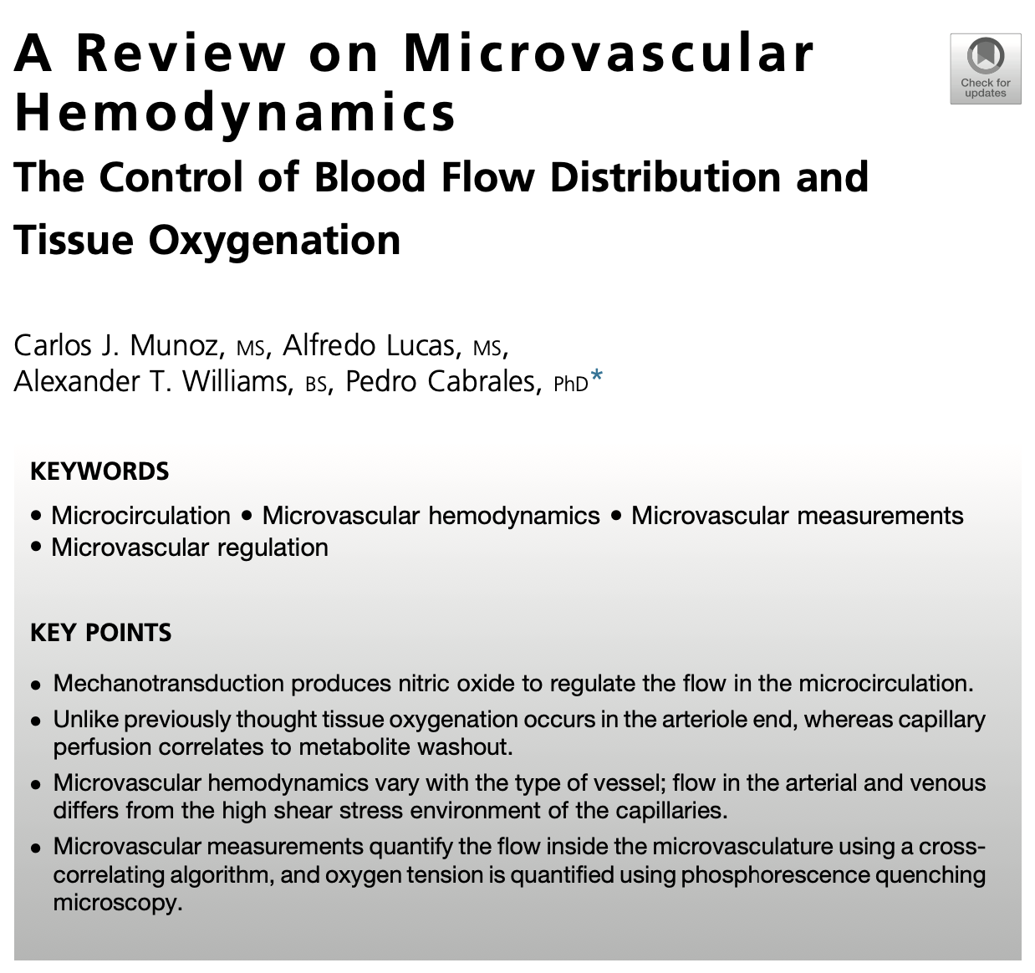

Introduction
- Microcirculation aimed to match to metabolic needs of surrounding cells/tissues
  - Configuration of blood vessels optimized to achieve most efficient blood flow
- Anatomically, includes arterioles, venules, capillaries

Microcirculation anatomy
- Arterioles/venules
  - Branching patterns
    - Dichotomous tree- main branch progressively divides into 2 until capillary reached
    - Arcading tree- Branches of tree can connect with each other to produce polygonal network
      - Common conformation in mesenteric circulation, skeletal muscle, thermoregulatory cutaneous vessels
  - Oxygen delivery to tissues
    - Determined by Hb affinity for O2 and O2 concentration gradient between blood and tissues
      - Oxygen can diffuse 100-200um
  - Tone of vessels regulated by smooth muscle cells (SMC) arranged in multi-layer spiral configuration
    - Interaction with NO causes decreased in intracellular Ca and vasodilation/relaxation
- Capillaries
  - Smallest luminal diameter- diameter can decrease to smaller than RBC, necessitating deformation of the RBC as it passes through
  - Capillary compliance is different depending on the tissue
    - Ex: pulmonary capillary compliance >> muscle capillary compliance

Mechanotransduction and NO Regulation
- NO production is directly related to degree of mechanotransduction/shear stress on endothelium
  - Stimulates the production of endothelium-derived nitric oxide synthase (eNOS)
- NO receptors are endocytosed/desensitized to NO as the concentration increases
- Cell-free Hb also causes rapid and irreversible scavenging of NO
  - Binding of NO to Hb can also convert NO to NO3 and cause methemoglobinemia
Oxygen exchange in microcirculation
- Microcirculation supplies 60-70% of tissue oxygenation
  - Continuous branching of arteriole system causes reduced ratio of proportional oxygen content: cross sectional area

Microcirculation Hemodynamics
- Arteries and venules
  - Blood flow under the influence of shear stress from the vessel walls
    - Causes partial blunting of the blood velocity profile
    - Shape of the curve becomes more parabolic as the rate of flow increases or decreases
  - Cell free layer (CFL) at the edge of the vessel wall (AKA the glycocalyx) reduces the resistance of blood flow by “pushing” cells away from the wall
- Capillaries
  - Plasma flow
    - Shear stress related to shear velocity
    - Flow rate remains parabolic if 2 RBCs are a distance of >1.3x the capillary diameter apart from each other

  - RBC flow
    - Resistance on each individual RBC decreases the closer they are together within the capillary
    - Thickness of CFL= square root of the velocity
    - Resistance = inverse square of the RBC velocity
    - At a branch point, will typically flow into the branch with a higher velocity

Microcirculation Dysfunction
- Shock leads to decreased density of functional capillaries
- Decreased blood viscosity, decreased in vessel wall shear stress, shedding of EG, pathologic hyperfibrinolysis and diffuse coagulopathy

Experimental Microvascular Measurements:
- Intravital microscopy
  - Uses laser doppler technique or orthogonal polarization spectral imaging on skin, nail flap or lip
  - Also experimental model of dorsal skin flap in hamsters
- Velocity measurements
  - High-magnification microscopy allows for collection of frame by frame analysis of short videos
- Measurement of oxygen tension
  - Phosphorescence quenching microscopy (PQM) used to make high-resolution microvascular PO2 measurements

Crit Care Clinics July 2020

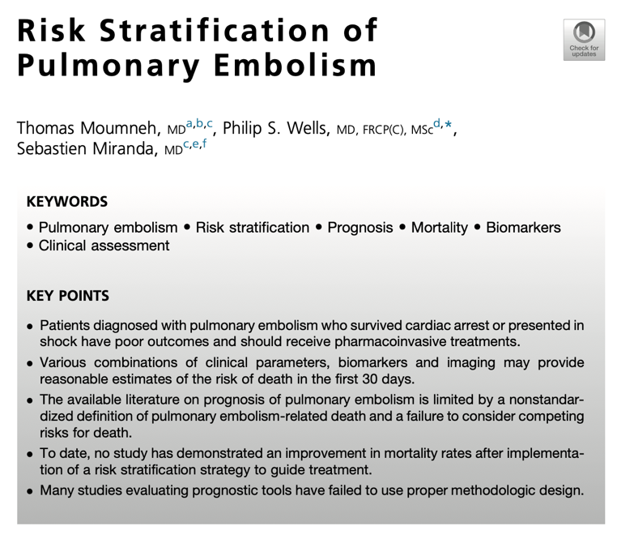
Introduction:
- Highest risks of hospital death unsurprisingly associated with PE that cause cardiac arrest and/or shock
- Risk stratification strategies include clot burden, baseline CP function, comorbidities that may contribute to clot recurrence, efficacy of treatments
- Can be difficult to determine if PE alone contributed to death as comorbidities that cause PE and can also be fatal independent of PE
  - Post-mortem CTA not helpful
- Delayed diagnosis/treatment appears to be associated with worse outcomes
Summary:
- Diagnosis of clot burden
  - CTA
    - Retrospective studies and meta-analyses have shown poor correlation of clot location (central/saddle vs other) and vascular obstruction scoring (Mastora, Qanadli, Meyer scores) with short/long term risks of death or need for thrombolytics or embolectomy
  - Thoracic Echo
    - Useful for diagnosis of RV thrombi, but not useful for determining prognosis/treatment
      - Available studies are poorly controlled for the hemodynamic stability of the patient on outcome
  - Lower Extremity US
    - 2016 meta-analysis showed association with deep vein thrombus (DVT) and 30d mortality (OR: 1.89)
    - Prospective RCT (PREPIC) of insertion of CVC filter in patients with DVT and concurrent PE did not prevent mortality/recurrence
  - D Dimers
    - Multiple studies have shown correlation between elevated D Dimers and mortality (15d and 30d).
      - Differences in measurement techniques and classification of “elevated” between studies
- Clinical Parameters
  - Syncope
    - Not associated with increased mortality when meta-analysis controlled for systemic hemodynamic stability
  - Hypotension
    - Meta analysis of 4 cohorts, hemodynamic instability correlated with 90d all cause mortality
    - Prospective study suggested hypotension associated with increased short term (1w) mortality rate
    - Hemodynamic instability is a major indication for starting thrombolytic therapy
  - Hemoptysis
    - Rare and likely related to PE and unlikely to result in death
- Clinical Scores
  - (simplified) Pulmonary Embolism Severity Index (PESI and sPESI)
    - Derived from a retrospective study to Predicts 30d all cause mortality
      - 11 clinical criteria in PESI
      - 6 clinical criteria in sPESI
    - Lower scores suggest that at-home management may be appropriate
  - Hestia criteria
    - Patients meeting any of the checklist criteria are recommended to be managed as inpatients
    - NOT a prognostic indicator
  - Geneva prognostic score
    - Includes 6 criteria, but is less practical than PESI because of the need for lower extremity US and art gas
- Biomarkers of RV dysfunction
  - Cardiac troponin
    - Specific but non-sensitive marker of RV dysfunction in the context of PE
      - “abnormal” levels derived from studies of myocardial infarction
  - BNP and pro BNP
    - Secreted due to myocardial stretching
    - More sensitive, less specific than troponins for RV dysfunction
  - Heart-type fatty acid-binding protein (H-FABP)
    - Released by cardiomyocytes in context of acute coronary syndrome
    - Meta-analysis suggests better prediction of PE related mortality compared to troponin or BNPs
      - No studies have actually compared these tests directly
- Other tests
  - ECG
    - Sinus tach, complete RBBB, ST elevation associated with increased risk of hemodynamic collapse
      - Changes more commonly associated with patients presenting in shock
  - Transthoracic Echo
    - Most common changes with PE include increased RV end diastolic diameter, RV/LV end diastolic diameter >1, RV hypokinesia, paradoxical septal wall motion, PH, Tricuspid regurg
    - RV dysfunction associated with increased short-term mortality
  - CTA
    - Meta-analysis suggests that RV/LV diameter ratio >1 on transverse sections had 2.5 fold increase of all-cause mort and 5 fold risk of PE related mortality

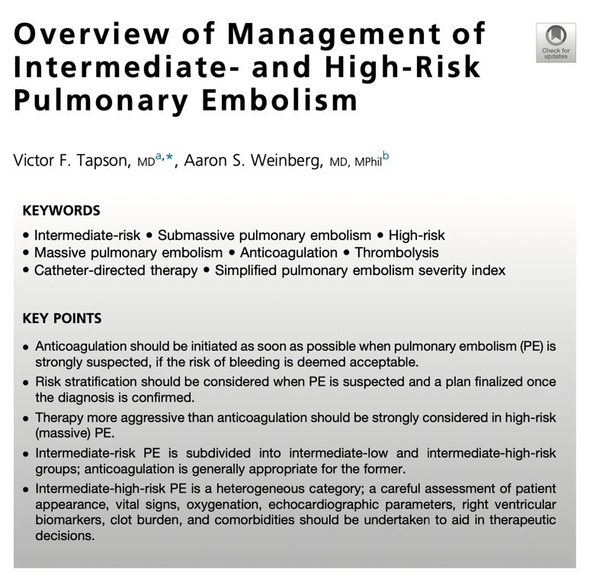
Summary:
- Former nomenclature “massive PE” and “submassive PE” have been replaced with “high risk” and “intermediate risk”
  - “Supermassive”/”catastrophic” PE cause CPA
  - “High risk/massive PTE”: defined as emboli that cause hemodynamic instability
    - Treatment requires more than anticoagulants
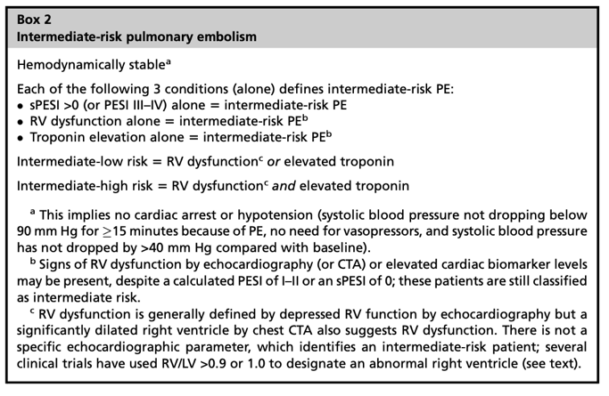
  - “Intermediate risk/submassive PTE”: defined as RV dysfunction without hypotension
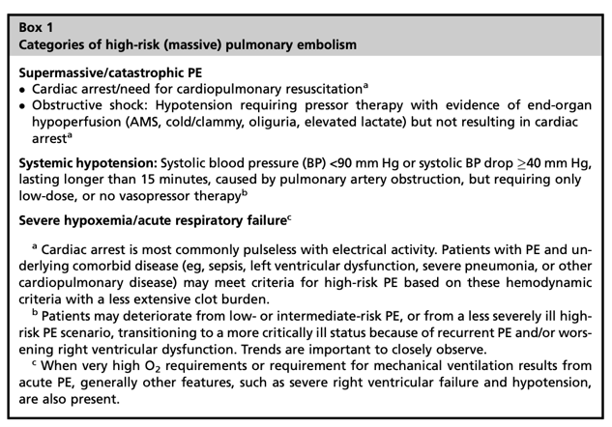
- Classification of intermediate risk PE
  - Majority of risk factors are discussed in previous article summary
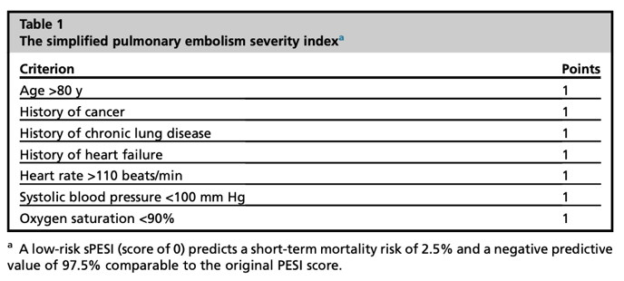
  - Simplified Pulmonary Embolism Severity Index (sPESI) has been validating in predicting 30d mortality in acute PE
  - Range of intermediate-low to intermediate-high

  - Association of clot burden with mortality has been inconclusive in available studies
  - Anticoagulation therapy has been proven to improve outcomes in acute PE
- General Treatment of acute PE
  - Pulmonary Embolism Response Team (PERT)
    - Clinical guidelines for PE management have been published by PERT consortium
    - PERT individuals responsible for supplementing care specific for PE cases
  - Anticoagulation
    - Should be started IMMEDIATELY after diagnosis of acute PE unless risk of bleeding is high
    - No clear evidence for “best anticoagulant”
      - IV UFH may be better in hypotensive cases
      - More stable cases may be better suited for SC LMWH which has more predictable activity
      - Transition to PO anticoagulant after stable for 24-48h on IV/SC
    - If unable to anti-coagulate, a IVC filter placement should be performed
  - Oxygen/ventilation
    - Consider nasal oxygen supplementation, high flow or mechanical ventilation based on the oxygenation/Aa gradient of the patient
    - PPV may negatively impact an already stressed RV in the case of a PE
    - If mechanically ventilating, TV ~6mL/kg, use PEEP, Pplat < 30mmH2O, use hemodynamically neutral sedation
  - IVF and vasoactive therapy
    - Caution with IVF to avoid overloading the RV
    - NE is the most commonly used due to A1 and minimal B1 properties
      - Dobutamine can be considered as a second agent, but may negatively impact V/Q
- Considerations in Catastrophic/Supermassive PE
  - Immediate anticoagulation/thrombolysis initiated ASAP
    - Thrombolysis (most commonly TPA) in the case of CPR is still recommended- usually bolus
    - No evidence for survival improvement associated with measuring fibrinogen levels
    - Consider stopping/reducing heparin infusion during thrombolysis
  - Consider catheter-directed therapy if experienced clinician available
  - Extracorporeal membrane oxygen (ECMO)and/or embolectomy should be considered in very severe cases
    - Need to decide on this ASAP prior to anticoagulation (need ECMO catheter)
- Considerations in High-risk PE
  - Thrombolysis (systemic or catheter-directed) is the SOC
- Considerations in intermediate-risk PE
  - Anticoagulation is the SOC
  - Because of heterogenous clinical presentations of this group, trending clinical signs important
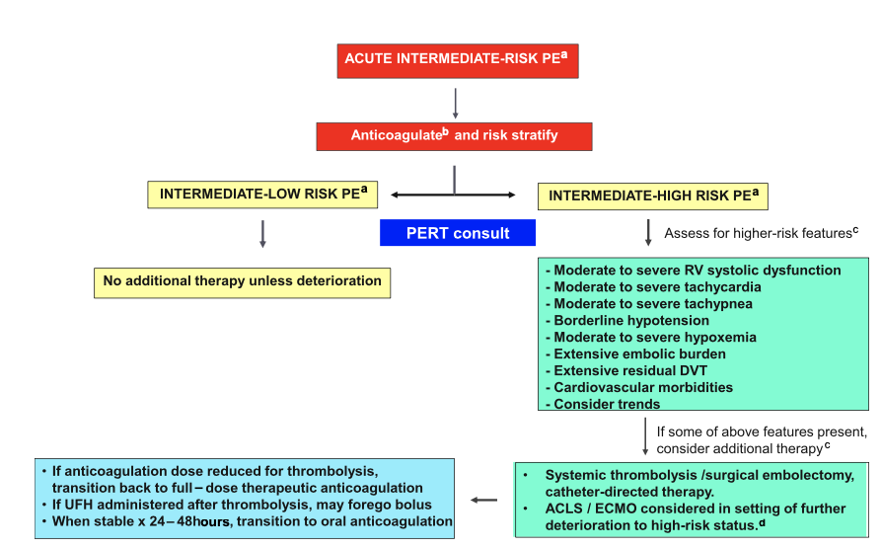
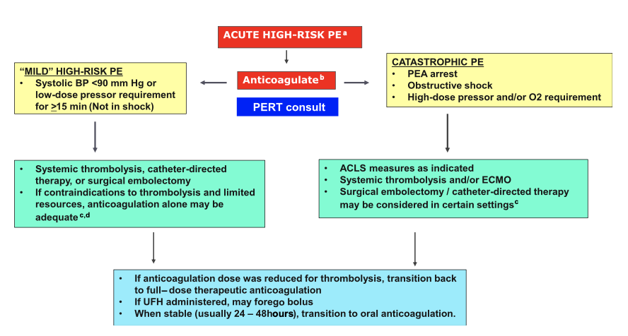

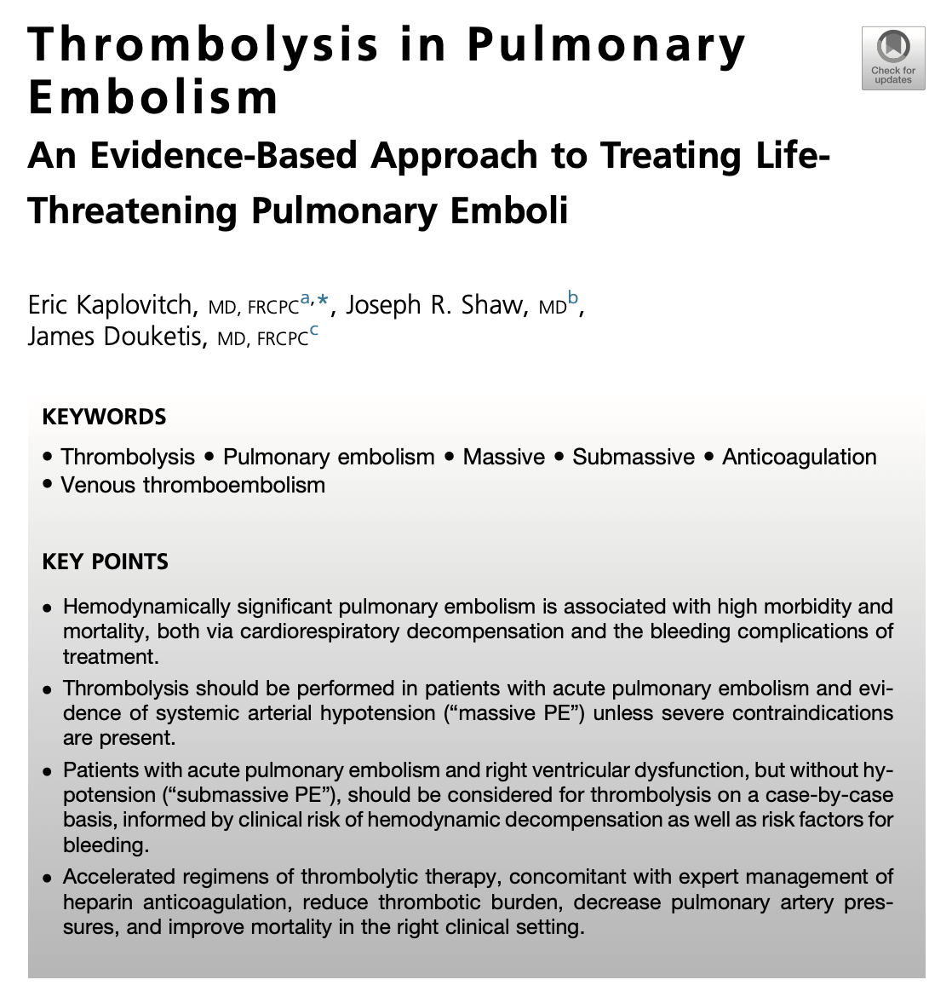

Introduction:
- PE large enough to cause hemodynamic instability associated with high morbidity/mortality
  - High mortality due to primary hemodynamic instability and bleeding side effects from treatment
  - Majority of PE-related deaths occur in the first 24h
  - 30d mortality
    - 25% mortality in shock
    - 65% mortality in CPA
- Large differences in results of meta analyses that have been done to date
  - Likely due to small study sizes and heterogenous groups
Summary:
- Discovery of thrombolytics
  - Streptokinase (originally called streptococcal fibrinolysin) first isolated from group A streptococcus in 1933
  - First successful treatment cohort reported in 1967
- Clinical use of thrombolytics
  - Recommended for “massive PE” or PE’s that cause systemic arterial hypotension (see previous summaries for detailed notes on clinical definitions)
    - Growing evidence for use in severe “submassive PE”4
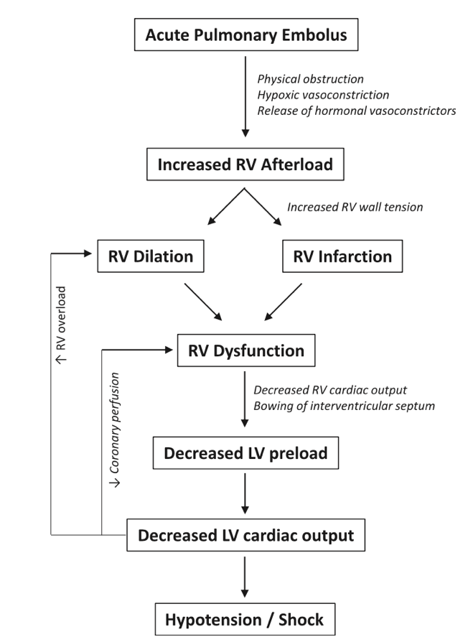
- Pathophysiology
  - Large acute PE increase in PVR and RV afterload
    - Causes physical obstruction as well as PA vasoconstrictors secondary to regional hypoxia
  - Increased RV afterload RV dilation and increased RV metabolic demand
  - RV dilation bowing of intraventricular septum and decreased LV preload
  - Leads to hypoxia and decreased cardiac output
    - Hypoxia from VQ mismatch , R to L shunting if flow through foramen ovale reversed
- Clinical evidence in Massive PE
  - Difficult to establish homogenous patient/treatment groups
  - First RCT was the Urokinase Pulmonary Embolism Trial (UPET)
    - Compared urokinase bolus followed by 12h infusion followed by heparin to heparin alone
    - Urokinase group showed accelerated resolution of PE based on pulmonary arteriograms, rads and R sided pressures
    - No difference in mortality between the two groups
      - Most unstable individuals at presentation appears to experience more radiographic benefit from thrombolysis
    - Limitations: included both massive and submassive PEs
    - Most bleeding complications occurred within 24h in both groups
      - Urokinase:45%, heparin alone: 27%
  - Ly et al
    - Compared streptokinase bolus followed by 72h infusion to heparin alone
    - Improved angiograms in streptokinase group
    - Numerically increased bleeding in thrombolytic group (28.6% vs 18.2%)
  - Dotter et al
    - Compared streptokinase bolus and 18-72h infusion followed by heparin to heparin alone
    - Improved angiograms in streptokinase group
    - No statistic difference in bleeding between groups
  - Sanchez et al
    - 40 patient RCT comparing 1h 1,500,000 IU streptokinase followed by heparin to heparin alone in massive PEs
    - Trial was stopped early due to preliminary results (first 8 patients) showing huge clinical difference in mortality btwn groups (100% mort in heparin group vs 0% in streptokinase group)
      - Statistically earlier presentation following onset of signs in streptokinase group may have skewed results
- Clinical Evidence in Submassive PE
  - Larger spectrum of clinical presentations in this category of PEs
    - Must interpret meta-analyses cautiously as the categorization of radiologic “massive” PEs may include hemodynamically stable patients
    - Decision regarding thrombolysis should be made on case by case basis
  - Goldhaber et al 1993
    - Compared alteplase followed by heparin to heparin alone in hemodynamically stable patients with RV dysfunction
    - Thrombolytic group had statistically more effective at improving RV hemodynamics
    - Ultimately triggered additional studies in submassive Pes
  - MAPPET-3 trial
    - Compared alteplase bolus and infusion with heparin to placebo and heparin In acute PE without systemic hypotension but with RV dysfunction or PH
    - Placebo group was more likely to require escalation to rescue thrombolysis
  - Fasullo et al
    - Same interventions as MAPPET-3, but only in patients with echo-confirmed RV dysfunction
    - Alteplase group had statiscically improved echo at 24h and statistically significant decrease in in-hospital mortality (0% vs 17.1%)
  - Tenecteplase Or Placebo: Cardiopulmonary Outcomes at Three months (TOPCOAT) trial
    - Compared bolus of Tenecteplase and LMWH or placebo and LMWH in hemodynamically stable patients with evidence of RV strain
      - RV strain confirmed via echo or increased troponin or BNP
        - Majority of patients met inclusion criteria with biochemical parameters rather than echo
    - No difference in in-hospital mortality between group
    - Decreased functional capacity, lower perception of wellness and increased risk of recurrence at 90d in the placebo group
  - Pulmonary Embolism Thrombolysis (PEITHO) trial
    - Largest trial in submassive PEs to date
    - Compared weight-based dose of tenecteplase and heparin vs placebo and heparin in submassive PEs
    - Required RV dysfunction confirmed by echo AND an elevated troponin for inclusion
    - Tenecteplase decreased death and hemodynamic decompensation at 7d
      - Mostly driven by decreased hemodynamic decompensation
      - Statistically insignificant difference in mortality
    - Improvement in hemodynamics associated with statistically increased risk of bleeding
      - Increased risks in patients >75
  - Ultrasound Accelerated Thrombolysis of Pulmonary Embolism (ULTIMA)
    - Randomized clinical trial of catheter-based interventions with catheter-guided alteplase and heparin to heparin alone in submassive PEs with RV dilation
    - Improved outcomes in thrombolytic group
    - Interest in this approach stems from potential decreased bleeding risks
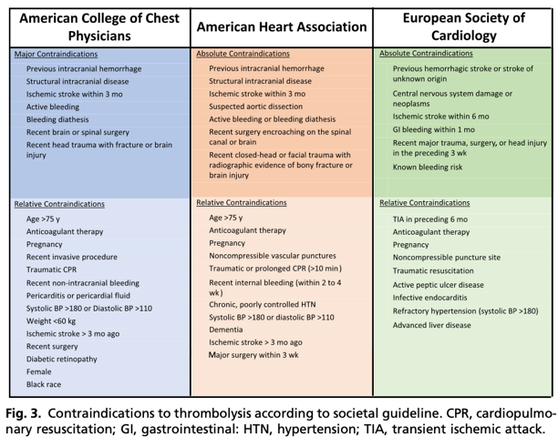
      - Need to consider other complications such as pulmonary hemorrhage, perforation of PA and arrythmias
- Clinical Considerations in Thrombolysis
  - Need to consider bleeding risks in clinical decision
    - See figure 3 (to the right)
  - Thrombolytic Agents
    - Only 3 have FDA approval
      - Urokinase: 4400-IU/kg bolus followed by 4400IU/kg/hr over 12-24h
      - Streptokinase: 25,00IU loading dose over 30min followed by 100,000 IU/hr over 12-24h
      - Alteplase: 100mg over 2 hours **MOST COMMON**
    - Evidence appears to support befit of shorter infusions
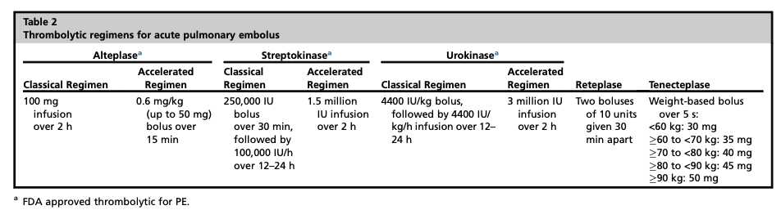
      - More rapid clot lysis, lower bleeding rates, similar clinical outcomes
    - Balancing thrombolysis with anticoagulation
      - UFH often the preferred anticoagulant
        - US-based: UFH often held during thrombolysis
        - EU-based: UFH often continued during thrombolysis
          - If held, restart when aPTT is </= 80s (<2x normal value)
      - LMWH and direct oral anti-coagulants should be switched to UFH if thrombolysis needed

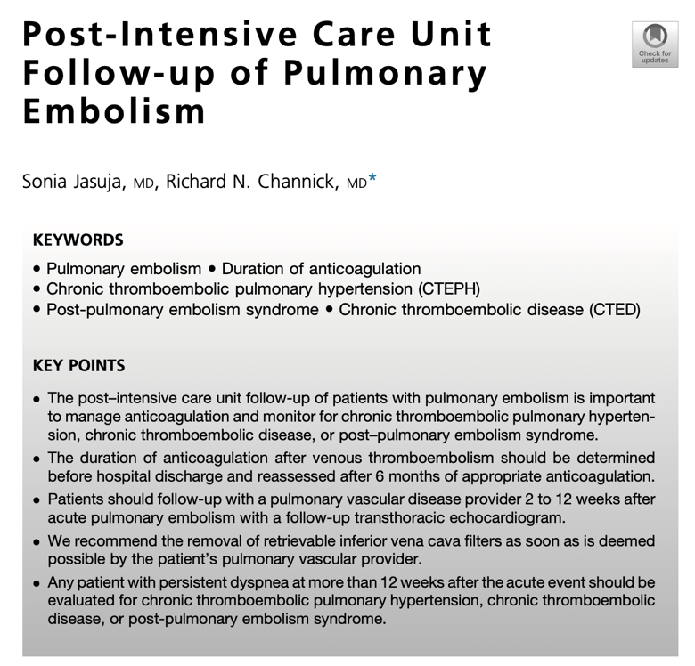
Introduction:
- High recurrence rate of PEs and potential for long-term sequela necessitates long-term management
  - Recurrence rate as high as 30%
  - Up to 9% of people develop chronic thromboembolic disease (CTED)
- Consensus statements regarding PE follow-up care available from the Pulmonary Embolism Response Team Consortium Consensus Practice and the 2019 European Society for Cardiology Guidelines on Pulmonary Embolism
Summary:
- ICU Hospitalization
  - Submassive PE
    - Recommend at least 24h ICU care
    - OR at least 24h of hemodynamic stability after catheter-directed or half-dose thrombolysis
  - Massive PE
    - ICU care for 24-48h once extubated, off pressors
    - Recommend repeat echo 48h after receiving thrombolytics
- Recheck timeline
  - Initial follow up visit
    - 2-4w for intensively managed patients
    - 4-12w for less severely affected patients
  - Caudal vena cava filter should be removed within 2-4w
- Risk of PE recurrence
  - Recurrence of PE greatest for several months after event and after anticoagulation has been discontinued
    - ~8% of patients had recurrent PE within 3m of initial event
    - Risk factors include patient factors (generally do not resolve) and environmental factors (can resolve)
    - Lower recurrence rate in:
      - Minor surgeries, oral contraceptives, short hospital admission
    - Higher recurrence rate in:
      - Active malignancy (Largest risk factor for recurrence), prior VTE without predisposing factors and antiphospholipid antibody syndrome
- Duration of anticoagulation
  - First VTE related to transient/reversible events (major trauma/fracture of hip/leg, surgery/anesthesia,
    - At least 3-6m of anticoagulation
  - Recurrent VTE or PE without identifiable cause OR in first time PE with persistent risk factors (IBD, autoimmune disease, prolonged travel and oral contraceptive/exogenous hormone use)
    - Low dose anticoagulation with apixaban or rivaroxaban after 6m
  - Antiphospholipid antibody syndrome and active malignancy
    - Indefinite therapeutic anticoagulation
- Determining risks of bleeding
  - RIETE score developed specifically for VTE patients
    - Other scores developed for a fib patients can also be used: HAS-BLED, ATRIA, HEMORR2HAGES
  - Recommend continuing anticoagulation in high risk patients and switching to UFH and placing vena caval filter if complications arise
- Post-Pulmonary Embolism Sequelae
  - Occurs in 1-4% of patients
    - Clinical signs range from mild deconditioning to severe pulmonary hypertension (CTEPH)
  - Chronic Thromboembolic Pulmonary Hypertension (CTEPH)
    - 0.1-9% of patients
      - Possible risk factors include unprovoked PE, hypothyroidism, symptom onset >2w before diagnosis, RV dysfunction, DM and thrombolytic tx/embolectomy, splenectomy, IBD, ventriculoatrial shunt and osteomyelitis
    - Considered if patient still clinical after 3m, at least 1 persistent lobar/segmental unmatched perfusion defect on VQ imaging AND evidence of PH
    - Needs to be identified and treated with endarterectomy quickly
      - Non-surgical candidates treated with balloon pulmonary angioplasty or medical therapy
  - Chronic Thromboembolic Disease
    - Considered if patient still clinical after 3m, at least 1 persistent lobar/segmental unmatched perfusion defect on VQ imaging WITHOUT evidence of PH
  - Post-pulmonary Embolism Syndrome
    - No defined diagnostic criteria
    - Experience dyspnea/exercise intolerance without evidence of VQ defect, predicted VO2 peak of <80%

October 2020

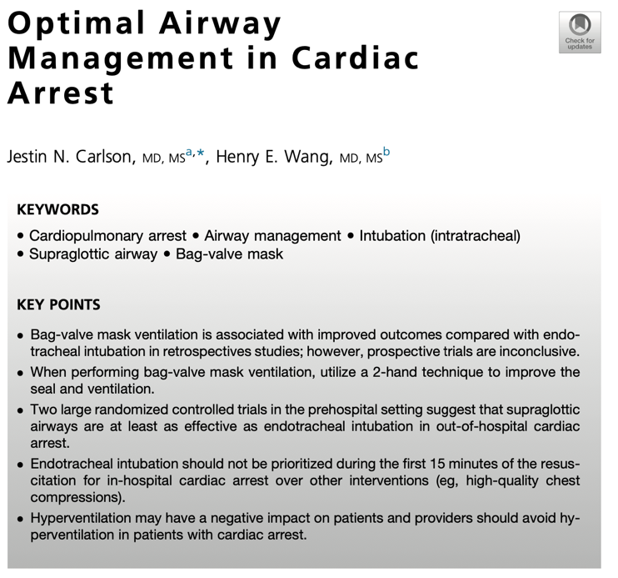
Intro:
- There has been a recent shift from recommendations of ABC (early intubation) to CAB (prioritizing chest compressions)
- Majority of literature is from retrospectives. Each study has different defined optimal end-points (ROSC vs survival at different timepoints vs neurologic function, etc)
Types of airway management:
- Endotracheal Intubation (ETI) has been considered the gold standard, but recent studies have challenged its benefit over other airway management techniques
  - Overall, no consensus has been made over the optimal type of airway management in human CPR
- Bag-Valve Mask
  - Cardiac Arrest Airway Management (CAAM) Trial
    - Noninferiority, prospective RCT comparing the primary outcome of favorable neuro function of BVM vs ETI in out-of-hospital cardiac arrest (OHCA).
    - Similar neurologic function at 28d between two groups
    - Complications including ventilation failure and regurgitation more common in BVM group
      - Presence of increased complications resulted in conclusion that BVM may not be non-inferior to ETI
  - Performance of BVM
    - Challenging ventilation using BVM if there is facial air, facial trauma which may limit the seal of the facemask
    - One and two person techniques (E-C technique) for securing the mask while delivering breaths via bag
- Supraglottic Airways (SGA)
  - May be beneficial due to no interruption of chest compression (CC) during placement
  - No clear benefit between SGA and ETI in two available RCT
  - Retrospective studies may have confounding factors associated with clinical presentation bias
    - Meta-analysis of 10 retrospective studies concluded improved ROSC, survival to hospital admission, neurologic function, in SGA
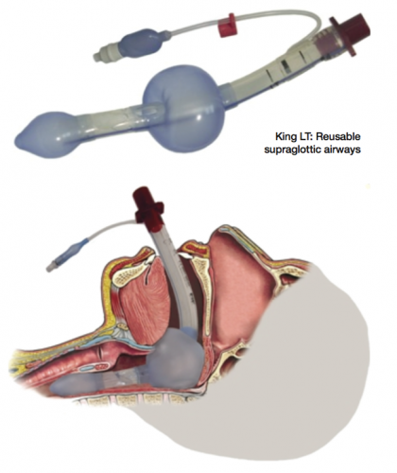
    - Patients perceived to have better odds of survival (witnessed CPA and immediate response to defib may get a ETI vs unwitnessed CPA in asystole may get an SGA)
  - Two current RCT comparing SGA and ETI
    - Pragmatic Airway Resuscitation Trial (PART)
      - Compared 72h survival in OHCA treated with laryngeal tube (LT) or ETI
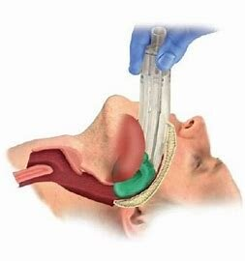
      - Improved primary outcome (72h survival) in LT group
        - Also improved secondary outcomes (ROSC, survival to discharge, intact neuro status)
        - Also higher first attempt placement success in LT compared to ETI
    - AIRWAYS-2
      - Compared functional outcome at hospital discharge or 30-d between OHCA treated with i-gel or ETI
      - Similar rates of favorable function between two groups
        - Improved outcomes in i-gel in the per protocol analysis

- Endotracheal Intubation (ETI)
  - Considered the gold standard for airway management, but may interrupt other aspects of CPR and is technically challenging
  - Retrospective propensity-matched study of in-hospital CPA showed a WORSE survival in patients who were intubated in first 15m of CPR compared to those not intubated during that timeframe.
  - Retrospective time-dependent propensity study compared advanced airway management (ETI, SGA) vs non-advanced
    - Advanced airway management had improved outcomes ONLY in patients with shockable rhythms
    - No difference in outcomes in patients with non-shockable rhythms
  - First attempt success
    - Successful ETI on first attempt has been associated with better outcome
      - Multiple attempts may also result in more complications
      - First attempt success rate of 72% in EMS database
    - ETI uncommonly performed which may contribute to low success rate
      - According to national Emergency Airway Registry, 7% of all intubations in an ED setting were performed for CPA (less than 1 intubation per year for ER physician performing a total of 10 intubations per year)
      - Studies suggest needing 240 ETI attempts before achieving a first attempt rate >90%
  - ETI placement strategies
    - Video Laryngoscopy (VL)
      - Increased first-attempt success rates in VL compared to DL in an ED setting for both novice and experienced providers
      - Use of VL also associated with first-attempt success rate in hospitalized patients
      - Similar first-attempt success rates in VL vs DL in out-of-hospital intubation
    - Gum elastic bougie
      - Bougie use in Emergency Airway Management (BEAM) RCT at a single instutition comparing first attempt success rate in bougie-facilitated intubation vs intubation with a styletted ET tube in patients with at least on difficult airway characteristic (large tongue, obesity, facial trauma)
        - Higher first-attempt success in Bougie group in difficult airway and all groups
  - Hyperventilation
    - Previous work suggests hyperventilation during CPA may worsen outcome
      - Increased intrathoracic pressure decrease MP and increases jugular venous pressure resulting in decreased perfusion of CNS.
      - Hyperventilation leads to hypocapnia and cerebral vasoconstriction
    - EPIC Study concluded that there was no difference in primary and secondary (survival to hospital discharge, survival to hospital admission)

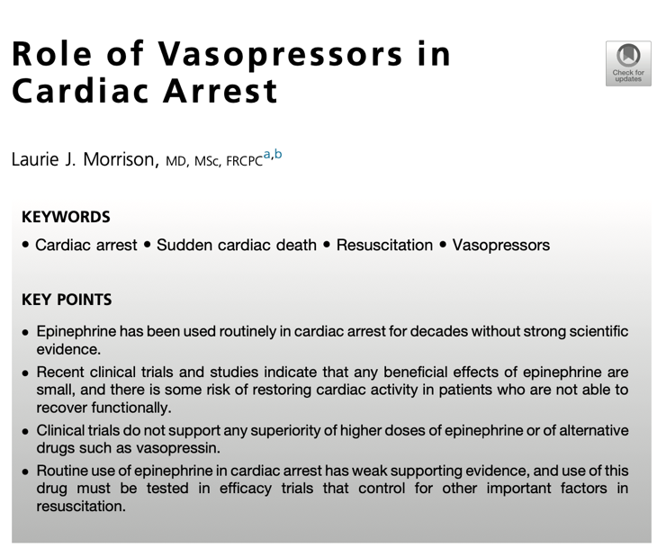
Intro:
- Vasopressors in CPR are largely under-studied
  - May be less important in settings of high quality CPR and post-arrest care
- Epi is currently the most common and longest-used vasopressor used in CPR settings
Evidence Summary:
- Successful ROSC largely depends on prompt high quality CPR and early defibrillation if indicated
  - Additional treatments that distract/delay these interventions worsen outcomes
- RCT by Olasveengen et al out of Norway compared CPR with drugs vs CPR in no drugs in cases of OHCA.
  - No difference in survival to hospital discharge between groups
    - Suggests that high-quality BLS may be more important
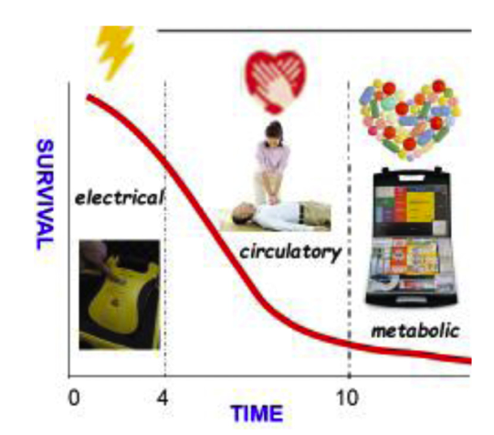
- Wisfeldt et al in 2002 suggested a 3 phase model. 10 minutes after cardiac arrest, the prognosis is poor due to worsening degree of ischemic injury
- Two placebo controlled randomized trials comparing epi vs no epi in OHCA (one in UK, one in Australia)
  - Both showed increased ROSC in Epi group
  - One showed a survival benefit at 30d and 3m
    - Higher rate of survival with poor neuro function at 30d
  - Neither study controlled for quality of CPR
  - Different cohorts of presenting rhythms between the two studies
    - UK=50% PEA or asystole, Australia=20% PEA or asystole
    - Subgroup analysis revealed a benefit to epi in cases of non-shockable rhythms
      - Meta-analysis of data reported cumulative OR for ROSC in non-shockable rhythms of 1% in epi group and 0.4% in non-epi group
        - Lead to International Liaison Committee on Resuscitation (ILCOR) consensus statement recommending epi ASAP in cases of non-shockable rhythm
- Vasopressin vs Epi
  - All trials of vasopressin alone or in combo with epi were neutral for benefit or harm over epi alone
- High dose epi
  - Low dose epi is associated with lower ROSC, survival to hospital admission
  - Not currently recommended by ILCOR
- Recent shift toward physiologic directed care for CPA vs guideline-based
  - I.e. Epi is not appropriate in every case of CPA
  - Additional discussion on this in the next article

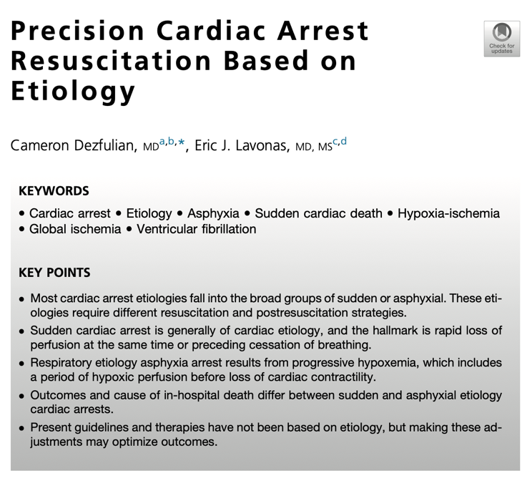
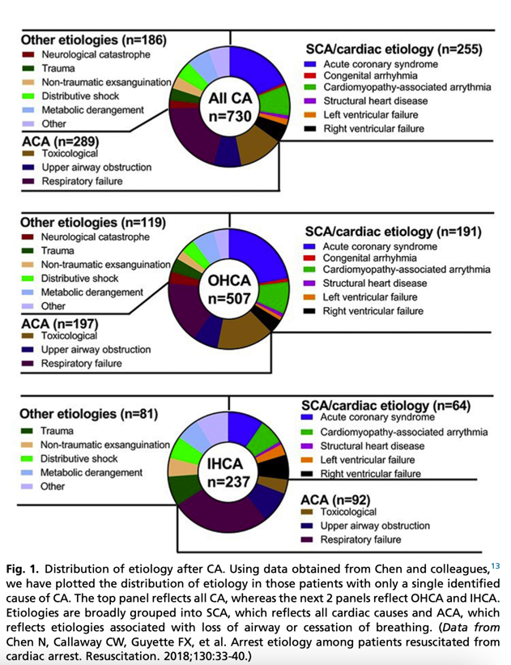
Intro:
- Classification of cardiac arrest
  - Location of arrest
    - Out of hospital (OHCA) vs.
    - in-hospital (IHCA)
  - Etiology of the arrest
    - Sudden cardiac arrest (CTA)
      - Cessation of cardiac output leading to global ischemia
    - Asphyxial cardiac arrest (ACA)
      - Loss of breathing/airway which results in global hypoxemia and then cardiac arrest
  - Presence of shockable rhythm
- Recent literature suggests that ACA may be becoming more common than CTA in OHCA
  - Most of the available research is in CTA
- Majority of resuscitation guidelines published by the American heart association (AHA) do not have an etiologic-based approach

Pathophysiology of Cardiac Arrest
- ACA
  - Profound global hypoxemia present at the time of cardiac arrest/start of chest compressions
    - Compressions don’t drastically increase O2 delivery (Low blood oxygen content)
  - Causes anoxia (PO2 below minimum threshold for aerobic metabolism)
    - Anoxia of heart and brain occurs if PO2< 22mmHg
      - Heart: no tissue necrosis if reperfusion occurs within 20 minutes
      - Brain: ATP depleted within 3-5minutes, 95% of tissue injured after 15m
        - Initially compensates by increasing cerebral blood flow (CBF) 4-500% in response to hypoxia
          - Cannot compensate if PO2 in the single digits
  - ACA associated with worse brain injury than SCA
    - Cerebral acidosis and cerebral hyperlactatemia occur due to lack of oxygen and continued glucose delivery via CPR
        - Degree worse than in SCA
    - Mild cerebral acidemia is likely protective, worse cerebral acidemia associated with increased neuronal cell death
      - Activates acid-sensitive ion channels (ASICs) induce glutamate-independent brain injury by causing Ca influx in neurons
    - Free radical/reperfusion injury
      - Worse in ACA due to iron delocalization/lipid peroxidation
- SCA
  - Near-normal oxygen levels present at the start of chest compressions
    - Compressions promote oxygen delivery
  - Most commonly due to myocardial infarctive event
  - More commonly present with shockable rhythms (VF/VF)
    - Shockable rhythms associated with better outcome
Outcomes of Arrest
- Majority of research suggests improved outcomes associated with SCA due to brain injury/pathophys of ACA discussed above.

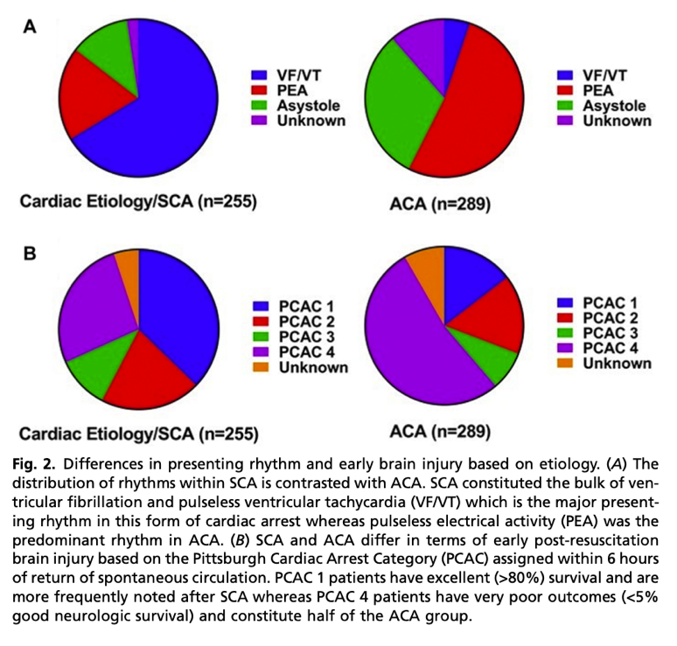

  - Resuscitation Outcomes Consortium (ROC) suggested a worse outcome
    - ROC is a pre-hospital database. Etiology of OHCA may not be immediately apparent and may change following further hospitalization /workup
      - This study reported a lower proportion of ACA than listed in chart above
- Opioid poisoning is a leading cause of ACA in human medicine
  - Associated with good outcome- but likely that majority of cases were not truly pulseless at time of resuscitation/naloxone administration
- Post-resuscitative shock/myocardial dysfunction more severe in SCA vs ACA
  - This may be the reason for the early hospitalization deaths
  - Vs delayed death associated with ACA/brain injury
Clinical Management
- Resuscitation guidelines
  - Currently, many emergency dispatchers instruct bystanders to start compression only CPR due to ease of instruction
  - ACA
    - Hands only CPR may worsen anoxic brain injury because ventilation (and improved blood oxygen content) is not included
      - Need further studies to prove if results are neutral or worsened in human/clinical models
  - SCA
    - Early chest compressions Restoration of blood flow and delivery of blood oxygen reservoir is key
      - Hands-only CPR may be appropriate
- Post resuscitation guidelines
  - Angiography to screen for coronary ischemic lesion is the standard of care
    - Recent RCT compared urgent vs delayed angiography in patients presenting with VT/VF
      - No difference in outcome
      - Was not controlled for other causes of VT/VF
  - Therapeutic Hypothermia
    - 2 RCT investigating OHCA SCA patients with VT/VF showed benefit at 33C
    - Another RCT of OHCA SCA compared 33C to 36C and found no difference
      - Trend toward improved hemodynamics at 36C
    - HYPERION trial enrolled IHCA and OHCA with non-shockable rhythms (majority deemed to be ACA) and compared 33C vs 37C
      - Improved neurologic outcome in 33C cohort
    - No study strictly looking at ACA is available (yet)

