Crit Care Clinics: Feb 2018

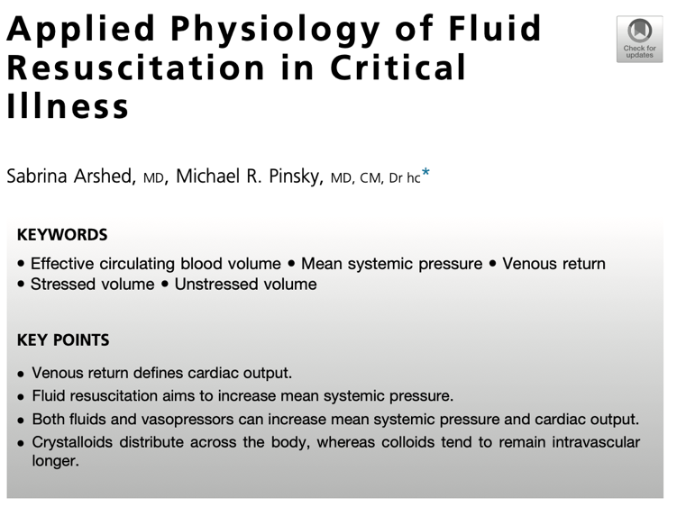
Introduction:
- Not all causes of hypotension benefit from the administration of IVF
- The “best” type of fluid used for resuscitation is controversial
- Fluid therapy should be goal directed and individually tailored to each patient’s needs

Summary:
- Goal of fluid therapy is to increase the MAP and improve venous return
- Increasing MAP is only beneficial if MAP>right atrial (RA) pressure
  - If RA pressure rises, venous return decreases
- MAP only starts to increase when blood volume> unstressed vascular volume
  - Unstressed vascular volume: volume contained by vessels WITHOUT causing vessel stretch (approx. 60-70% blood volume)
    - MAP=0
    - Varies based on vascular tone and distribution towards/away from high capacitance vessels
  - Stressed vascular volume: Volume in excess of unstressed vascular volume that contributes to vessel stretch (approximately 30-40% blood volume)
  - Vascular compliance= MAP/(stressed vascular volume- unstressed vascular volume)
- Types of shock
  - Cardiogenic shock
    - Causes:
      - Heart failure of any etiology (myocardial, valve disease,
    - Pathophys
      - SBP <90mmHg and hypoperfusion caused by arterial hypotension, increased cardiac filling pressure, increase venous pressure. Often causes pulmonary edema
    - Treatment/role of fluids:
      - Inotropic agents
        - Trade off of improved perfusion with increased ATP demand
      - Conservative fluid therapy to improve coronary perfusion
      - Avoid vasopressors- associated with poor outcome
  - Obstructive Shock
    - Causes
      - PCE tamponade, pneumothorax, massive PTE
    - Pathophys
      - Impaired ventricular filling or ejection causing decreased CO
    - Treatment/Role of fluids:
      - Fluid therapy often contraindicated in massive PTE as it causes further dilation of RV
  - Hemorrhagic (hypovolemic) Shock
    - Causes:
      - Traumatic injury
    - Pathophys
      - Loss of blood volume and/or trauma induced coagulopathy (10-34% of patients)
    - Treatment/Role of fluids:
      - Fluids indicated to restore volume
      - Crystalloids may cause interstitial edema, abdominal compartment syndrome
      - Blood products especially if rapid hemorrhagic losses- Consider 1:1 plasma: blood
  - Distributive Shock
    - Causes
      - Sepsis, trauma, perioperative state
    - Pathophys
      - Vasoplegia, impaired blood flow distribution causing increased unstressed vascular volume
    - Treatment/Role of Fluids
      - Aggressive fluid resuscitation if early
- Fluids
  - Balance between intracellular and extracellular (intravascular and interstitial)
    - Balance between oncotic and hydrostatic pressures. The glycocalyx has also become more known/important recently
  - Crystalloids:
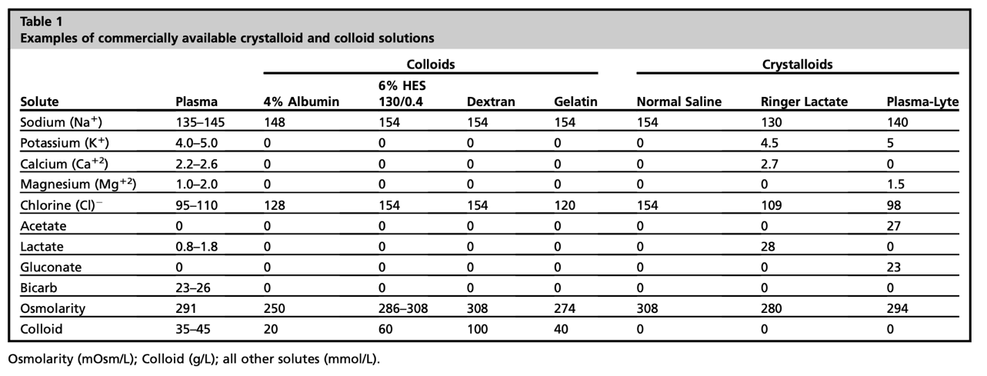
    - Tend to distribute into the intracellular spaces more than colloids
    - Studies have demonstrated improved outcomes when using balanced fluids (p-lyte, LRS) vs normal (0.9%) saline
      - 0.9% saline has supraphysiologic concentrations of Na and Cl and is acidifying
    - Aggressive resuscitation can lead to extravasation into the interstitial space- especially in cases of vasoplegia/glycocalyx damage
      - Study of crystalloids vs albumin showed improved outcomes with albumin in septic shock
  - Colloids
    - Tend to stay intravascular due to high molecular weight compounds that increase oncotic pressures.
    - In America, Albumin is the most commonly used colloid followed by hydroxylethyl starch (HES)
      - HES use banned in the UK due to association with AKI in septic patients
    - Studies
      - Saline vs Albumin Fluid Evaluation (SAFE) trial: compared 4% albumin with 0.9% saline
        - No difference in 28 day all-cause mortality
        - Relative risk of death increased when albumin used in TBI
        - Improved outcomes when albumin used in sepsis/septic shock
      - ALBOIS Study: compared albumin with normal saline
        - Septic shock patients were the only group that had better outcomes with albumin
      - Crystalloid vs Hydroxyethyl Starch Trial (CHEST): compared 6% HES to 0.9% saline
        - No difference in 90 day all-cause mortality
        - HES group had double the amount of adverse events (skin rash, pruritus, AKI)

Crit Care Clinics July 2020

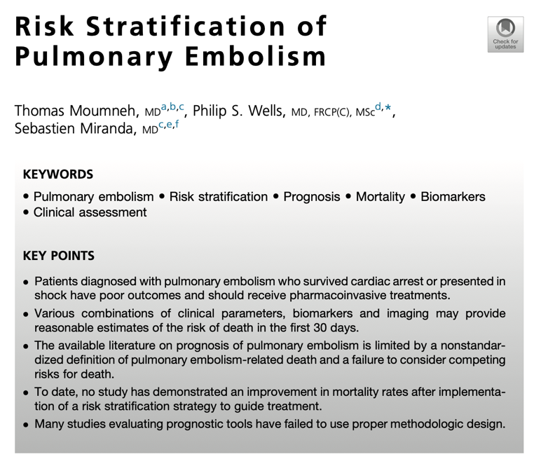
Introduction:
- Highest risks of hospital death unsurprisingly associated with PE that cause cardiac arrest and/or shock
- Risk stratification strategies include clot burden, baseline CP function, comorbidities that may contribute to clot recurrence, efficacy of treatments
- Can be difficult to determine if PE alone contributed to death as comorbidities that cause PE and can also be fatal independent of PE
  - Post-mortem CTA not helpful
- Delayed diagnosis/treatment appears to be associated with worse outcomes
Summary:
- Diagnosis of clot burden
  - CTA
    - Retrospective studies and meta-analyses have shown poor correlation of clot location (central/saddle vs other) and vascular obstruction scoring (Mastora, Qanadli, Meyer scores) with short/long term risks of death or need for thrombolytics or embolectomy
  - Thoracic Echo
    - Useful for diagnosis of RV thrombi, but not useful for determining prognosis/treatment
      - Available studies are poorly controlled for the hemodynamic stability of the patient on outcome
  - Lower Extremity US
    - 2016 meta-analysis showed association with deep vein thrombus (DVT) and 30d mortality (OR: 1.89)
    - Prospective RCT (PREPIC) of insertion of CVC filter in patients with DVT and concurrent PE did not prevent mortality/recurrence
  - D Dimers
    - Multiple studies have shown correlation between elevated D Dimers and mortality (15d and 30d).
      - Differences in measurement techniques and classification of “elevated” between studies
- Clinical Parameters
  - Syncope
    - Not associated with increased mortality when meta-analysis controlled for systemic hemodynamic stability
  - Hypotension
    - Meta analysis of 4 cohorts, hemodynamic instability correlated with 90d all cause mortality
    - Prospective study suggested hypotension associated with increased short term (1w) mortality rate
    - Hemodynamic instability is a major indication for starting thrombolytic therapy
  - Hemoptysis
    - Rare and likely related to PE and unlikely to result in death
- Clinical Scores
  - (simplified) Pulmonary Embolism Severity Index (PESI and sPESI)
    - Derived from a retrospective study to Predicts 30d all cause mortality
      - 11 clinical criteria in PESI
      - 6 clinical criteria in sPESI
    - Lower scores suggest that at-home management may be appropriate
  - Hestia criteria
    - Patients meeting any of the checklist criteria are recommended to be managed as inpatients
    - NOT a prognostic indicator
  - Geneva prognostic score
    - Includes 6 criteria, but is less practical than PESI because of the need for lower extremity US and art gas
- Biomarkers of RV dysfunction
  - Cardiac troponin
    - Specific but non-sensitive marker of RV dysfunction in the context of PE
      - “abnormal” levels derived from studies of myocardial infarction
  - BNP and pro BNP
    - Secreted due to myocardial stretching
    - More sensitive, less specific than troponins for RV dysfunction
  - Heart-type fatty acid-binding protein (H-FABP)
    - Released by cardiomyocytes in context of acute coronary syndrome
    - Meta-analysis suggests better prediction of PE related mortality compared to troponin or BNPs
      - No studies have actually compared these tests directly
- Other tests
  - ECG
    - Sinus tach, complete RBBB, ST elevation associated with increased risk of hemodynamic collapse
      - Changes more commonly associated with patients presenting in shock
  - Transthoracic Echo
    - Most common changes with PE include increased RV end diastolic diameter, RV/LV end diastolic diameter >1, RV hypokinesia, paradoxical septal wall motion, PH, Tricuspid regurg
    - RV dysfunction associated with increased short-term mortality
  - CTA
    - Meta-analysis suggests that RV/LV diameter ratio >1 on transverse sections had 2.5 fold increase of all-cause mort and 5 fold risk of PE related mortality

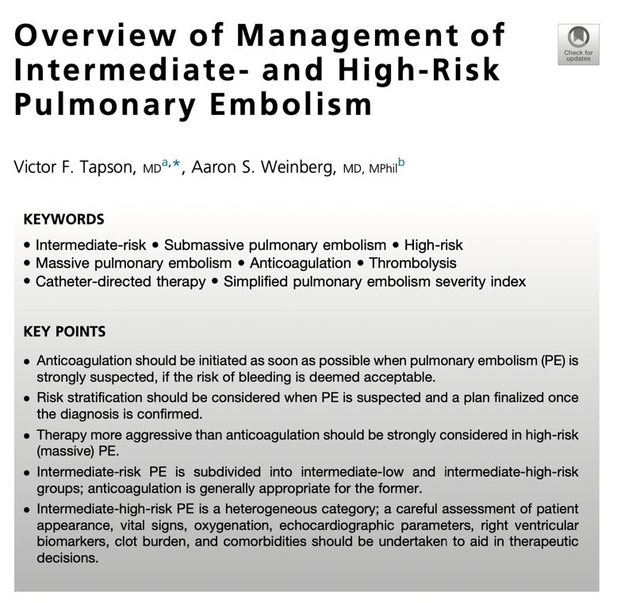
Summary:
- Former nomenclature “massive PE” and “submassive PE” have been replaced with “high risk” and “intermediate risk”
  - “Supermassive”/”catastrophic” PE cause CPA
  - “High risk/massive PTE”: defined as emboli that cause hemodynamic instability
    - Treatment requires more than anticoagulants
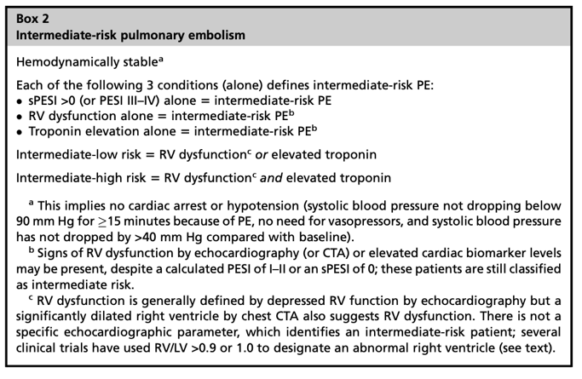
  - “Intermediate risk/submassive PTE”: defined as RV dysfunction without hypotension
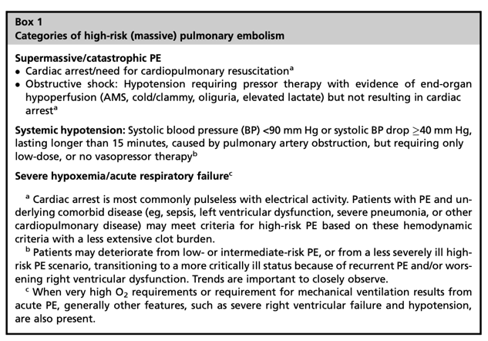
- Classification of intermediate risk PE
  - Majority of risk factors are discussed in previous article summary
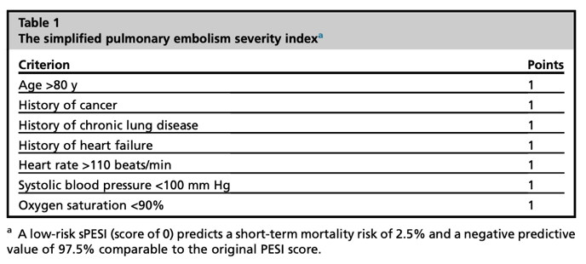
  - Simplified Pulmonary Embolism Severity Index (sPESI) has been validating in predicting 30d mortality in acute PE
  - Range of intermediate-low to intermediate-high

  - Association of clot burden with mortality has been inconclusive in available studies
  - Anticoagulation therapy has been proven to improve outcomes in acute PE
- General Treatment of acute PE
  - Pulmonary Embolism Response Team (PERT)
    - Clinical guidelines for PE management have been published by PERT consortium
    - PERT individuals responsible for supplementing care specific for PE cases
  - Anticoagulation
    - Should be started IMMEDIATELY after diagnosis of acute PE unless risk of bleeding is high
    - No clear evidence for “best anticoagulant”
      - IV UFH may be better in hypotensive cases
      - More stable cases may be better suited for SC LMWH which has more predictable activity
      - Transition to PO anticoagulant after stable for 24-48h on IV/SC
    - If unable to anti-coagulate, a IVC filter placement should be performed
  - Oxygen/ventilation
    - Consider nasal oxygen supplementation, high flow or mechanical ventilation based on the oxygenation/Aa gradient of the patient
    - PPV may negatively impact an already stressed RV in the case of a PE
    - If mechanically ventilating, TV ~6mL/kg, use PEEP, Pplat < 30mmH2O, use hemodynamically neutral sedation
  - IVF and vasoactive therapy
    - Caution with IVF to avoid overloading the RV
    - NE is the most commonly used due to A1 and minimal B1 properties
      - Dobutamine can be considered as a second agent, but may negatively impact V/Q
- Considerations in Catastrophic/Supermassive PE
  - Immediate anticoagulation/thrombolysis initiated ASAP
    - Thrombolysis (most commonly TPA) in the case of CPR is still recommended- usually bolus
    - No evidence for survival improvement associated with measuring fibrinogen levels
    - Consider stopping/reducing heparin infusion during thrombolysis
  - Consider catheter-directed therapy if experienced clinician available
  - Extracorporeal membrane oxygen (ECMO)and/or embolectomy should be considered in very severe cases
    - Need to decide on this ASAP prior to anticoagulation (need ECMO catheter)
- Considerations in High-risk PE
  - Thrombolysis (systemic or catheter-directed) is the SOC
- Considerations in intermediate-risk PE
  - Anticoagulation is the SOC
  - Because of heterogenous clinical presentations of this group, trending clinical signs important
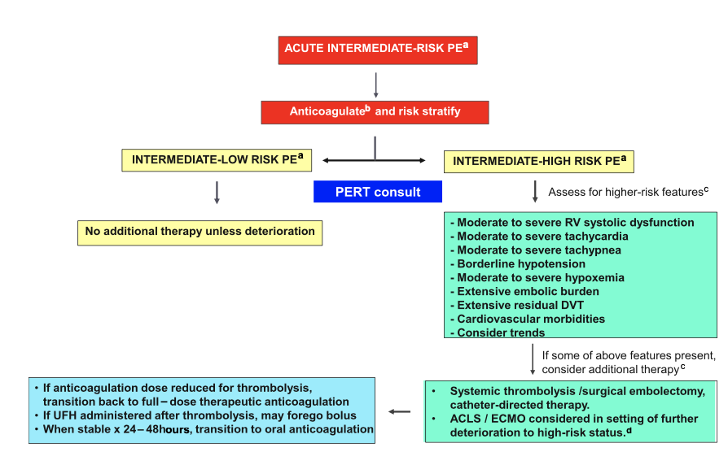
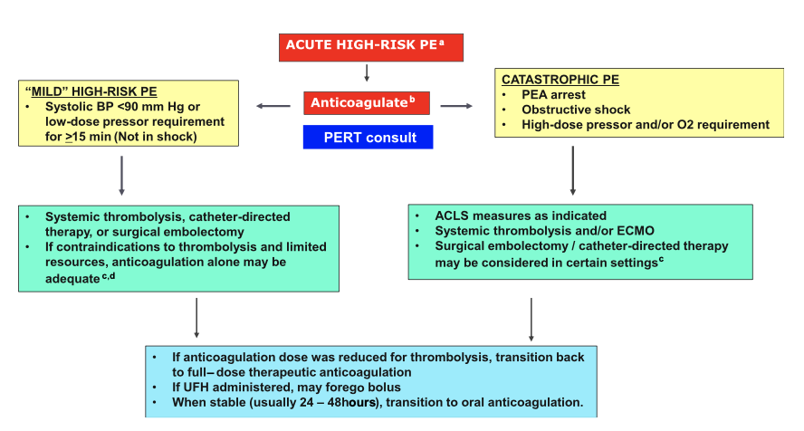

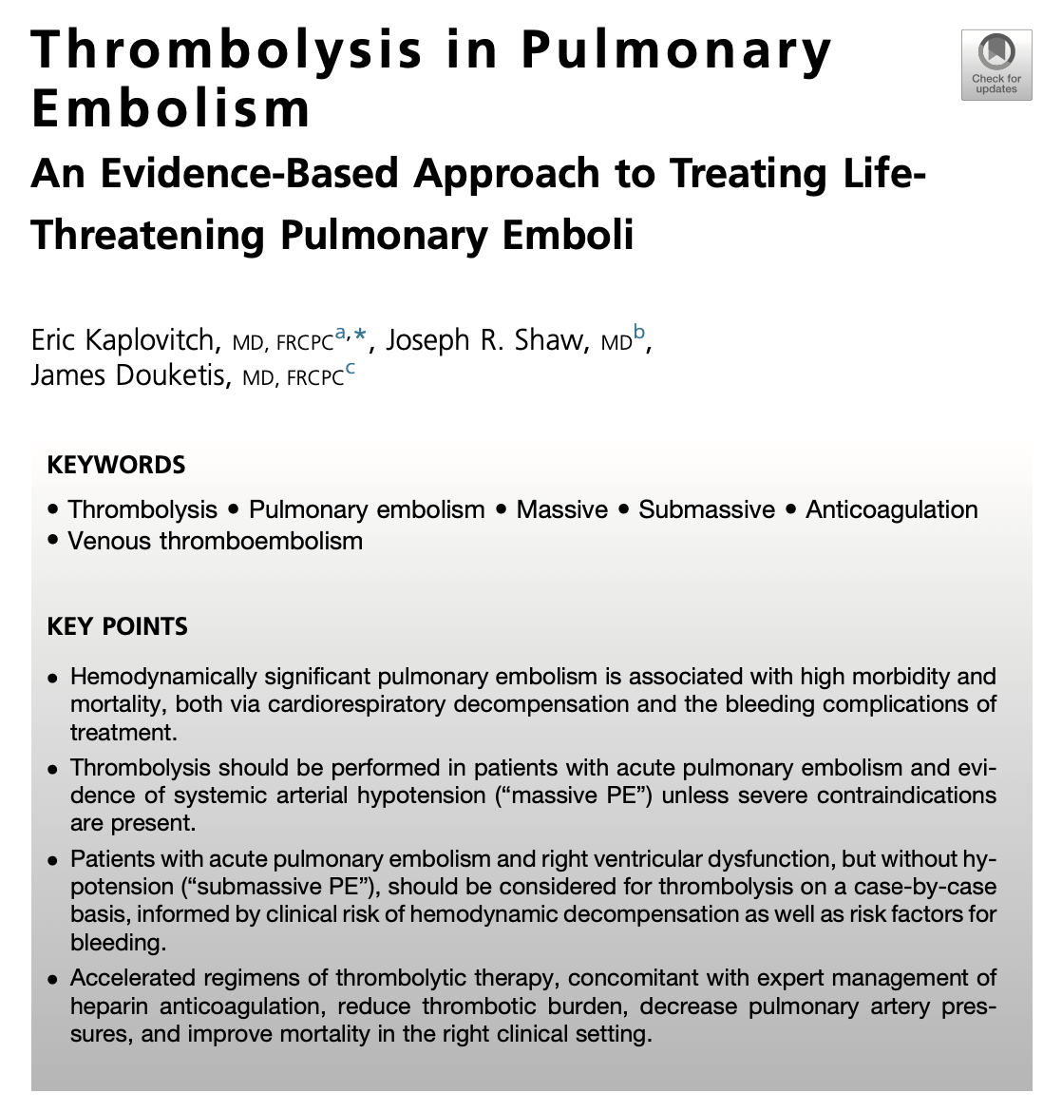

Introduction:
- PE large enough to cause hemodynamic instability associated with high morbidity/mortality
  - High mortality due to primary hemodynamic instability and bleeding side effects from treatment
  - Majority of PE-related deaths occur in the first 24h
  - 30d mortality
    - 25% mortality in shock
    - 65% mortality in CPA
- Large differences in results of meta analyses that have been done to date
  - Likely due to small study sizes and heterogenous groups
Summary:
- Discovery of thrombolytics
  - Streptokinase (originally called streptococcal fibrinolysin) first isolated from group A streptococcus in 1933
  - First successful treatment cohort reported in 1967
- Clinical use of thrombolytics
  - Recommended for “massive PE” or PE’s that cause systemic arterial hypotension (see previous summaries for detailed notes on clinical definitions)
    - Growing evidence for use in severe “submassive PE”4
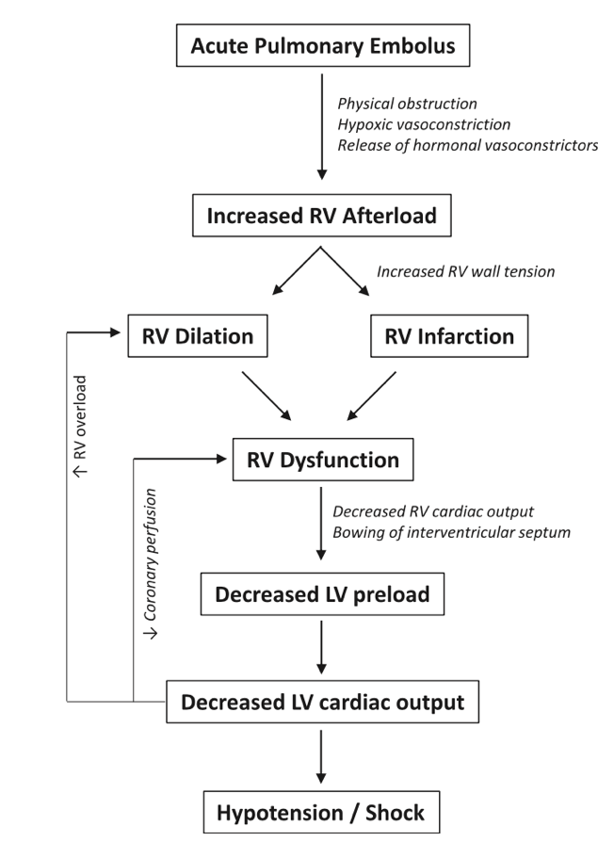
- Pathophysiology
  - Large acute PE increase in PVR and RV afterload
    - Causes physical obstruction as well as PA vasoconstrictors secondary to regional hypoxia
  - Increased RV afterload RV dilation and increased RV metabolic demand
  - RV dilation bowing of intraventricular septum and decreased LV preload
  - Leads to hypoxia and decreased cardiac output
    - Hypoxia from VQ mismatch , R to L shunting if flow through foramen ovale reversed
- Clinical evidence in Massive PE
  - Difficult to establish homogenous patient/treatment groups
  - First RCT was the Urokinase Pulmonary Embolism Trial (UPET)
    - Compared urokinase bolus followed by 12h infusion followed by heparin to heparin alone
    - Urokinase group showed accelerated resolution of PE based on pulmonary arteriograms, rads and R sided pressures
    - No difference in mortality between the two groups
      - Most unstable individuals at presentation appears to experience more radiographic benefit from thrombolysis
    - Limitations: included both massive and submassive PEs
    - Most bleeding complications occurred within 24h in both groups
      - Urokinase:45%, heparin alone: 27%
  - Ly et al
    - Compared streptokinase bolus followed by 72h infusion to heparin alone
    - Improved angiograms in streptokinase group
    - Numerically increased bleeding in thrombolytic group (28.6% vs 18.2%)
  - Dotter et al
    - Compared streptokinase bolus and 18-72h infusion followed by heparin to heparin alone
    - Improved angiograms in streptokinase group
    - No statistic difference in bleeding between groups
  - Sanchez et al
    - 40 patient RCT comparing 1h 1,500,000 IU streptokinase followed by heparin to heparin alone in massive PEs
    - Trial was stopped early due to preliminary results (first 8 patients) showing huge clinical difference in mortality btwn groups (100% mort in heparin group vs 0% in streptokinase group)
      - Statistically earlier presentation following onset of signs in streptokinase group may have skewed results
- Clinical Evidence in Submassive PE
  - Larger spectrum of clinical presentations in this category of PEs
    - Must interpret meta-analyses cautiously as the categorization of radiologic “massive” PEs may include hemodynamically stable patients
    - Decision regarding thrombolysis should be made on case by case basis
  - Goldhaber et al 1993
    - Compared alteplase followed by heparin to heparin alone in hemodynamically stable patients with RV dysfunction
    - Thrombolytic group had statistically more effective at improving RV hemodynamics
    - Ultimately triggered additional studies in submassive Pes
  - MAPPET-3 trial
    - Compared alteplase bolus and infusion with heparin to placebo and heparin In acute PE without systemic hypotension but with RV dysfunction or PH
    - Placebo group was more likely to require escalation to rescue thrombolysis
  - Fasullo et al
    - Same interventions as MAPPET-3, but only in patients with echo-confirmed RV dysfunction
    - Alteplase group had statiscically improved echo at 24h and statistically significant decrease in in-hospital mortality (0% vs 17.1%)
  - Tenecteplase Or Placebo: Cardiopulmonary Outcomes at Three months (TOPCOAT) trial
    - Compared bolus of Tenecteplase and LMWH or placebo and LMWH in hemodynamically stable patients with evidence of RV strain
      - RV strain confirmed via echo or increased troponin or BNP
        - Majority of patients met inclusion criteria with biochemical parameters rather than echo
    - No difference in in-hospital mortality between group
    - Decreased functional capacity, lower perception of wellness and increased risk of recurrence at 90d in the placebo group
  - Pulmonary Embolism Thrombolysis (PEITHO) trial
    - Largest trial in submassive PEs to date
    - Compared weight-based dose of tenecteplase and heparin vs placebo and heparin in submassive PEs
    - Required RV dysfunction confirmed by echo AND an elevated troponin for inclusion
    - Tenecteplase decreased death and hemodynamic decompensation at 7d
      - Mostly driven by decreased hemodynamic decompensation
      - Statistically insignificant difference in mortality
    - Improvement in hemodynamics associated with statistically increased risk of bleeding
      - Increased risks in patients >75
  - Ultrasound Accelerated Thrombolysis of Pulmonary Embolism (ULTIMA)
    - Randomized clinical trial of catheter-based interventions with catheter-guided alteplase and heparin to heparin alone in submassive PEs with RV dilation
    - Improved outcomes in thrombolytic group
    - Interest in this approach stems from potential decreased bleeding risks
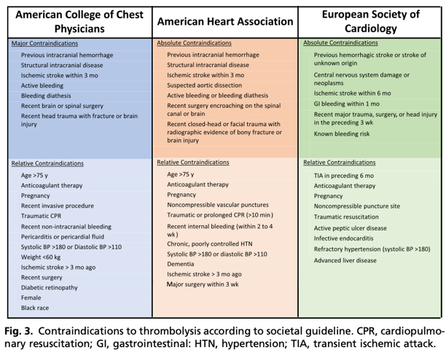
      - Need to consider other complications such as pulmonary hemorrhage, perforation of PA and arrythmias
- Clinical Considerations in Thrombolysis
  - Need to consider bleeding risks in clinical decision
    - See figure 3 (to the right)
  - Thrombolytic Agents
    - Only 3 have FDA approval
      - Urokinase: 4400-IU/kg bolus followed by 4400IU/kg/hr over 12-24h
      - Streptokinase: 25,00IU loading dose over 30min followed by 100,000 IU/hr over 12-24h
      - Alteplase: 100mg over 2 hours **MOST COMMON**
    - Evidence appears to support befit of shorter infusions
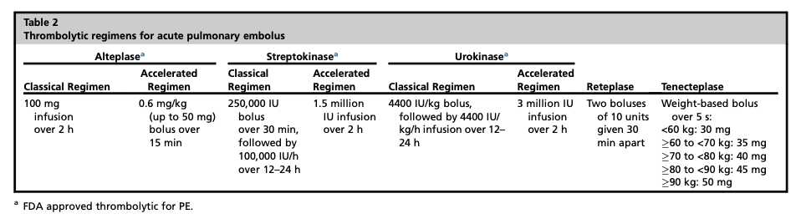
      - More rapid clot lysis, lower bleeding rates, similar clinical outcomes
    - Balancing thrombolysis with anticoagulation
      - UFH often the preferred anticoagulant
        - US-based: UFH often held during thrombolysis
        - EU-based: UFH often continued during thrombolysis
          - If held, restart when aPTT is </= 80s (<2x normal value)
      - LMWH and direct oral anti-coagulants should be switched to UFH if thrombolysis needed

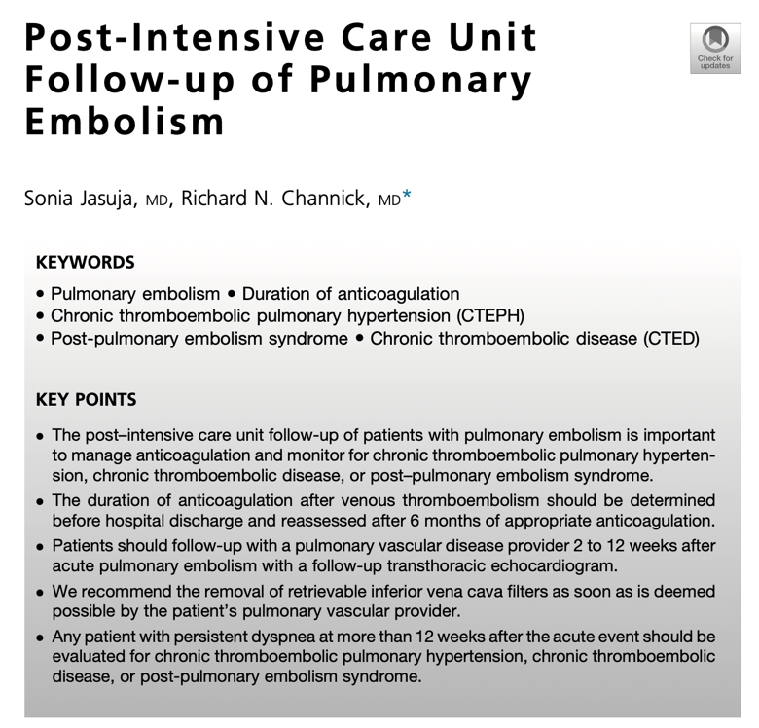
Introduction:
- High recurrence rate of PEs and potential for long-term sequela necessitates long-term management
  - Recurrence rate as high as 30%
  - Up to 9% of people develop chronic thromboembolic disease (CTED)
- Consensus statements regarding PE follow-up care available from the Pulmonary Embolism Response Team Consortium Consensus Practice and the 2019 European Society for Cardiology Guidelines on Pulmonary Embolism
Summary:
- ICU Hospitalization
  - Submassive PE
    - Recommend at least 24h ICU care
    - OR at least 24h of hemodynamic stability after catheter-directed or half-dose thrombolysis
  - Massive PE
    - ICU care for 24-48h once extubated, off pressors
    - Recommend repeat echo 48h after receiving thrombolytics
- Recheck timeline
  - Initial follow up visit
    - 2-4w for intensively managed patients
    - 4-12w for less severely affected patients
  - Caudal vena cava filter should be removed within 2-4w
- Risk of PE recurrence
  - Recurrence of PE greatest for several months after event and after anticoagulation has been discontinued
    - ~8% of patients had recurrent PE within 3m of initial event
    - Risk factors include patient factors (generally do not resolve) and environmental factors (can resolve)
    - Lower recurrence rate in:
      - Minor surgeries, oral contraceptives, short hospital admission
    - Higher recurrence rate in:
      - Active malignancy (Largest risk factor for recurrence), prior VTE without predisposing factors and antiphospholipid antibody syndrome
- Duration of anticoagulation
  - First VTE related to transient/reversible events (major trauma/fracture of hip/leg, surgery/anesthesia,
    - At least 3-6m of anticoagulation
  - Recurrent VTE or PE without identifiable cause OR in first time PE with persistent risk factors (IBD, autoimmune disease, prolonged travel and oral contraceptive/exogenous hormone use)
    - Low dose anticoagulation with apixaban or rivaroxaban after 6m
  - Antiphospholipid antibody syndrome and active malignancy
    - Indefinite therapeutic anticoagulation
- Determining risks of bleeding
  - RIETE score developed specifically for VTE patients
    - Other scores developed for a fib patients can also be used: HAS-BLED, ATRIA, HEMORR2HAGES
  - Recommend continuing anticoagulation in high risk patients and switching to UFH and placing vena caval filter if complications arise
- Post-Pulmonary Embolism Sequelae
  - Occurs in 1-4% of patients
    - Clinical signs range from mild deconditioning to severe pulmonary hypertension (CTEPH)
  - Chronic Thromboembolic Pulmonary Hypertension (CTEPH)
    - 0.1-9% of patients
      - Possible risk factors include unprovoked PE, hypothyroidism, symptom onset >2w before diagnosis, RV dysfunction, DM and thrombolytic tx/embolectomy, splenectomy, IBD, ventriculoatrial shunt and osteomyelitis
    - Considered if patient still clinical after 3m, at least 1 persistent lobar/segmental unmatched perfusion defect on VQ imaging AND evidence of PH
    - Needs to be identified and treated with endarterectomy quickly
      - Non-surgical candidates treated with balloon pulmonary angioplasty or medical therapy
  - Chronic Thromboembolic Disease
    - Considered if patient still clinical after 3m, at least 1 persistent lobar/segmental unmatched perfusion defect on VQ imaging WITHOUT evidence of PH
  - Post-pulmonary Embolism Syndrome
    - No defined diagnostic criteria
    - Experience dyspnea/exercise intolerance without evidence of VQ defect, predicted VO2 peak of <80%

