Giving Day testing: selection of mobile devices

Introduction
Given the variety of mobile devices—vendors, versions and browsers—it is helpful to determine combinations more likely to be used by our Giving Day audience.
Selections have been made based on general stats, and stats specific to the most recent Giving Day.

Mobile devices selected for testing
- iPhone 11 with Safari and Chrome
- iPhone XR with Safari
- iPhone 8 with Safari
- Galaxy S9 with Chrome
- Galaxy S6 with Chrome
- iPad with Safari
- Microsoft Surface

Statistics

General usage in the United States
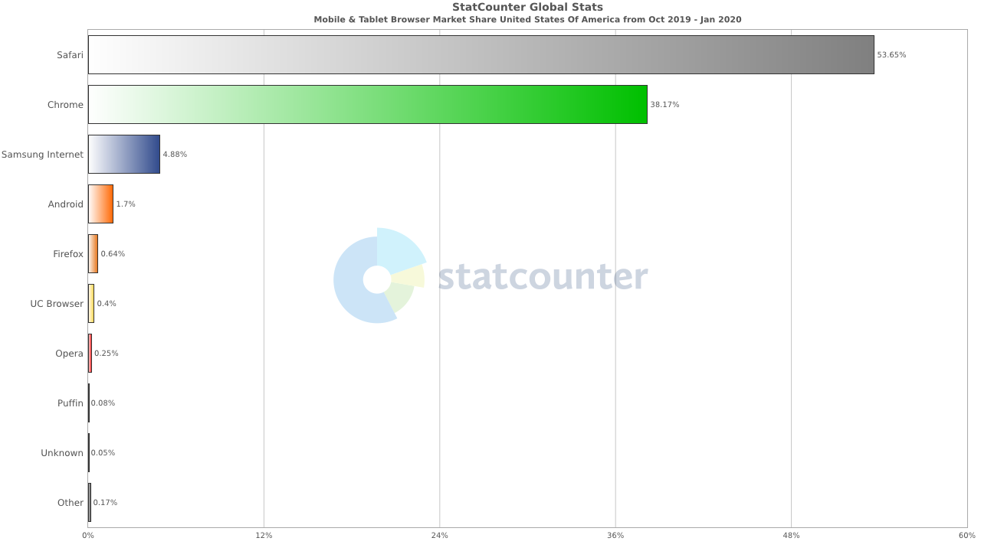
Chart summary: Mobile and tablet browser share USA from October 2019 – January 2020. Source: statcounter
Table 1 Mobile and tablet browser share Oct. 2019 - Jan. 2020
Mobile browser | Usage (%)
Safari | 53.65
Chrome | 38.17
Samsung Internet | 4.88
Other | 3.30

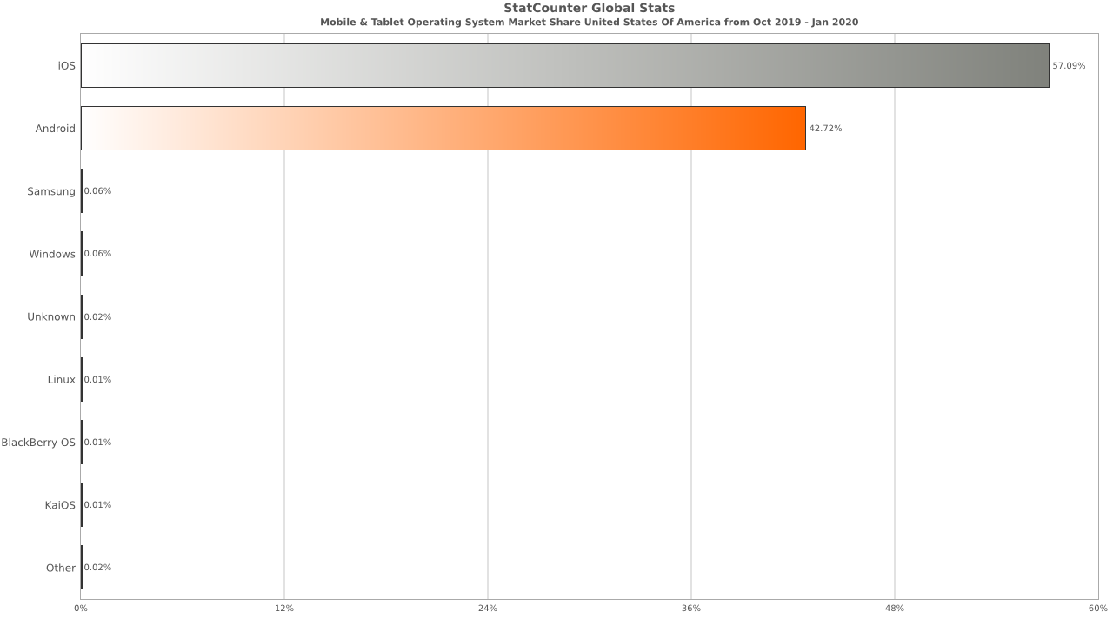
Chart summary: Mobile and tablet operating system market share USA from October 2019 – January 2020. Source: statcounter
Table 2 Mobile and tablet system market share USA Oct. 2019 - Jan. 2020
Mobile system | Usage (%)
iOS | 57.09
Android | 42.72
Other | 0.19
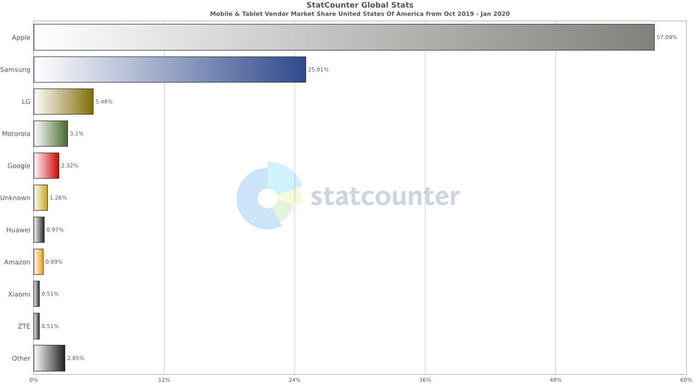
Chart summary: Mobile and tablet vendor market share USA from October 2019 – January 2020. Source: statcounter
Table 3 – Top three mobile and tablet vendor market share USA Oct. 2019 - Jan. 2020
Mobile vendor | Usage (%)
Safari | 57.10
Chrome | 25.01
LG | 5.48
Other | 12.41

Usage during Giving Day 2019
Table 4 – Top four mobile device usage during Giving Day 2019 - device type, percentage of mobile users, and percentage of mobile revenue. Source: Google Analytics data
Mobile device | Mobile device users (%) | Mobile device revenue (%)
iPhone | 75.36 | 60.99
iPad | 6.61 | 21.06
Surface | 0.81 | 9.35
Samsung | 7.77 | 5.13
Other | 9.45 | 3.47

Additional factors
- Extra emphasis is placed on iPhone testing because, in addition to high usage, unique problems were discovered on iPhone devices during initial testing.
- Testing on Microsoft Surface is recommended in spite of its low usage because users of this device have contributed a significant amount of revenue.

