

AWS Immersion Day

Amazon Lex Hands-On Lab
  - Getting Started with Chatbots on AWS

Amazon Lex Overview
Amazon Lex is a service for building conversational interfaces into any application using voice and text. Amazon Lex provides the advanced deep learning functionalities of automatic speech recognition (ASR) for converting speech to text, and natural language understanding (NLU) to recognize the intent of the text, to enable you to build applications with highly engaging user experiences and lifelike conversational interactions. With Amazon Lex, the same deep learning technologies that power Amazon Alexa are now available to any developer, enabling you to quickly and easily build sophisticated, natural language, conversational bots (“chatbots”).

This lab will walk you through launching, configuring, and customizing a Chabot that you will create with Amazon Lex.

Launch CloudFormation Stack
In this lab we will leverage a CloudFormation template to build and provide an initial configuration for a Lex powered chat bot. Additional information pertaining to this automation can be found here.

- Sign into your AWS account: https://console.aws.amazon.com
- In the upper right hand corner, confirm you are in the desired AWS region (e.g., N. Virginia)
- Use this CloudFormation button to launch in AWS Region us-east-1:
- Click on Next in the Create Stack screen
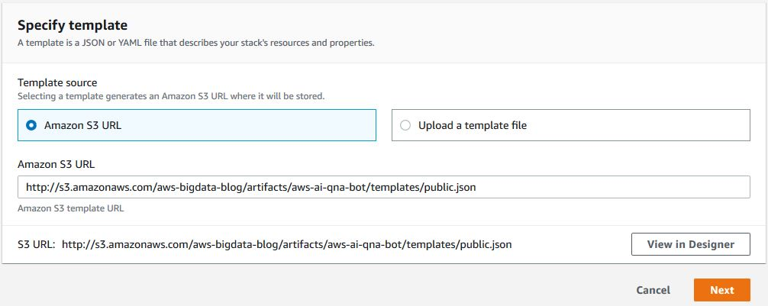
- In the Parameters section, enter a valid Email and Username and click Next
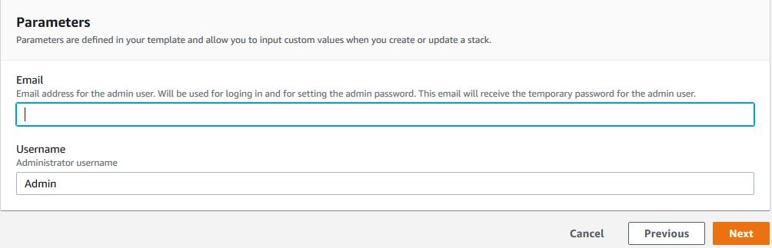
- On the Configure stack options screen, click Next
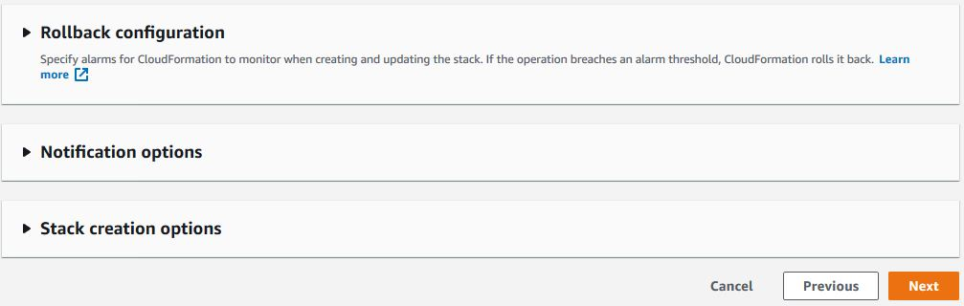
- On the Review QnABot screen, check the 2 acknowledgements at the bottom and click Create Stack
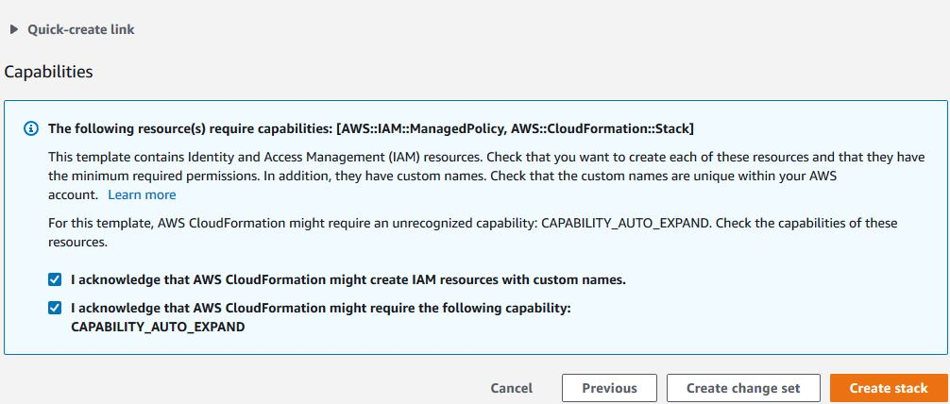
- The stack will take a few minutes to complete. Once the stack has reached a CREATE_COMPLETE state, continue to the next step (approximately 15 minutes).

Create Initial Content
Once the CloudFormation stack is in a completed state, you will notice that you would have received an email with a temporary password to the email address specified in the template. Before you can begin using the chat bot you will need to load some questions and answers. To do so, will need to obtain the ContentDesignerURL from the Outputs tab of the Master stack (“QnABot”).
- Obtain the ContentDesignerURL from the outputs tab of the QnABot Stack
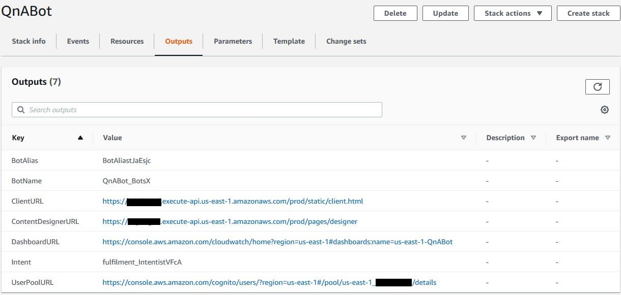
- Navigate to the URL and sign in with the Username (default is “Admin”) and temporary password from the email
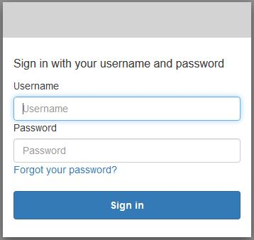
- On the next screen, you will be prompted to reset the password
- Once logged in, select the ADD button to create your first question
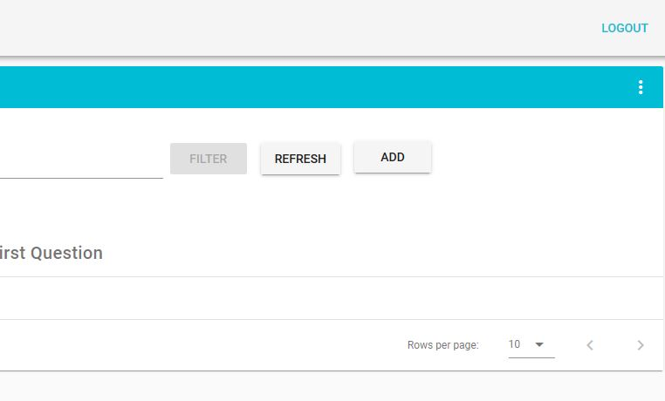
- Enter the id: QnaBot.001
NOTE: Use a naming convention to identify your items within categories.
- Enter the question: What is Q and A Bot
- Enter the answer: The Q and A Bot uses Amazon Lex and Alexa to provide a natural language interface for your FAQ knowledge base, so your users can just ask a question and get a quick and relevant answer.
- Choose the CREATE button (bottom right of the card)
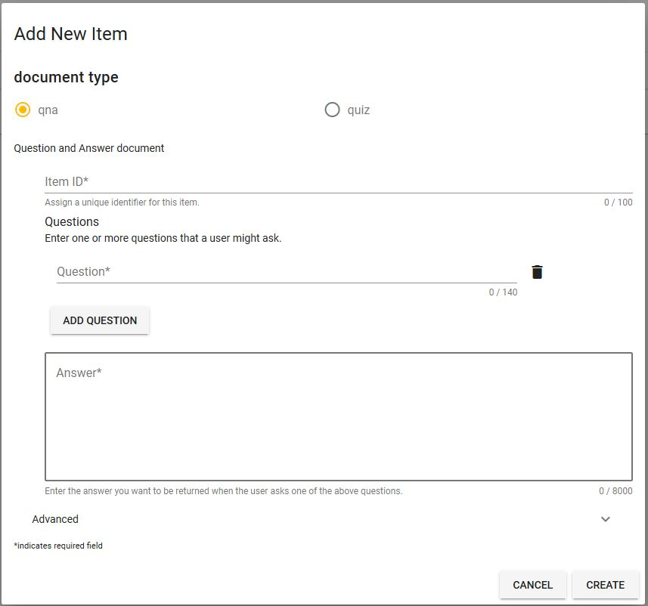
- Choose Import from the top left tools menu ( ☰ ), then enter the URL below, and choose IMPORT
https://raw.githubusercontent.com/aws-samples/aws-ai-qna-bot/master/assets/examples/documents/blog-samples.json

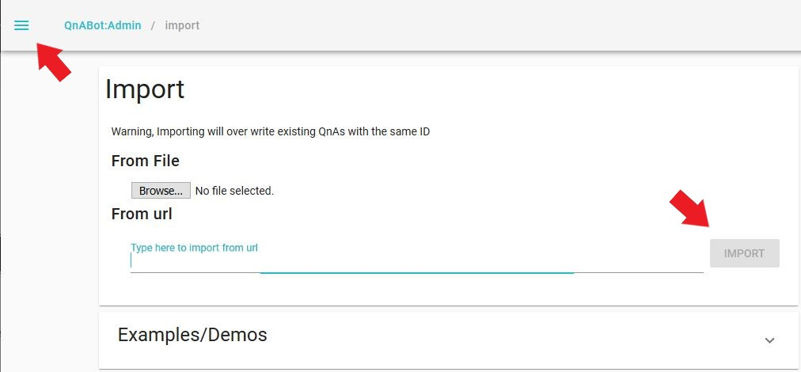

- Once the upload is complete, navigate to the QnABot:Admin page

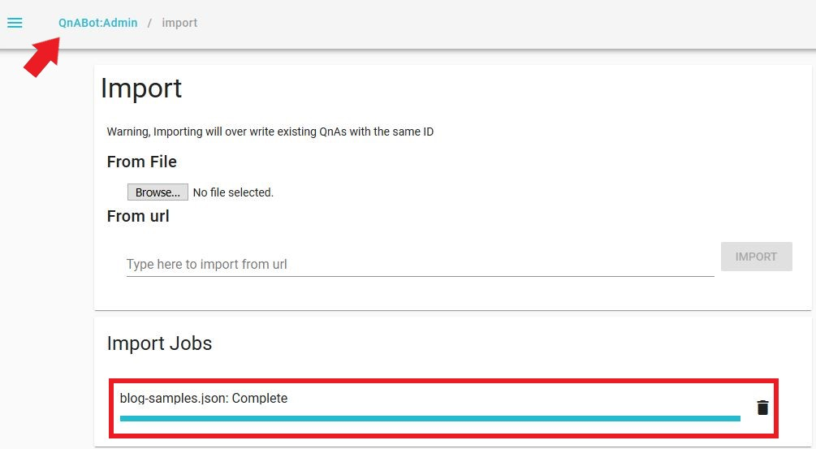

- Choose LEX REBUILD from the top right edit card menu ( ⋮ )
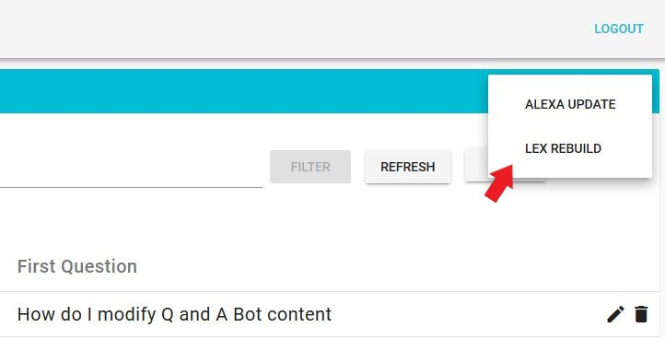

- Once the rebuild is complete, move on to the next step

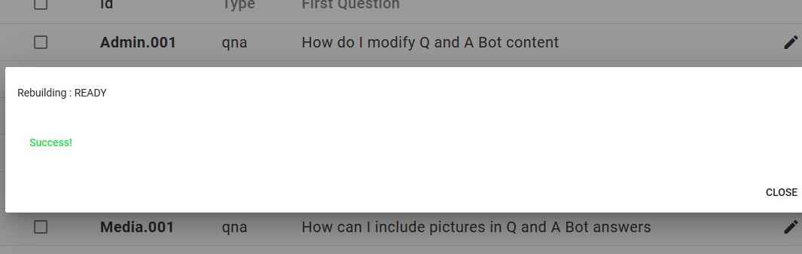

Getting answers using a Lex Web Client UI
- Launch the client by choosing QnABot Client from the Content Designer tools menu ( ☰ )
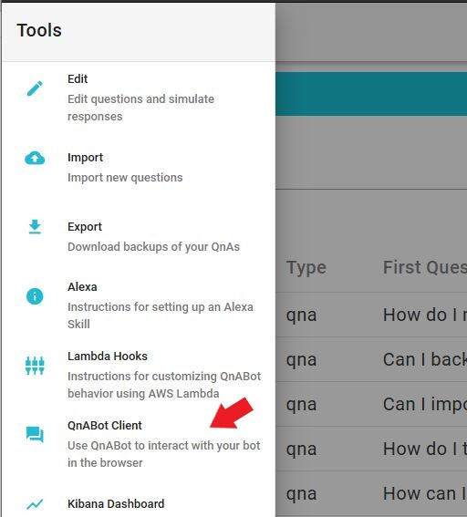

- A new window will open with the chat bot, when your browser requests access to the microphone on behalf of the web application, allow it (if you have one)
- Try it! Choose the microphone icon (bottom right) and say, “What is a Q and A Bot?”
- You can test with any other question you provided

Adding Images to your answers
You can easily augment your answers with image attachments that can be displayed on a user’s Lex Web Client UI, Amazon Alexa smartphone app, or new Amazon Echo Show device touch screen. Use images to display maps, diagrams, or photographs to depict places and products relevant to the question.
- Log in to the Content Designer, and choose Add
- Enter ID: Alexa.001
- Enter question: What is an Amazon Echo Show
- Enter answer: Echo Show brings you everything you love about Alexa, and now she can show you things. She is the perfect companion for Q and A Bot.
- Expand Advanced
- In the Topic section, enter the values below:
  - Card Title: Echo Show
  - Card Image Url: https://images-na.ssl-images-amazon.com/images/I/61OddH8ddDL._SL1000_.jpg
- Choose CREATE to save the new item
- Go ahead and test your newly added question

Using SSML (Speech Synthesis Markup Language) to control speech
- In Content Designer, edit item QnaBot.001 (“What is Q and A Bot”). Open the Advanced section and enter the following text in the SSML Answer field:
<speak>QnABot is <emphasis level="strong">great</emphasis>. But I want to tell you a secret. <amazon:effect name="whispered">I am not a real human.</amazon:effect>. Can you believe it? </speak>

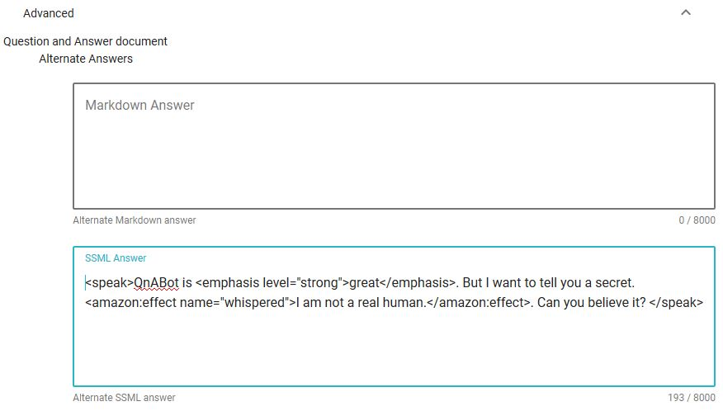
- Choose Update at the bottom to save
- Try it out by asking “What is a Q and A Bot”

Additional Resources
If you had fun with this lab and are looking for additional information, feel free to check out the links below:
https://aws.amazon.com/blogs/machine-learning/creating-a-question-and-answer-bot-with-amazon-lex-and-amazon-alexa/
https://aws.amazon.com/blogs/machine-learning/building-a-conversational-business-intelligence-bot-with-amazon-lex/
https://aws.amazon.com/lex/

