Respiratory Acid-Base Disorders:

PaCO2 is regulated by alveolar ventilation.

Primary increases in PaCO2 ____ body fluids leading to respiratory ______ = ___ventiliation
Primary decrease in PaCO2 _____ body fluids leading to respiratory ____ = _____ventiliation

Fick’s law =
diffusion of gases is directly proportional to surface area and inversely proportional to thickness of membrane.

Control of alveolar ventilation
Drive originates with respiratory centers of medulla (ventral respiratory column) which consists of network responsible for respiratory rhythm generation and respiratory pattern formation. Respiratory rhythm generation and pattern formation are altered by homeostatic control system (plasticity). Neuro pathways lead to muscle contraction, which subsequently drives alveolar ventilation.

Chemoreceptors and chemoreflexes
Chemoreceptors: provide sensory inputs to respiratory control system concerning changes in CO2 or O2. Alveolar ventilation is altered via negative feedback mechanism to minimize variations in normal gas levels.

Primary stimuli for changes in alveolar ventilation are hypoxemia (PaO2 <60mmHg) and carbon dioxide-induced changes in intracellular and extracellular pH, but different magnitude of change.
- CO2 changes of 1mm will increase alveolar ventilation 20-30%
- PaO2 can change up to 20mmHg with little alteration in ventilation.

Chemoreceptors located in both peripheral and central nervous system.
- O2 chemoreceptor in
carotid body at bifurcation of internal/external carotid arteries (responsible for 90% of increase in minute ventilation due to hypoxemia) and aortic body in aortic arch (minimal role in change of ventilation).
- CO2/pH receptors in CNS through brainstem
  - Retrotrapeziud nucleus (RTN), serotonergic and GABAergic neurons in raphe nuclei, etc
  - Central receptors more significant for producing changes in ventilation mediated by CO2
  - Lungs are only avenue of CO2 elimination and CO2 diffused efficiently across alveolar capillary wall so CO2 partial pressure essentially the same in alveoli as arteries.
  - In steady state, PaCO2 inversely proportional to alveolar ventilation (Va) based on this alveolar ventilation equation: PaCO2 = 0.863 (VCO2/VA)
    - VCO2 is metabolic production of carbon dioxide
    - 0.863 constant that equates dissimilar units for CO2 and A
    - VA is fraction of total minute ventilation that is produced at gas exchange units of lung
  - Portion of gas not reaching gas exchange area is termed dead space gas. Dead space tidal volume ration (VD/VT) refers to portion of each tidal volume that ventilates dead space and is “wasted”.
    - Equation can be rewritten: PaCO2 = 0.863 (VOC2/VE[1-VD/VT])

Mechanoreflexes:
Ventilation also influenced by sensory inputs originating from chest wall, pulmonary and airway receptors. Receptors in airway activated in response to changes in pressure, cold, irritation, or stretch
- Laryngeal stimulation by negative pressure or cold results in reflex activity directed at maintaining upper airway patency
- Airways below larynx contain slowly (SAR) and rapidly (RAR) adapting stretch receptors and bronchopulmonary C givers which upon activation result in reflex events including bronchoconstriction/dilation, protective reflexes (cough), alterations in respiratory timing

Ventilatory regulation mainly controlled by autonomic nervous system. CNS receives afferent inputs from sensory information via mechanoreceptors and chemoreceptors integrated within brainstem breathing center to generate neural resp rhythm and pattern. Resp output can be further modulated by neurochemical signals (serotonergic inputs) with subsequent contraction of effector inspiratory muscles (diaphragm).
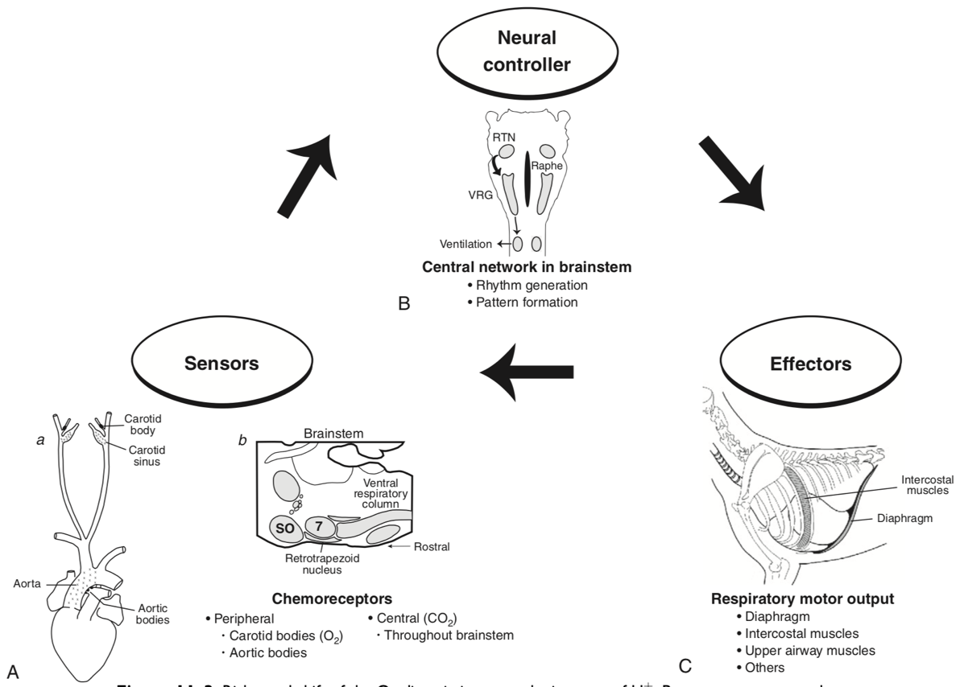
Gas diffusion and transport during respiration
- Carbon dioxide:
  - O2 transported and used by tissues, metabolic processes in body produces 15K mmol of CO2 daily.
  - Lungs responsible for excreting a great deal more carbonic acid (H2CO3 and dissolved CO2) each day more than kidneys. Therefore, alveolar ventilation and CO2 removal have large influence in acid-base balance.
  - Dissolve CO2 20x (how many times) more soluble than O2
  - Very diffusible, so assume complete equilibration of PCO2 that is rapidly achieved between intracellular and extracellular compartments, so CO2 diffused rapidly from tissues into red blood cells
  - Red blood cells form bicarbonate through this reaction:
    - CO2 + H2O (CA) H2CO3 H+ + HCO3-
    - First reaction slow in plasma but fast within erythrocyte due to presence of carbonic anhydrase (CA)
    - Carbonic acid spontaneously dissociates into H+ and HCO3- at intracellular pH
  - When concentration rises, HCO3- ions diffuse from red cells into plasma. Cell membrane relatively impermeable to cations (H+) and chloride ions diffuse into red cells from plasma to maintain electroneutrality (so-called “chloride shift”)
  - In lungs, shift of chloride out of red cells facilitated by high intracellular concentration of chloride (~60mEq/L) when compared to other cells.
  - Most of CO2 (~81%) transported to lung as bicarbonate.
  - Small amount (~8%) dissolved CO2 in plasma
  - Some combined with terminal amino group of blood proteins (~11%), most important of which is carbaminohemoglobin
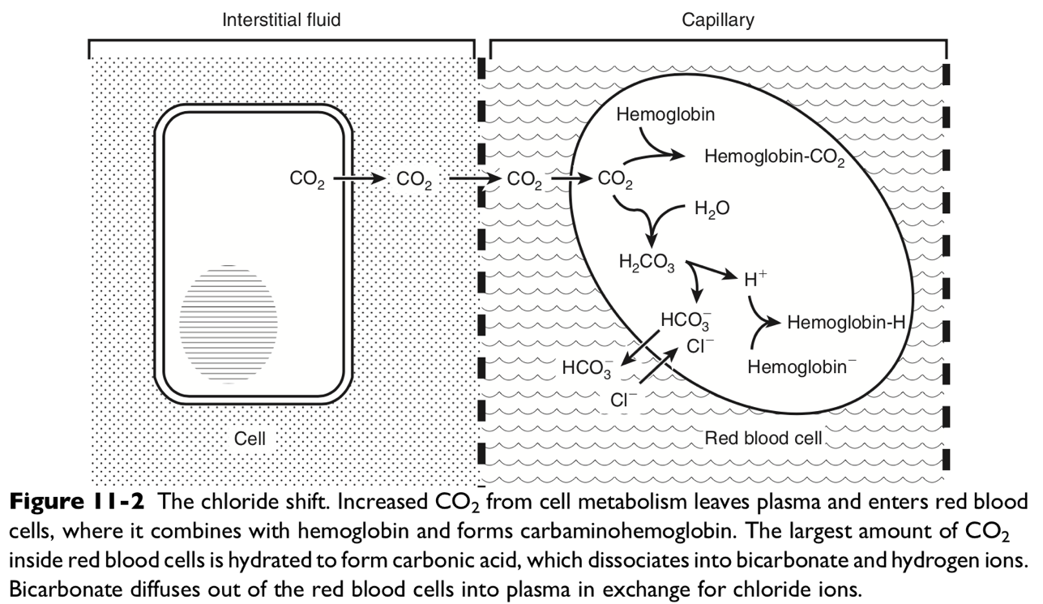

- Oxygen:
  - Alterations in O2 level when hypoxemic can alter respiratory acid-base status
  - Oxygen transport initiated by contraction of diaphragm with consequent movement of inspired gas down the airways to alveoli. Within resp zone, alveolar ventilation and gas exchange occur as O2 move down its concertation gradient into red blood cells.
  - Partial pressure of O2 in red blood cells approximates alveolar gas within first third of lung capillaries, primary due to lungs considerable diffusion capabilities
  - O2 carried in blood to meet O2 demand of tissue in 2 forms:
    - dissolved and combined with hemoglobin
    - Most O2 delivered is bound to hemoglobin, only small amount dissolved
      - 0.003mL dissolved O2 per 100mL of blood/mmHg PO2
    - Maximal amount of O2 that can be combined with hemoglobin called oxygen capacity
      - ~1.36mL of O2 can combine with 1g of hemoglobin
      - Assuming 15g of hemoglobin per 100mL of blood, ~21mL O2 per 100mL blood carried to tissue
  - O2-hemoglobin dissociation curve
    - shows that at low PO2, amount of O2 carried by hemoglobin increase rapidly with increases in PO2.
    - At higher PO2 (>60-70mmHg), curve flattens off and little additional hemoglobin loading occurs.
    - Unloading of large amount of O2 from hemoglobin is facilitated in tissues where O2 pressures are much lower (10-60mmHg) and curve is very steep.
    - Factors that shift curve to right and aid in unloading of O2 to tissues
      - Increased H+ ions, CO2 concentrations (as seen in resp acidosis), increased temperature, increased 2,3-diphosphogycerate (2,3-DPG) which is a compound that competes with O2 for its binding site on hemoglobin.

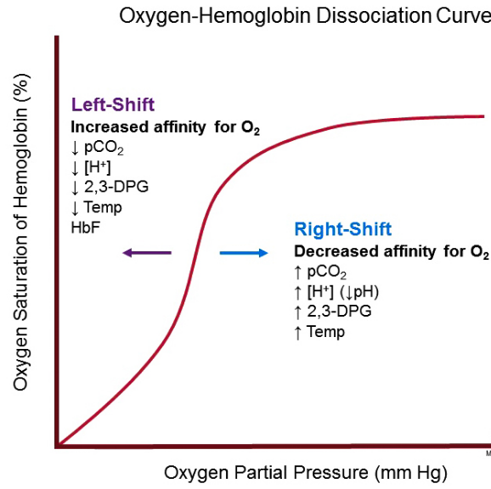

Alveolar-arterial Oxygen Gradient
- When patient presented with hypoxemia associated with respiratory acid-base disorders, must distinguish between hypoxia from primary lung disease vs alveolar hypoventilation
- On room air, alveolar gas equation dictates at steady state, arterial or alveolar oxygen (PAO2) tension will decrease with increased PCO2
  - PAO2= PIO2 – PACO2/R
  - R= respiratory exchange ration that accounts for difference between CO2 production and O2 consumption at steady state
    - R = 0.8 in normal animal
  - PIO2 is inspired O2 tension
    - At sea level, PIO2 = 150mmHg
  - PACO2 is alveolar PCO2, however since it is highly soluble, PACO2 = PaCO2
- (A-a) O2 gradient = PAO2 – PaO2 = [150 – (PaCO2/0.8] – PaO2
  - Since R=0.8, 1/0.8= 1.25, Can see equation as = [150-1.25PaCO2]-PaO2
- Normal <15
  - Clinically, normal excludes pulmonary disease and suggests some form of central alveolar hypoventilation or abnormality in chest wall/inspiratory muscle
- If >25, component of hypoxemia is from ventilation-perfusion mismatch
- FYI, FiO2 dependent on barometric pressure, so will be lower at high altitude
  - Altitude 500m, PIO2 = 140mmHg
  - Altitude 1000m, PIO2 = 130mmHg

Hypoxemia
Five causes of hypoxemia = ________

Question: Which states of hypoxemia will increase PaO2 with oxygen supplementation?

V-Q mismatch, hypoventilation, diffusion impairment

Question: Which states of hypoxemia will affect A-a gradient?

V-Q mismatch, right-to-left shunt

- Low partial pressure of inspired O2 (PIO2)
  - Hypoxemia due to reduction in mean alveolar oxygen levels (PAO2) subsequently reducing PaO2
  - Caused by decease in barometric pressure
    - High altitude residence
    - Nonpressurized airline flight
  - Caused by improper inhalant anesthetic technique
    - N2O without O2
  - This causes subsequent increase in alveolar ventilation secondary to hypoxemia which decrease PaCO2. A-a O@ gradient remains normal because of concomitant decrease in PIO2
- Hypoventilation
  - PAO2 is determined by balance between removal of O2 by blood and replenishment of O2 by alveolar ventilation
    - As alveolar ventilation decreases, PAO2 and PaO2 will decrease as PACO2 and PaCO2 must increase
    - A-a gradient does not change
  - Due to sigmoid shape oxygen-hemoglobin dissociation curve, effect of increasing alveolar ventilation on arterial oxygen saturation is minimal above PaO2 of 55-60mmHg
  - Causes of hypoventilation include CNS disease, resp depressant pharmacologic agents, neuromuscular disease affecting resp muscles, chest wall injury, upper airway obstruction, severe diffuse pulmonary disease
- Diffusion impairment
  - Occurs when there is incomplete equilibration of alveolar gas and pulmonary end-capillary blood.
    - Equilibration of O2 between alveolus and erythrocyte is rapid under normal condition, so this type of hypoxemia is infrequent
  - Seen with thickening of alveolar-capillary membrane (diffuse pulmonary interstitial disease with “alveolar-capillary block” or loss of alveolar or capillary surface area (emphysema or vasculitis)
  - Can be seen in high cardiac output that markedly decrease transit time of red cells (exercise)
- Ventilation-alveolar perfusion mismatch (V-Q mismatch)
  - Although there are regional differences in VQ throughout mammalian lung, heterogeneity is limited, so V-Q ration ~0.8
    - This ratio enables mixed venous blood to be fully oxygenated and CO2 eliminated w/o increase in minute ventilation
  - Most common cause of hypoxemia
  - Occurs when there is perturbations in ventilation or perfusion resulting in inefficient gas exchange
  - Low V-Q = low PaO2 and high alveolar PCO2
    - Hypercapnic and hypoxemic blood
    - Poorly ventilated, adequately perfused
    - Examples: increased airway resistance (asthma, bronchitis, chronic obstructive pulmonary disease
  - High V-Q = high PaO2 and low PaCO2
    - Poor perfusion, adequately ventilated
    - Increased ventilation does not improve oxygenation
    - Examples: increased compliance (emphysema) or low output states (pulmonary embolism)
  - V-Q mismatch usually hypoxemic but normal to decreased PaCO2 because chemoreceptors respond and change CO2 with minute ventilation
  - Hypoxemia from V-Q mismatch can be corrected with increasing fraction of inspired oxygen (FiO2)
  - Severity of V-Q mismatch can be assessed using A-a O2 gradient for both abnormally low and high V-Q ratios
- Right-to-left shunt
  - Severe form of V-Q mismatch, results when mixed venous blood complete bypasses ventilated pulmonary alveoli and return to arterial circulation
  - Normal animal has small amount (2-3%) of shunting present
  - In pathologic state, shunt results from perfusion of lung areas that receive no ventilation due to atelectasis or consolidation (V-Q=0) or from deoxygenated blood flow through anatomic right-to-left channels
    - Examples V-Q=0: pulmonary edema, atelectasis, pneumonia
    - Examples of right-left shunt:
abnormal cardiac defects like PDA, VSD, ASD, tetralogy of fallot with right-to-left blood flow bypassing lungs.
  - Small amounts of shunt results in clinically relevant hypoxemia because venous blood oxygen content is extremely low and mixed blood is added directly to arterial blood without alveolar gas exchange.
  - Decreased PaO2 with normal to decreased PaCO2 leads to A-a gradient changes
    - However, PaO2 levels with increased shunting will fail to return to normal even with O2 supplementation

Respiratory acidosis
- Respiratory acidosis, primary hypercapnia, results from CO2 production that exceeds elimination via lung
  - Respiratory failure with resultant alveolar hypoventilation
  - Increased PaCO2, decreased pH, compensatory increase in blood HCO3-
- Metabolic compensation in respiratory acidosis
  - Acute respiratory acidosis
    - Acute increase in pCO2 causes intracellular CO2 levels to increase
    - An increase in CO2 concentration shifts the reaction CO2 + H2O (CA) H2CO3 H+ + HCO3- to the right.
      - Bicarbonate and H+ concentrations slightly increase within 10 minutes because of dissociation of H2CO3 into HCO3 and H+.
      - Bicarbonate ions are released from erythrocytes in exchange for chloride, increasing the plasma strong ion difference (SID).
    - An increase in CO2 concentration also shifts the general buffer reaction (A- + H+ HA) to the left.
    - Intracellular buffers (e.g., hemoglobin, hemoglobin + H+ reduced hemoglobin) play a critical role in acute buffering of hypercapnia, handling 97% of the H+ load in dogs.
    - Only 3% of the H+ load is handled by extracellular buffers (i.e., plasma proteins).
    - As a result, for each 1- mm Hg increase in PCO2, these buffers increase HCO3 0.15 mEq/L
    - Presence of moderate hypoxemia does not alter the adaptive response to acute respiratory acidosis
  - Chronic respiratory acidosis
    - If hypercapnia persistent, renal compensation occurs to stabilize plasma HCO3- at higher concentration within 2-5 days
    - Chronic hypercapnia causes intracellular H+ to increase in the renal tubular cells. Upregulation of the Na+-H+ antiporter of the renal brush border occurs and hydrogen ions are exchanged for sodium and then excreted as NH4+Cl.
    - Intracellular HCO3 is reabsorbed and exchanged for Cl, resulting in an increase in plasma SID, chloruresis, and negative chloride balance.
      - The chloride lost in the urine decreases urine SID because the chloride is accompanied by NH4+ rather than sodium ions.
    - A new steady state is reached when the increased filtered load of HCO3 resulting from the increased plasma concentration of HCO3 is balanced by increased renal reabsorption of HCO3. The net effect is buffering of the respiratory acidosis and hyperchloremic hyperbicarbonatemia caused by chronic hypercapnia.
    - For each 1-mm Hg increase in PCO2, HCO3 will increase 0.35 mEq/L
    - Renal response to chronic hypercapnia is not altered by moderate hypoxemia, dietary Na or Cl restriction, alkali loading, or adrenalectomy
    - Renal compensation is incomplete and unable to return pH to normal value unless longstanding (>30 days) resp acidosis in dogs
  - Causes of respiratory acidosis
    - This can occur with any disease process involving neural control of ventilation, mechanics of ventilation, or alveolar gas exchange resulting in hypoventilation, ventilation-perfusion mismatch, or both
    - Acute usually from sudden severe primary parenchymal disease (fulminate pulmonary edema) or airway/pleura/chest wall/neurologic/neuromuscular disease
    - Chronic from sustained hypercapnia and has many causes.
    - In cases of neuromuscular disease, degree of hypercapnia not proportional to severity of muscle disease and may be underestimate w/o blood gas analysis.
      - Muscle weakness and elastic load has decreased modulation of central resp output leading to rapid shallow or dyspneic breathing pattern leading to chronic CO2 retention
    - Hypercapnia can result from decrease in alveolar ventilation (from decrease in total minute ventilation or increase in dead space to tidal volume ratio) or with increase metabolic production of CO2.
      - With decreased alveolar ventilation, you can have decreased total minute ventilation (global hypoventilation) or abnormal ventilation-perfusion ratios in lung
      - With increase metabolic production, normally lung can eliminate, but if there is impaired or fixed alveolar ventilation like heat stroke or malignant hyperthermia, then respiratory acidosis can develop
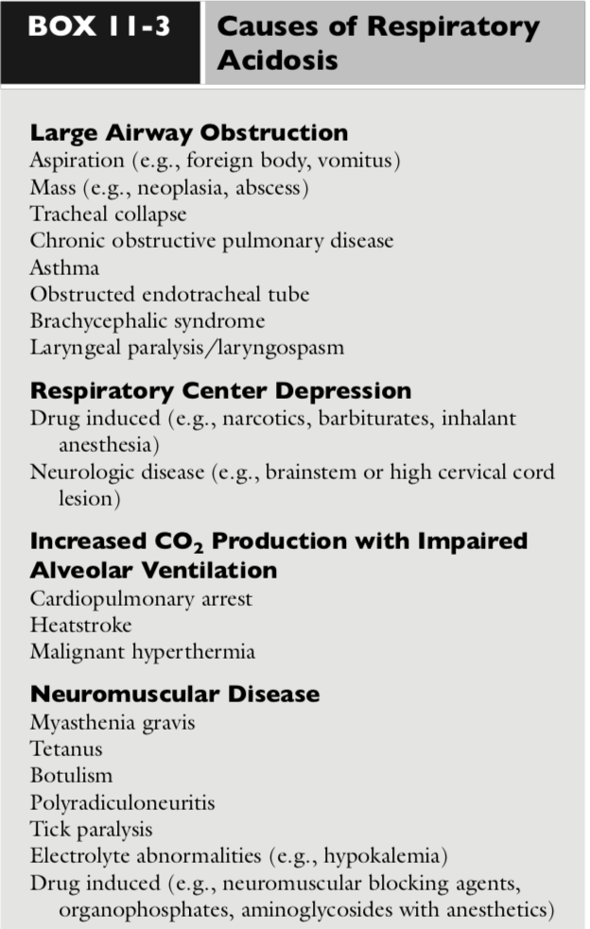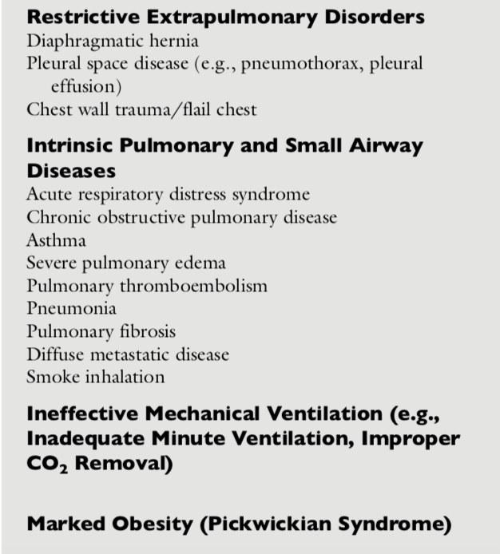
- Diagnosis and Clinical Features of Resp Acidosis
    - Clinical signs from underlying disease responsible for hypercapnia
    - For life-threatening acute hypoventilation (cardiopulmonary arrest, airway obstruction), hypoxemia is the immediate threat to life
      - Patient dies from hypoxemia before hypercapnia can become severe
      - Abrupt cessation of ventilation is fatal within 4 min, but hypercapnia wouldn’t develop for 10-15 min
    - Hypercapnic stimulates sympathetic nervous system and releases catecholamines
      - Tachyarrhythmias
    - Metabolic changes include retention of Na and water, due to ADH release, increased cortisol secretion, and activation of RAAS.
    - Gastroparesis due to altered gastric muscle activity and fundic tone
    - Acute acidosis shifts oxygen-hemoglobin dissociation curve to the right, promoting unloading of oxygen at tissues and enhancing oxygen delivery and carrying capacity

  - Treatment of resp acidosis
    - Rapid diagnosis and elimination of underlying cause
    - Because patient will develop life-threatening hypoxia before life-threatening hypercapnia, supplemental O2 and assisted ventilation may be needed for acute resp acidosis
      - In chronic hypercapnic, O2 may decrease drive for breathing, which may worsen resp acidosis by suppressing ventilation. PaO2 should be kept between 60-65mmHg
    - If respiratory muscle fatigue or failure occurs with progressive acidemia or hypoxemia, mechanical or assisted ventilation may be needed
    - Dibart has resp failure in face of concurrent hypoxemia diagnosed with PaCO2 >50mmHg in nonsedated or nonanesthetized animal, PaO2 <50mmHg with FiO2 >0.5
    - If mech vent started, care must be taken to decrease CO2 slowly
      - Rapid decrease in humans lead to cardiac arrhythmias, decreased cardiac output, reduced cerebral blood flow
      - Sudden decrease in blood PCO2 may also results in posthypercapneic metabolic alkalosis and rapid diffusion of CO2 from cerebrospinal fluid into blood, thus quickly increasing cerebrospinal pH
    - Bicarb or other alkalinizing solutions not indicated in resp acidosis
      - Bicarb admin increased SID and may decrease H+ and vent drive, worsening hypoxemia, and increase CO2
    - Administration of parenteral solution with adequate Cl- facilitates recovery from chronic hypercapnia and prevents development of metabolic alkalosis after PaCO2 has returned to normal

Respiratory Alkalosis
- Resp alkalosis or primary hypocapnia =
decreased PCO2, increased pH, and compensatory decrease in HCO3- in blood
  - Hyperventilation: Occurs with alveolar ventilation exceeds required elimination of CO2 produced by metabolic processes in the tissue

- Metabolic compensation in resp alkalosis
  - Acute resp alkalosis
    - When PCO2 acutely decreases, CO2 leaves cell to achieve new equilibrium point. Chloride ions leave red blood cells in exchange for HCO3-, decreasing plasma SID and increasing intracellular SID
    - H+ translocation into extracellular space in exchange for Na and K decreases plasma SID
    - Intracellular phosphate and protein are major buffers in acute adaptive response
    - Extracellular buffering with release of H+ only 1% of response, intracellular buffering 99% of acute response (opposite of resp acidosis)
    - 1mmHg decrease in PCO2 will have a compensatory decrease of 0.25 mEq/L in HCO3 concentration
  - Chronic Resp alkalosis
    - 1mmHG decreased in PCO2 will have compensatory decreased of 0.55 mEq/L in HCO3
    - pH will be normal or near normal with compensation, but it may take up to 4 weeks to achieve
  - Causes of Resp Alkalosis
    - Due to stimulation of peripheral chemoreceptors by hypoxemia, primary pulmonary disease, direct activation of the brainstem respiratory centers, overzealous mechanical ventilation, and situations that cause pain, anxiety, or fear.
    - In addition, respiratory alkalosis can occur during recovery from metabolic acidosis because hyperventilation persists for 24 to 48 hours after correction of metabolic acidosis.
    - When PO2 <60mmHg, peripheral chemoreceptors mediate an increase in rate and depth of breathing, leading to hypocapnia
    - Decreased O2 delivery can also lead to hypocapnia (severe anemia, shock)
    - Pulmonary diseases may cause respiratory alkalosis with hyperventilation due to hypoxemia or due to stimulation of stretch receptors/nociceptive receptors
      - Stretch receptors in smooth muscle of tracheobronchial tree
      - Nociceptive receptors like irritant receptors in epithelium of small airways and juxta capillary receptors (j receptors) lining capillaries in interstitium
      - Stimulated by irritants, interstitial edema, fibrosis, or pulmonary capillary congestion
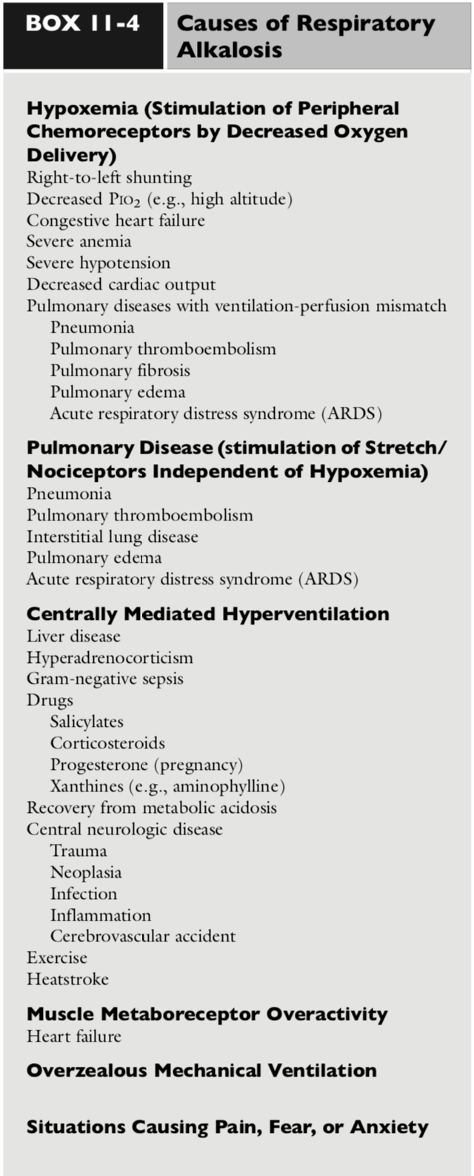
    - Diagnosis and Clinical Features of Resp Alkalosis
      - Clinical signs due to underlying disease process
      - If pH > 7.6, neurologic, cardiopulmonary, metabolic consequences
        - Only seen in acute resp alkalosis before renal compensation ensues
        - Arteriolar vasoconstriction leading to decreased cerebral and myocardial perfusion
        - PCO2 <25mmHg can also cause decrease in cerebral blood flow and clinical signs of confusion and seizures
      - Hypocapnia in anesthetized patients lead to decreased blood pressure and cardiac output, but not in awake patients, most likely due to blunted reflex tachycardia
      - Acute alkalemia shifts oxygen-hemoglobin dissociation curve to the left, reducing release of O2 to tissues by increasing affinity of hemoglobin for oxygen
        - Chronic negates this effect by increasing concentration of 2,3-DPG in red cells.
      - Hypokalemia may occur due to translocation of K into cells and renal/extra renal losses with acute resp alkalosis
        - Decrease 0.4-0.6mEq/L for each 10mmHg decrease in PCO2
        - Not seen in chronic resp alkalosis
    - Treatment of Resp alkalosis
      - Directed toward treatment of underlying cause. Hypocapnia itself not major threat
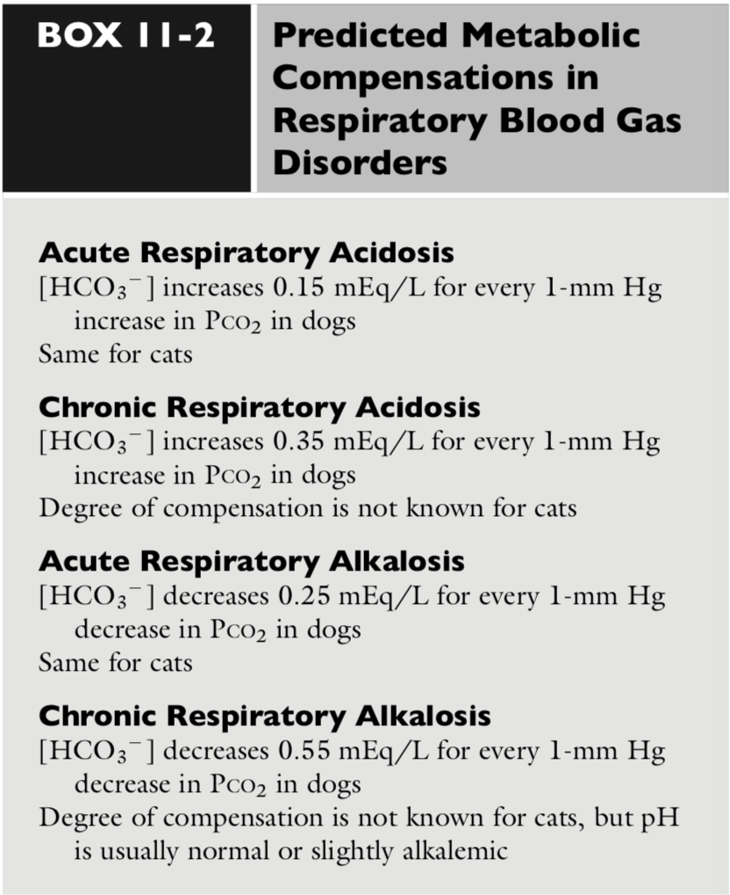

Dyspnea
- Clinical sign of acute or severe respiratory dysfunction and abnormal acid-base regulation
- Defined as difficult or labored breathing, in people described as unpleasant sensory experience of breathing discomfort or “pain”
- Three types = _________

  - Air hunger
    - Imbalance in perception of increased drive to breathe from chemoreceptors (hypoxemia and hypercapnia) relative to afferent signaling of stretch receptors in thoracic cavity and lungs
    - Does not require abnormal arterial O2 or CO2 levels, it is balance of patient’s actual alveolar ventilation vs ventilation needed to maintain normal acid-base regulation
  - Increased work of breathing
    - Increased respiratory pressures generated to breathe in face of decreased compliance, airway obstruction, or alteration sin resp muscle length
      - Ex: upper airway obstruction in which cognitive awareness of inability to breathe reaches distressing level
  - Thoracic tightness
    - Taken from humans, asthmatic chest tightness secondary to bronchoconstriction
  - Treatments aimed at removing inciting cause, but other treatments considered include nebulized furosemide, opioids, corticosteroids

