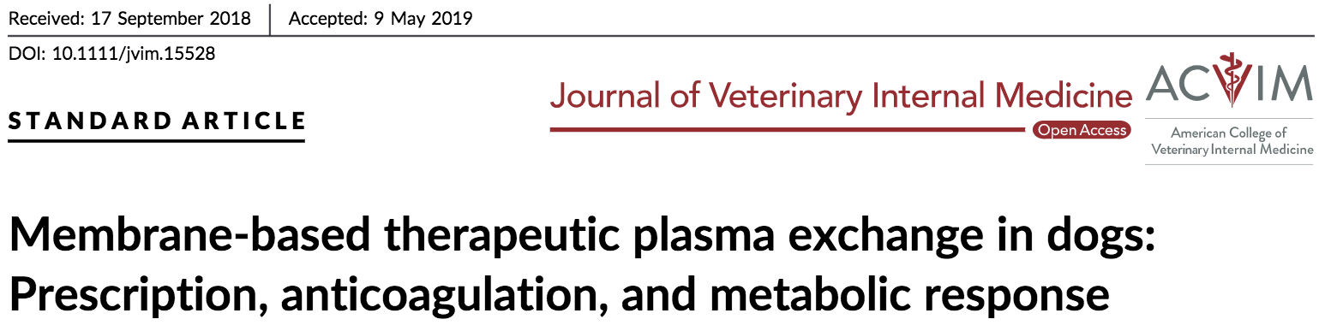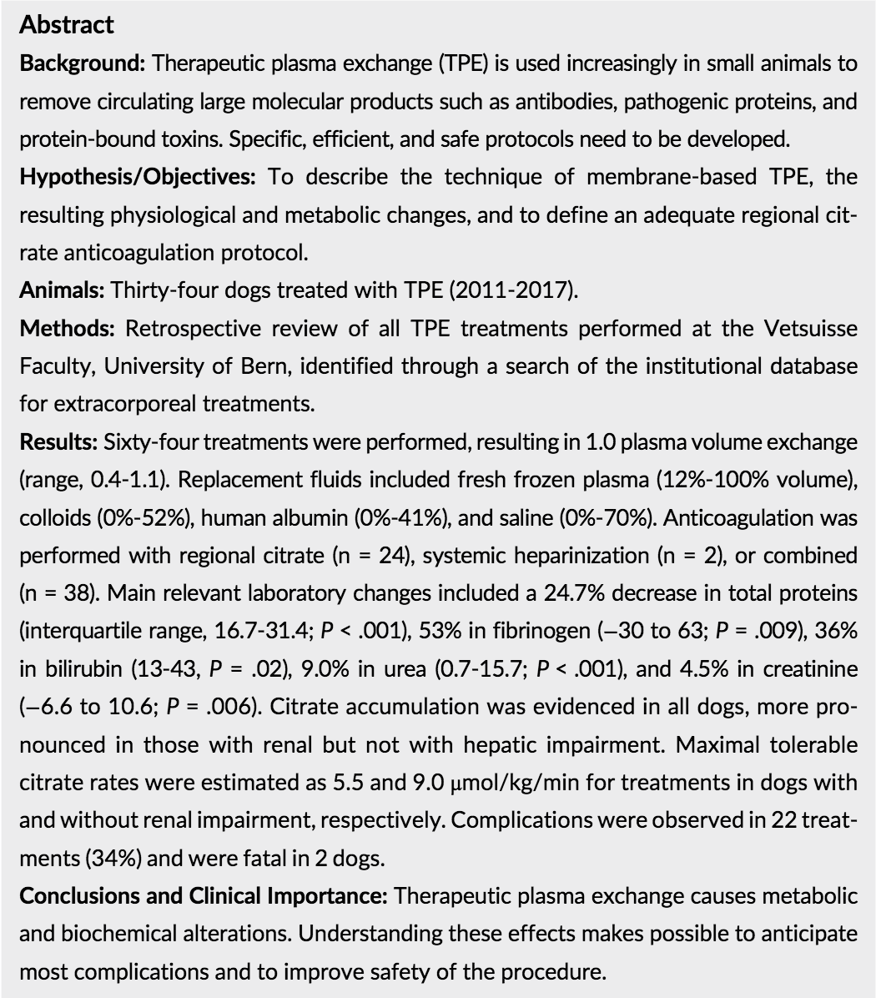
Results:
- Stable serum albumin, moderate decrease in serum fibrinogen concentration, substantial decreased serum bilirubin with dos with markedly increased values before treatment. Electrolytes, VBG, and other biochemistry values were relatively stable.

- All dogs showed citrate accumulation but rare clinical signs of hypocalcemia. Higher citrate accumulation seen in dogs with renal impairment but not dogs with liver impairment.

- 1/3 of treatments showed signs of complication, but most were mild and self-limiting.
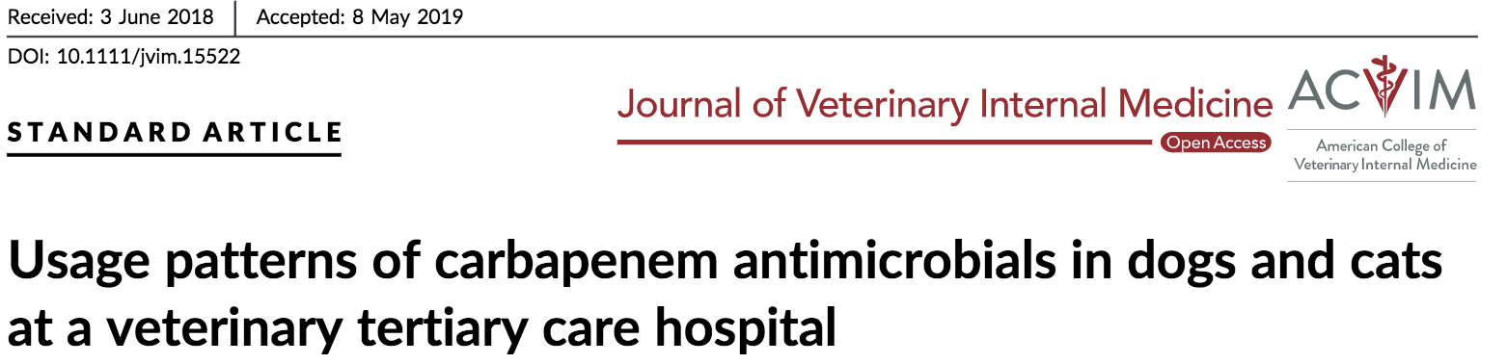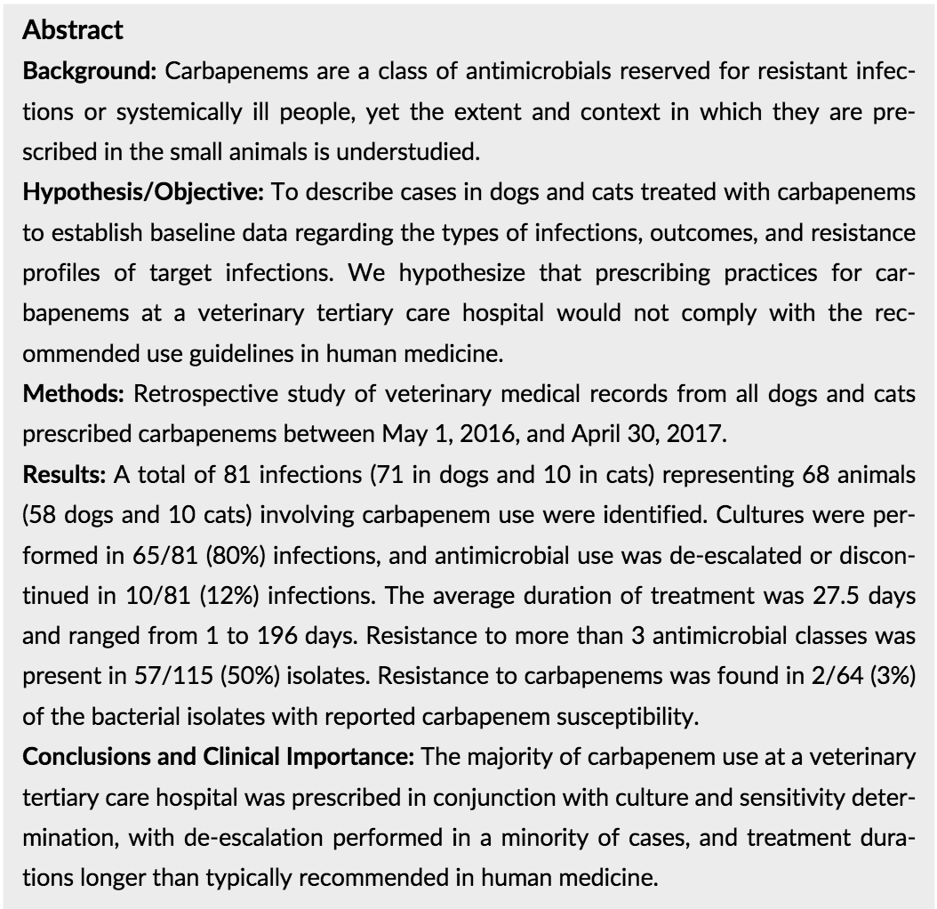

Carbapenems broad spectrum of activity against gram-positive and gram-negative aerobes and anaerobes. Treat multidrug resistant (MDR) Enterobacteriaceae infections, including Escherichia coli and Salmonella and their effectiveness in treating resistant organisms is largely because of their resistance to destruction by beta-lactamases.

Because of their importance in treating life-threatening infections in human and veterinary medicine, judicious use of carbapenems is recommended, and there are multiple sets of guidelines for appropriate use in humans. In human medicine, imipenem-cilastatin is used primarily for hospital-acquired and healthcare-associated pneumonia, intra-abdominal infections, neutropenic fever, complicated UTIs, polymicrobial necrotizing fasciitis, severe diabetic foot infections, and osteomyelitis. Meropenem is primarily used for skin and soft tissue infections, intra-abdominal infections, acute pancreatitis, obstetric and gynecologic infections, respiratory infections, bacterial meningitis, and febrile neutropenia. Many of the human clinical conditions for which these drugs are used are characterized by high rates of drug resistance or by complicated mixed infections.

The goal of this retrospective study was to review cases over the course of 1 year at a veterinary tertiary care hospital in which either imipenem or meropenem was prescribed to cats and dogs, to determine the type of infection they were used to treat and whether the infection was cultured before prescribing a carbapenem, duration of treatment, if antimicrobial treatment was de-escalated with culture results, and survival statistics for dogs and cats in which carbapenems were used. Understanding current prescribing patterns is a first step in providing guidance for and targeting stewardship interventions

The International Society for Companion Animal Infectious Diseases (ISCAID) guidelines for carbapenem use in UTIs state that the use of critically important antimicrobials in companion animals is only justified if (1) infection is documented based on clinical culture and cytological abnormalities,(2) resistance to all other reasonable options and susceptibility to the carbapenem chosen is documented, (3) the infection is potentially treatable (the animal will likely survive and the infection will likely be eventually cleared), and (4) consultation with an expert in infectious disease and antimicrobial treatment is sought. For both imipenem and meropenem, guidelines from ISCAID for respiratory tract infections in companion animals state that they should be reserved “for the treatment of multidrug-resistant infections, particularly those caused by Enterobacteriaceae or P. aeruginosa, consultation with an infectious disease veterinary specialist or veterinary pharmacologist before use is recommended.

This retrospective study showed that clinicians were mostly compliant with the recommendations by ISCAID to obtain cultures (80%) before carbapenem use and to use these drugs in dogs and cats with a high likelihood of survival. There is room for improvement in reduction of HAIs, duration of treatment, and actively de-escalating treatment regimens that have options other than carbapenems available. Implementation of hospital-level guidelines is effective in reducing the number of antimicrobial prescriptions without influencing patient outcomes. This could be particularly useful in reducing the duration of use of carbapenems in both humans and animals, which might help curb the development of resistance to this crucial drug class.

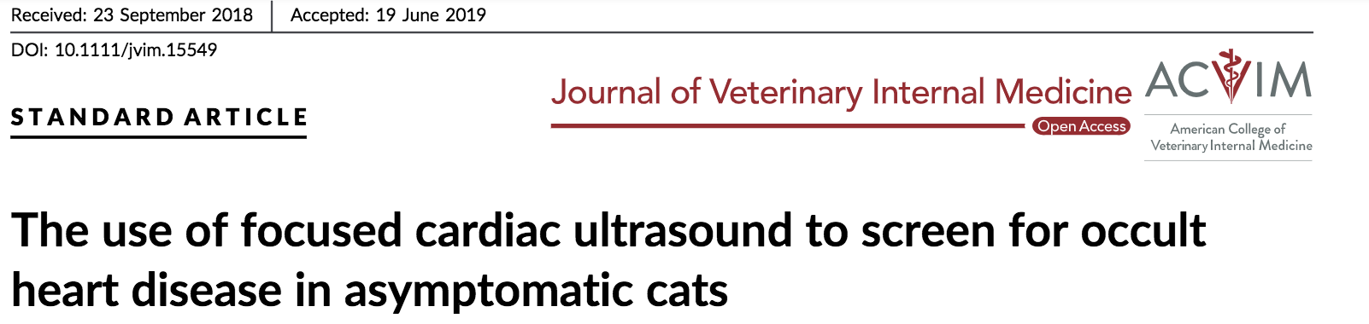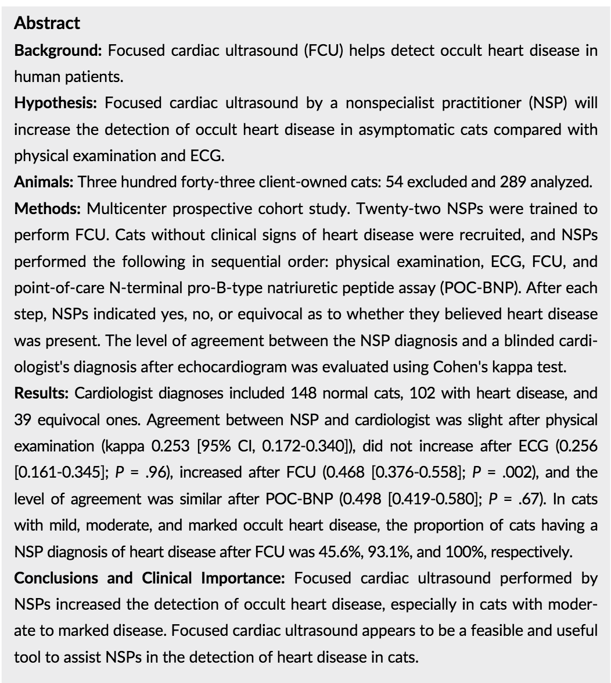
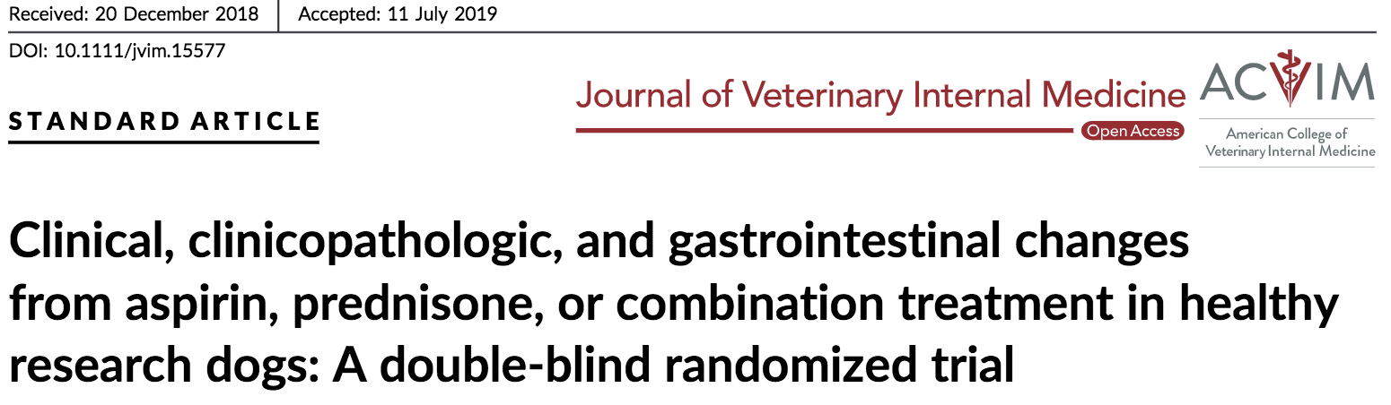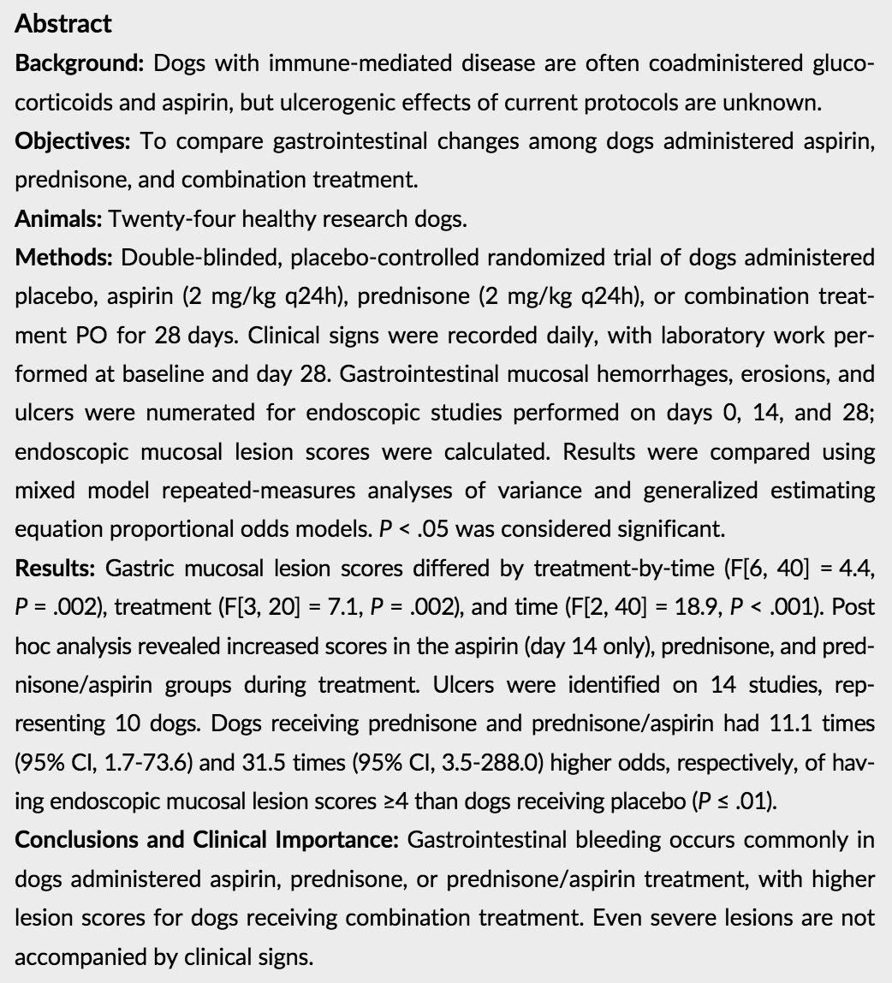

A study using an aspirin dose of 0.5 mg/kg q24h found no significant difference in endoscopically identified gastric mucosal lesions between healthy dogs administered prednisone alone and prednisone with aspirin. However, the use of an aspirin dose that achieves consistent antiplatelet effects might increase GI bleeding due to additive inhibition of prostaglandin formation and potential local effects on the gastric mucosa. Therefore, this study looks at 2mg/kg q24 aspirin dose.

Discussion:
Total gastric endoscopic mucosal lesion scores increased significantly in dogs administered aspirin (day 14 only), prednisone, and prednisone/aspirin combination treatment in this study. Increases were primarily due to increased numbers of punctate and invasive erosions, although ulcers developed in 10 dogs over the course of the study. Both numbers of lesions and endoscopic lesion scores were higher on day 14 than 28, with significantly higher values in the aspirin and prednisone/aspirin group on day 14 compared to day 28. However, a number of dogs had new lesions, such as ulcers, identified on day 28, suggesting ongoing primary disease. Dogs receiving prednisone and prednisone/aspirin combination treatment had 11.1 times and 31.5 times higher odds to have endoscopic lesions scores≥4 (eg, >25 punctate erosions,≥1invasiveerosion,≥1 ulcer, or all) than dogs administered placebo

Although gastric mucosal damage was marked and often severe, it was not accompanied by changes in food intake, vomiting, fecal score, or weight. Neither hematemesis or melena was noted. Furthermore, many clinicopathologic changes associated with GI bleeding were not identified. The BUN:creatinine ratio detects changes consistent with GI bleeding in absence of increases in BUN concentration, given the latter's poor sensitivity for bleeding.

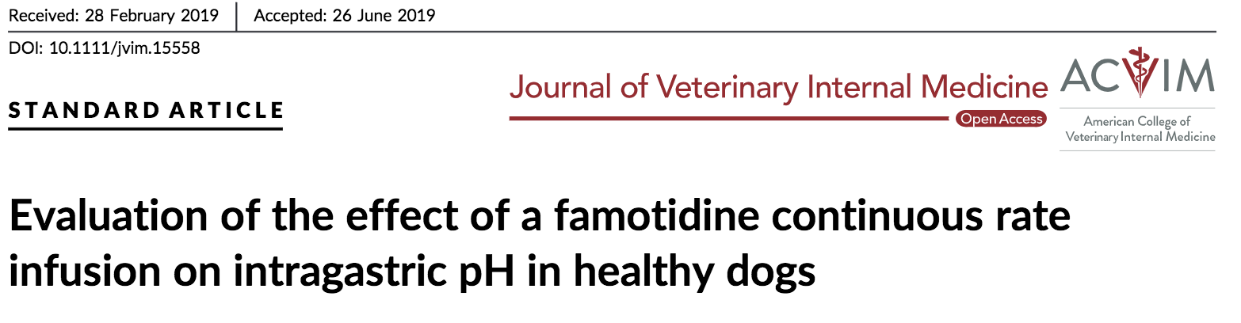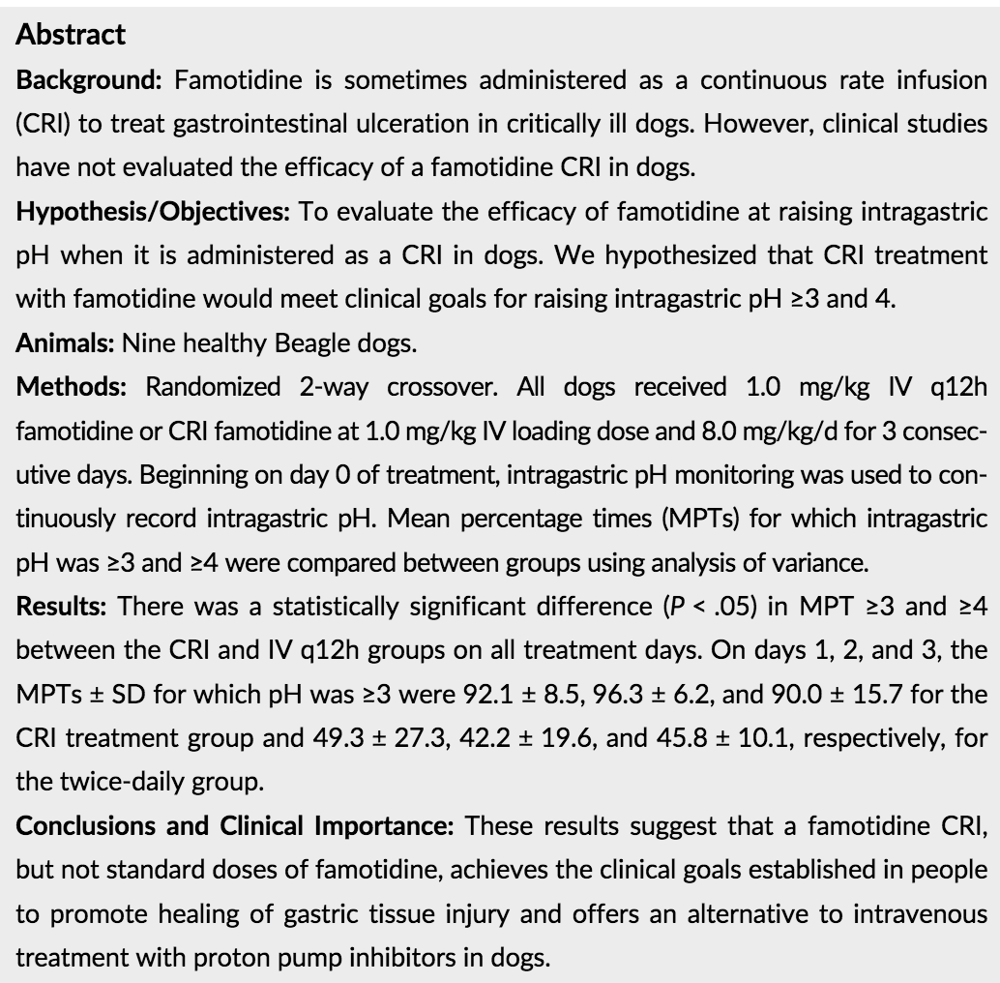

In the present study, they evaluated the effect of famotidine when administered as an intravenous CRI for a consecutive 72 hours in healthy dogs. In humans, the treatment goals for duodenal ulceration and GERD include maintaining an intragastric pH≥3 for at least 75% of a 24-hour period and a pH≥4 for at least 67% of the day. On all treatment days, the CRI treatment group met or exceeded these clinical goals whereas the standard twice-daily famotidine treatment group did not meet the clinical goals on any day of treatment.

The administration of famotidine CRI did appear to be associated with vomiting, as more vomiting events were noted in this treatment group; however, the study was underpowered to detect a significant difference between groups.
