CALCIUM
Role in body:
- Needed intra and extracellularly
  - Skeletal action / contraction
  - Vascular smooth muscle tone
  - NT transmission and nerve conduction
  - Enzymatic reactions
  - Membrane transport and stability
  - Coagulation
  - Hormone secretion
  - Bone formation and resorption
  - Hepatic glycogen metabolism
  - Cell growth and division
  - Intracellular messenger
- Kept within narrow range
Calcium homeostasis
- Integrated actions of parathyroid hormone (PTH), calcitriol, calcitonin

  - Main regulators: PTH and calcitriol (1,25 dihydroxyvitamin D3)
    - PTH – minute to minute control of iCa
    - Calcitriol – day to day
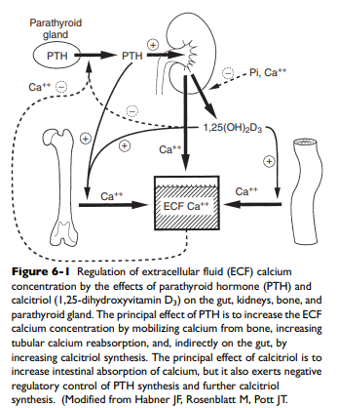
- Major target organs: intestines, bone, kidneys
  - Increase intestinal absorption and transport of Ca from diet
    - Enteric absorption depends on status of intestines – integrity of villi, acidity, presence of other diet components
    - Daily diet intake equals amount lost in urine and feces
  - Increase renal tubular reabsorption**
    - Non- protein bound calcium, filtered by glomerulus and undergoes renal reabsorption – reclaiming more than 98% in health
  - Redistribution of calcium from bone
    - Skeleton – supplies Ca and Phos when intestinal and renal absorption is inadequate
    - Important for acute regulation

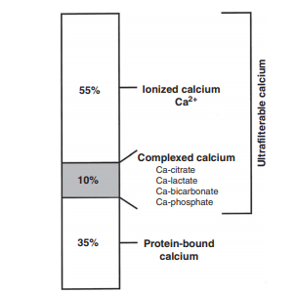
Calcium within body
- 99% in skeleton – hydroxyapatite
- <1% readily available
  - Small amount in bone ECF
Extracellular Ca
- 3 fractions in serum/plasma:
  - Ionized (56%) – biologically active
  - Complexed – phosphate, bicarb, sulfate, citrate, lactate (10%)
  - Protein bound (34%) – storage pool, buffering system
Intracellular Ca
- Secondary messenger
- Maintained at very low level = rapid diffusion into cells from ECF or ER
- After increase, intracellular Ca is rapidly:
  - Buffered by cytosolic proteins (troponin C, calmodulin, calbindin)
  - Transported into organelles (mitochondria, ER)
  - Exported out of cell
- If intracellular Ca is elevated – can lead to toxicity and cell death

PARATHYROID HORMONE
- PTH = 84 AA single chain polypeptide
- Synthesized and secreted from chief cells of the parathyroid glands; little stored
  - Balance of PTH synthesis and degradation within chief cells
- Short half-life (3-5 min) in serum steady rate of secretion needed to maintain serum concentrations
- PTH secretion is relatively constant but may have a mild pulsatile pattern in response to minor fluctuations in the concentration of serum iCa
- Basal secretory rate of PTH is approximately 25% of the maximal rate, and PTH is constantly secreted during normocalcemia
  - Complete inhibition of PTH secretion does not occur even with severe hyperCa

- PTH = MINUTE TO MINUTE CONTROL, fine regulation of iCa
- Role:
  - Increase distal tubular reabsorption / decrease Ca loss in urine
    - Tubular reabsorption in DCT (active process), and in thick ascending limb LOH indirectly via increasing net positive change in nephron lumen stimulating diffusion out of lumen
  - Increase bone resorption and number of osteoclasts and activity (biphasic)
    - Immediate = osteoblast pump out Ca from bone ECF
    - Late = osteoclast driven bone resorption and bone remodeling
  - Accelerate formation of calcitriol by kidneys in PCT
  - Decrease phos concentration by reducing PCT resorption in kidneys
PTH regulation
- Calcitriol (via vitamin D receptor) and extracellular iCa (via plasmalemma Ca receptor) control the parathyroid cell processes
- Calcitriol
  - Exerts overall control of PTH synthesis and secretion
  - Regulates expression of Ca receptor gene
  - Inhibits PTH mRNA synthesis and stimulates synthesis of Ca receptor adequate levels of calcitriol needed for parathyroid to respond to changes in extracellular Ca
  - Decreased calcitriol increases PTH secretion
    - Uremia and reduced serum calcitriol concentrations (due to hyperphosphatemia) results in poorly regulated chief cell function and renal secondary hyperparathyroidism (glandular hyperplasia)
  - Increased calcitriol decreases PTH secretion – negative feedback loop

- ECF Ca
  - Elevated iCa increases rate of degradation of PTH within the gland, decreasing secretion
  - HypoCa is primary stimulus for PTH secretion
    - Epi, dopamine, secretin, PGE2, isoproterenol – minor

- Phosphorus concentrations regulate PTH indirectly
  - Renal calcitriol synthesis reduced by (modest) hyperphosphatemia plasma iCa decreases due to reduced effects of calcitriol on intestine, bone, kidneys
  - Markedly increased serum phosphorus concentrations (as seen in advanced renal failure) can further lower the serum iCa concentration (by mass law effect) increase in PTH secretion because of the lowered calcium
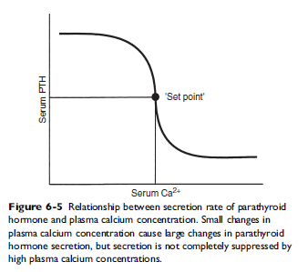
- PTH secretion can be inhibited by very high and very low concentrations of serum iMg

- The rate of PTH secretion is inversely proportional to the concentration of extracellular Ca sigmoidal
  - Allows for large changes in PTH concentration for small iCa changes precise control

PTH Feedback Loops
- Long negative feedback loop
  - Increased serum iCa concentration results from PTH stimulation of renal calcitriol production and subsequent enhanced GI absorption of Ca
  - Effect takes hours to develop because calcium-binding proteins associated with Ca absorption must be induced in enterocytes
- Short negative feedback loop
  - Mediated by binding of calcitriol to VDRs in parathyroid cells inhibits transcription of PTH gene
  - A normal concentration of iCa must be present as it would be inappropriate to suppress PTH synthesis in a hypocalcemic patient
PTHrP
- Plays central role in pathogenesis of hypercalcemia of malignancy, mimics PTH
- PTHrP is produced widely in the body and has numerous actions in the developing fetus and adult animal independent of its role in cancer-associated hypercalcemia
  - Autocrine, paracrine, intracrine functions
- Binds to PTH receptors in bone and kidney with equal affinity to PTH

VITAMIN D / Calcitriol
- Cholecalciferol D3 – animal origin
- Ergocalciferol D2 – plant origin
- Cholecalciferol (vitamin D3) major metabolites:
  - Calcidiol (25-hydroxyvitamin D3)
    - Major circulating vit D and serves as a pool for further activation via 1α hydroxylase or catabolism by 24-hydroxylation
  - Calcitriol (1,25 dihydroxyvitamin D3)
- Humans: vit D met by consumption of D2 or D3 or synthesis of D3 in skin after UV light exposure 7-dehydrocholesterol forms previtamin D3 in the presence of UVB light followed by thermal conversion from pre Vit D3 to Vit D3
- Dogs/cats cannot photosynthesize and are dependent on vit D in diet absorbed intact from SI

- Absorbed from GIT vitamin D binding proteins transport vitamin D to liver hydroxylation via 25, hydroxylase 25-hydroxyvitmain D (calcidiol) hydroxylated to 1, 25 dihydroxyvitamin D3 (calcitriol) via 1α hydroxylase within mitochondria of the PCT in kidneys
  - 24R-hydroxylase inactivates vitamin D metabolites
Synthesis stimulation:
- Decreased calcitriol, phos, Ca leads to increased PTH levels stimulates calcitriol production
- PTH mediates dephosphorylation of renoredoxin (regulator of 1a-hydroxylase) results in increased synthesis of calcitriol
  - Renoredoxin is inhibited by high concentrations of phos or Ca in the renal tubule
Inhibition:
- Increased calcitriol, hyperCa, FGF-23, and increased phosphate loading
- Calcitriol inhibits production of PTH directly and indirectly via increased in Ca
Actions of calcitriol:
- Calcitriol is the only natural form of vitamin D with significant biologic activity
- Increases serum Ca and phos concentration via intestines primarily, also bone and renal Ca and phos resorption
- Enhances the transport of Ca and phos from the intestinal lumen to plasma across the enterocyte
  - Ca enters from the intestinal lumen passively through calcium-selective channels binds reversibly to mobile calbindins actively transported out the basolateral side via a Ca-ATPase and Na-Ca antiporter
  - Calcitriol increases synthesis of calbindins to serve as buffers to protect enterocytes from toxic concentrations of Ca while ferrying across the cell
- Calcitriol is necessary for bone formation and mineralization deficiencies lead to impaired bone growth (rickets) and osteomalacia in adults; also important for normal bone resorption
- Calcitriol negatively feedsback on itself in the kidneys to prevent overproduction of calcitriol
- Negative feedback on PTH production in the parathyroid gland by direct (bind to its receptor in parathyroid gland) and indirect (increased iCa) means
  - Long-standing calcitriol deficiency results in chief cell hypertrophy and hyperplasia

In short …
- When blood iCa, calcitriol decreases - PTH synthesis stimulated
  - PTH has direct effects on bone (increase osteoclast number and function) and kidneys, and indirect on intestines via calcitriol
  - Calcitriol is formed in kidney by activation of renal mitochondrial 1α hydroxylation of 25-hydroxycholecalciferol under the influence of PTH
- Calcitriol increases Ca absorption from intestines and works with PTH to stimulate osteoclasts
- Calcitriol induces renal transport mechanisms activated by PTH to increase tubular resorption of Ca preventing loss to urine
- PTH has negative auto-feedback via calcitriol
- Calcitriol has negative autofeedback on itself

Calcitonin
- Made in C cells in thyroid gland
- Role to limit degree of post prandial Ca -- inhibits osteoclasts
- Minor role in calcium homeostasis

Normal Response to HYPOCa
- Corrective responses mediated by PTH and calcitriol
- Marked increase in PTH within seconds – secretion of preformed PTH can maintain Ca for 1-1.5 hours
  - Renal reabsorption of Ca and excretion of phos occurs within minutes
  - Bone mobilization of Ca and phos takes 1-2 hours
  - After several hours of hypoCa increased PTH secretion stimulates synthesis of calcitriol
- Increases calcitriol
  - Increases intestinal Ca and phos resorption
- Enhances ability of chief cells to produce PTH
  - Hypertrophy and hyperplasia of chief cells over days to weeks
Normal response to HYPERCa
- Decrease in PTH secretion, increased degradation of PTH in chief cells, decreased calcitriol synthesis
- Increased calcitonin hyperplasia of C cells in thyroid gland

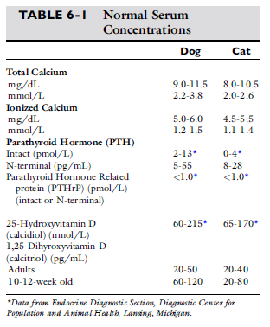
DIAGNOSTICS
Total Ca
- More readily available but does not accurately reflect iCa
- Dogs: tCa overestimates normocalcemia; underestimates hypocalcemia
- Cats: iCa underestimates hypercalcemia and normocalcemia; overestimates hypocalcemia
Methods:
- Fasting serum or heparinized plasma should be used
  - Oxalate, citrate, EDTA = no no Ca binds these and results in falsely low results
- Isotope dilution with mass spectrometry = gold standard
- Colorimetric and spectrophotometry = most commonly used
- Hemolysis and lipemia can results in falsely increased tCa levels (so can acetaminophen and hydralazine)
- Hyperbilirubinemia falsely decreases tCa
- Normal ~ 9-11mg/dL – slightly higher in young animals due to bone maturation, too high (>12) evaluate diet for phos, Ca, vit D
- May be lower due to hypoalbuminemia
- Adjustment formulas (based on albumin) not reliable or recommended
Ionized Ca
- iCa regulates its own homeostasis by binding to Ca receptors parathyroid chief cells, C cells regulates PTH and calcitonin secretion
- iCa directly regulates own tubular resorption
Methods / Handling:
- Ca ion selective electrodes
- Portable, disposable bedside analyzers -cartridge with impregnated biosensor for iCa
- Heparinized samples should be used though results are lower compared to serum samples
  - Dogs: 0.05-0.26 mmol/L lower
  - Cats: 0.05-0.14 mmol/L lower
- Acidemia favors dissociation of iCa false increase
- Alkalemia favors protein binding of iCa false decrease (air exposure causes release of CO2 alkalinizes sample)
- iCa more stable in serum than whole or heparinized blood
- pH correcting formulas are species specific and many analyzers calculate for it
- Normal range ~ 1.25-1.45 mg/dL (dog), 1.15-1.35 mg/dL (cat)
PTH
- Circulates as intact PTH and carboxy terminal fragments – only intact PTH is active
- Best measured in serum or plasma – stored and shipped frozen (EDTA best)
- Two-site immunoradiometric assay (IRMA) test for intact human PTH has been validated for cats and dogs
PTHrP
- Two-site IRMA test and N-terminal RIA
- Fresh or frozen EDTA plasma
Vit D Metabolites
- Calcidiol and calcitriol are metabolites of interest
- Refrigerate or freeze
- Do not exposure to light
- Young animals have higher calcitriol levels
Bone biopsy / aspirates
- LSA, myeloproliferative disease, multiple myeloma
HYPERCALCEMIA
- Can serve as marker of disease or cause disease
Clinical signs of toxicity
- Increased iCa causes alterations in cell membrane permeability, pump activity, energy production = decreased cell function, cell death
  - Tissue level – nervous system, GI, heart, kidneys most clinically important
- Pu/pd, anorexia, lethargy, weakness most common
- MOA:
  - Ca normally blocks Na channels, inhibiting depolarization of nerve and muscle fibers
  - High levels of Ca decrease the neuron membrane permeability to Na raises threshold for depolarization decreasing excitability
- General mnemonic for remembering the effects of hyperCa = “stones, bones, groans, moans, thrones, tones, and psychiatric overtones"
  - Stones (kidney)
  - Bones (bone pain)
  - Groans (abdominal pain, nausea and vomiting)
  - Moans (malaise, ADR)
  - Thrones (polyuria) resulting in dehydration due to nephrogenic DI, nephrocalcinosis
  - Muscle tone (hypotonia, muscle weakness, hyporeflexia)
  - Psychiatric overtones (depression, anxiety, somnolence, stupor, coma)
- Signs most severe when hyperCa happens rapidly (vit D intoxication), if very high, or if prolonged

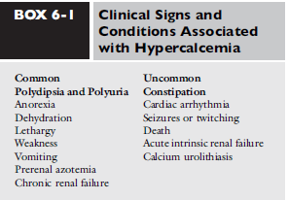

- Histology changes more likely to develop the longer present, not the magnitude
- Na and K concentrations can magnify the clinical signs of hyperCa by their effects on cell membrane excitability (particularly in nerve and muscle)
- Acidosis increases the proportion of serum Ca that is ionized worsening clinical signs (alkalosis decreases Ca – decreased ionization)
- Ca x phos > 60 mineralization, though phos levels do not matter in severe hyperCa
Renal effects of hyperCa
- Functional effects reversible, but structural changes may not be reversible
- Azotemia (esp if due to malignancy):
  - Prerenal: anorexia, vomiting, hypodipsia, pu, volume depletion
  - Renal: vasoconstriction, decreased permeability of glomerulus, acute tubular necrosis from ischemia and toxic effects, nephrocalcinosis, tubuloinsterstial inflammation, interstitial nephrosis
- Early functional effects: decreased concentration ability (USG < 1.030)
  - Reduced tubular reabsorption of Na and impaired action of ADH = nephrogenic DI
  - Decreased aquaporin expression
  - Reduced reabsorption of Ca and antagonism of PTH
  - Medullary washout due to increased renal medullary blood flow
    - All help to excrete Ca
  - Polydipsia due to polyuria but also due to direct stimulation of thirst center by Ca
- Later structural changes: mineralization of renal tubules, basement membranes, interstitial fibrosis, tubular degeneration
- Dehydration – increased fluid losses (vomiting, pu) decreased GFR prerenal azotemia
  - *azotemia and isosthenuria / hyposthenuria may be due to effects of hyperCa not just from renal disease (reversible)
- AKI/F can occur but CKD more common
- Toxic effects of Ca more pronounced when accompanies by increased PTH leads to increased Ca into cells (as in CKD)
- Ascending limb of LOH and DCT show the earliest structural lesions, but lesions in the collecting system are ultimately the most pronounced
- Granular and tubular casts contribute to intrarenal obstruction and azotemia
- Ca-Ox stones common with longstanding hyperCa
- Nephrocalcinonis can occur in chronic hyperCa as well as other normocalcemic conditions (dystrophic mineralization)
Other organs
- Anorexia, vomiting, constipation reduced excitability of GI smooth muscle and direct effects on nervous system
- Increased gastric hyperacidity (increased gastrin and H+ secretion from parietal cells) and reduced gastrin clearance GI ulceration
- Decreased excitability of skeletal muscle contributes toward weakness
- Lethargy from direct effects on CNS; seizures and muscle twitching rare
- PR interval prolongation and decreased QT arrhythmias (including v-fib)
- Hypertension due to increased effect of Ca on vascular smooth muscle and ability of Ca to increase secretion of catecholamine and activate adrenergic receptors
Work up
- Ensure hyperCa is repeatable
- Imaging CXR, AXR, AUS + FNA – infiltrative disease, organomegaly
- Bone marrow if cytopenic
- US of cervical region (primary hyperPTH)
- iCa should be measured with PTH to determine levels of appropriateness
- If no identifiable cause found then measure PTHrP + PTH

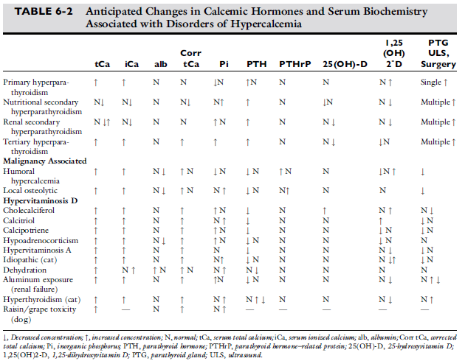
NON-PATHOLOGIC HYPERCa
- Lipidemia, young animal, post prandial, hemoconcentration/dehydration – can cause transient or false increase in Ca
Hypoadrenocorticism
- 2nd most common cause of hyperCa, mild increases
- Levels may be associated with degree of hyperK
- tCa more likely to be elevated than iCa
- Ca returns to normal after institution of corticosteroid replacement

CKD
- Can cause CKD or be due to CKD
- PTH increased – renal secondary hyperPTH
  - tCa may be elevated but iCa is usually normal or low (<10% of dogs have elevated iCa)
- Clinical signs of hypercalcemia uncommon in CKD patients

PATHOLOGIC HYPERCa
Hypercalcemia of malignancy
- Most common in dogs and third most common cause in cats
- Three mechanisms (1) HHM, (2) hypercalcemia induced by metastases of solid tumors to bone, (3) hematologic malignancies growing in the bone marrow
Humoral HyperCa of Malignancy (HHM)
- HyperCa, hypophos, hypercalciuria
- Increased osteoclastic bone resorption
- PTHrP stimulates calcium reabsorption in kidneys, compromised renal function may also play a role (decreased renal excretion)
- Patients with cancer and HHM are expected to have shorter survival
- Common tumors causing HHM:
  - LSA, thymoma, multiple myeloma, melanoma, squamous cell carcinoma, AGASACA, bronchogenic carcinoma/adenocarcinoma, osteosarcoma, fibrosarcoma, undifferentiated sarcoma, undifferentiated renal carcinoma, anaplastic carcinomas of the lungs and diaphragm, and thyroid carcinoma
LSA
- Found in 20-40% of dogs with LSA; usually T cell
- Increased osteoclast resorption without evidence of bone metastasis
Hematologic Malignancies
- Some hematologic malignancies present in the bone marrow produce hyperCa by inducing local bone resorption
Tumor Metastasis to Bone
- Local bone resorption associated with tumor growth
Primary HyperPTH
- Uncommon
  - Older dogs (10.5yo) and cats (12.9yo)
- Excessive PTH secretion from parathyroid relative to serum iCa
- Solitary parathyroid adenoma >>> carcinoma, hyperplasia
- Ectopic parathyroid tissue near thoracic inlet or mediastinum possible
- Clinical signs maybe mild – pu/pd, lethargy, urolithasis, UTI; many no signs
- Dx: elevated tCa, iCa with normal or increased PTH, normal or increased calcitriol, decreased phos, increased ALP
- US of neck – hypo or anechoic nodule
- Surgery – one large gland, others are not identified (suppressed)
- Surgery corrects prob in 94%, Ca normal within a week
Hypervitaminosis D
- Excess cholecalciferol (vit D3) or metabolites (calcidiol, calcitriol)
- Mostly from increased intestinal absorption of calcium
- Rodenticide, toxicity from human vitamins/medications, overzealous dietary supplementation, iatrogenic from treatment of hypoparathyroidism
- HyperCa occurs within 24 hours of ingestion
- Mild hyperphos, azotemia may not be present right away
Granulomatous disease
- HyperCa from calcitriol synthesis from macrophages during granulomatous inflammation
- Normal macrophages express 1α hydroxylase activity (converting 25-hydroxyvitamin to calcitriol) when stimulated by interferon or LPS
- Blasto has been implicated, also Pythium, histo, shisto, coccidio
Idiopathic hyperCa of cats
- Most common cause of hyperiCa
- Most have no clinical signs, though signs may include mild weight loss, chronic constipation, vomiting, anorexia, IBD, uroliths or renoliths possible
- iCa increased, PTH lower half of reference range, PTHrP negative, calcitriol suppressed
- Pathogenesis unknown
- Treatment options include diet changes (increased fiber or renal diet), glucocorticoids, pamidronate +/- routine SQF, furosemide, calcimimetics
Uncommon causes
- AKI, non malignant skeletal lesions (osteomyelitis, HOD, disuse osteoporosis)

TREATMENT of HYPERCa
Definitive treatment
- Remove parathyroid, treat granulomatous lesion, treat neoplasm, etc
- TCa >16 mg/dL – basis for aggressive therapy, or lower if clinical (~20 mg/dL candidate for crisis management)
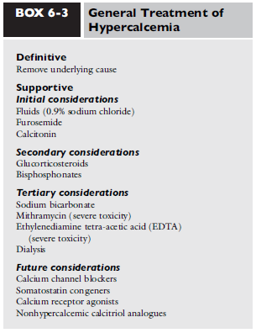
Supportive treatment
- Reduce magnitude of hyperCa
- Repeatable iCa should be determined before starting aggressive treatment
- tCa does not need to be normalized
Initial therapy:
- Fluids:
  - Correct dehydration and hemoconcentration
  - Kidneys respond to ECF volume contraction by increased resorption of Na and Ca from glomerular filtrate – correction allows for naturiesis and calciuresis to occur
  - 0.9% NaCl – competition from Na reduces tubular Ca reabsorption
- Diuretics:
  - Furosemide following rehydration promotes calciuresis (intermittent boluses 2-4mg/kg q8-12hr or CRI 1mg/kg bolus then 1mg/kg/hr)
  - Thiazides should not be used – cause increased Ca resorption
- Calcitonin: may be useful in severe hyperCa
  - Reduces activity of osteoclasts
  - Magnitude of effect is unpredictable, expensive
  - Listed as antidote for cholecalciferol rodenticide toxicity
Secondary therapy:
- Steroids: especially in LSA, AGASACA, MM, thymoma, Addison’s, vit A or vit D toxicity, idiopathic, or granulomatous disease
  - Reduces bone resorption, decreases intestinal absorption, increases renal excretion
  - Cytotoxic to neoplastic lymphocytes
- Bisphosphonates:
  - Inhibit bone resorption (osteoclast activity and function), induces osteoclast apoptosis
  - Effects can last 1-4 weeks
  - Zoledronate >> potency than pamidronate
  - IV over PO (poor bioavailability, vomiting, esophagitis, cramping, etc)
Tertiary / novel therapies:
- NaHCO3: serum iCa is reduced as acidosis is corrected; dose dependent and lasts 2-3 hours, may promote Ca complexing with albumin and bicarb
- HyperCa crisis: EDTA infusion to form complex that can then be removed by kidney
- Mithramycin: potent osteoclast inhibitor but short lived effect and potential for severe toxicity
- Dialysis
- Calcimimetics: activate Ca receptor in parathyroid gland thus stopping PTH secretion; used for renal secondary hyperPTH in humans
- CCBs for calcium effects on cardiovascular system
- Hypervitamin D/cholecalciferol intoxication: cholestyramine for several weeks, vit D is fat soluble and has long half life; AlOH phosphate binders
HYPOCALCEMIA
- Clinical signs: increased excitability of neuromuscular tissues; circulatory effects – hypotension and decreased contractility, resp arrest from paralysis
- Other lyte abnormalities may precipitate onset of signs of hypoCa (hypoK)
- Muscle tremors, seizures, muscle cramping, stiff gait, restlessness, aggravation, disorientation, pyrexia from increased muscle activity, tachycardia, increased QT (EAD), pruritus, facial twitching
- Low iCa in ECF increase the permeability of neuronal membranes to Na progressive depolarization
  - Ca interacts with the exterior surface of Na channels of nerve cells when Ca is absent the voltage level required to open voltage gated Na channels is significantly altered (less excitation is required)
Dx approach
- HypoCa develops when bone mobilization is reduced, skeletal Ca accretion is enhanced, urinary losses increased, GI absorption reduced, translocated intracellularly
- Look at Ca relative to PTH
- In PTH independent cases: hypoCa from redistribution of Ca into body spaces, excess phos effects, deficiencies in vit D or Ca
DDx:
Hypoalbuminemia (tCa)
- Mild and no clinical signs
Renal failure
- Second most common cause
- Decreased calcitriol synthesis
  - Reduced intestinal absorption
  - Increased skeletal resistance to PTH
- Increased phos (law of mass effect)
  - Less important - to decrease iCa by 0.1 mg/dL phos must increase by 3.7 mg/dL
- Secondary hyperparathyroidism is common with renal failure - characterized by low or normal iCa with elevated PTH

Critical Illness
- Common in critically ill patients, especially with sepsis
- Magnitude of hypoCa correlated with severity of illness and increased mortality rates
- Causes (multifactorial):
  - Parathyroid gland insufficiency or suppression
  - Sepsis/SIRS pro-inflammatory cytokines (TNFα, IL-1, I-6) downregulating PTH release and receptors
  - Vit D deficiency or lack of Vit D activation
  - HypoMg
  - AKI/AKF
  - Post-CPR – complexed with lactate
  - Acute pancreatitis
    - Saponification
    - Increase FA (from increased SNS tone and catecholamine release – FA mobilized and can chelate Ca)
    - Increased calcitonin
    - PTH resistance
    - HypoMg
  - Transfusions (citrate)
  - DM
  - Accumulation of Ca in tissues, body fluids, cells
  - Elevation in calcitonin precursors (procalcitonin)
Eclampsia / puerperal tetany
- 1-3 weeks post partum, small dogs, rare in cats
- Poor dietary source of calcium, loss of calcium during lactation, fetal skeletal ossification, parathyroid gland dysfunction / atrophy
- Concurrent hypophosphatemia possible
- May be hyperthermic (muscle activity)
Rhabdomyolysis
- Translocation of calcium into damaged skeletal muscle (post HBC)
- Clinical signs rare
Small intestinal disease (IBD, PLE, lymphangiectasia, LSA)
- Decreased intestinal absorption – complexed with FA in lumen
- Decreased vitamin D absorption nutritional secondary hyperparathyroidism
- Hypomagnesemia – supplementation increases PTH secretion
Alkali administration
- After bicarb administration; may become clinical
Acute reversal of HyperCa (parathyroidectomy)
- Parathyroid atrophy during hyperCa
- Parathyroidectomy, chemo for LSA, anal sac resection
Tumor lysis syndrome
- Release of intracellular K, phos
- HypoCa due to Ca-phos salts deposited into tissues
Nutritional secondary hyperparathyroidism
- Vit D deficiency / low Ca, high phos diet results in increased PTH secretion returns Ca to normal but decreases phos causes weak bones due to fibrous osteodystrophy
  - Can be seen in BARF diets
- Renal secondary hyperPTH affects bones of face
- Nutritional secondary hyperPTH affects long bones and vertebrae
Secondary HyperPTH from Cushing’s
- Cortisol decreases intestinal Ca absorption and increases renal excretion of Ca
- PTH levels may normalize with trilostane
Effect of drugs
- Bisphosphonates, enrofloxacin, phosphate enemas
Hypoparathyroidism
- Absolute or relative deficiency of PTH
  - (1) suppressed secretion of PTH without parathyroid gland destruction, (2) sudden correction of chronic hypercalcemia, (3) absence or destruction of the parathyroid glands (surgery, trauma, immune mediated)
  - Commonly idiopathic in dogs; post thyroidectomy in cats
  - Acute, severe hyperMg or hypoMg can suppress PTH secretion
- Results in:
  - Increased urinary Ca loss, decreased intestinal absorption, reduced bone resorption hypoCa
  - Decreased urinary excretion of phosphorus > reduced intestinal and bone resorption hyperphos
  - Decreased calcitriol synthesis decreased Ca intestinal resorption
Miscellaneous
- Ethylene glycol – can chelate Ca
- Pansteatitis
- Acute respiratory alkalosis (Ca shifts to protein bound)
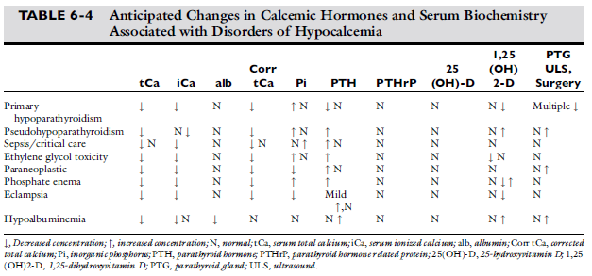

Treatment of HypoCa
- Recommended in patients with clinical signs, severe hypo iCa with or without signs, continued decrease in iCa
- Not necessary to return levels to normal
Acute management
- Tetany or seizures – Ca salts IV
  - 5-15mg/kg of elemental Ca over 10-20 min 0.5-1 mL/kg calcium gluconate
    - Calcium chloride is 3x as potent and can cause severe irritation if extravasation occurs
    - Rapid IV = cardiotoxicity (ST elevation, shortened QT, bradycardia)
  - SQ not recommended – severe reactions seen even if given diluted 1:1
  - Lag time in resolution of signs as CSF equilibrates
Subacute management
- Bolus will only correct for 1-12 hours unless underlying cause is corrected start vitamin D metabolites ASAP (can take days to maximize Ca intestinal transport)
  - Continue parenteral Ca
    - CRI 2.5-3.75mg/kg/hr of elemental calcium
    - Do not add to fluids with phos, lactate, acetate, bicarb – complex/chelate

Chronic maintenance
- Oral Ca will be absorbed once treated with vitamin D metabolites
- Once vitamin D metabolites reach max effect dietary Ca is sufficient and oral supplements can be d/c’d
- TUMS 25-50mg/kg/day divided
  - Ca(HCO3)2 has highest bioavailability
- Vitamin D
  - Life long in patients with primary hypoparathyroid
    - Ergocalciferol: inexpensive, high doses required, long half life
    - Calcitriol: rapid onset of action, short half-life, treatment of choice
    - Calcidiol, cholecalciferol: less common
Follow up / Complications
- Daily Ca levels needed during initial stabilization, then weekly until target level reached/maintained, then q3 months
- Goal to maintain just below normal
- Vit D metabolite should not be adjusted until had time to reach max effect
- HyperCa can occur
  - ARF, hypercalciuria nephrocalcinosis, urolithiasis, reduced renal function, death

LIT REVIEW
