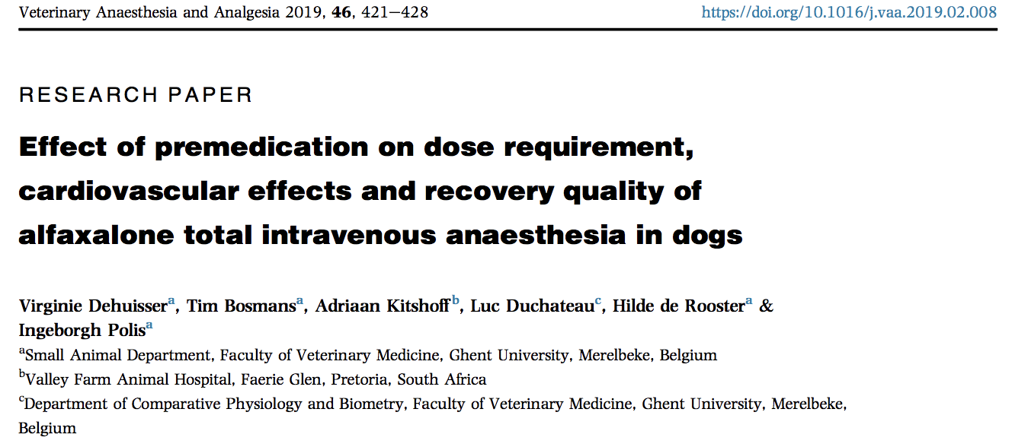

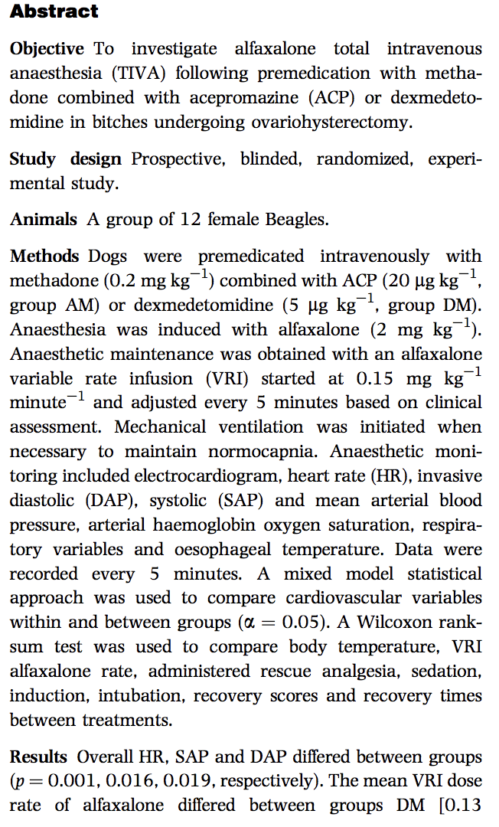

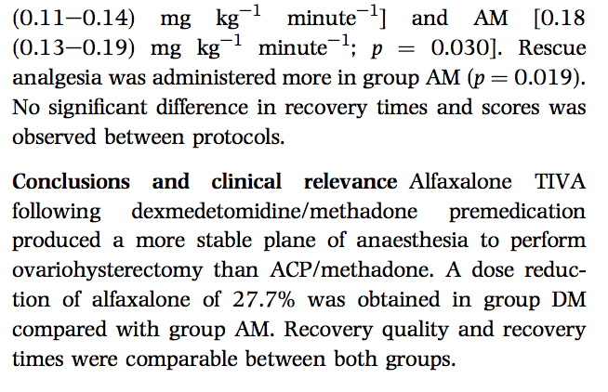
- Total intravenous anesthesia (TIVA) = solely IV induction and maintenance
- Alfaxalone synthetic neurosteroid enhancing inhibitory effect of GABA on GABA-A receptor. Rapid onset, short duration, wide safety margin, rapid plasma clearance, and little accumulation in tissue
- Hypothesized that dexmedetomidine would result in a more stable plane of anesthesia and a significant dose reduction of alfaxalone compared with ACP premedication. Recovery characteristics were hypothesized to be better following ACP compared with dexmedetomidine premedication
- NIBP measured 5 min before premed, 15 min after premed. Once anesthetized, BP measured by direct arterial BP and recorded every 5 min

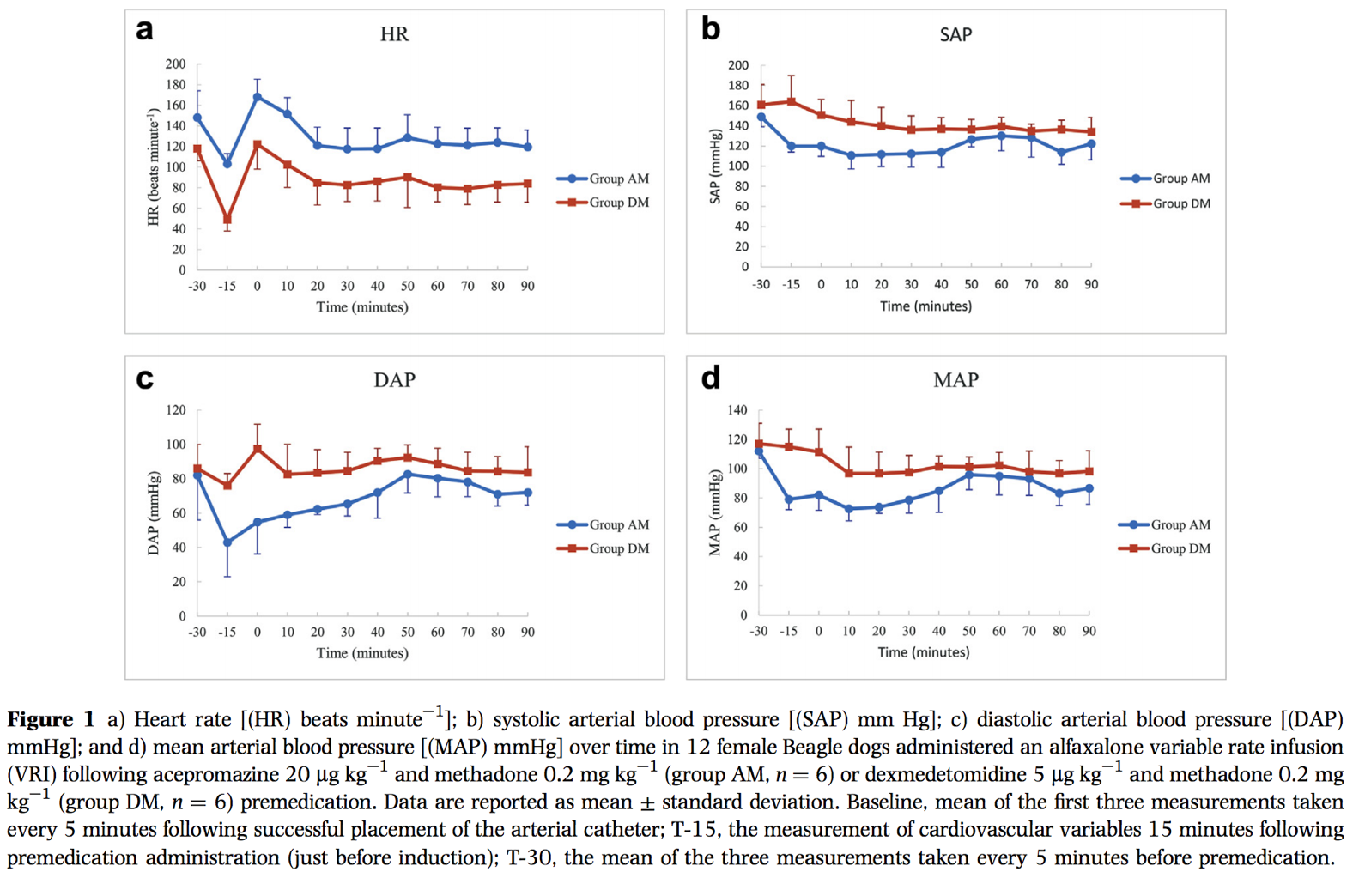
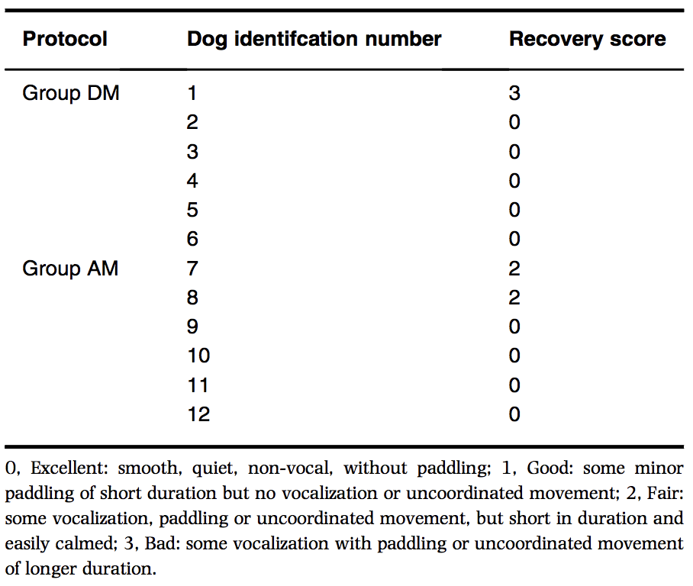

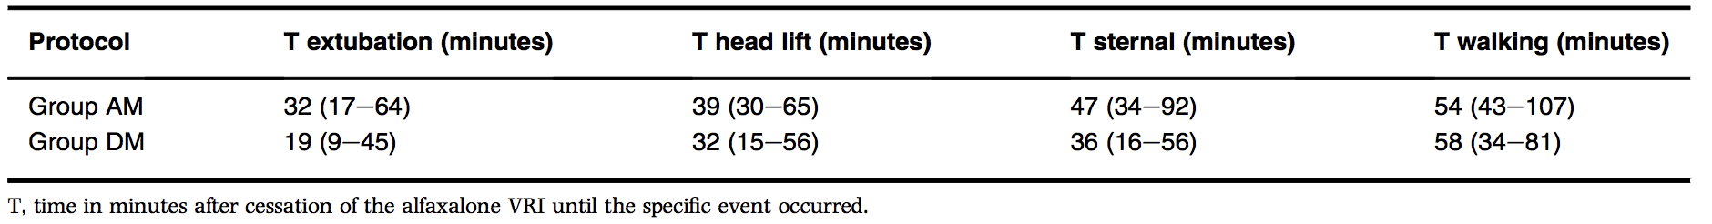

Discussion:
- Induction and intubation between groups were both excellent, rescue analgesia needed intraop with ACP/methadone group (additional methadone 0.1mg/kg IV)
- Dex med group had higher sedation pre-med score
- All dogs required ventilatory support at some point due to hypoventilation during anesthesia
- DM group lower alfaxalone maintenance dose (0.13mg/kg/min) compared to AM group at 0.18mg/kg/min. 27.7% reduced dose
- Post induction tachycardia seen in AM group but not in DM group
- Both had overall lower HR compared to baseline HR, with DM lower than AM.
- SAP/DAP lower in AM group. Vasodilation due to ace vs vasoconstriction with dexmed
- Comparable recovery times and smooth recoveries.

