ANAPHYLAXIS (Greek – against protection)
- Definition:
  - Severe, life-threatening, systemic allergic reaction that occurs suddenly after contact with an allergy causing substance
- Spectrum of labeling – severe allergic reaction/hypersensitivity to anaphylaxis
  - Many cases may be missed
Hypersensitivity reactions (4 types) “objectively reproducible symptoms or signs initiated by exposure to a defined stimulus at a dose tolerated by normal persons”:
- Type I – immediate / allergic reactions; IgE dependent
- Type II – cytotoxic; IgG, IgM dependent – antigen is associated with patient cells (IMHA, ITP, etc)
- Type III – complex mediated; IgG, IgM - Ag complex dependent
- Type IV – delayed; T lymphocyte dependent
Pathophysiology
- 2 distinct immunologic pathways
  - Classic pathway = IgE mediated
  - Alternative pathway= IgG + antigen mediated (no IgE)
- Non-immunologic pathway
  - Physical factors (opioids, cold, heat, exercise)
- Key mediators
  - Early (granules): histamine, tryptase, heparin, chymase, proteoglycans
  - Mid (membrane): arachidonic acid, PAF
  - Late (nucleus): cytokines/chemokines (IL3-6, 8, 10, 13; TNFa)
1. Classic – IgE Pathway
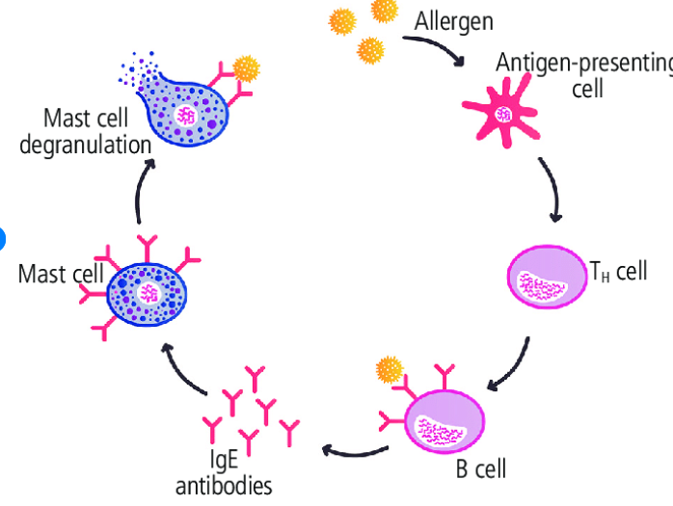
- Initial exposure: IgE antibodies produced in response to initial antigen (“allergen”) IgE Ab’s bind with high affinity to IgE receptor (FceRI) located on plasma membrane of mast cells and basophils initial hypersensitivity reaction is silent

- Re-exposure: allergen forms bridge across 2 cell bound IgE Ab molecules and cross links them cell membrane change ensues and activates cells tyrosine kinase phosphorylates tyrosine residues phospholipase C activates IP3 increase in intracellular Ca from SER protein kinase phosphorylates myosin on secretory granules granule exocytosis = release of preformed mediators
- PLC also activates PLA2 leading to cleavage of AA from membrane production of mid phase mediators (leukotrienes, prostaglandins) and also precursors to PAF
- PLC also ultimately leads to upregulation / nuclear production of cytokines and chemokines in the late phase

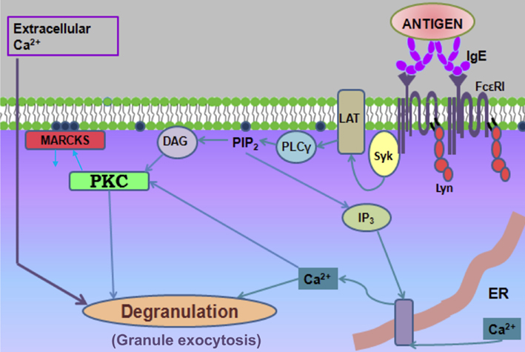

- Cells recruited release more mediators and stimulate increased production of lipid derived mediators such as prostaglandins and leukotrienes leading to amplification of the allergic reaction
- IgE
  - Low concentration in serum due to short half life (~2 days), binding to/sequestration on mast cells, low production
  - Can recognize various epitopes of allergen
  - Allergen is between 10-40kDa
  - Individuals prone to allergies produce more CD4+ Th2 cells increased production of IL13 and IL4 directs differentiation into B cell IgE secreting plasma cells
2.Alternative pathway (non IgE)
- Mediated by IgG or complement
- Antigen-IgG complexes presumably form in blood and lymph before binding to FcγRIII on macrophage, neutrophils, basophils
- IgG mediated pathway requires more Ab than Ag
  - High IgG and low allergen – can block IgE mediated reaction without inducing anaphylaxis via the alternative pathway
- No histamine released, but PAF is
- Complement activation can be induced by the presence of IgG immune complexes leads to release of C3a, C5a and C5b-9 which triggers activation of mast cells, basophils through binding of their specific receptors
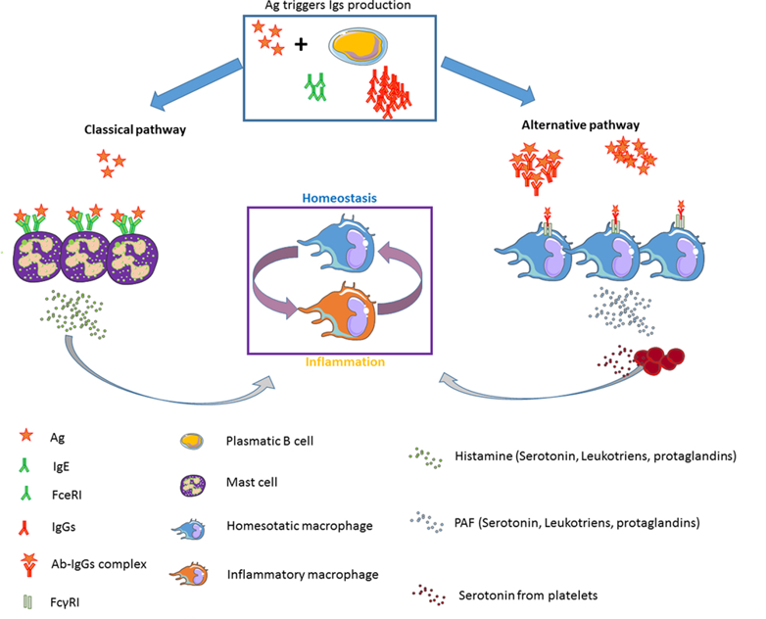

Non immunologic anaphylaxis
- Agents cause release of mast cell and basophil contents without help from immunoglobulins
  - Cold, heat, exercise, NSAIDs, opioids, ethanol, radiocontrast agents
  - Certain drugs (opioids, vancomycin, dextrans, neuromuscular blocking agents, quinolones) can directly stimulate mast cells (humans)
- This mechanism does not require sensitization, so hypersensitivity or anaphylaxis can occur upon the first exposure to an antigen
Chemical Mediators
- Severity and fatality of reaction due to amount and rapidity of mediators released
- A lot of redundancy in system
Preformed / early mediators – released within seconds of mast cell activation
- Histamine
  - Synthesized by mast cells, basophils, platelets, histaminergic neurons, enterochromaffin cells stored in vesicles and released upon stimulation
  - Acts through H1, H2, H3 receptors circulatory shock in anaphylaxis
    - H1R – vasodilation (NO), increased permeability, decreases inotropy and chronotropy, cutaneous and respiratory signs
      - Rhinitis, pruritus, bronchoconstriction, coronary vasoconstriction, cardiac depression
      - Vasodilation decreased venous return, cardiac collapse
    - H2R – increases gastric acid secretion, coronary and systemic vasodilation, increases HR and contractility
    - H3R – stimulation of receptor inhibits NE release from presynaptic terminals of sympathetic effector nerves in heart and vasculature accentuating shock and preventing neural adrenergic stimulation and compensatory response
    - H4R – may be involved with chemotaxis and mast cell release, may mediate pruritus
  - Limited use as serum biomarker due to very short half life
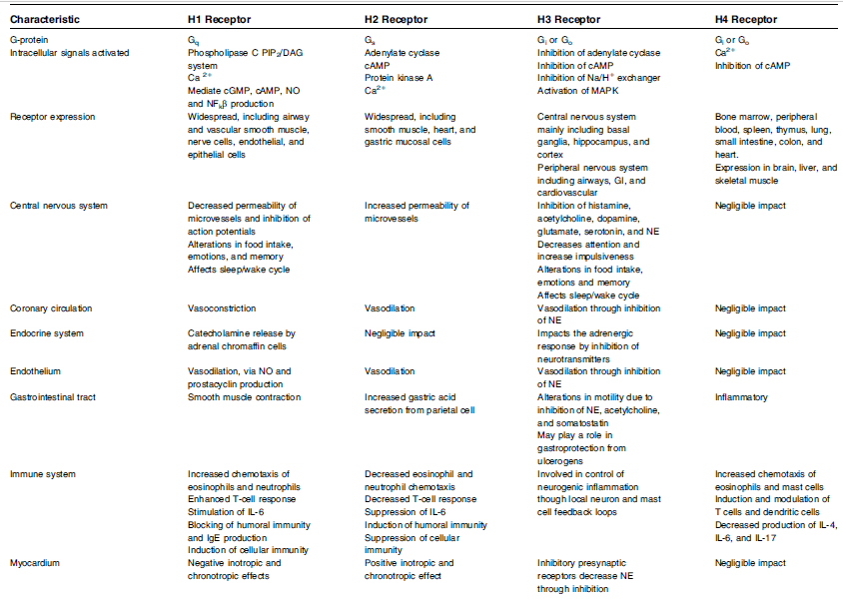
  - Urine histamine or metabolite N-methylhistamine can be collected over 24 hours; not helpful in emergency setting

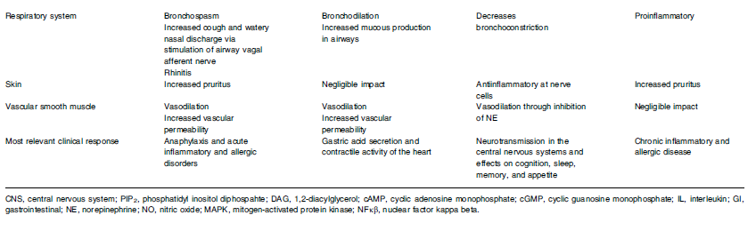
- Tryptase
  - Serine protease; used as biomarker (humans)
    - Concentration assocated with severity of signs
    - Not sensitive biomarker for food induced anaphylaxis
  - Activates complement, coagulation, kallikrein
  - Causes hypotension, angioedema, thrombosis, DIC
- Heparin
  - Modulates tryptase activity
  - Opposes complement, prevents clot formation and plasmin activation
- Chymase
  - Converts angiotensin I to angiotensin II independent of ACE
  - Decreases severity of hypotension

Newly synthesized mediators - released within minutes

- Prostaglandin (PGD2) and leukotrienes
  - Eicosanoids produced by release of arachidonic acid from phospholipid membranes by phospholipase A2 AA metabolized by lipoxygenase to produce leukotrienes and cyclooxygenase to produce prostaglandin PGH2
  - Prostaglandin PGH2 further metabolized to thromboxane, prostaglandins, prostacyclin prostaglandin PGD2
    - PGD2 = potent bronchoconstrictor, pulmonary and coronary vasoconstrictor, peripheral vasodilator
  - Lipoxygenase pathway yields slow reacting substances of anaphylaxis (SRS-A) slower onset of action, 1000x more potent than histamine, longer duration of action
    - Leukotrienes LTC4, LTD4, LTE4 increase bronchoconstriction, vascular permeability, airway remodeling
    - LTB4 – chemotactic agent, contributed toward late phase and protracted reactions

- PAF
  - Targets heart, pulmonary vessels, microcirculation – key mediator in hypotension
  - Binds PAF receptor incites secondary messenger system to increase intracellular calcium vasodilation
  - Also activates PLA2 increase in prostaglandins and leukotrienes
  - Also activates PI3 kinase -> inducing increased eNOS increase NO vasodilation via increasing guanylyl cyclase and cGMP
    - Uncontrolled eNOS can lead to refractory hypotension
  - PAF/PI3/NOS pathway also results in myocardial depression
  - Activates platelets
  - PAF-acetyl hydrolase (PAF-AH) is the key enzyme for deactivating PAF
    - Patients who are low in PAF-AH are more likely to have anaphylaxis (increased PAF = more severe reaction)
  - Dysregulation of PAF cascade is a large part of the mechanism for anaphylaxis in humans
  - Attempting to use PAF/PAF-AH as biomarker – not available in vet med
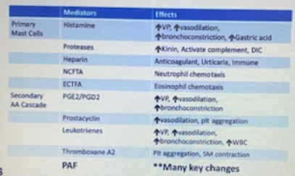

Cytokines/chemokines – released within hours
- IL4, IL5, IL6, IL8, IL9, IL13, IL33, TNFa
  - Leading to shock, vasodilation, permeability, hypovolemia, impaired cardiac function occur; cardiovascular collapse, respiratory compromise, circulatory shock
  - TNFa recruits effector cells and activates neutrophils, increases cytokine synthesis
  - IL4, IL13 very important
    - IL4 3-6x increase in cellular responsiveness to inflammatory and vasoactive mediators (esp histamine, leukotriene, PAF)
Concurrent pathways activated
- Complement and kallikrein-kinin systems = coagulation and fibrinolytic systems
  - Complement activated by generation of C3a (anaphylatoxin) leads to mast and basophil degranulation, increased vascular permeability, smooth muscle contraction
  - Kallikrein production of bradykinin vasodilator; also activates FXII intrinsic coagulation pathway clot formation and clot lysis through plasmin formation
- Plasmin can also activate complement
- Decreases in FV, FVIIII, fibrinogen, DIC = coagulation cascade activation

Clinical Manifestations
- The more rapidly the symptoms manifest, the more severe a reaction will be and the more likely it is to progress to being life threatening
- 4 categories:
  - Cutaneous – precursor to more severe reaction; erythema, urticaria, pruritus, facial angioedema, rhinorrhea
    - May not be seen in patients with anaphylaxis
  - Respiratory – bronchospasm, stridor, tachypnea, cough; laryngeal and pharyngeal edema, bronchoconstriction, increased mucus production
  - Cardiovascular – hypotension, vasodilation = erythema of skin, pale MM, prolonged CRT, depressed mentation; rapid CV collapse
    - Vasodilation + increased permeability = mixed distributive-hypovolemic shock pattern
    - Increased permeability up to 35% of intravascular volume shifts into extravascular space
    - Tachycardia most likely though bradycardia from increased vagal stimulation can also occur
  - GI – nausea, v/d
    - Direct effect of inflammation, secondary to portal hypertension
  - Other – weakness, syncope, seizures, conjunctival injection, lacrimation

- Organ systems affected directly relate to the distribution of the largest mast cell population
  - Specie differences due to variations in immune response, location and distribution of smooth muscle, rate of Ag degradation, responsiveness to inflammatory mediators
    - Dog – GIT, liver; cutaneous
    - Cats – respiratory
    - Humans – lungs, heart
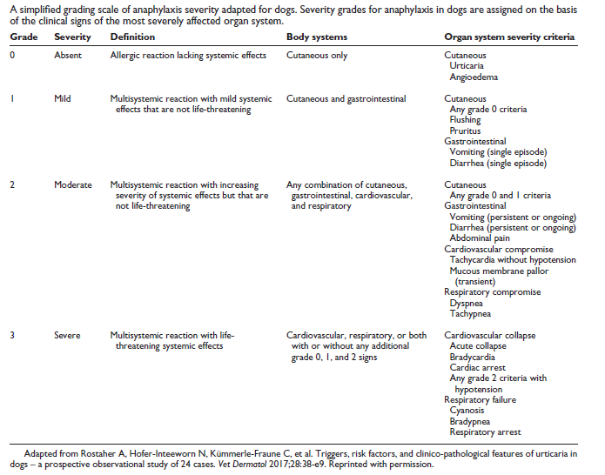

- Dogs:
  - Degree of severity of shock directly proportional to the degree of congestion of the liver and gallbladder
  - Histamine released from mast cells in GIT circulates to portal vein causes hepatic arterial vasodilation leading to increase in hepatic blood flow within seconds ALSO constriction of hepatic venous sphincter at junction of CdVC and hepatic veins ↑↑↑ vascular resistance (220% within 12 sec) blood supply out of liver compromised ↓ CO (decreased preload)
    - Increased ALT, gallbladder edema (halo, striations)
    - Hepatocellular congestion and necrosis
    - Hemoabdomen (ooze through liver capsule)
    - Portal hypertension v/d, hemorrhagic enteritis
- Cats:
  - Severe respiratory distress (open mouth breathing), ptyalism, facial swelling, pruritus, v/d, shock
  - Case report on BNP ophthalmic ointment

- Biphasic reactions – 1-72 hours later (most 8-10 hours)
  - Late phase reactions, thought to increase risk of fatal reactions
  - Results from the release of inflammatory mediators by T-cells, endothelial cells, neutrophils, and macrophage attracted by mast cell chemotactic factors
- Protracted reactions also possible

- Serum sickness / Type III hypersensitivity
  - Days to weeks later
  - IgG binds to Ag soluble Ag-Ab complexes in the presence of Ag excess binds complement C3a produced mast cell degranulation
  - Complexes lodge in glomerulus, endothelium, synovium leads to vasculitis, IMPA, proteinuria, myocardial lesions
Diagnosis
- Clinical dx based largely on history and clinical findings; pattern recognition and probability
  - Hx: new foods, medications, vaccines, insect bites
- Ddx: severe asthma, pheochromocytoma, systemic mastocytosis, vasovagal event

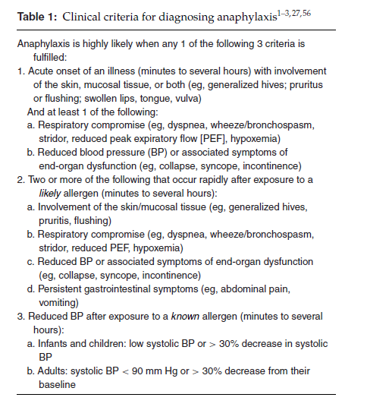
- 2005 NIH and FAAN delineated clinical characteristics that would diagnose anaphylaxis
  - Help identify anaphylaxis in 95% of cases

- Biomarkers:
  - Humans: tryptase and histamine concentrations – however not sensitive or specific, assays not universally available, not able to be performed on an emergency basis
    - Not available in vet med
  - PAF / PAF – AH
    - Decrease in PAF-AH = more severe anaphylaxis

- ALT: increases in <12 hours, peaks at 24-48hr, returns to normal over 2-3 weeks (Se 85%, Sp 98%)
- Gallbladder halo / striations (wall >3mm thick and striations) almost immediate after onset of signs (Se 94%, Sp 98%); indicative of GB inflammation independent of GB disease and is associated with impaired venous drainage
  - ATL increase + GB striations correlate significantly with anaphylaxis

- Skin allergy testing – does not predict anaphylaxis

Treatment
- Epinephrine - #1 treatment for anaphylaxis with shock / CV compromise
  - Stimulates beta and alpha adrenergic receptors (a1 = vasoconstriction – increase vasc resistance / BP, coronary artery perfusion, reduce airway mucosal edema; b1 = positive inotrope, chronotrope; b2 = bronchodilation, suppresses release of mast cell mediators by binding beta receptors on mast cells, relieves urticaria)
  - Phosphorylates and inactivates PAR receptors
  - Studies have shown no beneficial effect when given as a bolus during maximal hypotension; need CRI
  - Administration:
    - Bolus 0.01mg/kg (1:1000 – 1mg/mL solution) IM – max 0.3mg in dogs <40kg, 0.5mg > 40kg q5-15min PRN
    - If shocked then CRI 0.05mcg/kg/min and titrate up
    - EpiPen 0.15mg, 0.3kg IM – difficult to dose in patients <15kg; short needle – difficult to get through coat or if high BMI through SQ to muscle; short half life (12-18mo)
      - Alternative – prefilled syringes from DVM – but short half life (3-4mo)
- Antihistamines
  - Used to downregulate allergic response, minimize histamine release
  - H1 antihistamines (diphenhydramine, cyproheptadine, hydroxyzine) – inverse agonist with high affinity for inactive state of H1R, non competitive antagonist – stabilize receptors in this conformation and shift equilibrium to inactive state
    - First generation cross BBB and cause drowsiness, GI signs
    - Second generation safer but not available injectable (cetirizine, loratadine)
    - Good in localized reactions and less severe systemic reactions
    - Relieves cutaneous and nasal symptoms, but do not prevent or relieve more serious signs
    - No high-quality evidence for or against use in anaphylaxis shock
  - H2 antihistamines (famotidine, randitine, cimetidine)
    - Inverse agonist
    - May help with cutaneous signs when used with H1
  - Considered ancillary treatment and should not be used in place of epi
  - 1-4mg/kg PO or IM dogs; 0.5-2mg/kg PO or IM cats
  - Slowly IV 0.5-1mg/kg in dogs (max 50mg)
- Glucocorticoids
  - Does not relieve initial symptoms and should not be first line
    - Onset of action takes 4-6 hours
    - Down regulates late phase Eo response
    - Switches off transcription of pro-inflammatory cytokines and blocks AA cascade and may prevent biphasic reaction
    - Pretreatment with antihistamines and GC will not prevent anaphylaxis from happening but may blunt physiologic response
- Bronchodilators
  - Albuterol to relieve bronchospasm and respiratory signs
  - Aminophylline - PDEi increasing cAMP and release of endogenous epi, inhibits release of histamine and SRS-A; relaxes bronchial smooth muscle and pulmonary vasculature
- Fluids
  - Aggressive resuscitation – extravasation of blood volume and vasodilation = decrease in effective circulating volume (distributive and hypovolemic shock)
- Oxygen
- Vasopressors (refractory anaphylaxis)
  - Dopamine, NE, vasopressin to overcome vasodilation if epi and fluids are not enough to maintain SBP
  - New methylene blue
- New methylene blue
  - Histamine induces eNOS increased NO production
  - NO causes vasodilation indirectly by increasing the activation of guanylyl cyclase GC increases the concentration of smooth muscle cGMP cGMP causes relaxation of vascular smooth muscle
  - NMB inhibits guanylyl cyclase increasing vascular resistance, counteracting NO pathway
  - Human literature – consider in anaphylaxis with vasopressor refractory hypotension
  - Side effects to consider: hemolysis, MetHb, interference with pulseOx
- Glucagon
  - Ionotropic and chronotropic effects independent of catecholamine, bypasses beta receptors – useful in patients on beta blockers and in an anaphylactic crisis
  - Inhibits production of iNOS and thereby NO
- Anticholinergics
  - Sometimes needed for patients on beta blockers for persistent bradycardia
- Humans: Ab for IgE to help prevent IgE binding to FceRI on mast cell
- PAF antagonists – currently being researched in humans

- Anaphylaxis can also resolve spontaneously within minutes to hours if there is sufficient endogenous production of compensatory mediators, such as epinephrine, angiotensin II, and endothelin
Monitoring
- Ideally, closely monitored for 3 days for biphasic reaction

Prognosis
- Individualized based on severity and progression of reaction
- Recent retrospective (JAVMA 2020) showed 14.9% non-survival for dogs with severe anaphylaxis (multi-systemic reaction with life threatening effects – cardiovascular, respiratory)
- Factors associated with non-survival included:
  - Hypothermia – body temperature was significantly lower in patients that died
    - Histamine implicated owing to heat loss directly due to peripheral vasodilation and indirectly to negative effects on CO, shock
    - Histamine has central effects in hypothalamus causing hypothermia
  - Hyperphosphatemia – 40% of patients that died had values > 12.0 mmol/L.
    - Release from hepatocytes due to necrosis and impaired hepatic uptake and utilization of phosphates
    - Potentially from rhabdomyolysis resulting in release of cellular phosphates
  - Elevated PT; PT/aPTT > 50% of reference range
    - Possibly due to DIC or activation of the intrinsic coagulation system via complement (C3a, C5a), bradykinin, FVIII, and FXII
  - Hypoglycemia (<80mg/dL) and dextrose administration and hypoglycemia within 6 hours, especially if refractory hypoglycemia
    - Possible sequela of increased cellular utilization or a decrease in hepatic production or mobilization of glucose
    - Possibly as the result of sepsis induced by bacterial translocation brought on by compromised gastrointestinal mucosal defenses (portal hypertension, shock gut)
  - Gallbladder wall edema was evident in 84.5% of patients in this study that had AUS
  - Peritoneal effusion was noted in 65.5% of the patients that had AUS most were characterized as hemorrhagic effusions, the others were considered protein-rich transudates with a hemorrhagic component (PCV > 2%)

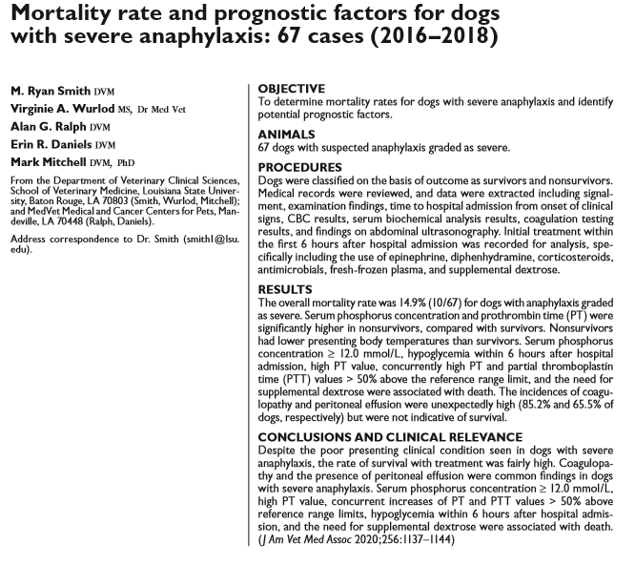
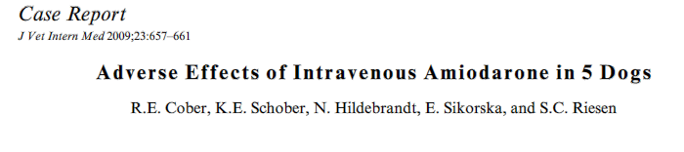
- Related to polysorbate 80 solvent in the old formulation

