Meeting LibGuide Accessibility Goals
Reviewing Guides
- Unpublish or delete all guides that are not currently in use.
This will reduce the number of guides that need to be reviewed and modified.
- Color contrast: Use one of the color analyzer tools to determine whether you have sufficient contrast between text and background. (See below)
- Think about navigational clues: Change any navigational clues that point to something by color or by directional terms like “above,” or “on the right”.
- Headings: All caps, bold text, italicized text, or colored texts to indicate a “heading” are not accessible. Use a heading tag. Note: Since Springshare uses Heading 1 and Heading 2 for the title and box names, use Heading 3, then Heading 4 to denote subheadings within a guide. Headings must be hierarchical. You can use CSS to adjust the size. (see below)
- Links:
a. Link names should be descriptive.
Accessible: Go to the Best Practices guide for more information.
Not accessible: Click here for more information.
b. Links should open in the same window. This is currently the default setting. If an exception needs to be made, there should be something to indicate that the link will open in a new window.
- Images: Any image meant to convey information should have that information included in the Alt Text field in the Add Image function. Note: If the image is purely decorative, or if information is already clearly communicated in the text, you can leave the ALT tag empty. A screenreader will just jump over it.
- Lists in Rich Text: Use bulleted lists or numbered lists.
- Tables: Avoid using tables for layout.
Creating Guides
- Create lists of resources using the LibGuide features for adding links, databases or books.
- Add a new box.
- At the bottom of the box, open Add/ Reorder to add a link.

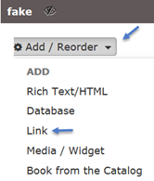

- Use the Rich Text Editor only when you need to add a chunk of text or an image. Using the Rich Text editor to create lists of resources can lead to accessibility issues.

- Create headings using heading tags. These are available in a drop-down menu from the text editor. You can use css to adjust the size of the H3 tag. See below.

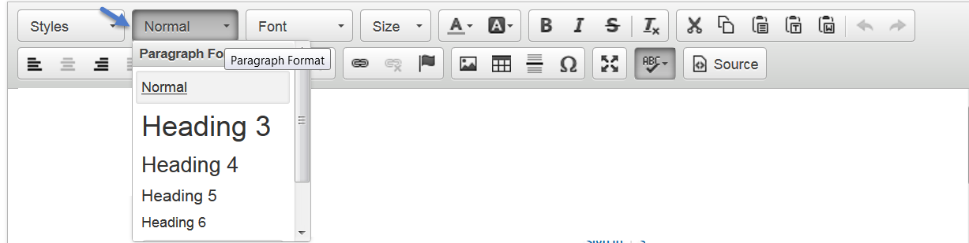

- If you are adding an image to convey information visually, add Alternative Text for the image.

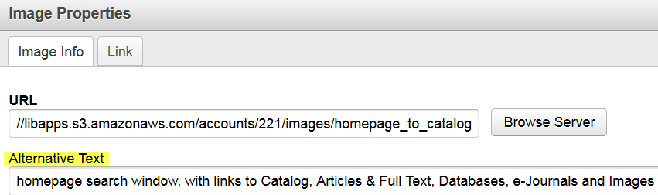

- If you are creating a list (list of contents, list of steps) in the rich text editor, use bullets or numbers.

VI. Use a Color Analyzer to check for sufficient contrast between text and background.
For Chrome: Color Contrast Analyzer (Chrome Web Store)
For Firefox: https://webaim.org/resources/contrastchecker/
- Use CSS if you need to change the default style properties.

Caution! A missing angle bracket, curly bracket, colon, or a typo can break your guide. Springshare won’t bring it back to life. If you’re not familiar with CSS, ask us. We’re happy to help.

Sample CSS:
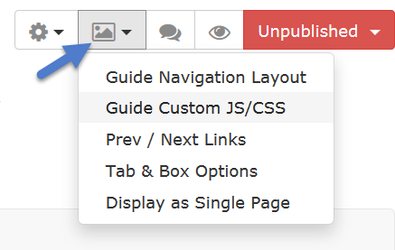 | <style>  a:link {font-weight:bold;}  body, body.s-lg-guide-body { font-family: Verdana, Arial, Helvetica, sans-serif; font-size:12px;}  h3 {  font-size: 13px; font-weight:bold; }  </style>

Note: The Heading 3 will still look huge in edit mode, but the CSS will make it look fine in view mode.

Best Practices for Building Guides & Accessibility Tips, including a one-hour training video: http://tinyurl.com/y4c6h9gh

