Journey Mapping - Hasbrouk

Why a particular location:
dual monitors, focused on where labs/office are, convenient from office/lab, proximity to food/drink, parking was easy, access to computers and software, solo vs. group and type of work done in different spots

What works:
Themes: ownership of space, convenience/proximity (parking), wanting to get away from people in program, want to be near people in program, access to food, tech (computers, software, printing, LCDs), collection for discipline

What doesn’t (Mann specific)
Individual rooms are tough to get, too many undergrads in grad area, limited food options on the weekend, study rooms aren’t comfy and too much trouble to get a key, more phone charging stations, height adjustable chairs, hvac too loud

Ideal Space needs:
food and drink, privacy, ownership of space to secure stuff but not personalize, most people said quiet, variety of furniture, technology

Daily items needed:
laptops, food, split on textbooks - heaviness/necessity vs convenience, chargers, misc. course materials

Group Work:
convenience - a space that everyone can find, reserving important but less so, not much group work once your classes are done and you’re working on dissertation/research.

BRB TGIF

Most don’t know that Mann has a grad study area, those that visit said it looks mundane - nothing that would draw them to that space

Where do you go to do your work and why?
Convenience, personalization of space, powerful computers, collaborative space, lockable storage, comfortable chairs, natural light, somewhere that isn’t home (too distracting, too lonely), good food and coffee, quiet, interaction with classmates,

What works or doesn’t work for you about these spaces?
Not enough room, Classes not close to office, personal belonging security, no hard metal chairs, need for separated casual and social spaces, fluorescent lighting

Do you have office hours or collaborate with others often? If yes, where do you do this and why?
Bissett - likes booths and that can plug into large LCD, Research group work room - powerful computers w/monitor space; collaborative space; large table; everyone’s there on that floor and easy to find,

What would your perfect workspace look like/have?
Dual monitors - large screen would do in a pinch, privacy, natural light, outlets, comfy chairs, good food, lots of open space/not cluttered, able to play music, nice architecture, reservable spaces with an easy way to see the reservation, bulletin board with troubleshooting help resources

What do you need to do your work that you can’t find on campus?
Healthy variety of late night food, Nothing except window in his office, A way to study distraction free (stop social media) , Outlets, large tables for drawing, nap room, desk space

Other comments/observations:
Does not like modern sterile industrial architecture, it looks bad and is not welcoming or relaxing. Likes A.D. White Library. CISER Maintenance is frustrating, hard to connect with disciplines outside your own, no grad orientation, don’t use 3rd floor because no food is allowed, don’t know much about the library

Grad Locker Survey

Why location:
Close to window, need for privacy

Likes of desk:
Area is quiet, large enough, natural light

Dislikes of desk:
Next to other shared desks, uncomfortable chair, can’t use locker

Likes of grad area:
Quiet (everyone mentioned this), one said convenient

Dislikes of grad area:
Small area per person, open to anyone, sometimes noisy, don’t like asking people to move

Other comments:
Non-wooden chair, privacy screens, key should be for the locker at the desk

CUL Grad Survey Themes

Why they chose Mann Library:
- Convenience
- Resources of interest
- Food and coffee
- Windows
- Computer software – STATA, Adobe Creative Suite
- Grad study rooms – privacy
- Good working tables
- Good place to meet with others – conversation or project work, collaboration space; space like 282

What they’d like more of:
- Standing stations
- napping furniture
- adjustable height chairs
- docking stations

Items called out specifically by multiple people:
- Green shelter chairs - they really like the privacy that these chairs afford
- Poster printing - this is a huge service for them and very convenient
- Phone charging in furniture - they like the furniture that we have that has usb outlets and they want more
- Finding books – both in the stacks and in our catalog was a problem for a lot of grad students. This doesn’t really fit with an area redesign but it is worth noting that this is a problem that we might be able to solve.

DEA 6500 - Mezzanine
Pros:
- Natural Light
- Well Ventilated
- Segregated Space
- Space feels large and open

Cons:
- Lack of identity
- Too noisy
- Lack of defined function
- Hard to find/Students don’t know the space exists
- Unused furniture
- Frustration working together on group project - Lack of reservable space for group work and tech for such work (whiteboards, projectors, LCDs, public computers)
- Lack of Privacy
- No space for different levels of interaction/attention and noise

Suggestions:
- Space
  - Doors with keypad entrance/Sign on the door denoting only for graduate students
  - Make the space ADA compliant
  - Better signage
  - Furniture with sound absorption
- Desks
  - Desk lamps
  - Variety of comfortable chairs, tables and study spaces
  - More outlets
  - Dual Screens
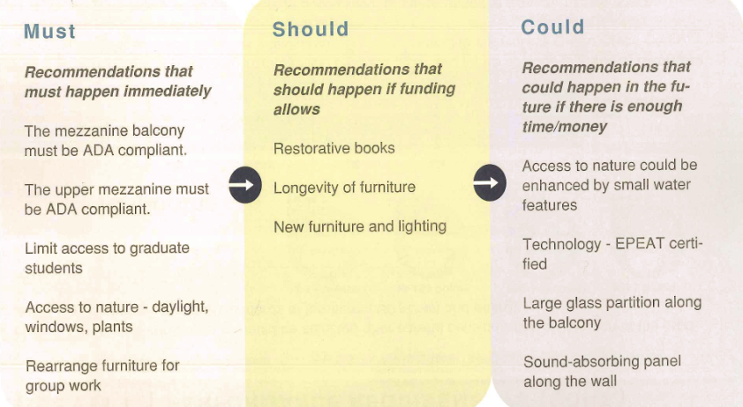
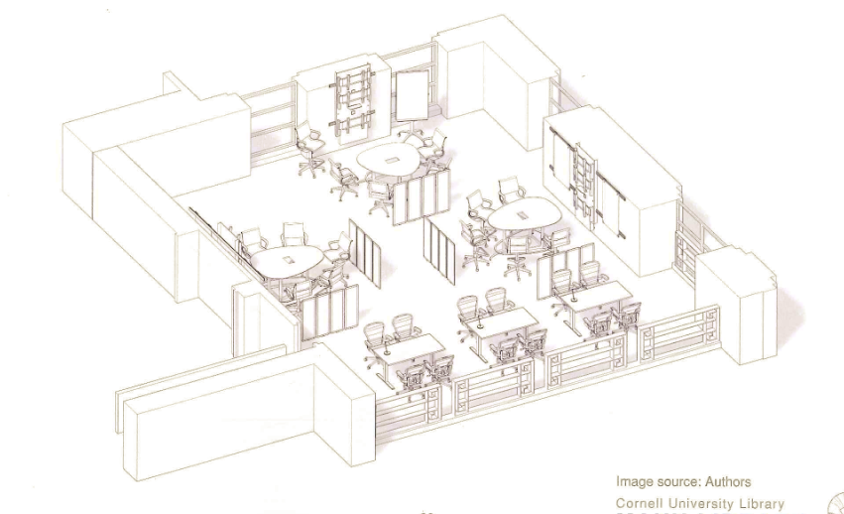

DEA 3590 - Grad Study Space

Pros:
Natural light

Cons:
- Lack of visual and auditory privacy
- Not enough technology for individual study
- No sense of ownership of space and desk
- User discomfort due to furniture, lighting and temperature
- Not quiet enough
- Undergraduates use the space
- Needs more privacy
- Furniture uncomfortable
- Gets very bright in the afternoon, creates glare - need window blinds
- Too crowded and easy to get distracted
- Desktop computers and printer
- Desks too close together
- Chairs are uncomfortable
- No library signage denotes that there is a graduate study space

Suggestions:
- White boards and monitors in collaborative areas
- Add privacy - use partitions
- Differentiate the graduate student area more
- Create personal territories to help concentration
- Create ownership
- Support independent research
- Enhance comfort
- Move collaborative work study area away from personal study areas
- Better furniture - ergonomic
- Create lockable door for grad study area
- Larger, more, and better signage that it is a graduate study area
- Provide dual monitors
- Offer computers with software to aid in research (minimum of 3)
- More personal study space, fewer group workstations
- Separate circulation to the mezzanine from the graduate research area
- Add printing station
- Increase outlets
- Desks should be able to be personalized
- More lockers
- Desk lights
- Unused space - soft seating options aren’t used as much
- Task lights needed
- Better lighting
- Adjustable seating
- ADA complaint and some seats for wheelchair users, means seating should be easily movable.
- Be able to personalize space since it is reservable. Leaving things at desk
- Incorporation of a computer lab…. Access to general software, computers , printer,
- Collaborative space
- Provide dual monitors
- Offer computers with software to aid in research (minimum of 3)
- More personal study space, fewer group workstations
- Separate circulation to the mezzanine from the graduate research area
- More task lighting
- Better signs to denote personal/reserved desks
- More comfortable chairs

Survey results :

- Students stay mostly 2 -3 hours in the afternoon
- Not private enough
- Desk space is not adequate
- Seats are not comfortable
- Users use the wall lockers or no lockers
- Too cold
- People are generally slightly more satisfied with the variety and comfort of furniture
- Fair amount of satisfaction with light and temperature
- Users use the wall lockers or no lockers
- Most users do not use the lockers at all
- Most users do not use the mezzanine
- Most users said it can be too loud

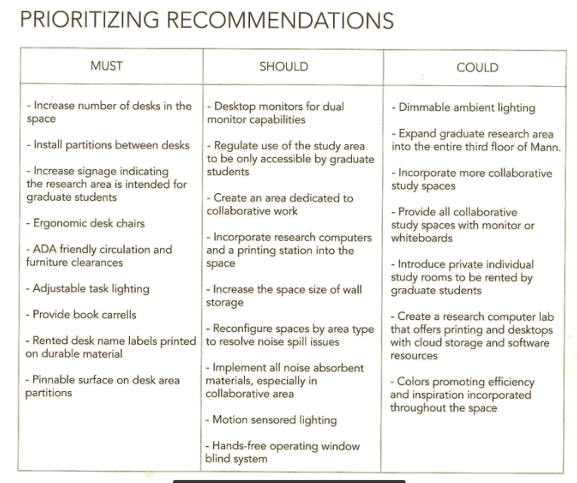
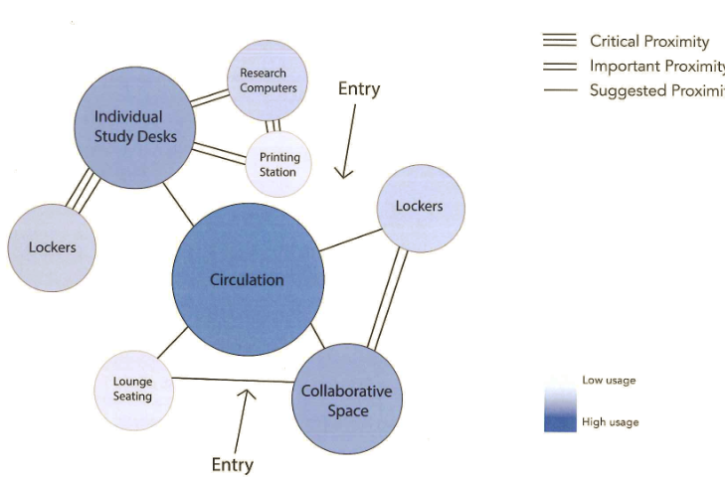

https://www.hermanmiller.com/products/workspaces/collaborative-furniture/prospect-creative-space/product-images/

