Antiplatelet Drugs
- Primary indication for antiplatelet drug therapy is to inhibit platelet function in states of hypercoagulability or state of increased platelet reactivity

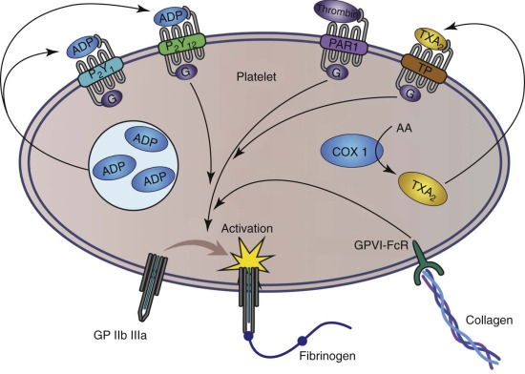
FIGURE 167-1. Schematic of pathways for platelet activation. Many G protein–coupled receptors activate the fibrinogen receptor glycoprotein IIb/IIIa (GPIIb/IIIa) after interaction with specific agonists, including thrombin, adenosine diphosphate (ADP), and thromboxane A₂ (TXA₂). ADP is released from platelet α-granules, and TXA₂ is produced by cyclooxygenase (COX) transformation of membrane-derived arachidonic acid (AA). Collagen also activates the platelet via the GPVI receptor.

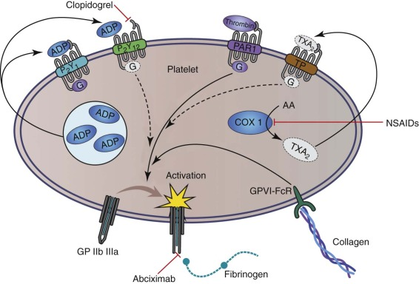
FIGURE 167-2. Same schematic as in Figure 167-1 showing the target receptors of the major antiplatelet medications. Clopidogrel interferes with adenosine diphosphate (ADP) binding at the P2Y₁₂ receptor, whereas nonsteroidal antiinflammatory drugs (NSAIDs) interfere with the production of thromboxane A₂(TXA₂) by platelet cyclooxygenase-1 (COX-1). Abciximab interferes with the binding of fibrinogen to the activated glycoprotein IIb/IIIa (GPIIb/IIIa) receptor.

Adenosine Diphosphate Receptor Antagonists
- Two ADP receptors on platelet
  - P2Y1 receptor: with agonism is associated with PLT shape change and mild, reversible aggregation
  - P2Y12 receptor: with agonism is associated with integrin activation and platelet granule secretion
    - Also plays a role in ADP-induced thromboxane A2 (TXA2) production
- Thienopyridines
  - Irreversible binding to P2Y12 receptor, inhibits primary and secondary PLT aggregation as well as inhibiting ADP-induced conformational change of glycoprotein IIB/IIIa receptor complex
  - Clopidogrel (Plavix), ticlopidine (ticlid, discontinued in US), prasugrel (Effient)
  - Clopidogrel most common thienopyridine used in veterinary medicine
  - Cat dose 18.75mg per cat PO q24 shown to decrease ADP and collagen induced PLT aggregation as well as PLT serotonin release (which is an indicator of dense granule secretion)
  - Dog dose of 1mg/kg PO q24 showed to decreased ADP induced PLT aggregation as soon as 3 hours post, however some studies use loading dose of up to 10mg/kg.
  - Human loading dose 600mg per person followed by maintenance of 75-150mg/day for percutaneous coronary intervention for acute coronary syndrome
  - In humans, suspect polymorphism in hepatic P-450 enzymes and speed of generation of active metabolite causes variation in speed and efficacy of PLT inhibition, which may be seen in dogs and cats as well.
  - After stopping medication, PLT activity normal after 7 days
- Nucleoside analogs
  - Does not require hepatic metabolism, reversible inhibition of P2Y12 receptor
  - Cangrelor IV and Ticagrelor oral used in people
  - After stopping medication, PLT activity normal after 1 hour with cangrelor and 12 hours with ticagrelor

Cyclooxygenase Inhibitors
- In activated PLTs, COX enzyme in the platelet cytosol produce TXA2 from arachidonic acid. TXA2 is vasoconstrictor and PLT agonist leading to recruitment and activation of PLT at site of vascular injury
- Acetylsalicylic acid (ASA, aspirin) causes irreversible blockade of PLT COX-1, which would be permanent blockade for life of platelet (~6-7days).
  - Ultralow-dose protocols with small amount given daily will gradually result in blockade of all PLT COX in the body
  - administered to healthy dogs at dosages of 8-20 mg/kg, but one report indicated that 10 mg/kg did not affect platelet function when measured by PFA-100 PLT function analyzer
  - Another report indicated only 8 of 24 treated dogs receiving 1mg/kg PO q24 for 10 days showed prolonged closure times (PFA-100)
  - Cat studies have not shown consistent evidence that ASA is effective antiplatelet agent.
    - High dose ASA ~15mg/kg PO q48 decreased collagen-induced PLT aggregation but not ADP-induced aggregation
    - Better collateral circulation in cats with experimental ATE was seen with dose 130mg/kg PO 1 hour prior to thrombosis which then showed decreased ADP-induced PLT aggregation
- Other NSAIDS can cause reversible blockade of PLT, but do not result in such profound decreases in PLT activity
  - PLT COX thought to be primarily COX-1, so drugs with high degree of specificity of COX-2 thought to have minimal to no effect on PLT reactivity
  - Dog dose carprofen 4mg/kg PO q24 10 days, but lesser degree in inhibition

FATCAT Study
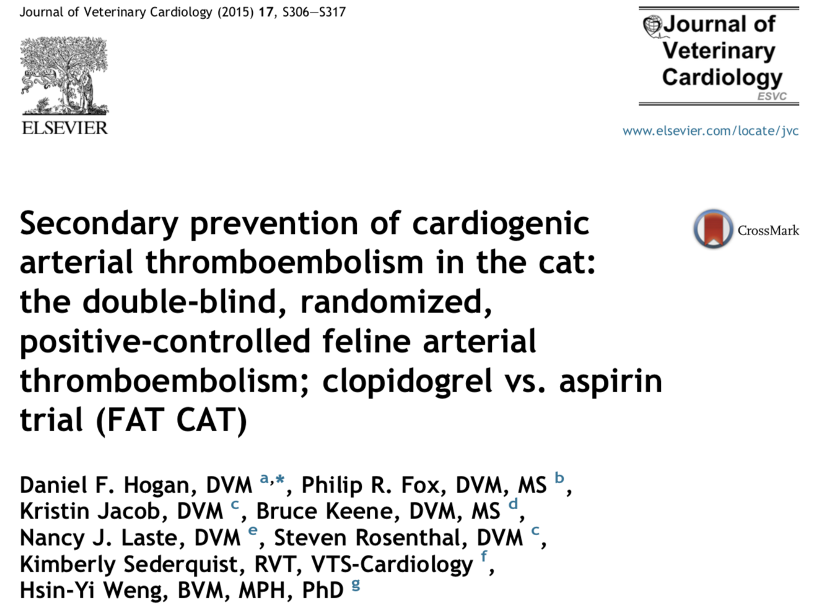
- 75 cats that survived a CATE were randomly assigned to receive either clopidogrel (18.75 mg PO q 24 h) or aspirin (81 mg tablet PO q 72 h)
- Objective: To determine if clopidogrel administration is associated with a reduced likelihood of recurrent cardiogenic arterial thromboembolism (CATE) in cats compared to aspirin administration
- Results: Clopidogrel administration was associated with significantly reduced likelihood of recurrent CATE compared to aspirin (p=0.024) and had a longer median time to recurrence [443 (95% CI 185-990) days vs. 192 (95% CI 62-364) days, respectively]. Clopidogrel was also associated with a significantly reduced likelihood of the composite endpoint of recurrent CATE or cardiac death (p ¼ 0.033) with a longer median time to event [346 (95% CI 146-495) days vs. 128 (95% CI 58-243) days].
- Conclusions: Clopidogrel administration significantly reduces the likelihood of recurrent CATE compared with aspirin in cats; both drugs were well tolerated.

Fibrinogen Receptor Antagonists-αIIbβ3 (GP IIbIIIa)
- Inhibits final common pathway of PLT activation with expression of active GPIIbIIIa fibrinogen receptor
- Abciximab (ReoPro), eptifibatide (integrilin), tirofiban (aggrastat) – all only IV
- Primarily used in humans with percutaneous coronary intervention in treatment of ACS and myocardial infarctions in high-risk patients.
- Combined with other PLT inhibitors and systemic anticoagulants like heparin
- Limited use in vet med at this time
- Abciximab given as 0.25-mg/kg IV bolus followed by a CRI of 0.125 mcg/kg/min
- Integrilin DON’T GIVE IN CATS, fatal cardiotoxicity

Questions:
1) ADP receptor antagonists, like clopidogrel, act on P2Y12 receptor

2) ASA causes irreversible inhibition of COX-1.

Anticoagulants
- Animals predisposed to hypercoagulable state secondary to cardiac, metabolic, infectious, genetic, and inflammatory diseases
  - PTE, portal vein thrombosis, splenic vein thrombosis, vena cava thrombosis, ATE, neoplasia, IMHA, systemic inflammatory states, sepsis, DIC, PLE, PLN, hepatic disease, hyperadrenocorticism, and iatrogenic conditions
  - Cardiac cats, not really in dogs
  - Weak evidence for sepsis, SIRs, DIC
  - Studies in dogs with hyperadrenocorticism weak for showing that they are at risk of thrombosis
- Virchow’s triangle: thrombus formation due to endothelial damage, systemic hypercoagulability, and/or alterations of blood flow (including stasis)
- Arterial clots are generally formed under conditions of high shear and include platelets held together by fibrin strands (also known as white clots).
  - Therapy aimed at decreasing PLT function
- Clots formed within the venous system and under low-shear conditions consist mostly of fibrin and red blood cells (red clots)
- Ultimate goal of anticoagulants is to inhibit fibrin formation, but they do not cause lysis or speed breakdown of existing clots

Vitamin K Antagonists
- Warfarin (coumarin)
  - In people, well absorbed, highly protein bound, long circulating half-life of 37 hours, so good for long term management
  - Little veterinary info on optimal dose of warfarin and specific diseases in which warfarin is indicated
  - Inhibits vitamin K epoxide reductase in liver, so vitamin K cannot be recycled by reducing vitamin K epoxide back to vitamin K
    - Coagulation factors II,VII,IX,X are inactive zymogens produced by liver that must be carboxylated by vitamin K, which converts it to vitamin K epoxide.
    - Since shortest half-life is factor VII (6.2hrs), first clinical sign of warfarin activity is prolonged PT
  - Dog dosing 0.22mg/kg PO q12
    - For ATE, when warfarin dose adjusted to international normalized ratio (INR) 2.0-3.0, improved ambulatory function and effective treatment
  - Cat dosing 0.06-0.09mg/kg PO Q24
    - For ATE, median survival times did not change or was shorter than those given no anticoagulant medications
    - High incidence of adverse bleeding events and fatal hemorrhage
  - Monitoring
    - Frequent PT or INR, initially weekly
      - INR= (PTpatient/PTreference)^ISI
      - ISI is the international sensitivity index which represents relative strength of thromboplastin reagent in comparison to international standard
    - INR has not been validated for veterinary patients

Heparins
- Heparins act through enhancement of the inhibitory activity of antithrombin (AT)
  - AT acts as an anticoagulant by inactivating serine proteases such as factor Xa (FXa), thrombin, and others
  - When AT is bound to heparin, it changes conformation in such a way that it becomes vastly more efficient at inhibiting serine proteases
- Heparins also causes release of tissue factor pathway inhibitor (TFPI) from the endothelial cell surface into the flowing blood
- Under physiological circumstances, the endothelial cells produce heparan-sulfate proteoglycans
  - The HSPGs bind AT, which then is fully capable of inactivating the thrombin that produced in the vicinity
- Thrombin is resistant to AT-heparin when the thrombin is bound to fibrin
  - Once fibrin has formed, it can act as protective reservoir for active thrombin

Unfractionated heparin
- Heterogeneous (in both size and charge) mixture of glycoaminoglycans derived from porcine intestinal mucosa
- Depending on the preparation, the mean molecular weight is around 15,000 Da, with a range of 5000 to as much as 30,000
- Administered SQ or IV, rapid onset of action
- Higher-MW heparin inactivates FIIa and FXa with 1:1 ratio for anti-Xa to anti-IIa activity
- Lower-MW heparin binds FXa and has a 4:1 ratio of anti-Xa to anti-IIa activity
- Once bound to AT, UFH inhibits FIXa,FXa, FXIa, FXIIa, and FIIa (mostly FIIa and FXa)
- Inexpensive but has the highest variability in dose–response relationship due to being highly protein-bound which can also bind to surface of endothelial cells, macrophages, and PLT
  - consequently the greatest potential for over-anticoagulation
  - variation of doses due to acute systemic inflammation and binding to acute-phase proteins
- Dogs with immune-mediated hemolytic anemia may require much higher (and less predictable) doses of UFH to achieve a therapeutic plasma concentration
- Anti-Xa target 0.35-.70
Low-molecular-weight Heparins
- Only contain glycoaminoglycans with average MW near 5000 Da but heterogenous distribuition in this smaller size range.
- LMWHs all enhance AT inhibition of FXa more so than AT inhibition of thrombin, so less major bleeding events
- Not highly protein bound and does not bind readily to endothelial cells so bioavailability more predictable
- Longer elimination half-life of 3-6 hours so dosed q12-24 in people
- Renally excreted, so care must be taken with impaired renal function
- Vet products like dalteparin (fragmin) and enoxaparin (lovenox)
- Cats and dogs q6-8hrs
- AntiXa target: 0.5-1
Adverse events
- Thrombocytopenia, bleeding, osteoporosis
Monitoring
- Evaluate the activated partial thromboplastin time (aPTT) for adequate prolongation
- Tend to use UFH with a target prolongation of 1.5- to 2.0-fold
- Anti-Xa can be measured 4-6 hrs after administration but may not correlate with clinical anticoagulation
Data in Vet med
- The dose–response relationships are likely to be much less predictable in sick animals than they would be in healthy individuals
- In dogs: UFH at 200 U/kg as a single SC injection indicated adequate anticoagulation with a duration of up to 6 hours. When administered as repeated SC injections of 500 U/kg either every 8 hours or every 12 hours
- Repeated SC injections of dalteparin at 150 U/kg every 8 hours indicated adequate heparin levels
- In cats: UFH at 250 U/kg SC every 6 hours produced likely therapeutic anticoagulation in one study. In another study, UFH heparin dosage of 300 U/kg SC every 8 hours seemed adequate
Drug | Species | Dosage | Comments
Unfractionated heparin | Dog | 150-300 U/kg SC q8h  30-50 U/kg/hr IV CRI  500 U/kg SC q8-12h | Adjust to target aPTT or anti-Xa level
Unfractionated heparin | Cat | 50-300 U/kg SC q6-8h  250 U/kg SC q6h | IV loading doses may be given before starting SC therapy
Low-molecular-weight heparin | Dog | Dalteparin 100-175 U/kg SC q12h  Enoxaparin 0.8 mg/kg SC q6h | Optimal dosing interval unknown
Low-molecular-weight heparin | Cat | Dalteparin 100-200 U/kg SC q6-8h  Enoxaparin 0.75-1 mg/kg SC q6-12h | Optimal dosing interval unknown

Questions:
- List 2 anti-thrombotic actions of heparin
  - through enhancement of inhibitory activity of antithrombin (AT)
  - release of tissue factor pathway inhibitor (TFPI) from endothelial cell surface into flowing blood
- With warfarin monitoring, we monitor prolongation of PT or calculate INR
- With heparin monitoring, we target for prolongation of aPTT by a factor of 1.5 to 2 fold
- What are the differences between an arterial thrombi and a venous thrombi?
Arterial: formed in high-shear; platelet rich (white clots)
Venous: formed in low-shear; fibrin-rich (red clots)
Thrombolytic agents
- Used for dissolution of thrombi through breakdown of fibrin (fibrinolysis) by serine protease plasmin
- Endogenous thrombolysis mediated by tissue plasminogen activator (t-PA), synthesized in vascular endothelial cells which facilitate conversion of plasminogen to active plasmin
- Therapeutic thrombolysis is used for conditions including venous thrombosis, pulmonary embolism, systemic arterial occlusive disease, ischemic stroke, and acute myocardial infarction

(a) First generation: includes streptokinase (SK) and urokinase (UK). Lack fibrin specificity, which theoretically increases the risk of a secondary hypocoagulable state attributable to non-specific degradation of fibrinogen, factors V, VII, XII, and prothrombin

(b) Second generation: endogenous agents that possess some fibrin selectivity. Include tissue plasminogen activator (t-PA)

- Streptokinase
  - Does not directly convert plasminogen to plasmin
  - Acts by binding to plasminogen in a 1:1 ratio, forming an active enzymatic complex capable of subsequent conversion of circulating and fibrin-bound plasminogen molecules to plasmin
  - Also degrades coagulation factors including V, VII, and prothrombin
  - Streptokinase is produced by streptococci, which can lead to antigenic stimulation in patient, especially with repeated administration
  - Dosage: 90,000 IU IV over 1 hour then 45,000 IU/hr for up to 12 hours
  - No longer commercially available
- Urokinase
  - More fibrin specific than streptokinase
  - An important advantage of urokinase over streptokinase in humans is the lack of antigenicity - cannot be assumed in the dog and cat
  - Dosage: loading dose 4,400 IU/kg over 10 min then 4,400 IU/kg/hr for 12 hours
  - Not available in US
- t-PA
  - Non antigenic in humans
  - The mechanism of action involves formation of a complex between fibrin, t-PA, and plasminogen.
  - t-PA is a weak activator of plasminogen in the absence of fibrin, but in the presence of fibrin produces a 500 to 1000 fold increase in activation
  - Fibrin specificity of t-PA is relative, and when the dose of t-PA is increased to achieve effective thrombolysis, the risk of plasma proteolysis and excessive bleeding increases
  - t-PA is less antigenic, does not induce hypotension, and is the preferred treatment for lysis of aged thrombi (vs streptokinase)
  - Cat dosing: IV CRI 0.25-1mg/kg/hr for total dose of 1-10mg/kg
    - tPA human recombinant activase (alteplase)
  - Dog dose (clinical experience limited) but potentially consider same dose as cat
  - Cost prohibitive in average to large sized dogs
- Adverse effects
  - Bleeding (thrombocytopenia, PLT dysfunction, hypofibrinogenemia, systemic lytic state)
  - Reperfusion injury (degree proportional to amount of infarcted tissue)
    - Can lead to severe metabolic acidosis and hyperkalemia
- Bilateral Lysis of Aortic Saddle Thrombus with Early TPA (BLASTT) study
  - New study being done at Ohio State
  - prospective study tPA for treatment of ATE in cats
  - To participate in this clinical trial your cat must have:
    - A diagnosis of ATE affecting at least 2 limbs
    - An observed onset of ATE
    - Rapid clinical assessment that permits initiation of TPA infusion within 6 hours of the thromboembolic event.

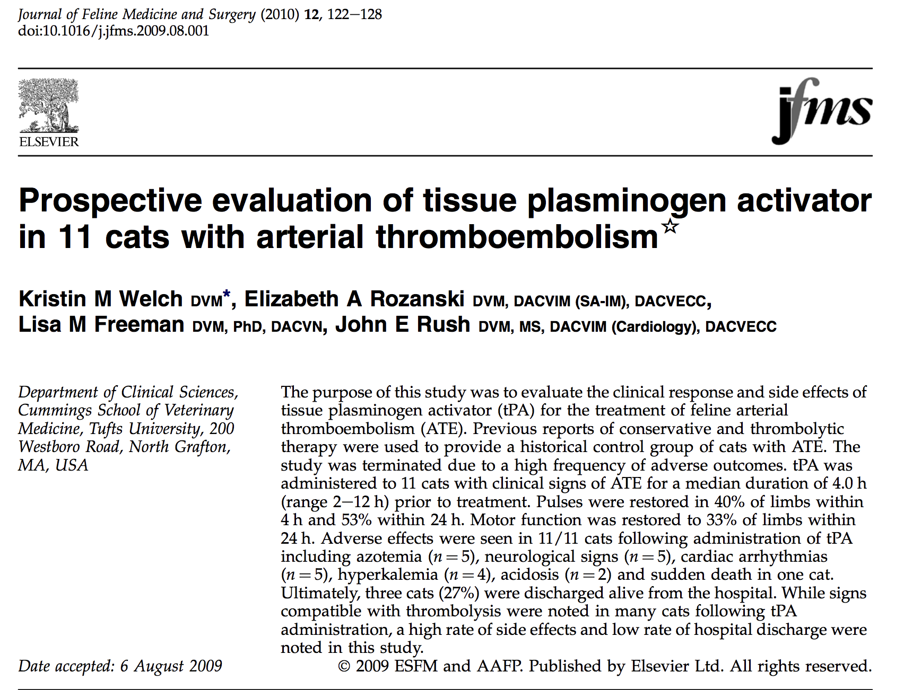

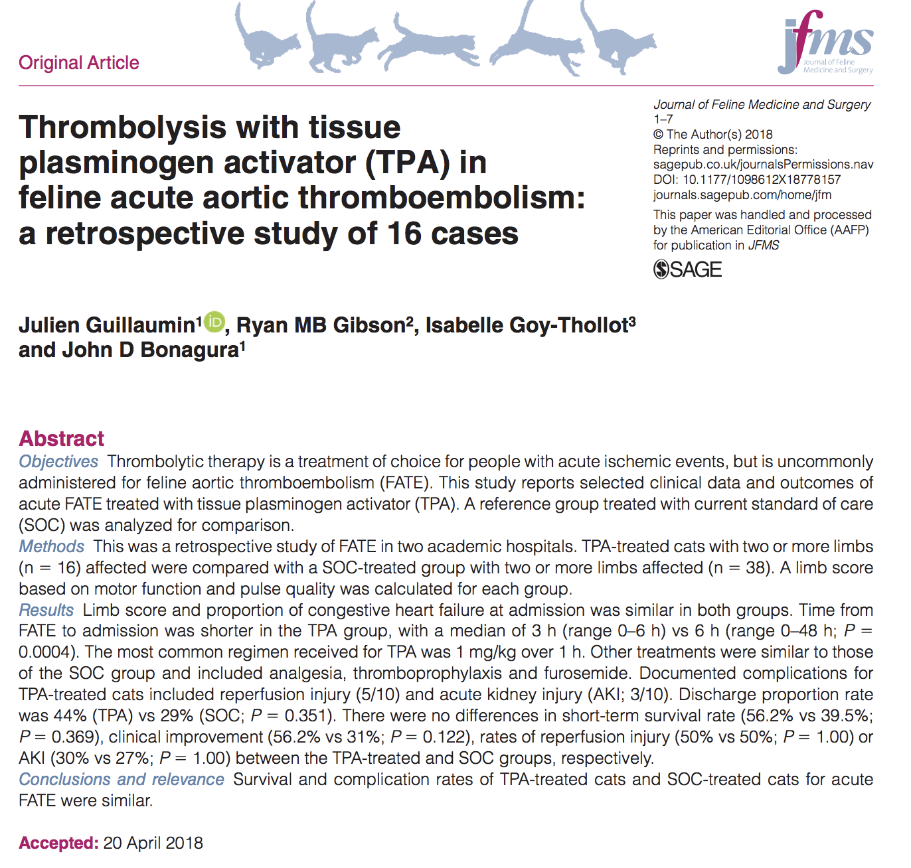

Antifibrinolytic Drugs

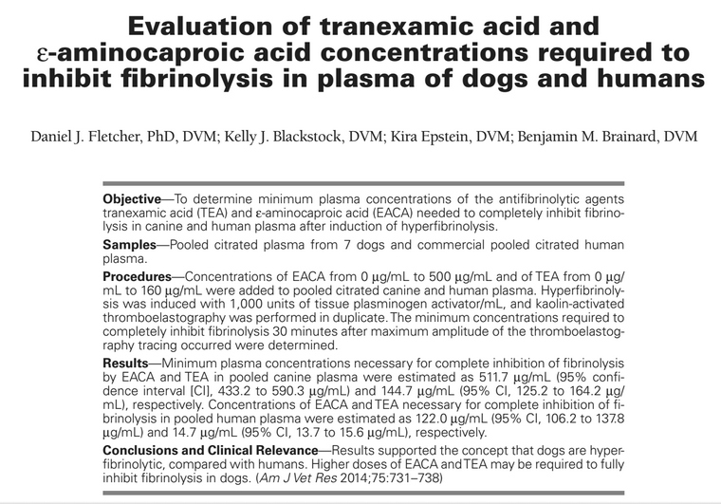

- EACA and TEA inhibit fibrinolysis by blocking the lysine binding site of plasminogen
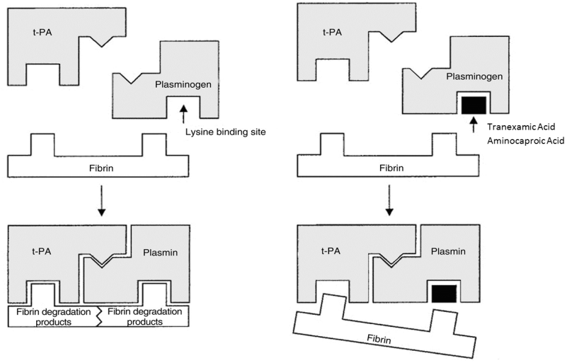
- Dogs: stronger fibrinolytic response, likely required higher dose of EACA/TXA (25% more tPA)
- Methods/Results
  - n=7 dogs /citrated pooled plasma ; commercial pooled human plasma
  - Kaolin-activated TEG; identify the concentration of tPA to use (1000 U/ml)
    - Canine plasma appears hypercoagulable compared to human plasma: shorter R and K; steeper alpha angle, higher MRTG, shorter TMRTG
    - They chose this dose of tPA because TEG curves were similar in both species and this dose allowed direction comparison with the findings from literature.
    - Without tPA neither dog nor human had fibrinolysis w/in 30 min of MA.
  - Kaolin-activated TEG with 1000 U/ml tPA; various concentrations of EACA and TXA
Plasma concentrations of EACA and TEA for
complete inhibition of fibrinolysis at 30 minutes
 | EACA | TXA
Dog | 511.7 µg/mL | 144.7 µg/mL
Human | 122.0 µg/mL | 14.7 µg/mL
- Conclusions: dogs are hyperfibrinolytic compared to people; higher dose of EACA or TXA may be needed; IN VITRO study

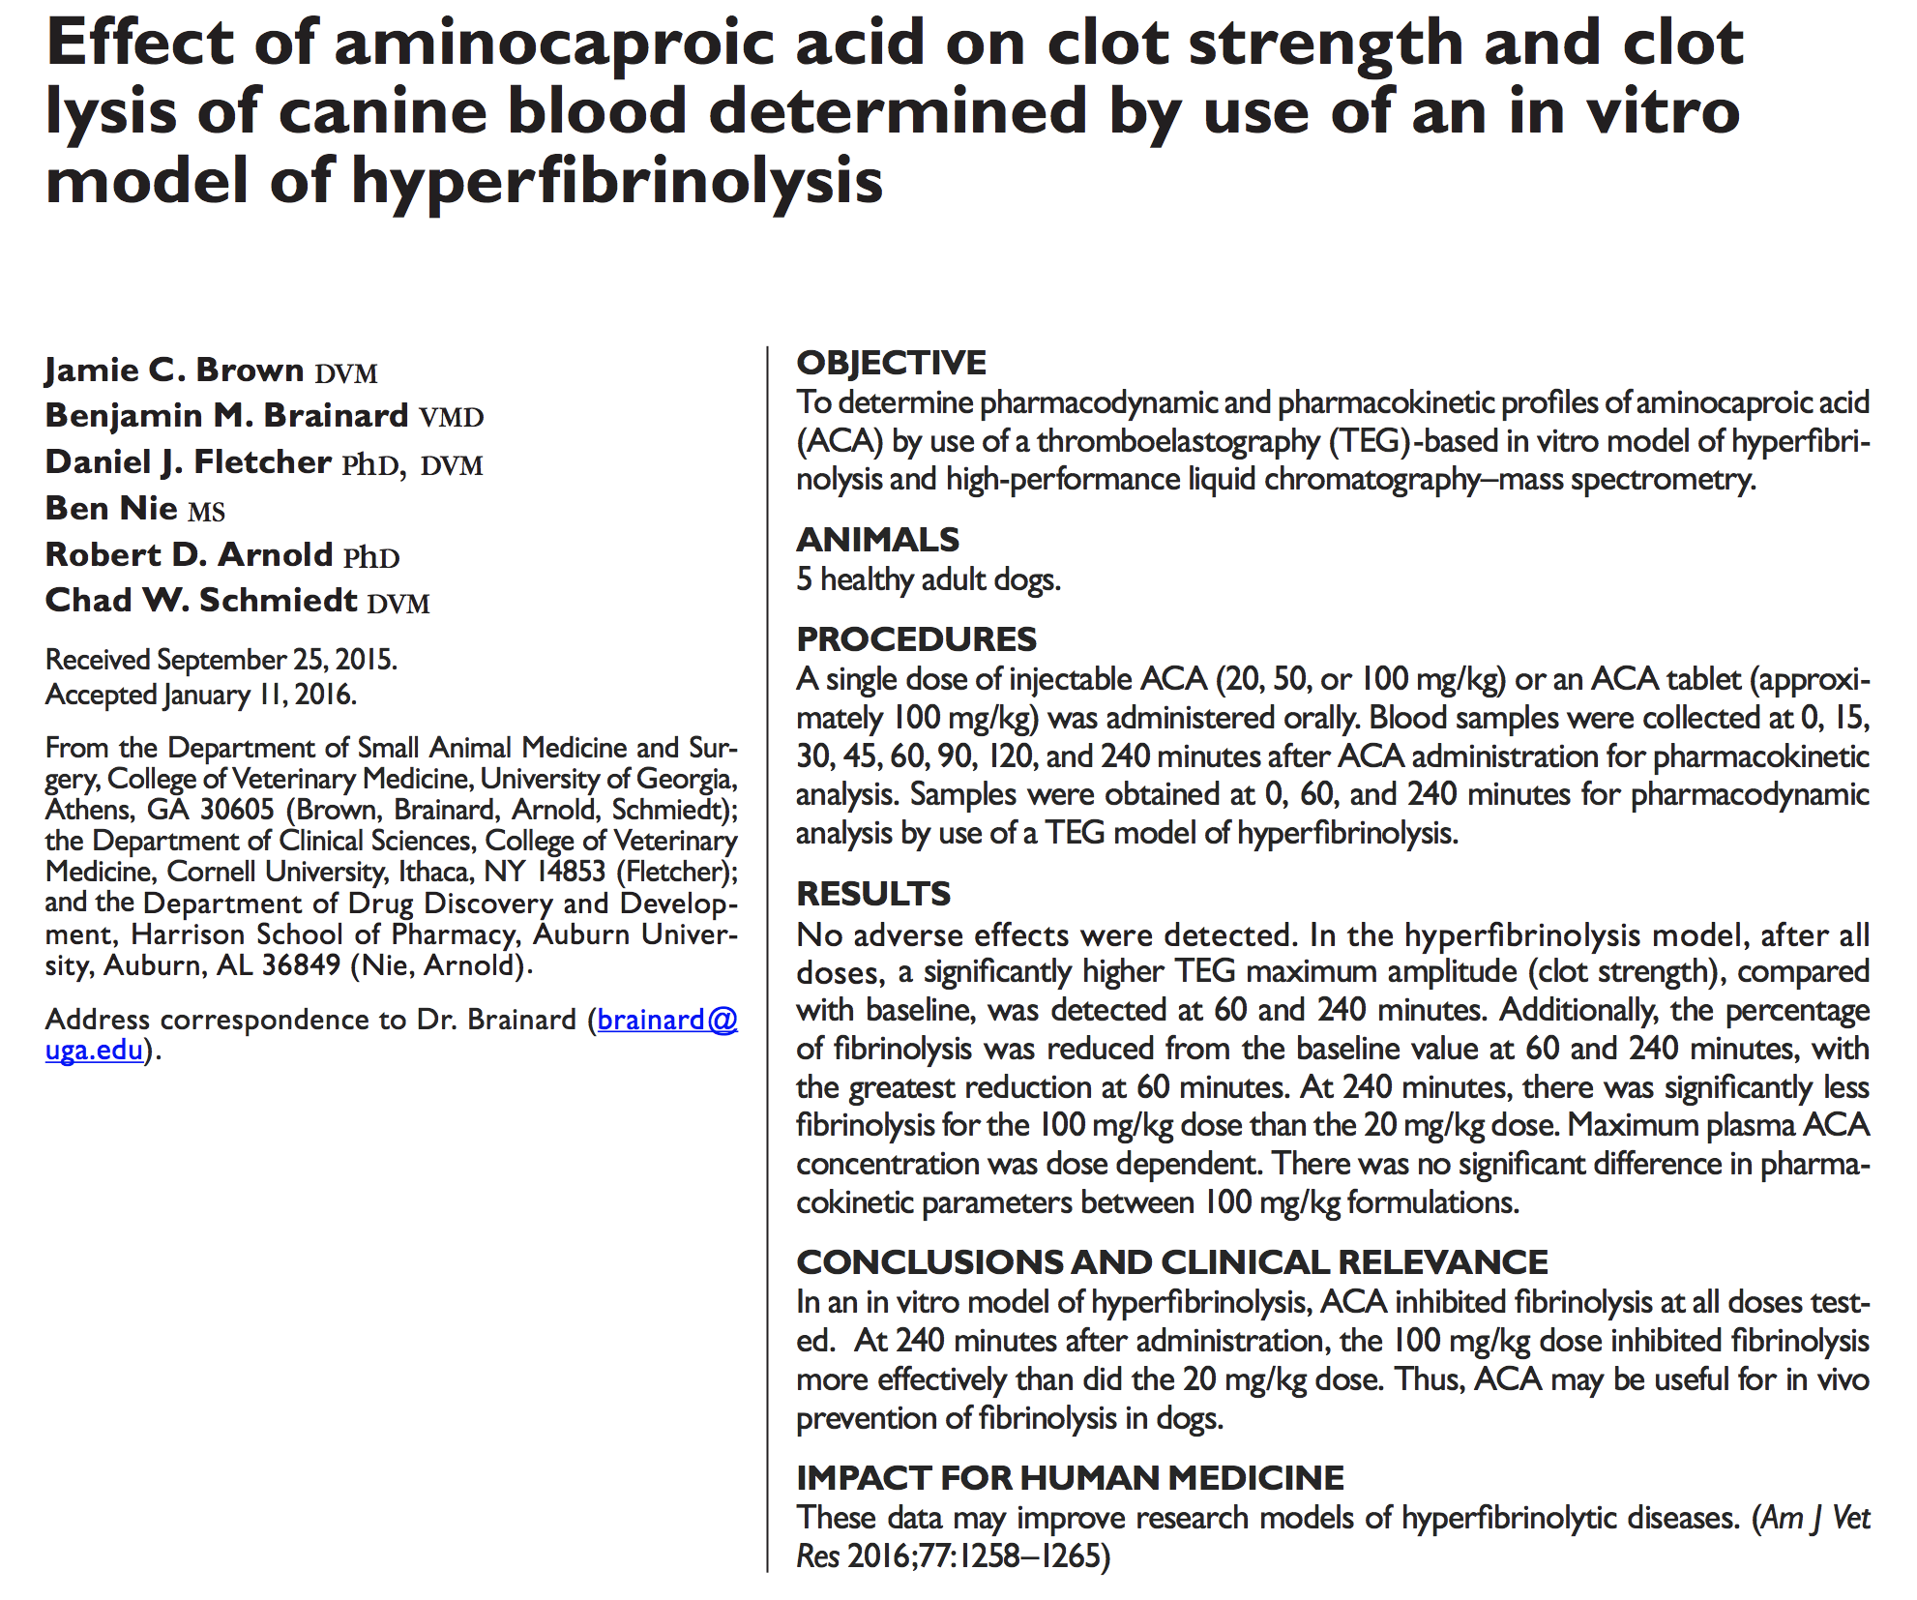

Table 170-1. Suggested Drug Dosages for Commonly Used Hemostatic Drugs
Drug | Dosage | Special Considerations
ε-aminocaproic acid | 50-100 mg/kg IV loading dose (over 1 hr) followed by 15 mg/kg/hr CRI or q8h until bleeding is controlled  15-40 mg/kg IV bolus followed by 500-1000 mg PO q8h | Dilute in 0.9% saline, LRS, or D5W to 20-25 mg/ml
Tranexamic acid | 10-15 mg/kg SC, IM, or slow IV followed by 1 mg/kg/hr CRI for 5-8 hr | 10 mg/kg q12-24h in renal disease
Protamine | 1 mg for every 1 mg (100 U) heparin slowly IV  Decrease dose by 50% for every 30 min elapsed since heparin administration | May cause severe anaphylaxis, hypotension, and pulmonary hypertension
Yunnan Baiyao | Dogs:  <15 kg—1 capsule PO q12h  15-30 kg—2 capsules PO q12h  >30 kg—2 capsules PO q8h  Cats: 1/2 capsule PO q12h | Capsules can also be opened and sprinkled on wound

