What I learned at IVECCS 2018

- Viscoelastic testing Dr. Armelle de Laforcade
  - TEG vs ROTEM
    - TEG cup holding blood sample oscillates vs ROTEM pin rotates instead
    - TEG US vs ROTEM Europe
    - Both measure clotting time, clot formation, clot strength, maximum strength, and lysis but with different measurements/labels
  - Limitations
    - Two different activators
      - Kaolin
      - Tissue factor
      - They both reduce K line (time clot reaches fixed strength) to different extents
      - These two activators are not interchangeable with the machine, so you just pick one
    - Pre-analytic variables
      - Blood sampling
      - Pipetting
      - Sample handling
    - Effect of hematocrit
      - Anemia with reduced viscosity increases PLT fraction which artifactually causes hypercoagulable tracing
      - Higher hematocrit = hypocoagulable tracing
    - Heparin affects samples
  - Uses
    - Hypercoagulable states
      - IMHA, PLN/PLE, pancreatitis, sepsis, cushings, CKD, cancer, trauma
    - Growing interest in testing for fibrinolysis
      - Prediction of bleeding in animals
    - Monitoring for acute traumatic coagulopathy
      - Hypocoagulation and hyperfinbrinolysis
    - Monitoring heparin therapy
      - Limited studies show TEG machine may be too sensitive to heparin

- Guidelines for Empiric Antimicrobial Choices in Sepsis by Dr. Steven Epstein
  - Escalation versus de-escalation approach
    - Escalation: choose antimicrobial with narrow spectrum of activity of pathogen causing suspected infection and adjusting after culture
    - De-escalation: choose broad spectrum antimicrobial aimed to cover all pathogens most frequently related to infection including MDR pathogens, adjusting to more narrowed after culture
      - Considered appropriate for patients with severe sepsis or septic shock
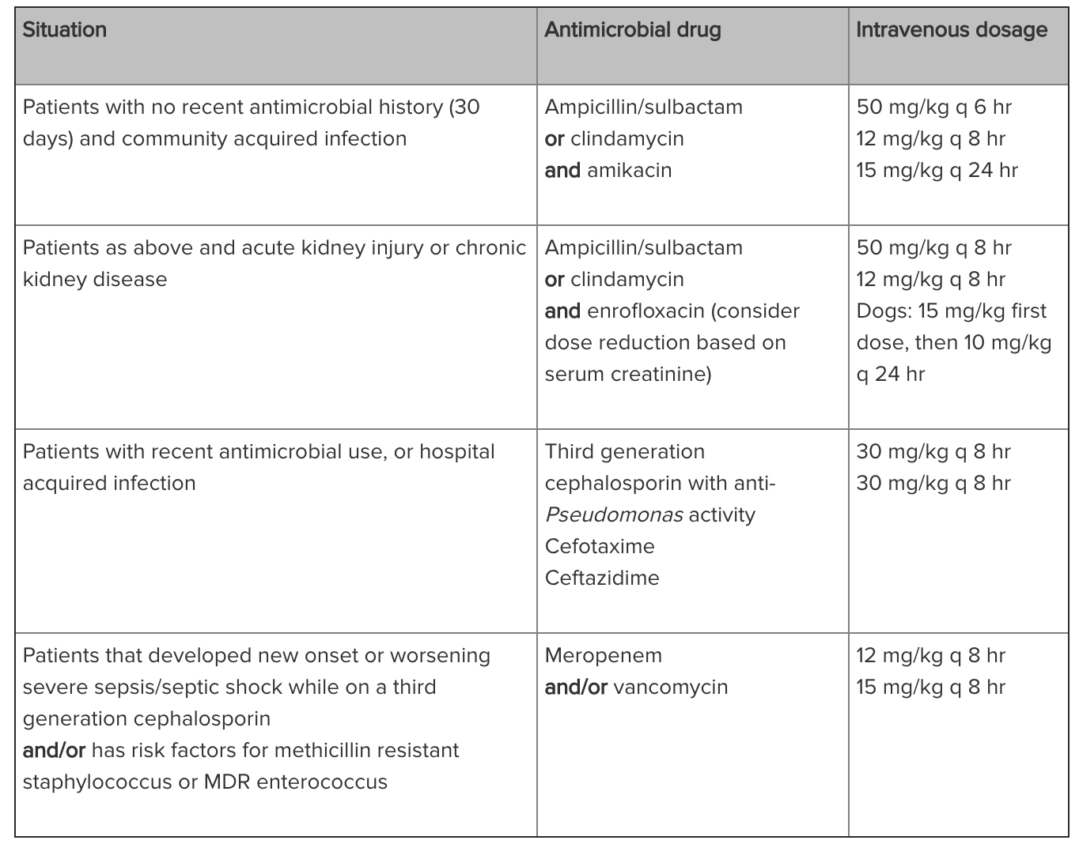
- Antibiogram at UC Davis decreases their need for airway washes and cultures, updated every 3-5 years.
- Discussed short term (3-7 day) versus long term (10-14 day)

