Exploratory Celiotomy
Definitions:
- Celiotomy: Surgical incision into the abdominal cavity
- Laparotomy: Flank incision
- Acute abdomen: Sudden onset of substantial clinical signs referable to the abdominal cavity (abd pain, distension, vomiting)
- Evisceration: herniation of peritoneal contents through the body wall with exposure of abdominal viscera
Preoperative concerns:
- Surgery be indicated for diagnostics and/or therapeutic reasons
- Some conditions are life threatening
  - GDV, Colonic perforation, severe hemorrhage
- Differentiate surgical emergencies from those that can be managed medically
  - Decision to operate based on history, PE, rads, AUS, and laboratory data
  - PE can be unreliable in predicting severity
    - Patients condition at the time of the exam, delayed development of clinical signs
    - Depressed or lethargic animals may not show pain
    - Clinical signs of hemorrhage are often inapparent after trauma
    - Delay of 3-4 hours between injury and development of shock are common in hepatic or splenic laceration
    - Observe trauma patients for 8-12 hours
      - Life threatening hemorrhage apparent before this
      - Traumatic bilious peritonitis may not have overt signs for weeks
      - Traumatic mesenteric avulsion, seldom associated with clinical signs until peritonitis develops (several days after injury)
      - Peritoneal lavage may help identify patients with significant abdominal trauma
  - Preoperative management
    - General observations: Attitude, posture, TPR, abdominal auscultation, percussion, palpation + rectal exam
    - Serial exams are important to detect trends
    - IVC placement- IVF, drugs, drawing blood
    - CBC, platelet count, TP, BG, BUN
    - Chem, Coags – depending on condition and underlying condition
    - UA- via cysto or catheterization
    - Indwelling u-cath for urine output quantification
    - Ab rads- peritoneal fluid and air accumulation
    - Acute abdomen of uncertain cause- abdominocentesis, diagnostic peritoneal lavage, FAST, CT if rads are nondiagnostics
    - Electrolyte and hydration abnormalities should be corrected before surgery
    - If free air noted post traumatic injury – consider exploratory as there may be rupture or perforation of the GI
  - Abdominal evisceration
    - Post surgical dehiscence or trauma
    - May have gross contamination
    - Warrants immediate surgical intervention
Anesthetic Considerations
- Not in shock: can be premedicated with benzo, an opiod and induced with propofol, ketamine, or etomidate given IV to effect
Antibiotics
- Depends on underlying disease, overall general health, length, and type of surgical procedure
Surgical Anatomy
- Rectus sheath: composed of an external and internal leaf
  - External leaf- formed by an aponeurosis of the EAO and a portion of the aponeurosis of the IAO
  - Aponeurosis of the TA joins the external leaf near the pubis
  - Internal leaf consists of a portion of the aponeurosis of the IAO and the aponeurosis of the TA and the transversalis fascia
  - The internal leaf disappears in the caudal third of the abdomen, where the aponeurosis of the IAO joins the external leaf, leaving the caudal rectus abdominis muscle covered by a thin sheet of transversalis fascia and peritoneum
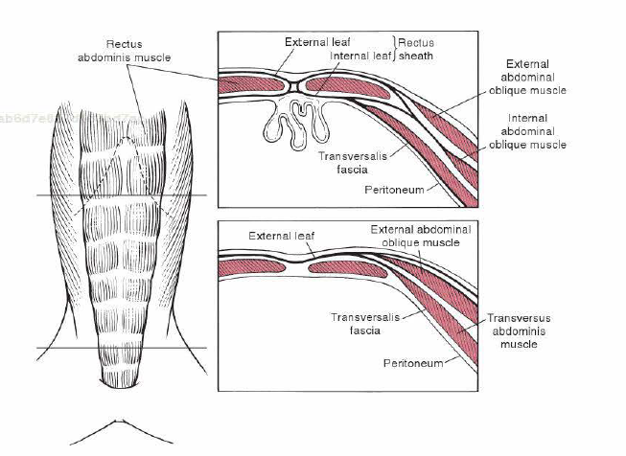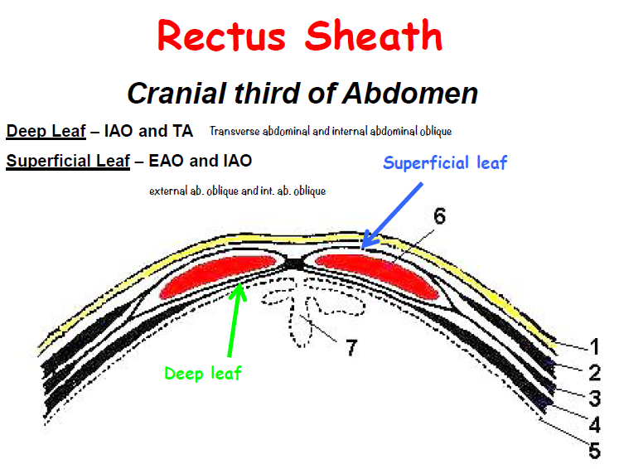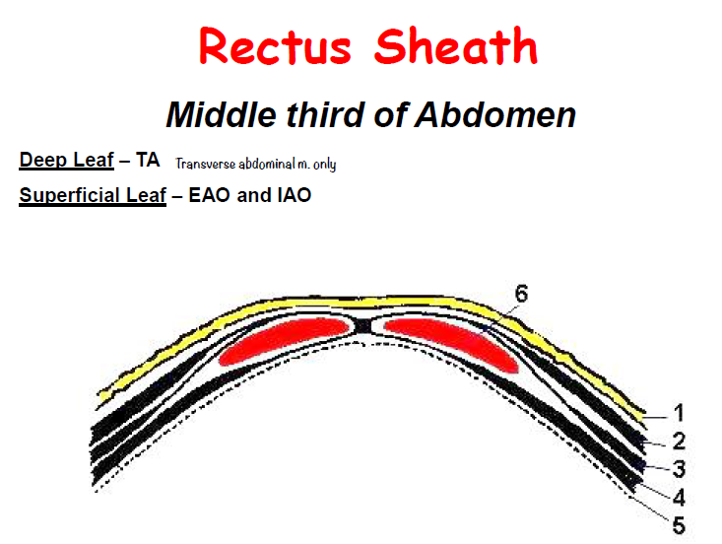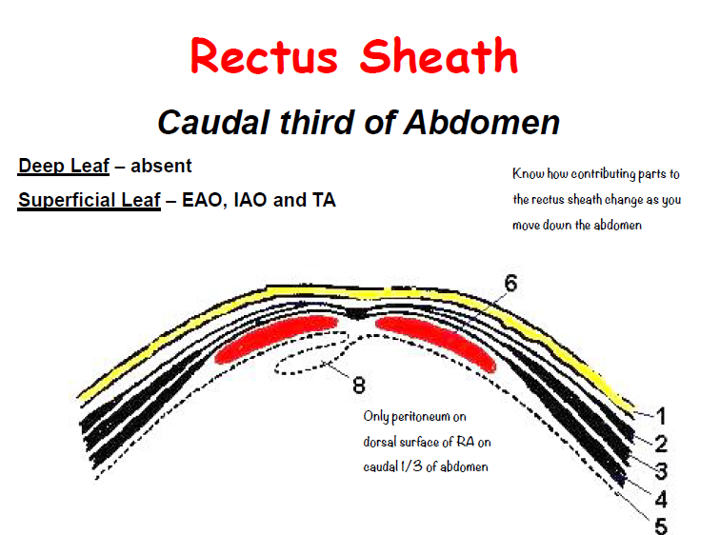

Surgical Techniques:
- Generally explored via ventral midline incision
- Entire abdomen, including inguinal areas and caudal thorax should be prepared
- Prepping too small an area is a common mistake
- Incision must extend from the xiphoid to the pubis to visualize abdominal structures adequately
- If only a specific abdominal structure is to be examined, a shorter incision can be made
- For bladder exploration- caudal abdominal incision extending from umbilicus to pubis
- For cranial abdominal incision- umbilicus to xiphoid allows for evaluation of liver and stomach
- The midline incision can be extended laterally at the xiphoid process (1cm caudal to the last rib) to facilitate exposure of the liver, biliary system, and diaphragm
- A paracostal or paralumbar celiotomy can be used to expose kidneys and adrenal glands
  - Most commonly used for unilateral adrenalectomy
- Count surgical sponges before making incision and before closure

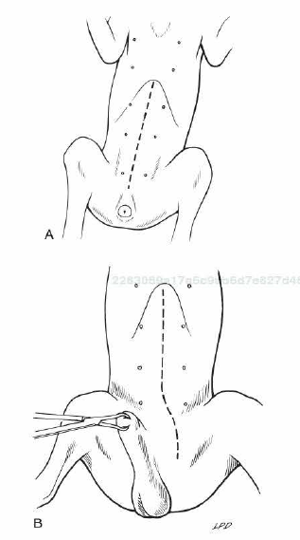
Ventral midline celiotomy *Cats and female dogs
- Patient in dorsal recumbency
- Ventral midline incision near the xiphoid extending caudally to pubis
- Sharply incise tissues until the external fascia of the RA is exposed
- Ligate/cauterize small subcutaneous bleeders
- Identify the linea alba
- Tent the abdominal wall, make a sharp incision into the linea alba with a scalpel
- Palpate the interior surface of the linea for adhesions
- Use scissors to extend incision cranially/caudally
- Digitally breakdown the attachments of one side of the falciform fat, or excise and remove completely (interferes with visualization)
Ventral midline celiotomy in male dogs
- Patient in dorsal recumbency, place a towel clamp on the prepuce and clamp it to one side of the body
- Drape the tip of the prepuce and clamp outside surgical field
- Make ventral midline incision from xiphoid, continuing caudally to the prepuce.
  - Curve the incision to the left or right of the penis and prepuce and extend to the level of the pubis
  - Incise the SQ tissues and fibers of the preputialis muscle to the level of the rectus fascia
  - Ligate or cauterize large branches of the caudal superficial epigastric vein at the cranial aspect of the prepuce
  - Retract incised skin and SQ laterally and locate the linea alba and external fascia of the RA.
  - Don’t attempt to locate the caudal linea alba until SQ tissues have been incised and abdominal musculature fascia has been identified
  - Continue as previous (tent abdominal wall etc)
Paracostal celiotomy
- Place in lateral recumbency, place a rolled towel or sandbag between patient and operating table
- Incision from ventral vertebral column to near the ventral midline
- Center the incision halfway between the wing of the ilium and the last rib
- Extend the incision through the EAO with scissiors
- Separate IAO and TA muscle fibers and expose the peritoneal and transversalis fascia
- Tent the peritoneum and sharply incise it with scissors
Abdominal exploration
- Systematically explore the entire abdomen
- Use moistened lap sponges to protect tissues from drying during the procedure
- If generalized infection or diffuse intraoperative contamination
  - Flush with copious amounts of warm sterile saline
    - Historically antiseptics such as povidone iodine or chlorhexidine have been added to lavage fluids
    - Povidone iodine is the most widely used antiseptic
      - Not shown a beneficial effect in experimental and clinical trials, because the carrier polyvinylpyrrolidone, inhibits macrophage chemotaxis
      - No evidence that adding antibiotics is beneficial
      - Room temp lavage should not be used (heated lavage fluids helpful for increasing temp)
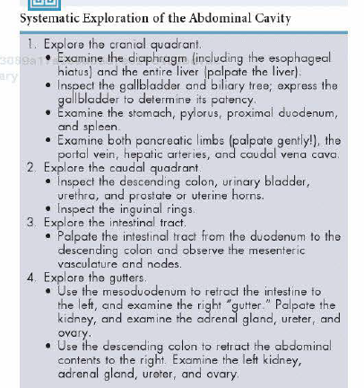
Abdominal wall closure
- Remove abdominal fluid and blood
- Inspect that foreign material and surgical equiptment have been removed
- Sponge count and compare
- Linea alba- closed with simple interrupted or simple continuous suture
- Simple continuous doesn’t increase risk of dehiscence
- Strong absorbable suture (PDS, Maxon, Monocryl, Biosyn) should be used for continuous and 6-8 knots should be placed at the end of each end of the incision line
- Monofilament, nonabsorbable suture (Novafil, Prolene, Nylon) associated with suture sinus formation and should be avoided
- Surgical gut and stainless steel wire should not be used for continuous suture pattern

- On each side of the incision, incorporate 4-10mm of fascia into the suture
- Place interrupted suture 5-10mm apart
- Tighten to appose but not strangulate
  - Too tight sutures adversely affect wound healing
  - Incorporate full thickness bites of the abdominal wall in the sutures if the incision is midline
    - Don’t incorporate falciform ligament
  - If a paramedian incision- close external rectus sheath without including muscle in the sutures
  - Do not include peritoneum in the sutures
  - Close SQ with simple continuous of absorbable suture
  - Reappose the preputialis muscle fibers
  - Use nonabsorbable (simple continuous interrupted or continuous appositional or stainless steel) to close the skin
  - Place skin sutures without tension
  - For paracostal celiotomy- close individual muscle layers with synthetic absorbable suture in continuous or interrupted pattern
    - Eliminate dead space between muscle layers
    - Appose SQ with absorbable suture in continuous or interrupted pattern
    - Close skin with non-absorbable in simple interrupted or continuous pattern
Healing and the abdominal wall
- Ability of tissues to hold suture dependent on strength of tissue and orientation of collagen fibrils
- Skin and fascia strong, muscle and fat are weak
- Peritoneum doesn’t contribute to wound strength
- Suturing peritoneum may increase incidence of adhesions
- Incorporate fascia in the linea closure (holding layer is fascia rather than muscle)
Suture materials and Special instruments
- Balfour retractors, poole or yankauer suction tips, malleable retractors, mixter (right angle) forceps
Post operative care
- Check incision 2x daily
- E-collar or sidebar
- Early signs of altered wound healing- inflammation and edema
- Swelling and serosanguineous drainage – consistent with acute incisional dehiscence
- Dehiscence 3-5 days post surgery – minimal healing occurred and sutures weakened
  - May occur earlier if knots tied improperly or fascia not incorporated
- Evisceration- can cause sepsis and severe blood loss secondary to mutilation of intestines
- If technical failure- entire suture line should be removed and replaced
  - Debridement is unnecessary and delays wound healing
  - Intestines should be inspected, cavity lavaged, and open abdominal drainage or suction drainage may be considered
  - Wound disruption after 10-21 days usually causes hernia formation rather than evisceration.
Complications
- Dehiscence and abdominal evisceration
  - Most common cause – suture breakage, knot slippage or untying, sutures cutting through tissue
  - Higher rates may be seen with infection, fluid or electrolyte imbalances, anemia, hypoproteinemia, metabolic disease, immunosuppression, abdominal distension, tx with corticosteroids, chemo or radiation therapy
Age considerations
- Healing may be delayed in debilitated, very young, very old, hypoproteinemic…
- Chromic gut shouldn’t be used in these patients
- Survival after evisceration is high may be due to it occurring in young animals and promptly recognized and treated
Esophageal Foreign Bodies
General considerations and clinically relevant pathophysiology
- Most foreign bodies are bones, although metal, rawhides, balls, string, other objects also possible
- Lodge because they are too large to pass or have sharp edges that become embedded in esophageal mucosa
- Found at thoracic inlet, base of heart, in epiphrenic (diaphragm) area
  - Extraesophageal structures limit dilation in these areas
- Persistence stimulates peristaltic activity
- Pressure necrosis may occur and can cause perforation
- Esophagitis- may interfere with esophageal motility and lower esophageal high pressure zone function
- Food may be regurgitated or cause proximal esophageal distension
  - Prolonged distension disrupts normal neuromuscular function and reduces peristalsis
- Perforation and aspiration pneumonia are major complications
- May perforate esophageal wall and great vessels at base of heart causing severe hemorrhage into mediastinum
- May establish a fistula with the trachea, bronchi, pulmonary parenchyma, or skin
Clinical presentation
- Dogs more affected than cats (indiscriminate eaters)
- Small breeds more commonly affected (smaller esophagus)
- Cats- strings and needles
- Most common in the first 3 years
- Yorkies, WHWT, Berners overrepresented
- Present within minutes to weeks
  - Pawing at the mouth, oral/cervical pain, dysphagia, regurgitation, gagging, excessive salivation, retching, inappetance, restlessness, depression, dehydration, respiratory distress
  - Weight loss and emaciation if long term
  - Can be anorexic, febrile, dyspneic with pleural effusion
  - Hypovolemic shock if penetrating a major vessel adjacent to the esophagus
  - Important to differentiate between vomiting and regurgitation- acute onset regurg suggests esophageal foreign body
Physical Exam
- Normal to slightly depressed
- May be palpated in cervical esophagus
- Poor body condition if anorexic or regurgitating for weeks
- Abnormal lung sounds with aspiration pneumonia
Diagnostic imaging
- May appear radio-opaque, but may be poorly demarcated and resemble pulmonary masses
- May be an adjacent soft tissue opacity, cervical subcutaneous emphysema, and a dilated air-filled cranial esophagus
- May have pneumonia and tracheal distortion
- Examine for pneumomediastinum and pneumothorax and pleural effusion
- Esophograms rarely necessary
- Non-ionic iodinated contrast agents are the safest will not cause pulmonary edema
- Can also be diagnosed via endoscopy
Lab findings
- Neutrophilic leukocytosis
- Hypoglycemia in young patients unable to eat or SIRS
Differentials
- Vascular ring anomaly, extraluminal masses, esophageal neoplasia, strictures, esophagitis, gastroesophageal intussusception, diverticula, hiatal hernias, megaesophagus, cricopharyngeal dysfunction
- Pulmonary tumors, and esophageal masses can mimic radiographic findings
Surgical treatment
- Important for rads just before induction to ensure the fb hasn’t moved and theres no evidence of perforation
- 90% can be removed endoscopically
- Rigid endoscopes preferred compared to flexible
- Surgical removal should be elected if
  - Obvious perforation (pneumothorax or pleural exudate)
  - Endoscopy can’t retrieve
  - Fishook is completely through and free to lacerate intrathoracic vessels
- After removal, re-evaluate endoscopically and re-radiograph to look for evidence of perforation
- Perforation- debridement and surgical closure. Smaller perfs close on their own
Preoperative management
- Correct dehydration, electrolyte abnormalities, give prophylactic antibiotics
Anesthesia
- Deep GA and muscle relaxants (reduce esophageal tone)
- Preoxygenate
- If aspiration pneumonia, PPV should be performed with lower tidal volumes, normal peak ventilation pressures, higher respiratory rates
Surgical technique
- Extract with endoscope, pull out with balloon type catheter, advance into stomach, perform esophagotomy or partial esophagectomy
Endoscopic removal of esophageal foreign bodies
- Rads, rigid endoscope- larger diameter, better for visualization and esophageal dilation
- Insufflate with minimal amounts of air- too much can rupture weakened areas, can cause gastric dilation, and a tension pneumothorax
- Once found, aspirate fluid and debris, draw it as far as possible into the rigid scope, and remove both
- If severe trauma, place gastrotomy tube
- If cannot be grasped, may be able to be pushed into the stomach
  - If no sharp objects present, if not embedded in the wall, if no perforation
  - Don’t administer antacids
- Fishhooks can generally be removed via rigid scopes
  - If point is pointed caudad. Grasp and bend the hook so when pulled the point of the hook is pulled straight out, parallel with esophageal lumen
  - If craniad. Grasp the eye of the hook with rigid forceps. Advance the rigid endoscope. Hold the eye of the hook so the shaft remains parallel with the lumen of the esophagus and the rigid grasping forceps as one unit, tearing the hook out of the mucosa.
Balloon catheter assisted removal
- Pass a balloon catheter distal to object, inflate the balloon, object removed as the catheter is pulled out through the mouth
- Only for fb with smooth contour
- Rads afterwards to look for evidence of perforation (pneumomediastinum, pneumothorax)
Surgical removal
- Esophagotomy or partial esophagectomy
- Distal esophageal fb can be removed by a gastrotomy
  - Incise midway between greater and lesser curvature, direct forceps into distal esophagus, grasp object, pull into stomach, remove
  - Esophagotomy or partial esophagectomy is performed when risk of perforation or laceration is high. Evidence of mediastinitis, pleuritis, or esophageal necrosis
    - Debride all esophageal disruptions if necessary close in one or two layers
    - Bronchoesophageal and tracheoesophageal fistulas must be closed
    - Partial or complete pulmonary lobectomy is required with bronchoesophageal fistulae. 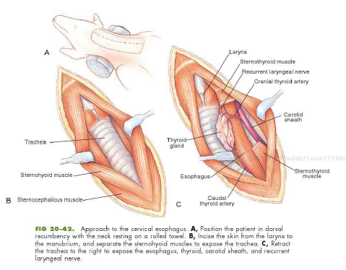
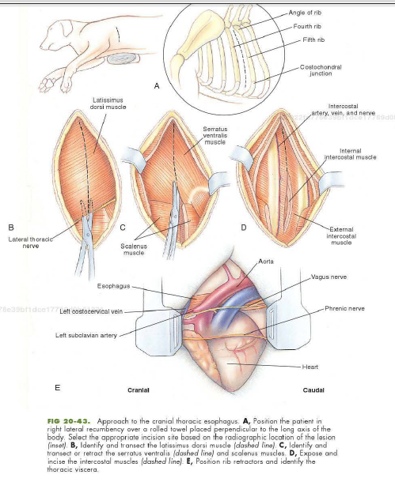
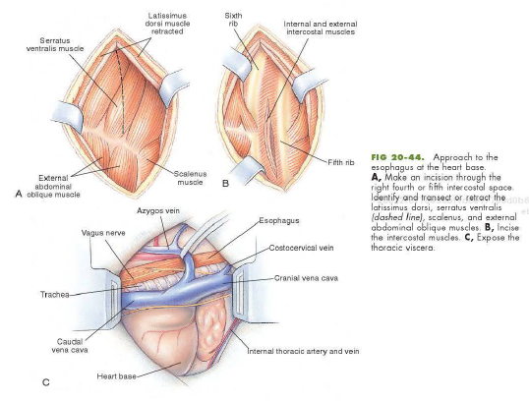

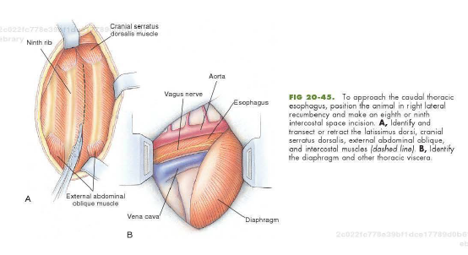
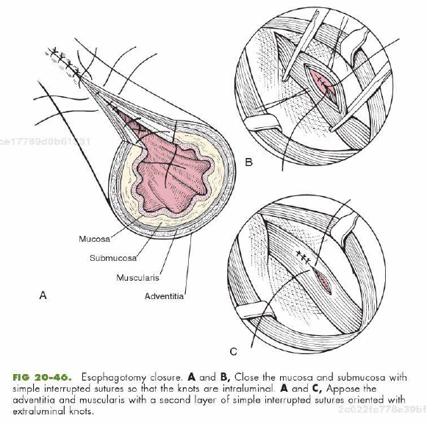
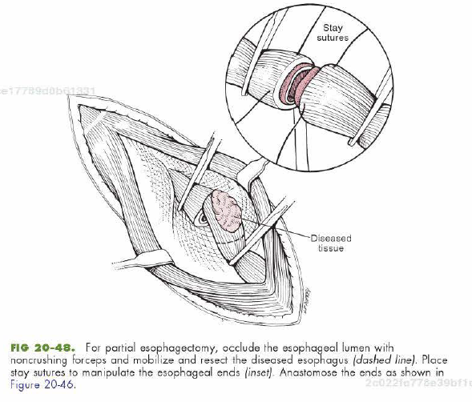
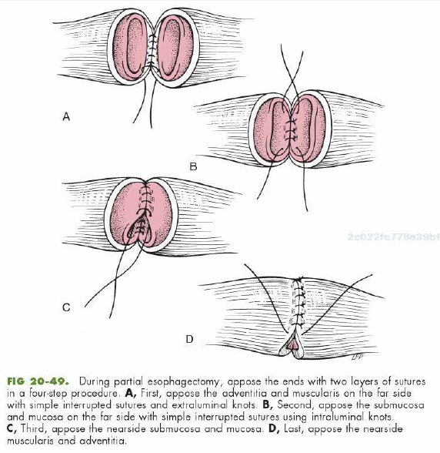
Suture Materials and Special Instruments
- Endoscopes for nonsurgical removal, thoracic retractors for surgical removal or intrathoracic foreign bodies. Noncrushing intestinal forceps to occlude the esophageal lumen for esophagotomy and esophagectomy procedures
Postoperative care and assessment
- Observe for 2-3 days for esophageal leakage and infection
- Treat any potential esophagitis and aspiration pneumonia
- Antibiotics for several days if esophagus severely eroded or ulcerated
- Minimal esophageal trauma: offer water within 24-48 hours followed by small meals of gruel
  - Moist food at 5-7 days, then gradual return to normal diet
- Moderate to severe trauma: avoid PO intake 3-7 days
  - Gastrotomy feeding tube
- Esophagitis- H2 receptor antagonists or PPI
- Antibiotics against oral anerobes (ampicillin, amoxicillin, clindamycin)
- Corticosteroids may help prevent cicatrix formation
- Analgesia to control pain
Complications
- Esophagitis, ischemic necrosis, dehiscence, leakage, infection, fistulae, esophageal diverticula, and stricture formation
- Perforation may lead to mediastinitis, pleuritis, pyothorax
- Higher rates in dogs weighing <10kg and cases where material present >3 days
Prognosis
- Good if no perf
- Guarded if perforation has resulted in mediastinitis or pyothorax
Gastrotomy/Enterotomy
Definitions
- Gastrotomy: incision through the stomach wall into the lumen
- Partial gastrectomy: resection of a portion of the stomach
- Gastrostomy: Creation of an artificial opening into the gastric lumen
- Gastropexy: permanently adheres the stomach to the body wall
- Pylorectomy: Attachment of the stomach to the duodenum
- Gastroduodenostomy: Attachment of the stomach to the duodenum
- Billroth 1: Removal of the pylorus and attachment of the stomach to the duodenum
- Billroth 2: Attachment of the jejunum to the stomach after a partial gastrectomy
- Pylormyotomy: Incision made through the serosa and muscularis layers of the pylorus only
- Pyloroplasty: Full thickness incision and tissue reorientation performed to increase the diameter of the gastric outflow
Preoperative concerns
- Vomiting, anorexia, dehydration, hypokalemia, hematemesis, peritonitis, aspiration pneumonia, esophagitis
- Mild esophagitis- withhold food for 24-48 hours and treat with H2 receptor antagonists
- Severe esophagitis- withhold PO food for 7-10 days
- Gastrotomy tube may be placed
- Treatment with H2 receptor antagonists or PPI
- Sucralfate may help
- Metoclopramide of cisapride to improve gastric emptying
- Antibiotics against oral contaminants
- Food withheld 8-12 hours before surgery to ensure the stomach is empty
- Gastroscopy: fast for 18-24 hours
- Pediatric patients: Fast for 4-6 hours to prevent hypoglycemia
Antibiotics
- Antibiotics can be used if entering gastric lumen, however, animals with normal immune system undergoing simple gastrotomy rarely require them
- Cefazolin 22mgkg IV at induction and repeated 1-2x at 2-4 hour intervals
- Should be given before induction and continued 12 hours post op
- Except for helicobacter, bacteria are scarce (low PH)
Surgical Anatomy
- Stomach divided into cardia, fundus, body, pyloric antrum, pyloric canal, pyloric ostium
- Esophagus enters stomach at cardiac ostium
- Body of the stomach lies against the left lobes of the liver
- Gastric (lesser curvature) and gastroepiploic (greater curvature) supply the stomach and are derived from the celiac artery
- Short gastrics arise from the splenic artery and supply the greater curvature
- Hepatogastric ligament- portion of lesser omentum that passes from the stomach to the liver
- Gastric mucosa accounts for half the stomachs weight
- Short gastric vessels are often avulsed with GDV, accounting for intraabdominal hemorrhage
Surgical techniques
- Gastrotomy generally safer than performing esophagotomy or enterotomy
- Peritonitis is uncommon
- Stricture or obstruction also rare
- Billroth procedures more difficult and associated with more severe complications
Gastroscopy
- Endoscopy more sensitive with looking for erosions, ulcers, physaloptera, and other lesions
- Endoscopy is the preferred method for gastric mucosal biopsy (allows one to obtain more tissue samples)
- Most important lesions not readily diagnosed by endoscopic biopsy: scirrhous carcinomas, pythiosis, and submucosal lesions
- Intraoperative gastroscopy can be performed to help the surgeon find a mucosal lesion
Gastrotomy
- Most common indication is foreign body
- Ventral midline incision, use balfour retractors, inspect contents, isolate stomach with lap sponges, place stay sutures, make gastric incision in hypovascular area
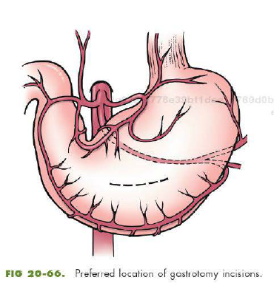
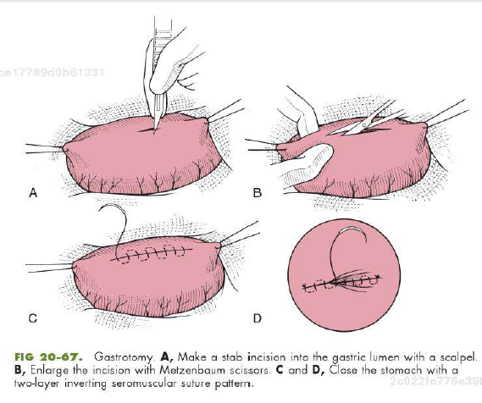
- Use suction to aspirate the contents
- Close with 2-0 or 3-0 absorbable suture in a 2 layer seromuscular pattern
- Include the serosa, muscularis, and submucosa in the 1st layer, using a cushing or simple continuous pattern, then follow with a lambert or cushing pattern that incorporates the serosal and muscularis layers
- Alternatively, close the mucosa in a simple continuous as a separate layer to reduce post op bleeding
- Before closing abdominal incision substitute for sterile instruments and gloves
- Always check the entire GI tract
Partial gastrectomy and invagination of gastric tissues
- Indicated with necrosis, ulceration, or neoplasia involves the greater curvature of the stomach
- Necrosis associated with GDV: resection or invagination
- Invagination obstruction from excessive intraluminal pressure and excessive bleeding is possible.
- Assess extent of necrosis: serosal color, wall texture, vascular patency, bleeding on incision
- Necrotic tissue may range from gray-green to black and often feels thin
- IV flouroscein not accurate
- If you question viability remove or invaginate if not, may result in perforation, peritonitis, and death
- Melena is observed a few days after gastric invagination
- NOTE: Do not use mucosal color to predict gastric viability. Can be black in dogs with GDV because of vascular obstruction
- Damage may predispose to ulceration
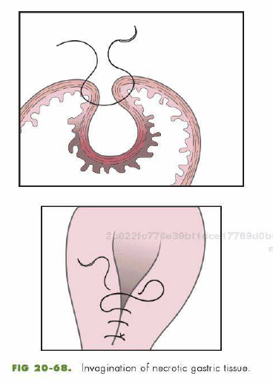

Gastric Dilatation Volvulus
Definitions
- GDV (aka gastric torsion or bloat): Enlargement of the stomach associated with rotation on its mesenteric axis
- Simple dilatation: stomach engorged with air or froth, not malpositioned
General considerations and clinically relevant pathophysiology
- Acute condition with a mortality rate of 20-45% in treated animals
- Gastric enlargement secondary to a gastric outflow obstruction
- Cause unknown, but exercise after a large meal has been suggested to contribute
- Adding table food or canned food to the diet decreased incidence
- Other contributing causes: anatomic predisposition, ileus, trauma, primary gastric motility disorder, vomiting, stress
- Risk: Males, older, underweight, fed large volumes, eating one meal rapidly, raised feeding bowl, fearful temperament, having a deeper and narrower thorax, MWD, atmospheric pressure
- GDV rotates clockwise from 90-360, generally 220-270
- Duodenum and pylorus move ventrally and to the left and become displaced between esophagus and stomach
- Spleen usually displaced to the right ventral side of the abdomen
- Caudal vena cava and portal vein compression reduces venous return and cardiac output causing myocardial ischemia
  - Central venous pressure, MAP, CO are reduced
  - Obstructive shock and inadequate tissue perfusion
  - Cardiac arrhythmias, especially in dogs with tissue necrosis
  - Increased troponin levels
  - Reperfusion injury contributes to tissue damaging resulting in death
- Lazaroids (radical quenching antioxidants) may increase survival (further studies needed)
- Partial or chronic GDV may occur (progressive, non life threatening)
  - Associated with V+, anorexia, wt loss
  - Plain or contrast rads are diagnostic
Diagnosis
Clinical presentation
- Large, deep chested, but also reported in cats and small dogs
- Common in middle aged to older
- Thoracic depth to width is highly correlated with risk of bloat
- History of progressively distended and tympanic abdomen or animal recumbent and depressed with distended abdomen
- Arched back, in pain, non productive retching, hypersalivation, restlessness
Physical exam findings
- Various degrees of abdominal tympany, splenomegaly occasionally palpated, signs of shock including weak pulses, tachycardia, prolonged CRT, pale mm, +/- dyspnea
Diagnostic imaging
- Rads for dilatation vs dilatation + volvulus
- Decompress before rads are taken
- Right lateral and dorsoventral are preferred views
  - VD may lead to aspiration
- Free abdominal air suggests gastric rupture and air within the wall of the stomach indicates necrosis
Laboratory findings
- CBC – thrombocytopenia if DIC
- Low K common, but may be normal or elevated
- Elevated lactate, metabolic acidosis
- Metabolic alkalosis caused by sequestration of H ions in gastric lumen can offset the metabolic acidosis causing the blood pH to be normal (mixed disturbance)
- Respiratory acidosis caused by hypoventilation secondary to gastric impingement on the diaphragm and diminished ventilator compliance
- Higher values of lactate are prognostic and associated with gastric necrosis and a poor prognosis
Differential diagnosis
- Overeating, small intestinal volvulus, primary splenic torsion, diaphragmatic hernia, ascites (but you would have a fluid wave)
- NOTE: Cant differentiate GDV from gastric dilatation because you can pass a stomach tube. Stomach tubes can still be passed with twisted stomachs
Medical management
- Large bore catheter in jugular or both cephalic veins
  - Isotonic fluids, hypertonic saline, hetastarch, or mixture of saline and hetastarch
- Blood gas
- CBC
- Chem
- Broad spectrum abx
- If dyspneic- oxygen therapy
- Gastric decompression
  - Large bore IVC, trochar, stomach tube (measured from point of nose to xiphoid process)
    - Careful not to perforate the esophagus
    - Once the air has been removed, flush with warm water
      - Failure to lavage results in rapid redilatation afterwards
Surgical treatment
- Should be performed as soon as the animal is stabilized
Preop management
- IVF and Abx, electrolyte and acid base abnormalities corrected, ECG should be monitored
Anesthesia
- Stable without arrhythmias, hydro and diazepam then induce with etomidate, thiobarbituates, or propofol
- If depressed premeds may not be needed
- Preoxygenation followed by rapid induction
- Etomidate maintains CO and is not arrythmogenic
- Lidocaine and thiobarbituates may be used if arrhythmias present
- If bradycardia- anticholinergics (atropine or glycopyrrolate) may be given
Surgical anatomy
- Rupture of short gastrics is common and may contribute to blood loss and gastric infarction or necrosis
- 80% of arterial flow is to the mucosa, remainder to the muscularis and serosa
  - Observation of mucosal color not a reliable indicator of gastric wall viability
  - Mucosa often appears darkened because of vascular compromise even when full thickness necrosis is not present
Positioning
- Placed in dorsal for a midline incision
Surgical technique
- Goals
  - 1. Inspect stomach and spleen and identify and remove damaged and necrotic tissues
  - 2. Decompress stomach and correct malpostitioning
  - 3. Adhere the stomach to the body wall to prevent subsequent malpositioning
- Upon entering will see greater omentum covering dilated stomach
- Decompress with large bore needle and suction or orogastric stomach tube
- For clockwise rotation, rotate counterclockwise by grasping pylorus with the right hand and greater curvature with the left hand
- Push greater curvature toward the table while elevating the pylorus
- Check to make sure spleen is in left abdominal quadrant
- If splenic necrosis or significant infarction perform a partial or complete splenectomy
- Remove or invaginate necrotic gastric tissues
- Avoid entering the gastric lumen if possible.
- Verify the gastrosplenic ligament is not torsed
- Before closing palpate the intrabdominal esophagus to ensure the stomach is derotated
- Perform a permanent gastropexy
Suture materials and special instruments
- Absorbable or non absorbable suture can be used for gastropexy
- Foley is needed for a tube gastropexy
- Balfour retractors, handheld retractors and extra towel clamps are helpful
Post op care and assessment
- Electrolyte, fluid and acid base monitored
- Many require K supplementation
- Small amts of food 12-24 hours after vomiting
- Centrally acting emetic and H2 receptor antagonists
- Monitor for hypoalbuminemia and anemia
- Ventricular arrhythmias common 12-36 hours after surgery
  - Myocardial depressant factor, reduced CO, myocardial ischemia may contribute
  - Lidocaine ineffective when animal hypokalemic
  - Lidocaine bolus followed by CRI can be given
    - Signs of lidocaine toxicity – muscle tremors, vomiting, seizures
  - Procainamide (bolus followed by CRI)
  - Sotalol may be effective to those not responsive to lidocaine or procainamide
Complications
- Sepsis and peritonitis
- DIC occurs in 16%
- Assessment of clotting, treatment with plasma, fluids, heparin are necessary, as coagulopathies increase the risk of death
- Arrythmias in 45.5% - but did not increase the risk of death
Prognosis
- With timely surgery prognosis is fair
- Mortality rates as high as 45% have been reported, but 10% becoming more common
- GD no V, better prognosis than GDV
- Prognosis is poor if gastric necrosis or perforation occurs or surgery is delayed
- Lactate <6 suggests gastric necrosis not present, thus a fair prognosis
- Dogs with gastric necrosis 10x more likely to die
- Some dogs respond to decompression and medical stabilization alone, but high likelihood of recurrence
- Arrythmias associated with increased mortality
- Concurrent splenectomy associated with higher mortality rates
Gastropexy
- To permanently adhere the stomach to the body wall
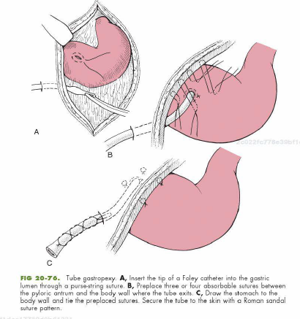

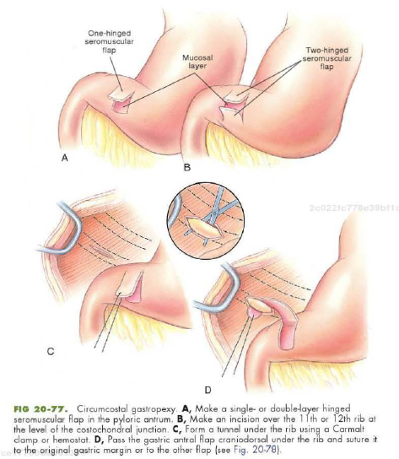

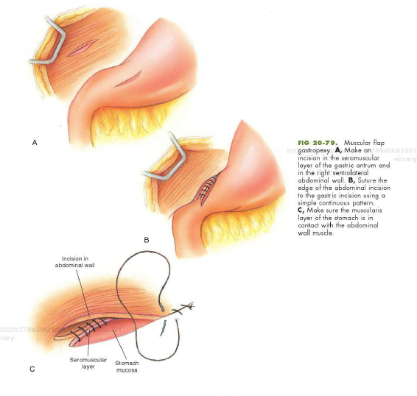
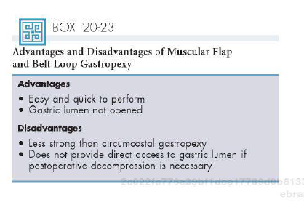
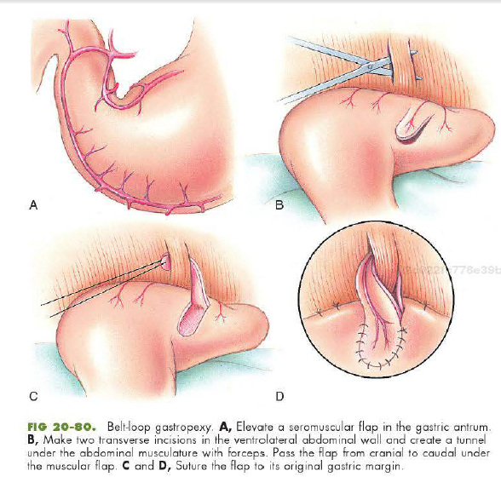
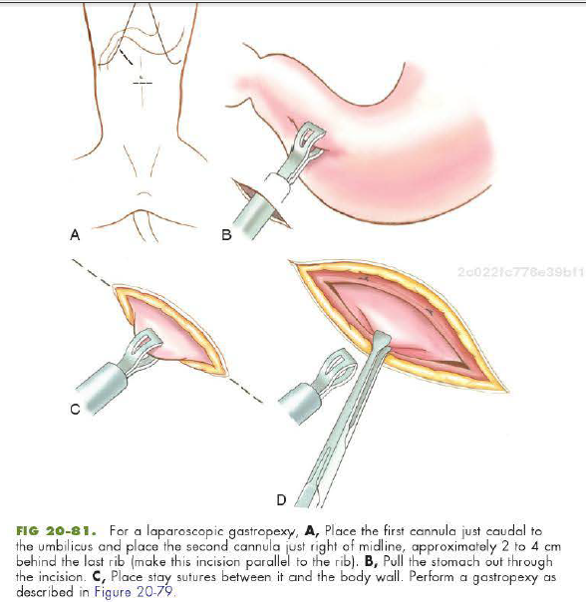
Surgery of the Small Intestine
Definitions
- Enterotomy- incision into the intestine
- Enterostomy- removal of a segment of the intestine
- R&A- enterostomy with reestablishment of continuity between the divided ends
- Intestinal plication – surgical fixation of one intestinal segment to another
- Enteropexy- fixation of intestinal segment to the body wall
Preoperative concerns
- Surgery most often indicated for GI obstruction, trauma, malpositioning, infection, diagnostic or supportive procedures
- Diagnosis based on Hx, PE, rads, AUS, BW, endoscopy and/or biopsy
- Alleviating hypotension is important because it is associated with intense portal vasoconstriction that causes the breakdown of the intestinal mucosal barrier allowing increased endotoxin absorption
- Electrolyte changes with profuse vomiting
- Potential need for transfusions
- Benefits of stabilizing before surgery must be weighed against risk of ischemic necrosis
- Explore without delay if
  - Penetrating abdominal injury
  - Large numbers of neutrophils or degenerate neutrophils
  - Bacteria in abdominal effusion
  - Blood to peritoneal fluid glucose difference is greater than 20
  - Peritoneal fluid lactate is >2.5-5.5
  - Extraluminal gas bubbles
  - Esophageal or gastric intussusception
  - Bacterial culture of fluid positive for pathogenic bacteria
Anesthetic considerations
- Two large bore catheters
- Patient may be depressed and not need premeds
- Monitor for arrhythmias
- ECG, Pulse ox, and BP monitored thoroughout
- Induce with ketamine and a benzo or etomidate
- Avoid propofol as it causes hypotension and these patients can already be hypovolemic
- Visceral manipulation may induce bradycardia
  - Atropine or glycol
- Avoid hypothermia
Antibiotics
- Some patients have surprising large numbers of bacteria in the upper small intestine
  - Bacteroides, Clostridium, Enterococcus, Staphylococcus, and E.coli.
  - Resident bacteria typically proliferate in diseased bowel because stagnant luminal contents and devitalized wall are excellent growth media.
  - Prophylactic Antibiotics are indicated
  - First generation cephalosporins should be administered before surgery of the upper and middle small intestine
  - Second generations or extended spectrum penicillins for distal small intestines and large intestine
  - Redosed 2 hours after initial dose

Surgical Techniques
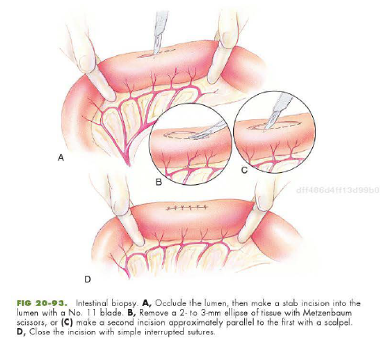
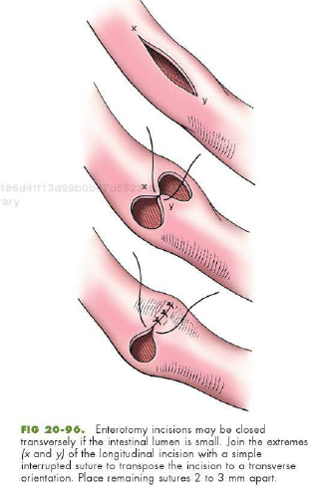
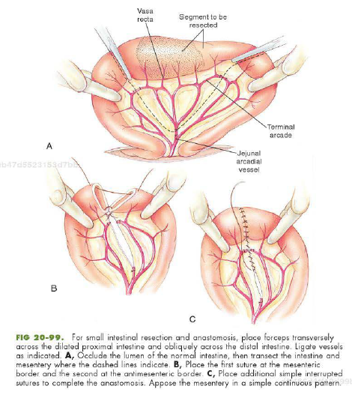

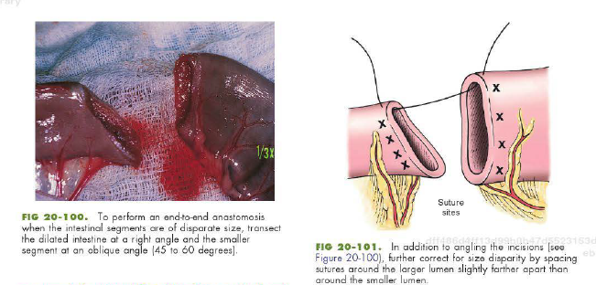

Healing of the small intestine
- Optimal healing depends on good blood supply, accurate mucosal apposition, and minimal surgical trauma
- Approximating suture patterns facilitate rapid healing
- Intestines generally heal rapidly but healing can be delayed by local and systemic factors
  - Hypovolemia, shock, hypoproteinemia, debilitation, concurrent infection
  - Tension on the repair, administration of corticosteroids
- Three phases of healing
  - Lag phase- days 0-4 associated with inflammation and edema of the healing intestine
    - Fibrin seal during the first few hours
    - Fibrin clot does contribute to wound strength, most of strength is due to sutures
    - Macrophages important in wound debridement and production of growth factors that modulate fibroplasia and angiogenesis
    - Healing is weakest at the end of lag phase because of fibrinolysis and collagen deposition
      - Dehiscence most commonly occurs 3-5 days after intestinal surgery
  - Proliferative phase- 3-14
    - Fibrous repair occurs, rapid gain in wound strength
    - Strength of repair approximates normal intestine 10-17 days after surgery
  - Maturation phase
    - 10-180 days
    - Collagen is reorganized and remodeled
Suture materials and special instruments
- Self retaining abdominal retractors, malleable retractors, doyen non crushing forceps, babcock forceps, metzebaums, no 11 blade, penrose drain, and suctin. 3-0 and 4-0 monofilament absorbable suture.
- Patients with low albumin prefer long lasting monofilament absorbable or non absorbable
Post operative Care
- Analgesics
- Aggressive monitoring for intestinal ischemia
- IVF, for hydration, electrolyte and acid base abnormalities
- Early feeding is important
- Early ambulation should be encouraged to minimize ileus
- Clinical signs and response to abdominal palpation
- If peritonitis suspected
  - Abdominocentesis with culture and sensitivity, CBC, Chem
  - Abdominal explore if degenerate neutrophils with engulfed bacteria
- Dehisence rate 7-16% with 74-85% of those patients dying
- High risk for leakage if 2 or more identified:
  - Preop peritonitis, intestinal fb, albumin <2.5
Complications
- Shock, leakage, ileus, dehiscene, perforation, peritonitis, stenosis, short bowel syndrome, and death
- Clinically significant strictures are rare
- Recurrent intestinal obstruction
Age considerations
- Young animals- parasites, garbage or FB gastroenteritis, and intussusception.
  - More prone to hypothermia and hypoglycemia
- Healing delayed in older animals

Surgery of the Large Intestine
Preoperative concerns

- Surgery of the large intestine is indicated for lesions that cause obstruction, perforation, colonic inertia, or chronic inflammation.
- The most common causes of obstruction are tunwrs, intussusceptions, and granulomatous masses.
Antibiotics
- Risk of infection after colorectal surgery is high
- Abx reduce morbidity and mortality
- Systemic abx effective against anerobes and gram negative aerobes should be given
  - Recommend 2nd generation cephalosporins
    - Cefmetazole, Cefoxitin, Cefotetan
  - 3rd generation are available but expensive
  - Amikacin + Clindamycin can ge given IV at induction
  - Aminoglycosides (neomycin, kanamycin) and metro can be given orally 25 hours before surgery
Surgical Anatomy
- The cecum, ascending colon, transverse colon, descending colon, and rectum are segments of the large bowel.
- In dogs, the cecum is an S-shaped, blind pouch located to the right of the mesenteric root
- In cats, it is a short, straight, blind pouch.
- The blood supply to the large bowel is from the ileocolic artery, a branch of the cranial mesenteric artery, and the caudal mesenteric artery.
- Run parallel to the intestine, giving off short vasa recta vessels, which penetrate the intestinal wall.
  - Branches of the ileocolic and left colic artery anastomose.
  - The ileocolic artery supplies the ileum, cecum, and ascending and transverse colon
  - It gives rise to rise to the middle colic and right colic arteries.
  - The right colic artery supplies the cecum, the ascending colon, and part of the transverse colon.
  - The middle colic artery supplies part of the transverse colon and half of the descending colon; it anastomoses with the left colic artery, which supplies the distal half of the descending colon.
  - The left colic and cranial rectal arteries originate from the caudal mesenteric artery.
    - The cranial rectal artery primarily supplies the cranial rectum but also sends several vasa recta to a short segment of the terminal colon.
    - The internal iliac artery supplies branches to the rectum via prostatic or vaginal artery branches
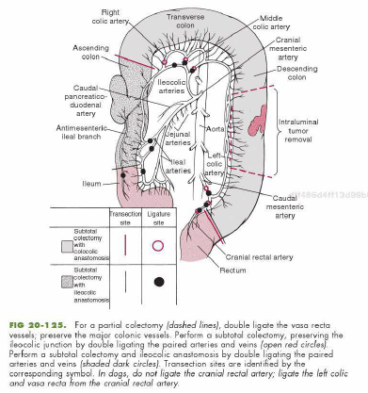
Healing of the large intestine
- Colonic healing, similar to small intestine, but delayed
- Wound tensile strength lags behind and dehiscence is more likely
- Collateral circulation is poor compared to small intestine
- High intraluminal pressure develops during passage of a solid fecal bolus
  - Mechanical stress on the suture line may lead to dehiscence
- Stapled anastomoses have higher bursting pressure during the early lag phase and a higher tensile strength after 7 days than hand sutured anastomoses
Suture materials and special instruments
- Same as for small intestinal surgery
Post-operative care
- Closely monitor for vomiting and regurg to prevent aspiration
- Analgesics given as needed
- Hydration, electrolyte, and acid base monitored and corrected
- IVF until eating and drinking
- ABX discontinued 2-4 hours post sx unless peritonitis
- Stool softeners and laxatives
- Cyproheptadine as an appetite stimulant in cats (preferred over diazepam)
- Abdominal palpation, monitoring
- Early ambulation and oral intake
Complications
- Hemorrhage and fecal contamination
- Shock, leakage, dehiscence, perforation, peritonitis, stenosis, incontinence and death
- Leakage can be minimized by placing a serosal patch around the anastomoses
- Postoperative strictures are rare, incontinence rarely associated with colectomy
Age consideration s
- Young animals with rectal prolapse and intussusception as a result of parasite infestation or garbage or foreign body ingestion
- Prone to hypoglycemia and hypothermia
- Neoplasia more common in older animals

Pancreatic Surgery
Definitions
- Pancreatectomy: surgical removal of all or part of the pancreas
- Insulinoma: Functional tumor of pancreatic B-islet cells, excessive insulin production
- Zollinger-Ellison syndrome: non-b-islet cell tumors in which excess gastrin is secreted
Preoperative management
- Wide range of clinical signs: anorexia, vomiting, cranial abdominal pain, ascites, shock, dyspnea, melena.
  - Cats: lethargy, poor appetite, dehydration (vomiting much less common and/or noticeable)
- Important to diagnose pancreatitis before surgery
  - Animals neither require nor benefit from surgery
  - Poor visceral perfusion due to anesthesia and/or manipulation can exacerbate disease
- AUS important in diagnosis with 40-60% sensitivity
- Pancreatitis, pseudocysts, abcessesm neoplastic lesions, nodular hyperplasia, EPI, Pancreatolithiasis, congenital anomalies, and pancreatic edema cannot always be reliably differentiated
- Vomiting animals require correction of fluid, electrolyte, and acid-base abnormalities
- Diabetics may be prone to pancreatitis- recommend CBC, Chem, UA, UC
Anesthesia
- For diabetics- maintain BG between 100 and 300. Stress of surgery usually results in hyperglycemia
  - Day before: normal diet, normal insulin
  - Food withheld 6-8 hours before surgery or a small meal given after morning insulin
  - Surgery in the AM, with BG measured in the AM
  - 1-2 hours before surgery If BG is 150-300 animal should receive ½ normal dose of insulin SQ
  - BG checked at induction and hourly thereafter
  - If BG low: 0.45% NaCl + 2.5% Dextrose
  - If normal: LRS
  - If BG greater than 300: Give additional small dose of insulin
  - Frequent BG checks
- Maintaining perfusion is important to help prevent post op panc
- Generally premed with anticholinergic and opiod, induce with thiopental or propofol, and maintain on iso or sevo
Antibiotics
- Not been shown to benefit dogs with panc
- Often administered to prevent secondary infection from necrotic pancreatic and peripancreatic tissue
- Prophylactic Cefazolin 22mg/kg often administered to patients undergoing pancreatic biopsy or partial pancreatectomy
- Should be based on C & S testing of infected tissues
Surgical anatomy
- Composed of a right limb, left limb, and small central body
- Right limb lies within the mesoduodenum
- Dorsal aspect of the right pancreatic lobe visualized by retracting the duodenum laterally
- Pancreatic body lies in the bend formed by the pylorus and duodenum
- Left lobe is viewed within the deep leaf of the greater omentum by retracting the stomach cranial and tranverse colon caudally
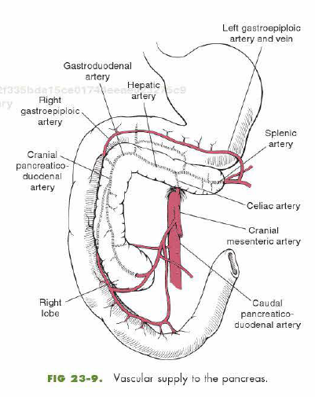
- Main blood supply to the left lobe is provided by branches of the splenic artery
  - Branches of the common hepatic and gastroduodenal arteries also supply portions
- Main blood supply to the left lobe are the pancreatic branches of the cranial and caudal pancreaticoduodenal arteries that anastamose in the gland
  - The cranial pancreaticoduodenal artery is a terminal branch of the hepatic artery
  - The caudal pancreaticoduodenal arises from the cranial mesenteric artery
- The proximity and shared blood supply of the pancreas and duodenum make duodenal resection difficult if pancreatic function is to be maintained.
- Pancreas has endocrine and exocrine functions
- Pancreatic duct drains the right lobe and accessory panc duct drains the left lobe
- The accessory duct is the largest excretory pancreatic duct in the dog
  - Opens into duodenum at minor duodenal papilla
- Smaller pancreatic duct often absent
  - Opens into major duodenal papilla, adjacent to common bile duct
- Pancreatic duct is the principal and often times only duct in cats
- NOTE: Extrahepatic biliary obstruction may occur secondary to pancreatic swelling or masses because of impingement of the common bile duct as it enters the major duodenal papilla. Attempting to resect such masses may cause laceration and/ or rupture of the bile duct.

Surgical Technique
- Ventral midline abdominal incision, gentle palpation and visual inspection of the pancreas, free portion of the greater omentum retracted cranially and covered with moist sponges
- Omental leaf overlying the pancreas can be bluntly separated to allow visualization
- When neoplasia suspected examine lymphnodes along splenic vein and those at the hilus of the liver and head of pancreas
- Handle gently to avoid causing pancreatitis
- Pancreatic biopsy and partial pancreatectomy can be performed
- Biopsies help differentiate benign from neoplastic
  - Exploratory laparotomy and direct visualization usually indicated
- Partial pancreatectomy insulin secreting tumors, gastrin secreting tumors, or pancreatic adenocarcinoma
- Total pancreatectomy infrequently performed in vet med
  - Difficult to bluntly dissect pancreaticoduodenal vessels without damage to branches supplying duodenum
  - Performed in conjunction with R&A of proximal duodenum, ligation of common bile duct, and cholecystojejunostomy
    - Associated with high morbidity and mortality
Laparoscopic Pancreatic Biopsy
- More commonly done in cats due to difficulty diagnosing panc
- Take multiple biopsies
Surgical Pancreatic Biopsy
- If diffuse disease, remove a small portion of the caudal aspect of right pancreatic limb
- Focal lesions near extremity can be removed similarly
- If no obvious disease, multiple biopsies should be taken
  - For focal lesions use a trucut or vim-silverman needle or shave off a small sample, being careful not to damage blood vessels or pancreatic ducts
Partial pancreatectomy
- Suture fracture technique
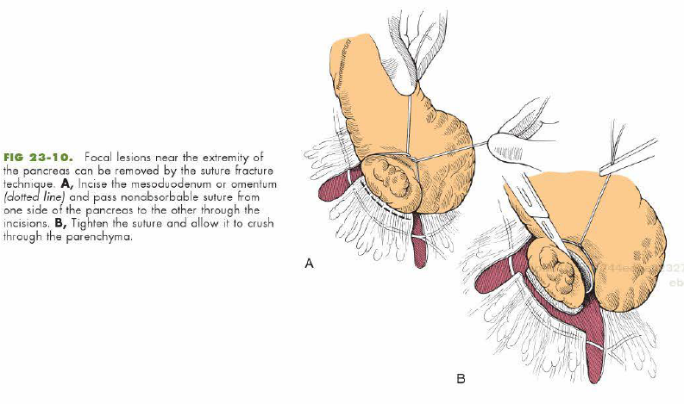

- Blunt separation of pancreatic lobules and ligation of ducts can be performed anywhere in the pancreas
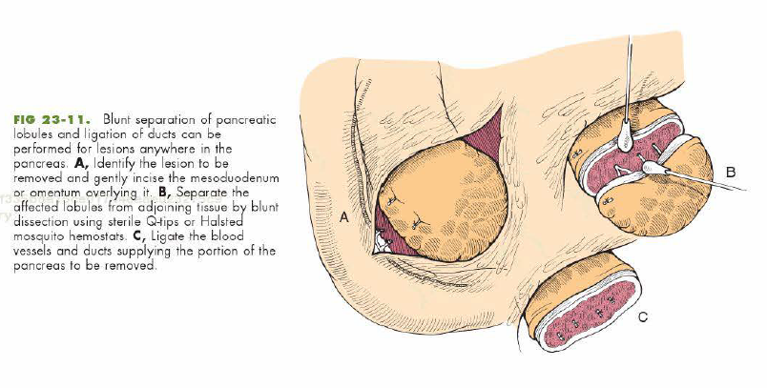

Healing of the pancreas

- Fibrous stroma of the pancreas allows healing to occur by protein synthesis, epithelialization, and fibrin polymerization
- Obstruction of pancreatic duct can be caused by parenchymal edema or obstruction at the duodenal papilla, but rarely by wound contraction
- Concern: Effect of healing on flow and drainage of pancreatic secretions
  - If duct to remaining portion left intact, 80% of pancreas can be removed without causing deleterious effects
Suture material and special instruments
- Duct ligation performed with nonabsorbable suture material (Polypropylene or Nylon) with inflammatory, asceptic, or neoplastic conditions
- Monofilament absorbable may be used in septic conditions; braided suture avoided
- Chromic gut suture can be rapidly digested and should not be used

Postop care
- Enteral feeding delayed 2-5 days, feed as soon as they can be fed enterally without getting worse
- Small amounts of low fat bland food
- IV fluid therapy as pancreatic perfusion is paramount
- Plasma oncotic pressure shoulf be maintained if hypoalbuminemic via administering plasma or hetastarch
- Treating DIC (adequate BP and perfusion pressure), replacing clotting factors, fresh frozen plasma
- Antiemetics, H2 receptor antagonists, analgesics as needed
- If sepsis identified, appropriate antibiotic therapy should be continued for 10-14 days
Complications
- Pancreatitis- minimize with good visceral perfusion and gentle tissue handling
- Octreotide (somatostatin) has been used anecdotally to try to prevent post op panc
- Severe acute panc associated with high mortality and multiorgan failure
- EPI if pancreatic drainage completely obstructed
  - Pancreatic supplements of commercial pancreatic extract
  - Low fat, highly digestible food
  - Administering abx
- Diabetes may result when 80-90% of pancreatic tissue is removed
  - Supplement with insulin
Age considerations
- Usually middle aged to older animals affected
- Meet nutritional and metabolic needs

Pancreatic Abcesses and Pseudocysts

Definitions
- Pancreatic abcess: Collection of purulent material and necrotic tissue within and extending from the pancreatic parenchyma
- Pancreatic pseudocysts (pancreatic cysts): Collections of pancreatic secretions and cellular debris enclosed within a wall of granulation tissue or fibrous sac that lacks and epithelial wall
General considerations and clinically relevant pathophysiology
- Abcesses are pancreatic or peripancreatic collections of purulent, necrotic, and hemorrhagic tissue that probs occurred as a consequence of acute panc.
  - In humans can occur as a consequence of chronic ductal obstruction
- Pancreatic pseudocyst
  - Common in humans secondary to acute panc, rarely in small animals
  - Maybe be associated with recurrent panc or trauma
  - Not true cysts
    - Fluids from damaged panc ducts and vessels (not secreted by the lining of the cyst)
  - May be incidental or associated with abdominal signs such as pain and vomiting
  - Humans- complications such as infection, rupture, or acute hemorrhage associated with high mortality
Diagnosis
- Signalment parallels diagnosis for panc (middle aged to older, dogs more than cats)
- Anorexia, depression, diarrhea, vomiting, previous gastroenteritis
PE
- Pain on abdominal palpation, depression, icterus, (pyrexia-uncommon), palpable cranial abdominal mass, abdominal distension, weak or reluctant to stand, some asymptomatic
Diagnostic Imaging
- Rads- ill defined soft tissue density in the right cranial abdominal quadrant
- Loss of serosal detail
- AUS more sensitive- mass in the area of pancreas
- GB and bile duct distension may be noted
- Pancreatitis
- Need evaluation of the fluid to differentiate pseudocysts from other fluid filled masses
- FNA is reasonable in dogs given the low incidence of septic panc
- Resolution of the abcess/psuedocyst after ultrasound guided drainage is possible
Lab Findings
- Leukocytosis, neutrophilia, lymphopenia, monocytosis, hyperbilirubinemia, ALP (extrahepatic cholestasis), ALT, hypocholesterolemia, hyponatremia, hypokalemia Lipase and Amylase. Bilirubinuria
- Absence of neutrophilia doesn’t exclude pancreatic abcessation
Differential diagnosis
- Other causes of vomiting and cranial abdominal pain
- AUS most useful test
- Exploratory may be required for definitive diagnosi
Medical Management
- Percutaneous drainage, some need no treatment
- Lesions in dogs generally sterile, can be septic abcesses in cats
- In humans- mortality with pancreatic ancess with medical therapy is 100%, less with surgical treatment
- Some abcesses/pseudocysts may resolve without therapy
Surgical treatment
- Symptomatic dogs may benefit from drainage
- If septic peritonitis/pancreatitis search for a cause
- A vast majority of pancreatic lesions and masses are inflammatory without malignancy
- Adhesions may be present of ruptured and reformed
- If surgically resolved, omentalization is preferred over external drainage
Preop management
- Can percutaneously drain
- Abx if sepsis is believed to be present
Surgical technique
- Midline incision, explore, locate mass and obtain cultures of the infected tissues. Breakdown adhesions for visualization. Debride necrotic tissue with sharp and blunt dissection. Resect necrotic pancreas without damaging adjacent vessels or tissue. Once debrided, place omentum in it and secure with sutures. Determine common bile duct patency. If not patent, catheterize and try to obtain flow prior to performing cholecystoenterostomy. Don’t ligate the common bile duct. If peritonitis, lavage abdomen. Abdomen may be closed or left open if peritonitis.
Suture materials and Special instruments

- Absorbable suture
- Aerobic and Anerobic culture swabs
- Copious amounts of warm fluids
Post op care
- Treat for panc
- Monitor for worsening inflammation
- Clinical assessment more important than BW or AUS findings
- Blood cultures if bacteremia suspected
Repeat surgery may be necessary in the future
Prognosis
- Animals with inflammatory pancreatic lesions- guarded
- Mortality higher with necrotic mass lesions and pancreatic abcesses
- Cats may have a good prognosis (extrahepatic biliary obstruction secondary to acute panc)
- Post op complications- progression of diabetes, septic peritonitis, local gastrostomy tube stoma inflammation, local gastrostomy tube stoma infection, mild dermal suture reaction.

