Post Arrest Care
- 85% of dogs and cats with ROSC die or are euthanized prior to discharge (hofmeister JAVMA 2009)
- 67% mortality in people with ROSC, better survival in children than adults

- Early care: focus on prevention of reoccurrence of arrest and limiting organ injury
  - Propagating sustained ROSC
    - Monitoring
    - Identify and treat reversible causes of arrest
    - Assess and treat abnormalities in electrolytes, glucose, acid base, PCV, O2, CO2
    - Treat VT with lidocaine
    - Consider catecholamines and positive inotropes
    - Ventilation (manual or mechanical) almost always needed, target CO2 32-43 (dogs) 26-36 (cats)
- Later care: treatment of underlying disease, prognostication and rehabilitation

List 4 pathophysiologic processes that contribute to post-cardiac arrest syndrome

- Post ROSC pathophysiologic processes:
  - IR injury
  - PCA brain injury
  - PCA myocardial dysfunction
  - Persistent precipitating condition
  - These will not occur if ROSC is rapidly achieved

- 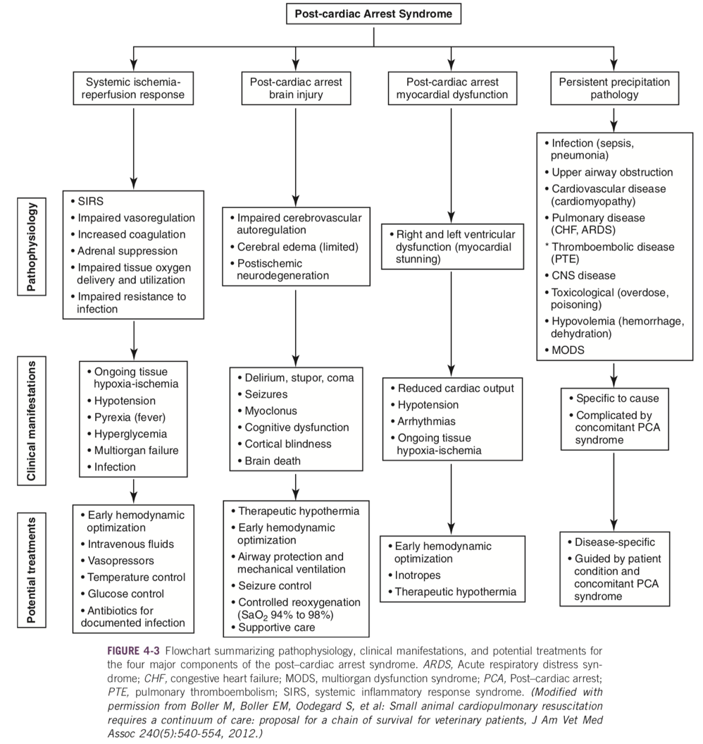
- Systemic response to IR: sepsis-like syndrome
  - Accumulated oxygen debt during CPA and ROSC leads to endothelial activation and systemic inflammation, and is predictive of MODS and death
  - Similar to severe sepsis in regard to inflammation, coagulation and endothelial damage
  - High concentrations of TNF-alpha, IL6, IL9, IL10
  - Treatment considerations:
    - Hemodynamic optimization
      - EGDT has been implemented for PCA care in people
      - Treat to (1) optimize oxygen delivery and (2) decrease tissue oxygen demand (eg ventilation, sedation, NMB, temperature control)
      - RECOVER endpoints
        - CVP 0-10mmHg
        - MAP 80-120
        - ScvO2 >70%
        - BUT Elevated scvo2 secondary to impaired tissue oxygen utilization is common after high dose epi
        - Lactate <2.5
        - Single post ROSC value not useful as will be elevated from ischemia
        - Clearance more important, but may be decreased with hypothermia
        - UOP
        - Will be higher in patients with therapeutic hypothermia
        - Markers of vasodilation, and echo for LV function should also be considered
        - Give fluids, vasopressors and inotropes accordingly
        - Hemoglobin goals not defined
    - Glycemic control
      - Hyperglycemia post arrest in people is associated with worse outcomes
      - Hyperglycemia experimentally worsens canine ischemic brain injury
      - In humans moderate (not tight) glycemic control (<180) is recommended PCA
    - CIRCI
      - Steroids are important for regulating vascular tone and endothelial permeability
      - CIRCI/RAI after ROSC is associated with increased mortality in people
      - No direct evidence for corticosteroid administration in PCA care
        - Risk of infection, ulcer, exacerbating neurologic injury
      - Routine not recommended, but low dose hydrocortisone can be considered in dogs/cats with vasopressor dependent shock
- Post-cardiac arrest brain injury
  - Cerebral dysfunction is most common cause of death in PCA care people
  - Occurs from cerebral IR, much of damage hours to days after injury
    - During ischemia ATP stores in brain depleted in 2-4mins (vs 20-40mins in myocardium)
    - Most injury occurs during reperfusion
    - Calcium overload -> neuronal death and ROS
    - ROS burst in reperfusion -> oxidative damage to cells
    - Both necrosis and apoptosis occur to varying degrees
    - Autoregulation of flow is impaired for some time after ROSC
    - No-reflow may occur -> poor microvascular perfusion despite adequate CPP post ROSC, frequently from intravascular thrombosis
    - May also have increased macroscopic flow from elevated CPP and failed autoregulation -> edema, worsened reperfusion injury

Describe some therapeutic strategies to minimize progression and severity of post-cardiac arrest brain injury

Controlled reoxygenation, mild therapeutic hypothermia, normocapnea, hypertension, limit seizures,
  - Controlled re-oxygenation
    - Excessive ROS production and exhaustion of protective mechanisms -> damage to lipids, DNA and proteins
    - Arterial hyperoxemia after ROSC increases oxidative brain injury and worsens neurologic outcomes and survival
      - Canine experimental study target of SpO2 94-96% (PaO2 80-100) is ideal for improved neurologic outcomes and reduced neuronal degeneration
  - Mild therapeutic hypothermia
    - Beneficial in OHCA, unclear for IH
    - Mechanisms:
      - Reduced mitochondrial injury
      - Decreased cerebral metabolism
      - Reduced calcium inflow into cells
      - Reduced neuronal excitotoxicity
      - Reduced ROS production
      - Reduced apoptosis
      - Suppression of seizure activity
    - Reduced to 32-34C (89.6-93.2F)
    - The sooner the better
    - Optimal duration unknown
      - Likely better longer in more severely injured
      - Dogs recommend 24-48hrs, then rewarm by 0.25-0.5C per hour

List some potential complications of mild therapeutic hypothermia

    - Complications include: Shivering (increases metabolic rate), coagulopathy, diuresis, arrhythmias, increased systemic vascular resistance -> reduced cardiac output, hyperglycemia, immunosuppression (increased infection eg pneumonia)
    - Ensure adequate sedation/NMB otherwise shivering and increased muscle tone will negate benefits
    - In people adverse effects did not alter mortality
    - Use with care if sepsis or coagulopathy already present
    - Even if not doing MTH consider
      - Not rewarming hypothermic patients
      - Preventing fever and hyperthermia as this is associated with increased mortality

Critical Care Medicine 2011

- Retrospective observational study
- All Dutch hospitals, looked at outcomes in out-of hospital arrest prior to implemtation of MTH, and post
- 5317 patients
- Excluded those with GCS>8
- Recommendations:
  - Use MTH (32°C–34°C) for 12–24 hrs in comatose patients after out-of-hospital cardiac arrest following VF, with an arrest shorter than 15 mins
  - Start cooling as soon as possible after the return of spontaneous circulation
  - The target mean arterial pressure is between 90 and 100 mm Hg
  - Use passive rewarming
  - Avoid hyperthermia
- Implementation of mild therapeutic hypothermia in Dutch intensive care units is associated with a 20% relative reduction of hospital mortality in cardiac arrest patients.

- 2013
- 950 patients unconscious after out of hospital arrest, randomized to 33 or 36C
- No difference in mortality or neurologic outcome

  - Other neuroprotective strategies
    - Post CPA seizures can occur (in people in 5-15% of PCA period, and in 40% of comatose PCA patients)
      - In humans this is associated with worse outcomes
      - Non-convulsive status is common
      - Seizures increase cerebral oxygen demand
      - No benefit to seizure prophylaxis shown
      - Consider prophylactic barbiturates if comatose or sedated
    - Cytotoxic and vasogenic cerebral edema also worsens outcomes in people
    - Intracranial hypertension is rare but significantly compromises CPP when present
      - Consider mannitol or hypertonic saline (no evidence to support)
    - Supranormal CPP is beneficial
      - RECOVER identified benefit for neurologically intact survival with mild hypertension (drug induced)
      - MAP >150
    - CO2 responsiveness or cerebral arteries abolished for several hours in prolonged ischemia, but maintained with mild damage
      - Hyperventilation worsens outcomes in these patients
      - Target normoventilation
  - No data about monitoring or targeting ICP (sustained elevations in ICP are uncommon)
  - Avoid hyperglycemia
  - Neuro assessment and prognostication
    - Repeat exam every 2-4hrs
    - MGCS can be used to tract status, but not validated for this indication
    - In people neuro state in first 24hrs not reliable predictor of outcome
    - Good neuro status is good prognostic indicator, but poor neuro status doesn’t mean anything
    - But 24-72hrs coma and absent PLR increased likelihood of poor outcomes
    - After 3d if no PLR and Coma reliably predict failure to regain consciousness
    - Elevated CSF neuron-specific enolase is associated with poor neurologic outcome
    - Imaging not validated for prognostication

Explain the concept of post-cardiac arrest myocardial dysfunction

- Myocardial dysfunction
  - Characterized by:
    - Increased CVP and PCWP
    - Reduced left and right sided ventricular function
    - Reduced LV ejection fraction and cardiac output
    - Normal coronary blood flow
    - Ventricular tachyarrhythmia
    - In severe cases -> cardiogenic shock
  - =myocardial stunning (not necrosis) secondary to IR
  - Reversible, resolves within 24-48hrs
  - Severity depends on extent of ischemia as well as conditions of reperfusion
  - No-reflow of myocardial capillaries may also occur
  - MD worsened by:
    - Epinephrine intra-arrest
    - High energy/monophasic defibrillation
  - Can be attenuated by hypothermia, no other treatments effective in reducing occurrence
  - Dobutamine improves LV function and CO
- Other therapies post-arrest
  - Metabolic protectants
    - Eg ethyl pyruvate, PARP inhibitors, mitochondrial protectants, anti-oxidants
    - Early stages of investigation in lab
    - A number have showed promise but have not evaluated effect on survival or any clinical evidence
  - Hemodilution
  - Sedation/NMB (minimal data – mostly recommended to facilitate therapeutic hypothermia)
  - May have better outcomes when treated at specialty facilities with more experience and intensive care

