Introduction
- Pancreatitis is the most common disorder of exocrine pancreas in both dogs and cats
- Pancreatitis = inflammation (infiltration with inflammatory cells) of exocrine pancreas
  - Term pancreatitis is commonly expanded to include necrosis (necrotizing pancreatitis) or irreversible structural changes such as fibrosis (chronic pancreatitis)
- Develops when there is excessive activation of trypsin and other pancreatic proteases within the pancreas, which overwhelms local safeguards within acinar cells
  - Initial activation may be due to oxidative stress or hypotension
  - Trypsin and chymotrypsin directly stimulate migration of neutrophils to pancreas with subsequent production of reactive oxygen species, nitric oxide, cytokines, and activation of other pathways that further perpetuate inflammation in the pancreatic area
- Reported mortality rate for severe acute pancreatitis in dogs range from 27-42%

Signalment and risk factors
- Any age, breed, or sex
  - Most are middle aged
  - Miniature schnauzers and terrier breeds (especially yorkies) are increased risk in USA
  - Cocker spaniels, Cavalier king charles, border collies, and boxers increased risk for chronic pancreatitis in UK
- Majority of cases considered idiopathic
- Risk factors:
  - Hypertriglyceridemia, endocrine diseases, prior surgery, infections, and dietary factors

Clinical signs and PE findings
- Clinical signs vary greatly
  - Subclinical signs, mild signs such as intermittent anorexia and weakness with no GI signs
  - Typically can present with one or more of the following clinical sings and in various combinations: acute onset anorexia, weakness, vomiting, diarrhea, and/or abdominal pain
  - Severe acute pancreatitis might even present with hypovolemic shock, DIC, or multi-organ failure
  - Cats may present with anorexia and/or lethargy but GI signs are less common
- PE
  - Dehydration, abdominal pain, icterus, fever or hypothermia, bleeding diathesis, or ascites

Routine Clinical Pathology
- CBC/chem/UA changes in pancreatitis are non-specific and therefore non-diagnostic for pancreatitis– however should still be performed for diagnosis or exclusion of other concurrent disease
- CBC: anemia or hemoconcentration, leukocytosis or leukopenia, thrombocytopenia
- Chem
  - Different combinations of increased in liver enzyme activity and hyperbilirubinemia are common
    - May be associated with extrahepatic biliary tract obstruction
    - In cats, concurrent IBD, cholangitis or heptic lipidosis
  - Variably present azotemia, most often associated with dehydration but severe cases of pancreatitis, azotemia might be result of concurrent renal failure
  - Hypoalbuminemia, hypertriglyceridemia, hypercholesterolemia, hyper/hypoglycemia
  - Hypokalemia, hypochloremia, and hyponatremia
  - Evidence of coagulopathy (prolonged ACT, PT, PTT) can be seen in some cases

Serum tests of pancreatic function and pathology
- Pancreatic lipase immunoreactivity (PLI) assays
  - Considered the most sensitive and specific serum test of diagnosis of pancreatitis in both cats and dogs.
  - Pancreatic lipase is exclusively of pancreatic origin so this immunoassay measures pancreatic lipase concentration in serum to quantify exclusively lipase of pancreatic origin
    - In contrast to traditional activity assays for lipase, which indiscriminately measures activities of lipases of multiple origins
  - More widely available immunoassay is Spec cPL for dogs and Spec fPL for cats
    - Spec cPLI normal reference interval 0-200ug/L; grey zone 201-399 ug/L; and ≥400 ug/L considered highly suggestive of pancreatitis
    - Spec fPLI normal reference interval 0-3.5ug/L; grey zone 3.6-5.3 ug/L; and ≥5.4 ug/L considered highly suggestive of pancreatitis
    - Results can take 24 hours to come back
  - Sensitivity cPLI between 72-78% and fPLI 79%
  - Canine and feline SNAP PL is rapid, in-clinic, semi-quantitative, visually read test for estimation of pancreatic lipase in serum
    - Recent validation study showed there is 90-100% agreement between SNAP cPL and Spec cPL; 82-92% between SNAP fPL and Spec fPL
    - Results incorporates a reference spot that corresponds to upper limit of reference interval (200ug/L for canine, 3.5ug/L for feline)
    - Result is either normal (less intense than reference spot) or abnormal (equal or more intense that reference spot)
      - This assay unable to determine between gray zone (200-400 ug/L) and consistent with pancreatitis (≥400ug/L) so this diagnostic tool is to rule out pancreatic (ie normal test makes diagnosis of pancreatitis very unlikely)
  - Recently VetScan cPL Rapid was developed, with aim of combining benefits of quantitative assay with point-of-care benefits of SNAP cPL
    - Semiquantitative immunoassay
    - Unlike SNAP cPL which is a binary assay, VetScan cPL results are numerical
    - Can be used to distinguish among patients without pancreatitis (≤200ug/L), those with equivocal results (201-399ug/L), and those with cPL results consistent with pancreatitis (≥400ug/L)
    - Must be used with VetScan VUE from Abaxis
    - Sensitivity 73.9-83.3% and specificity 76.9-83.8%
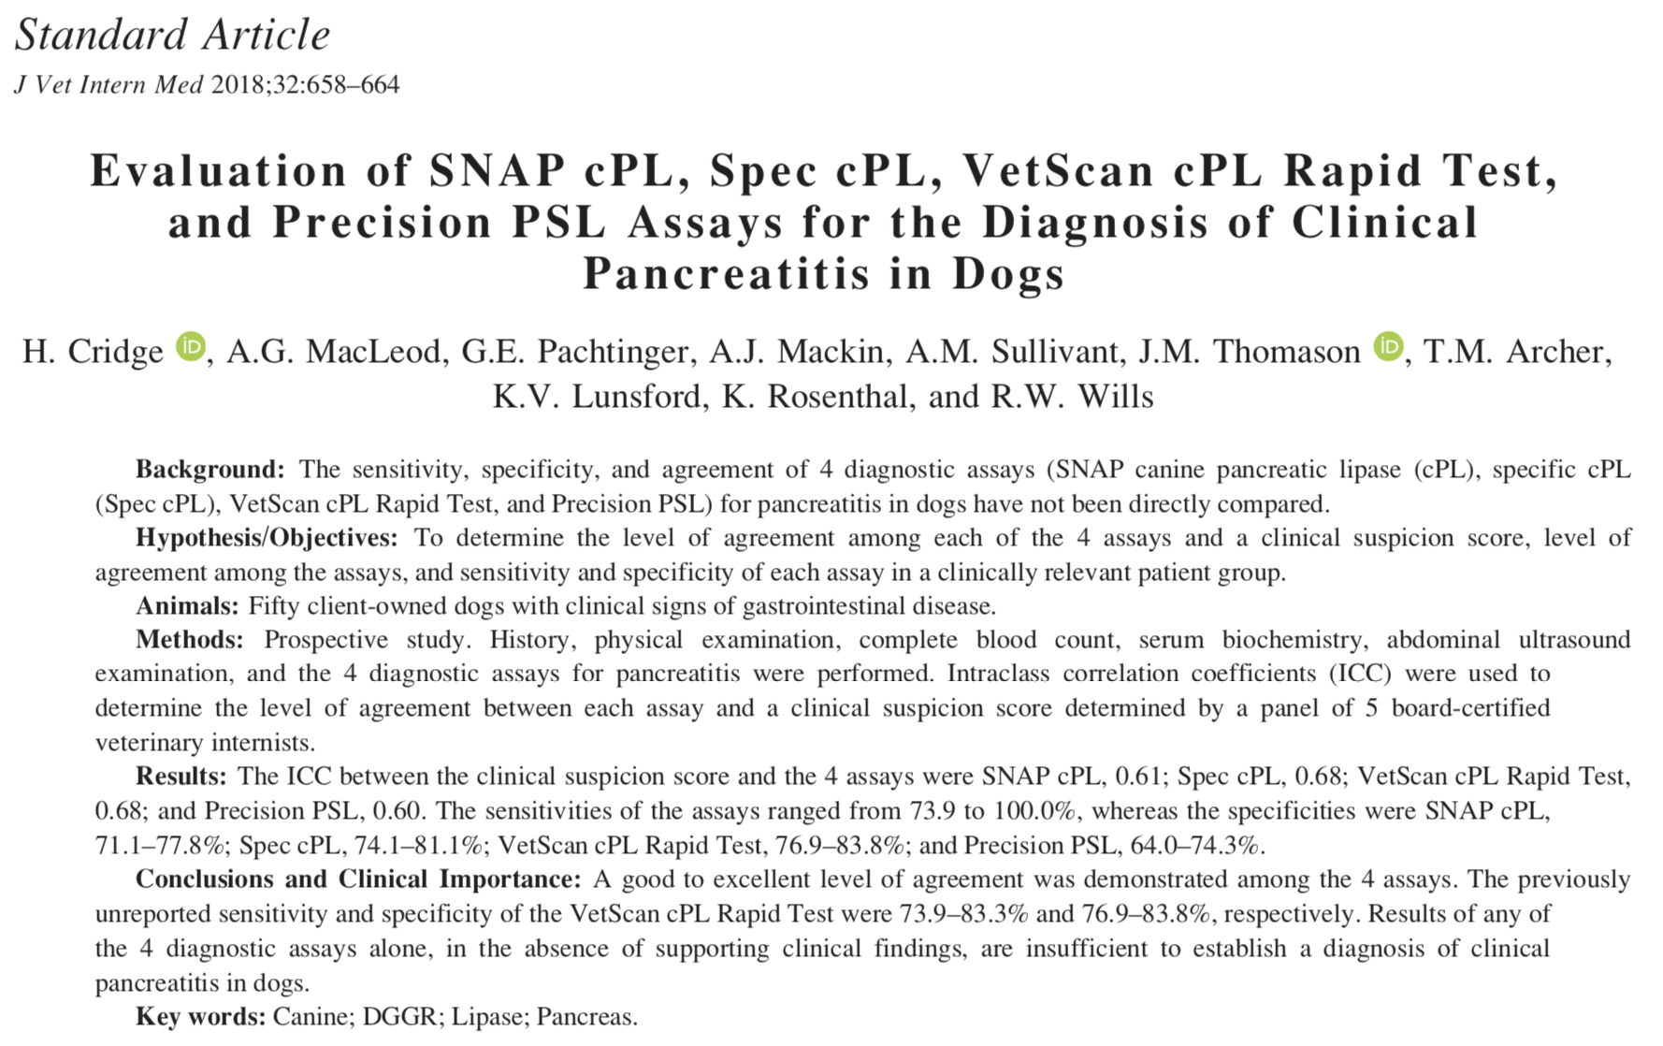

- Trypsin-like immunoreactivity (TLI)
  - Immunoassay measures trypsinogen and, to lesser extent, trypsin concentrations in serum
  - Limited usefulness for diagnosis of pancreatitis
    - Sensitivity low (36-47%) possibly due to short half-life of trypsinogen in serum
- Serum amylase and lipase activity
  - Also very low sensitivity and specificity, so should not be used for diagnosis of pancreatitis
  - Many other tissues such as gastric mucosa and hepatic parenchyma synthesize amylases and lipases
  - Recently, a new lipase activity assay (DGGR) using the substrate 1,2-o-dilauryl-rac-glycero glutaric acid-(6 ́methyl resorufin)-ester was validated for use in dogs and cats.
    - Multiple studies show substantial agreement between this assay and Spec PL assays
    - Shows promise as a test to aid in diagnosis of pancreatitis
- Other diagnostic markers
  - Studies of serum pancreatic elastase-1 concentrations in serum and trypsinogen activation peptide (TAP) concentrations in plasma and urine show some promise as well

Diagnostic Imaging
- Abdominal radiographs
  - Logical initial approach useful for the diagnosis and/or rule out of other diseases
  - When pancreatitis is on the list, other test needed to confidently diagnose or rule out pancreatitis
  - Typically normal or only show non-specific signs
  - Such findings include increased soft tissue opacity and decreased serosal detail in cranial right abdomen, displacement of stomach and/or duodenum, gaseous dilation of bowel loops adjacent to pancreas, and abdominal effusion
- Abdominal ultrasound
  - Considered the imaging method of choice for diagnosis of pancreatitis
    - Also useful to diagnosis or rule out other diseases that cause similar clinical signs
  - Diagnosis of pancreatitis via AUS highly dependent on expertise of ultrasonographer and quality of equipment used
  - Limited number of studies that have systematically evaluated performance of AUS for diagnosis of pancreatitis, with most studies more than a decade old.
  - Ultrasonographic findings for pancreatitis include:
    - hypoechoic areas within pancreas (possibly indicating necrosis or fluid accumulation)
    - hyperechoic areas of pancreas (possible indicating pancreatic fibrosis)
    - increased echogenicity of surround mesentery (due to necrosis of peripancreatic fat)
    - enlargement and/or irregularity of pancreas
    - dilation of pancreatic or biliary duct
    - abdominal effusion
- Other imaging modalities
  - Contrast-enhanced computed tomography (CECT) used in human patients with suspected pancreatitis, but not thoroughly investigated in cats and dogs
  - Recent study evaluating MRI and magnetic resonance cholangiopancreatography for diagnosis of pancreatitis in cats reported promising results

What is considered the gold standard for diagnosis of pancreatitis?

Histopathology of pancreas
- Considered gold standard for diagnosis of pancreatitis, but not ideal due to several limitations
- Definitive differentiation between acute and chronic pancreatitis
  - Presence of permanent histopathological changes (fibrosis and acinar atrophy) considered suggestive of chronic pancreatitis
  - Absence of such changes in inflamed pancreas indicates acute pancreatitis
- Predominant inflammatory cellular infiltrate (neutrophils or lymphocytes) further divide pancreatitis into suppurative or lymphocytic
  - Suppurative inflammation compatible with acute disease
  - Lymphocytic inflammation compatible with chronic disease
- Limitations
  - Clinical significance of histopathological findings difficult to determine
    - No standardized criteria that distinguish microscopic findings to clinical disease
    - Therefore, clinically insignificant pancreatic lesions could lead to false diagnosis of clinical pancreatitis
  - Exclusion of pancreatitis based on histopathology difficult because inflammatory lesions of pancreas are often highly localized and can easily be missed
  - Pancreatic biopsy requires invasive procedures that are expensive and potentially detrimental in patients that are hemodynamically unstable
  - Common complications of surgical biopsy of pancreas include vomiting, abdominal pain, nausea, anorexia, and lethargy

Cytology of pancreas
- Minimally invasive test, usually performed under ultrasound guidance or during laparotomy
- Acute pancreatitis: hypercellularity and presence of entire and degenerate neutrophils and degenerate pancreatic acinar cells
- Chronic pancreatitis: small number of lymphocytes and neutrophils, usually characterized as low cellularity
- Highly localized lesions may be missed, so negative FNA cytology results not sufficient to rule out pancreatitis

Assessment and prediction of severity of pancreatitis
- Serum PLI and TLI concentrations lack prognostic significance because they correlate poorly with histopathological severity
- Severity of pancreatitis determined by clinician’s clinical judgment
- Severe pancreatitis diagnosed typically after animal has entered critical stage
  - Systemic complications such as oliguria, renal azotemia, icterus, severely elevated liver enzyme activity, hypocalcemia, hypoglycemia, severe hyperglycemia, hyperkalemia, leukocytosis, shock, or DIC
  - Poor prognosis
- Recent study serum paraoxonase 1 activity together with triglyceride and C-reactive protein concentrations suggested to represent disease severity

Treatment (Mansfield - Journal of Small Animal Practice 01/2015)
- Intravenous fluid therapy
  - Crystalloids mainly used in pancreatitis for correction of dehydration or hypovolemia
    - There is a theoretical benefit in using alkalinising crystalloid fluids, such as lactated Ringer’s solution (LRS), to increase pH and therefore prevent further trypsin activation within the acinar cell
  - Colloids and hypertonic saline may be beneficial in those with severe disease
  - Plasma transfusion purported benefit include replacement of circulating α-macroglobulins, coagulation factors, and anti-inflammatory factors.
    - No proven benefit in humans or in dogs
    - Considered if coagulopathy develops
- Antiemetics
  - Vomiting due to pancreatitis is likely both centrally and peripherally mediated
  - Even dogs not showing overt signs of nausea or vomiting should be treated with an anti-emetic, especially in early stages to encourage voluntary eating
  - Maropitant blocks neurokinin-1 (NK1) receptor and substance P production (so blocks both centrally and peripherally mediated emesis)
  - Additional anti-emetic agents such as serotonergic antagonists (ondansetron) can be added
- Antibiotics
  - Used for treatment of infected pancreatic necrosis or treatment of bacterial translocation, prophylactic antibiotics without signs is not recommended
    - Bacterial translocation has been documented in experimentally induced pancreatitis but not definitively documented in naturally occurring disease
    - Poor gut mucosal health (melena or hematochezia) combined with prolonged fasting and/or hypotension could increase suspicion of bacterial translocation.
- Gastric acid suppression and Nasogastric suctioning
  - Proposed that reduction of gastric acid production could lead to decreased pancreatic exocrine stimulation.
  - Currently no evidence that reducing gastric acidity improves outcome in dogs with pancreatitis
  - If clinical evidence of gastric ulceration or esophagitis, gastric acid suppression is indicated and proton pump inhibitors have be shown to be most effective at increasing gastric pH for longest period of time.
  - Multiple randomized clinical trials have been done for assessing NG sunctioning in humans with mild to moderate pancreatitis with no shown benefit and maybe showed prolonged pain and nausea
- Corticosteroids
  - There may be a potential reason for using low-dose hydrocortisone in dogs with severe pancreatitis that have poor systolic pressures and minimal response to fluid resuscitation; however, it is believed that optimisation of other aspects of management should be completed before corticosteroid therapy is carried out.

- Analgesia
  - Pain is a common clinical sign of pancreatitis, typically seen as crouched appearance, guarding of abdomen on palpation
  - Mu-opioids (morphine, methadone, hydromorphone, fentanyl)
  - NMDA antagonist (ketamine)
  - Lidocaine
  - Tramadol
  - Gabapentin

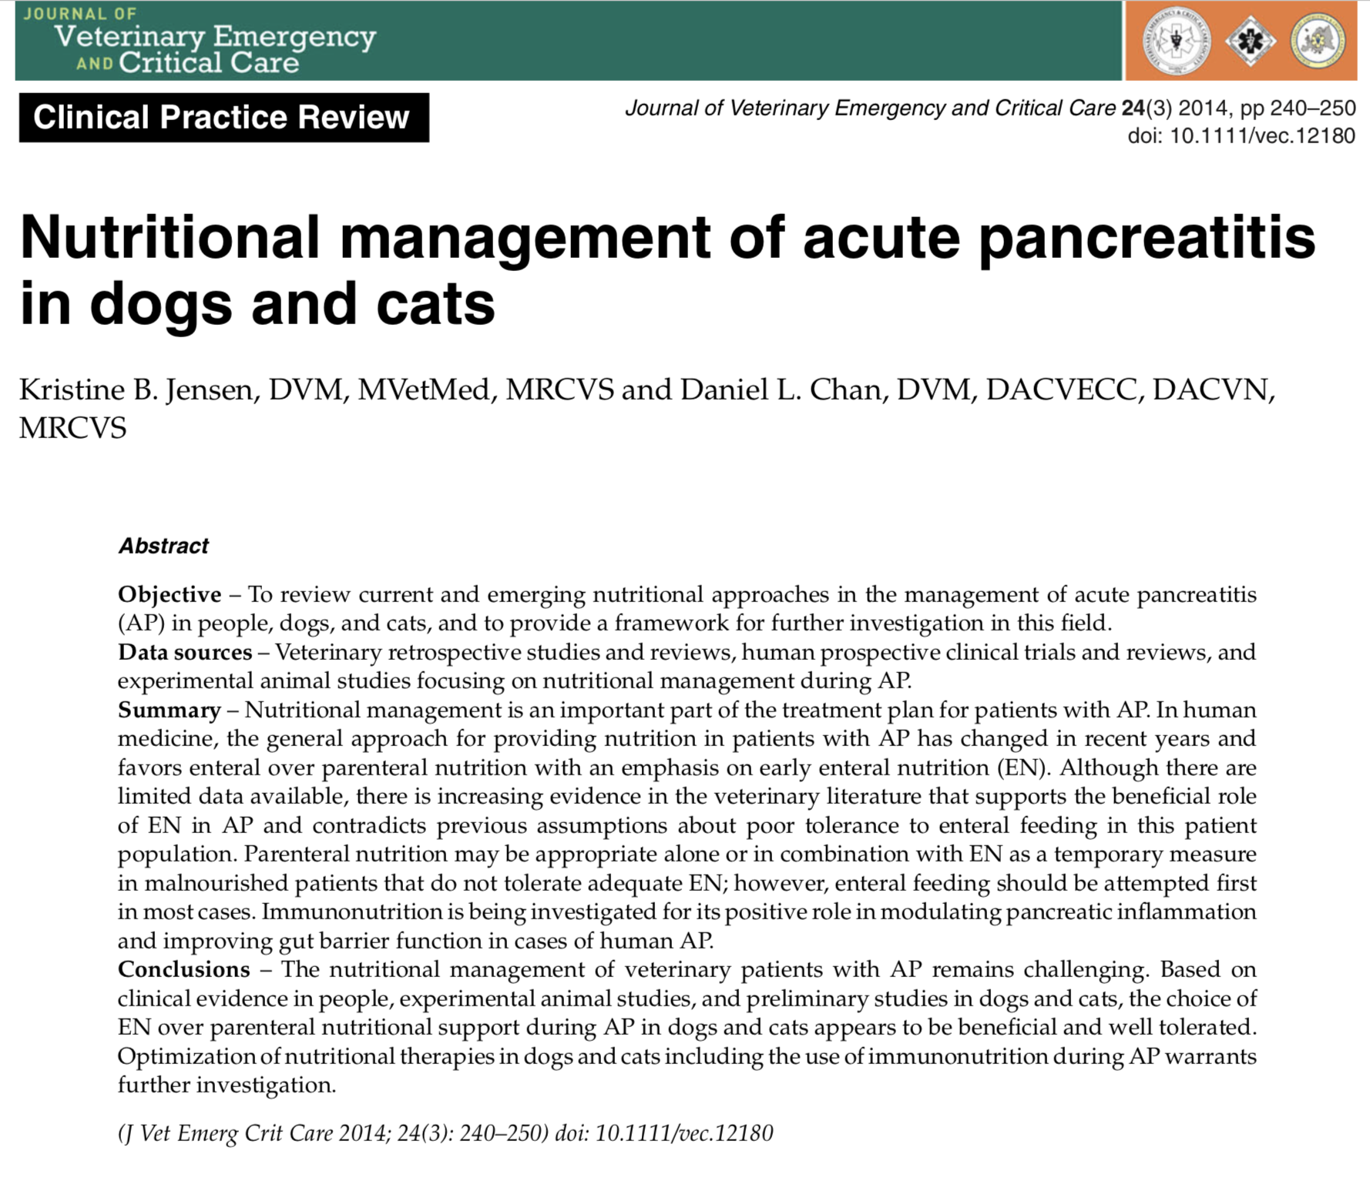
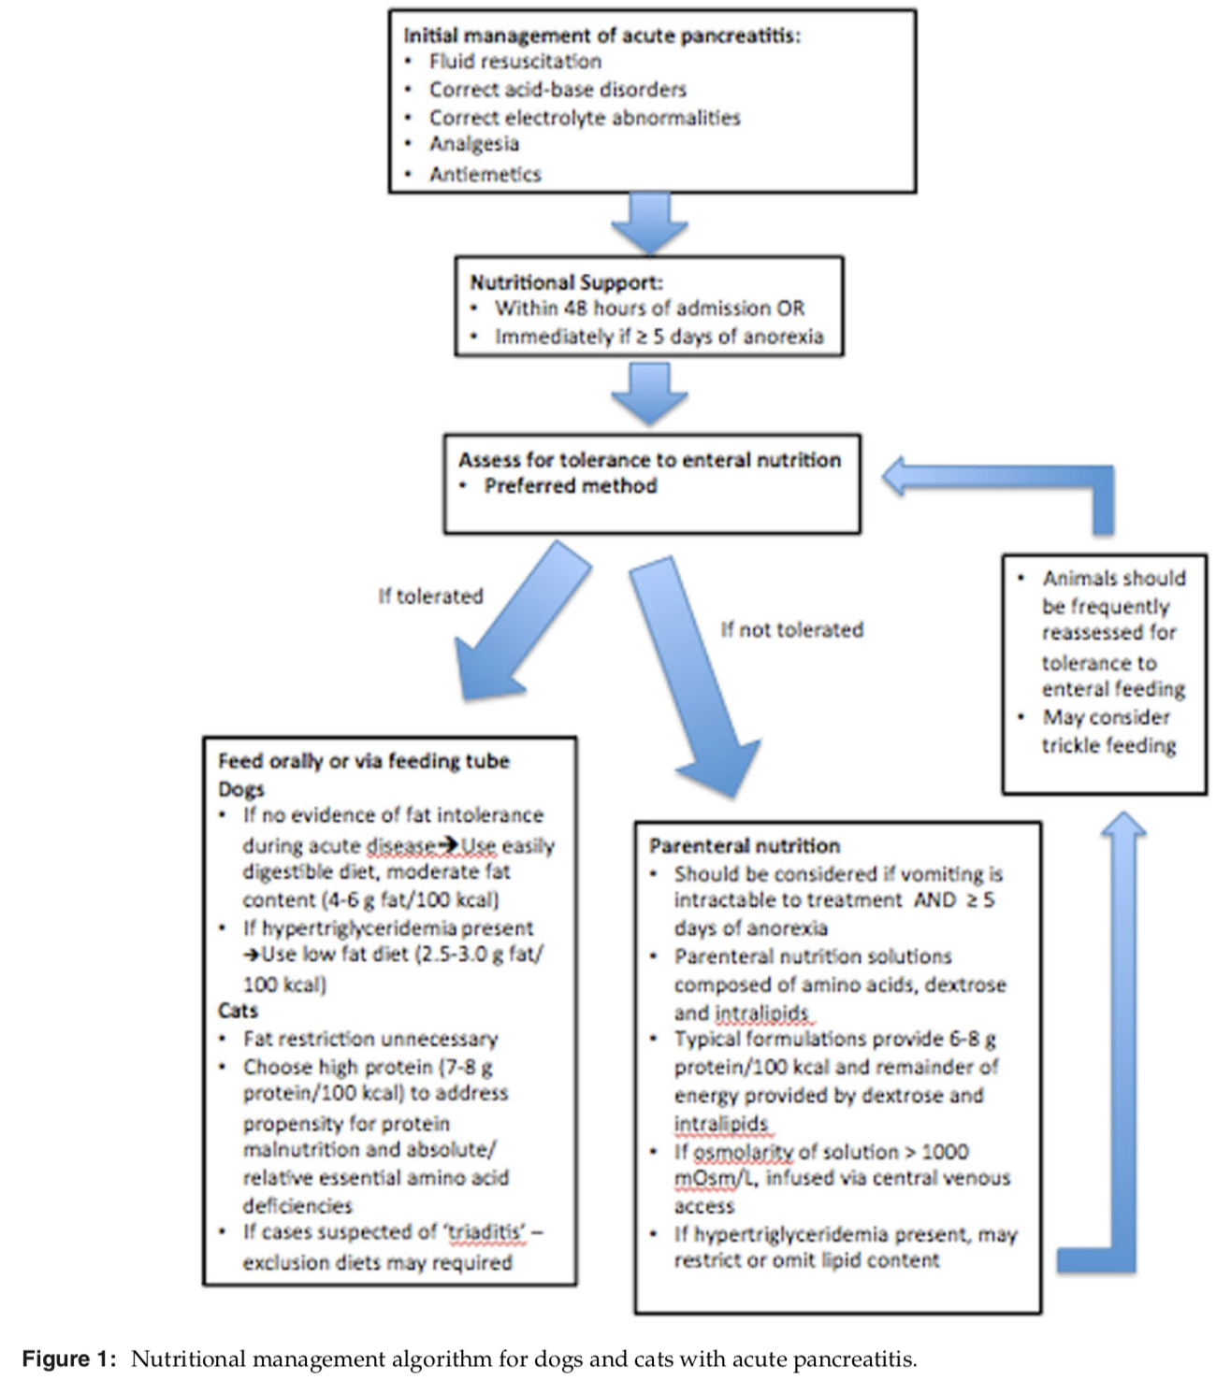

- Nutrition
  - Initially, the consensus was to “rest” the pancreas based on assumption that ongoing pancreatic secretion would perpetuate pancreatic inflammation
  - Now, it is thought that GI tract itself is a major contributor to systemic inflammatory state during pancreatitis if it is not supplied with luminal nutrients like amino acids
  - In human and animal experimental models, it has been shown that fasting leads to intestinal mucosal atrophy, increased rate of enterocyte apoptosis in the intestines, changes in mucin composition, and decreased glutamine and arginine transport
  - Conversely, it has been shown that nutrition delivered directly to intestine decreased villus atrophy, reduced bacterial translocation, and decreased pancreatic inflammation in canine models of pancreatitis.
  - Medical consensus
    - Mild pancreatitis (no systemic complications): fast within 48 hours until they are able to eat voluntarily, unless they reached 5 days of anorexia, in which enteral feeding should be initiated immediately after
    - Severe pancreatitis: interventional feeding (through NG tube or esophageal feeding tube) should be instituted as soon as possible
  - Optimal enteral diet has not been identified
    - Avoidance of high-fat diets in dogs, especially in presence of hypertriglyceridemia; no evidence supporting fat restriction in diet of cats
  - Enteral nutrition preferred over parenteral nutrition whenever possible
  - In human medicine, typically nasojejunal feedings; but in veterinary medicine, NG tube is simple placement and more feasible option

- Parenteral nutrition
- Considered in patients with severe pancreatitis and intractable vomiting who do tolerate enteral nutrition
- The use of PN in experimental animal models has been associated with high risk of infection and gut atrophy, with subsequent risk of bacterial translocation and sepsis
- The most frequently cited complications of PN include metabolic disturbances such as hyperglycemia, hyperlipidemia, azotemia, hypophosphatemia, and mechanical issues related to technical aspects of PN administration.
- Therefore, monitoring clinical vital parameters, body weight, serum biochemistries, and catheter sites for evidence of complications should be performed regularly

- Energy requirements
  - Resting energy requirement (RER) represents the energy requirement of a normal but fed animal at rest in a thermoneutral environment
  - Current convention is to use Kleiber equation where RER = [body weight in kg]0.75 × 70 as starting point for initiating nutrition support
  - If patient has been anorexic for more than 3-5 days, it is recommended to start feeding at 1/3 RER on day 1 and gradually increase calories if tolerated to reach RER by day 3
    - This is to ensure tolerability to volume fed and decrease risk of metabolic complications such as vomiting, regurgitation, signs of abdominal pain, hyperglycemia, hypertriglyceridemia, and hypophosphatemia

- Emerging role of immunonutrition
  - Meta-analyses of use of immune-enhancing diets in critically ill people have shown reduction of hospital stay and infection rate, but no effect on mortality rate
  - There is increased evidence in human medicine that certain nutrients such as glutamine, arginine, and fatty acids play an important role in modulating metabolic, inflammatory and immune processes in pancreatitis
    - Pancreas has high protein turnover, and glutamine supplementation in animals has prevented atrophy of pancreatic acinar cells, improved pancreatic exocrine function, and improved outcomes following critical illness
      - Arginine is an essential amino acid in cats and dogs and an intermediary in urea cycle, which deficiency can lead to hyperammonemia and development of hepatic encephalopathy.
