Low Tidal Volumes & the PreVent Trial

- Risks of large tidal volumes?
  - volutrauma through alveolar overdistension
    - disruption of the pulmonary epithelium and endothelium
    - cellular death
    - failure of surfactant production
    - release of pro-inflammatory mediators
    - alveolar edema
    - hyaline membrane formation
    - interstitial hemorrhage
    - can lead to gross barotrauma (air leaks)
- Risks of low tidal volumes?
  - Hypoxemia
  - Respiratory acidosis
  - Atelectrauma – injury from opening and closing of lung units
    - Avoided in low volume ventilation strategies through high PEEP and recruitment maneuvers
    - Increased stretching forces (shear forces) at margins between aerated lung and atelectic lung
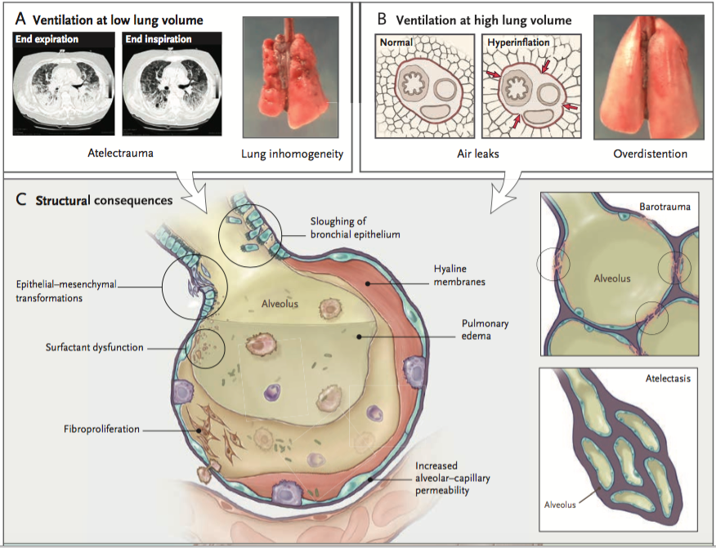
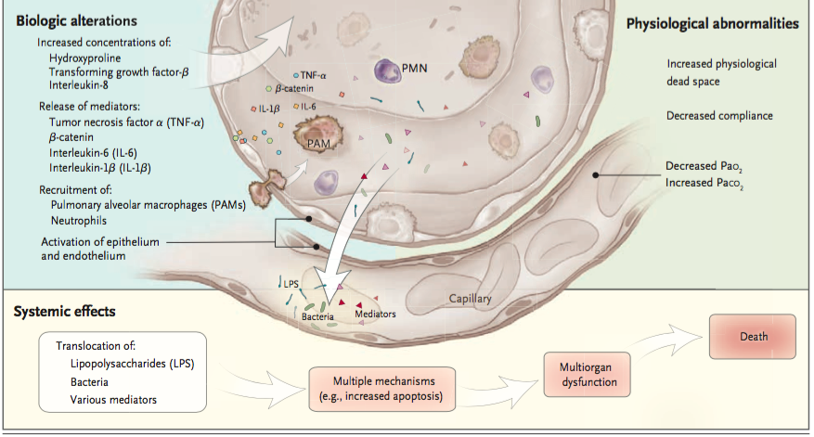

Patients with ARDS have relatively non-aerated dependent lung regions and aerated nondependent lung regions. Given the small volume available for ventilation, this condition is referred to as “baby lungs”. As such, low tidal volume ventilation strategies are recommended in acute respiratory distress syndrome (ARDS) ...

Tidal volume recommendations: <6-8 mL/kg
Plateau pressure recommendations: <30 cm H20

These recommendations are based from the following studies:

Acute Respiratory Distress Syndrome Network, Brower RG, Matthay MA, et al. Ventilation with lower tidal volumes as compared with traditional tidal volumes for acute lung injury and the acute respiratory distress syndrome. N Engl J Med. 2000;342(18):1301-1308. doi:10.1056/NEJM200005043421801.
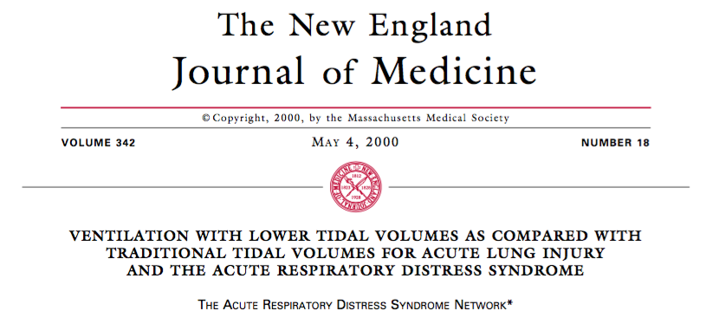
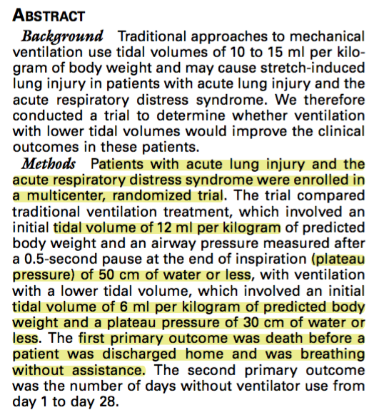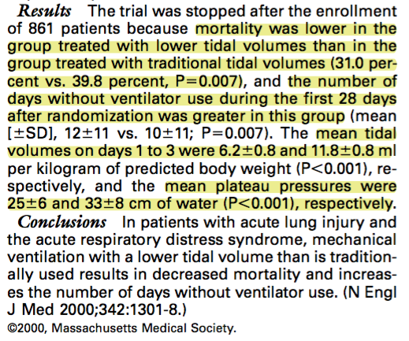

Needham DM, Yang T, Dinglas VD, et al. Timing of low tidal volume ventilation and intensive care unit mortality in acute respiratory distress syndrome. A prospective cohort study. Am J Respir Crit Care Med. 2015;191(2):177-185. doi:10.1164/rccm.201409-1598OC.
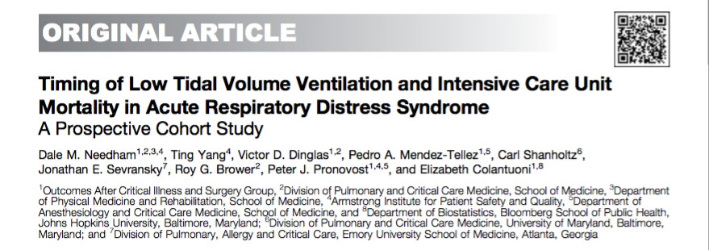
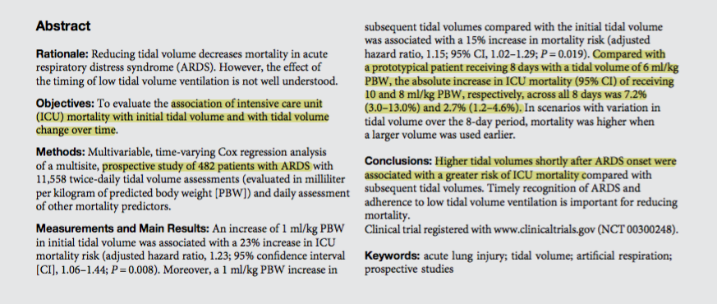

It is less clear as to whether tidal volume restriction benefits patients without ARDS (most patients that are ventilated!) ….
Lee PC, Helsmoortel CM, Cohn SM, Fink MP. Are Low Tidal Volumes Safe? CHEST. 1990;97(2):430-434. doi:10.1378/chest.97.2.430.
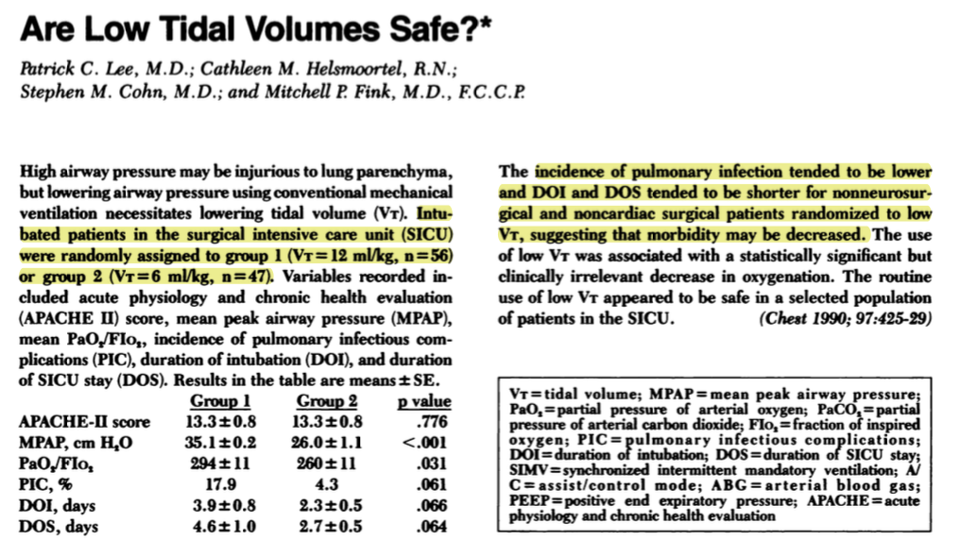

Determann RM, Royakkers A, Wolthuis EK, et al. Ventilation with lower tidal volumes as compared with conventional tidal volumes for patients without acute lung injury: a preventive randomized controlled trial. Crit Care. 2010;14(1):R1. doi:10.1186/cc8230.
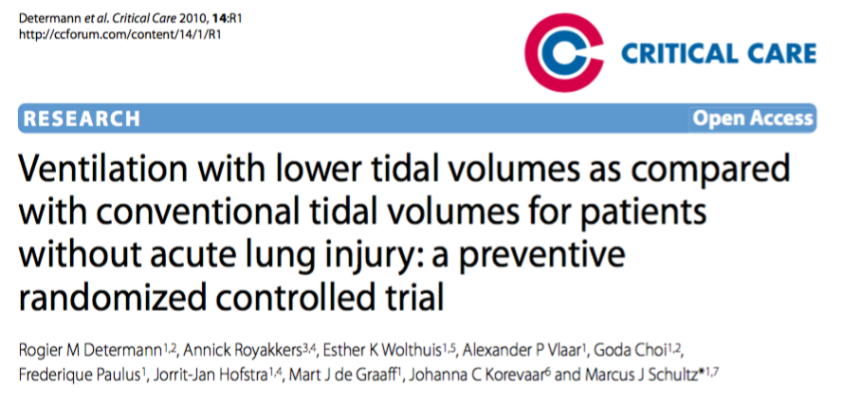
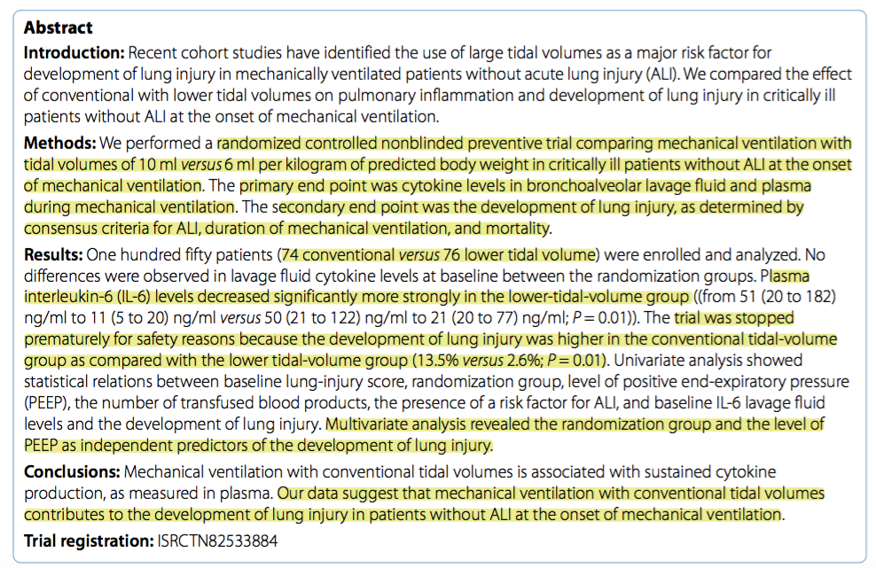
Various systematic reviews to support the use of low tidal volumes compared to high tidal volumes in non-ARDS patients…
Serpa Neto A, Simonis FD, Barbas CSV, et al. Association between tidal volume size, duration of ventilation, and sedation needs in patients without acute respiratory distress syndrome: an individual patient data meta-analysis. Intensive Care Medicine. 2014;40(7):950-957. doi:10.1007/s00134-014-3318-4.

Neto AS, Simonis FD, Barbas CSV, et al. Lung-Protective Ventilation With Low Tidal Volumes and the Occurrence of Pulmonary Complications in Patients Without Acute Respiratory Distress Syndrome: A Systematic Review and Individual Patient Data Analysis. Critical Care Medicine. 2015;43(10):2155-2163. doi:10.1097/CCM.0000000000001189.

However, some studies indicate that lower tidal volumes may lead to greater patient-ventilator dyssynchrony, higher sedation requirement, and prolonged duration of mechanical ventilation
Ferguson ND. Low tidal volumes for all? JAMA. 2012;308(16):1689-1690. doi:10.1001/jama .2012.14509
Kallet RH, Campbell AR, Dicker RA, Katz JA, Mackersie RC. Effects of tidal volume on work of breathing during lung protective ventilation in patients with acute lung injury and acute respiratory distress syndrome. Crit Care Med. 2006;34(1):8-14. doi:10.1097/01.CCM .0000194538.32158.AF

Protective Ventilation in Patients Without ARDS = “PReVENT Trial”
Writing Group for the PReVENT Investigators, Simonis FD, Serpa Neto A, et al. Effect of a Low vs Intermediate Tidal Volume Strategy on Ventilator-Free Days in Intensive Care Unit Patients Without ARDS: A Randomized Clinical Trial. JAMA. 2018;320(18):1872-1880. doi:10.1001/jama.2018.14280.
OBJECTIVE:
Determine whether a low tidal volume ventilation strategy is more effective than an intermediate tidal volume strategy in patients without acute respiratory distress syndrome (ARDS)

STUDY DESIGN:
- RCT from 2014-2017 in 6 intensive care units in the Netherlands
- Patients without ARDS who received invasive ventilation shortly before or after admission to the ICU, who were not expected to be extubated within 24 hours
- Randomized within 1 hour of arrival to the ICU
- Exclusion criteria: presence of ARDS, <18 yrs age, pregnancy, ventilation >12hrs prior to admission to ICU, increased and uncontrollable intracranial pressure, history of pulmonary disease, new PTE, previously randomized in this trial

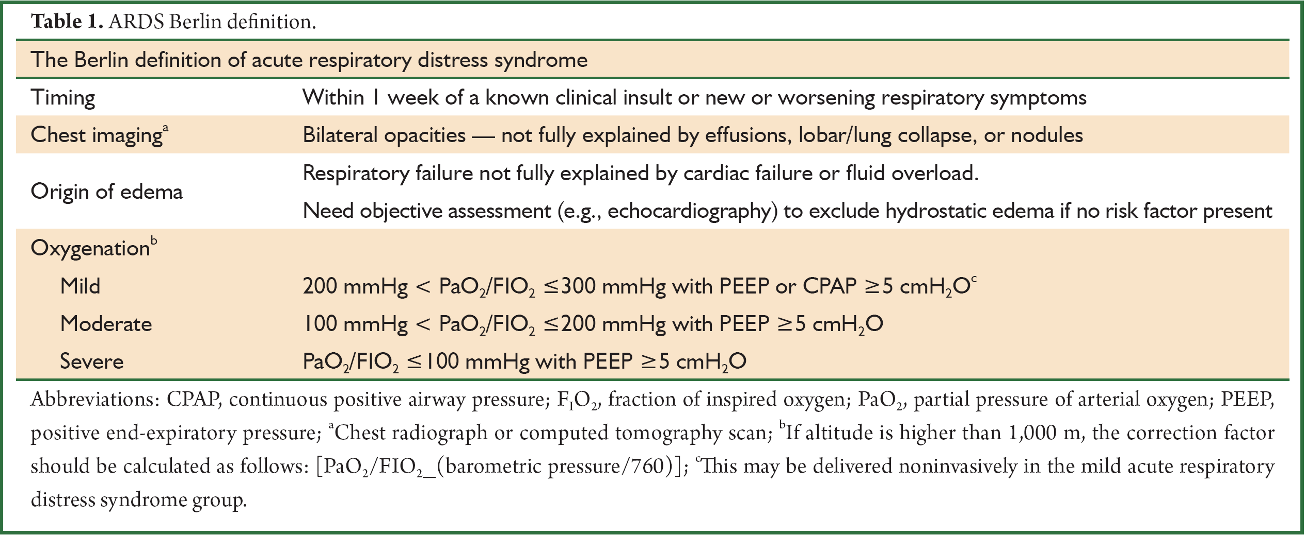

- Study groups (randomized in a 1:1 ratio):
  - Received either volume-controlled or pressure support ventilation
    - Volume control ventilation is TIME triggered, VOLUME limited, and VOLUME/TIME cycled. Breaths are MANDATORY (machine initiates, administers, and terminates)
    - Pressure support ventilation FLOW/PRESSURE triggered, PRESSURE limited, and FLOW cycled. Breaths are SPONTANEOUS but SUPPORTED (patient initiated, machine supported, patient terminates)
  - 1. Low tidal volumes (n = 477)
    - If volume controlled …
      - Started at 6 mL/kg (predicted body weight)
      - Decreased by 1 mL/kg every hour to a minimum of 4mL/kg
    - If pressure support…
      - the lowest level of pressure support was used to reach the target tidal volume with a minimum of 5 cmH2O
      - If at minimum pressure support and the tidal volume increased to more than 8 ml/kg, this was accepted
    - Tidal volume could be increased by 1 mL/kg/hr (in either volume controlled or pressure support) In cases of severe dyspnea, increasing levels of discomfort, respiratory rate > 35/min, uncontrollable acidosis, or patient-ventilator asynchrony
  - 2. Intermediate tidal volumes (n = 484)
    - If volume controlled…
      - Started at 10 mL/kg
      - If Pplat > 25 cm H2O, tidal volume was decrease in increments of 1 mL/kg/hr
    - If pressure support …
      - the pressure support level was adjusted to reach the target tidal volume while keeping maximum airway pressure < 25 cmH20
- Ventilator settings were checked at least every 8 hours and were readjusted as necessary
- Assigned ventilation strategies continued to maximum of 28 days
- Primary outcome: number of ventilator-free days and alive at day 28 (composite endpoint)
- Secondary outcomes:
  - length of ICU and hospital stay
  - mortality (ICU, hospital, 28-day, 90-day)
  - development of ARDS, ventilator-associated pneumonia, severe atelectasis or pneumothorax
  - amount of sedative prescribed, use of analgesics and neuromuscular blocking agents, transfusion of blood products, need for decreasing dead space, and occurrence of delirium

STATISTICS:
- Sample size of 476 patients per group estimated to have 80% statistical power to show a difference of 1 ventilator-free day at day 28 (estimated SD of 5 days), allowing for 20% dropout rate
- Additional subgroup analysis performed: with vs without pneumonia; with vs without sepsis; PaO2/FiO2 ≤200 vs >200; lung injury prediction score ≥4 vs <4; surgical vs medical admission; Simplified Acute Physiology Score ≥ 50 vs < 50; invasive ventilation > 6 hours before randomization vs ≤6 hours before; intubation inside versus outside the ICU

RESULTS - PATIENTS:
- 477 enrolled in low tidal volume group; 484 to the intermediate tidal volume group
- Baseline characteristics were similar between groups (Table 1)

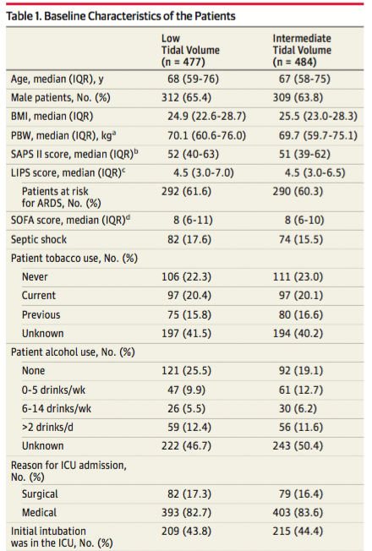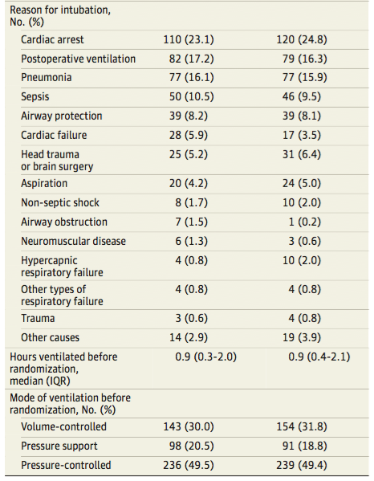
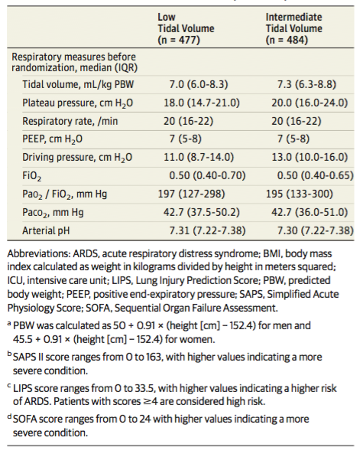

RESULTS - INTERVENTION:
- Median time between start of ventilation and randomization was 0.88 hours (IQR, 0.36-2.01); median time between start of ventilation in the ICU and randomization was 0.57 hours (IQR, 0.23-1.00)
- During the first 3 days of ventilation, tidal volumes and airway pressures were significantly different between the groups
  - Low tidal volume group:
    - Plateau pressures and driving pressure were lower
    - Respiratory rate was higher
    - PaCO2 was higher and arterial pH was lower
  - Minute ventilation, PEEP, PaO2 and FiO2 did not differ significant between groups
- Majority of patients managed in volume controlled mode day 1, but then most changed over to pressure support by day 2

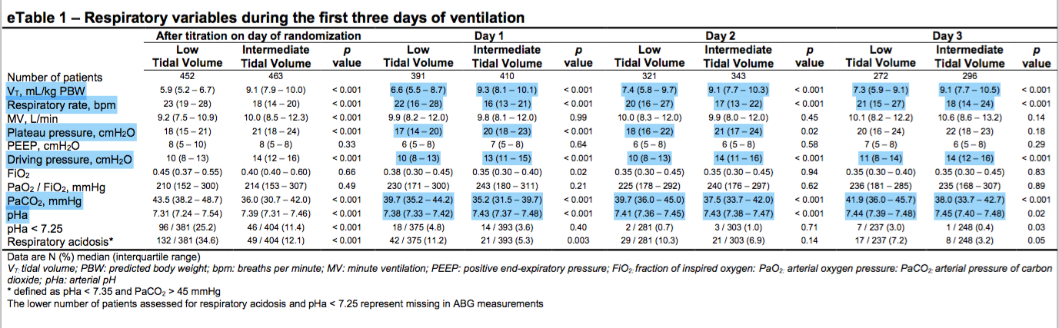

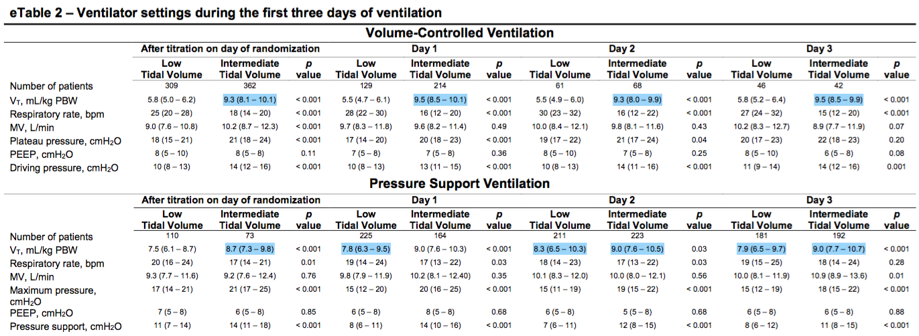

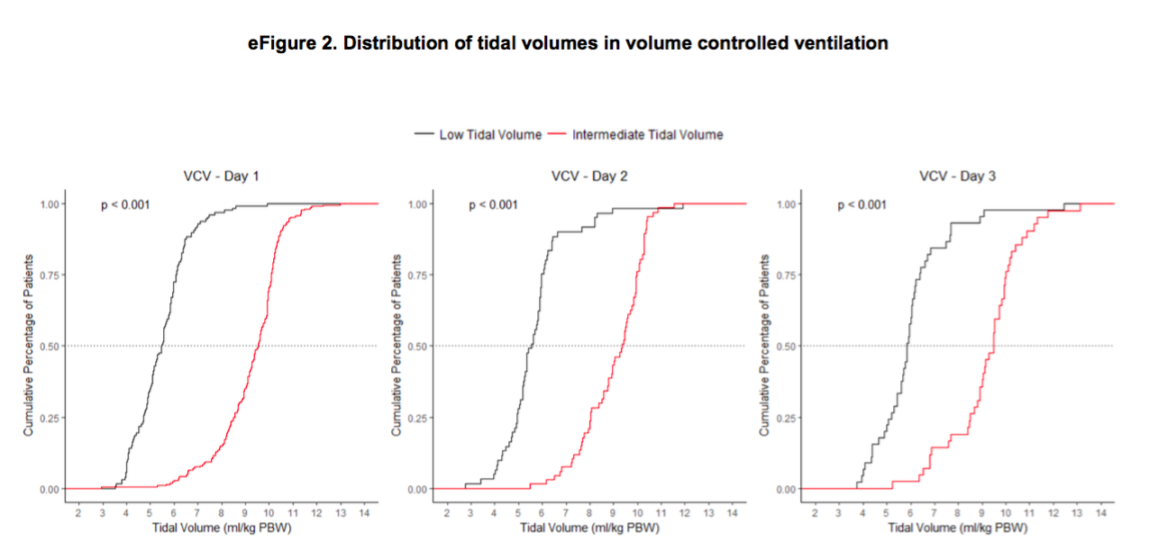
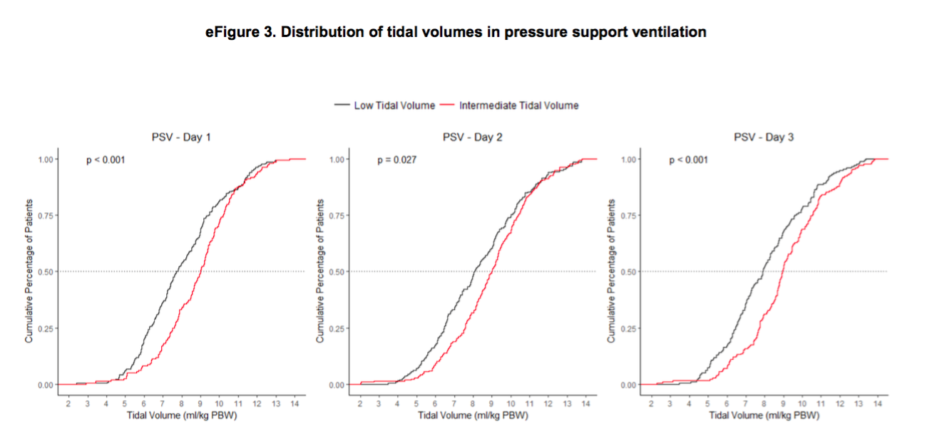

RESULTS – OUTCOMES:

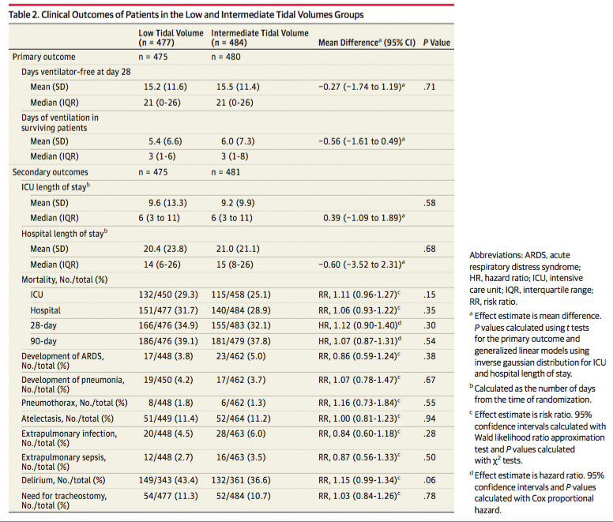

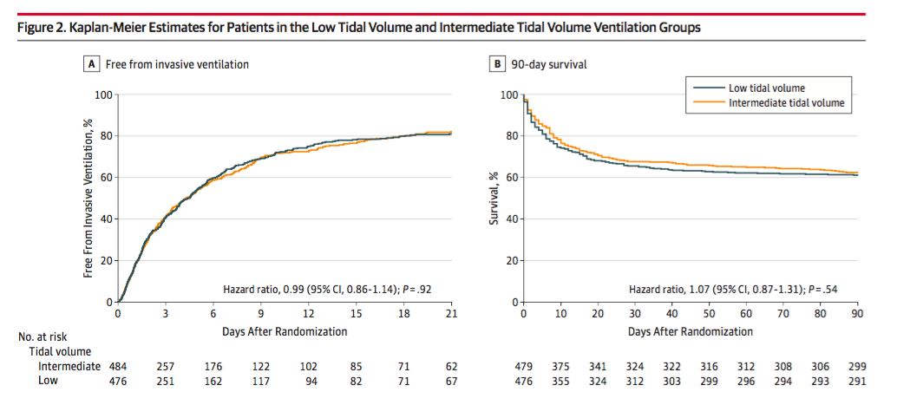
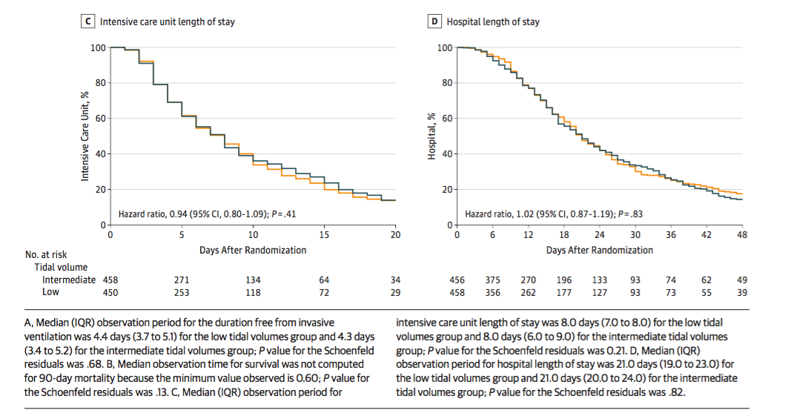

- At day 28 patients in both groups had a median of 21 ventilator-free days (IQR, 0-26) (mean difference, –0.27 [95% CI, –1.74 to 1.19]; P = .71)
- No significant difference in
  - ICU stay (median, 6 vs 6 days; 0.39 [–1.09 to 1.89]; P = .58)
  - hospital length (median, 14 vs 15 days; –0.60 [–3.52 to 2.31]; P = .68)
  - 28-day mortality (34.9% vs 32.1%; hazard ratio [HR], 1.12 [0.90 to 1.40]; P = .30)
  - 90-day mortality (39.1% vs 37.8%; HR, 1.07 [0.87 to 1.31]; P = .54)
- No significant difference in the percentage of patients developing the following adverse events:
  - ARDS (3.8% vs 5.0%; risk ratio [RR], 0.86 [0.59 to 1.24]; P = .38)
  - pneumonia (4.2% vs 3.7%; RR, 1.07 [0.78 to 1.47]; P = .67)
  - severe atelectasis (11.4% vs 11.2%; RR, 1.00 [0.81 to 1.23]; P = .94)
  - pneumothorax (1.8% vs 1.3%; RR, 1.16 [0.73 to 1.84]; P = .55)
- No difference between groups regarding needs for:
  - duration of and amount of sedative
  - analgesics and neuromuscular blocking agents
  - development of delirium
- Additional exploratory analysis revealed no difference in tidal volume except for intubation inside (mean difference, -2.50 [IQR, -4.63 to -0.36]) vs patients intubated outside the ICU (mean difference, 1.45 [IQR -0.52 to 3.43]; P for interaction = .01)

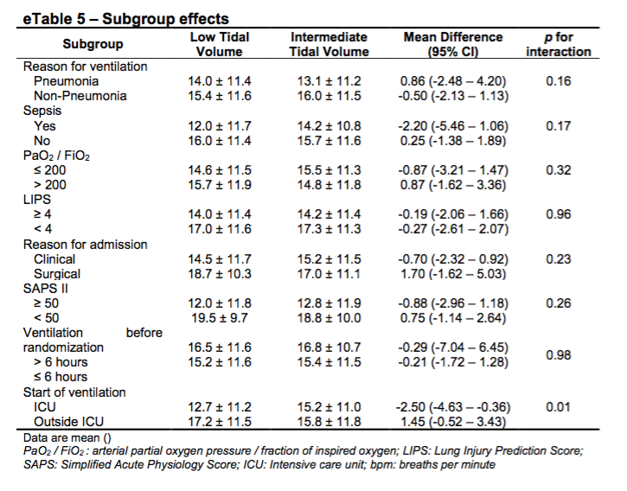

CONCLUSIONS:
- In patients without ARDS, a low tidal volume strategy did not result in a greater number of ventilator-free days than an intermediate tidal volume strategy
- In addition, there was no difference in length of stay, mortality rate, or the occurrence of pulmonary complications between groups
- The low tidal volume strategy was associated with respiratory acidosis

DISCUSSION:
- Compared to previous 2 studies:
  - Time between start of ventilation and randomization was shorter; necessary expected duration of ventilation was shorter in this study
  - TV 9ML/kg compared to 10 and 12 mL/kg in other studies, with limiting of inspiratory pressure
  - Because pressure support was used more frequently in this study, the low tidal volume group was 7 mL/kg, which is slightly higher than the 6 mL/kg in the other studies
- Why was no difference seen?
  - Level of distending pressures induced by an intermediate tidal volume may have still been protective for patients without ARDS
  - Low tidal volume strategy was associated with respiratory acidosis, which may have influenced duration of ventilation
- Tidal volume restriction was associated with respiratory acidosis and increased paCO2
  - This was not compensated for by an increase in respiratory rate given that minute ventilation was constant between the two groups
  - Low tidal volume strategy promotes less efficient alveolar ventilation than an intermediate tidal volume strategy
- PROS
  - Study was large and involved 6 centres improves external validity
  - Randomized minimizes bias
  - Marginal loss to follow-up
  - Intermediate tidal volume (10 mL/kg) more applicable to current practice than previous trials that used 12 mL/kg
- CONS
  - Not blinded
  - Patient group was heterogeneous
    - Even through subgroup analysis was performed (eg. pneumonia and sepsis), these subgroups may have been underpowered to have detected a difference
    - Patients with chronic pulmonary disease were excluded – thus not applicable to these patients
  - Many patients were missed for randomization given the short time that was allowed (706/ 2734 or 26%) or many refused consent (304/2734 or 11%) may have predisposed to selection bias
  - Did not investigate tidal volumes higher or lower than those used in this trial
  - Inadequate separation between low and intermediate groups after day 1
    - Underpowered to detect any true difference? Type II error
  - Tidal volume may not be the most important target in preventing VILI (e.g. driving pressure?)
    - Driving pressure has been suggested as the key variable in preventing lung injury
    - Driving pressure = Pplat - PEEP
  - Composite outcome chosen (number of ventilator-free days and alive at day)
    - Did not expect a significant difference in mortality, but without including mortality would be difficult to discern given the high rate of mortality in the ICU

CONCLUSION:
No difference was found between lower and intermediate tidal volumes in patients without ARDS – therefore should likely continue to target lower tidal volumes in patients without ARDS? Or is this evidence that it’s okay to ventilate at higher tidal volumes in patients without ARDS?

