NEJM Nov 2018 – February 2019

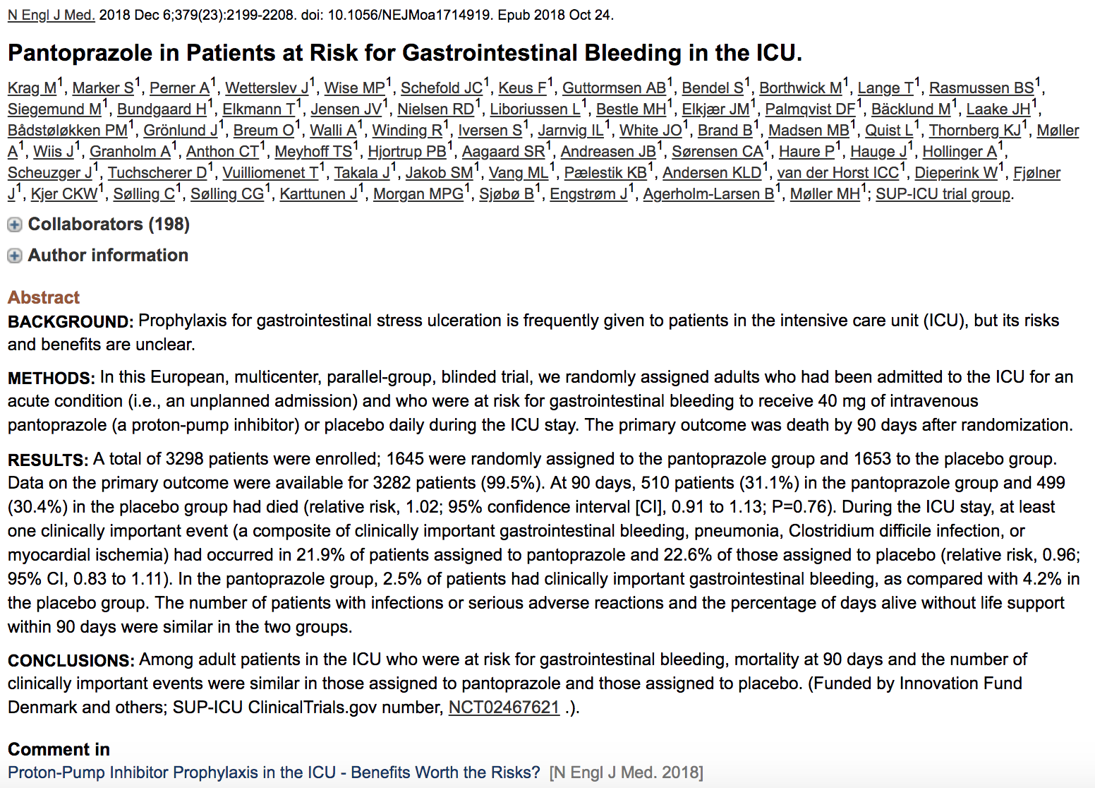

- In acquired thrombotic thrombocytopenic purpura (TTP), an immune mediated deficiency of von Willebrand factor-cleaving protease ADAMTS13 allows unrestrained adhesion of vWF multimers to platelets and microthrombosis
- Calpacizumab is an anti-vWF Ig fragment that inhibits interaction between vWF multimers and platelets
- Double blind controlled trial
  - 145 calpacizumab or placebo during plasma exchange (PE) and for 30 days after
  - Primary outcome: time to normalization of platelet count with D/C PE 5 days after
  - Secondary outcomes (composite)
    - TTP related death
    - TTP recurrence
    - Thromboembolic event during treatment
    - Refractory TTP
    - Normalization of organ damage markers
- Results
  - Median time to normalization of platelet count was shorter with calpacizumab than placebo (2.69 days vs 2.88 days)
  - Patients who received calpacizumab were 1.55 times as likely to normalize platelet count vs placebo
  - % with composite outcome 74% lower with calpacizumab (12% vs 49%)
  - % with recurrence TTP 67% lower with calpacizumab (12% vs 38%)
  - Refractory disease in no patients in calpacizumab and 3 in placebo
  - Calpacizumab > less PE and hospitalization time
  - Mucocutaneous bleeding in 65% patients with calpacizumab and 48% placebo
  - 3 patients in placebo group died
  - 1 in calpacizumab group died from cerebral ischemia, after end of treatment period

Stress Ulcer Prophylaxis in the Intensive Care Unit (SUP-ICU) trial

- Intro
  - Critically ill patients are at risk for stress related GI bleeding associated with adverse outcomes
  - Risk factors include mechanical ventilation, coagulopathy, hepatic or kidney failure
  - Concerns about adverse effects of PPI including C. difficile infection, pneumonia and MI
- Design
  - Multicenter, stratified, parallel group, placebo controlled blinded clinical trial
  - Patients 18+ admitted to ICU for acute condition with at least one risk factor for clinically important GI bleeding (shock, anticoagulants, RRT, MV > 24hrs, liver disease, coagulopathy)
  - IV injection of pantoprazole or placebo as single bolus SID. If readmitted with 90 days, initial treatment regimen resumed.
  - Primary outcome was death by 90 days after randomization
  - Secondary outcomes: clinically important events in the ICU (GI bleeding, pneumonia, C. difficile, acute MI), clinically important GI bleeding in the ICU (overt GI bleeding, spontaneous decrease in SBP, MAP, DBP of > 20mmHg r more, vasopressor initiation or 20% increase in dose, decrease Hgb 2g/dL, transfusion 2+ units pRBCs, infection, adverse reactions, % days alive without the use of life support (MV, circulatory support, RRT) within 90 days.
- Results
  - 1645 assigned to pantoprazole
  - 1653 assigned to placebo
- 31.3% in pantoprazole group and 30.4% in placebo group
- 21.9% in pantoprazole group and 22.6% in the placebo group had one or more clinically important events in ICU
- 2.5% pantoprazole and 4.2% placebo had clinically important GI bleeding
- Did find an interaction between intervention effect and disease severity that suggested higher 90 day mortality among patients who had more severe disease and received pantoprazole

