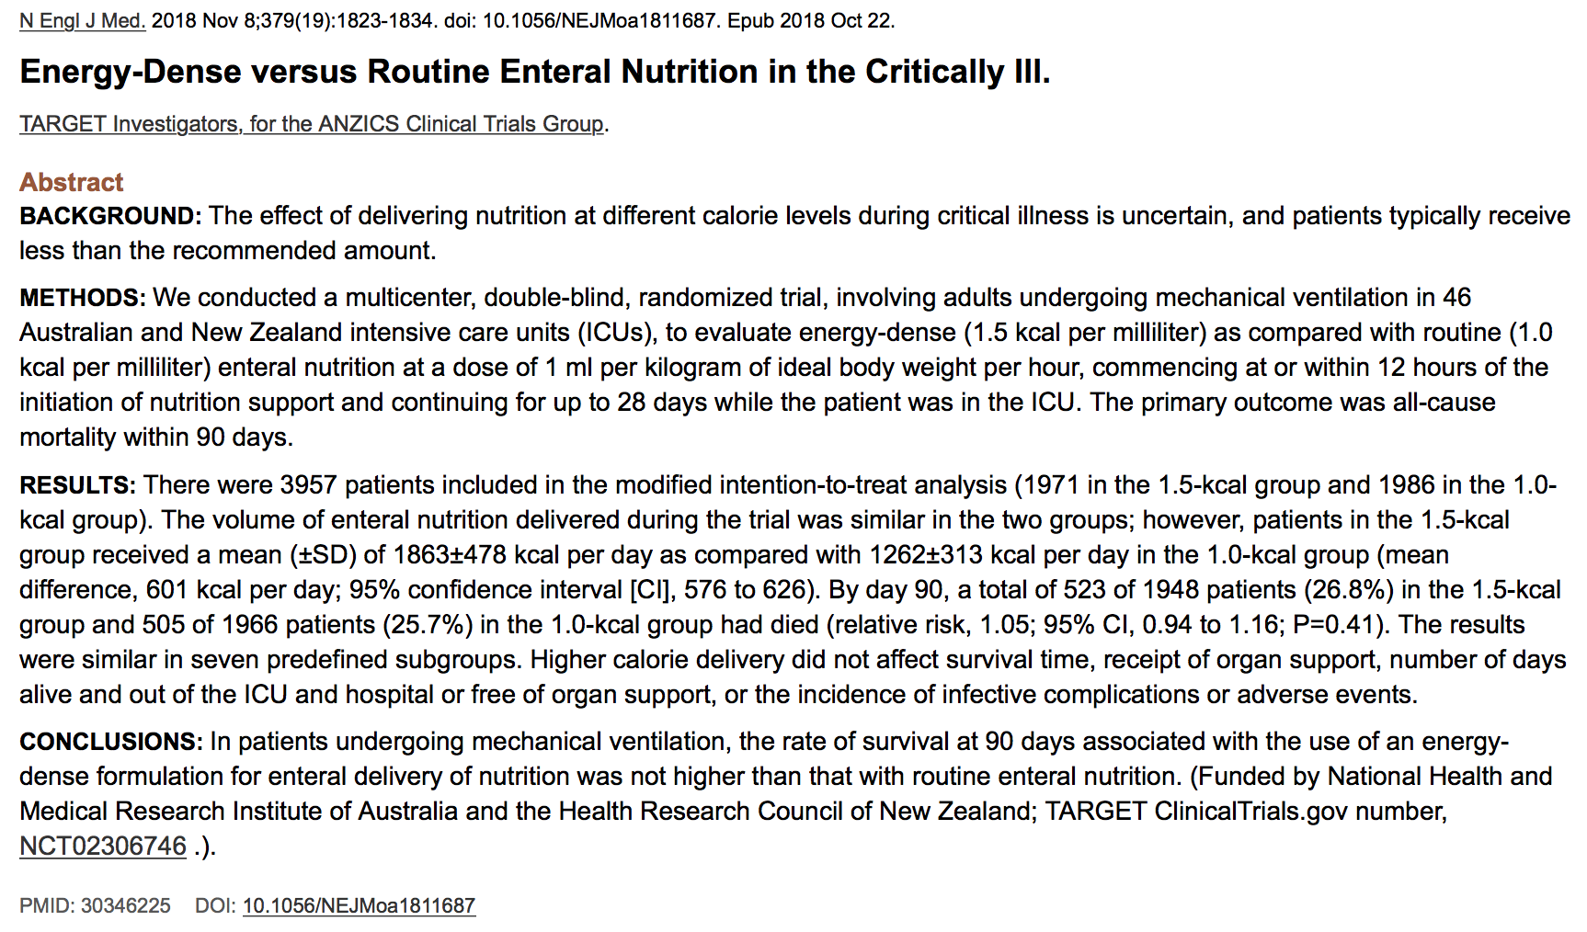

- Goal: To evaluate energy-dense (1.5 kcal/mL) vs routine (1.0 kcal/mL) enteral nutrition (dose 1 mL/kg of ideal body weight/hour.)
- 3957 mechanically ventilated patients included in the modified intention to treat analysis
  - 1971 in the 1.5 kcal group
  - 1986 in the 1.0 kcal group
- Volume delivered similar between the two groups
  - High calorie mean 1863 +/- 478 kcal/day
  - Routine calorie mean 1262 +/- 313 kcal/day
  - Mean difference 601 kcal/day
  - Median of 6 days of nutrition support
  - Estimation of daily caloric requirements were available for 65% of the patients
    - High calorie delivered 103 +/- 27% of estimated requirement
    - Routine calorie delivered 69 +/- 18% of estimated requirement
  - Median largest gastric residual volume was larger in high calorie group
  - Regurgitation was more common in high calorie
  - High calorie group received more promotility drugs and insulin
- Outcome by day 90 (death)
  - 523/1948 patients (26.8%) in 1.5 kcal group
  - 505/1966 patients (25.7%) in the 1.0 kcal group
  - High calorie did not affect survival time, receipt of organ support, number of days alive, number of days out of ICU and hospital or number of days free or organ support, nor the incidence of infective complications or adverse events.

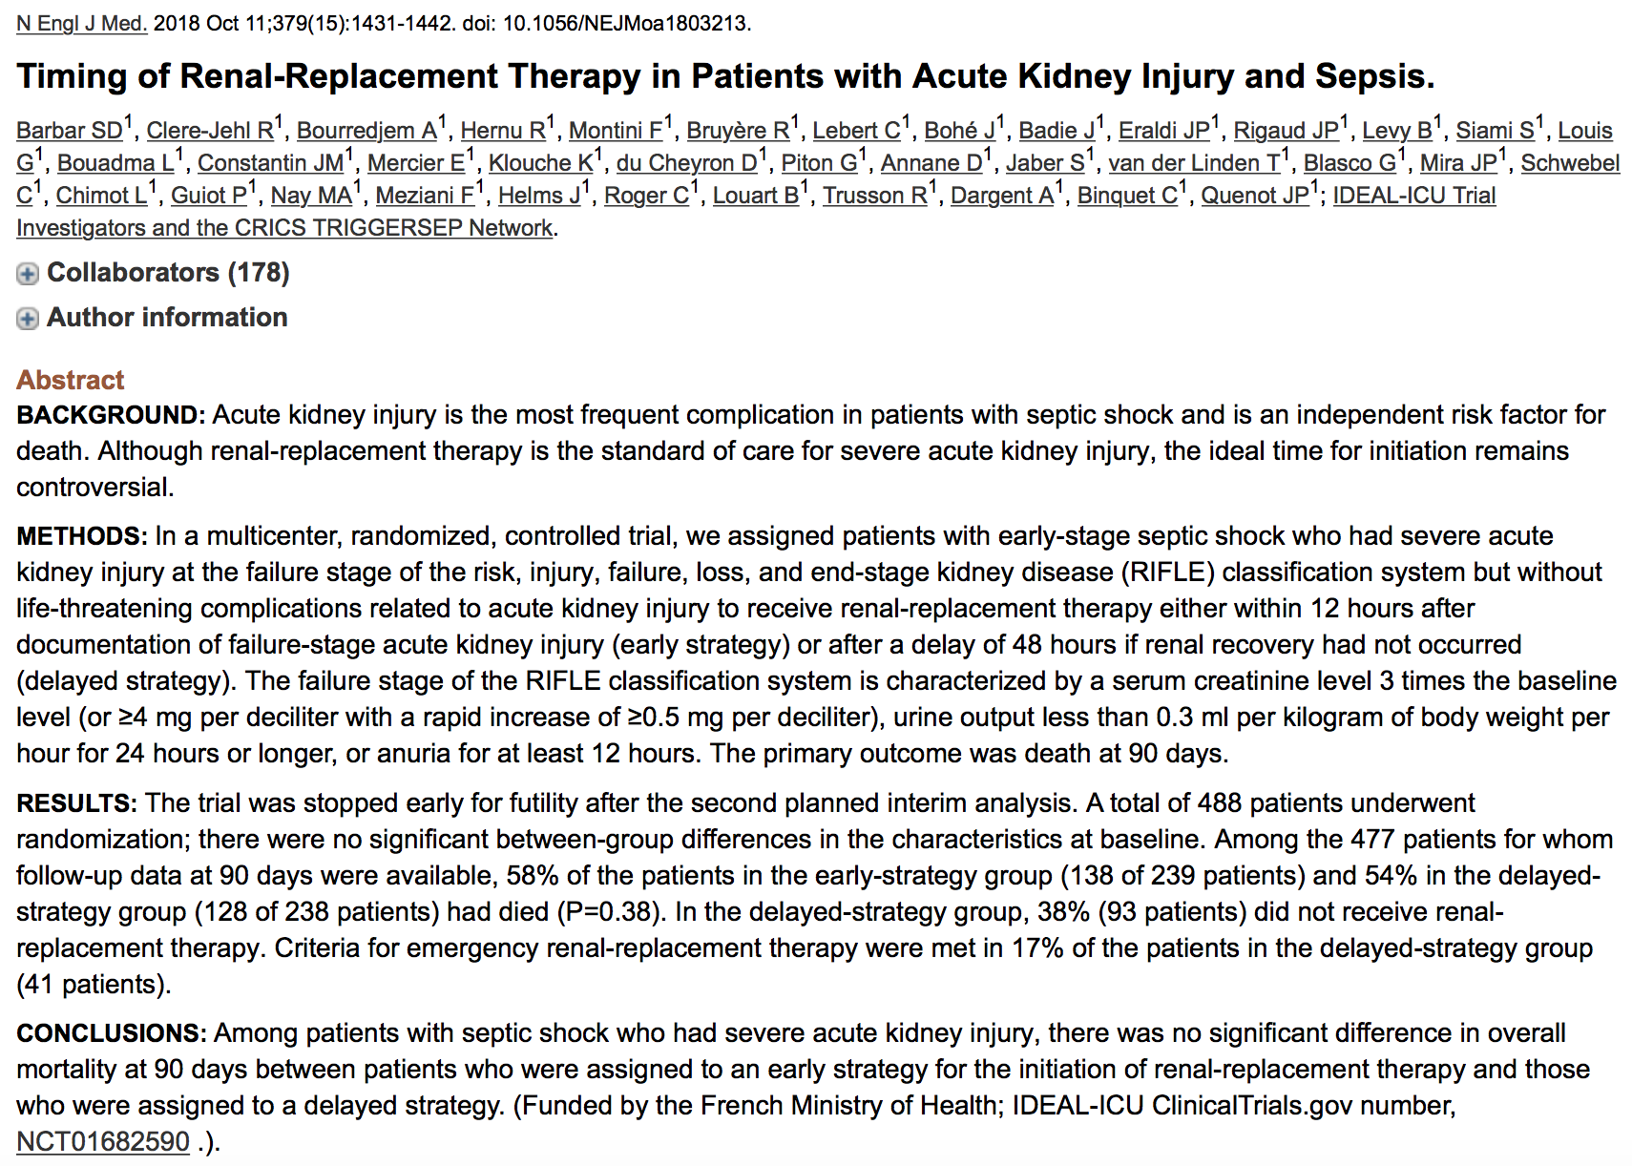

- “IDEAL-ICU” Trial
- Multicenter, randomized, controlled trial in patients with early stage septic shock who had severe acute kidney injury at the failure stage of the risk, injury, failure, loss and end stage kidney disease (RIFLE) classification system but without life-threatening complications related to AKI
  - Failure stage of RIFLE = serum CRE level 3 times baseline or greater than or equal to 4 mg/dL with rapid increase of greater than or equal to 0.5 mg/dL
  - Urine output < 0.3 mL/kg/hr for 24 hours or longer
  - Anuria at least 12 hours
- Randomized to receive RRT within 12 hours after documentation of failure stage AKI (early strategy) OR after 48 hours if renal recovery had not occurred (delayed strategy)
- Primary outcome death at 90 days
- Trial stopped early for futility after the second planned interim analysis
  - 488 patients, 477 ad follow up data at day 90
  - 58% of patients in early strategy group died by 90 days
  - 54% in the delayed strategy group had died.
    - 38% of delayed strategy group did not receive RRT
    - Criteria for emergency RRT met in 17% of delayed strategy group
- Conclusion: risk of death is not increased if renal-replacement therapy is postponed for at least 48 hours as long as care is taken to identify patients in whom criteria for emergency RRT are likely to be met.
- 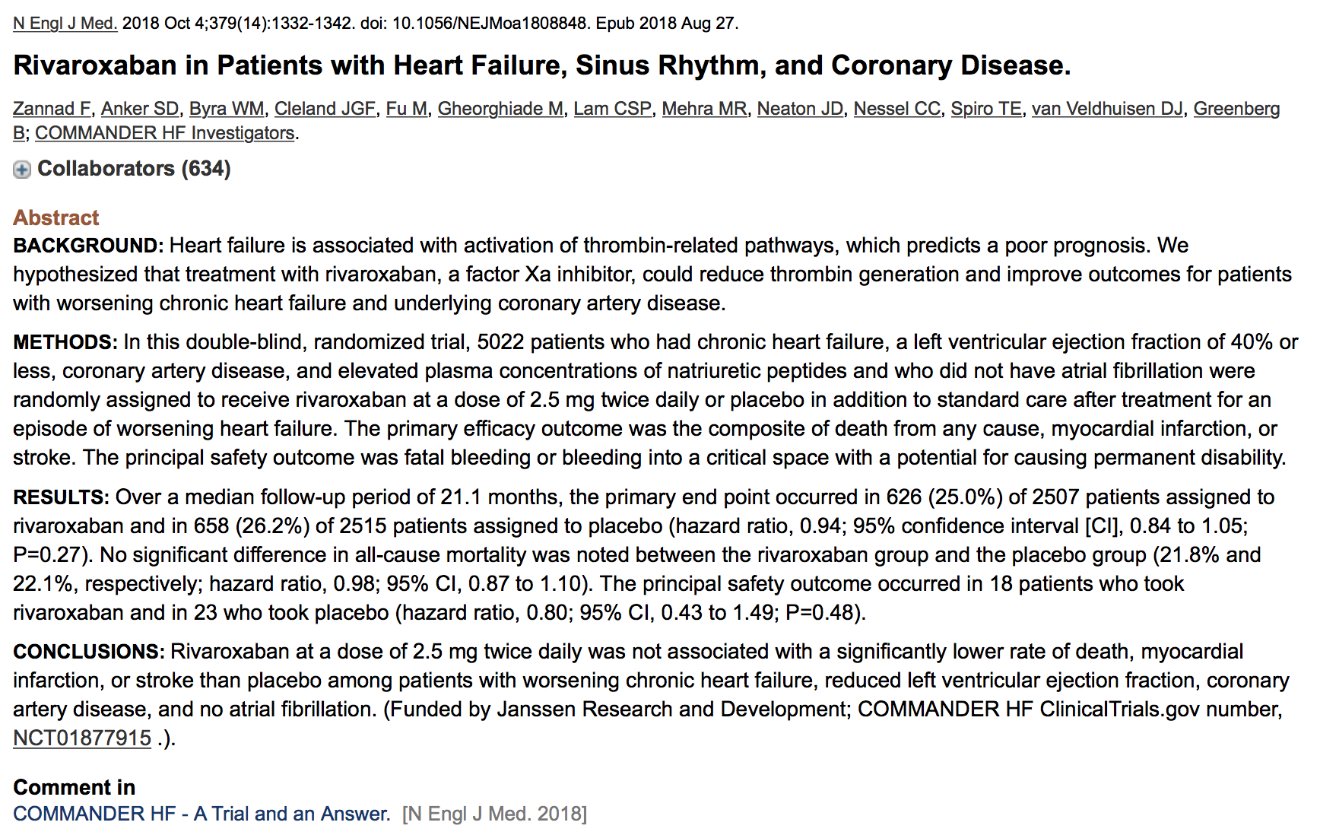Double blind randomized trial “COMMANDER HF trial”
  - Possible that activation thrombin related pathways may contribute to disease progression by inducing inflammation, endothelial dysfunction and arterial and venous thrombosis
  - Rivaroxaban: oral direct factor Xa inhibitor
- 5022 patients with chronic heart failure, LVEF ≤ 40%, coronary artery disease and elevated natriuretic peptides WITHOUT atrial fibrillation randomly assigned to receive 2.5 mg BID rivaroxaban OR placebo in addition to standard of care after treatment for an episode of worsening heart failure.
  - Primary outcome composite of death, myocardial infarction, stroke
  - Safety outcome: fatal bleeding or bleeding into critical space with potential for causing permanent disability
- Populations
  - Enrolled patients with 3 month history of chronic heart failure who had been treated for episode of worsening heart failure in previous 21 days
  - 2507 rivaroxaban
  - 2515 placebo
- Results
  - Median follow up 21.2 months
  - 25% of rivaroxaban and 26.2% placebo died
  - Fatal/Debilitating bleeding in 18 rivaroxaban and 23 placebo
  - No significant differences

