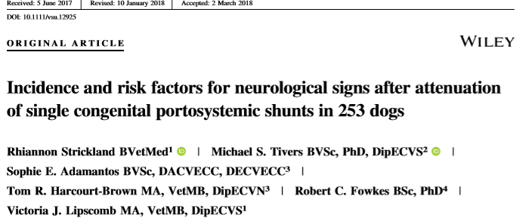
Background:
- Postattenuation neurological signs (PANS) are a complication of the surgical management of congenital portosystemic shunts (CPSS) - reported in up to 12% of dogs.
- While well recognized, underlying etiology is unclear and may be linked to changes associated with hepatic encephalopathy (HE) prior to surgery
- PANS has been distinguished from HE, and occurs in spite of full attenuation of the CPSS at surgery. Blood osmolality may also play a role in PANS.
- The effects of prophylactic antiseizure medications in the perioperative management of dogs with CPSS have been met with mixed results.
- The objective of this study was to determine the incidence, outcome, and predisposing factors for PANS and seizures in dogs undergoing surgical attenuation of single CPSS.
  - Hypotheses: that age, the presence of HE presurgery, extrahepatic location of the shunt, and alterations in Osm postoperatively would be associated with the incidence of PANS and seizures. In addition, perioperative administration of levetiracetam would not affect the incidence of PANS or seizures.
Study:
- Retrospective, Feb 2000 – July 2015
- Records of dogs undergoing surgical attenuation of single PSS viewed
  - N = 253; median age 0.87 yo; 196 extrahepatic, 57 intrahepatic; 54 dogs received Keppra 24+ hours prior to and 5+ days after surgery
- 28 dogs (11%) developed PANS
  - 12 developed seizures
  - 5 did not survive to discharge
Results/Conclusions:
- Presence of HE immediately pre-operatively and increasing age were independent risk factors for developing PANS after single attenuation CPSS
  - Odds ratio increasing 1.476-fold with each year of age – longer time for dogs to have been exposed to alterations within CNS
- Location of shunt did not correlate with the development of PANS
- Perioperative treatment with Keppra did not reduce PANS or seizures but may have reduced mortality in severely affected cases
- As age is a risk factor, surgery should not be delayed for a prolonged period of time.
- Clinical signs of HE should be stabilized before surgery
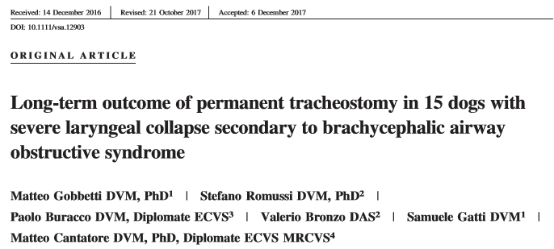
Background:
- Laryngeal collapse is one of the most common causes of end-stage obstruction of the upper airways and is a well recognized consequence of brachycephalic airway obstructive syndrome (BAOS).
- Cricoarytenoid–thyroarytenoid lateralization and partial laryngectomy has a high peri-operative mortality rate (50%) in brachycephalic dogs.
- Permanent tracheostomy may be a safer alternative.
- The objective of this study was to review the long-term outcome of dogs with severe laryngeal collapse secondary to BAOS treated with permanent tracheostomy.
  - Due to anatomic characteristics such as a small tracheal diameter and the presence of redundant skin folds prompted it is hypothesized that permanent tracheostomy in brachycephalic breeds would be associated with a high complication rate.
Study:
- Retrospective across 3 universities 2004 – 2015
- Diagnosis of grade 3 laryngeal collapse (Leonard’s classification) - collapse of the corniculate processes of the arytenoid cartilages with loss of the dorsal arch of the rima glottidis), and persistent severe dyspnea despite initial surgical management of BAOS (staphylectomy, wedge rhinoplasty, and sacculectomy).
- N= 15 (6 Pugs, 5 Frenchies, 2 Chihuahua, 1 Pekingese, 1 Cavie) met criteria and had permanent tracheostomy placed
- Complications were classified as “major” if they were life threatening or required surgical revision (mucocutaneous dehiscence, stenosis, obstruction caused by mucus plug, obstruction caused by skin folds)
- Minor complications = no surgical intervention needed
- Owner opinion of QOL assessed
Results/Conclusions:
- 12/15 dogs had major complications; 6 dogs required revision surgery
  - 8/12 dogs died or were euthanized (4 died due to acute stoma obstruction)
- 7/15 dogs died due to unrelated causes or were alive at time of writing (47%) – 4 had at least one revision surgery
- Median survival time overall was 100 days
  - Median survival time of dogs who died related to surgery was 15 days
  - Median survival time for dogs dying of unrelated causes was 1982 days
- Early mortality was common 6/15 dogs died due to surgical complications within first 20 days
- The first 16 weeks post surgery appear critical – all dogs who survived first 16 weeks survived long term or died of unrelated causes – likely due to reduction in tracheal inflammation and hypersecretion
- Long term survival (exceeding 5 years) with good QOL was achievable in 5/15 dogs
- Post operative QOL (assessed for 9 dogs) was judged as markedly improved by owners; 4 stated unchanged
- 8 of 12 owners thought management of stoma was simple; 4 owners though it was demanding
- Permanent tracheostomy may be a suitable salvage procedure for brachycephalic dogs with severe laryngeal collapse that failed previous conservative surgeries

