VET SURG Oct-Nov 2018
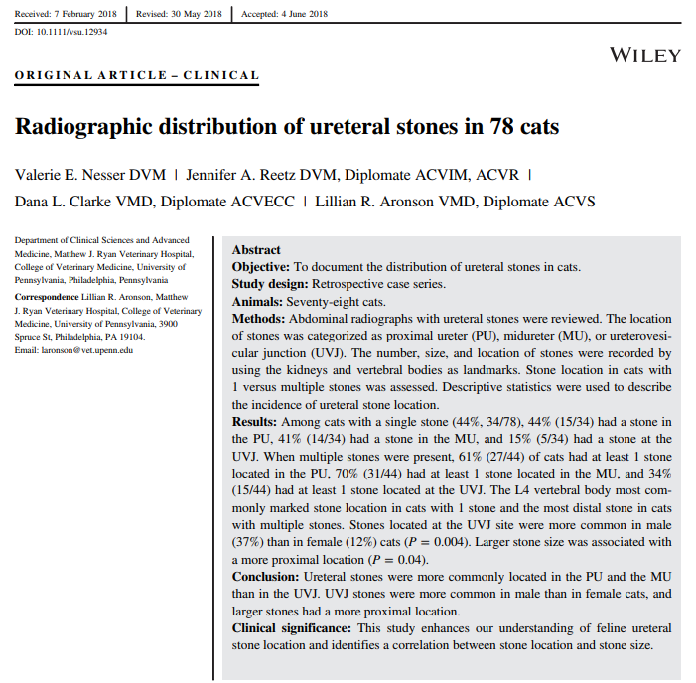
Stone number and location within the ureter is an
important consideration during decision making for surgical
intervention.
Stone number and location within the ureter is an
important consideration during decision making for surgical
intervention.
- Stone number and location within the ureter is an important consideration during decision making for surgical intervention - interventional and surgical success / complication rates have been associated with the location of the obstruction (human med)
- Locations: Proximal ureteral (PU) stones - stones cranial to the caudal pole; ureterovesicular junction (UVJ) - adjacent to the bladder trigone ); midureter (MU) – stones not located in the PU or at the UVJ
- There was no statistical difference in the frequency of stone location in the PU, MU, or UVJ in cats with a single stone, in cats with multiple stones, or when comparing stone locations between cats with a single stone and cats with multiple stones.
- PU, MU was a common site of ureteral stones in cats with single and multiple stones.
- The UVJ was the least common stone location
- Male cats were significantly more likely to have a stone at the UVJ site compared with female cats – unknown why
- Larger stone size was associated with a more proximal ureteral location.

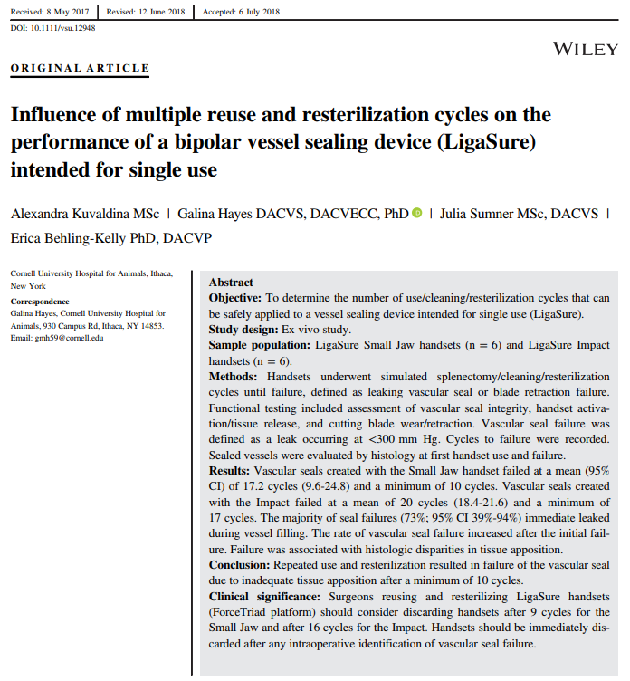
Results of this study of simulated canine splenectomy
lead us to recommend discarding handsets as soon as the
surgeon detects any intraoperative evidence of creation of a
poor vascular seal (bleeding despite sealing) because this
problem is likely to worsen with continued use. For the
LigaSure Small Jaw, incomplete cutting may be a signal that
incomplete seal formation is imminent. To reduce the risk of
poor seals, the LigaSure Small Jaw should be discarded after
9 use cycles, and the LigaSure Impact should be discarded
after 16 use cycles. These cycle numbers are based on the
premise of discarding the handset in the cycle preceding the
minimum number of cycles at which vascular seal failure
was detected in each group.
- The majority of handsets failed due to inadequate vascular seal rather than failure of handset activation or blade retraction
  - ~25% had an incomplete seal that may not have been detected intraoperatively if patient was hypotensive (BP >100, 180, 254 mmHg needed to reveal leak)
- LigaSure Small Jaw - incomplete cutting (blade wear) may be a signal that incomplete seal formation is imminent
- LigaSure Small Jaw should be discarded after 9 use cycles
- LigaSure Impact should be discarded after 16 use cycles.
  - Numbers are based on discarding the handset in the cycle preceding the minimum number of cycles at which vascular seal failure was detected in each group
- Conclusion: Small Jaw and Impact LigaSures can be reused for a limited number of cycles but should be immediately discarded as soon as any intraoperative evidence of failed vascular seal is identified.

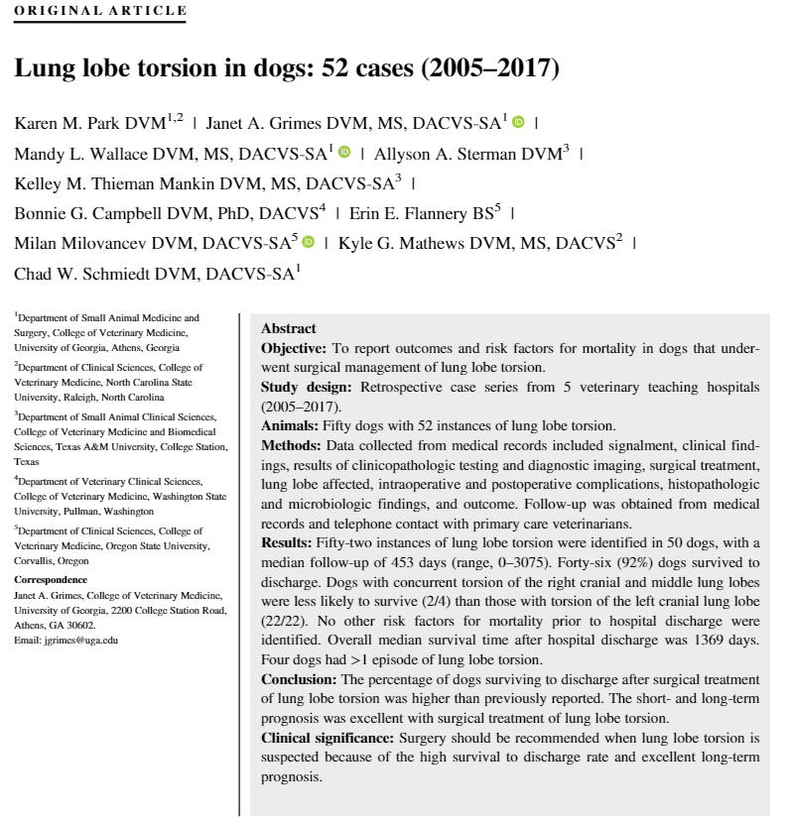
- Survival rates after surgical treatment was higher in this study (92% survival to discharge) compared to what had previously been reported (50-78%); MST 1369 days
- No survival difference for pugs vs non-pugs (previously pugs had a higher reported survival rate)
- Brachycephalic vs sighthound vs all other groups – no difference in survival
- No significant difference in survival rate idiopathic vs secondary lung lobe torsion – 62% of cases were idiopathic in this study
- Right middle and left cranial lung lobe torsion accounted for 84% of cases in the present study (42% each)
- 91% of pugs had left cranial lung lobe torsion – consistent with previous studies
- Pleural effusion was identified as a predisposing cause for lung lobe torsion (25% of cases) - most of those cases due to chylothorax (9/13)
- Lung lobe torsion was listed as a top differential in 50% of cases with thoracic ultrasound, 64% of cases with thoracic radiographs, and 97% of cases with CT – CT more specific and may detect prior to other signs (pleural effusion, consolidation)
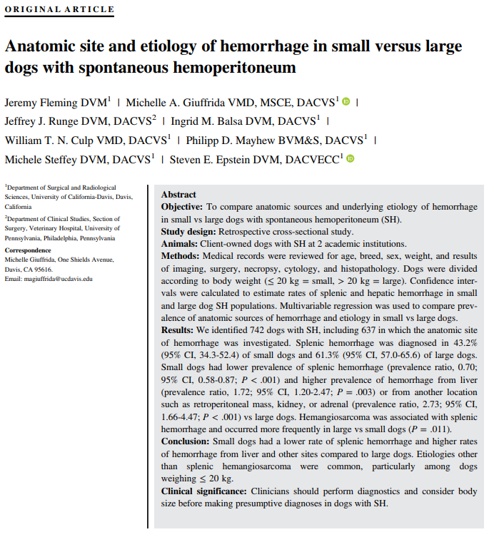
- Dogs ≤ 20 kg had a lower prevalence of splenic hemorrhage and higher prevalence of hemorrhage from both liver and other abdominal organs compared with larger dogs
  - Spleen as the source of SH found in 43.2% of small dogs and 61.3% of large dogs
- Despite this difference in splenic hemorrhage rates between large vs small dogs, the aggregate rate of splenic hemorrhage all SH dogs was 57.8% = similar to that of the large dog group suggests that the unique disease characteristics of small dogs might not be apparent when small and large dogs are analyzed together; this statistic may over estimate the location of bleeding for small dogs
- 27.2% of small dogs were diagnosed with hepatic sources of hemorrhage, nearly twice the prevalence observed in large dogs (15.8%)
- The spleen was the single most common source of hemorrhage among both large and small dogs.
  - However 43% of small dogs with splenic SH and 57% of small dogs with nonsplenic SH were found to NOT have HSA when a definitive diagnosis was obtained splenic HSA accounts for less than half of small-dog SH
- Small dogs = 273% more likely to have other anatomic sources of SH (most commonly adrenal gland masses and retroperitoneal masses not associated with an organ) than large dogs
- Implications for clinical practice - when a small dog presents with SH, a presumptive diagnosis of splenic HSA should not be made and additional Dx (ultrasound or other discriminating tests) are performed to characterize source of hemorrhage; owners should be given epidemiologic data derived from small dogs rather than data derived predominantly from large-dog populations to make more informed decisions

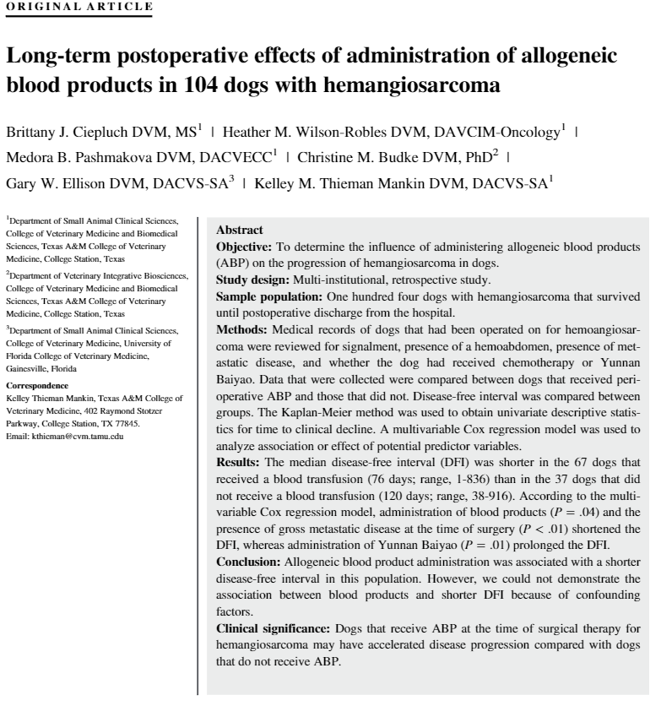
Conclusion says it all: Allogeneic blood product administration was associated with a shorter disease-free interval in this population however the association between blood products and shorter DFI cannot be made because of confounding factors (type I error, small sample size, retrospective, metastatic disease and hemoabdomen also had a hazard ratio > than 1 and independently were associated with a decreased disease free interval, different blood products being used, multiple confounding factors, etc)

