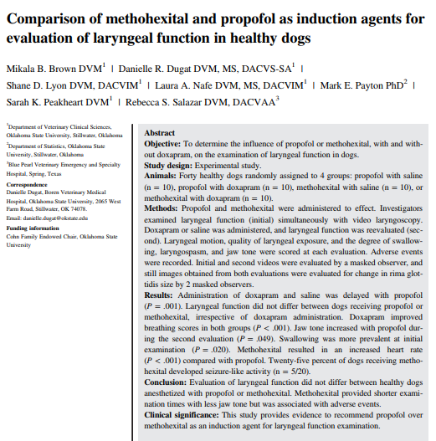
- Propofol commonly used but can cause apnea
- Methohexital - rapidly acting barbiturate anesthetic agent, similar to thiopental; it produces a short period of anesthesia as a single agent. Has potential adverse effects to include tachycardia, seizure like events, and necrosis with perivascular administration
- Study looked to compare the 2 agents +/- doxapram
- Adverse events identified in methohexital group were tachycardia, seizure-like activity (25% of cases), vomiting and regurgitation
- Main finding of this study - laryngeal function did not differ in dogs anesthetized with propofol or methohexital though examination consistently took longer when dogs received propofol rather than methohexital
- Doxapram did not influence laryngeal function in this study, irrespective of induction agent used
- The results of this study provide evidence to support continued use of propofol as the preferred induction agent for laryngeal function examination

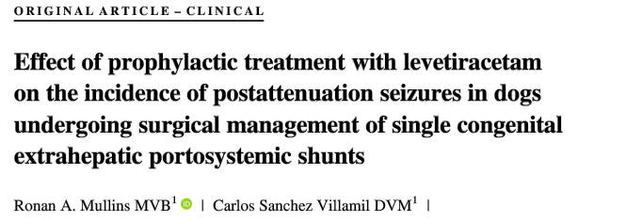
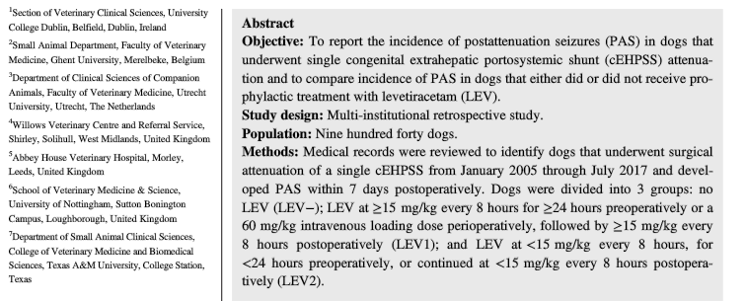

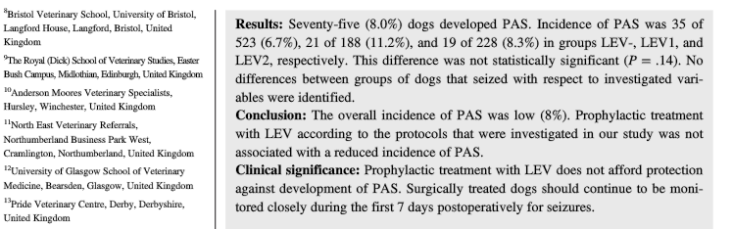

- Study looked to evaluate for post attenuation seizures in dogs that had an AE treatment with Keppra, >15mg/kg q8hr for more than 24 hours prior to shunt attenuation or 60mg/kg perioperatively and continued >15mg/kg q8hr postoperatively, or < 15mg/kg less than 24 hours prior to surgery but continued <15mg/kg post operatively
- Findings:
  - Overall incidence of PAS was low (8%) - similar to that reported in recent literature
  - Prophylactic treatment did not result in a reduced incidence of PAS compared with dogs that did not receive any prophylactic Keppra
  - No significant differences were identified between groups of dogs that seized with respect to signalment; shunt morphology; concurrent conditions; incidence of preoperative neurologic signs and seizures; preoperative medical management; method and degree of shunt attenuation; type and timing of PAS; electrolyte, ammonia and glucose concentrations at the time of seizures; and shortterm survival.
- The results of this study provide evidence to corroborate findings of 2 recent studies that prophylactic treatment with LEV does not afford protection against development of PAS

