Veterinary Surgery Feb 2019 – April 2019
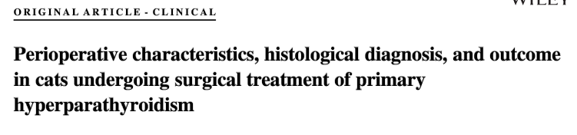
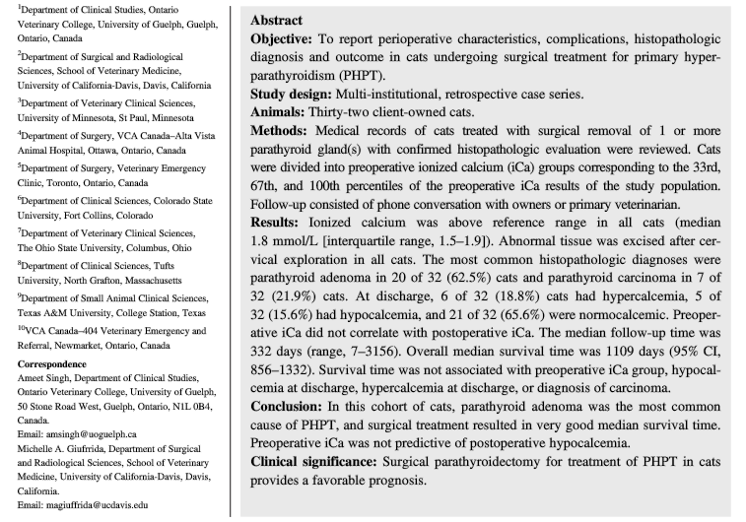
- Feline PHPT has been reported infrequently in the veterinary literature - parathyroid adenoma reported as most common
- Retrospective study to describe perioperative characteristics, complications, histological diagnosis, and outcome in cats undergoing surgical treatment of PHPT
- RESULTS:
  - Hypocalcemia developed at some point during hospitalization in 11 (34.4%) cats
  - No clinical signs of hypocalcemia in any cat; iCa value below reference range detected at median time of 36 hours
- At time of discharge, 18.8% were hypercalcemic, 15.6% were hypocalcemic, 65.6% were normocalcemic
- Preoperative iCa was not associated with hypocalcemia during hospitalization or discharge, or hypercalcemia at discharge
- PTH level was not associated with hypocalcemia or persistent hypercalcemia
- MST was 1109 days
  - Not associated with preoperative iCa, hypocalcemia or hypercalcemia at discharge or diagnosis of carcinoma
- Parathyroid carcinoma was diagnosed in 21.9% of cats – higher than that reported in dogs (0%–15%); was not associated with survival time

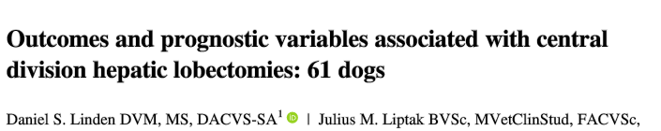
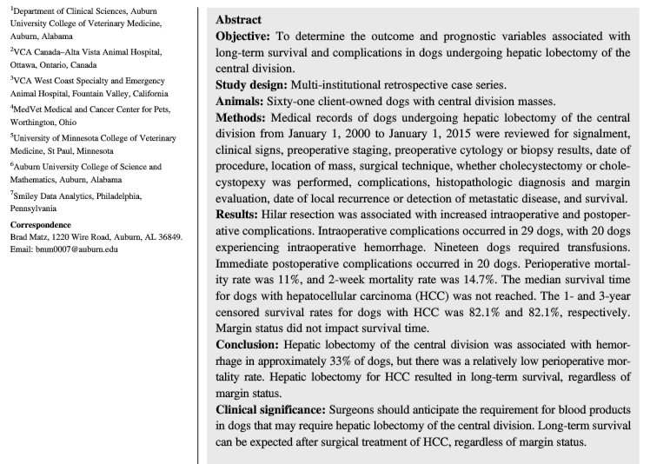
- Hepatocellular carcinoma most common primary hepatic tumor in dogs and cats
- Surgical intervention is the treatment of choice for solitary liver tumors in dog; left division hepatectomies are usually technically simpler than those of the right or central division (anatomy)
- Retrospective study: determine the outcome and prognostic variables associated with hepatic lobectomy of the central division (quadrate, right medial)
- RESULTS:
  - Intraoperative complications in 37.7% of dogs – hemorrhage (31% needing transfusions) and injury to the extrahepatic biliary system
  - Immediate postoperative complications (0–48 hours) in 33% of dogs - anemia; cardiac arrhythmias; coagulation abnormalities; hypoglycemia; uncontrollable hemorrhage, respiratory distress secondary to pneumothorax, anuric renal failure
  - Short-term postoperative complications in 12 (19.7%) dogs - aspiration pneumonia; continued hemorrhage; incisional infection/inflammation; hyperglycemia, perforated duodenal ulcer with secondary septic peritonitis (chronic NSAID use), incisional dehiscence, MODS, pancreatitis, incisional seroma
  - Long-term postoperative complications - pancreatitis
  - Perioperative mortality rate was 11% (consistent with previous studies)
  - Censored 1- and 3-year survival rates for dogs with HCC were 82.1% and 82.1%, respectively
  - Intraoperative and postoperative complications were more common when hilar resection was performed (complex vascular arrangement and extensive dissection necessary)
  - TA stapler used – less intraop complications
  - Margins did not impact long term survival

