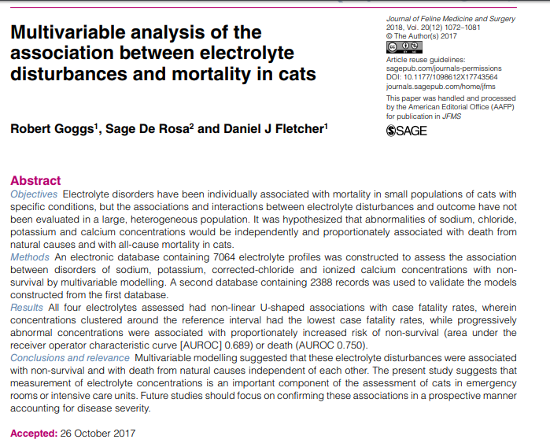
- Study looked to analyze the association between electrolyte abnormalities and mortality outcome in cats
- There were prominent non-linear ‘U’ shaped relationships between electrolyte concentrations and case fatality rates for all four electrolytes assessed (Na, K, Cl – corrected, iCa)
- Patients with electrolyte concentrations close to the median value (within reference intervals) had low case fatality rates, while patients with abnormal concentrations had increased case fatality rates proportionate to the degree of abnormality
- Patients with more than one disturbance in either direction are at greater risk of a poor outcome irrespective of the combination of electrolyte disturbances present
- The strength of the association between death and electrolyte abnormalities suggests such disturbances should be taken seriously and that clinicians should take steps to identify and manage the underlying diseases

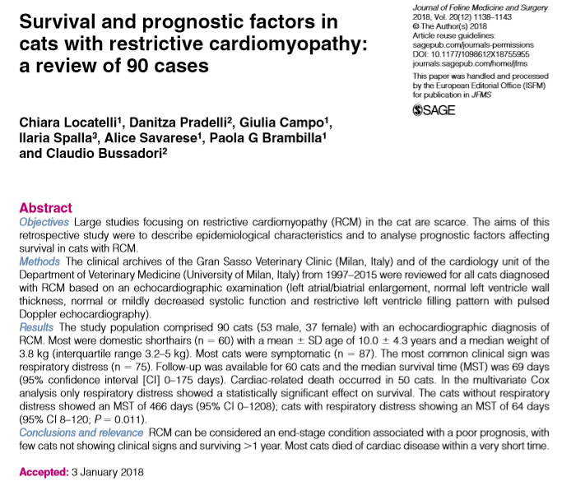
- MST was 69 days with cardiac related death in 83%
- Respiratory distress showed a statistically significant effect on survival - without respiratory distress showed a MST of 466 days (very rare), with respiratory distress MST of 64 days (range in other studies 1-4 mo)
- RCM is almost exclusively diagnosed at a late stage when cats are referred after the development of clinical signs
- Long-term prognosis is poor
- RCM was the second most commonly diagnosed CM in cats in this population - 10 year prevalence of 15% in all cats with CM
- Heart murmur was rarely identified in cats with RCM – consistent with lack of a heart murmur is not a useful screening tool in cats

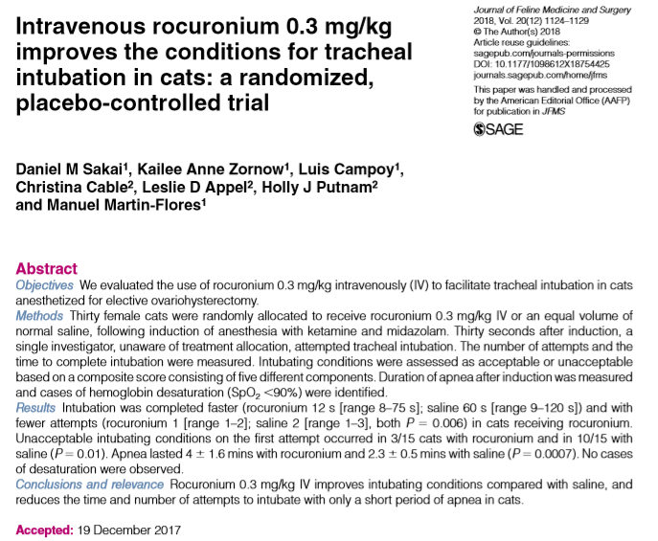
- Neuromuscular blocking agents (NMBAs) are commonly used to facilitate tracheal intubation in people - improves the quality of intubation and reduces the incidence of trauma
- Non-depolarizing NMBAs at the doses commonly used almost invariably result in apnea of long duration – oxygen desaturation, PPV necessary
- Study looked to evaluate low dose rocuronium (0.3 mg/kg IV) for ease of intubation
- Number of attempts to intubate and the time to intubate were significantly less in cats receiving rocuronium
- PPV was administered for significantly longer time (~4 min) for cats receiving rocuronium to those receiving saline control (~2min)
- PPV was required for all 15 cats receiving rocuronium and 7/15 cats receiving saline
- No cases of hypoxemia (SpO2 <90%) was observed
- No cases of residual neuromuscular block were seen in recovery (all cats had rocuronium reversed with edrophonium after return of spontaneous ventilation during surgery – helps decreases the occurrence of residual muscular weakness during emergence from general anesthesia)

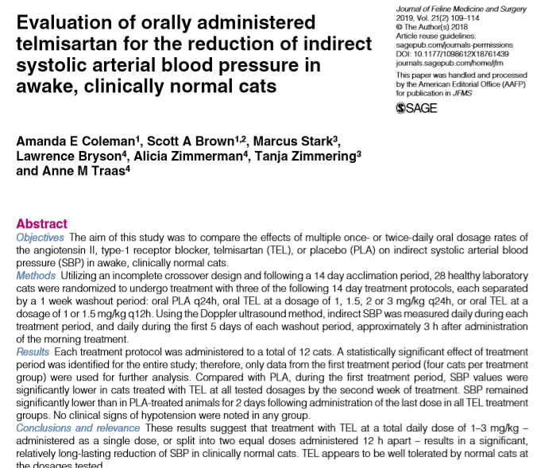

- Benazapril has not been shown to improve survival benefit and lacks efficacy as an anti hypertensive agent in cats
- Telmisartan has been found to have antiproteinuric effects non-inferior to benazepril however antihypertensive efficacy has not been evaluated
- This study looked at BP effects of Telmisartan in healthy cats at different doses and dosing intervals compared to placebo
- After week 1, the 1mg/kg/day and 1.5mg/kg/day did not significantly drop BP but other doses/intervals did
- By week 2 all doses and intervals resulted in statistically significant decreases in BP compared to placebo/baseline (25-37mmHg range decrease)
- Greatest reduction in week 1 with >2mg/kg/day doses
- Testing in hypertensive cats needed; duration of BP control not tested in this study

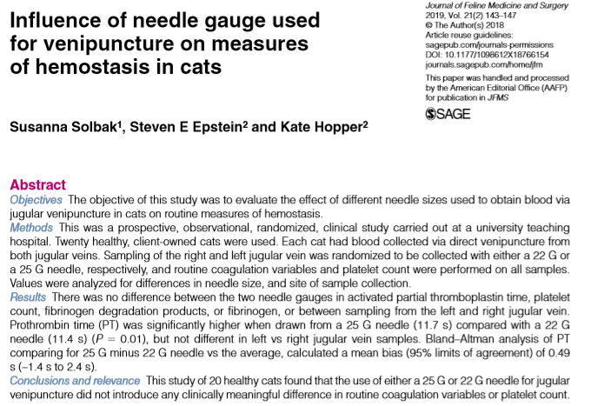
- Smaller diameter needle exerts higher shear forces as blood is collected can activate both platelets and coagulation factors coagulation variables and platelet count may be altered
- Humans - platelet count but not PT or aPTT has been shown to differ with varying needle sizes; dogs no differences with 21, 21, 25g needles
- Cat platelets have greater aggregability in response to shear stress- will various needle sizes will affect tests of hemostasis in cats (22 vs 25g)?
- No difference between the two needle gauges for platelet count, proportion of samples with platelet clumping, aPTT, FDPs or fibrinogen, PT

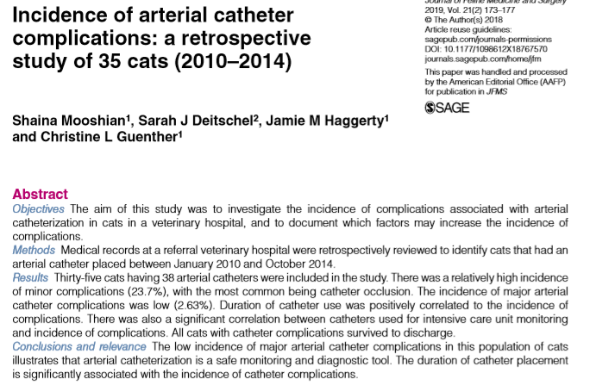
- Minor complications were noted for nine arterial catheters (n = 9/38; 23.7%) of which all were catheter occlusion
- One major complication was noted, with one cat suffering ischemic injury secondary to a coccygeal arterial catheter resulting in tail amputation (1/38; 2.6%)

Reviews (Jan 2019):
- HYPERTENSIVE OCULAR DISEASE IN CATS A guide to fundic lesions to facilitate early diagnosis
- ACUTE PAIN IN CATS Recent advances in clinical assessment

