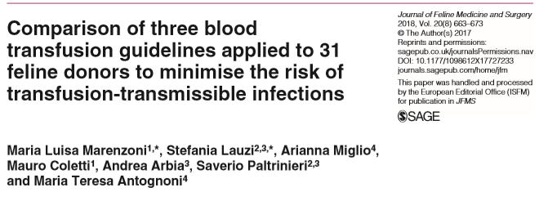
Background:
- With the increasing need for feline blood donors an appropriate screening system is needed to identify risk factors and characteristics of “low risk” donors to help prevent transfusion transmissible infections (TTI)
- Several guidelines (GLs) are used for testing protocols in veterinary medicine. GLs are generally developed according to the circumstances and needs of each country. GLs may differ in some aspects, such as the microorganism to be screened or the screening methods used.
Study:
- Italian GL applied to 31 feline candidate blood donors voluntarily enrolled over a 1 year period.
- GL tests from Europe and US not currently utilized in Italy’s screening process were also included.
- Based on Italian, European and American GLs: hemoplasmas, feline leukemia virus (FeLV), feline immunodeficiency virus (FIV), Anaplasma phagocytophilum, Ehrlichia species, Bartonella species, Babesia species, Theileria species, Cytauxzoon species, Leishmania donovani sensu lato and feline coronavirus (FCoV), were screened.
- Rapid antigen and serological tests and biomolecular investigations (PCR) were used.
- Several PCR protocols for haemoplasma and FeLV DNA were compared – nest PCR always more sensitive
- Found that some of the enrolled cats, while clinically healthy, had risk factors for harboring TTIs.
  - Results for FIV and FeLV infections were negative using rapid tests however when tested with the most sensitive PCR protocol – 1 cat tested positive for FeLV provirus
  - 4/31 (12.9%) of cats were PCR positive for hemoplasma DNA positive despite a normal blood smear
    - All the PCR protocols identified the positive cats but the nested PCR was 10-fold more sensitive
  - Five cats were positive for FCoV antibodies using a more sensitive PCR test
Conclusions:
- The inclusion of tests to screen microorganisms in other GLs caught diseases that otherwise would not have been identified through their (Italian) GL alone.
- Authors recommend biomolecular methods should be used to identify proviral FeLV DNA and hemoplasma.
- Also recommend appropriate recruitment protocols currently not considered in GLs (life style questions, travel) and educational courses for owners.
- The cost and time of the screening procedures may be reduced if appropriate tests are selected.

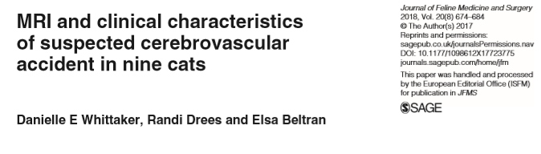
Background:
- Cerebrovascular accidents (CVAs) are defined as a disruption in cerebral blood supply leading to neurological dysfunction and are classically associated with clinical signs that are peracute in onset and non-progressive after 24 h.
- Cerebrovascular disease is the subject of multiple reviews in canine patients it has rarely been reported in the cat.
- MRI characteristics of CVAs in dogs are well described, but in cats they are limited to a single report of two cases of rostral cerebellar infarction.
- There are species-specific adaptations in cerebral blood supply.
- Aim of study is to report the MRI features, clinical characteristics (inclusive of concurrent systemic disease), and short- and long-term outcome of CVAs in the feline population
Study:
- Cats presenting to a single referral hospital (Queen Mother Hospital for Animals, Royal Veterinary College) between January 2005 and September 2016 with acute onset, non-progressive (after 24 h) intracranial signs were retrospectively reviewed.
- Cats that presented within 48 h of onset of clinical signs, had full physical and neurological examinations and underwent MRI within 72 h of presentation were included.
  - n = 9
- Reviewers defined infarcts according to location
Results/Conclusions:
- When CVA occur in cats they are most commonly located caudal to the tentorium, and particularly, the cerebellum.
- In all cases clinical signs reflected neurological dysfunction and varied dependent on the location of the CVA.
  - Middle cerebral artery and caudal cerebral artery exhibited signs of forebrain dysfunction
  - Rostral and caudal cerebellar arteries exhibited signs of cerebellar dysfunction
  - Basilar artery exhibited signs of brainstem dysfunction
- CVAs in cats occur in the same vascular territories as in dogs and have similar MRI features.
- Concurrent systemic disease was common (8/9 cats – 4 HCM, 2 pulmonary masses, 1 hyperthyroid diagnosed and treated 1 yr prior to CVA)
  - A cat presenting with signs consistent with a CVA warrants a full systemic investigation.
- Short term survival was favorable (8/9 cats survived 48hr to hospital discharge); information on only 2/7 cats 5-10 weeks after discharge was available (one had complete recovery, the other had good recovery with some persistent neurologic signs – head tilt, vestibular ataxia)

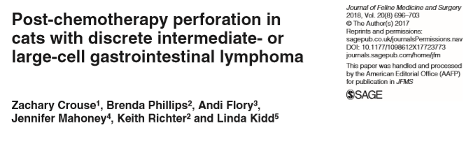
Background:
- Gastrointestinal (GI) perforation is a well described complication of GI lymphoma in people, commonly occurring within days of initiation of chemotherapy.
- There are no studies documenting the prevalence of GI perforation in cats with intermediate- or large-cell GI lymphoma or whether it is associated with induction of chemotherapy.
- The objectives of this study were to document the prevalence and timing of post-chemotherapy perforation in cats with discrete GI masses caused by intermediate- or large-cell lymphoma.
- Authors hypothesized that tumor size, suppurative inflammation within the mass at the time of diagnosis and presence of hypoproteinemia would be associated with perforation.
Study:
- Retrospective: records reviewed June 2006 and May 2012 Veterinary Specialty Hospital San Diego and the Veterinary Specialty Hospital North County. December 2007 and May 2015 Angell Animal Medical Center
- Cats with a diagnosis of intermediate- or large-cell lymphoma based on cytologic or histopathologic examination of a mass lesion of the GI tract and treated with chemotherapy were identified. If the mass was surgically excised, the case was excluded.
- A clinical diagnosis of GI perforation was made using ultrasound findings and analysis of abdominal fluid.
- 23 cats with intermediate- (n = 3) or large-cell (n = 20) lymphoma were included.
  - 18 cats were treated with a COP or CHOP based chemotherapy
  - 3 cats received prednisolone at a cytotoxic dose (1.2–1.9 mg/kg/day)
  - 2 cats were treated with oral lomustine (10 mg/cat or 34–43 mg/m2) and either subcutaneous methylprednisolone acetate (4.2 mg/kg every 14 days) or oral prednisolone (2.9 mg/kg/day).
  - 11 received L-asparaginase as an adjunct to treatment or a rescue therapy during their treatment.
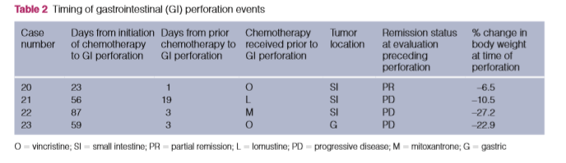
  - 2 treated with a CHOP-based protocol received intravenous (IV) mitoxantrone (6 mg/m2) as a rescue therapy in addition to the standard protocol.
Results/Conclusions:
- GI perforation was confirmed in 4/23 cats (17%), and occurred at 23, 56, 59 and 87 days after induction of chemotherapy.
- Perforation occurred 1 day after receiving vincristine, 19 days after receiving lomustine, 3 days after receiving mitoxantrone and 3 days after receiving vincristine.
- The median time to perforation after induction of chemotherapy was 57.5 days (range 23–87 days).
- It is unlikely that apoptosis and cell death associated with induction of chemotherapy caused GI perforation in these cats.
- However, GI perforation occurred 1–3 days after a recent chemotherapy treatment or after the introduction of a novel chemotherapy drug as a rescue therapy in 3 of 4 cats.
  - a combination of tumor cell death and progressive disease may have contributed to GI perforation.
- There was no association between tumor size, the presence of hypoproteinemia or suppurative inflammation within the mass at the time of diagnosis and subsequent perforation.
- Magnitude of weight loss (>5%) within 15–28 days of induction of chemo was found to be significantly associated with perforation.

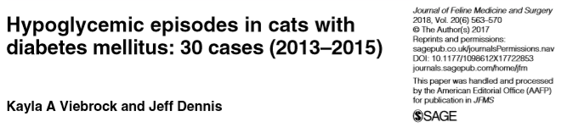
Background:
- Hypoglycemia is also a significant concern when pursuing insulin therapy in cats with diabetes mellitus.
  - In a quality-of-life study, >50% of diabetic cat owners worried that a hypoglycemic episode might occur and 35% of owners indicated hypoglycemic episodes could possibly be occurring in their cats.
  - Investigational studies have found that asymptomatic hypoglycemia is common in cats on insulin therapy.
- As recommendations for treating DM and the types in insulin has changed over the last 25 years, and as clinicians may be using more intensive treatment protocols to help patients achieve diabetic remission, this study wanted to:
  - 1) review the characteristics of diabetic cats receiving insulin therapy presenting to a specialty and emergency center for clinical signs attributed to hypoglycemia and
  - 2) identify the factors that may have contributed to the hypoglycemic episode, the patient’s clinical signs and laboratory findings, and the response of hypoglycemic cats to therapy.
Study:
- Prospective study
- 28 cats were presented a specialty and emergency facility a total of 30 times for symptomatic hypoglycemia between March 2013 and Dec 2015. (hypoBG defined as <65mg/dL).
- Cats categorized into:
  - Mentally dull, weak, ataxic but responsive (n= 14) at presentation
  - Stupor or coma (n= 15)
  - Normal (n=1)
  - BG ‘low’ < 20mg/dL subcategorized (n= 10 with stupor/coma; n=4 dull, weak, ataxic)
- 13 on glargine, 10 on protamine zinc insulin, 6 NPH, 1 porcine insulin; all cats dosed 2x daily
- Median dose was 0.8 U/kg (range 0.2–1.8 U/kg)
- 7 cats (23%) had had their insulin dose increased within 3 months of their initial presentation, 3 cats (10%) had had their dose decreased. 2 cats presented twice during the study period - insulin dose had been decreased from an average 1.2 U/kg to 0.6 U/kg per dose prior to the second presentation. 6 had a previous hypoglycemic event prior to study.
Conclusions:
- 16/30 cases attributed hypoglycemic event to reduced ingestion or subsequent vomiting of a meal after insulin had been administered or the accidental double-dosing of insulin.
- Cause of hypoglycemia unknown in 14/30 cases.
- 18/30 cats has resolved signs within 2 hrs
- 13/14 dull, weak, ataxic cats had neurologic improvement in 12 hours and complete resolution w/in 48hr
- 9/15 stupor/coma cats had improvement at 12hr and were discharged within 96 hours; 6 others were euthanized for lack of improvement
- 10 cats had concurrent illness – this may have been a cause of change of insulin requirement
- If neurologic improvement was seen within 12 hours of treatment, the more likely the cat was to recover despite mental status or glucose level at presentation.

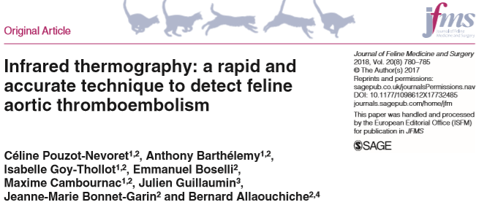
Background:
- Thermography is a painless, non-invasive, non- ionizing diagnostic imaging technique that records the cutaneous thermal patterns generated by the emission of surface heat.
  - Has been used in dogs for the diagnosis of femoral arterial thrombosis, mammary tumor, thoracolumbar disc disease, and cranial cruciate ligament rupture.
  - In humans, is an accurate imaging technique for diagnosis of ATE in infants and deep venous thrombosis in adults.
- The purpose of this study was to evaluate the diagnostic accuracy of infrared thermography as a new diagnostic tool for FATE cats.
Study:
- Prospective study between June 2015 and April 2017 for cats admitted to ICU for acute hind limb paralysis
  - FATE (n=10) diagnosed via ultrasound
  - Control (n= ) paralysis not related to ischemic process, diagnosed by XR, CT, MRI, CSF
- Thermal imaging was performed on all FATE and control cats (3 views taken – all 4 limbs, ipsilateral forelimb/hindlimb view right and left side)
- The maximum (Tmax), minimum (Tmin) and average (Tav) temperatures were determined for each of the four limbs within a hand-drawn region of interest on the dorsal limb extremity.
- Temperature differences between Tmax, Tmin and Tav of forelimb (non-affected) and hindlimb (affected) were calculated between: (1) ΔT – the forelimb with the highest temperature and the hindlimb with the highest temperature; (2) δT – the forelimb with the lowest temperature and the hindlimb with the lowest temperature;; (3) RightΔT – the right forelimb and the right hindlimb; (4) LeftΔT – the left forelimb and the left hindlimb
Results/Conclusion:
- A difference of at least 2.4 degree Celsius between the ipsilateral non-affected and affected limbs had 100% specificity and PPV for detecting FATE
  - This temperature difference may be too low to detect on PE but can be picked up on thermography
- Due to small population size, a larger pool is needed for confirmation.
- Thermography may be a promising non invasive diagnostic tool for FATE.

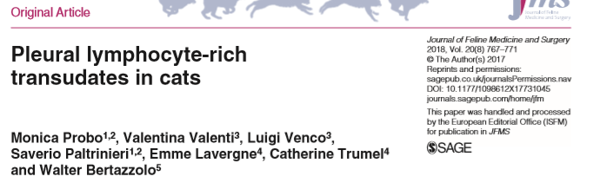
Background:
- The classification of effusions as transudates, modified transudates and exudates is traditionally based on measurement of protein concentration, specific gravity and total nucleated cell counts, in order to characterize them as transudates, modified transudates and exudates.
- Non-chylous lymphorrhagic effusions are transudate forms due to leakage of lymph, but do not contain chylomicrons, and therefore do not show the classical milky aspect of true chylous effusion.
  - lymphocyte-rich transudate (LRT) might represent an alternative and more appropriate designation for these kind of effusions
- One of the most common causes of pleural effusion in cats is an increased hydrostatic pressure of the vascular or lymphatic system often caused by congestive heart failure (CHF).
- The aim of this study was to retrospectively investigate the clinical features and etiology of feline pleural LRTs, and to assess the association between this condition and heart diseases in the cat.
Study:
- Retrospective, 2013-2016
- All transudative effusions with a predominance of lymphocytes on cytology that were considered non- chylous based on visual appearance were included. Pleural effusions classified as neoplastic, exudates or chylous were excluded.
- Only cats that received a complete clinical examination, thoracic radiography and echocardiography were included - diagnosis and classification of cardiac disease was primarily based on echocardiography criteria
- 33 effusion samples met the criteria
  - Triglyceride and cholesterol concentration were available for 19 cases and was consistent with non chylous effusion
  - Lymphocytes comprised >80% of all nucleated cells in 20/33 cases, 60–79% in 8/34 cases and <60% in five cases.
Results/Conclusions:
- 23/33 cases (69.7%) had a concurrent cardiac disease; 9/23 had intra-thoracic mass/neoplasia; 1/23 developed LRT secondary to previous pyothorax
- Authors propose that when a clear lymphatic origin of pleural fluid cannot be demonstrated (chyle), lymphocyte rich transudate (LRT) might be considered a better name for these kinds of effusions rather than “non-chylous lymphorrhagic effusions.”
- The presence of a pleural lymphocyte-rich transudate in a cat should prompt the search for cardiac disease or intrathoracic neoplasia.

