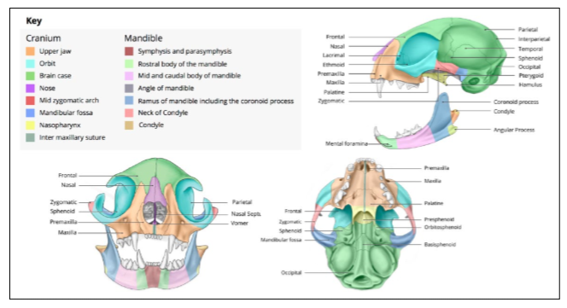
Journal Feline Medicine & Surgery – Feb 14 – April 4 2019
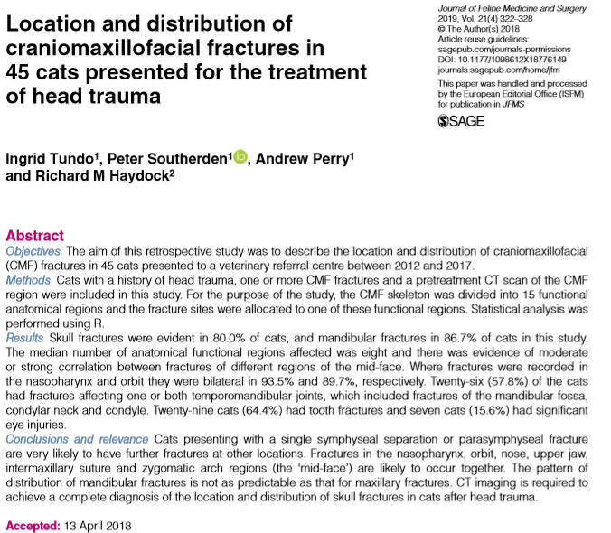
- Can result from HBC, fight, or a fall from a height (high-rise syndrome)
- PE insufficient to accurately classify maxillofacial injuries
- CT imaging superior to XR - incidence and distribution of facial fractures may help develop an understanding of the most appropriate diagnostic and treatment options for these patients
- Retrospective study - describes the location, distribution, fracture pattern, and correlation of the with functional regions and associated ophthalmic and dental injuries in 45 cats
- RESULTS:
  - HBC most common injury causing fracture
  - 80.0% of cats in study had skull fractures (with 81% being bilateral) and 86.7% had mandibular fractures (18% bilateral)
  - Medium 8 fractures per cat
  - Skull fracture - fractures to the ‘mid-face’ region were most common (nasopharynx (68.9%), orbit (68.9%), nose (51.1%), upper jaw (51.1%), intermaxillary suture (44.4%) and zygomatic arch (33.3%))
    - Fractures in these region likely to be bilateral and occur together
  - If a cat had a mandibular symphyseal or parasymphyseal fracture there was an 84.6% chance of another mandibular fracture and a 73.1% chance of a fracture in the skull
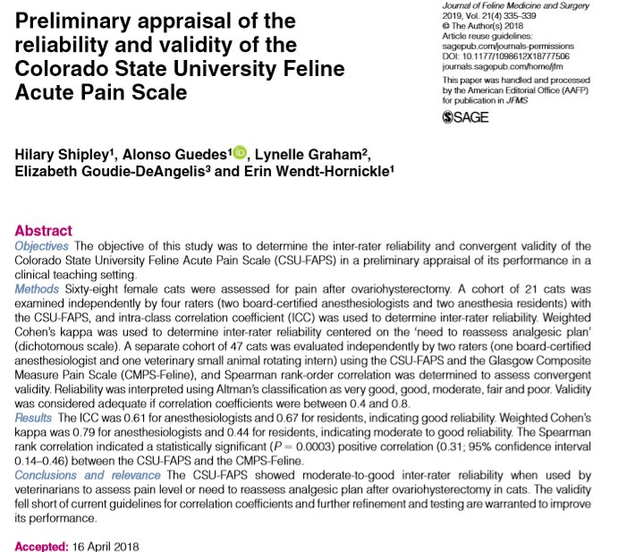

- Uncontrolled pain is detrimental - QOL, increases in cortisol and catecholamines predispose to tissue edema, ischemia, hyperglycemia, infection and impaired wound healing
- Behavioral signs of acute pain in cats: depression, immobility, remaining in a hunched position with the head down, guarding behaviors, attempting to escape, squinting of the eyes, hissing, growling, and resistance to palpation or handling
  - May also appear very similar to signs of distress = overlooked
- Current study: assess the inter-rater reliability and convergent validity of the CSU-Feline Acute Pain Score in a clinical/teaching setting
- RESULTS:
  - CSU-FAPS was simple to use
  - Moderate to good inter-rater reliability when used by veterinarians with advanced training in anesthesia (residents and anesthesiologists)
  - The convergent validity of the scale fell short of current guidelines for correlation coefficient (Glascow Composite Measure Pain Score – Feline was criterion)
  - Refinement of the scale could be beneficial to increase consistency of results
- Relatively reliable but not valid measure

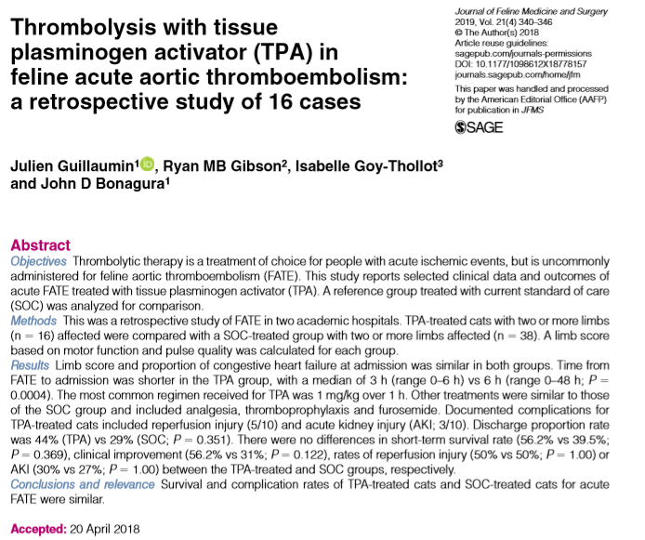
- Prognosis for FATE is poor - euthanasia as high as 90% in some reports
- Current standard treatments = analgesia and thromboprophylaxis - the prognosis is still guarded (survival with treatment 27–45%)
- Humans, mortality and functional outcome improved if tPA given within 6 hours of acute ischemic event
- Veterinary medicine - thrombolysis in FATE has been considered unrewarding (lack of efficacy, risks of reperfusion injury (RI) with hyperkalemia)
- Retrospective study: report clinical data and outcomes associated with the early use and short-term infusion of TPA in FATE vs SOC without TPA (10 year period)
- RESULTS:
  - TPA given within 3 hours of presentation (though significant difference in time to presentation between TPA and SOC group)
  - Euthanasia rate vs spontaneous death was similar in both groups (55.55% for TPA-treated vs 66.7% in SOC)
  - Short-term (48 h) survival proportion were not different between groups (56.25% in the TPA-treated vs 39.5% SOC)
  - 4/7 cats in TPA ground had recurrence of FATE (median time 106 days)
  - SOC group - 25% and 50% developed AKI and RI - not statistically different to the TPA-treated group
  - TPA group – 7/16 had motor function improvement w/in 12 hours of treatment (none in SOC group did not (no significance noted)
  - Overall underpowered – differences may not have been detected
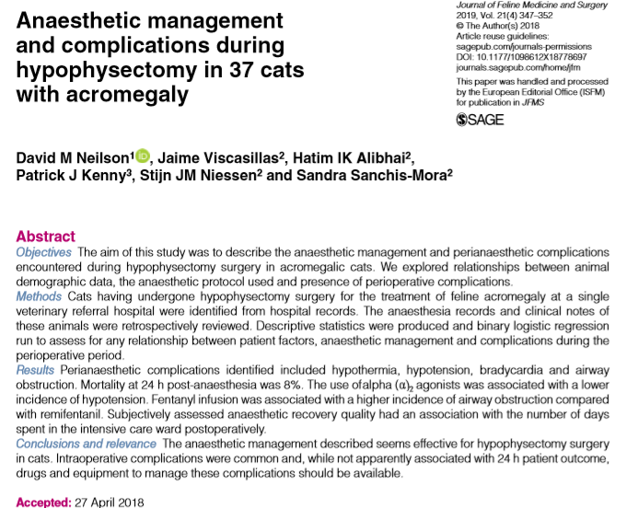
- Hypersomatotropism - growth hormone-secreting pituitary gland adenoma
- Though typically slow-growing, neurological disease is possible
- Traditionally treated with radiation though more surgeons are performing hypophysectomies
- Retrospective study: describe the anesthetic management and complications encountered during hypophysectomy surgeries, assess the relationship between complications and the anesthesia protocol used, and the impact and presence of complications on the perioperative outcome
- RESULTS:
  - Ax management consisted of methadone +/- midazolam, alpha 2 agonist, alfaxalone, acepromazine as premed; propofol or alfaxalone +/- midaz to induce; sevo or iso for maintenance with fentanyl or remifentanil; insulin CRI; hydrocortisone CRI; desmopressin conjunctival; buprenorphine post op
  - Cats that did not receive an α2 agonist were more likely to suffer hypotension during the anesthetic period
  - Cats that received a CRI of remifentanil were less likely to suffer airway complications than cats that received fentanyl infusion
  - Interestingly cats with recovery described as ‘abnormal’ were discharged quicker from the ICU compared with cats with a recovery quality described as ‘unremarkable’
  - Intraoperative complications: hypothermia, bradycardia, hypotension and airway obstruction
  - 3/38 (8%) died within 24 hours of anesthetic recovery
  - Median time in ICU post-op was 6.8 days +/- 3.8
  - Mortality rate lower than previous studies

