JOURNAL FELINE SURG & MED
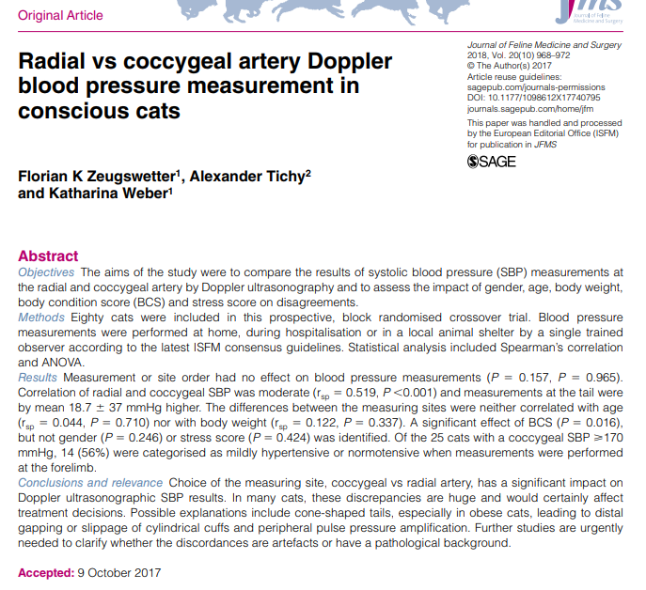
- Replicated findings in two other studies – site of BP measurement (radial vs coccygeal a.) impacted the SBP results using Doppler syphgmomamanometry
- Mean SBP measurements were only moderately correlated (r=0.519)
- Readings on tail were on average 18.7mmHg higher than on forelimb
- Discrepancies in SBP were significantly greater in cats with a BCS > 4 (5 pt scale)
- 14/25 cats that were categorized as hypertensive based on SBP obtained from coccygeal a. were categorized as mildly hypertensive to normotensive with radial a. measurement
  - if sole result of coccygeal measurement was used this would have impacted treatment decisions (i.e initiation of anti-hypertensive medication)
- Differences attributed to cuff shape / fit, difference in peripheral pulse pressure at different body sites, BCS
- Authors recommend documenting BP measurement site and interpret them with caution.
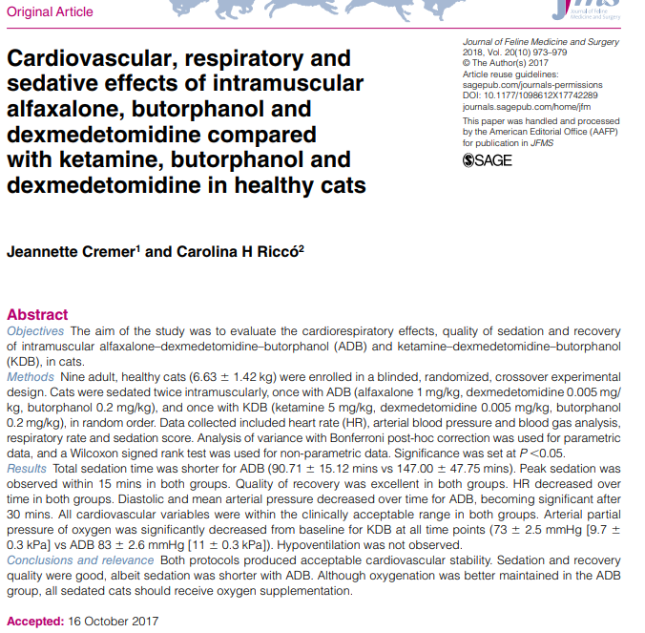

- Adequate sedation achieved with both protocols
- Sedation time with alfaxalone was significantly shorter
- No differences in the two groups were observed with respect to quality of sedation, recovery and cardiovascular effects
- Hypoxemia occurred more frequently in the ketamine group was but was also observed in a few cats in the alfaxalone group however hypoventilation was not observed – attributed to V/Q mismatch from atelectasis from positioning
- All sedated cats should receive supplemental oxygen
In conclusion, there is evidence that Small Jaw and Impact
LigaSures can be reused for a limited number of cycles with-
out deterioration of the vascular seal quality, but they should
be immediately discarded as soon as any intraoperative evi-
dence of formation of a failed vascular seal is identified.

