JVIM JUNE – OCT 2018
Questions

- Which of the following is true regarding fenoldopam and its’ use for treatment of AKI in dogs? “Effects of fenoldopam on kidney function parameters and its therapeutic efficacy in the management of acute kidney injury in dogs with heatstroke” (J Vet Intern Med. 2018)

  - Fenoldopam use in dogs with heatstroke-induced AKI is associated with reduced mortality
  - Fenoldopam is a dopamine-1 receptor agonist that increases GFR
  - Fenoldopam use is associated with hypotension
  - Fenoldopam treatment in dogs with naturally occurring heatstroke is associated with reduced incidence of AKI

- In “Effect of cross-match on packed cell volume after transfusion of packed red blood cells in transfusion-naïve anemic cat” (J Vet Intern Med. 2018) Cats that received cross-match compatible blood compared to cats that received non-crossmatched blood…

  - Had a reduced incidence of transfusion reactions and had a higher change in PCV at 24-hours post-transfusion
  - Had a reduced incidence of transfusion reactions and had no difference in PCV change at 24-hours post-transfusion
  - Had no difference in incidence of transfusion reactions and had a higher change in PCV 24-hours post-transfusion
  - Had no difference in incidence of transfusion reactions and had no difference in PCV change at 24-hours post-transfusion

JVIM SEPT - OCT 2018

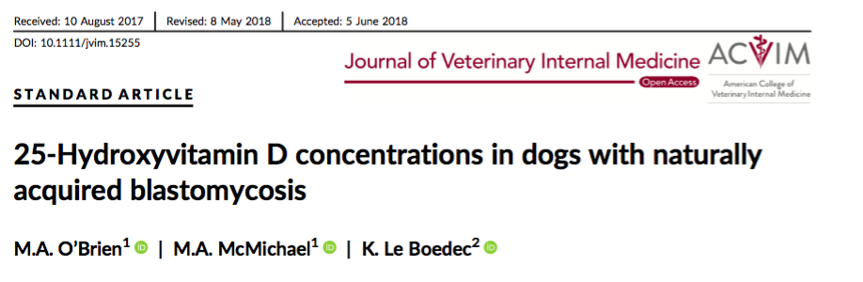
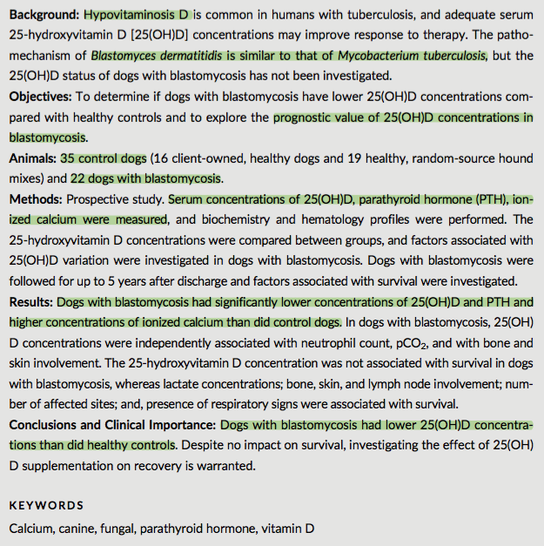

- Vitamin D plays a role in immunomodulation of monocyte/macrophage function
- Hypovitaminosis D is known to be a risk factor for development of Mycobacterium tuberculosis in humans, which follows a similar pathogenesis to blastomycosis
- Blasto dogs had lower Vitamin D, PTH and higher iCa++ levels than healthy dogs, but there was no association between vitamin D levels and survival
  - 27.3% of blasto dogs had vitamin D levels below the reference range
- Dogs with lower vitamin D levels may be at higher risk of infection?
  - Or are the lower levels just a result of infection?
  - Would supplementation improve response to therapy?

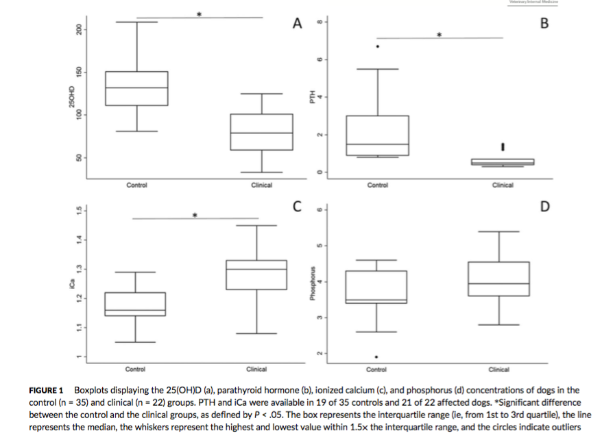

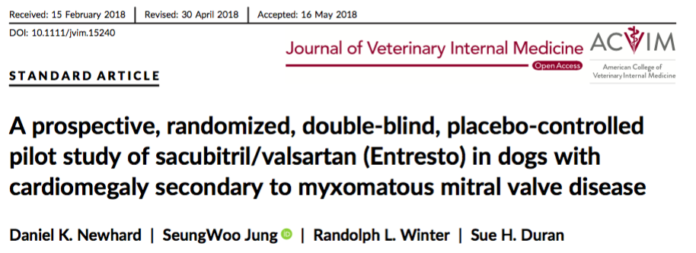
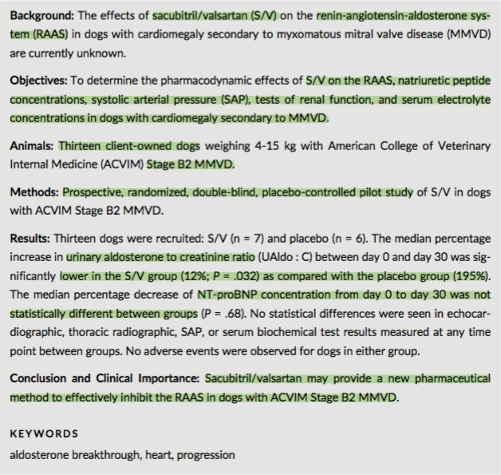

- Chronic activation of RAAS contributes to the development of CHF
- ACE-I are standard-of-care for treatment of heart failure secondary to MMVD
- ACE-I are effective at decreasing plasma levels of ACE, but less effective at decreasing tissue concentrations of ACE
  - Most ACE is present in tissues
  - Most AngII production in tissues is through non-ACE mediated pathways
  - Aldosterone production continues! i.e. aldosterone breakthrough
- Angiotensin II receptor blockers (ARB) are used to inhibit effect of AngII from non-ACE dependent pathways, but they do not stop aldosterone breakthrough all together
- Sacubitril/ Valsartan = angiotensin receptor blocker/ NEP inhibitor
  - Neprilysin (NEP) is an enzyme that naturally cleaves NPs
  - Increased NEP concentrations are positively associated with CV death and hospitalization in humans with heart failure
  - Sacubitril/ Valsarten showed an overwhelming benefit compared to enalapril in humans with symptomatic heart failure
- Aim: determine effect of S/V on RAAS and NP system in dogs by measuring urinary aldosterone-to-creatinine ratio and plasma NT-proBNP concentrations, compared to placebo
  - Hypothesis: lower UAldos:C and lower plasma NT-proBNP
- 20 mg/kg PO q12
- S/V has a beneficial inhibitory effect on RAAS in dogs with Stage B2 MMVD
- No difference in NT-proBNP

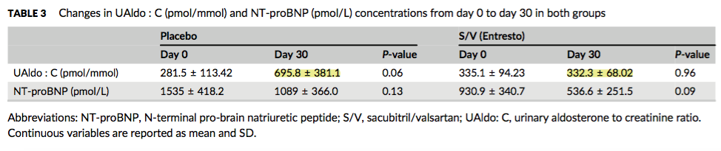

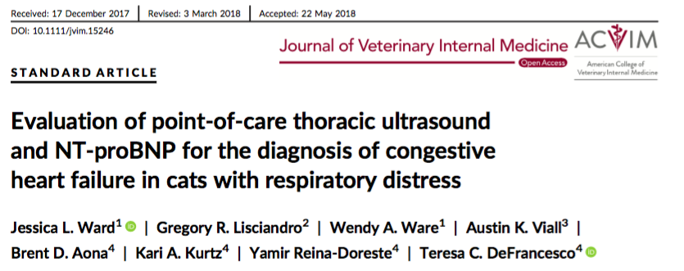
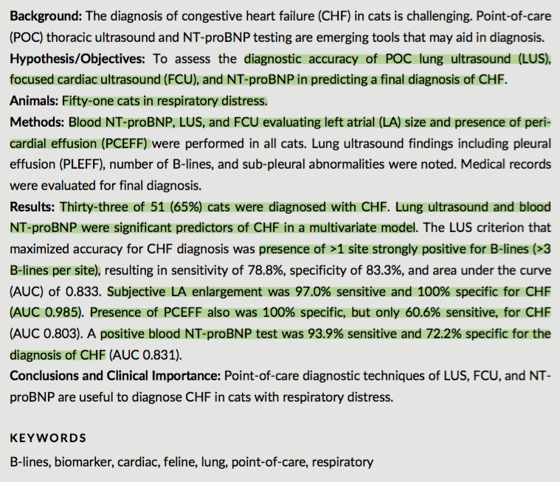

- Exclusions: inc respiratory rate/ effort due to pain or other non-cardiac/ non-respiratory cause; recent history of trauma.
- Patients that received furosemide prior to lung ultrasound were NOT excluded.
- 15/51 cats had a murmur on presentation, there was no significant difference in the incidence of CHF between those with a murmur and those without
- 13/51 cats had a gallop; all of which were diagnosed with CHF (i.e. cats with CHF were more likely to have a gallop than those with non-cardiogenic respiratory disease)
- Non-cardiogenic respiratory cats had a higher presenting respiratory rate than CHF cats
- No difference in HR or rectal temperature

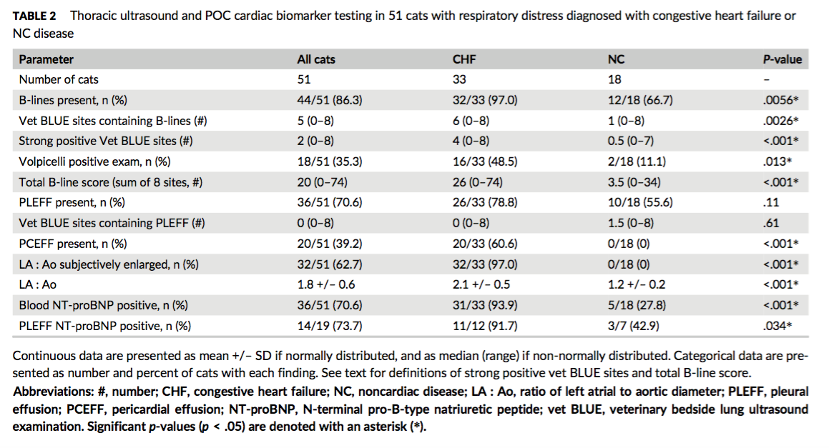

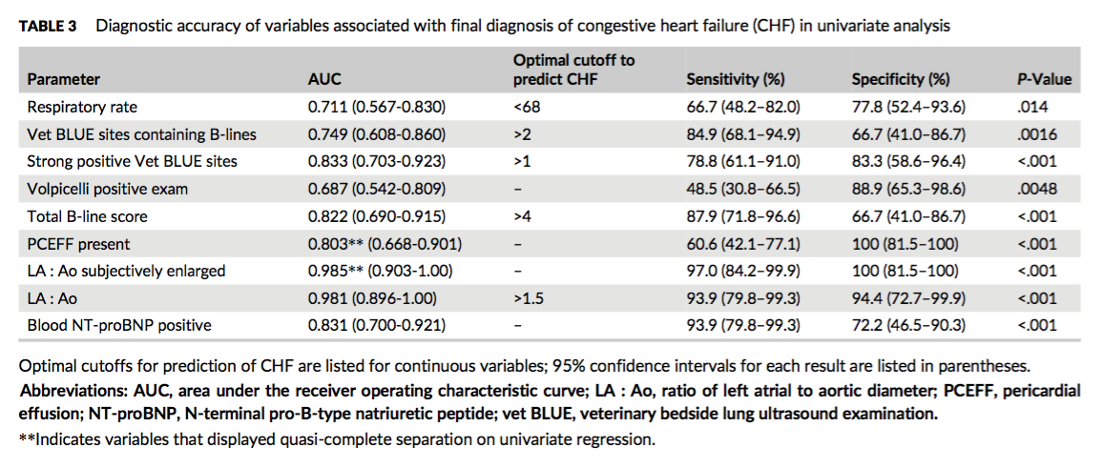

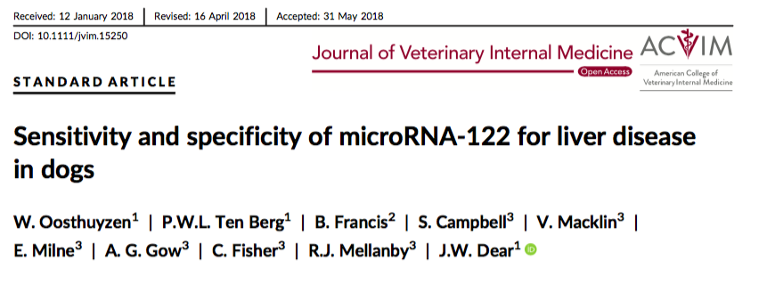
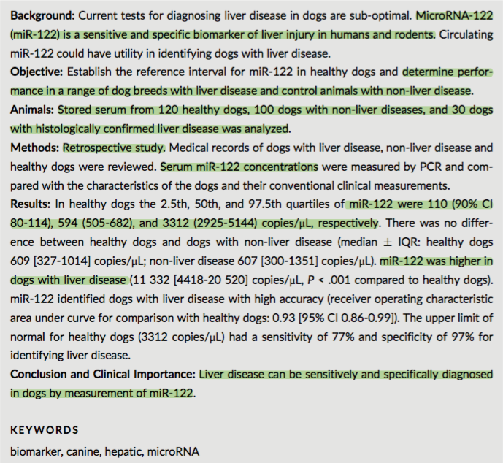

- mIRNA are small, non-protein coding RNAs that regulate post-transcriptional gene expression - miRNA-122 is highly expressed in hepatocytes

