JVIM JUNE – OCT 2018

Thomason JM, Archer TM, Wills RW, Mackin AJ. Effects of immunosuppressive agents on the hemostatic system in normal dogs. J Vet Intern Med. 2018;32(4):1325-1333. doi:10.1111/jvim.15132.

BACKGROUND: In dogs, the effects of immunosuppressive medications on hemostasis are not well known.

HYPOTHESIS/OBJECTIVES: The objective was to determine the effects of immunosuppressive medications on primary and secondary hemostasis. Our hypothesis was that cyclosporine and prednisone would increase markers of hypercoagulability and thromboxane synthesis, while azathioprine, mycophenolate mofetil, and leflunomide would have minimal effects on hemostasis.

ANIMALS: Eight healthy dogs.

METHODS: A randomized, cross-over study used aggregometry, the PFA-100 platelet function analyzer, viscoelastometry, platelet count, and prothrombin and activated partial thromboplastin times to evaluate hemostasis during the administration of prednisone, azathioprine, cyclosporine, mycophenolate mofetil, and leflunomide for 1 week each at standard oral doses. Urine 11-dehydro-thromboxane-B2 (11-dTXB2 ) and 6-keto-prostaglandin-F1α (6-keto-PGF1α ) concentrations, normalized to urine creatinine concentration, were measured.

RESULTS: The aggregometry amplitude decreased from 51 ± 21 to 27 ± 14 (P = .002) during leflunomide treatment (ADP activation), but there were no differences in amplitude (P = .240) for any medications when platelets were activated with collagen. For all medications, there were no significant differences in viscoelastometry indices (ACT, P = .666; ClotRate, P = .340; and platelet function, P = .411) and platelet count (P = .552). Compared with pretreatment values, urinary 11-dTXB2 -to-creatinine ratio increased (P = .001) after drug administration (from 3.7 ± 0.6 to 5.6 ± 1.1). Cyclosporine was associated with an increase (P < .001) in the 6-keto-PGF1α -to-creatinine ratio (from 10.3 ± 4.6 to 22.1 ± 5.3).

CONCLUSIONS AND CLINICAL IMPORTANCE: Most immunosuppressive drugs do not enhance platelet function or coagulation in healthy dogs, suggesting that these medications might not predispose hypercoagulable dogs to thromboembolism. The results of our study need to be correlated with the clinical outcomes of hypercoagulable dogs.

- Treatment of IMHA is centered on immunosuppressive medications: glucocorticoids, cyclosporine, azathioprine, mycophenolate mofetil, leflunomide
- High incidence of thromboembolism in dogs with IMHA – increase in hyperactive platelets, procoagulant microparticles, intravascular tissue factor expression
- Cyclosporine administration is associated with a significant increase in thromboxane A2 synthesis
  - Thromboxane A2 (eicosanoid) is primarily produced by activated platerls, although also produced by leukocytes and endothelial cells
  - Triggers vasoconstriction, enhances platlet activation and aggregation decreased blood flow, promotes coagulation, potentially predisposing for thrombus formation
    - In humans renal transplant patients treated with cyclosporine have increased thromboxane A2 synthesis associated with increased rate of thrombus formation within the renal parenchyma compared to patients treated with azathioprine
  - Unknown effects of mycophenolate mofetil, azathioprine and leflunomide and the hemostatic system in dogs
- 8 healthy Walker Hound dogs in 5 way, randomized, cross-over study
- PFA-100, Sonoclot Analysis (viscoelastrometric) and PT/aPTT, urine 11-dehydro-thromboxane B2 (stable thromboxane A2 metabolite), urine 6-keto-prostaglandin F1alpha (stable prostacyclin metabolite)
- No significant differences in viscoelastometry indices and platelet count
- Aggregometry decreased during leflunomide treatment
- Urine 6-keto-prostaglandin F1alpha increased in dogs treated with cyclosporine – increased prostacyclin concentrations may counteract the prothrombotic properties of prostacyclin
- Conclusions:
  - Most immunosuppressive drugs do not enhance platlet function or coagulation in healthy dogs, indicating that they should not predisponse dogs to thromboembolism
  - Any increase in thromboxane production is either insufficient, or counteracted by concurrent increase in prostacyclin production, to result in altered platelet function

Segev G, Bruchim Y, Berl N, Cohen A, Aroch I. Effects of fenoldopam on kidney function parameters and its therapeutic efficacy in the management of acute kidney injury in dogs with heatstroke. J Vet Intern Med. 2018;32(3):1109-1115. doi:10.1111/jvim.15081.

BACKGROUND: Acute kidney injury (AKI) is common in dogs, but evidence of efficacy of its treatment is lacking.

OBJECTIVE: To evaluate the efficacy of fenoldopam in the management of AKI.

ANIMALS: Forty dogs with naturally occurring heatstroke.

METHODS: Dogs were prospectively enrolled and divided into treatment and the placebo groups (fenoldopam, constant rate infusion [CRI] of 0.1 µg/kg/min or saline, respectively). Urine production (UP) was measured using a closed system. Urinary clearances were performed at 4, 12, and 24 hours after presentation to estimate the effect of fenoldopam on UP, glomerular filtration rate (GFR) and sodium fractional excretion (NaFE).

RESULTS: At presentation, severity of heatstroke, based on a previously developed scoring system, was similar between the study groups, but was significantly worse in nonsurvivors compared with survivors. Fenoldopam administration was not associated with hypotension. Overt AKI was diagnosed, based on the International Renal Interest Society guidelines in 22/40 (55%) of the dogs. Overall, 14/40 dogs (35%) died, with no significant (P = .507) mortality rate difference between the fenoldopam (6/20 dogs; 30%) and placebo (8/20; 40%) groups. The proportion of dogs with AKI did not differ between the fenoldopam and the placebo groups (9/20; 45% versus 13/20; 65%, respectively; P = .204). There were no differences in UP, GFR, and NaFE between the fenoldopam and the placebo groups.

CONCLUSION AND CLINICAL IMPORTANCE: Fenoldopam CRI at 0.1 µg/kg/min did not have a clinically relevant effect on kidney function parameters in dogs with severe heatstroke-associated AKI.

- Low-dose dopamine suggested as treatment for AKI in humans; recent evidence does not support this
- Fenoldopam is selective dopamine-1-receptor (DA-1) agonist vasodilation selective increase in renal cortical and outer medullary blood flow and GFR
  - Unlike dopamine, not associated with adverse effects from alpha and beta-adrenergic receptor activation
  - Study of AKI in human ICU patients showed fenoldopam CRI led to a decreased occurrence of AKI; but other studies show conflicting information
  - Veterinary study showed increased GFR in healthy dogs
- Fenoldopam CRI @ 0.1 mcg/kg/min initiated 4hrs post-presentation once normotensive
- Limitations:
  - Dogs that were euthanized due to grave prognosis were defined as non-survivors
  - Small sample size with half the dogs not meeting criteria for AKI
  - Most dogs (73%) the diagnosis of AKI was already made by presentation – so effect of fenoldopam preventing progression of AKI could not be assessed
  - Relatively low dose of fenoldopam based on human literature - higher dosages (0.5–0.8 mg/kg/min) reported in veterinary study
- “Results do not support the use of fenoldopam at a dosage of 0.1 mg/kg/min for managing heatstroke-associated AKI”

Beaumier A, Rush JE, Yang VK, Freeman LM. Clinical findings and survival time in dogs with advanced heart failure. J Vet Intern Med. 2018;32(3):944-950. doi:10.1111/jvim.15126.

BACKGROUND: Dogs with advanced heart failure are a clinical challenge for veterinarians but there are no studies reporting clinical features and outcome of this population.

HYPOTHESIS/OBJECTIVES: To describe clinical findings and outcome of dogs with advanced heart failure caused by degenerative mitral valve disease (DMVD).

ANIMALS: Fifty-four dogs with advanced heart failure because of DMVD.

METHODS: For study purposes, advanced heart failure was defined as recurrence of congestive heart failure signs despite receiving the initially prescribed dose of pimobendan, angiotensin-converting-enzyme inhibitor (ACEI), and furosemide >4 mg/kg/day. Data were collected for the time of diagnosis of Stage C heart failure and time of diagnosis of advanced heart failure. Date of death was recorded.

RESULTS: At the diagnosis of advanced heart failure, doses of pimobendan (n = 30), furosemide (n = 28), ACEI (n = 13), and spironolactone (n = 4) were increased, with ≥1 new medications added in most dogs. After initial diagnosis of advanced heart failure, 38 (70%) dogs had additional medications adjustments (median = 2 [range, 0-27]), with the final total medication number ranging from 2-10 (median = 5). Median survival time after diagnosis of advanced heart failure was 281 days (range, 3-885 days). Dogs receiving a furosemide dose >6.70 mg/kg/day had significantly longer median survival times (402 days [range, 3-885 days] versus 129 days [range 9-853 days]; P = .017).

CONCLUSIONS AND CLINICAL IMPORTANCE: Dogs with advanced heart failure can have relatively long survival times. Higher furosemide dose and non-hospitalization were associated with longer survival.

- The median time during which dogs were in stage C before advancing to advanced heart failure was 163 days (range, 10–743 days)
- Median survival time after the diagnosis of advanced heart failure was 281 days (range, 3–885 days).
- Longer survival time was noted for dogs receiving a furosemide dose greater than or equal to the median dose of 6.70 mg/kg/day (median survival 5 402 days [range, 3–885 days]) compared to those receiving a furosemide dose lower than the median (median survival = 129 days [range, 9–853 days]; P=0.017; Figure 1).
- Dogs that were hospitalized on the day of diagnosis of advanced heart failure had a shorter survival time (median survival = 163 days [range 3–464 days]; compared to dogs treated as outpatients (median survival = 318 days [range, 9–885 days]; P= 0.011)
- Limitations
  - Did not use ACVIM consensus statement definition of advanced heart failure (Stage D)

Hori Y, Iguchi M, Heishima Y, et al. Diagnostic utility of cardiac troponin I in cats with hypertrophic cardiomyopathy. J Vet Intern Med. 2018;32(3):922-929. doi:10.1111/jvim.15131.

BACKGROUND: Cardiac troponin I (cTnI) is useful for assessing hypertrophic cardiomyopathy (HCM) in cats.

OBJECTIVE: To measure plasma cTnI concentrations in healthy cats and evaluate the clinical utility of cTnI in determining the severity of HCM.

ANIMALS: Clinically healthy cats (n = 88) and cats with HCM (n = 93).

METHODS: Multicenter prospective study. Cats with HCM, including hypertrophic obstructive cardiomyopathy at various stages, were diagnosed using echocardiography. Plasma cTnI concentrations were analyzed by a commercial laboratory. Receiver-operating characteristic curve analysis was used to evaluate the accuracy of plasma cTnI concentrations to detect HCM.

RESULTS: The median cTnI concentration was 0.027 ng/mL (interquartile range, 0.012-0.048 ng/mL) in healthy cats. Concentrations were significantly higher in diseased cats than in healthy controls, and concentrations were significantly higher in cats with heart failure than in asymptomatic cats. A plasma cTnI concentration of 0.163 ng/mL had a sensitivity of 62.0% and specificity of 100% when used to distinguish normal cats from asymptomatic HCM cats without left atrial dilatation. A cutoff of 0.234 ng/mL had high sensitivity (95.0%) and specificity (77.8%) for assessing heart failure. The areas under the receiver-operating characteristic curves were 0.85 and 0.93, respectively.

CONCLUSIONS AND CLINICAL IMPORTANCE: Increased cTnI concentrations reflect the severity of HCM. If other causes of cardiac injury are ruled out, plasma cTnI concentration may be useful for predicting the severity of HCM in cats.

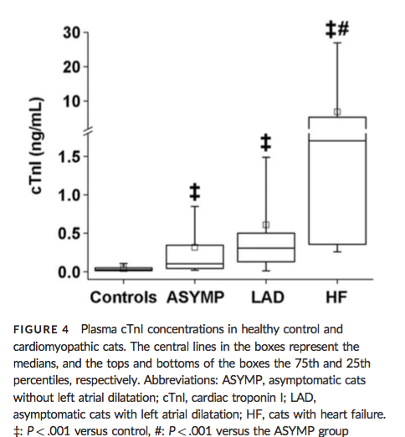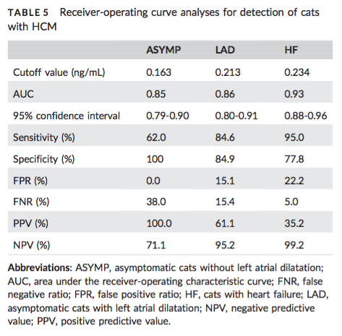

Sylvane B, Prittie J, Hohenhaus AE, Tozier E. Effect of cross-match on packed cell volume after transfusion of packed red blood cells in transfusion-naïve anemic cats. J Vet Intern Med. 2018;32(3):1077-1083. doi:10.1111/jvim.15120.

BACKGROUND: Novel feline RBC antigens might contribute to decreased efficacy of RBC transfusion and increased incidence of acute transfusion reactions (ATR).

OBJECTIVES: To examine the effect of major cross-match in transfusion-naïve anemic cats on the incidence of acute immunologic transfusion reaction and transfusion efficacy for up to 24 hours after transfusion.

ANIMALS: Forty-eight client owned transfusion-naïve anemic cats.

METHODS: Prospective, randomized, controlled study. All transfusion-naïve cats receiving packed red blood cells (pRBC) transfusions from January 2016 to August 2017 were eligible for inclusion. Cats in the study group received cross-match and blood type compatible pRBCs and cats in the control group received noncross-matched blood type compatible pRBCs. Incidence of ATR and change in PCV after transfusion was recorded.

RESULTS: No significant difference in incidence of transfusion reactions between cross-matched and noncross-matched groups (CM+ 4/24; 17%, CM- 7/24; 29%, P = .16). No significant difference between groups in mean change in PCV after transfusion scaled to dose of pRBCs administered at any time point after transfusion (immediate: CM+ 0.62 ± 0.59, CM- 0.75 ± 0.48, P = .41; 1 hour: CM+ 0.60 ± 0.66, CM- 0.74 ± 0.53, P = .43; 12 hours: CM+ 0.70 ± 0.55, CM- 0.66 ± 0.60, P = .81; 24 hours: CM+ 0.64 ± 0.71, CM- 0.55 ± 0.48, P = .70).

CONCLUSIONS AND CLINICAL IMPORTANCE: Our results do not support use of the major cross-match test to increase efficacy of, and to decrease adverse events associated with, RBC transfusion in AB blood typed transfusion-naïve cats.

- Suggestion that there may be a subclinical level of hemolysis in transfused RBCs because of undetected alloantibodies in uncross-matched blood transfusions
- Major crossmatched should detect these incompatibilities and result in greater efficacy of transfusion
  - Weltman JG, Fletcher DJ, Rogers C. Influence of cross-match on posttransfusion packed cell volume in feline packed red blood cell transfusion. J Vet Emerg Crit Care. 2014;24:429–436.
- Lower than anticipated values (1% increase for 1 mL/kg pRBC) are not secondary to incompatibilities between donor and recipient blood – perhaps this is an inaccurate formula to calculated expected PCV rise, or is due to repeated smapling, ongoing loss/ destruction, or fluid dilution
- dy, 19% of all major cross-matches per- formed in transfusion-naïve cats in the CM1 group revealed an incom- patibility
  - Crossmatch incompatibilities are not always clinically relevant?
- Similar incidence of FNHTR between groups, which is expected given that crossmatch does not detect incompatibilities between leukocytes
- PCV before transfusion was an independent predictor of PCV post transfusion
  - Perhaps cats with lower PCV

Darnis E, Boysen S, Merveille A-C, Desquilbet L, Chalhoub S, Gommeren K. Establishment of reference values of the caudal vena cava by fast-ultrasonography through different views in healthy dogs. J Vet Intern Med. 2018;32(4):1308-1318. doi:10.1111/jvim.15136.

BACKGROUND: Clinical assessment of intravascular volume status is challenging. In humans, ultrasonographic assessment of the inferior vena cava diameter, directly or as a ratio to the aortic diameter is used to estimate intravascular volume status.

OBJECTIVES: To ultrasonographically obtain reference values (RV) for caudal vena cava diameter (CVCD ), area (CVCa ) and aortic ratios using 3 views in awake healthy dogs.

ANIMALS: One hundred and twenty-six healthy adult dogs from clients, students, faculty, or staff.

METHODS: Prospective, multicenter, observational study. Two observer pairs evaluated CVCD by a longitudinal subxiphoid view (SV), a transverse 11th-13th right hepatic intercostal view (HV), and a longitudinal right paralumbar view (PV). Inter-rater agreements were estimated using concordance correlation coefficients (CCC). For body weight (BW)-dependent variables, RVs were calculated using allometric scaling for variables with a CCC ≥ 0.7.

RESULTS: The CCC was ≤0.43 for the CVC/aorta ratio at the PV and ≤0.43 in both inspiration and expiration for CVC at the SV. The RVs using allometric scaling for CVCa at the HV for inspiration, expiration, and for CVCD at the PV were 6.16 × BW^{0.762}, 7.24 × BW^{0.787}, 2.79 × BW^{0.390}, respectively.

CONCLUSIONS AND CLINICAL IMPORTANCE: The CVCD, measured at the HV and PV in healthy awake dogs of various breeds has good inter-rater agreement suggesting these sites are reliable in measuring CVCD. Established RVs for CVCD for these sites need further comparison to results obtained in hypovolemic and hypervolemic dogs to determine their usefulness to evaluate volume status in dogs.

- evaluation of inferior vena cava diameter (IVCD) and collapsibility index (IVCCI) as well as the ratio of IVC compared with the aortic diameter (IVC/Ao) all have been evaluated to assess intravascular volume status.
  - Correlate well with intravascular volume status and can predict fluid responsiveness in human patients

Makielski KM, Brooks MB, Wang C, Cullen JN, O'Connor AM, LeVine DN. Development and implementation of a novel immune thrombocytopenia bleeding score for dogs. J Vet Intern Med. 2018;32(3):1041-1050. doi:10.1111/jvim.15089.

BACKGROUND: A method of quantifying clinical bleeding in dogs with immune thrombocytopenia (ITP) is needed because ITP patients have variable bleeding tendencies that inconsistently correlate with platelet count. A scoring system will facilitate patient comparisons and allow stratification based on bleeding severity in clinical trials.

HYPOTHESIS/OBJECTIVES: To develop and evaluate a bleeding assessment tool for dogs, and a training course for improving its consistent implementation.

ANIMALS: Client-owned dogs (n = 61) with platelet counts <50,000/μL; 34 classified as primary ITP, 17 as secondary ITP, and 10 as non-ITP.

METHODS: A novel bleeding assessment tool, DOGiBAT, comprising bleeding grades from 0 (none) to 2 (severe) at 9 anatomic sites, was developed. Clinicians and technicians completed a training course and quiz before scoring thrombocytopenic patients. The training course was assessed by randomizing student volunteers to take the quiz with or without prior training. A logistic regression model assessed the association between training and quiz performance. The correlation of DOGiBAT score with platelet count and outcome measures was assessed in the thrombocytopenic dogs.

RESULTS: Clinicians and technicians consistently applied the DOGiBAT, correctly scoring all quiz cases. The odds of trained students answering correctly were higher than those of untrained students (P < .0001). In clinical cases, DOGiBAT score and platelet count were inversely correlated (rs = -0.527, P < .0001), and DOGiBAT directly correlated with transfusion requirements (rs = 0.512, P < .0001) and hospitalization duration (rs = 0.35, P = .006).

CONCLUSIONS AND CLINICAL IMPORTANCE: The DOGiBAT and assessment quiz are simple tools to standardize evaluation of bleeding severity. With further validation, the DOGiBAT may provide a clinically relevant metric to characterize ITP severity and monitor response in treatment trials.

- Platelet count did not correlate with any outcome measures
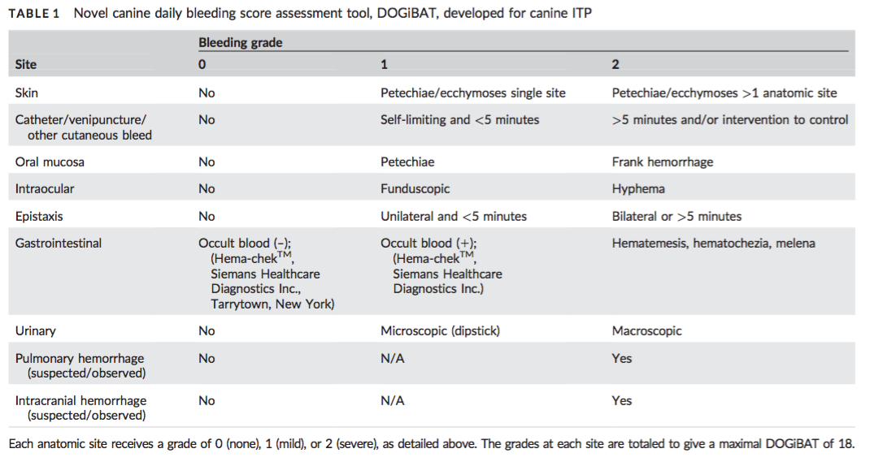

Troia R, Gruarin M, Grisetti C, et al. Fractional excretion of electrolytes in volume-responsive and intrinsic acute kidney injury in dogs: Diagnostic and prognostic implications. J Vet Intern Med. 2018;32(4):1372-1382. doi:10.1111/jvim.15146.

BACKGROUND: The value of fractional excretion (FE) of electrolytes to characterize and prognosticate acute kidney injury (AKI) is poorly documented in dogs.

OBJECTIVES: To evaluate the diagnostic and prognostic roles of FE of electrolytes in dogs with AKI.

ANIMALS: Dogs (n = 135) with AKI treated with standard care (February 2014-December 2016).

METHODS: Prospective study. Clinical and laboratory variables including FE of electrolytes, were measured upon admission. Dogs were graded according to the AKI-IRIS guidelines and grouped according to AKI features (volume-responsive, VR-AKI; intrinsic, I-AKI) and outcome (survivors/ non-survivors). Group comparison and regression analyses with hazard ratios (HR) evaluation for I- AKI and mortality were performed. P < .05 was considered significant.

RESULTS: Fifty-two of 135 (39%) dogs had VR-AKI, 69/135 (51%) I-AKI and 14/135 (10%) were unclassified. I-AKI dogs had significantly higher FE of electrolytes, for example, FE of sodium (FENa, %) 2.39 (range 0.04-75.81) than VR-AKI ones 0.24 (range 0.01-2.21; P < .001). Overall, case fatality was 41% (55/135). Increased FE of electrolytes were detected in nonsurvivors, for example, FENa 1.60 (range 0.03-75.81) compared with survivors 0.60 (range 0.01-50.45; P = 004). Several risk factors for death were identified, including AKI-IRIS grade (HR = 1.39, P 5 .002), FE of electrolytes, for example, FENa (HR = 1.03, P < .001), and urinary output (HR = 5.06, P < .001).

CONCLUSIONS AND CLINICAL IMPORTANCE: Fractional excretion of electrolytes performed well in the early differentiation between VR-AKI and I-AKI, were related to outcome, and could be useful tools to manage AKI dogs in clinical practice.

- “Volume-responsive” and “intrinsic” AKI have been proposed in human medicine to ameliorate the classification of “prerenal” and “renal” kidney injury.
  - intrinsic AKI refers to structural damage to the renal parenchyma
  - volume-responsive AKI is characterized by a transient reduction of renal function, which can be reversed after short-term fluid administration
  - volume- responsive AKI is characterized by low (<1%) FE of sodium (FENa), increased (>35%) FE of urea (FEurea), and increased urine creatinine (uCr) to sCr ratio (uCr/sCr; >40)
- Definitions
  - volume-responsive AKI was defined as an increase in urine production above 1 m/kg/hr over 6 hours of adequate fluid therapy, or a decrease in sCr concentrations to baseline over 48 hours
  - intrinsic AKI was defined as persistent azotemia for longer than 48 hours, inappropriate oligo/anuria despite appropriate fluid therapy once any volume deficit had been restored and euvolemia achieved, or both.
- FEX = uX sCr=uCr sX
- Results
  - Significantly higher frequencies of death were detected in dogs with intrinsic compared with volume-responsive AKI (52.2% versus 17.3%, P < .001), and in dogs with oligo/anuria, as previously defined, compared with nonoliguric ones (69.8% versus 23.9%, P < .001).
  - Frequency of death was significantly higher in dogs with oligo/anuria than in dogs with intrinsic AKI dogs (P 5 .007).

Guzmán Ramos PJ, Fernández Pérez C, Ayllón Santiago T, Baquero Artigao MR, Ortiz-Díez G. Incidence of and associated factors for bacterial colonization of intravenous catheters removed from dogs in response to clinical complications. J Vet Intern Med. 2018;32(3):1084-1091. doi:10.1111/jvim.15118.

BACKGROUND: Infection rate associated with intravenous (IV) catheter placement is emerging as an important issue in small animal veterinary medicine, mostly because of the economic costs associated with these infections. Identification of possible associated factors may provide useful information for the surveillance and prevention of such infections.

OBJECTIVES: To determine the incidence of positive bacterial cultures obtained from IV catheters used in dogs hospitalized for at least 48 hours and removed because of clinical complication. To identify the bacteria involved and factors associated with bacterial colonization.

ANIMALS: One-hundred eighty-two dogs that underwent IV catheterization from January 2015 to July 2015 at the Veterinary Teaching Hospital of Alfonso X el Sabio University of Madrid were enrolled in the study.

RESULTS: The bacterial colonization rate of all IV catheters removed in response to clinical complications was 39.6%, the cumulative proportion of catheters that remained in place at 24, 48, and 72 hours after placement was 89.5, 78, and 59.4%, respectively. Multivariable Cox proportional hazards regression indicated significant associations for staff who performed catheterization (junior, P = .002; student, P = .034) and use of steroidal anti-inflammatory drugs (P = .036). The most frequently isolated bacterium was Acinetobacter spp. (21.7%).

CONCLUSIONS AND CLINICAL IMPORTANCE: The bacterial colonization incidence related to IV catheter placement was slightly higher than the incidence described in other veterinary studies. Associated factors not previously described in veterinary medicine were found. The most frequently isolated organism was Acinetobacter spp., indicating its importance as an emerging pathogen in catheter colonization.

