November 2018 – February 2019 Literature Review

Veterinary radiology & ultrasound
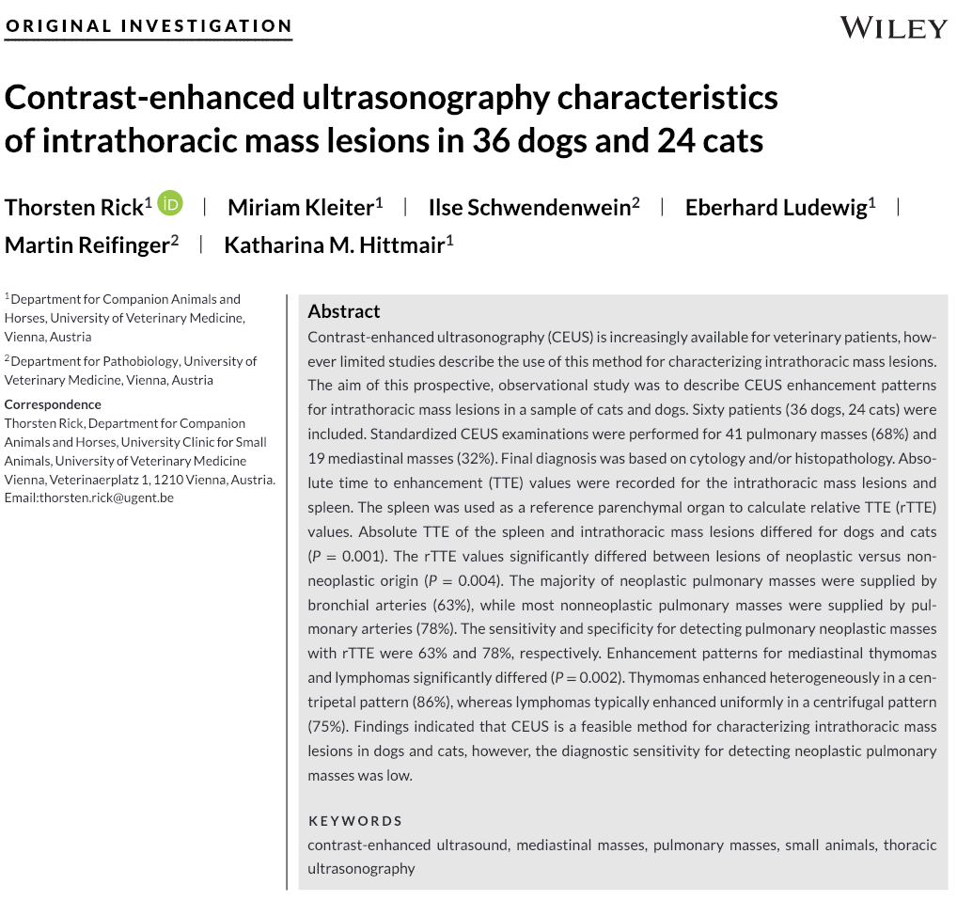
- CEUS used in human medicine to differentiate pulmonary mass via vascularization patterns
- Prospective observational study Oct 2014 to January 2017; 60 animals met inclusion criteria
- CEUS enhancement and vascularization patterns were different in a portion of neoplasia and nonneoplastic pulmonary and mediastinal masses
  - Malignant pulmonary lesions had bronchial arterial vascularization (Sn 63%, Sp 78%), whereas benign lesions were supplied by pulmonary arteries

JAAHA
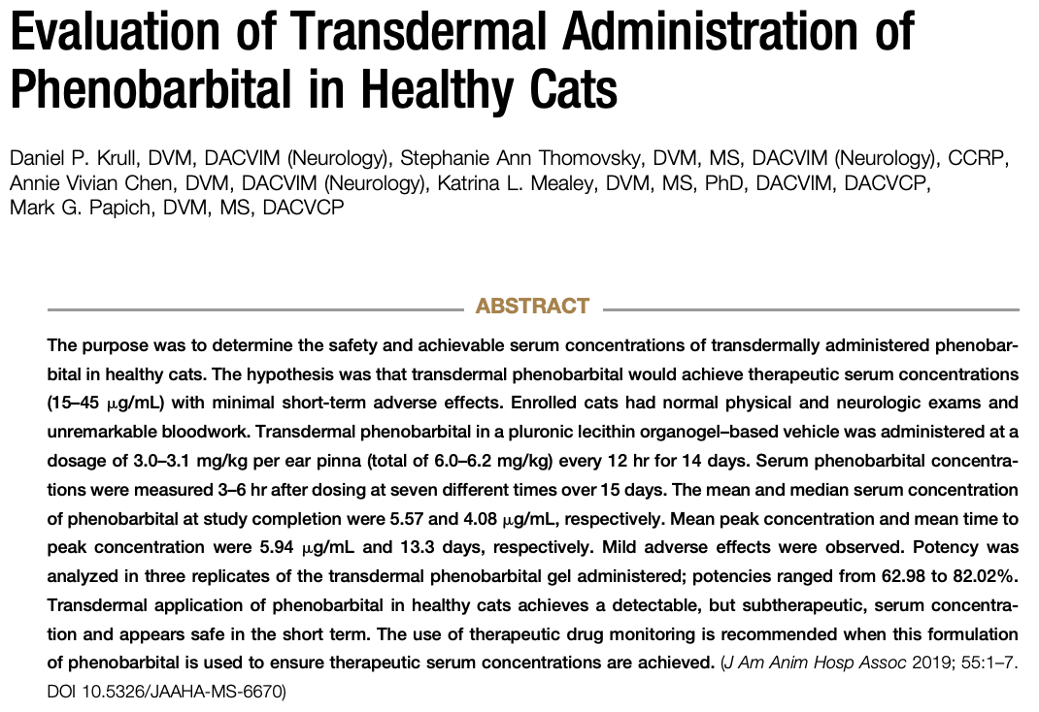
- Ideal compounds for transdermal requires low MW, lipophilic, soluble in oil and water, and high partition coefficient and melting point
  - Phenobarbital has properties to be a good candidate for transdermal application
- Subtherapeutic serum concentration achieved avoid transdermal if possible

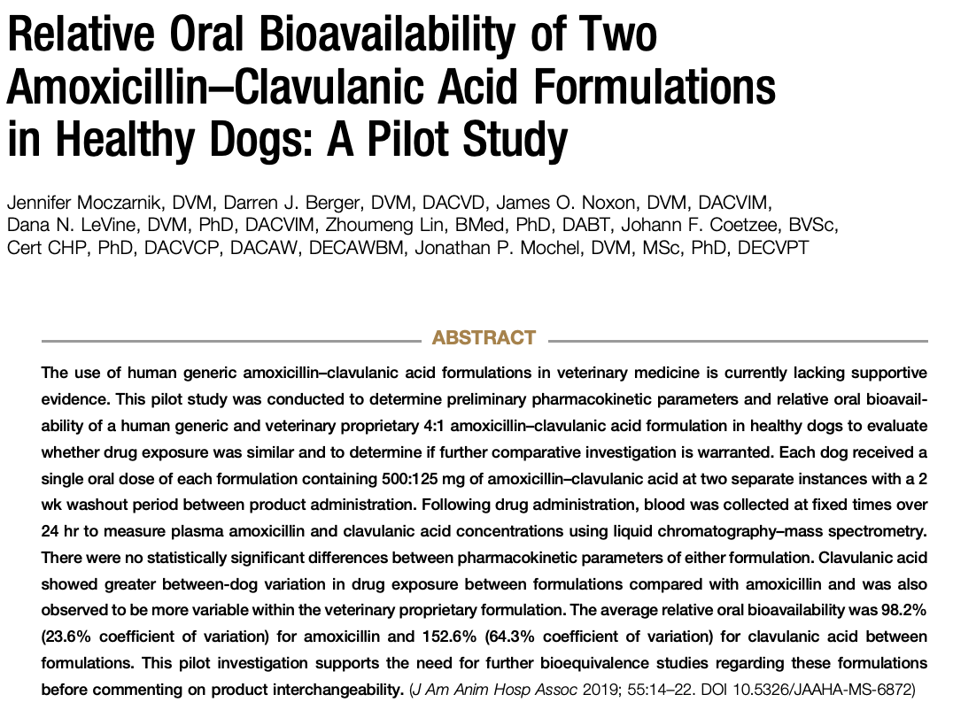
- Compared Clavamox (375+250mg) to Augmentin (625mg) -- single dose, randomized crossover study
- No statistically significant differences between pharmacokinetic parameters of either formulation.
- Good relative oral bioavailability
- High variation of clavulanic acid patient variation in the veterinary formulation compared to human formulation

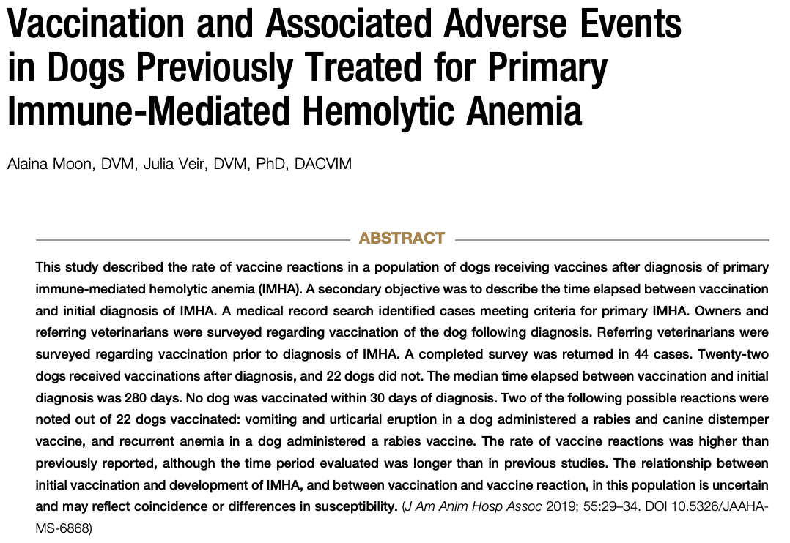
- Vaccine rx defined as relapse of IMHA, vomiting or diarrhea, anaphylaxis, facial swelling, hives, onset of a different immune-mediated disease, or other
- 2/22 dogs (9%) had vaccine rx
  - One had vomiting + urticarial eruption, the other became anemic after rabies & distemper vacc
- Median days b/w vaccination and initial IMHA dx = 280 days
- Still unsure about relationship b/w initial vaccination and development of IMHA, as well as b/w vaccination and relapse.

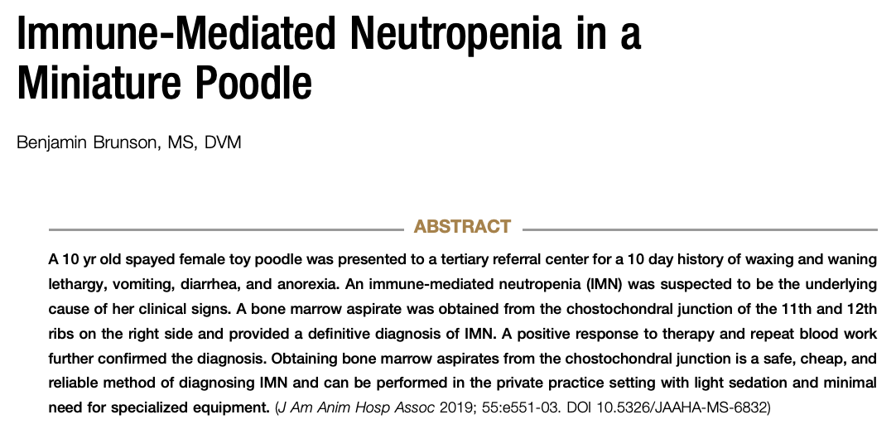
- CBC: Neutropenia at 0.9 x 10^3u/L, no bands, monocytosis, nonregenerative anemia
- Bone marrow aspirate can be performed at 11-12th costochondral junction under butorphanol IV sedation with local lidocaine block; 22G hypodermic needle attached to 3mL syringe
  - Disadvantage of utilizing this site: limited sample size per site, risk of puncturing underlying structures (liver, lung), inability to evaluate marrow architecture
  - However, evaluation of diagnostic quality of these samples has shown similar results to traditional sites (1970 paper in JSAP and 2014 paper in JVECC)
- Tx: IV dexamethasone at 2mg/kg prednisone equivalent + mycophenolate (10mg/kg IV q12h)
- Good standard of diagnosis is anti-neutrophil flow cytometry in humans, but has low sensitivity

