February – April 2019

J Vet Radiology and Ultrasound
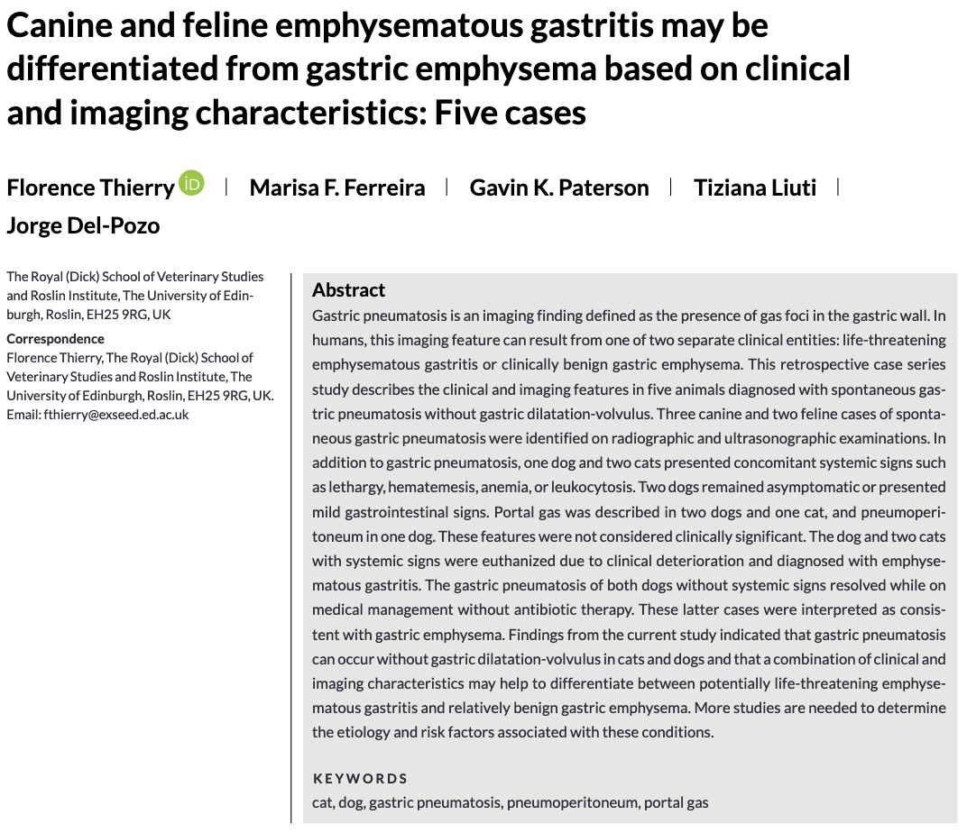
- Emphysematous gastritis is a much more severe disease compared to gastric emphysema
- Spontaneous gastric pneumatosis can occur w/o GDV
  - Resolved w/ medical management good outcome
  - Can develop portal gas does not affect prognosis in people or in pets
  - Can develop pneumoperitoneum d/t gas diffusion from gastric wall to peritoneum
- Pets w/ emphysematous gastritis had severe clinical signs and had poor outcome all euthanized
  - May have association to NSAID and corticosteroid use
- Diagnostic steps: abdominal radiographs & ultrasound if suspect emphysematous gastritis, should perform endoscopy
  - If identify evidence of gastric wall necrosis (areas of white, yellow or brown tissues as well as green-black exudate) emergency explore recommended
- Lethargy, pyrexia, hematemesis, leukocytosis or hypoalbuminemia may differentiate emphysematous gastritis from gastric emphysema
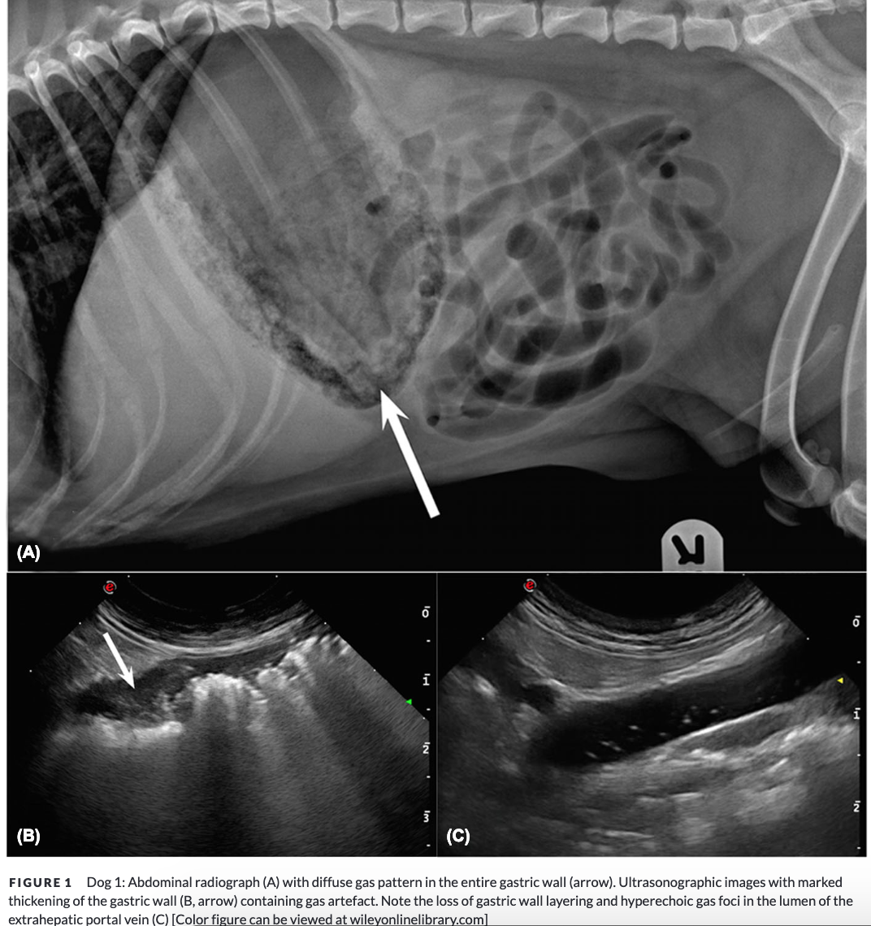
Dog 1 had emphysematous gastritis (post-mortem diagnosis)
- 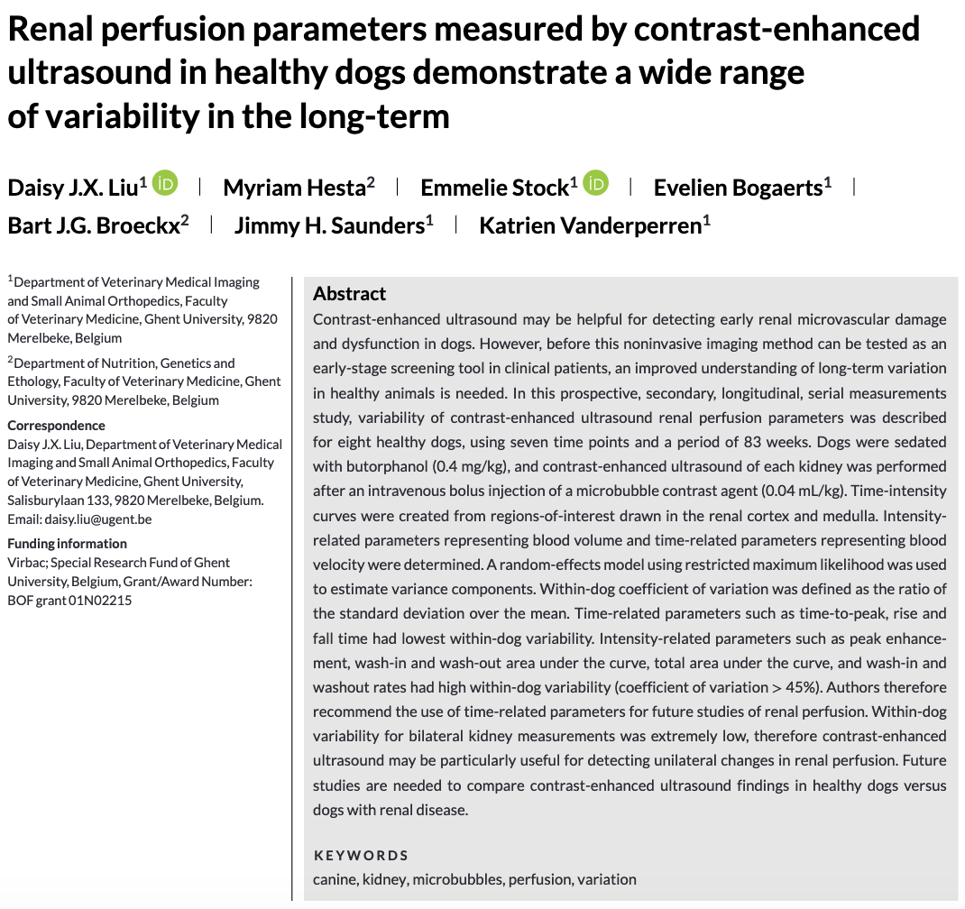
- Reduced renal perfusion and capillary rarefaction are implicated in CKD progressions in people
- Doppler US can only evaluate macrovascular perfusion, whereas contrast-enhanced US can estimate microvascular perfusion
  - In people, this parallels effective renal plasma flow
- Dogs were imaged pre and post-contrast by a 3rd year radiology resident
- Dogs were given 0.04mL/kg of a microbubble contrast agent
- Results: found large variation in contrast-enhanced US, may only be useful in detecting unilateral changes in renal perfusion
- 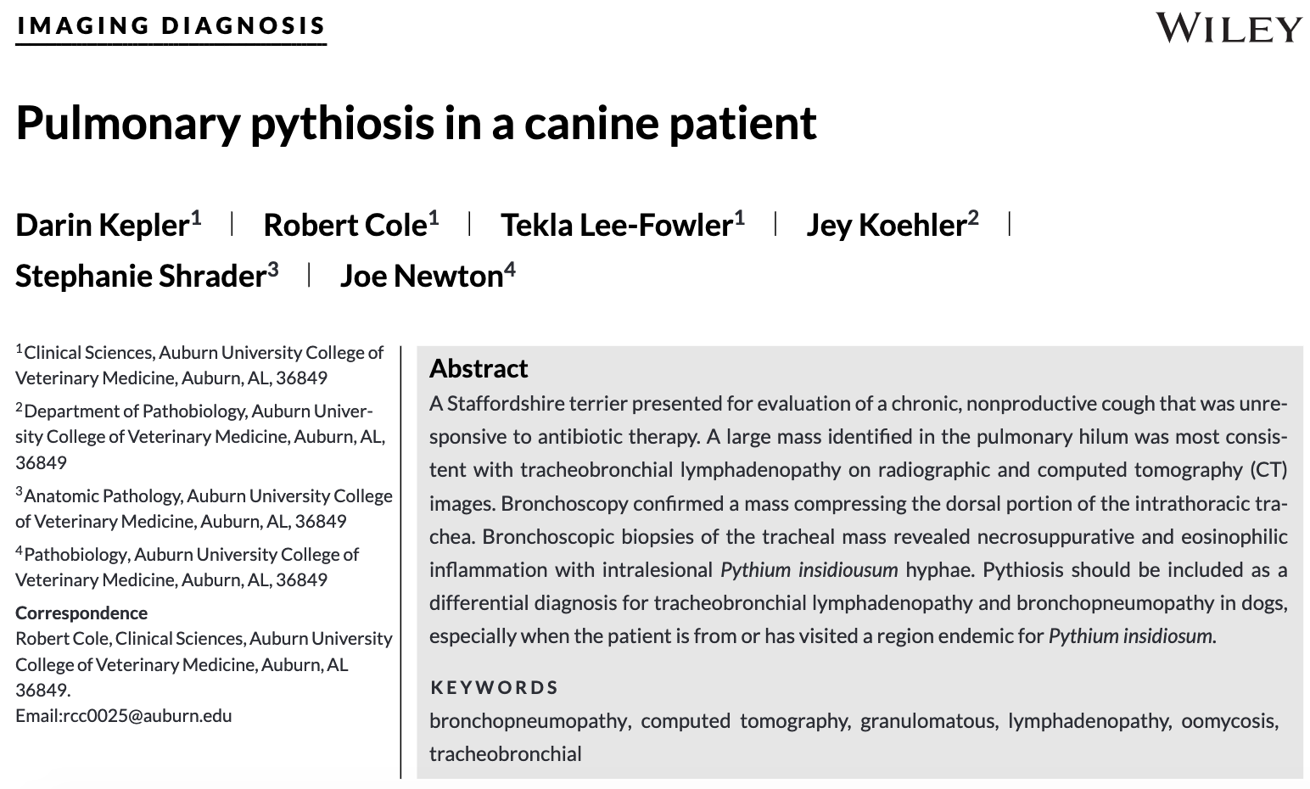
- Pythium insidiosum = etiologic agent for pythiosis
  - Most prevalent in the r regions bordering the Gulf of Mexico
  - Appears like a fungus but related to algae and diatomaea
  - Infection can be cutaneous, GI, and rarely systemic
  - Dogs: majority of signs are GI and less commonly cutaneous
  - Motile zoospores chemotaxis towards animal hair, wounds, and intestinal mucosa
  - Pulmonary form (as reported) either via ingestion or inoculation from a cutaneous wound
- Diagnosis:
  - Cytology hyphae
  - ELISA
  - PCR testing

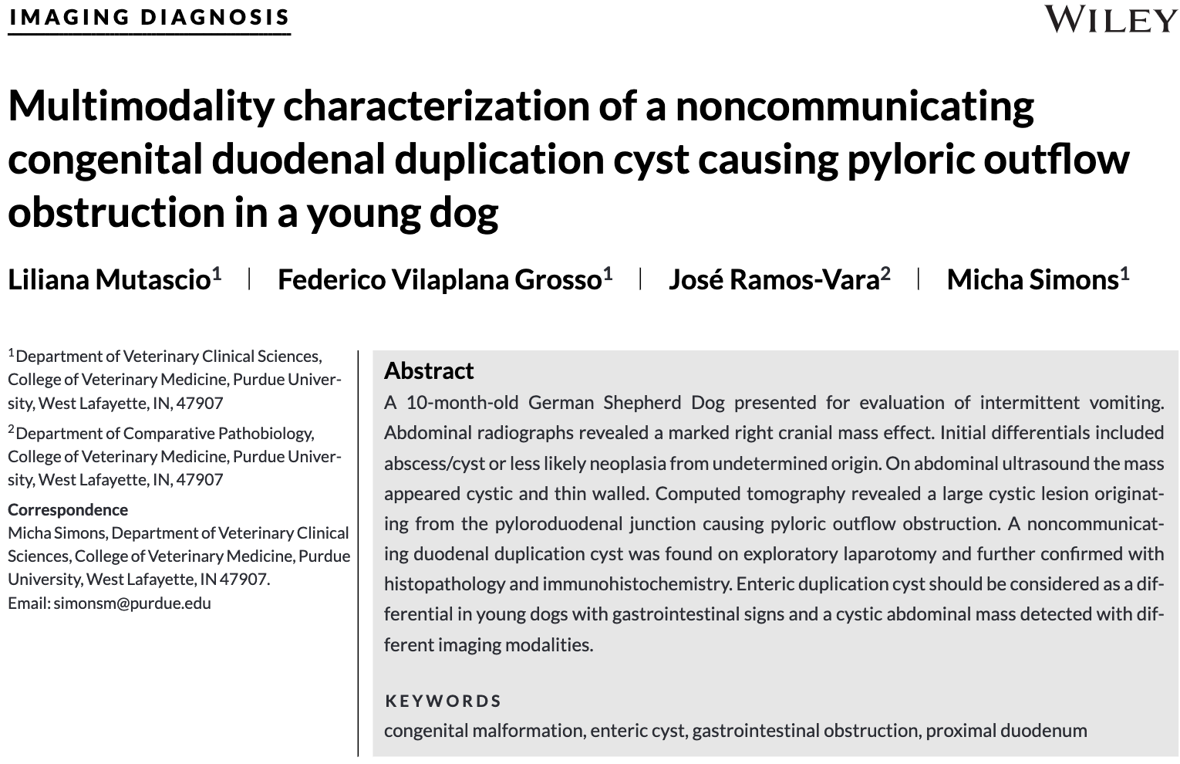
- Duplication cysts of the GIT are uncommon malformation suspect congenital
- Can be communicating or noncommunicating w/ the GIT lumen
  - Can be tubular or spherical
  - Histopathology for diagnosis
- The speculated developmental pathogenesis of intestinal duplication cysts involve failure of normal canalization of the developing gut and/or formation of abnormal connections between the neural ectoderm and intestinal endoderm
- They can cause intestinal obstructions surgical explore to resect said cyst
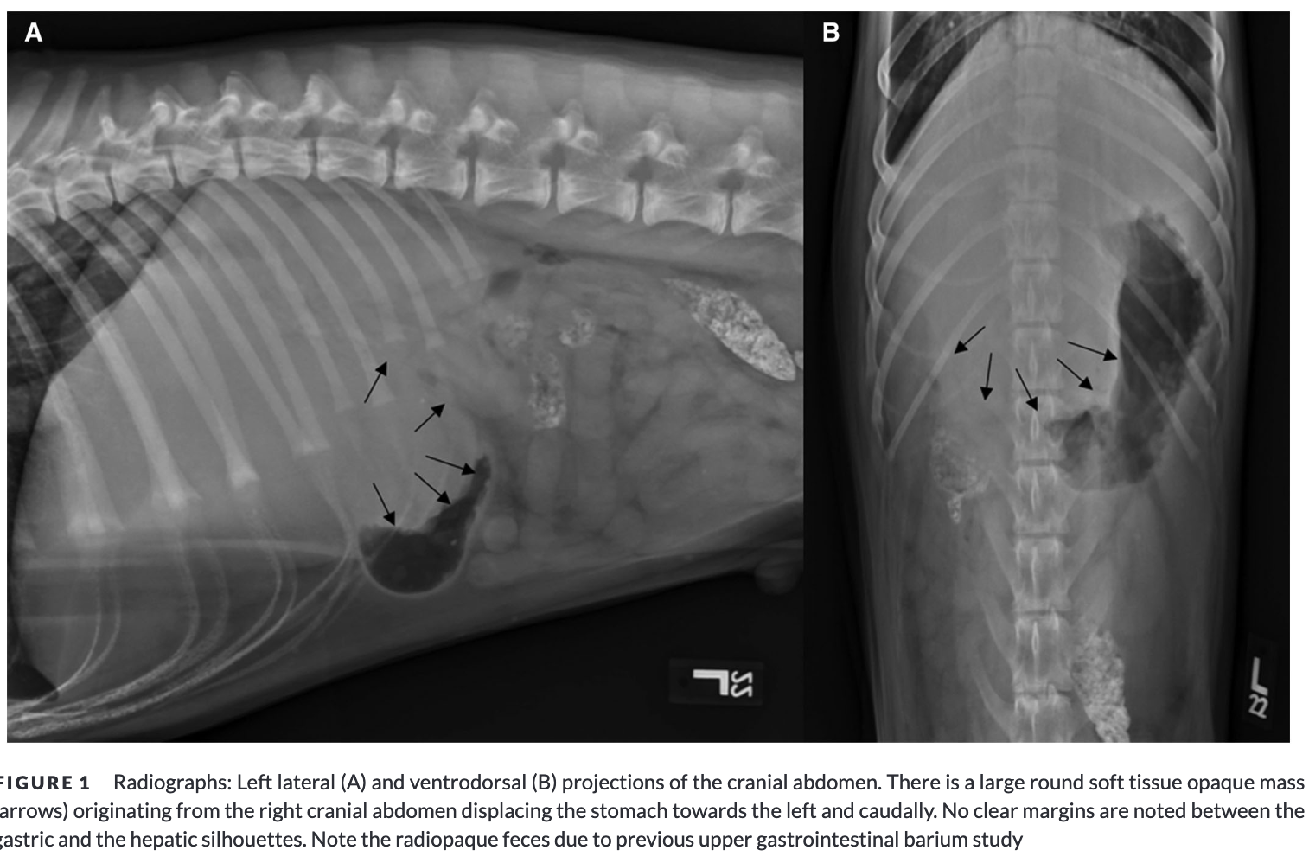

JAAHA
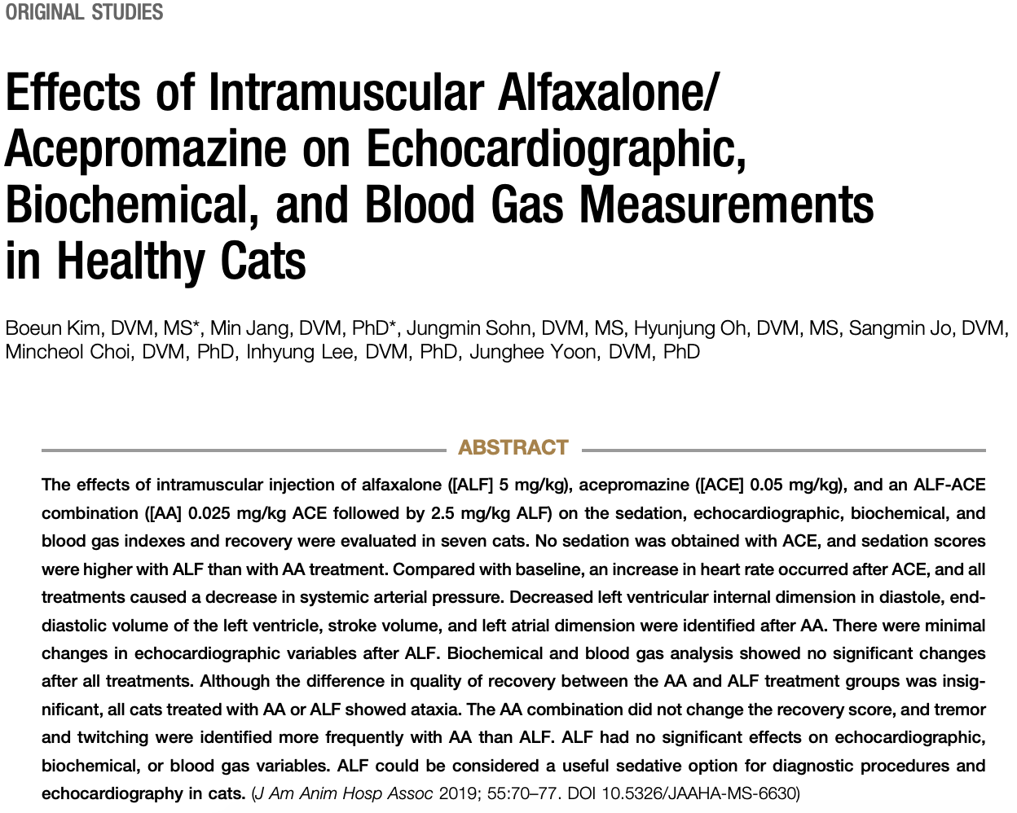
- Alfaxalone MOA: CNS depression by activity at GABA-A receptors
  - Short acting, non-irritant, non-cumulative
  - Dose-dependent sedation, decrease in HR, arterial BP and SVR
- Administration to ALF did not change echocardiographic variables except Ao diameter
  - Unsure if this is applicable to cats w/ underlying heart disease
  - May be useful in fractious cats that requires echo?
- ALF also did not alter biochemical or blood gas variables

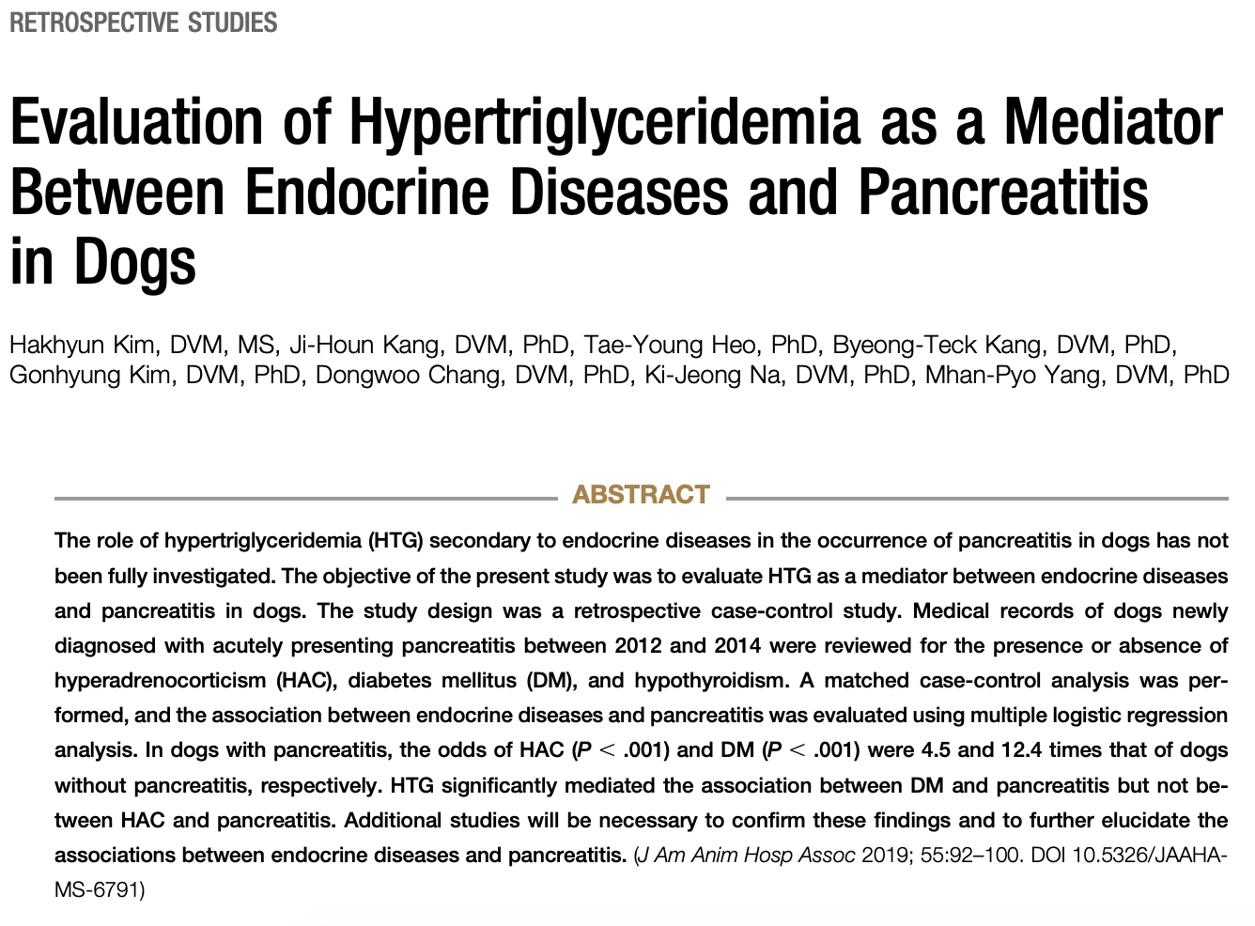
- Hypertriglyceridemia (HTG) is a reported risk factor for pancreatitis in humans
- Defined HTG as serum triglyceride > 116 mg/dL after 12 hours of fasting
- Proposed mechanisms for how HTG causes pancreatitis
  - Hydrolysis of triglycerides by pancreatic lipase high concentration of plasma FFA cytotoxic, causes pancreatic acinar cell or capillary injury
  - Increased FFA can incr concentration of chylomicrons activation of trypsinogen and initiate pancreatitis
  - Accumulation of chylomicrons in microcirculation disrupts blood flow in pancreatic capillary ischemic injury
- The prevalence of DM or HAC in dogs with acutely presenting pancreatitis might be higher
- HTG resulting from DM might be associated with acutely presenting pancreatitis.

