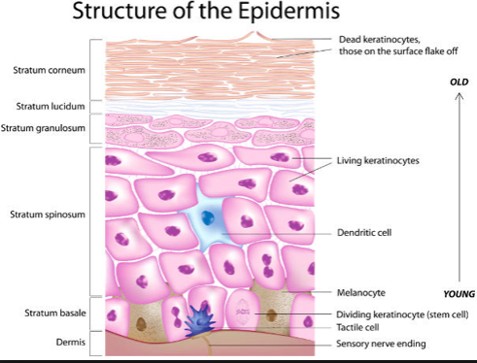
Immune Mediated Skin Disease
- ERYTHEMA MULTIFORME (EM)
- Uncommon, acute, cutaneous inflammatory reaction can lead to significant morbidity
- Characterized by epidermal apoptosis and lymphocyte satellitosis
- Pathogenesis not fully understood host-specific, cell mediated hypersensitivity reaction to various antigens
- Antigenically altered keratinocytes lead to increased keratinocyte expression of adhesion molecules trigger T cell activation and site specific extravasation into tissues keratinocyte apoptosis (mechanism of which is unknown)
- 2° to drug administration (TMS, penicillin, cephalosporin), idiopathic, diet, infection (bacterial, parvovirus, herpesvirus), neoplasia
- Can be mild to severe; usually self-limiting in 1-3 weeks
Clinical Signs:
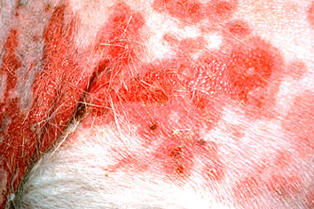
- Acute, symmetrical onset
- Erythematous macules or papules that spread peripherally and clear centrally annular target lesions (though not always seen)
- Dogs - vesicles, bullae, uticarial plaques may be present and center of lesion may necrose and slough
  - Most common on ventrum, mucocutaneous junctions, oral cavity, pinnae, footpads
- Cats - typically ulcerative/crusted or vesiculobullus lesions found on trunk and MC junctions
- Lesions are painful but non-pruritic
- Some animal may have systemic signs (pyrexia, inappetence, fever) prior to skin involvement
Diagnosis:
- Thorough history, PE, skin biopsy, PCR of viruses in skin (parvo, herpes)
- Histo: apoptotic epidermal cells/keratinocytes at all levels of the epidermis, vacuolation of the basement membrane zone, lymphocytes surrounding apoptotic keratinocytes and interface dermatitis (lymphocytes at the dermo-epidermal junction)

Treatment:
- Removal of underlying cause (d/c drug, possible food antigens)
- Food trial
- Immunosuppressive agents (glucocorticoids, cyclosporine, azathioprine) are controversial but may be beneficial in idiopathic cases when not contraindicated (infection)
- IVF; plasma or colloids may be needed as proteins may be lost through large cutaneous defects
- Abx, analgesia, nutritional support, wound management
- IVIG in severe cases
- Pentoxyfylline anecdotally
- Mild cases may regress over a few weeks spontaneously
- Chronic, idiopathic, or relapsing cases may require lifelong treatment
- Patients with widespread skin lesions or extensive oral and mucosal involvement have poor to guarded prognosis; some may die of septicemia, DIC, other causes

- TOPICAL EPIDERMAL NECROLYSIS (TEN)
- Rapid, rare, life-threatening, extensive vesiculobullous and ulcerative disorder of skin and oral mucosa in dogs, cats, humans
  - Mortality rate of 30-50%
- Similar to EM…but not
- Exact pathophysiology not well understood – believed to be a cellular immunologic reaction primarily involving keratinocytes; T cells and macrophage play a small role massive keratinocyte apoptosis
  - Elevation in cytokines that are not elevated in EM possible (IL-13)
- Causes: drugs (TMS, cephalosprorins, penicillins), flea dips, bacterial infections, hepatopathy, neoplasia, idiopathic, vaccine
Clinical Signs:
- Acute onset systemic signs (lethargy, pyrexia, anorexia, depression) precede dermal signs
- Multifocal or generalized erythematous macules or patches involving the body and multiple mucosal surfaces
- Lesions affect skin diffusely though face and extremities most commonly involved
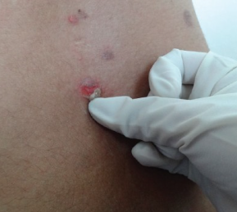
  - MC junctions – oral, GI, rectal, conjunctival, tracheal; footpads
- Hemorrhagic diarrhea – suggesting involvement of intestinal mucosa
- Positive Nikolsky sign – separation of the superficial layer of the epidermis from basal layer with gentle pressure sloughing
- Significant pain
Diagnosis:
- Skin biopsy needed
  - Histo = full thickness coagulation necrosis of the epidermis with minimal dermal inflammation (silent dermis or cell-poor inflammation)
  - APOPTOSIS WITHOUT ACTIVATION OF INFLAMMATORY PATHWAYS this is in contrast with the cell-rich inflammation that occurs in erythema multiforme
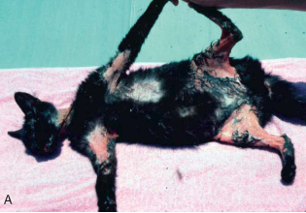
  - Dermo-epidermal separation results in subepidermal vesicles
Treatment:
- Aimed at identifying / treating underlying cause
- Extensive dermal involvement massive fluid, electrolyte, plasma protein losses
- Supportive care similar to burn patients – aggressive fluid replacement, antimicrobials, wound care, analgesia, nutritional support
- IVIg has been used (Fas blockade); cyclosporine (T cell and apoptosis pathways effects); NAC – counteract drug induced reactive oxygen specie production
- Steroids may not be helpful and can contribute to sepsis
- Resolution in 2-3 weeks
- Prognosis is guarded to poor and depends on severity of lesions; humans – mortality 30-50%, sepsis
- DDx: burns, severe EM without target lesions, toxic shock syndrome, vasculitis

- CUTANEOUS VASCULITIS
- Blood vessel walls are target of inflammatory response results in disruption of the vessel architecture, altered blood flow, ischemic injury to end tissues
- Type III hypersensitivity reaction with immune complex deposition along the endothelium
  - Type I reaction may be important during initial stage of disease
- Causes: drugs; vaccines; infections – viral, rickettsial, bacterial, parasitic; food sensitivity; insect bites; neoplasia
  - 50% are IDIOPATHIC
Clinical Signs:
- Signs- variable: erosions, ulceration, crusting, purpura, edema, plaques, alopecia, necrosis
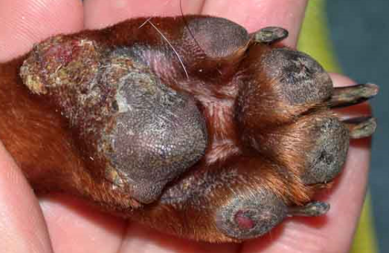
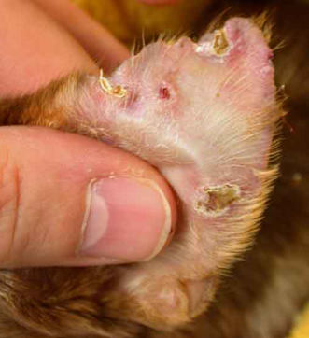
- Extremities more commonly affected: ear tips, footpads, oral mucosa, nasal planum, tail, lips, scrotum
  - Lesions that follow vascular pathways will have a linear pattern
  - Pinnal lesions are more often prevalent on the apex and concave surfaces
  - Often multiple paw pads affected – crusted, ulcers, can have thinning or smoothness
  - Claws may be affected – petechia within claw, onychodystrophy, onychomadesis, exudate within the claw
- Rabies vaccine induced vasculitis – focal cutaneous vasculitis at site of injection, annular areas of alopecia, hyperpigmentation develops 2-6 months later and lasts months to years
- Clinical course varies and depends on cause
- Single episode may last weeks, others can be chronic
Diagnosis:
- Based on biopsy and clinical suspicion – biopsy within 8-24 hours of onset is most diagnostic however difficult
- Thorough history – drugs, vaccines, infectious exposure (vector borne)
- Many cases will have thrombi formation – test for d-dimers (>500 with clinical signs is very specific)
Treatment:
- Removal of underlying cause
- Doxycycline while waiting PCR / antibodies for infectious diseases
- Pentoxfylline
- Glucocorticoids in severe cases
- Sulfasalazine, tetracycline/niacinamide, chlorambucil, azathioprine have been used
- Prognosis depends on extent of visceral involvement and underlying cause

- CUTANEOUS DRUG ERRUPTIONS
- Adverse reactions to any oral, parenteral, topical drug
  - Most common drugs are sulfonamides, penicillin, cephalosporins, rabies vax
- Variable cutaneous or mucocutaneous lesions
  - Focal, multifocal or generalized
- Uticaria, angioedema, maculopapular eruptions, exfoliative erythroderma, EM, TEN
- Diagnosis is difficult – signs within 1-3 weeks of starting a drug or after many months or years of therapy or up to 3 weeks after ending a drug
- Lesions typically resolve within 2-3 weeks after discontinuation
- Lesions should be treated with topical agents (chlorhexidine) to help prevent secondary infection
- Supportive care – IVF, abx, nutritional support
- Glucocorticoids are controversial but may be needed to control pruritus
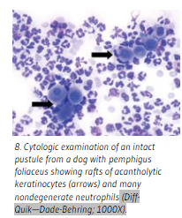
- PEMPHIGUS COMPLEX (“pemphigus” – Greek for vesicle)
- Vesiculobullous to pustular BLISTERING disorder of the skin or mucous membranes
- Dogs and cats have at least five varieties
- Uncommon, but most common of the autoimmune skin diseases in dogs

Pathophys and Cause:
- Affects the epidermis autoantibodies target tight junctions / desmosomes (cell to cell adhesions) acantholysis
- Acantholysis – breakdown of the epidermal intercellular desmosomal connections with separated keratinocytes becoming rounded up as darkly staining acantholytic cells = loss of cohesion between keratinocytes
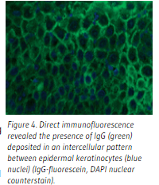
- Antibody binds interdesmosomal cell membranes and within desmosomes themselves
  - Desmosomal Ag targeted:
    - desmoglein (Dsg1) in PF
    - Dsg3 in PV
    - Dsg1 and Dsg3 in PV with mucosal involvement
- 2 subsets: pemphigus foliaceus (PF) and pemphigus vulgaris (PV) – PV much less common
  - Uncommon or rare: pemphigus vegetans (PVeg), paraneoplasic pemphigus (PNP), pemphigus erythematous (PE)
Causes:
- Drug eruptions
  - Drug induced – disease goes into remission following drug removal
  - Drug triggered – drug initiates a disease already latent in the patient and condition persists following drug removal
- Prior chronic allergic skin disease (PF)
- Mostly idiopathic / spontaneous in nature
General prognosis:
- Extensive disease within 1-2 weeks or insidious over 1 or more months; unpredictable course
- Pemphigus vulgaris - severe disease that is often fatal; many animals fail to respond to treatment
- Pemphigus foliaceus - less severe, fatal without therapy
- Pemphigus erythematosus and panepidermal pustular / pemphigus vegetans - usually benign disorders, rarely produce systemic signs, readily respond to treatment
Pemphigus Foliaceus
Signalment:
- Typical in middle aged to older dogs, but can occur at any age
- Possibly more common in males than females
- Akitas and Chows over represented others include Labs, Bulldogs, Dachshunds, Cockers

Clinical Signs:
- Papule/erythematous macules that progresses rapidly to pustular phase widespread areas of erosions and yellow crusting
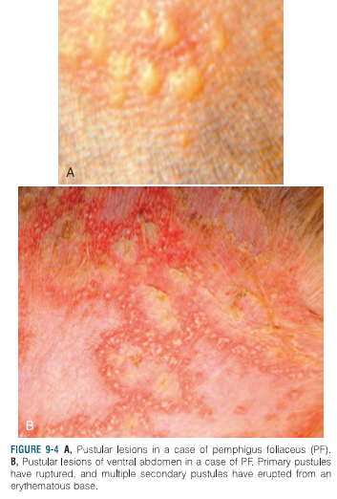
- Post inflammatory alopecia
- Varying pruritus, but mostly moderate to severe
- Head, face, ears affected in 80% of cases – BILATERAL SYMMETRY
  - Pinnae – well demarcated lesions
  - Nasal depigmentation may develop…but later (DLE this is a first, early change)
  - Footpads – fissures and crusts; hyperkeratosis “hard pads”
  - Mucosal lesions rare
- Secondary infections common
- Acute onset – depressed, anorectic, febrile, +/- lymphadenopathy

Diagnosis:
- Staph pyoderma is a differential – but does not typically does not start on face or ears or cause crusting of footpads
  - Other r/o demodicosis, dermatophytosis, DLE
- Intact pustules by cytology and biopsy offers best chance for definitive Dx
  - acantholytic cells which are rounded and deeply staining isolated keratinocytes are suggestive +/-neutrophils, Eo
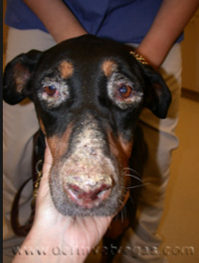
- Demonstration of antibody directed toward desmoglein I
- Culture of pustule
Treatment:
- Glucocorticoids - most improve over 10-14 days and dose reduce over the next 30-40 days
- +/- azathioprine; chlorambucil; topical steroids (0.1% tarolimus)
- Abx if documented cocci or prophylactically
- Prognosis can be good – depends on response to treatment (52% complete remission, 35% partial; satisfactory response in 93% of cases)
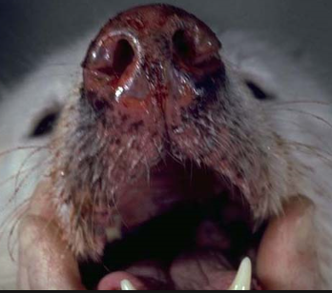
Pemphigus Vulgaris
- More severe but rarer; sudden or gradual onset
- No age, sex, breed predilection
- Lesions initially vesiculobullous then rapidly progressing to erosion and ulcerations
- Disease of the oral cavity and MC junctions (lips, nostrils, eyelids, prepuce, vulva, anus)– starts here and may spread to other areas of the integument (axillae, groin common)
- Positive Nikolsky sign – lack of epidermal cohesion
- Footpads and claw beds – onychomadesis (shedding of nail bed)
- Pruritus, pain variable
- Secondary pyoderma common
- Febrile and anorectic – especially if oral lesions
- Lesions are deeper in dermis than PF - acantholytic cells rarely observed
- Histo: suprabasilar intraepidermal cleft with the remaining basal cells exhibiting a tombstone appearance (basal cells still attached to basement membrane)
- Antibody targeting desmoglein 3, direct immunofluorescence usually positive
- Difficult to put and keep in remission - aggressive treatment with combo glucocorticoid and azathioprine or chlorambucil
- Abx are a must
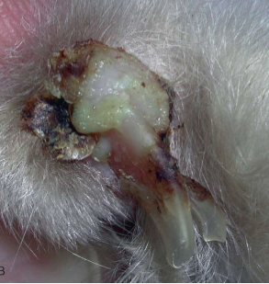
- Prognosis poor – 25% live 1 year
Pemphigus Paraneoplastic
- Unresponsive to immunosuppressive treatment
- Very poor prognosis
Pemphigus Erythematous
- Crossover b/w PF and DLE
- Exacerbated by sunlight
- Treat with glucocorticoids, tetracycline/niacinamide
Feline Pemphigus
- Much less common in cat
- No breed or sex predication
- Median onset 5yo
- Focal crusting lesions most common on head, face, ears – bilateral symmetry
- Claw folds very common
- Pruritus mild to severe
- Lethargic, febrile, anorexic
- Histopathology – neutrophils, Eo, intra and subcorneal pustules, acantholytic cells
- Tx: Prednisolone, cholambucil, triamcinolone +/- cyclosporine
- Prognosis is good

- SYSTEMIC LUPUS ERYTHEMATOUS (SLE)
- Uncommon disease in dogs and cats
- No age predilection, male dogs over represented, breed predilections for collies, Shetland sheepdogs, Poodles, and GSD; Himalayan, Siamese, Persian cats may be predisposed
Pathophys:
- Most severe form of the lupus diseases - involves more than cutaneous lesions
- Presents with a variety of clinical symptoms that reflect multiple organ or tissue damage
- Multifactorial etiology: genetic predisposition, immunologic disorder (T cell deficiency, B cell hyperactivity, deficiencies of complement components), viral infection, hormonal and UV light modulation
- B lymphocyte hyperactivity overabundance of autoantibodies formed against numerous self antigens
- ANA - found in up to 100% of the cases reported numerous nuclear components targeted (double-stranded DNA, histones, extractable nuclear antigens)
- Marked lymphopenia in active state of disease severely decrease in CD8+ T cells altered/increased CD4:CD8 ratio lymphocytotoxic autoantibody production and lymphocyte apoptosis increase nuclear antigen release upregulates ANA response
- Decrease in CD8+ T lymphocytes is directly related to disease severity; increase in CD8+cells is associated with a good response to therapy
Clinical signs:
- Fever (constant or irregularly cyclic), polyarthritis (non-erosive, non-deforming), proteinuria (>0.5 g/L), and skin disease (50% of cases)
- Other common manifestations include anemia, leukopenia, thrombocytopenia, peripheral lymphadenopathy, splenomegaly, and oral ulcers, pericarditis, polymyositis, myocarditis, pneumonitis, pleuritis, neurologic disorders (seizures, meningitis, myelitis, psychoses, polyneuropathy), and lymphedema (ANY SYSTEM CAN BE AFFECTED)
- Cutaneous manifestations are diverse - seborrheic skin disease, alopecia, diffuse or regional erythema, cutaneous or mucocutaneous vesiculobullous or ulcerative disorders, footpad ulcers and hyperkeratosis, discoid lupus erythematosus, panniculitis (lupus profundus), and nasal dermatitis
  - Multifocal or generalized
  - Commonly involve areas of skin poorly protected by hair: face (especially nose, lips, pinnae if erect), limbs (especially cranial aspect of thoracic limbs), axillae, groin, and ventral abdomen
  - May be exacerbated or induced by exposure to sunlight
- Pruritus is variable, scarring is common
Diagnosis:
- Clinicopathologic abnormalities depend on the organ systems involved
- Direct immunofluorescence or IHC deposition of Ig, complement, or both at the basement membrane zone = “positive lupus band” in 50% to 90% of patients
- ANA test is currently considered the most sensitive serologic test for SLE but not most specific
Prognosis:
- Unpredictable and depends on the organs involved
- In dogs - joint, skin, or muscle disease respond more reliably to medication and are maintained in relatively long periods of clinical remission
- 40% of the dogs with SLE have a survival time <1 year after the diagnosis
Treatment:
- High doses of systemic glucocorticoids (e.g., 2 to 6 mg/kg prednisone q24h) +/- azathioprine, chlorambucil
- Dogs that respond well to therapy often do so with glucocorticoids alone
- Patients prone to infections – must be identified quickly and treated aggressively

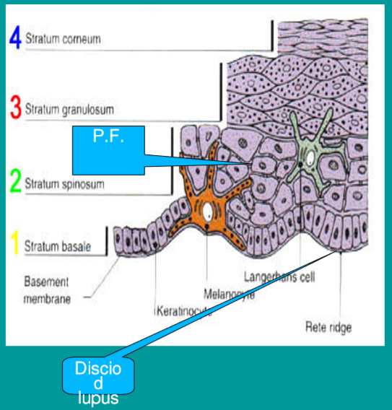
Discoid Lupus Erythematosus
- Relatively benign cutaneous disease with no systemic involvement
- No relationship or progression to SLE has been reported
- Sun exposure aggravates the disease in ~ 50% of cases photosensitivity may play a role in pathogenesis
Clinical signs:
- Initially depigmentation of nose conversion of the normally rough, cobblestone-like architecture of the nasal planum into a smooth surface erythema and scaling
  - Lesions tend to occur dorsally at the junction between the nasal planum and haired skin or along the ventral or medial aspects of the alar folds
- Later lesions include erosion, ulceration, and crusting, hyperkeratosis nasal involvement become extensive and lesions may spread up the bridge of the nose
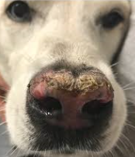
  - Erythematous and scaly macules or papules slowly evolve to a coin shaped (discoid) plaques with adherent scale, comedones, peripheral hyperpigmentation
- Less commonly lesions may be periocular, on the pinnae, distal limbs, lips and on the genitals
- Small punctate ulcers may be detected in the oral cavity
- Pruritus and pain are variable
- Scarring varies
- Commonly exacerbated or precipitated by exposure to UV light more severe in summer or sunny climates
- Otherwise clinically healthy
Diagnosis:
- Histo: lymphocytic interface dermatitis reaction pattern with basal keratinocyte vacuolar degeneration, apoptosis, loss of basal cells and basement membrane thickening
  - Linear deposition of IgG and IgM at the dermo-epidermal basement membrane zone is typical
- ANA test almost always negative
- Most common DDx include nasal solar dermatitis, nasal depigmentation, vitiligo-like disease, pemphigus erythematosus or pemphigus foliaceus, trauma, dermatomyositis, epitheliotropic lymphoma, drug reaction, uveodermatologic syndrome, contact dermatitis, and systemic lupus erythematosus
Treatment/Prognosis:
- UV protection, topical steroids, +/- tetracycline-niacinamide combination
- Generalized DLE – cyclosporine, GC, + topical tacrolimus – 50% may relapse when tapering
- Prognosis is usually good; therapy will probably need to be continued for life

Exfoliative cutaneous lupus erythematosus
- GSP, juvenile or young adults
- Scaling and alopecia, irregular and polycyclic patches and plaques with dyspigmentation
- Muzzle, pinnae, dorsal trunk progresses to limbs, sternum, and ventral abdomen +/- generalized peripheral lymphadenopathy
- Many develop arthralgia – stiff, lame, arched back
- Marked to moderate dermal lymphocyte infiltrate
- Tx: possible diet change, supplementation of FA, anti-seborrheic shampoos, abx; limited efficacy of immunomodulating drugs
- Most challenging variant to treat

Mucocutaneous lupus erythematosus
- GSD or crosses, more predominant in females, middle aged
- Perimucosal ulcerative skin lesions with vocalization when defecating or urinating – lesions around anus, genital or perigenital regions
- Less common around eyes, nasal planum, oral
- Erosions and ulcers most common – do not scar
- Not typically pruritic but painful
- Systemic signs not reported
- Lymphocyte invasion – interface dermatitis with basal keratinocyte damage
- glucocorticoids, tetracycline +/- niacinamide

- CANINE PERIANAL FISTULA (anal furunculosis)
- Painful sinus tracts or ulcers that spontaneously occur in the skin around the anus
- Immune mediated but pathogenesis is not well understood
  - Local T cell mediated inflammation (type 1 helper T cells); increased expression of matrix metalloproteinases from activated macrophages leading to impaired wound healing – persistent ulcers and sinus tracts
- GSDs are predisposed / over-represented
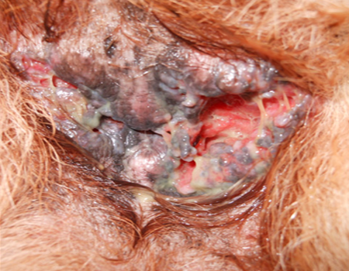
- Adult onset, middle aged most common; intact possible increased risk
- Causes: Possible genetic basis, adverse food reactions, dysfunction immune response to normal microbiome have been proposed
- Similar to fistulizing Crohn’s disease and suppurative hidradenitis in humans
- Debilitating disease
Clinical Signs:
- Single or multiple sinus tracts or ulcers in the skin around the anus – may be deep and craterform
- Despite term “fistula” lesions generally do not communicate with rectal lumen
- Owners may not be aware of lesions but see licking, tenesmus, hematochezia or mucopurulent discharge
  - Association with colitis – soft mucoid stools, diarrhea, increased frequency to go
- Ddx: ulcerated perineal neoplasm (perianal adenoma or adenoCA) and mucocutaneous lupus erythematous (MCLE)
- Histo rarely performed – periadnexal inflammation with or without furunculosis

Treatment:
- Prednisone, azathioprine or cyclosporine +/- ketoconazole
- Topical tacrolimus BID 0.1%
- Diet change
- Metronidazole
- Painful during defecation – stool softeners can be considered, pain meds

THERAPY OPTIONS
Glucocorticoids
- Mainstay of treatment
- High immunosuppressive doses needed (prednisone 2-6mg/kg/day) for days to weeks, and then tapering over months to lowest effective dose
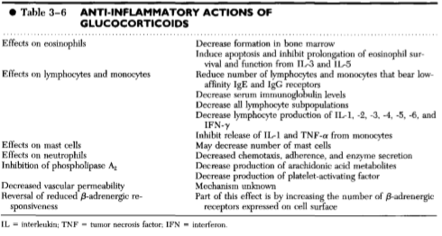
- Side effects to include: pu, pd, pp, behavior changes, diarrhea, vomiting, DM, muscle wasting, susceptibility to infection, etc…
Chlorabucil
- Orally administered alkylating agent cytotoxic effect is due to cross-linking of DNA
- Compared with other alkylating agents – slower acting and less toxic
- May be useful in the pemphigus complex, bullous pemphigoid, discoid and systemic lupus erythematosus, immune-mediated vasculitis, and lymphocyte and plasma cell malignancies
- Good in cats because they do not tolerate azathioprine as well as dogs, and good tablet size (mg)
- Commonly combined with a glucocorticoid +/- azathioprine in dogs only
- Oral dosage in dogs and cats is 0.1 to 0.2 mg/kg q24 - 48hr
- Side effects: myelosuppression possible; anorexia, vomiting, and diarrhea; alopecia and delayed hair growth after clipping
Azathioprine
- Antagonizes purine metabolism interfering with DNA and RNA synthesis - primarily affects rapidly proliferating cells
- Greatest effects on cell-mediated immunity and T lymphocyte-dependent antibody synthesis
- Beneficial for pemphigus complex and both types of lupus erythematosus
- Lag phase (3 to 6 weeks); used with steroids
- Oral dosage for dogs is 2.5 mg/kg q24h until clinical response is achieved then continued EOD for 30 days, slowly tapering down to 1 mg/kg q72hr
- Side effects: diarrhea (+/- hemorrhagic); vomiting; hypersensitivity reactions (liver); elevated ALP; pancreatitis; skin rashes, alopecia; bone marrow suppression; fatal leukopenia and thrombocytopenia in cats – do not use!
Cyclosporine
- Calcineurin inhibitor - binds to intracellular protein cyclophilin-1 which inhibits calcineurin prevents dephosphorylation of nuclear factor of activated T cells and subsequent production of pro-inflammatory cytokines (IL-2) decreased IL-2 leads to decreased growth and activation of T cells
- Also inhibits IFN-a transcription diminishes amplification signals for macrophage and monocyte activation
- Inhibits mononuclear cell function, antigen presentation, mast cell and eosinophil production, histamine and prostaglandin release from mast cells, neutrophil adherence, natural killer cell activity, and growth and differentiation of B cells
- Used in combo with glucocorticoids for pemphigus foliaceus, pemphigus erythematosus, DLE, canine perianal fistula
- Dog/cat oral dose 5 to 10 mg/kg daily (for cats divided and given twice daily) – absorption may be enhanced by administration with a fatty meal
- Side effects: gingival hyperplasia and papillomatosis, vomiting, diarrhea, bacteriuria, bacterial skin infection, anorexia, hirsutism, involuntary shaking, nephropathy, bone marrow suppression
Tetracycline / Niacinamide
- Mechanism of action is unknown
- Tetracyclines - antiinflammatory and immunomodulatory properties (suppression of lymphocyte blastogenic transformation and antibody production, suppression of leukocyte chemotactic responses, inhibition of the activation of complement component, inhibition of lipases and collagenases, and inhibition of prostaglandin synthesis)
- Niacinamide - blocks IgE-induced histamine release, prevents degranulation of mast cells, inhibit phosphodiesterases, and decrease protease releases
- Recommended for the treatment of DLE and pemphigus erythematosus in dogs (also reported use in pemphigus foliaceus, lupoid onychodystrophy, GSD metatarsal fistulae, sterile panniculitis, sterile granulomatous/pyogranulomatous dermatitis, vasculitis, and cutaneous histiocytosis)
- Initial dosage for dogs (>10 kg) is 500 mg of tetracycline and 500 mg of niacinamide given q8hr initially, tapering to q12hr and then to q24hr (<10kg – 250mg q8hr of both meds then taper)
- Side effects - uncommon, but vomiting, anorexia, lethargy, and diarrhea reported (attributed to niacinamides)
References:
Cain, CL. Canine perianal fistulas. Clinical presentation, pathogenesis, and management. Vet Clin Small Anim 49; 2019, 53–6.
Kersey KM, Rosales M & Roberts BK. Dermatologic emergencies: Identification and treatment. Compend Contin Educ Vet; 2013 (35).
Miller WH, Griffin CE & Campbell KL. Muller & Kirk's Small Animal Dermatology 7th Ed. Chapter 9. Autoimmune and immune-mediated dermatoses. 2013; 432-500.

