Resuscitation from hemmorhagic shock
DH
Head trauma
Spinal cord trauma

Gastric Dilatation Volvulus

Walker TG, Chan DL, Freeman LM et al. Serial determination of biomarkers of oxidative stress and antioxidant status in dogs with naturally occurring gastric dilatation-volvulus. Journal of Veterinary Emergency and Critical Care 17(3) 2007, pp 250–256

Background
- F2a-isoprostanes and malondialdehyde = indicate lipid peroxidation
- Vitamin C & E = free radical scavengers
- Glutathion peroxidase (GSHPx) = enzymatic antioxidant
- Oxygen radical absorbance capcity = assay used to assess total antioxidant capacity; mostly measures hydrophilic antioxidants
- GDV is a model of IR injury in dogs however the specific role of oxidative stress in GDV has not been elucidated
  - ROS produced in IR injury: superoxide ion, hydrogen peroxide, hydroxyl radical

Study design
- 13 client-owned dogs with GDV
- Biomarkers of oxidative and antioxidant status were measured at admission, 24h and 48h
  - Oxidative stress: F2a-isoprostanes (isoprostanes) and malondialdehyde (MDA)
  - Antioxidant status: Vitamin C, vitamin E, glutathione peroxidase (GSHPx), and oxygen radical absorbance capacity (ORAC)

Results
- Decreases in vitamin E, vitamin C, ORAC, and MDA
  - Vitamin C and ORAC (water soluble) decreased over time but were not depleted below “normal dog” levels
  - Vitamin E (fat soluble) did decrease below normal dog levels
  - MDA highest at admission – either missed the peak right at time of surgery, or the majority of oxidative stress occurs before surgery?
- No significant change in GSHPx or isoprostane

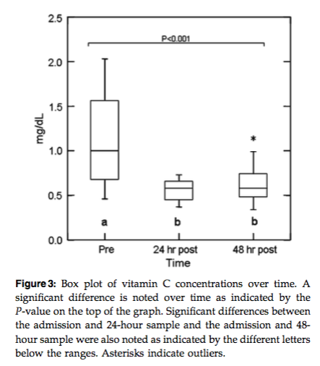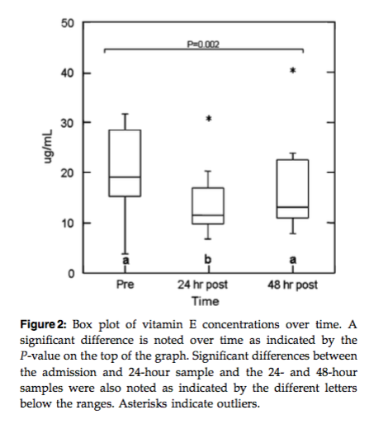

Conclusions
- Antioxidants are consumed by the generation of ROS from IR injury
  - Fluid dilution, anorexia, may also play a role
- Markers of oxidative stress (MDA and isoprostanes) potentially need to be measured earlier in disease process (time of surgery)

Guilford GW, Komtebedde J, Haskins SC, et al. Influence of allopurinol on the pathophysiology of experimental gastric dilatation-volvulus. J Vet Emerg Crit Care 1995; 5:51–60.

- Experimental GDV in 10 dogs
- 5 treated with allopurinol 50 mg/kg PO (xanthine oxidase inhibitor)
  - Allopurinol is metabolized to oxypurinol, which binds to xanthine oxidase and prevents formation of superoxide
- GDV corrected after 150 minutes, and patient resuscitated with 90 mL/kg LRS; dogs euthanized at 240 minutes
  - Blood samples at baseline, 145, 165, 180 and 360 mins
  - Tissue samples at baseline, 145, 390 mins
- Allopurinol administration associated with reduced incidence of hepatic necrosis (seen in 4/5 of control dogs, and 0/5 allopurinol dogs), lower phosphorus levels, and less increase in base deficits
- Conclusions: allopurinol protects against hepatic necrosis in dogs with GDV

Badylak SF, Lanz GC, Jeffries M. Prevention of reperfusion injury in surgically induced gastric dilatation-volvulus in dogs. Am J Vet Res 1990; 51:294–299.

- Xanthine oxidase and iron-dependent lipid peroxidation
- Experimental GDV in 21 dogs
- Treatment groups: allopurinol 15 mg/kg IV (a xanthine oxidase inhibitor), U74006F (an experimental lipid peroxidation inhibitor), or saline solution (NaCl, 0.85%)
- 3/8 dies in allopurinol group; 0/5 in U74006F group and 4/8 in saline group
- Tissue malondialdehyde (indicator of lipid peroxidation) was significantly greater in the duodenum, jejunum, colon, liver, and pancreas of the saline-solution treated and allopurinol-treated dogs than in the same tissues of the U74006F-treated dogs after surgical correction of the GDV
- Conclusions: lipid peroxidation is important component of reperfusion injury in GDV and may be preventable with appropriate treatment

Lantz GC, Badylak SF, Hiles MC, et al. Treatment of reperfusion injury in dogs with experimentally induced gastric dilatation-volvulus. Am J Vet Res 1992; 53:1594–1598.

- Evidence of reperfusion injury occurring in experimental model of GDV
- 24 dogs in 4 groups: deferoxamine (iron chelator), dimethylsulfoxide (DMSO - free radical scavenger), combination of both drugs, or isotonic saline
- 3 dogs in dimethylsulfoxide, 2 dogs in combination group and 4 dogs in saline group died

Organ transplantation

Mehl ML, Kyles AE, Reimer SB et al. Evaluation of the Effects of Ischemic Injury and Ureteral Obstruction on Delayed Graft Function in Cats After Renal Autotransplantation. Vet Surg 2006 35;341-246

Background
- Humans renal transplants with delayed graft function have an increased incidence of acute rejection, poor long-term graft function and reduced patient survival
- Incidence of delayed graft function in humans is 21-29%
  - Kidneys experiencing longer cold ischemia are associated with increased DGF
- Felines have ~40% rate of not having immediate graft function (serum creatinine outside reference interval day after surgery)
  - Caused by? Ureteral obstruction, renal vascular thrombosis and ischemia/ reperfusion injury??
- Previous studies have included operation on the ureter, which makes it difficult to separate ureteral obstruction from IR injury

Study design
- 6 intact female cats undergoing renal autograft transplantation without ureteral transection and reimplantation and a contralateral nephrectomy
- Tracked AUS findings, BUN/ creatinine
- Renal biopsy (ultrasound guided) performed on day 7
- Cats euthanized on day 21 for histology

Results
- Serum BUN (77.6 +/- 15.9 mg/dL) and Creat (3.2 +/- 0.8 mg/dL) increased after surgery and peaked 1-2 days post-op. Creatinine returned to reference range at 6 days post-op. BUN did not reach RI by the end of the study.
- No abnormalities identified on AUS or renal biopsy
- Necropsy showed histopath changes consistent with IR in one cat – interstitial fibrosis

Conclusions
- Ischemia and revascularization of the graft causes impaired graft function and contributes to delayed graft function

Mesenteric torsion/ intestinal incarceration

Nezu Y, Nezu Y, Shigihara K et al. Effects of small intestinal schema and reperfusion on expression of tumor necrosis factor-α and interleukin-6 messenger RNAs in the jejunum, liver, and lungs of dogs. Am J Vet Res 2008;69:512–51

Background
- Intestinal ischemia may not only lead to acute local injury but also distant inflammation response, organ damage, and MODS
- Increased production of pro-inflammatory cytokines are part of this process -> incduce microvacular dysfunction, activate endothelial cells and neutrophils

Study design
- 8 Beagles
- Cranial mesenteric artery occluded for 60 minutes in 4 dogs followed by repercussion for 480 minutes; other 4 not occluded (control)
- Serum TNFa and IL-6 activities
- Expression levels of TNFa and IL-6 mRNA in jejunal, hepatic and lung tissue measured before and after IR via real-time RT-PCR

Results
- Serum IL-6 activity increased after 180 minutes of reperfusion
- Jejunal: TNFa mRNA expression increased after 60 and 180 minutes
- Liver: IL-6 mRNA increased at 480 minutes
- Lung: TNFa and IL-6 increased at 480 minutes

Conclusions
- Intestinal ischemia and reperfusion induced systemic pro-inflammatory cytokine response
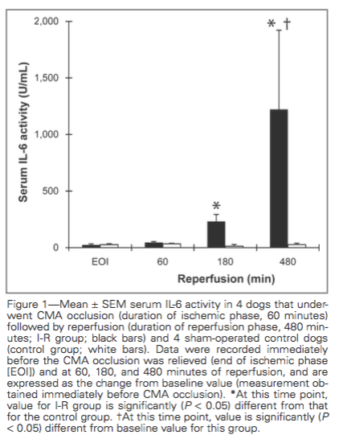
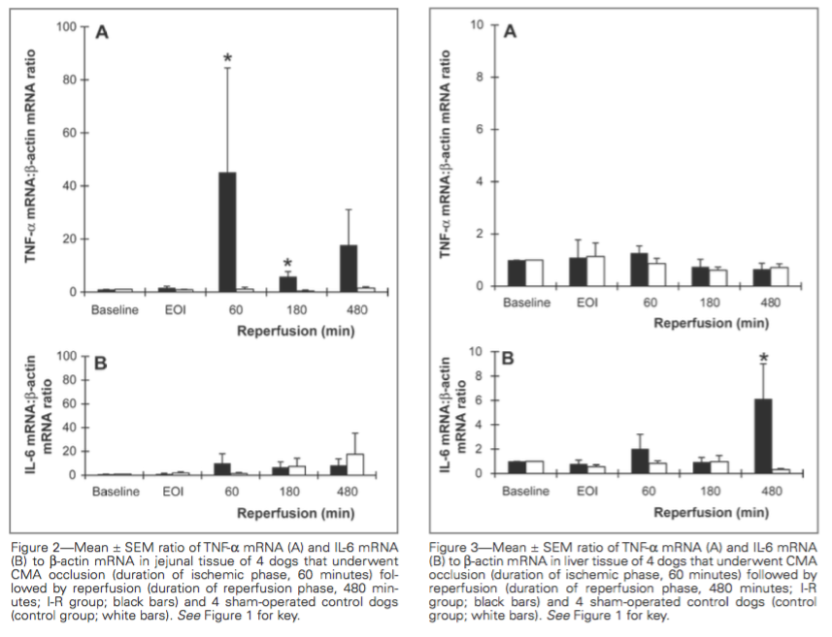

Feline Arterial Thromboembolism

Pion P, Kittleson M, Peterson S, et al. Thrombolysis of aortic thromboembolism in cats using tissue plasmino- gen activator: clinical data. Proceedings of the Ameri- can College of Veterinary Internal Medicine Annual Forum; 1987 May 21st, San Diego, CA. Blacksburg, VA: American College of Veterinary Internal Medicine 1987, p 925.
- 6 FATE patients
- Median time of clinical signs 17h (5-29h)
- TPA 0.25-1 mg/kg/hr CRI for a total of 1-10 mg/kg
- 43% cats discharged with aspirin prophylaxis, 50-90% re-embolized within 3 months

Welch KM, Rozanski EA, Freeman LM, et al. Prospective evaluation of tissue plasminogen activator in 11 cats with arterial thromboembolism. J Feline Med Surg 2010; 12: 122–128.
- 11 cats with FATE
- Enrolled within 12h of clinical signs
- 2 different TPA administration protocols, second dose given in 1/3 of cases
- Improved limb function in 67% of cats; 5 cats were azotemic (2 on presentation); 4 developed hyperkalemia
- Only 20% of cats discharged

Guillaumin, J., Gibson, R. M., Goy-Thollot, I. & Bonagura, J. D. Thrombolysis with tissue plasminogen activator (TPA) in feline acute aortic thromboembolism: a retrospective study of 16 cases. Journal of Feline Medicine and Surgery(2018).

Study design
- Retrospective; Ohio State and Lyon VetAgroSup from 2005-2015
- Treatment group: TPA-treated cats with 2 or more limbs affected
- Control group: 2 or more limbs affected; standard of care
- Exclusions: cats where no attempt at treatment beyond analgesia was tried, and resulted in euthanasia
- Primary outcome: proportion of cats that survived to discharge
- Secondary outcomes: 48 hour survival; clinical improvement; development of complications
- All patients assigned “limb score” retrospectively
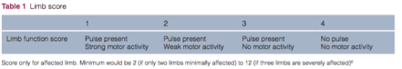

- AKI: 100% increase in serum creatinine between two time points
- RI: increased in serum K+ above reference range without concurrent rise in BUN or creatinine

Results
- 16 cats in TPA group (one also had right forelimb affected)
- 14 had confirmed or suspected heart diease; 1 had liver disease; 1 unknown
- Median time from onset to admission was 3h (range 0-6h)
- 38 cats in control group
- treated with analgesics, thromboprophylaxis, and treatment of underlying disease
- Median time from onset to admission was 6h (range 0-48h) * statistical significant
- No other significant difference between control and treatment groups
- Median limb score median 8
- TPA cats
- Mean time between admission and TPA administration: 1.5 +/- 0.6h
- 1 mg/kg TPA overdone hour (11)
- 10% of 1 mg/kg as loading dose over 1 minute (4)
- 17% over 1 minute, 46% over 30 mins, 37% over 1h (1)
- All received supportive care, analgesia, thromboprophylaxis
- Primary outcome:
- TPA group 56.3% survival (5 euthanized, 4 died)
- 44% recurrence rate with median time to recurrence 3.5 months

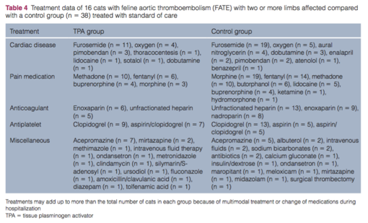

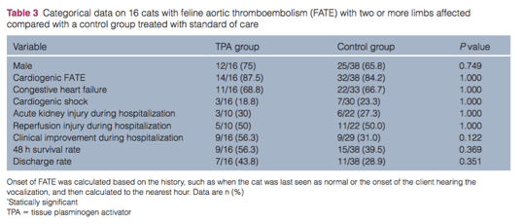

Conclusions
- No significant difference in primary outcome, secondary outcomes or complication rates between treatment and control
- Small number of cats in study - type 2 error?
- All TPA cats were treated within 3 hours of admission (median time to treatment 1.25h)
- Room for improvement with faster administration?
- Human TPA dose: 0.9 mg/kg dose with 10% given as a bolus and remaining 90% over the next hour
- Longer length to presentation in SOC group may have biased this group for survival
- Complication rate not different between the 2 groups

MooreK,MorrisN,DhupaN,etal.Retrospectivestudy of streptokinase administration in 46 cats with arte- rial thromboembolism. J Vet Emerg Crit Care 2000; 10: 245–257.

