Blood Pressure Monitoring

- Extremely useful monitoring tool; essential in guidance of use of inotropic agents and vasopressors
- Normal canine arterial blood pressure:
  - systolic 150 +/- 20 mmHg
  - mean 105 +/- 10 mmHg
  - diastolic 90 +/- 10 mmHg
- Mean arterial blood pressure = diastolic + (systolic - diastolic / 3)

Mean arterial blood pressure = cardiac output x systemic vascular resistance

Normal blood pressure does not guarantee adequate blood flow, as MAP is affected by vascular tone. Increases in SVR to maintain blood pressure, can actually diminish blood flow to peripheral tissues.

Hypotension = systolic blood pressure < 90 mmHg or MAP <60 mmHg in either species
- Causes of hypotension: decreased cardiac output secondary to reduced circulating volume, myocardial failure, severe bradyarrhythmia or tachyarrhythmia, decreased systemic vascular resistance due to peripheral vasodilation (secondary to sepsis or SIRS)

Hypertension can be primary (essential), which is rare in dogs and cats, or secondary to another disease process, such as kidney injury, hyperthyroidism, diabetes mellitus, hyperadrenocorticism, pheochromocytoma, and various medications (glucocorticoids, cyclosporine A, phenylpropanolamine, EPO)

Noninvasive BP Monitoring

Oscillometric, doppler, or photoplethysmography

- Based off of inflation of a cuff to occlude arterial flow, followed by measurement of the pressure at which flow returns
- Easy to use, cheap, but prone to error
- Particularly prone to error in hypotensive patients, hypothermic patients and small patients
- Cuff selection: width of approximately 30% the circumference of the limb for dogs and 30% for cats.
- Cuff should be at the level of the right atrium and patient should remain motionless in lateral recumbency.

Doppler: uses 10-mHz ultrasound pride to detect blood flow in an artery. Typically considered to measure systolic blood pressure, however one study in anesthetized cats found that Doppler more closely correlated with MAP

Oscillometric: cuff is alternatively inflated and deflated, and changes in cuff pressure due to pulse pressure changes are sensed by the transducer. Systolic and diastolic blood pressure are calculated from the MAP using built-in algorithms, there fore the MAP is the most accurate value

High-definition oscillometry (HDO): newer modality for blood pressure monitoring that are supposed to be advantageous to standard oscillometric monitors because they perform real-time analysis of arterial wall oscillations to obtain pressure-wave amplitudes, so systolic and diastolic pressures are measures instead of calculated

Photoplethysmography: originally designed for use on the human finger. Used “volume clamp principle” . Variation in blood volume in an extremity is detected by use of a cuff that is inflated and deflated fast enough to maintain a constant volume in the extremity, allowing for constant, real-time display of the cuff pressure (which equals intraarterial pressure). This is accurate in dogs and cats, but has not come into common use.

Telemetric Blood Pressure Monitoring

- Surgical implantation of a transmitting device that sense digital information to a receiver, which is collected by a computer
- Inserted subcutaneously, with polyurethane catheter that is fed into the femoral artery
- Used in laboratory settings
- Allow for free patient movement, prevent the stress of handling and restraint from interfering with accurate blood pressure readings

————————

Invasive/ Direct BP Monitoring

Direct BP measurement is the gold standard for blood pressure monitoring in veterinary and human medicine.

Advantages:

- beat-to-beat blood pressure monitoring and arterial waveform monitoring
  - Evaluation of pressure waveforms during arrhythmias can allow the clinician to distinguish which ones are cause poor pressures or pulse deficits, and can influence the decision to initiate treatment
  - Particularly useful in patients with hypovolemia or septic shock, that will need pressure monitoring over a long period of time (eg. anesthesia or hospitalization in ICU)
  - Helpful in guidance of fluid therapy and pressor use
- measurement of BP without handling of animal
- arterial catheter allows for ease of blood sampling

Disadvantages:

- technically challenging
- required more equipment
- can be inaccurate:
  - overdamping, underdamping, zeroing errors, etc
  - if compliant tubing is used, if the catheter is lodge up against the arterial wall, if a clot forms at the tip of the catheter, if air bubbles are present in the catheter or tubing, or if the catheter or tubing becomes kinked. All of these problems can result in the waveform becoming damped, which gives falsely low systolic and falsely high diastolic values
- Complications: hematoma formation, infection, thrombosis of artery, necrosis of the tissues distal to the catheter, haemorrhage if line becomes disconnected, over-heparinization in small patients.
  - All of these complications, except hematoma formation, are rare

Equipment and setup

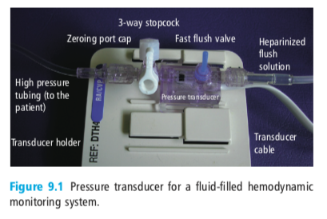

- At one end, the pressure transducer is attached to an administration set, which is attached to a fluid bag is Dpressurized to 250-300 mmHg to prevent backward flow of arterial blood into the tubing
  - The transducer will allow a slow forward flow of fluid through the system to decrease the risk of clot formation and catheter occlusion
  - Most pressure transducers also have a unidirectional flush valve
- At the other end of the transducer, rigid, noncompliant tubing is attached to the arterial catheter
  - standard extension tubing cannot be used, as its compliant nature will result in signal distortion
- The pressure transducer is connected to the hemodynamic monitor
- The pressure transducer converts the pressure changes into an electrical signal that is carried to the monitor by the transducer cable, and then the signal is amplified and displayed on a monitor as a pressure waveform showing the peak systolic pressure, dicrotic notice (created by closure of the aortic valve) and diastolic pressure. Numeric values for systolic, diastolic and mean arterial pressure are also displayed
- Before monitoring, the system, must be zeroed
  - The transducer is placed at the level of the right atrium (to best approximate central venous pressure)
  - The stopcock is closed is closed to the patient and opened to the atmosphere, and the ‘zero transducer’ is engaged. The waveform will be flat and read 0/0 (0)
  - The stopcock is closed to the atmosphere and opened to the patient

Normal arterial pressure waveforms

The waveform generated by the hemodynamic monitor is a reflection of the pressure changes transmitted along the arterial tree and sensed by the transducer.
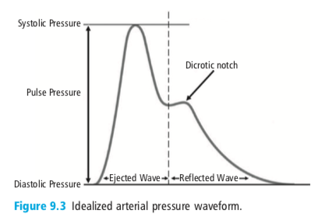
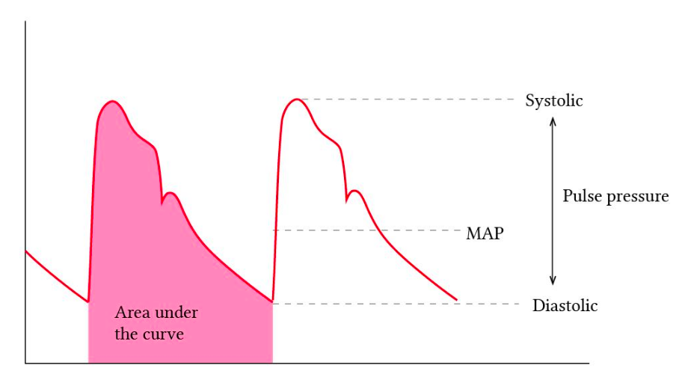

Diastolic arterial pressure (DAP) is a function of:
- blood viscosity
- arterial distensibility
- systemic vascular resistance
- length of the cardiac cycle

Systolic arterial pressure (SAP) is a function of:
- stroke volume
- velocity of left ventricular ejection
- systemic vascular resistance
- arterial distensibility
- left ventricular preload

Pulse pressure: the difference between the diastolic arterial pressure and the systolic arterial pressure

As the stoke volume runs off into the arterial tree tower the end of systole, there is a decline in pressure (initial downslope). Once aortic pressure exceed left ventricular pressure, the aortic calve closes. Elastic recoil of the arterial tree in the presence of a closed aortic valve causes a slight rebound (or elevation), resulting in the dicrotic notch (incisura). The presence of the dicrotic notice is largely a function of arterial elasticity and can be signficantly diminished to absent in the face of vasoconstriction.

Distal pulse amplification: changes that occur to the pressure wave as you move from central arterial circulation out the periphery:
- initial upstroke becomes steeper
- systolic pressure increases
- dicrotic notch appears later
- end-diastolic pressure decreases (i.e. wider pulse pressure)

The MAP does not change much.

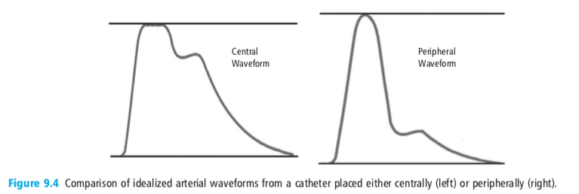
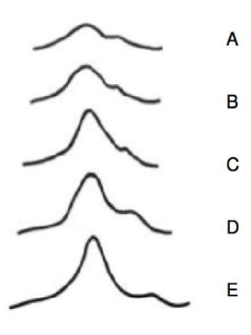

Calculations derived from the arterial pressure waveform

Mean arterial pressure

MAP = DAP + (SAP - DAP)/3
  - In patients with tachycardia and decreased filling time, this equation will underestimate MAP. Patients with narrow pulse pressure waveforms , this equation may overestimate MAP

Arterial blood pressure variation

There are normal minor variations in systolic blood pressure during both spontaneous and mechanical ventilation.

Hypovolemia magnifies this effects because the heart, vena cava and pulmonary veins will be more collapsible. This has led to the notion that respiratory cycle-associated arterial pressure variation could be used as an indicator of volume responsiveness for patients undergoing positive pressure ventilation. Spontaneously breathing patients will have a wide variation in tidal volume, and thus intrathoracic pressures, making it much more difficult to interpret the respiratory effects on arterial pressure.

Systolic pressure variation: difference between the maximum systolic pressure present during inspiration and the minimum systolic pressure present during exhalation.
  - SPV > 10 mmHg has been shown to correlate fairly well to hypovolemia in human patients
  - In people, SPV correlates well with pulmonary capillary wedge pressure and left ventricular end-diastolic area, both of which correlate with intravascular volume status

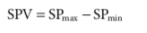

△up and △down: A reference SAP is measured during an end-expiratory pause. △up is the difference between the maximum systolic pressure during inspiration and the reference SAP, reflecting the positive-pressure-inspiratory increase in SAP. Conversely, △down is the difference between the reference SAP and the minimum systolic pressure during exhalation and reflects the expiratory decrease in SAP.
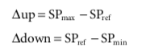
  - It is though the at the expiratory decrease in systolic pressure contributed to the majority of SPV seen in hypovolemia, and thus △down may be more useful, however this has not been proven to be true in human studies

Pulse pressure variation:
  - Obtained by dividing the difference between the minimum and maximum pulse pressures per a single breath by the mean of the two values. The result is expressed as a percentage.
  - PPV appears to have the strongest correlation to hypovolemia and volume responsiveness, with higher PPVs correlating to greater degrees of volume-responsiveness
  - A PPV of 10-15% is likely to indicate potential for fluid responsiveness. The higher the PPV the more likely the patient is to be fluid responsive.
  - The lower you are on the Frank-Starling curve, the more stroke volume will vary depending on the phase of ventilation
    - decree in preload due to mechanical inspiration results in a decrease in ventricular wall stretch → decreased stoke volume → greater difference inspiration and expiration stroke volumes

Limitations of arterial pressure variations:
  - patients must be undergoing positive-pressure ventilation
  - Accuracy is affected by presence of arrhythmias, effects of chest wall and lung compliance, right or left ventricular failure

Other uses for arterial pressure waveforms
  - can be used to determine cardiac output through pulse contour analysis - based on computation of the area under the systolic portion of the arterial pressure curve after calibration with a known cardiac output (typically measured by lithium or thermodilution)

Abnormal arterial pressure waveforms

Technical problems that cause abnormal arterial pressure waveforms

Damping: inherent tendency for the system itself to alter the pressure signal as it is transmitted from the patient to the transducer
  - Underdamping: resonant frequency of the monitoring system too closely matches the frequency of the pressure waveform. The result is a summation or resonance of the two frequencies, application of the signal, overestimation of the SAP, and underestimation of the DAP
    - All dABP monitoring systems will have some inherent underdamping effects
    - Results in waveforms with sharp peaks or points
    - Increasing the length of the tubing proportionally worsens the underdamping
  - Overdamping: results in attenuation or muting of the arterial pressure waveform, leading to a falsely low SAP and falsely elevated DAP
    - results in smooth waveform with loss of many of the defining characteristics
    - potential causes of overdamping include bubbles in the line, line occlusion, use of overly compliant tubing

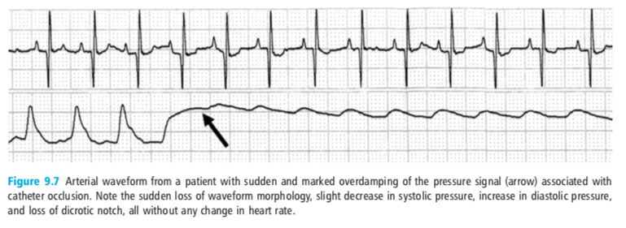

Patient problems that cause abnormal arterial pressure waveforms

- Arrhythmias

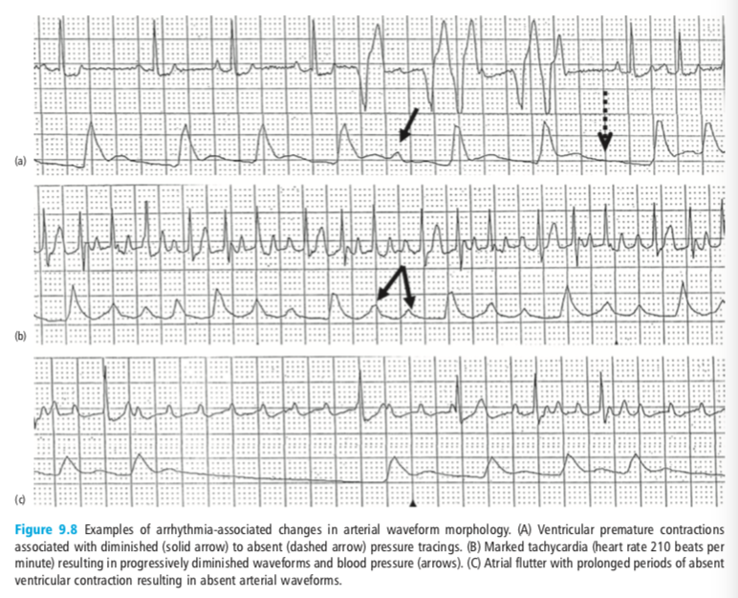

- Significant hypotension: can result in markedly muted waveforms secondary to small stroke volumes combined w tip peripheral vasoconstriction. These waveforms can be difficult to distinguish from those caused by overdamped systems.
  - Patients clinical status and the MAP will help distinguish - the MAP is typically preserved in over damped systems

- Pulses paradoxius
  - most commonly associated with pericardial effusion and cardiac tamponade
  - decrease in venous return (from increased pericardial pressure) results in a exaggeration of the difference between SAP during inspiration and SAP during exhalation

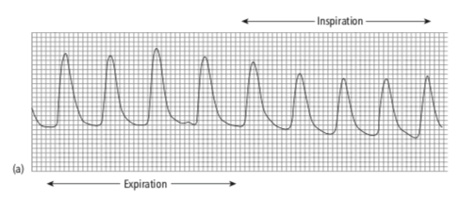

- Tall and narrow waveforms (increased pulse pressure, but short duration)
  - caused by increased SAP and very rapid falloff to DAP, with occurs due to decreased blood viscosity of backward flow of blood
  - water hammer or Corrigan’s pulses: aortic regurgitation, PDA, hypertension, hemodilutional anemia

