Diseases of Hypocoagulation

- Bleeding disorders result in inappropriate hemostasis predisposing to bleeding
- Some disorders result in spontaneous bleeding, others may be subclinical until bleeding occurs after invasive procedure
- Primary hemostatic disorders – decreased platelet numbers (thrombocytopenia); platelet dysfunction (thrombopathia); vascular anomaly (vasculopathy) rare
  - In critically ill patients thrombocytopenia has been associated with decreased survival; decrease in platelet count (even if within normal reference range) serves as an independent predictor of mortality
- Secondary hemostatic disorders – low concentration or activity of coagulation factors
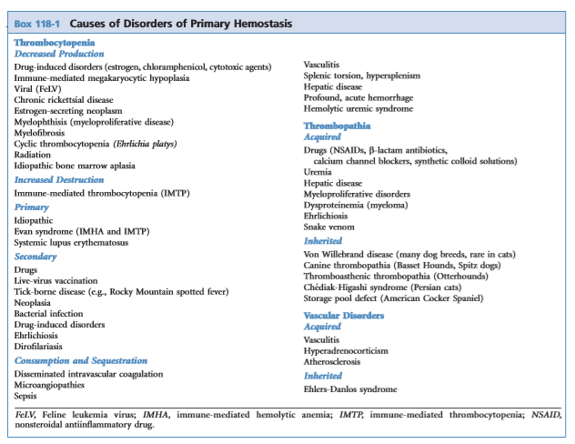
- Disorders of fibrinolysis (hyperfibrinolysis) can also contribute to bleeding – seen in DIC, massive trauma, and delayed post-operative bleeding in Greyhounds
- Inherited disorders usually only affect a single defect in hemostatic mechanism
- Acquired disorders affect more than one aspect of hemostasis

INHERITED PLATELET DISORDERS (disease of primary hemostasis)
Extrinsic Disorders
- Characterized by the lack of functional protein needed for platelet adhesion and aggregation
- Platelets are normal in structure and function

Intrinsic Disorders
- Disorders inherent to the platelets (i.e. abnormalities in platelet granules, membrane glycoproteins, signal transduction proteins, platelet production from megakaryocytes)
- Specialized techniques to document/diagnose

Clinical signs
- Varies depending on disease phenotype
- Typically mucocutaneous bleeding
- Excessive gingival bleeding during eruption of adult teeth, periodic bruising or petechial hemorrhaging, epistaxis, prolonged or severe bleeding after surgery or trauma, chronic GI and renal blood loss can result in iron deficiency anemia
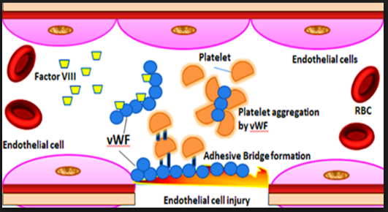
Von Willebrand’s Disease
- Most common extrinsic disorder is vWD in dogs (and people) deficiency and/or dysfunction of vWF
Physiology / Disease mechanism
- vWF: large, multimeric plasma glycoprotein important in platelet adhesion and aggregation
  - Adhesion - vWF bridges platelet to injured vessel wall via GPIb and exposed subendothelial collagen
  - Aggregation – contributes to platelet bridging via GPIb and platelet integrin αIIbβ3
- Synthesized by endothelial cells and megakaryocytes; secreted constitutively by endothelial cells or stored
  - Richest source is endothelial cells, lesser extent in platelets (in dogs)
- Small, medium and large vWF circulate in plasma
  - The largest vWF multimers are the most hemostatically effective at supporting platelet adhesion and are stored within Weibel-Palade bodies within vascular endothelial cells
- vWF also is a carrier for FVIII-coagulant (FVIII-C) – provides stability for FVIII-C in circulation by preventing protease-related degradation
  - Decrease in circulating vWF = secondary decrease in FVIII-C levels
  - PTT is usually normal unless FVIII-C levels are <30% of normal reference range
3 Classifications –based on presence of quantitative or qualitative abnormalities
- Type 1 – quantitative reduction in all sizes of vWF (most common vWD, >95% of cases in dogs)
  - All multimers are present but concentration is not enough for adequate hemostasis
  - Severity of bleeding varies
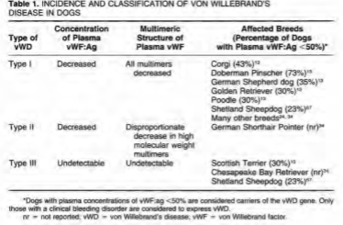
  - Autosomal dominant or recessive
- Type 2 – disproportionate decreases only in large multimers; severe and uncommon
  - 4 sub types – only type 2A in vet med
  - GSP, GWP
  - Autosomal recessive
- Type 3 – absolute lack of vWF
  - Severe
  - Decrease in FVIII
  - Autosomal recessive
Clinical signs:
- Mucosal bleeding, cutaneous bleeding, or excessive cavitary bleeding after surgery or trauma.
  - Petechia and ecchymosis uncommon
- Clinical signs worse with Type 2, 3 and variable with Type 1
  - The lower the [vWF] the greater the chance of bleeding

Diagnosis:
- Abnormal bleeding after vascular injury with normal platelet count and coag times should raise suspicion, or based on breed (i.e. Dobbies)
  - r/o thrombocytopenia (in-house analyzer, blood smear)
- Point of care:
  - BMBT – not specific for vWD (may be vWD or intrinsic thrombopathy)
    - Normal results are < 3 min to stop bleeding
    - Test is operator dependent and may be affected by age, gender, skin thickness, hematocrit, skin temp, vascular patterns (humans); platelet count and function
  - PFA-100 (platelet function analyzer) – measures plug formation in whole blood under high shear flow
- Quantitative:
  - ELISA assays (vWF:Ag) – quantifies concentration of vWF with species-specific antibodies to vWF
    - Values reported as % of normal; <50% is considered decreased and patient is carrier of trait with risk of bleeding (most bleeding vWF:Ag <35%)
    - 50-69% considered little to no risk for clinical disease but may be carrier
    - Type 3 - vWF:Ag ~ 0%
- Functional/Structural:
  - Multimeric analysis (immunoelectrophoresis) – differentiates Type 1 from Type 2
  - Functional vWF collagen-binding assay – measures quantity of functional vWF, preferentially detects large multimers
    - Detects vWD Type 2
- Genetic testing available
Treatment:
- Transfusion therapy:
  - If undergoing invasive procedure or to stop active bleeding
  - Plasma products rich in vWF
    - Cryoprecipitate (1 unit/10kg) derived from 200mL unit FFP
    - FFP (10-20mL/kg)
  - FWB if patient is also anemic – careful of volume overload, sensitization to RBC
- Other therapies:
  - Desmopressin acetate (DDAVP) stimulates endothelial V2 receptors to release intracellular stores of high molecular weight multimers of vWF (1-3mcg/kg IV) – questionable efficacy
    - May work for Type 1, not 2 or3
    - A greater increase in vWF cofactor occurs (measured by agglutination assays) than in vWF:Ag concentration study in dogs with Type I vWD found significant decrease in BMBT despite relatively poor increase in concentration
    - Max response is reached within 1-2 hours; administer pre-operatively
  - Avoid invasive procedures, anti-platelet, anti-coagulant drugs

Acquired vWD
- Seen in pulmonary hypertension, heart valve disorders enhanced degradation of high molecular weight vWF by ADAMTS13 (a disintegrin and metalloprotease with thrombospondin repeats) that cleaves vWF under high shear conditions
- Associated with hypothyroidism
- Auto-immune destruction of vWF
- HES/dextran administration (dilutional effect; decreased platelet aggregation with Dextran 40)
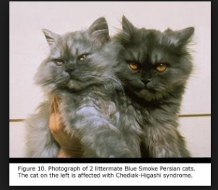
Chediak-Higashi Syndrome (CHS)
- Intrinsic disorder
- Storage pool disease deficiency in granule formation and function of melanocytes, platelets (dense granules), and leukocytes
- Platelets do not respond to or generate ADP, serotonin, divalent cations inability to form platelet aggregates (impaired function)
- Reported in Persian cats but not in dogs
- Patients have partial oculocutaneous albinism and immune system dysfunction
- Autosomal recessive
- Can be treated with platelet concentrates

Scott’s Syndrome
- Rare disorder, seen in GSD
- Phosphatidylserine and prothrombinase not expressed on activated platelet surface microparticle release impaired lack procoagulant activity (no generation of thrombin or conversion of fibrinogen to fibrin) no surface for assembly of coagulation protein complexes
Idiopathic Asymptomatic Macrothrombocytopenia
- Seen in Cavalier King Charles Spaniels but also in other breeds
- Autosomal recessive
- Inherited thrombocytopenia
- Characterized by large platelets and platelet numbers between 30-100K/uL
- Mutation in gene encoding beta-1 tubulin altered pro-platelet formation in megakaryocytes
- No clinical bleeding or altered platelet aggregation has been found
- May be misdiagnosed as acquired thrombocytopenia and can lead to inappropriate management and treatment
- Consider in patents with persistently low platelet counts in the absence of bleeding that is non-responsive to treatment with steroids and antibiotics
ACQUIRED PLATELET DISORDERS
Thrombocytopenia
Most common acquired hemostatic disorder in veterinary medicine.
Mechanisms
- Decreased Production
  - Suppression or destruction of megakaryocytes – immune mediated disease, drugs, toxins, infectious agents (chronic ehrlichiosis, FeLV, FIV, parvo), irradiation, hypoadrenocorticism, neoplasia, myelophthesis
    - Non immune mediated causes develops more gradually
  - Drug related bone marrow suppression/toxicity – chloramphenicol, chemo drugs, sulfonamides, estrogens, griseofulvin, and many others
- Consumption
  - Hemorrhage – trauma, anti-coagulant rodenticide, neoplasia (mild-moderate thrombocytopenia, transient, reversible)
  - Vasculitis
  - DIC – moderate to significant thrombocytopenia
- Sequestration
  - Splenomegaly / hypersplenism, neoplasia, severe hypothermia can cause sequestration of platelets in the spleen (usually mild)
- Increased destruction
  - Circulating platelets covered in Ab, Ab-Ag complexes, complement are phagocytized by macrophage in spleen, liver, bone marrow
  - Immune mediated thrombocytopenia - primary / idiopathic vs secondary – neoplasia, infectious, inflammatory, toxin, drugs
    - Drug (cephalosporins, penicillins, oxytetracyclines, fenbendazole, estrogen, phenobarbital, methimazole, etc)
      - Hapten dependent anti-body formation – drug binding to platelet causes antibody production and drug specific immune reaction (cephalosporin, penicillins)
      - Drug induction of antibody production that binds to platelet membrane proteins (GP IIbIIIa/integrin alphaIIbBeta3) – rifampin, FQ, vancomycin, sulfonamides
      - Auto-antibodies that react with platelet in absence of the drug (sulfas)
    - Feline: FeLV, FIV, panleukopenia, FIP, cytauxzoonosis, ehrlichia
    - Canine: parvovirus, ehrlichiosis, RMSF, anaplasma, babesia, leishmania, lepto, HW dz, sepsis, DIC, snakebites, LSA, HSA
  - Reported mortality rate (primary) 25-30%
  - ITP can cause the most severe form of thrombocytopenia
Clinical signs / diagnosis:
- Bleeding occurs below 25-50K
- Petechia, ecchymosis on MM, pinnae, inguinal area; mucosal bleeding oral, epistaxis, hyphema, hematemesis, melena, hematochezia, hematuria, prolonged bleeding or excessive bruising following venipuncture / trauma, CNS signs from cerebral or spinal cord bleeding
- Manual platelet count / blood smear to confirm accuracy of automated platelet count (r/o pseudothrombocytopenia)
  - Inflammatory conditions can cause platelet clumping, especially if traumatic venipuncture occurs
  - Cats have large platelets and can be miscounted as RBCs
  - Hpf should have 8-15 platelets (x15K = 120-225K)
- Mild, non-regenerative anemia may accompany (infectious, inflammatory, neoplastic causes)
- Dx work up = CBC, chemistry, clotting profile, CXR, AUS, infectious disease testing, anti-platelet antibody testing, bone marrow aspirate/core
Therapeutic approaches
- DIC – correct underlying causes plus supportive care (fluids, blood products, O2, anti-coagulation)
- ITP – immunosuppression
  - Glucocorticoids – down regulating Fc receptors on macrophage, preventing release of IL-1 and IL-6, reducing the APC process, reducing antibody adhesion to epitopes, direct inhibition of T-cell function
  - Cyclosporine, azathioprine, mycophenolate, leflunomide secondary immunosuppression
- Vincristine – causes release of platelets from megakaryocytes – given once
- IVIg (0.5mg/kg IV once) – shorter duration of stay in hospital. Works by Fc receptor blockade on mononuclear cells preventing phagocytosis (inhibition of Fc gamma receptor-mediated platelet destruction), and/or reduction in platelet-surface-bound antibody concentrations due to binding of antiplatelet autoantibody (antiidiotypic neutralization of antiplatelet antibodies)
- Splenectomy (humans) – second line treatment
- Platelet transfusion – only if life threatening bleeding (slow or stop bleeding), used up quickly
  - If given – marked for destruction
  - Fresh whole blood, PRP, cryo-preserved, lyophilized platelets, fresh platelet concentrate
  - One unit of whole blood-derived PRP results in a max platelet increase of 40K
  - FWB (thrombocytopenic and anemic patients) – 10mL/kg yield approx. 10K

Other Acquired Platelet Disorders
- Reduced platelet activity does not result in spontaneous hemorrhage unless other hemostatic problems co-exist; may be more prone to bleed after trauma or surgery
Drugs
- COX-1 inhibitors (aspirin) irreversibly inactivate COX resulting in inhibition of thromboxane A2 generation
  - Aspirin inhibits collagen induced platelet aggregation
- NSAID reversibly inactivate COX enzyme – platelet inhibition is transient and mild (<6 hours)
- Clopidogrel – platelet aggregation inhibitor inhibits ADP binding, reduces platelet aggregation
Uremia
- Affects platelet adhesion, secretion, and aggregation
- Defects in vWF function (receptor binding)
- Uremic patients also produce increased levels of NO and prostacyclin which can alter vascular tone and platelet function
- Decreased production of thromboxane has been reported
- Uremic toxins can directly inhibit platelets by competitively binding receptors
- Can be reversed by dialysis
- Platelet function can be increased by giving cryoprecipitate or DDAVP
Infectious
- Ehlichia – decreased platelet adhesion / aggregation
- FeLV – viral effects at stem cell level causing production of dysplastic / neoplastic megakaryocytes

INHERITED COAGULATION DISORDERS
- Less common than primary hemostatic disorders
- Usually involve a single factor and cause bleeding within the first year of life
- Mildly affected animals, or those with FVII deficiency, may not bleed until later in life, especially if they do not undergo trauma or surgery
- Arise from mutation within genes required for synthesis of processing of coagulation factors
Hemophilia A and B
- X linked bleeding disorders caused by functional (FVIII) or quantitative (FIX) deficiencies
- Hemophilia A is more common form in all species due to high de novo mutation rate in the coagulation FVIII gene
- Hemophilia A is a deficiency in functional FVIII – FVIII is needed for propagation phase of coagulation ultimately joins FIXa to activate FXa
- Deficiency in FVIII results in inability to generate enough thrombin for a mature clot to form
- Hemophilia B is a deficiency of FIX (“Christmas disease”) occurs less frequently
  - FIX need for activation of FX
Inheritance:
- Diagnosed in males – sex (X) linked, recessive inheritance pattern
- Heterozygous females do not express a bleeding tendency
- Hemophilia mutation transmitted by asymptomatic carrier dams
- Mildly affected males may survive to adulthood and propagate the trait if bred
Clinical Signs:
- Severity of bleeding is variable
- Anatomic location of bleeding tendency is localized to areas with little tissue factor (skeletal muscle and joints)
- Lameness due to hemoarthrosis, intramuscular and subcutaneous hematoma formation, prolonged hemorrhage from minor wounds and of gingiva during teeth eruption
- Severely affected patients at risk for severe or fatal hemorrhage (many die within the first year of life)
- Milder hemophilia may become apparent after trauma or surgery
Diagnosis:
- Both hemophilia A and B can cause specific prolongation of intrinsic pathway screening tests (ACT and aPTT)
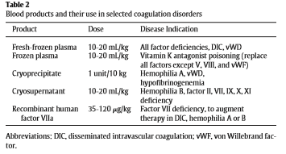
- Does not affect tests of extrinsic/common pathways or fibrinogen
  - Normal PT, TCT, fibrinogen
- Differentiation of hemophilia A and B requires specific measurements of FVIII and FIX coagulant activities (FVIII:C, FIX:C)
- Factor analysis will demonstrate a moderate or severe deficiency in FVIII
  - Severe hemophilia characterized by FVIII:C or FIX:C <2% of normal
  - Mild to moderate 2-20% of normal
Treatment:
- Transfusion is best way to control or prevent hemorrhage
- FFP has both FVIII and FIX
- Cryoprecipitate is a more specific product for replacement of FVIII
- Cryosupernatant supplies FIX

Factor XII Deficiency
- Common deficiency found in DSH and purebred cats
- FXII not required for fibrin clot formation in vivo and deficiency in this factor will not cause a bleeding problem
- Due to high prevalence, FXII deficiency should be considered as cause of prolonged PTT in cats, especially if there is a normal PT and no clinical signs of bleeding
- No treatment required
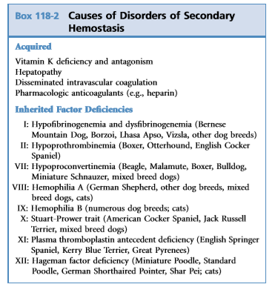
- Autosomal recessive

ACQUIRED COAGULATION DISORDERS (disorders of secondary hemostasis)
Vitamin K Deficiency

Physiology:
  - Vitamin K is necessary for activation of FII, VII, IX, X (serine proteases)
  - Vitamin K coagulation factors are produced in the liver as inactive proteins and contain glutamyl residues that must be carboxylated for the protein to become active carboxylation reaction requires reduced vitamin K vitamin K becomes oxidized (vitamin K epoxide) needs to be reduced again (recycled) by vitamin K epoxide reductase to carboxylate other factors
  - Failure of factor carboxylation = coag proteins cannot be bound by calcium bridges = not functional for coagulation

Mechanism of deficiency:

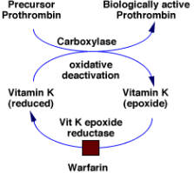
- Secondary to dietary insufficiency (rare), decreased absorption from severe GI disease, EPI, hepatopathy, biliary obstruction, broad spectrum oral antibiotics (inhibits Vitamin K synthesis in gut lumen)
- Vitamin K antagonism: warfarin, vitamin K rodenticides (irreversible inhibition of vitamin K epoxide reductase)
- Vitamin K stores becomes depleted and inactive non-carboxylated coagulation factors accumulate in the blood half-lives of factors are short rapid depletion coagulopathy/bleeding

Clinical impression/diagnosis:
- Spontaneous bleeding (anticoagulant rodenticide) vs subclinical bleeding with drug or disease related deficiency
- History of toxin ingestion, medications, associated diseases
- Bleeding occurs within 2-5 days of ingestion and may escalate quickly once detected
- Prolongation of PT occurs first – short half-life of FVII (4-6 hours), 36-72 hours before seen
- Prolonged aPTT occurs 2 days later when other factors are depleted
- PIVKA prolonged (liver produces inactive proteins antigenically similar to FII, VII, IX, X)
Treatment:
- Vitamin K1 2.5-5mg/kg SQ divided over several sites then oral 2.5mg/kg PO q12hr x 4wks, PT tested 48 hours after ending treatment

Hepatic Failure
- Primary hemostasis, secondary hemostasis and fibrinolysis can be altered in patients with hepatobiliary disease
- Traditionally thought to be hypocoagulable but hypercoagulation is also present

- Liver produces and activates the majority of factors that regulate pro-coagulation, anticoagulation, and fibrinolysis
- Liver synthesizes:
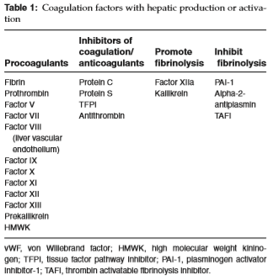
  - Fibrinogen, prothrombin, clotting factors (FII, VII, IX, X, XI, XII), prekallikrein
  - Coagulation inhibitors (protein C, protein S, antithrombin AT)
  - Fibrinolytic proteins (plasminogen, PAI-1, alpha 2 antiplasmin)
  - Decreased factor synthesis occurs when >70% of the liver mass is decreased (FVII shows earlier reduction due to short half-life of 6 hours)
- Liver clears activated factors and by-products (FDP, D-dimers)
- Hepatocytes important in Vitamin K dependent carboxylation of FVII, IX, X, protein C and S
Impact on Primary hemostasis
- Thrombocytopenia – GI hemorrhage, occult thrombosis, low grade consumption from DIC, immune mediated destruction, decreased production of thrombopoietin
- Decreased platelet function – hypoaggregability (changes in platelet plasma membrane lipid concentration impairs signaling or decrease thromboxane production; storage pool defects)
- FDPs not cleared by dysfunctional liver can competitively inhibit binding of fibrinogen to platelet receptors inhibition of aggregation
- Vascular injury within liver leads to portal hypertension and changes in normal splanchnic vascular flow generates shear stress leads to endothelial dysfunction and production of vasoactive substances that decreases platelet aggregation (NO) state of hypocoagulation

Impact on Secondary Hemostasis
- Decrease in coagulation factor synthesis, failure of vitamin K mediated carboxylation, alteration in anticoagulant production
- Despite increases in clotting times, spontaneous bleeding is rare
  - Advanced disease and non survivors - melena and hematochezia can develop
- Vitamin K deficiency
  - Decreased absorption due to decrease in bile flow, decreased intake, antibiotics alters bacteria and decreases vitamin K production in gut
- Differentiation of hepatic coagulopathy vs DIC is difficult as lab values are similar – in human medicine best discriminator is platelet count and low FVIII activity as well as evidence of end organ damage (indicative of DIC)
Hyperfibrinolysis in Liver Disease
- Mechanism not fully understood possible decrease in TAFI and PAI-1 (synthetic failure) and increase in tPA from decreased clearance
Hypercoagulability
- Altered vascular flow portal hypertension endothelial shear stress increase in splanchnic NO (vasodilation and hypotension) slow flow / stasis clot formation
- Increased procoagulant activity, decreased anticoagulant activity, altered vascular flow or disordered fibrinolysis unchecked thrombi generation and endothelial dysfunction, shear stress in sinusoids activate endothelial cells enhancing vWF and FVIII expression
- Decreased AT and protein C can occur (synthetic failure)
- Portal vein thrombosis (PVT) can occur secondary to inflammatory liver disease, neoplasia, vascular anomalies
Clinical impression/diagnosis:
- 93% of dogs and 82% of cats with hepatic disease have some sort of hemostatic dysfunction
- Petechia, ecchymosis, hematuria, melena result of hyperfibrinolytic state and platelet disorders
- Cyanosis, dyspnea (PTE), acute onset abdominal pain or ascites (PVT) hypercoagulable state
- Imaging US, XR, CT to look for evidence of thrombosis or bleeding
- Platelet count, PT/PTT, PIVKA, TEG
  - Coagulation tests do not distinguish between Vit K deficiency and factor deficiency – a vitamin K trial can be attempted
- Hyperfibrinolysis should be considered in patients with persistent bleeding despite corrected/normalized clotting times

Treatment:
- Once coagulation status has been established – treatment may be considered to reverse clinically relevant problems
- Blood products if indicated (surgery/biopsy)
  - In patients with mild prolongation of PT/PTT blood products should be given as rescue rather than prophylactically
  - FFP is first line treatment for spontaneous bleeding or iatrogenic bleeding – 5-15mL/kg
    - Bleeding cessation is an end point to therapy not normalized PT/PTT
  - Cryoprecipitate for hypofibrinogenemia (< 100mg/dL)
- Vitamin K1 SQ in all patients if prolonged PT/PTT and prophylactically in cholestatic patients (especially in cats) 0.5-1mg/kg SQ for 3-5 days then weekly if primary disorder is not corrected
- Thrombosis – anticoagulants (heparin, warfarin) may be considered; platelet inhibitors have not been evaluated
Acute Traumatic Coagulopathy

Background:
- Occurs after massive trauma and hypovolemia – accounts for more than 50% of trauma related deaths within the first 48 hours (humans)
- Severity of injury and degree of shock – positively correlated to the degree of coagulopathy in humans; is an independent risk factor for death
- Previously believed to be a late consequence of hemodilution (aggressive, large volume fluid resuscitation), dysfunction from inhibitory effects of hypothermia and acidemia on serine proteases and platelets, and ongoing loss of coag proteins and platelets through bleeding/consumption
- Now recognized as a distinct, endogenous coagulopathy that can develop within as little as 30 minutes post trauma – prior to resuscitative efforts, hypothermia, and acidemia
  - Clinical manifestation - systemic hypocoagulation and hyperfibrinolysis
  - Resuscitation associated coagulopathy (RAC) occurs later – secondary to hypothermia, hemodilution, acidemia
Three main hypotheses to explain mechanism underlying ATC
- Phenotypic variation of classic DIC (fibrinolytic phenotype)
  - During the first 24-48 hours post trauma patients suffer from DIC with a fibrinolytic phenotype after which a thrombotic phenotype occurs
  - Severe endothelial injury, hypoxia, and ischemia leads to generation of thrombin and systemic fibrin formation
  - Concurrent massive release of tPA into circulation results in large amounts of plasminogen to plasmin accounts for the proposed posttraumatic hyperfibrinolytic / hypocoagulable expression
  - As circulation is restored – the later thrombotic state develops due to greater expression of PAI-1

- Enhanced thrombomodulin-thrombin protein C pathway
- Thrombin is typically prothrombotic but when bound to thrombomodulin it switches from a procoagulant function to anti-coagulant function via activation of protein C
- Protein C exerts anticoagulant properties via inhibition of FVa and FVIIIa while exerting fibrinolytic properties via suppression of PAI-1 and TAFI

- Neuro-hormonal hypothesis
  - Trauma with tissue injury causes a dose dependent sympathoadrenal response releasing catecholamines into circulation circulating catecholamines directly damage the endothelial glycocalyx changes it to a more prothrombotic state allowing for hemostasis
  - To prevent systemic coagulation the body attempts to counterbalance the effects of prothrombotic endothelium with an anticoagulable and fibrinolytic response in the blood shedding of anticoagulant (heparin-sulfate and soluble thrombomodulin) and fibrinolytic (tPA) constituents from damaged glycocalyx into local circulation.
  - As degree of tissue trauma and endothelial damage increases the counter regulatory response goes out of control resulting in systemic hypocoagulation and hyperfibrinolysis
Pathophysiology / initiators of ATC:
- 6 key factors influence ATC – tissue injury, hypoperfusion, systemic inflammation, metabolic acidosis, hypothermia, hemodilution
  - Shock with tissue hypoperfusion is major driver – degree of hypoperfusion directly correlated with degree of coagulopathy

- Cross talk between inflammation and coagulation
  - Pro-inflammatory cytokines, TF, thrombin-thrombomodulin protein C pathway, endothelium, complement proteins, and platelets constitute the major players in the interplay
  - Trauma/hemorrhage evokes an immediate and marked release of pro-inflammatory cytokines (TNF alpha, IL-I, IL-6) and anti-inflammatory cytokines (IL-4, IL-10, IL-13), chemokines (IL-8), alarmins (HSP, high morbidity group box -1), activation of complement (C3a, C5) pathways
  - Complement proteins are markedly increased immediately post trauma - activation upregulates thrombomodulin expression and activation of protein C
  - Pro-inflammatory cytokines TNF alpha, IL-1B and IL-6 upregulate TF expression on circulating monocytes and endothelial cells TF exposed to circulating FVIIa = initiation of coagulation cascade and thrombin formation
  - Thrombomodulin is an endothelial protein that is expressed when endothelium is activated / injured TM complexes with thrombin = activates protein C at the endothelial protein C receptor = “anticoagulant thrombin” – cannot cleave fibrinogen to fibrin = hypocoagulable TM is expressed in excess in ATC
    - Severity of hypoperfusion associated with increase in plasma thrombomodulin
  - Endothelial injury results in massive release of tPA; activated protein C inhibits PAI-1 and TAFI = hyperfibrinolytic environment
  - During the later posttraumatic period inflammatory response favor a more pro-thrombotic tendency (pro-inflammatory cytokines down regulate protein S, endothelial based heparin sulfate proteoglycans, thrombomodulin, and endothelin protein C receptor)

- Metabolic acidosis and hypothermia
  - Lethal triad = hypocoagulability, acidosis, hypothermia
  - Later stages - other physiological factors such as acidosis (pH<7.2) and hypothermia (<33-34C) may exacerbate ATC
  - Factor Xa/Va complex may be reduced by as much as 50% at pH of 7.2, 90% pH 6.8
    - bicarbonate administration will not fix coagulopathy
  - Hypothermia decreases coagulation protease function activity and platelet aggregation

- Hemodilution
  - Physiologic: massive blood loss causes shift of extracellular water into the vascular space = dilution of hemostatic factors, red blood cells and platelets
  - Iatrogenic: large volume fluid resuscitation
    - Increases hydrostatic pressure which can disrupt the formation and any previously formed thrombi
    - Dilutes hemostatic factors, platelets and RBCs
    - Reduces blood viscosity, disrupts the compensatory vasoconstriction
    - Potentiates hypothermia and hyperchloremic acidosis
    - Synthetic colloid induced coagulopathy - associated with higher molecular weight and higher degree of substitution hydroxyethyl starch solutions
Diagnosis:
- Dynamic, variable disease = challenge to effectively and rapidly detect
- Lack of universally accepted, standardized, and precise tests
- Goals: identify ATC within 1 hour of presentation, institute immediate goal-directed therapy with appropriate blood components to prevent further hemorrhage
- Traditional tests:
- PT/PTT, fibrinogen concentration and platelet count
  - Do not reflect dynamic process, one moment in time
  - Do not give information on functionality of platelets and fibrinogen
- TEG/ROTEM- better at predicting and early identification of ATC and guiding treatment
  - ATC – problem with clot strength
- Moderate, severe, massive trauma increasingly more hypercoag, hypocoag, hyperfibrinolytic respectively
- Highly suggestive of ATC:
  - Hx of severe trauma with marked tissue injury, presence of marked hypoperfusion (SBP < 80 or MAP < 60mmHgl lactate > 5mmol/L ; base deficit <-6)
  - Hemorrhagic shock, uncontrolled or spontaneous bleeding
  - Viscoelastic tracing displaying persistently decreased clot strength < 40% of mean reference value, prolonged PT/aPTT > 1.5 lab reference mean
Treatment:
- New protocols for treatment allows for permissive hypotension (minimize dilutional coagulopathy), limiting fluids (HTS/colloids, limited crystalloids) and delivering higher ratios of plasma and platelets
  - Maintain MAP of 50mmHg
- FFP, pRBC 1:1 given preferentially for vascular volume support; plasma given early
- Cryoprecipitate can be given to increase fibrinogen levels
- Hemostasis control
  - Compressible hemorrhage - packing, hemostatic bandages or agent, tourniquet
  - “damage control surgery” if uncontrolled hemorrhage for non-compressible injuries (definitive repair 24-72 hours)
- Correct acidosis and hypothermia
- Pharmacological adjunctive therapy
  - Recombinant human factor VIIa (rhFVIIa) – procoagulant that promotes formation of the fibrin plug via activation of FX
    - Best used as second line if traditional efforts are refractory
    - High antigen response in dogs = not clinically feasible in vet med
  - Antifibronolytics (tranexamic acid and aminocaproic acid) – synthetic lysine analogues
    - May reduce risk of death due to bleeding but has not been found to reduce transfusion requirements
    - Use should be guided by viscoelastic testing, institute w/in 3 hours of trauma

DIC (more to come in future BR sessions)
- Systemic activation of coagulation leading to widespread microvascular thrombosis, compromising organ function / failure, and may ultimately exhaust clotting factor and platelet supplies and result in a hypocoagulable state / bleeding
- Occurs secondary to underlying disorder (sepsis, SIRS, neoplasia)
- Clinical signs vary – asymptomatic to organ failure/MODS to bleeding
  - Organ dysfunction is more common than overt bleeding
- Bleeding may be the effect of disorders of primary or secondary hemostasis (bleeding from catheter sites, epistaxis, hematoma, GI/urinary bleeding, intracavitary bleeding)
- Diagnosis = challenging! Continuum
- Dx based on underlying condition that could trigger DIC + (3 or more) thrombocytopenia, prolonged PT, PTT, elevated d-dimers, hypofibrinogenemia, schistocytes, reduced anti-thrombin

Delayed Post-Operative Bleeding in Greyhounds
- Bleeding is delayed 36-72 hours after surgery
- Hyperfibrinolysis is thought to be the cause
- Prophylactic treatment with ACA q8hr for 5 days post-surgery is recommended

Treatment of Hemorrhagic Disorders
- Transfusion therapy: control active bleeding, prevent abnormal bleeding, correct signs of blood loss anemia
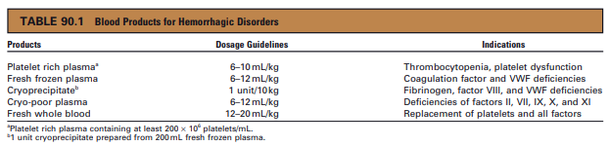
- Drug therapy: indirectly support hemostasis
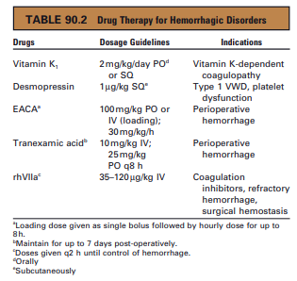
- Topical agents: direct application to control bleeding. Provide mechanical barrier and matrix for fibrin clot formation
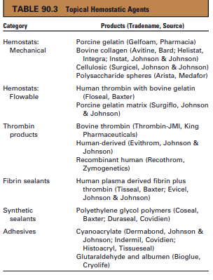

References:
Barr JW, McMichael M. Inherited disorders of hemostasis in dogs and cats. Topics in Compan An Med 2012; 27: 53-58.

Bourdeaux MK. Inherited platelet disorders. J Vet Emerg Crit Care 2012; 22: 30-41
Kavanagh C, Shaw S, Webster CRL. Coagulation in hepatobiliary disease. J Vet Emerg Crit Care 2011; 21; 589-604.

Brohi K, Cohen MJ, Ganter MT, et al. Acute coagulopathy of trauma: hypoperfusion induces systemic anticoagulation and hyperfibrinolysis. J Trauma 2008; 64: 1211-1217.

Palmer L, Martin L. Traumatic coagulopathy-part 1: Pathophysiology and diagnosis. J Vet Emerg Crit Care 2014; 24: 63-74.

Palmer L, Martin L. Traumatic coagulopathy-part 1: Pathophysiology and diagnosis. J Vet Emerg Crit Care 2014; 24: 75-92.

Thomas JS. Von willebrand’s disease in the dog and cat. Vet Clin North Am Small An 1996; 26: 1089- 1110.

Schalm’s Veterinary Hematology 5th Edition. Feldman B, Zinkle JG, Jain NC (2000). Chap 66-72; 81-83

Schalm’s Veterinary Hematology 6th Edition. Weiss & Wardrop (2010). Chap 77-83; 85-87; 90

Small Animal Critical Care Medicine 2nd Edition. Silverstein DC & Hopper K (2015). Chap 104 – 107

