Diseases of Hypercoagulability
Thrombocytosis
- Thrombocytosis is an increase in platelet numbers in peripheral blood in excess of reference range for species
- Thrombopoietin is the main thrombopoietic cytokine and is produced in the liver and kidney (other cytokines include IL-6, IL-1alpha, IL-9, I-11, leukemia inhibitory factor, GM-CSF)
- May be primary bone marrow disorder or secondary to variety of diseases and physiological states
- Thrombocytosis from nonmalignant causes is usually modest, transient and asymptomatic (< 1,000,000 platelet/uL)
- > than 1,000,000/uL may be life threatening and associated with clinical signs of bleeding to thrombosis
- May cause spurious or pseudohyperkalemia due to release of platelet cellular substances in serum before harvesting compare against heparinized plasma K+ to determine if true hyperkalemia
Secondary thrombocytosis (most common)
- Physiologic thrombocytosis
  - Increase in mobilization from splenic and pulmonary platelet pool (epinephrine release / splenic contraction)
  - Post splenectomy – platelets increase within 2-10 days and peak after two weeks, gradual return to baseline in 2-3 months (decrease in destruction)
- Drug induced thrombocytosis
  - Vincristine (increased megakaryopoiesis) and epinephrine +/- glucocorticoids (conflicting data)
  - Corticosteroids may decrease phagocytosis of platelets by macrophage
- Reactive thrombocytosis
  - Cytokine stimulation of thrombopoiesis (IL-6!)
  - Occurs after peripheral platelet loss (traumatic, neoplastic, infectious, immunologic, chronic hemorrhage), inflammatory conditions, infections, neoplasia, iron deficiency
Essential thrombocythemia (humans)
- Very rare in veterinary medicine
- Classified as a chronic myeloproliferative disease – proliferation of pluripotent hematopoietic stem cell leading to expansion of megakaryocyte compartment in bone marrow, growth and maturation of large mature megakaryocytes and excessive (autonomous) production of structurally and functionally abnormal platelets
- Clinical signs – microvascular thrombosis or bleeding
  - Increased platelet activation
  - Bleeding – abnormal functioning platelets (>1,000,000 platelets/uL)
Diagnosis:
- Normal to high thrombopoietin levels – dysregulation of feedback mechanism
- ET vs reactive thrombocytosis – thrombohemorrhagic events, mild to moderate non progressive splenomegaly (extramedullary hematopoiesis), no evidence of inflammation, abnormally large megakaryocytes in bone marrow, JAK2 mutations
- Bone marrow analysis
- Flow cytometry
Treatment:
- Hydroxyurea, anagrelide (inhibits megakaryocyte proliferation/differentiation), interferon alpha
- Aspirin for patients at risk of thrombosis
- Chemotherapy
HYPERCOAGULABLE STATES
- Hypercoagulability/thrombophilia – propensity for inappropriate thrombus formation; imbalanced prothrombotic state of platelet hyper-reactivity, excessive activation of coagulation, deficiencies of natural anti-coagulants and/or hyperfibrinolysis
- May be due to inherited or acquired causes
  - Inherited: Factor V Leiden mutation or protein C deficiency (humans, none in veterinary med)
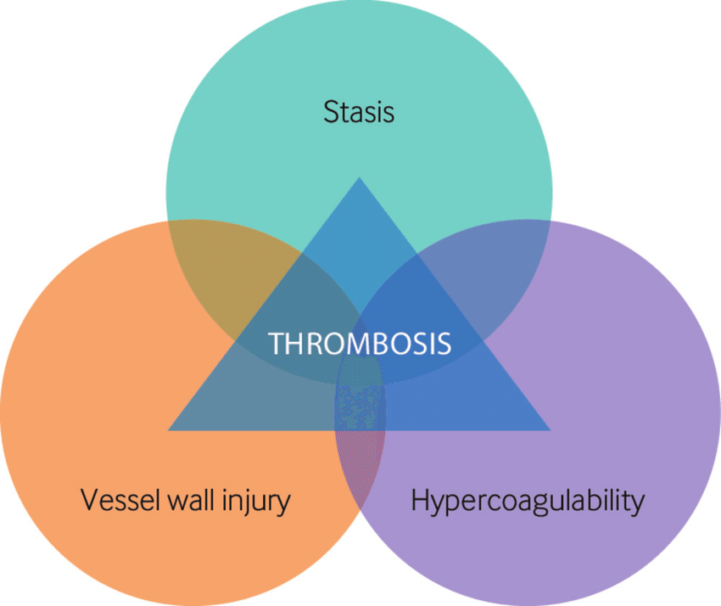
- Virchow’s triad – predisposition to thrombotic disease (overlap is common)
  - Endothelial dysfunction
  - Hypercoagulability of blood
  - Blood stasis or altered (turbulent) blood flow

Mechanisms of Thrombophilia
- Endothelial disturbances
- Endothelial barrier is comprised of vascular endothelial cells and luminal glycocalyx that houses many key anticoagulant elements
- Normally endothelium is anticoagulant in nature
- In injury, the endothelium transitions to a pro-thrombotic state
- Endothelial glycocalyx
  - Large network of negatively charged GAGs, proteoglycans and glycoproteins
  - Heparan sulfate is 50-90% of proteoglycans and facilitates binding of AT, heparin cofactor II, thrombomodulin function, tissue factor pathway inhibitor are housed
  - Serves as mechanoreceptor altered blood flow NO released during times of shear stress to maintain organ perfusion (vasodilation and decrease platelet aggregation)
    - NO important for inflammatory response, leukocyte adhesion, inhibition of platelet aggregation
  - Inflammation results in decrease of GAG = compromises glycocalyx, decreasing the function of key anticoagulants, decreased buffering of endothelial cells allowing inflammatory mediators to bind
  - Endothelial glycocalyx can be activated by TNF-alpha, bradykinin, thrombin, histamine, vascular endothelial growth factor
    - Once injury/activated – EC releases ultralarge multimers of vWF which can bind platelet GPIb-alpha receptors, initiate platelet tethering and activation
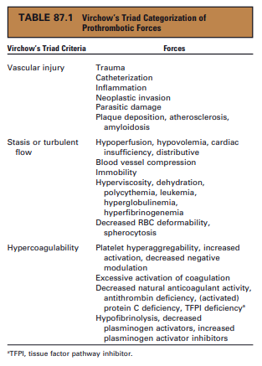
- Increased Procoagulant Elements
- Endothelial disruption exposes procoagulant substances (tissue factor) to circulating blood
- All coagulation occurs through interaction of TF and activated FVIIa
- TF may be expressed on macrophage/monocytes that have been activated by inflammation
  - Has also been expressed on neoplastic cells
- TF perpetuates inflammation through activating TNF alpha release
- Platelets are a source of procoagulant membrane
  - Activation leads to shape change and negatively charged phospholipids move to surface catalytic surface for prothrombinase and tenase propagation of clot formation
- Platelets activate and increase fibrinogen receptors (integrin alphaIIb beta3) on surface
- Alpha and dense granules are secreted releasing procoagulant elements (calcium, FVa, serotonin, fibrinogen, P-selecin, ADP (feline alpha granules also release vWF)
- Microparticles circulate in small vesicles released from activated or apoptotic cells provide surface for thrombin generation
  - MP can express TF on their surface, or have vWF binding sites or UL-vWF multimers characterized as procoagulant MPs

- Decreased Endogenous Anticoagulants
- Essential to restricting coagulation to the site of vascular insult
- Produced simultaneously – helps to prevent procoagulant state
- 3 primary anticoagulant proteins – each are directly or indirectly anti-inflammatory
- Antithrombin (AT) – acts to inhibit thrombin and FXa
  - Most effective when bound to heparin-like GAG on glycocalyx or when exposed to exogenous heparins
  - Decreased in systemic inflammation or critical illness due to
    - Consumption (thrombin generation)
    - Decreased production (negative acute phase)
    - Degradation by neutrophil elastase
      - Urinary loss can occur in glomerulonephritis
- Protein C – inhibits FVa and FVIIIa
  - Activated when trace thrombin binds to thrombomodulin on endothelium – microcirculation!
  - Protein S is a cofactor
  - TM binding to thrombin helps generate activated protein C prevents thrombin from acting on fibrinogen and platelets
  - Less functional during systemic inflammation due to decreased hepatic synthesis
  - TNF alpha can down regulate expression of TM and elastate from endotoxin activated neutrophils can cleave TM from endothelium
  - Circulating or soluble TM is less effective than when bound to endothelium
  - People – soluble TM is increased in people with sepsis and predicts presence of DIC, MODS, mortality
- TFPI – inhibits FVIIa-TF complexes and FXa (all components of TF or extrinsic pathway)
  - Released primarily from endothelial cells
  - Protein S is a cofactor for inhibition of FXa

- Alterations in Fibrinolysis
- Circulating plasminogen is incorporated into forming clots converted to plasmin by fibrinolytic activators (tPA, urokinase)
- Plasmin breaks down fibrin meshwork of formed clot, recannulize blood vessels
- tPA and urokinase are derived from endothelium and released upon activation / injury
- TNF alpha and IL-1beta cause a delayed but sustained release of plasminogen activator inhibitor (compared to tPA) leading to decreased fibrinolysis and persistence of thrombi

Common Conditions in Veterinary Medicine
- Arterial thrombosis – white thrombi “platelet rich,” high shear
- Venous thrombosis – red thrombi “fibrin, red blood cells,” low shear
- Canine most common conditions are PLN, neoplasia, IMHA, necrotizing pancreatitis, HAC, corticosteroid therapy
  - Canine TE – arterial and venous
- Feline most common conditions are aortic TE with cardiomyopathy (most common) and less frequently venous TE with neoplasia, multisystemic disease
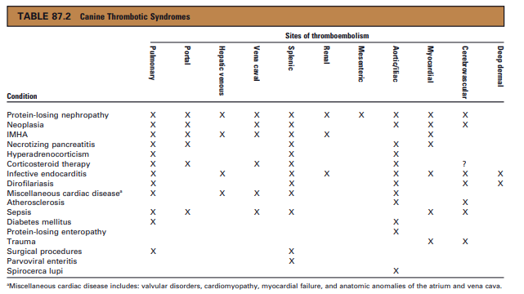
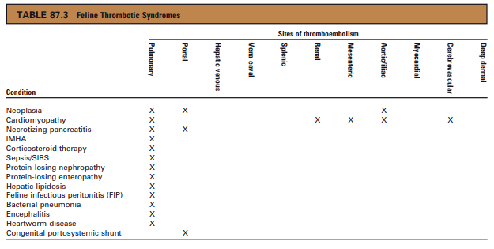
Systemic inflammation
- Complex – increased expression of TF, activation of endothelial cells and disruption of glycocalyx, impairment of anti-coag system, decreased fibrinolysis
- Process by which inflammation affects coagulation are interrelated
- Glycocalyx shedding and endothelial glycocalyx activation compromised production of local regulators (NO) and increased expression of procoagulant molecules (TF, UL vWF) and adhesion molecules (P-selectin) and derangement of anti-coagulant defenses
- Decreased activation of protein C, decreased concentration and effectiveness of AT, increased PAI-1 can slow fibrinolysis and impair coagulation defenses
- Sepsis! – to be covered soon
- Infectious conditions to include RMSF, heartworm disease, FIP – can cause platelet hyperfunction

Protein losing nephropathy
- Glomerular disease and significant proteinuria with or without nephrotic syndrome are at an increased risk for thrombosis / TE (reported to range from 22-50%)
- Arterial and venous TE have been reported
- People – PLN, proteinuria, hypoalbuminemia, low AT, and hypertension have been associated
- UPC > 0.5 = PLN, >2 = protein loss through glomerular disease
- Dogs with PLN and renal failure showed a hypercoagulable state (compared to healthy or systemically ill dogs)
Proposed mechanisms:
- Platelets are hyperaggregable and exhibit increased markers of activation (P-selectin)
- Increased in FVIII activity and fibrinogen concentration are increased
- AT is lost however AT levels fail to predict thrombotic events - low AT is not the only mechanism PLN associated hypercoagulability
  - Human – TE complications when AT falls below 50-70%
- TAFI and PAI-1 are increased (people) suggesting a decreased fibrinolytic state
- Hypoalbuminemia is associated with enhanced platelet aggregability
Diagnosis/treatment:
- Hypoalbuminemia (<2 g/dL) is a surrogate measure for TE risk
- TEG identified hypercoagulability in 89% of dogs in one study; UPC, serum albumin, AT and BP levels were not predictive of TEG-based hypercoagulability
- Hyperfibrinogenemia and low AT levels, and elevated FVIII have been described
- Historically treated with aspirin however as there are multiple mechanisms at play (not just decreased AT)
- Markedly decreased AT – heparins may have less efficacy
- Warfarin may be needed for more substantial anticoagulation

Immune mediated hemolytic anemia
- Venous thrombi have been identified post mortem in 30-80% of nonsurvivors
- Majority of deaths occur in the first 2 weeks – either from anemia or thrombotic disease
Proposed mechanisms:
- Inflammatory disease state, use of immune-suppressive drugs (corticosteroids), IV catheterization, blood product transfusion may all contribute
- Not completely understood – inflammatory mediator activation of coagulation, hemolysis mediated platelet hyper-reactivity and presence of antiphospholipid antibodies
- Release of procoagulant thromboplastin from lysed RBCs, alterations in coagulation factors, endothelial injury, altered blood viscosity have been proposed
- Circulating TF is implicated TF upregulation in whole blood, stimulation of endothelial gylcocaylx TF by cell free heme
- Platelet activation has been evaluated in 2 studies with differing results – P selectin increased in one study, also increase in MP
Diagnosis/treatment:
- Low AT, increased FDP and D-dimers, elevated fibrinogen are commonly reported but may not be reliable indicators and may have individual variability
  - High D-dimers suggest ongoing coagulation and fibrinolysis
- TEG studies have demonstrated hypercoagulability by shortened K time, high alpha, high MA, high G values
  - Anemia may skew results (increases MA - increased concentration of plasma proteins – unknown if this is an in vitro and in vivo effect lab finding)
- Survival benefit seen when dogs were administered aspirin
- Various antithrombotics have been reported (antiplatelet and anticoagulants) - aspirin, clopidogrel, heparins, rivaroxaban

Hypercortisolemia
- Pathogenesis ill defined
- Excess cortisol can cause increased fibrinogen concentrations, decreased AT concentrations, hypofibrinolysis (increased PIA-1 and alpha-2 antiplasmin), increased coagulation factors (FVIII), thrombocytosis
- Obesity, diabetes mellitus, hypertriglyceridemia are also prothrombotic conditions in people
- Hypercoagulable tendency has been identified in dogs with HAC
- Dogs HAC aortic thrombosis, pulmonary TE, splenic or portal vein thrombosis
- Conflicting evidence of hypercortisol induced thrombophilia – testing should be performed before starting anticoagulants
- If patients has multiple reasons to develop clots (surgery, trauma, infection) may considered anticoagulants then

Cardiomyopathies
- Arterial thromboembolism in cats; thrombosis can occur with atrial fibrillation and dilated cardiomyopathies in dogs (though less frequently)
  - 12-50% of cats with cardiomyopathy
- Heartworm disease, infective endocarditis - disrupt the endothelium and blood flow = promote thrombi formation and exaggerated platelet aggregation
Proposed mechanisms: multifactorial
- Endothelial disruption, blood turbulence or stasis, platelet hyper-reactivity and endothelial dysfunction
- Injury to endomyocardium can result in thrombus formation by exposure to subendothelial tissue factor, stasis of blood may result in impaired clearance of activated coagulation factor and enhancement of platelet endothelial interactions
  - Smoke swirling of blood caused by erythrocyte aggregates in the left atrium reflects blood stasis = risk factor for atrial thrombosis
- LA / auricle enlargement can lead to procoagulant state due to increased TF and vWF on areas of damaged or denuded endothelium + presence of mitral regurgitation potential to generate high shear platelet upregulation, release of alpha granule components, and increase sensitivity to agonists (i.e. ADP)
- Cats with severe HCM have platelets that are more sensitive to agonist stimulation - increased P-selectin, CD41 expression (activation) in resting and activated platelets; also have increased sPECAM-1 (inhibitory molecule)
Treatment:
- Platelet inhibitors (aspirin or clopidogrel)
- LMWH – dose and schedule undetermined
- tPA – similar survival compared to conservative management (ATE)

Neoplasia
- DIC – acute leukemias, hemangiosarcoma, mammary carcinoma, adenocarcinoma (highest rates)
- Malignant cells release of procoagulant substances and inflammatory cytokines tumor cell production of TNF alpha, IL-1beta induces TF and PAI-1
- Acquired APC resistance and anti-coagulant deficiencies
- TF has been identified on malignant cells and tumor vasculature and tumor cells have been found to release TF-bearing MPs
- Hypercoagulable TEG tracing in dogs with neoplasms in 70.4% of cases
- Anti-thrombotics, warfarin and aspirin used to decrease rate of metastasis – decreasing thrombotic spread
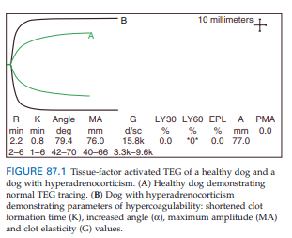
Diagnosis of hypercoagulability
- Hypercoagulable state often not identified until thrombotic event occurs or patient is in DIC
- Index of suspicion – history of predisposing condition
- Signs can be inapparent to sudden changes in respiration rate/effort (PTE), acute abdominal pain / effusion (portal vein, splenic vein thrombosis), loss of motor function, pain, cool extremity (ATE)
- Combination of tests (CBC/Chem/UA/CXR/AUS/CT/coag profile/etc)
- Platelet count, PT, PTT more accurate for detecting hypocoagulable state (drop in platelet count and prolongation of baseline PTT by >20% should raise concern for consumptive coagulopathy)
- Hypercoagulable state relies on identification of rise in procoagulant elements (MP, FV, FVII, fibrinogen), decrease in anticoagulants (AT, Protein C, Protein S, TFPI), decrease in fibrinolysis (decreased tPA, increase in PAI-1, TAFI)
- TEG, D-dimer, FDP may be useful
- Hypercoagulable samples clot more quickly, with a faster rate of clot formation, greater clot strength
- P-selectin expression, platelet-neutrophil aggregates may be markers of platelet activation

Antithrombotic therapy – coming soon
References
Fenty RK, deLaforcade AM, Shaw SP, et al. Identification of hypercoagulability in dogs with primary immune mediated hemolytic anemia by means of thromboelastography. J Am Vet Med Assoc 2011; 238: 463-467.
Pace SL, Creevy KE, Krimer PM, et al. Assessment of coagulation and potential of biochemical markers for hypercoagulability in canine hyperadrenocorticism. J Vet Intern Med 2013; 27: 1113-1120.
Ralph AG & Brainard BM (2015). Hypercoagulable states. In Silverstein DC & Hopper K (Eds) Small Animal Critical Care Medicine (pp ). St. Louis, MO: Elsevier Saunders.
Stokol T, Brooks M, Rush JE, et al. Hypercoagulability in cats with cardiomyopathy. J Vet Intern Med 2008; 22: 546-552.
Tablin F, Schaumacher T, Pombo M, et al. Platelet activation in cats with hypertrophic cardiomyopathy. J Vet Intern Med 2014; 28: 411-418.
White CR, Langston C, Hohenhaus AE, et al. Evaluation of the relationship between clinical variables and thromboelastographic findings in dogs with protein-losing nephropathy. J Vet Emerg Crit Care 2016; 26: 74-79.
Schalm’s Veterinary Hematology 5th Edition. Chap 71, 85
Schalm’s Veterinary Hematology 6th Edition. Chap 80, 87

