Congenital heart diseases:

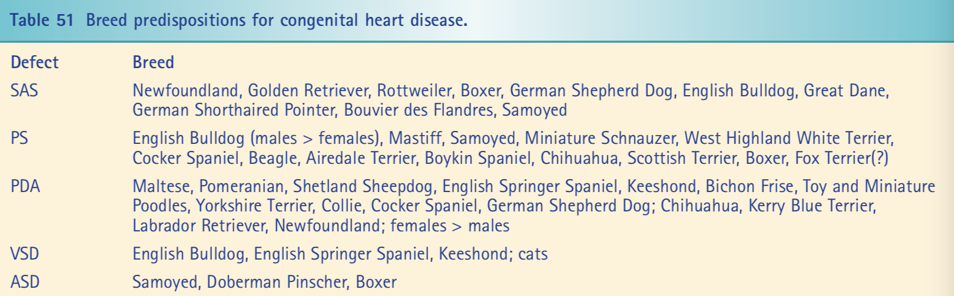

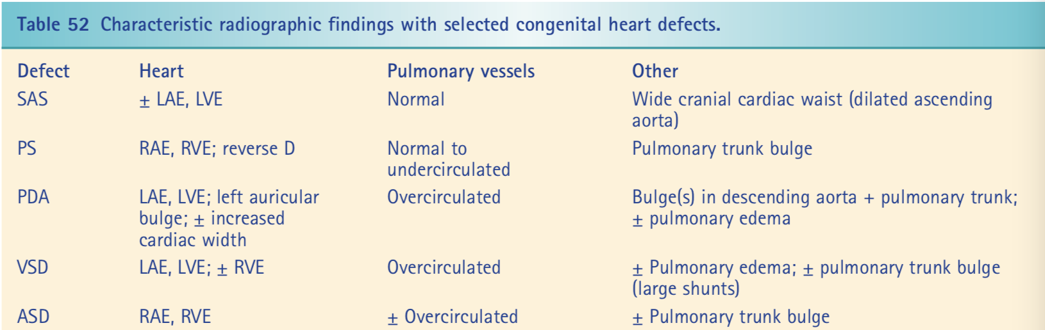

- PDA- Patent Ductus Arteriosus
  - Prevalence:
    - One of 3 most common congenital heart diseases in dogs
    - Rare but possible in cats
    - Most commonly hereditary in dogs
      - Toy/miniature poodles, german shepherds, collies, pomeranians, sheltie, maltese, yorkie, English springer spaniels, keeshonds
    - More commonly females over males
    - Extent of muscular hypoplasia divided into six types
      - Grade 1, 2 lack enough muscle to close aorta end but enough at pulmonary artery end to result in ductal closure
        - Aneurysmal dilation of aorta
        - Xrays DV bulge in descending aorta at level of main pulmonary artery
      - Grade 3,4,5 persistent patent ductus at small, medium, large sizes
      - Grade 6 no ductal constriction
  - Embryology:
    - Fetal life, ductus arteriosus allows blood flow to bypass the lung
    - Ductus arteriosus is muscular blood vessel extends from the bifurcation of pulmonary artery to ventral aspect of descending aorta, just beyond the origin of left subclavian artery
    - About the same size as aorta and pulmonary artery, so very little resistance to flow
    - Pulmonary vasculature markedly constricted in fetus, so high pulmonary vascular resistance
    - Blood flow goes from right heart to pulmonary artery through ductus arteriosus into aorta out to systemic circulation
      - Right to left shunt
    - At birth, lung expansion causes oxygen tension in systemic vasculature to increase (PaO2) and decreases pulmonary vascular resistance to be only 20% systemic vascular resistance
    - Increase in systemic oxygen tension stimulates musculature of ductus arteriosus to constrict (physiologic closure)
      - Within minutes to few hours after birth
    - Ductal smooth muscle undergoes degeneration and by 1 month, cytolysis complete leaving only elastic ligamentum arteriosum (anatomic closure)
    - In fetal development, prostaglandin concentration is high and maintains ductal patency
      - Closure of ductus arteriosus is prostaglandin mediated
      - Premature infants given aspirin (prostaglandin synthetase inhibitor) can enhance closure of ductus between 34-36 weeks of gestational age
  - Pathophysiology
    - Left to right shunt
      - Severity dependent on location of communication, size, resistance
      - Grade 3,4,5 ductal abnormalities result in shunting of blood rom systemic circulation into pulmonary circulation
      - Flow occurs during both systole and diastole
        - Systolic flow from left ventricle contraction pumping blood into aorta causing systolic pressure
        - Diastolic flow from pressure developed in aorta forcing higher-pressure systemic circuit to lower-pressure pulmonary circuit
      - Whatever blood flows through shunt into right heart will cause equal increase in left heart blood flow leading to increased left ventricular end-diastolic pressure (volume overload)
      - Left ventricle compensates by increasing in size (eccentric hypertrophy)
      - Increase afterload or decreased myocardial contractility increases end-systolic diameter
      - Increased volume causes dilation of LV and mitral annulus, leading to MR, worsening volume overload
      - If pulmonary artery pressure exceeds aortic pressure, then reversed PDA right to left shunt occurs
  - Murmur characteristics: continuous heart murmur best heard left cranial thorax of left axillary region
  - Radiographic changes:
    - Left atrial enlargement on lateral and VD
    - Left ventricular enlargement
    - Main pulmonary artery enlargement at 2’oclock bulge
    - Right heart enlargement not usually present
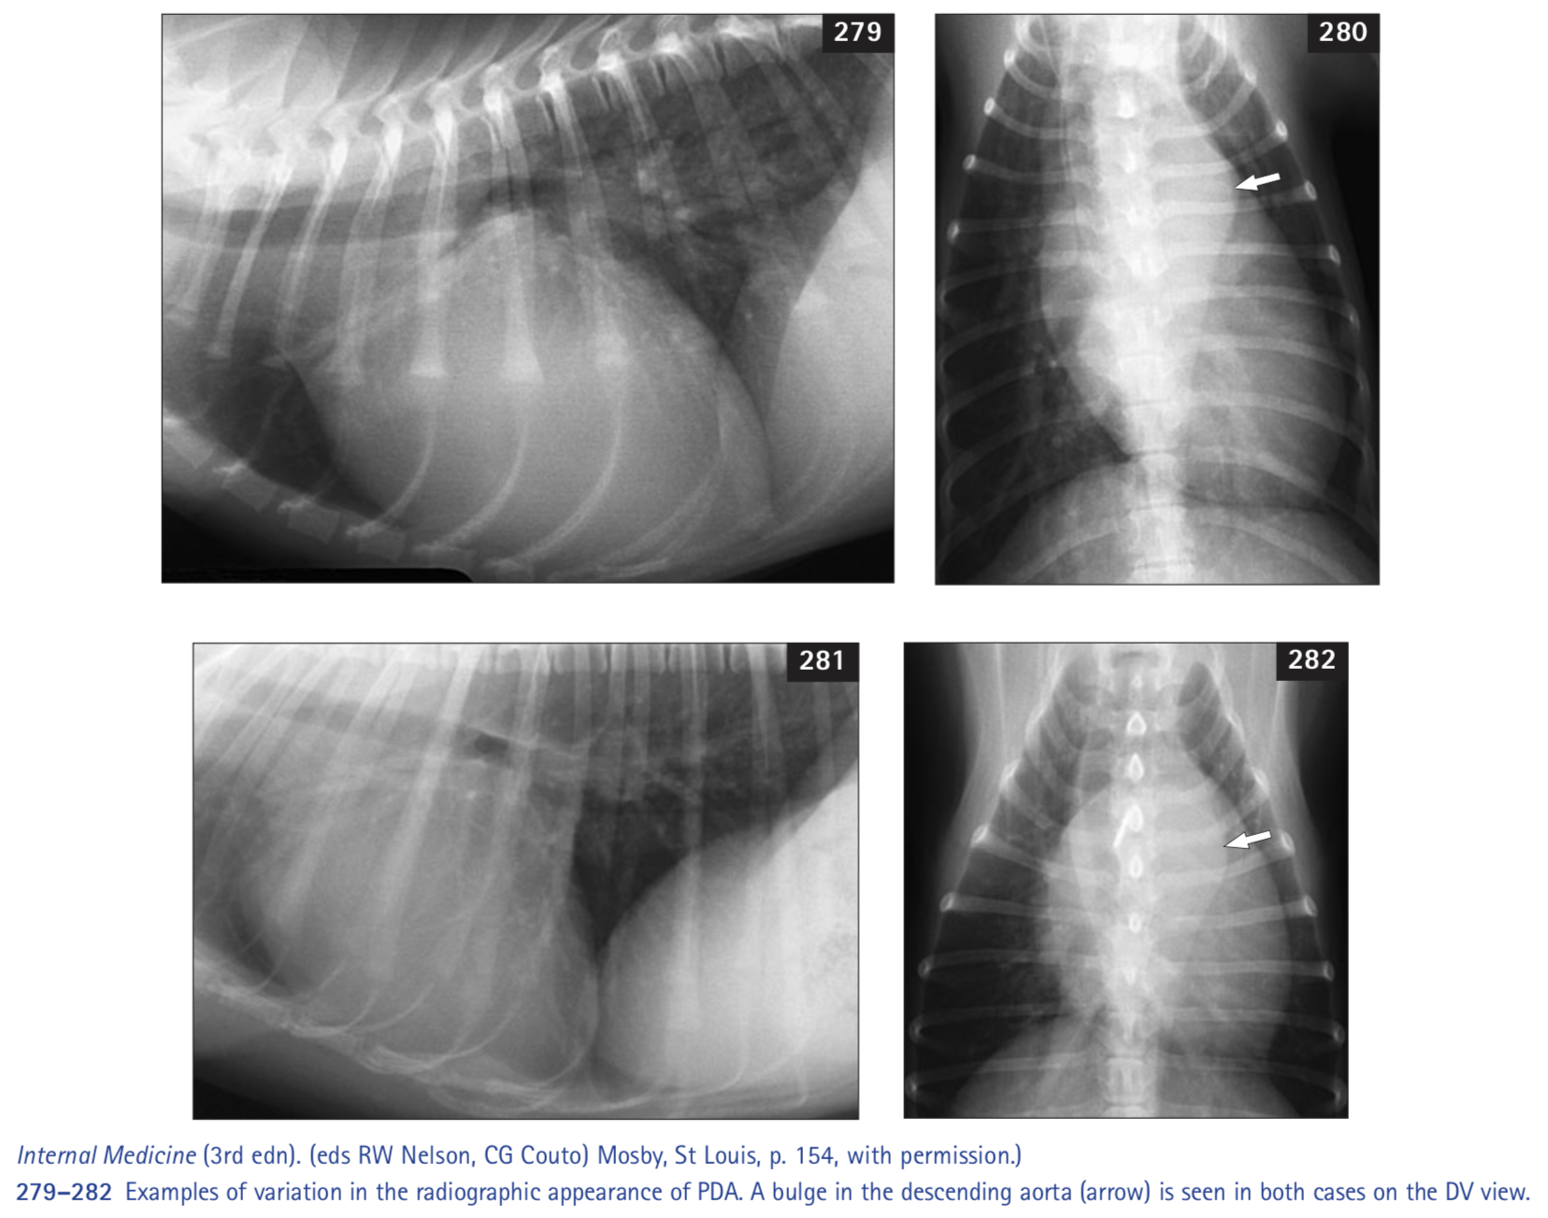
  - Echocardiography changes:
    - Left ventricular end-diastolic diameter is increased and the left ventricular wall thicknesses are normal.
    - Size of the left ventricle (end-diastolic diameter) generally should correspond to the size of the PDA.
    - Left ventricular end-systolic diameter is normal to increased, and shortening fraction is usually in the normal range.
    - End-systolic diameter tends to be normal in young dogs and increased in older dogs.
    - The left atrium is usually enlarged to a similar degree as the left ventricle.
    - The right ventricle and atrium are normal.
    - Continuous turbulent flow on Doppler in main pulmonary artery
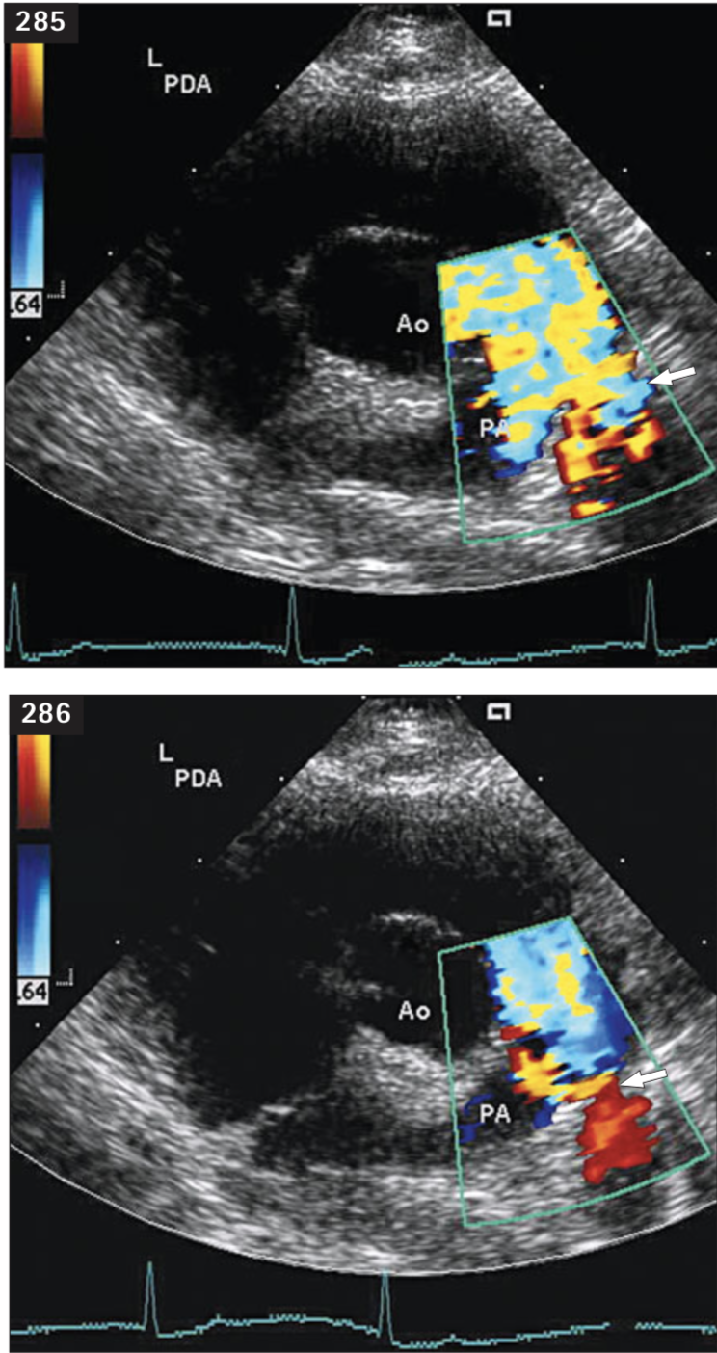
  - Interventional Treatment
    - Surgical ligation
      - Thoracotomy through left fourth intercostal space and suture ligation
      - Postoperative complications are not common
      - Residual MR or shunting (may continue to have heart murmur)
      - Not performed in right-left shunt due to severe vascular disease resulting inhigh and fixed pulmonary vascular resistance
        - Ligation leads to continued right heart output increased against fixed resistance, resulting in higher pulmonary artery pressure
        - Patients often die within first 36 hours post ligation
    - Ductal occlusion
      - Percutaneous cardiac catheterization
        - Femoral artery into descending aorta through PDA into pulmonary artery
        - Coil s, discs, sacks
        - Complications include migration of device leading to pulmonary embolism, ductal reopening, hemolysis
  - Medical management
    - Left to right shunt aimed at treating CHF
    - Right to left shunt aimed at reducing hematocrit
- Subaortic Stenosis
  - Prevalence
    - Larger breed dogs: Golden retrievers, newfoundlands, boxers, rotties, shepherds, English bulldog
    - Can occur in cats
  - Embryology
    - Embryologic basis is unclear
    - Valvular aortic stenosis is likely related to faulty development of the embryonic endocardial cushions in the truncoconal septum (truncus swellings), from which the semilunar valve leaflets originate.
    - The common form of SAS seen in dogs is probably due to a primary developmental fault in the region of transition from the conus to the truncus, a site that favors inflammation in later stages of development in humans.
  - Pathophysiology
    - Subvalvular narrowing caused by fibrous or fibromuscular ring below aortic valve
    - Clinical signs can vary to subtle subclinical fibrous tissue ridges to complete fibrous ring around LV outflow tract causing severe obstruction. Some have elongated, tunnel-like obstruction
    - Stenosis severity determines degree of LV pressure overload and resulting concentric hypertrophy
    - Coronary perfusion often compromised with narrowed coronary arteries with severe SAS
    - As hypertrophy progresses, myocardial ischemia and fibrosis worsens
    - Aortic or mitral regurgitation may worsen LV volume overload
    - SAS predisposes aortic valve endocarditis from jet lesion injury to underside of valve leaflets
    - SAS leads to arrhythmias, syncope, left-sided heart failure, and sudden death
      - 70% of severe SAS have sudden death within first 3 years of age
  - Murmur characteristics
    - Murmur may not be present until 1-2 years as obstructive lesion develops
    - Exercise or excitement may increase murmur intensity
    - Harsh systolic ejection murmur at or below aortic valve area left heart base
    - Murmur may radiate equally or more loudly to right heart base because of course of aortic arch
  - Radiographic changes
    - LV can look normal or enlarged.
    - Post aortic dilation: Prominent cranial waist in cardiac silhouette on lateral projection or cranial mediastinal widening
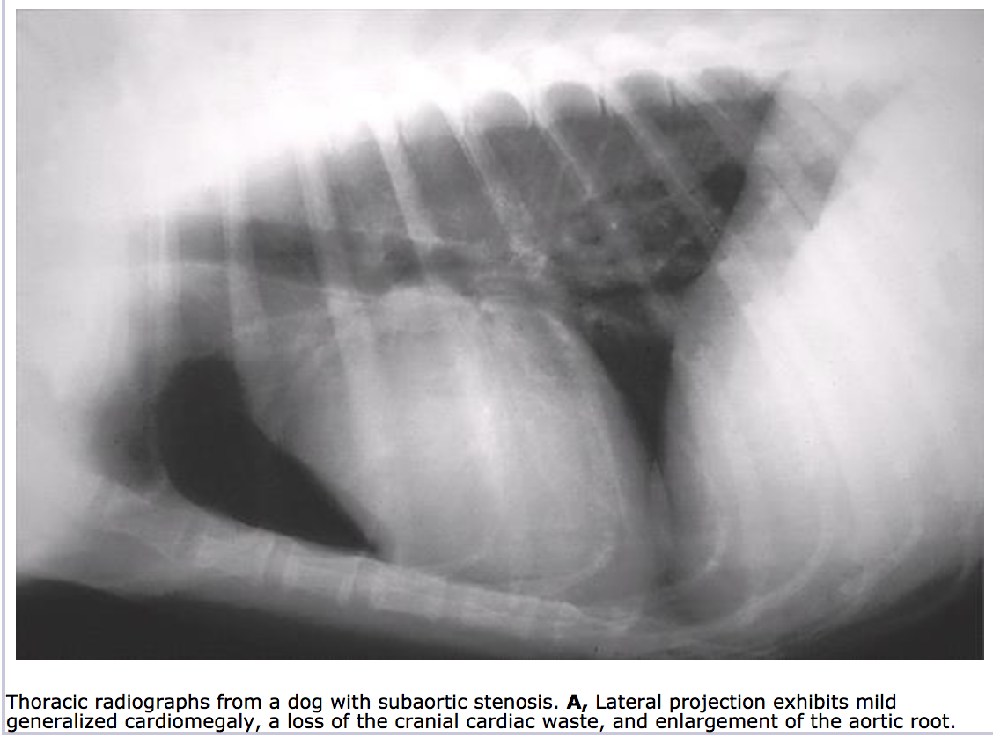
  - Echocardiographic changes
    - Extent of LV hypertrophy and subaortic narrowing seen on echo
    - Discrete subaortic tissue ridge can be seen in moderate to severe disease
    - Premature closure of aortic valve, systolic anterior motion (SAM) of anterior mitral leaflet, increased LV subendocardial echogenicity (fibrosis)
    - Dilation of ascenting aorta, aortic valve thickening, LA enlargement with hypertrophy
    - With dopper, systolic flow acceleration below aortic valve and turbulence extending into aorta, high peak systolic outflow velocity
      - Peak estimate gradients >100mmHg are associated with severe stenosis
      - Increased sympathetic stimulation or other causes of high cardiac output (excitement, fever) may increase outflow velocities
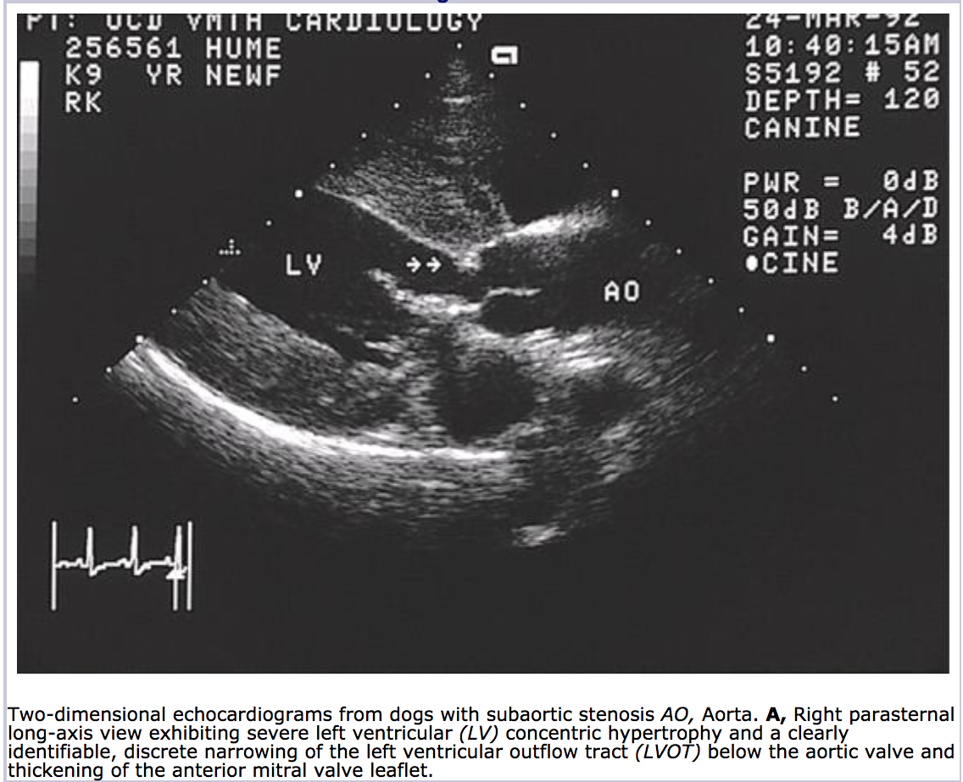
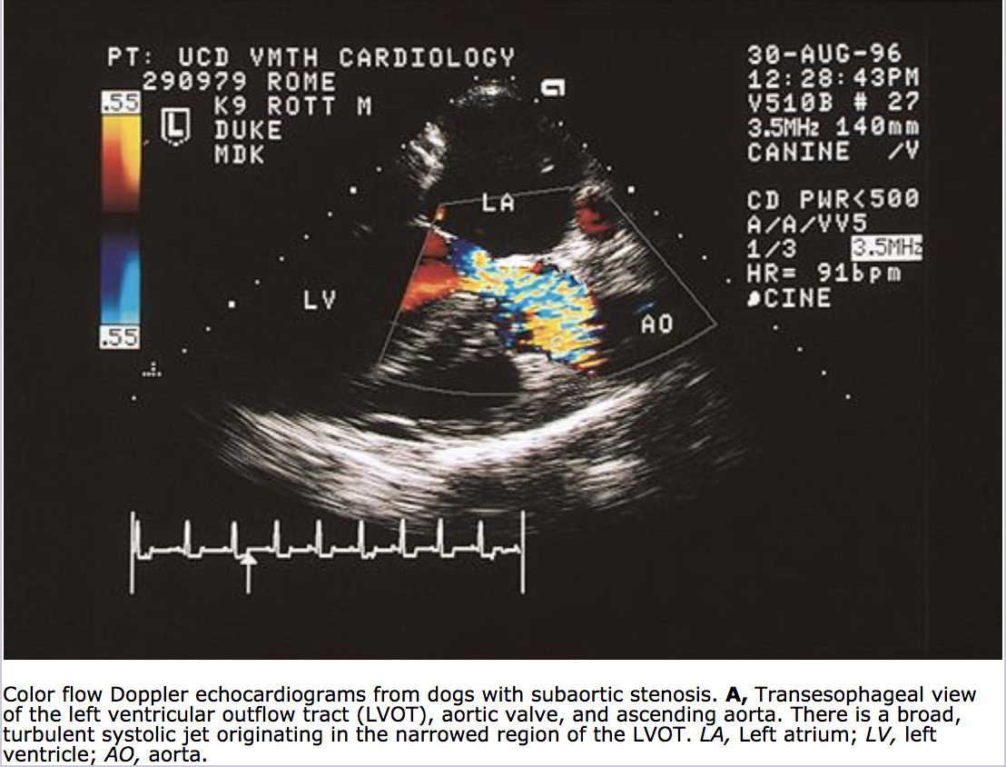
  - Surgical treatment
    - Cardiopulmonary bypass and open-heart surgery with surgical resection of stenotic region
      - One study did not show improved long term survival
    - Transcatheter ballon dilation
      - Reduced measured gradient
      - Improved clinical signs, but no improvement in survival times
      - May have partial restenosis over time
  - Medical management
    - Beta-adrenoergic blockers: reduce myocardial oxygen demand and minimize frequency/severity of arrhythmias
      - Atenolol or propranolol
    - Prophylactic antibiotics recommended in humans with SAS during potential bacteremic episodes (dentals, general surgery, severe skin disease)

- Pulmonic Stenosis
  - Prevalence
    - Small breed dogs: bulldogs, Chihuahua, beagles, terriers, miniature schnauzer
    - Clinical signs of exercise intolerance, syncope, or right sided CHF
  - Embryology
    - During embryonic development, the pulmonic valve originates from three swellings (two truncus swellings and one intercalated swelling) within the developing truncus arteriosus, by a process of excavation in a proximal direction.
    - It has been postulated that a maldevelopment of the distal bulbous cordis, from which these swellings originate, may lead to pulmonary valve stenosis.
  - Pathophysiology
    - Pulmonic stenosis is narrowing anywhere from right ventricular outflow tract to main pulmonary artery
    - Lesion may be valvular, subvalvular, or supravalvular but most common combo of valvular and subvalvular
    - Valve dysplasia with markedly thickened valve leaflets and annular hypoplasia without fusion of the commissures is more common than simple fusion of pulmonic valve cusps
    - Variably thickened asymmetrical, partially fused leaflets, and hypoplastic valve annulus
    - Pulmonic stenosis causes increased resistance to right ventricular systolic outflow
    - Increased systolic pressure of right side leads to RV hypertrophy, RA dilation, RV dilation
    - Poststenotic dilation of main pulmonary trunk
    - Development of tricuspid insufficiency and increased RV filling pressure predisposes to atrial arrhythmias and right congestive heart failure
    - Single anomalous left coronary artery has been described in association with PS in some English bulldogs, boxer, French bulldog.
      - Left main coronary artery encircles and compresses right ventricular outflow tract just below pulmonary valve before dividing into left descending and left circumflex coronary artery
      - Palliative surgical procedures and balloon valvuloplasy have caused death secondary to transection or avulsion of major left coronary branch in such cases
  - Murmur characteristics
    - Systolic ejection murmur high at left base with crescendo or crescendo-decrescendo quality
    - Sometimes early systolic click
    - May hear murmur right side from tricuspid insufficiency
  - Radiographic changes
    - Marked RV hypertrophy causes cardiac apex to shift dorsally and to the left
    - DV/VD “reverse D”
    - Pulmonary trunk bulge at 1’oclock on DV/VD
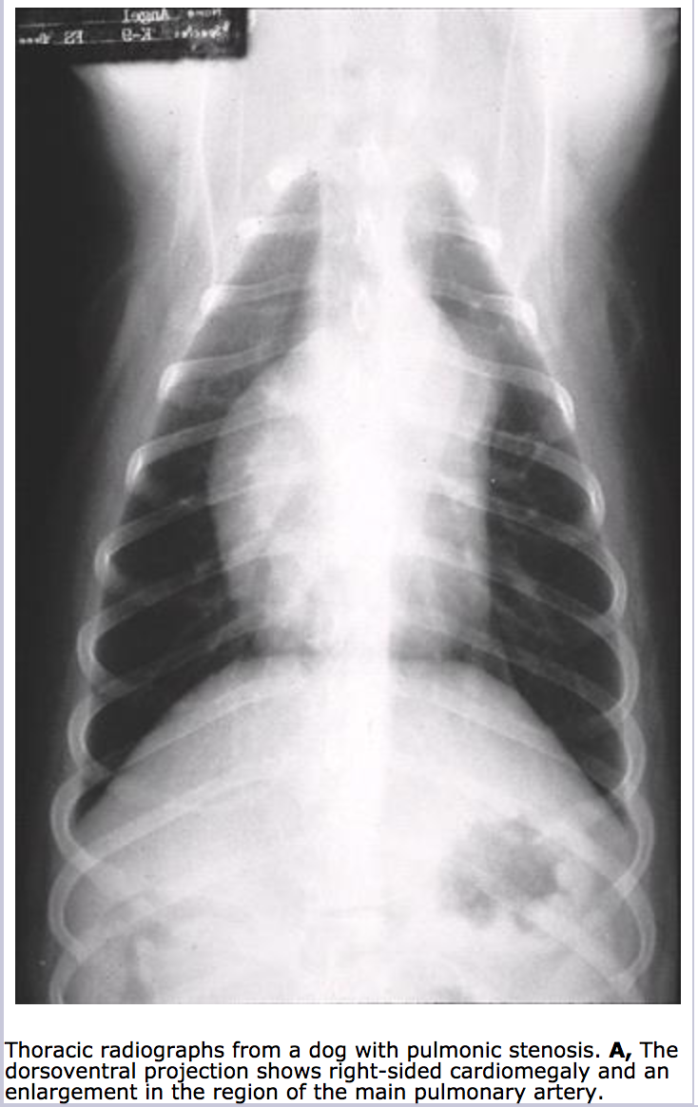
  - Echocardiographic changes
    - Stenosis causes increased RV systolic pressure, leading to RV enlargement and hypertrophy as well as RA dilation
    - Interventricular septum may appear flattened as high RV pressure pushes toward the left
    - Pulmonic valve usually appears thickened, asymmetrical, malformed
    - May see poststenotic dilation of main pulmonary trunk
    - With Doppler, may estimate systolic pressure gradient across stenotic valve
      - Doppler estimated gradients usually 40-50% higher than those recorded during cardiac catheterization
      - PS mild if gradient <50mmHg, severe if >80-100mmHg
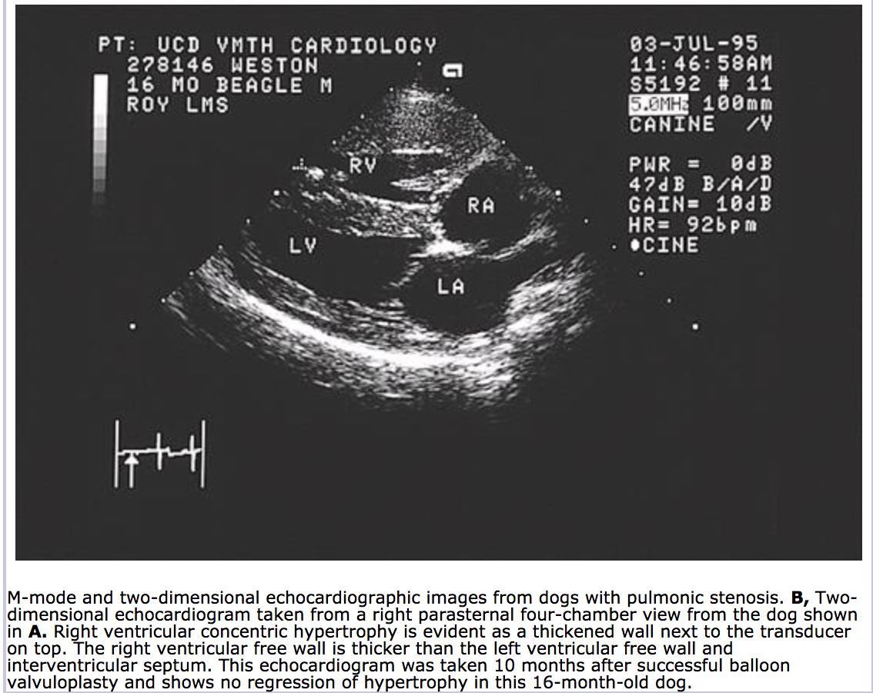
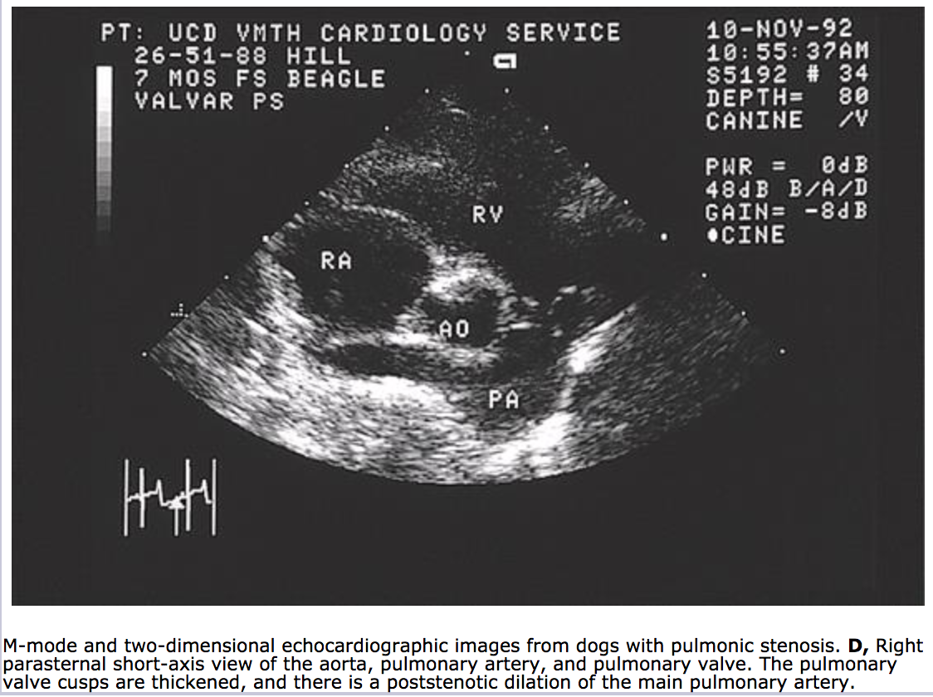
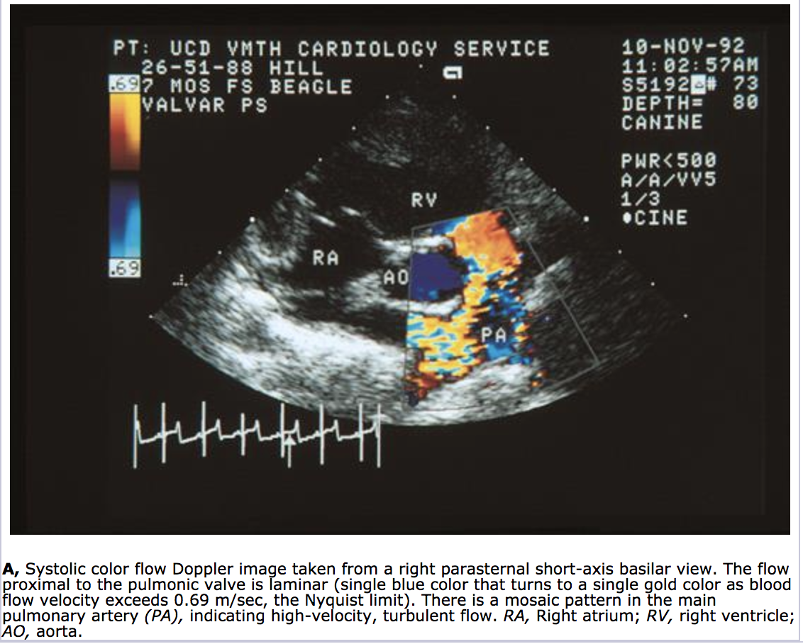
  - Surgical treatment
    - Balloon valvuloplasty with cardiac catherization recommended treatment if RV hypertrophy is not excessive
      - Contraindicated with dogs with single anomalous coronary artery
      - Prolongs survival and clinical signs even with severe PS
      - Successful reduction of obstructive pressure gradient by 50% or more seen in 75-80% treated with balloon valvuloplasty
      - Complications include perforation of heart with catheter/guide wire leading to cardiac tamponade, bleeding, or death or damage to tricuspid valve leading to right sided heart failure
    - Various surgical procedures for moderate to severe PS can be done, but typically balloon valvuloplasty performed first because less risky
  - Medical management
    - Beta-blocker
    - Exercise restriction
    - Treatment of CHF
  - Prognosis
    - Mild PS normal life span
    - Severe PS die within 3 years diagnosis
    - Tricuspid regurg, AF or other tachyarrhythmias, CHF worsen prognosis

- Atrial Septal Defect
  - Prevalence
    - Cats more often than dogs
  - Embryology
    - Two septa, the septum primum and the septum secundum, grow during fetal development to partition the two atria.
    - Osium primum is a defect low in interatrial septum
      - Likely part of AV septal defect (endocardial cushion defect or common AV canal
    - Osium secundum located in fossa ovalis region
    - Sometimes patent foramum ovali
  - Pathophysiology
    - Small ASDs no significant clinical abnormalities and are hemodynamically stable
    - Most commonly blood shunts from left atrium to right atrium
    - Large defect leads to volume overload of right heart and right ventricular enlargement (eccentric hypertrophy)
    - More significant if combined with pulmonic stenosis or pulmonary hypertension
  - Murmur characteristics
    - Soft left basilar systolic murmur from increased flow of blood across pulmonic valve
    - fixed splitting of second heart sound
  - Radiographic changes
    - Right heart enlargement
    - Left heart usually normal
    - Possible pulmonary trunk dilation
  - Echocardiographic changes
    - RA and RV dilation
    - Large ASDs can be visualized
    - Doppler echocardiography can identify smaller shunts with abnormal flow from left atrium into right atrium
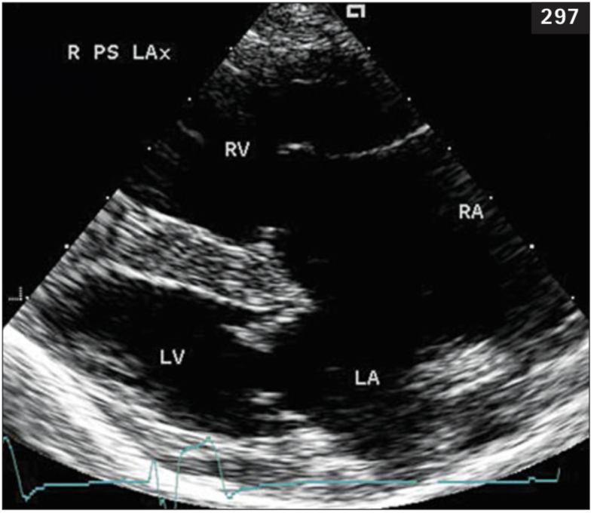
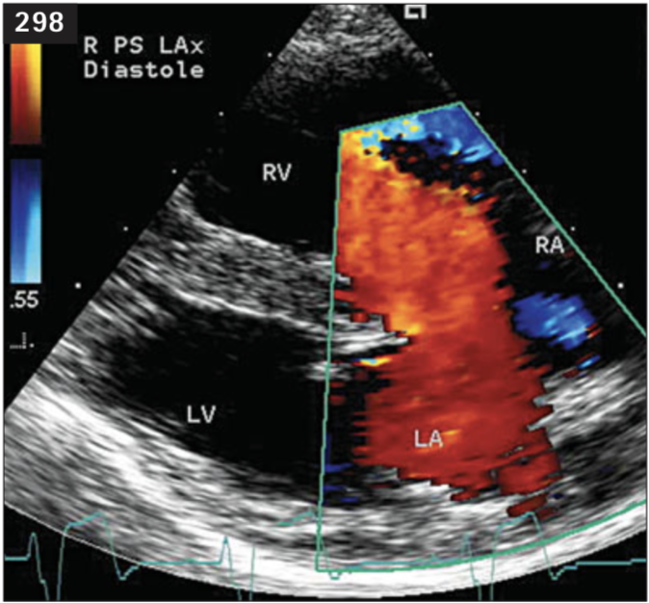
  - Surgical treatment
    - Large shunts treated surgically
    - Can consider catheter occlusive device
  - Medical management
    - Treatment for CHF if develops

- Ventricular Septal Defect
  - Prevalence
    - English bulldog, English springer spaniel, keeshond
    - Seen also in cats
  - Embryology
    - The ventricular septum is made up of the inlet septum; the outlet, or infundibular, septum; the trabecular septum; and the membranous septum
    - The inlet septum is the smooth portion of the septum that starts at the tricuspid valve orifice and extends to the papillary muscles. The trabecular septum is the portion of the septum that is primarily apical and is heavily trabeculated. The outlet septum is the smooth region of the septum that is cranial to the crista supraventricularis and extends to the pulmonic valve. The membranous septum is small and lies immediately below the aortic valve on the left side and between the tricuspid valve and the pulmonic valve on the right side.
  - Pathophysiology
    - Most often perimembranous VSD
      - Located high in membranous part of septum, just below aortic valve and under septal tricuspid leaflet
    - Blood flows from left ventricle to right ventricle in systole and diastole
    - Small defects clinically unimportant
      - Aortic input impedance and high resistance to systolic flow means flow through pulmonary circulation is not greatly increased so pressures normal in right ventricle and pulmonary artery systolic pressure
    - Large defects lead to right ventricular enlargement, and volume overload of left heart with enlarged LA and LV
    - Occasionally, aortic regurgitation from deformed septum which provides inadequate anatomic support for aortic root
    - Eisenmenger’s complex
      - VSD with pulmonary vascular disease leading to right to left shunting and cyanosis
      - Rare in cats and dogs
      - Can occur if VSD in large (same cross-sectional area of aorta or more)
      - Leads to no resistance to blood flow so blood flow distribution is based on relative impedances (resistance) of systemic and pulmonary vascular beds
        - Equal systolic pressures of ventricle and great arteries
      - Pulmonary vascular disease develops as compensation for pulmonary hypertension
        - Pulmonary vasculature thickens in response to markedly increased pressure in attempt to bring wall stress back to normal and prevent rupture
        - When pulmonary vascular resistance increases to greater than systemic vascular resistance, right to left shunting occurs
      - Surgical closure is contraindicated
      - Phlebotomy can relieve severe polycythemia
      - Long term prognosis poor
  - Murmur characteristics
    - Holosystolic heart murmur, loudest right cranial sternal border from shunt flow
    - If aortic regurgitation is present, diastolic decrescendo murmur at left base
  - Radiographic changes
    - Left heart enlargement and pulmonary overcirculation
    - Dilated main pulmonary trunk
    - Sometimes RV enlargement
  - Echocardiographic changes
    - Left heart dilation +/- RV dilation
    - Larger defects can be visualized on right parasternal long-axis plane just below aortic valve
    - Doppler shows shunt flow +/- aortic regurgitation
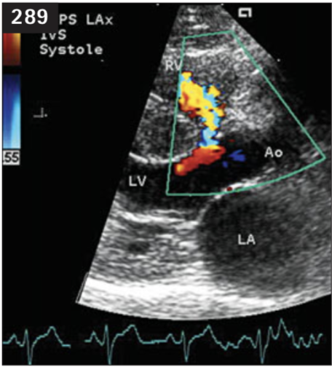
  - Surgical treatment
    - Large defects require cardiopulmonary bypass and intracardiac surgery
      - Suture a patch or directly suture close defect
      - Complication of damaging AV conduction system leading to AV block
    - Small defects can be treated with transcatheter coil or other occlusion devices
    - Palliated with constrictive band around pulmonary trunk to create mild suprvalvular pulmonic stenosis
      - Increases RV systolic pressure which will reduce systolic LV to RV pressure gradient reducing shunt volume
      - Complication is excessive tight band can cause shunt reversal
    - Surgical treatment contraindicated in pulmonary hypertension or shunt reversal
  - Medical management
    - Those with small to moderate shunts have normal life span with no treatment needed
      - Small VSDs can spontaneously close from myocardial hypertrophy around VSD or by seal formed from septal tricuspid leaflet or prolapsed aortic leaflet
    - Treatment for pulmonary hypertension or CHF if develops
    - Hydralazine administration
      - Decreases vascular resistance in systemic circulation at greater degree than pulmonary circulation.
        - This causes increased systemic flow through aorta and shunt/pulmonary blood flow decreases
        - Decreases venous return to left heart and decrases left ventricular diastolic pressure
        - Net result improved hemodynamics and lessened heart failure

- Tetraology of Fallot
  - Prevalence
    - Uncommon congenital cardiac defect in dogs and cats
    - Most common cause of cyanotic congenital heart defect in dog
    - Prognosis poor with most dogs dying within first year of life from hypoxemia or complications of polycythemia
    - Can commonly have other congenital defects or congenital cardiac abnormalities
    - Most dogs present between 2-8 monts of age
    - Typically purebred dogs: keeshonds, wirehaired fox terrier, English bulldog,
  - Embryology
    - Conotruncal septum forms too far cranially, leading to malalignment with lower portion of inteventricular septum
    - Also leads to narrowed right ventricular outflow tract and abnormal pulmonic valve formation
    - Studied in keeshonds
  - Pathophysiology
    - Characterized by large ventricular septal defect, pulmonic stenosis, overriding aorta, and right ventricular hypertrophy
      - Right ventricular concentric hypertrophy is secondary to right ventricular pressure overload from pulmonic stenosis
      - Overriding aorta is not hemodynamically important
    - Degree of clinical signs depends on severity of pulmonic stenosis and ventricular septal defect
    - Blood shunts from right to left side ventricle through nonresistive ventricular septal defect
      - Pulmonic stenosis increases resistance to blood flow out of right ventricle to the point that pulmonary vascular resistance is greater than systemic vascular resistance
    - Delivery of deoxygenated blood to systemic circulation results in systemic hypoxemia and polycythemia
      - Can result in cyanosis either at rest or with exercise
      - Polycythemia occurs when receptors in kidney (lesser extent liver) are stimulated by hypoxemia to release erythropoietin which stimulates red cell production to increase oxygen carrying capacity of the blood
      - Increased hematocrit increases blood viscosity which increases resistance to flow, decreasing cardiac output and decreasing tissue oxygen delivery
    - Because there is decreased pulmonary blood flow, there is decreased venous return to left ventricle, leading to decrease in left ventricular size and stroke volume
  - Murmur characteristics
    - Murmur commonly from pulmonic stenosis at left heart base
    - Murmur may occur from small to medium sized VSD
  - Radiographic changes
    - Right ventricular enlargement with reverse D on VD/DV
    - Decreased pulmonary vascular markings
      - May not be present in dogs with less severe disease
    - Main pulmonary artery may be normal, indented, or enlarged due to poststenotic dilation
  - Echocardiographic changes
    - Right parasternal long axis view can visualize VSD and overriding aorta
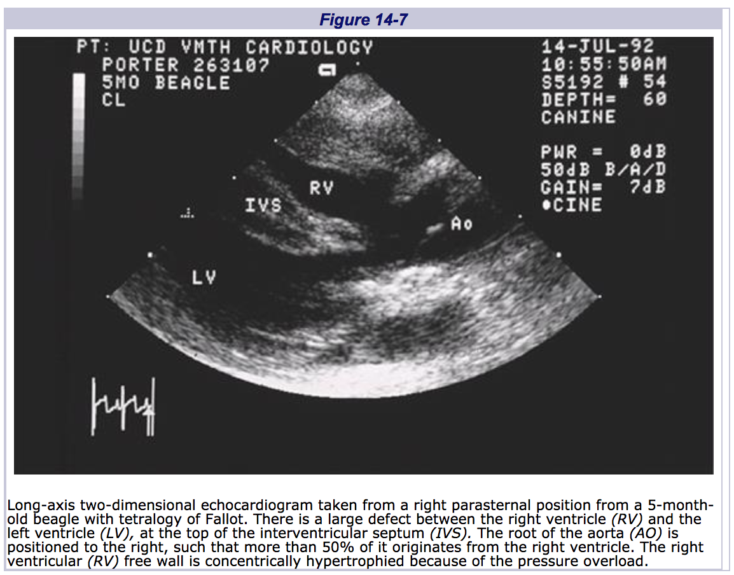
    - Color flow Doppler showed blood flow from right ventricle into aorta
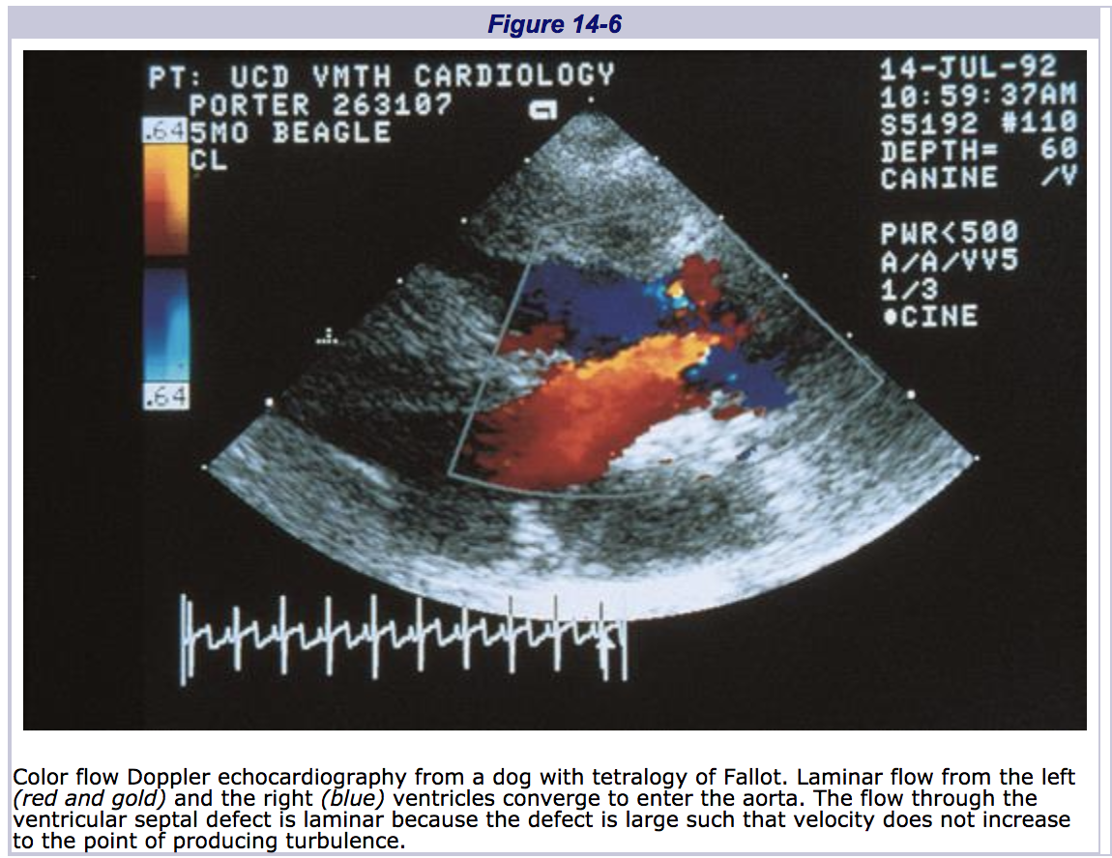
    - Can see right ventricular free wall thickening, to same degree or greater than left ventricular free wall
    - From right parasternal short-axis view of base of heart, right ventricular outflow tract, pulmonic valve/pulmonic stenosis, main pulmonary artery and branches
  - Surgical treatment
    - Corrective surgery
      - Corrective surgery to relieve pulmonic stenosis and patch VSD
      - Requires cardiopulmonary bypass and open-heart surgery
      - Impractical in most situations in veterinary medicine
    - Palliative surgery
      - Different techniques, but goal is to produce systemic to pulmonary anastomoses
      - Most common is Blalock-Taussig shunt which is anastomosis of left subclavian artery to pulmonary artery
        - Artificial PDA which takes some of the blood that shunted right to left from VSD back into pulmonary artery
        - Increases pulmonary blood flow and venous return to left heart
      - Complications include thrombus formation in shunt, stricture of shunt
      - Successful palliative surgery increases systemic oxygen tension but not back to normal. PaO2 can increase to 45-60mmHg leading to clinical improvement
    - Balloon valvuloplasty
      - Aimed at pulmonic valve dilation to increase pulmonary blood flow and decrease right to left shunting
      - Variable success rate
  - Medical management
    - Phlebotomy
      - Blood to be removed (mL) = [BW (kg) x 0.08] x 1000mL/kg x [actual hematocrit-desired hematocrit]/actual hematocrit
      - 8% of body weight is blood volume
      - Goal hematocrit between 60-65%
    - Hydroxyurea
      - Myelosuppressive agent that produce reversible bone marrow suppression
      - Used for cases that require frequent phlebotomies
      - Medication may need to be stopped if leukopenia, thrombocytopenia, or anemia are seen until blood count normalizes
    - Beta blocker
      - Propranolol is b-blocker of choice to help relieve hypoxemic episodes
        - Adrenergic drive to hypertrophied myocardium in right ventricular outflow tract can cause dynamic infundibular narrowing

