1. What is Poiseuille’s equation and how is it relevant to blood flow?

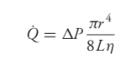

Q = flow rate (volume/ time)
△P = pressure difference (mmHg)
r = internal radius of the tube
L= tube length
n = fluid viscosity (affected by hematocrit)

Q = ΔP/ R
R = 8Ln / 𝛱r⁴
There are two ways blood flow through an organ can be changed:
1. Changing the pressure difference across a vascular bed
2. Changing vascular resistance

Small changes in internal radius will have a large influence on resistance to flow. Thus individual organ blood flows are regulated primary through changes in the radius of the vessels within organs, thus resulting in significant changes in vascular resistance. Vessel length and blood viscosity also influence vascular resistance, but are not as easily manipulated for the purpose of moment-to-moment control of blood flow.
Individual resistance to flow exists within each organ, i.e. organs with relatively low resistance receive relatively high flow.
Blood flow through all organs is passive and occurs only because arterial pressure is kept higher than venous pressure by the pumping action of the heart

2. Draw and explain the action potential for cardiac myocytes and cardiac pacemaker cells.
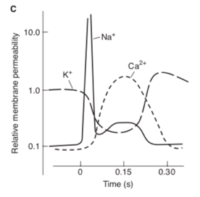
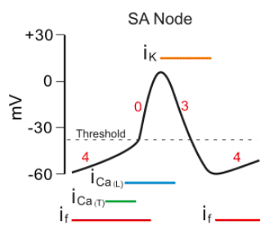
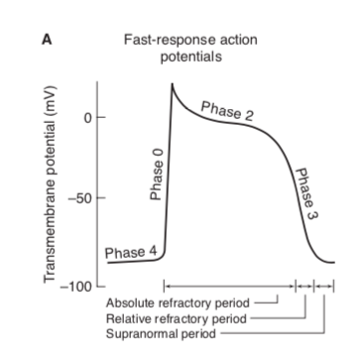

CARDIAC MYOCYTE:
phase 0 = rapid depolarization with substantial overshoot (positive inside voltage)
- opening of voltage-gated fast Na+ channels
phase 1 = rapid reversal of the overshoot potential*
- initial brief depolarization
- less Na+ conductance due to closure of Na+ channels
- transient outward K+ current (iTO)
phase 2 = long plateau
- slowly developed and prolonged opening of voltage-gated Ca+ channels, allowing inward Ca+ movement
- action of Na+/Ca+ exchanger in which 3 Na+ ions move into the cell in exchange for a single Ca+ ion moving out
phase 3 = repolarization (late, rapid)
- delayed increase in K+ permeability, resulting in high outward K+ current
- closure of the Ca++ and Na+ channels
phase 4 = stable, high (large negative) RMP
- resting membrane potential
- period during which inward and outward current are equal

PACEMAKER CELL:
phase 4 = slow depolarization
- depolarization to an unstable, slowly depolarizing “resting” potential referred to phase 4 depolarization, diastolic depolarization or pacemaker potential
- occurs due to:
  - conductance carried by “funny” channels (If)
  - funny current is turned on by repolarization of the membrane potential during the proceeding action potential
  - slight increase in permeability to Na+ and Ca+
- progressive decrease in membrane’s permeability to K+ during the resting phase
phase 0 = depolarization
- slower initial depolarization phase with lower amplitude overshoot
- primarily a result of inward movement of Ca+ ions
phase 3 = repolarization
- shorter and less stable plateau phase
- increase in K+ conductance, resulting in outward K+ current
phases 1 and 2 are not present

3. How is excitation contraction coupling different in cardiac muscle versus skeletal muscle?

1. Cardiac muscle cell contraction may be modulated (i.e. contractility!) - different intensities of actin-myosin interaction can result from a single action potential (largely dependent on variations in the amount of Ca++ reaching the myofilaments)

2. duration of cardiac muscle contraction is approximately the same as the action potential; therefore the refractory period is not over until the mechanical response is completed. This ensures that heart muscle cells cannot form fused contractions and enter state of tenany (and allows for diastole)

Cardiac muscle is connected by end-to-end structures called *intercalated disks*.
These disks contain:
Desmosomes: firm mechanical attachments between cell membranes
Gap junctions: Low-resistance electrical connections between adjacent cells formed by proteins called connexin. Allow for the heart to act as a *functional syncytium*

4. Describe how the autonomic nervous system controls chronotropy, inotropy, lusitropy and dromotropy. Include what neurotransmitters are used and what ion permeabilities are affected.

SYMPATHETIC NERVOUS SYSTEM
All portions of the heart are richly innervated by *adrenergic sympathetic fibres*. When active, these nerves release *norepinephrine* and interact with *β1-adrenergic receptor* on cardiac muscle cells to increase the heart rate, increase the action potential conduction velocity and increase the force on contraction and rates of contraction and relaxation.

Positive chronotropic effect: increases inward currents carried by Na+ (if) and Ca+ during diastolic interval (increases rate of diastolic depolarization)

Positive inotropic effect:
- Norepinephrine results in an increase in peak ISOMETRIC tension at a FIXED length.
(Mediated through β1 effects)
- Increased calcium current during the plateau phase of the action potential, resulting in more cross-bridges to be formed and a greater tension to be developed

Positive dromotropic effect: increases conduction velocity (mostly through AV node); shortened PR interval
- achieved primarily through alteration in the conductivity of gap junctions

Small positive lusitropic effect:
- Enhances the rate of relaxation
- Norepi increases the activity of sarcoplasmic reticular Ca++ATPase pump, increase the rate of calcium re-uptake and thus enhancing the rate of relaxation.
- Also shortens the duration of the action potential (by increasing K+ permeability) at higher heart rates, thus preventing compromise of diastolic filling time

PARASYMPATHETIC NERVOUS SYSTEM
Cholinergic parasympathetic fibres travel to the heart via the *vagus nerve* and innervate the SA node, AV node and atrial muscle. When active, parasympathetic nerves release *acetylcholine*, which interacts with *muscarinic receptors* to decrease the heart rate (SA node), decrease the action potential conduction velocity (AV node) and decrease the force of contraction of atrial muscle (not ventricular muscle).

Negative chronotropic effect: increases permeability of the resting membrane to K+ (hyperpolarizes) and decreases the diastolic permeability to Na+ (slows rate of spontaneous depolarization)
- tonic activity of the vagus nerve results in an average resting heart rate of approximately 70 beats/min

Negative inotropic effect

Negative dromotropic effect: decreases conduction velocity through the AV node; lengthened PR interval

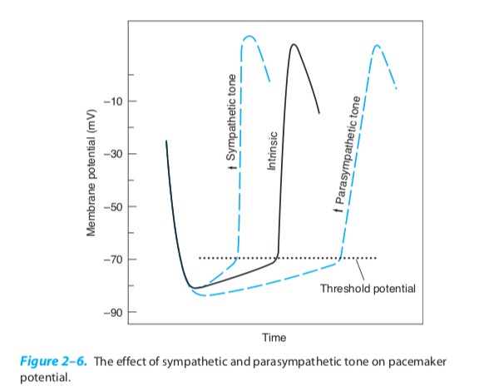

5. How does an increase in extracellular potassium concentration affect (a) the potassium equilibrium potential; (2) the cell’s resting membrane potential; (c) the cell’s excitability?
The potassium equilibrium potential will become less negative because a lower electrical potential is require to balance the decreased tendency for net K+ diffusion out of the cell
B/c the RMP is most permeable to K+, the RMP will always be closest to K+. Thus, the RMP will also become less negative (depolarize).
The RMP will be closer to the threshold, initially making the cell more excitable
The fast sodium channels will become inactivated, making the cell less excitable

6. Draw and describe the pressure volume loop of the left ventricle, and explain how this loop would change with (a) increased/ decreased preload; (b) increased/ decreased afterload; (c) increased/ decreased contractility

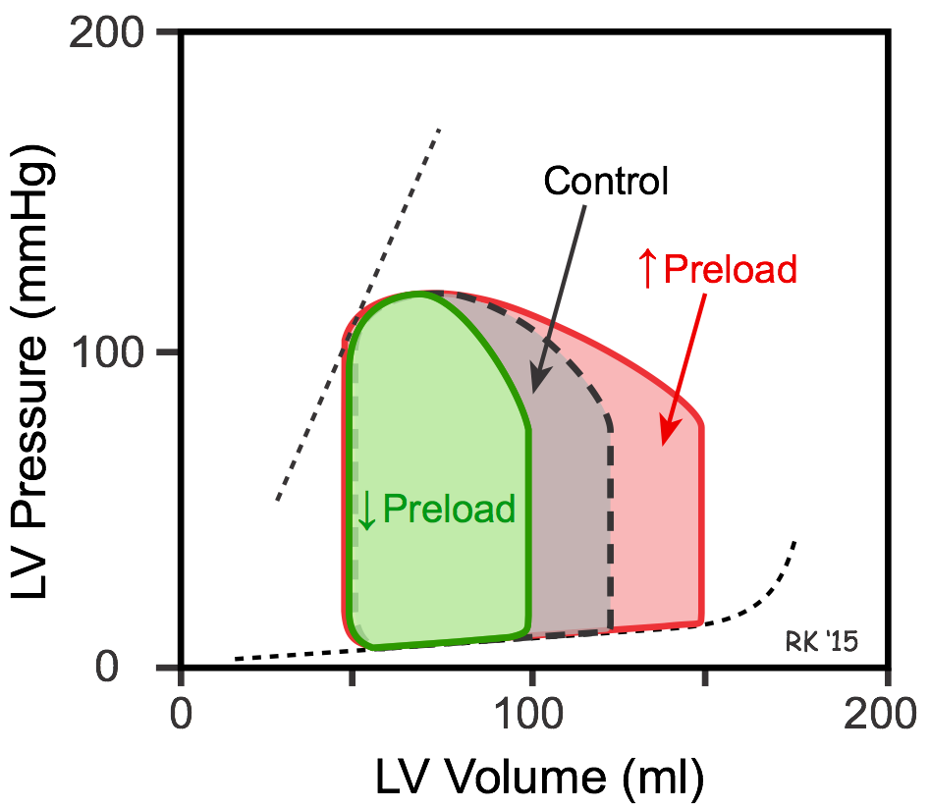
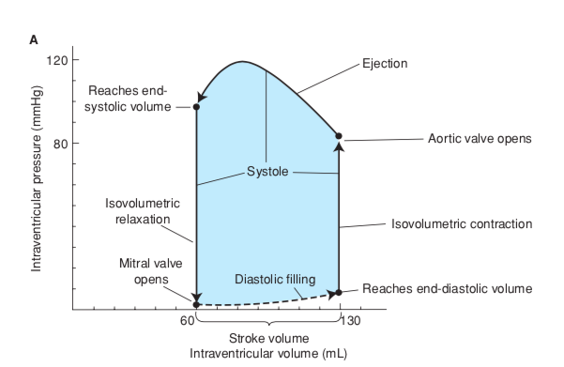
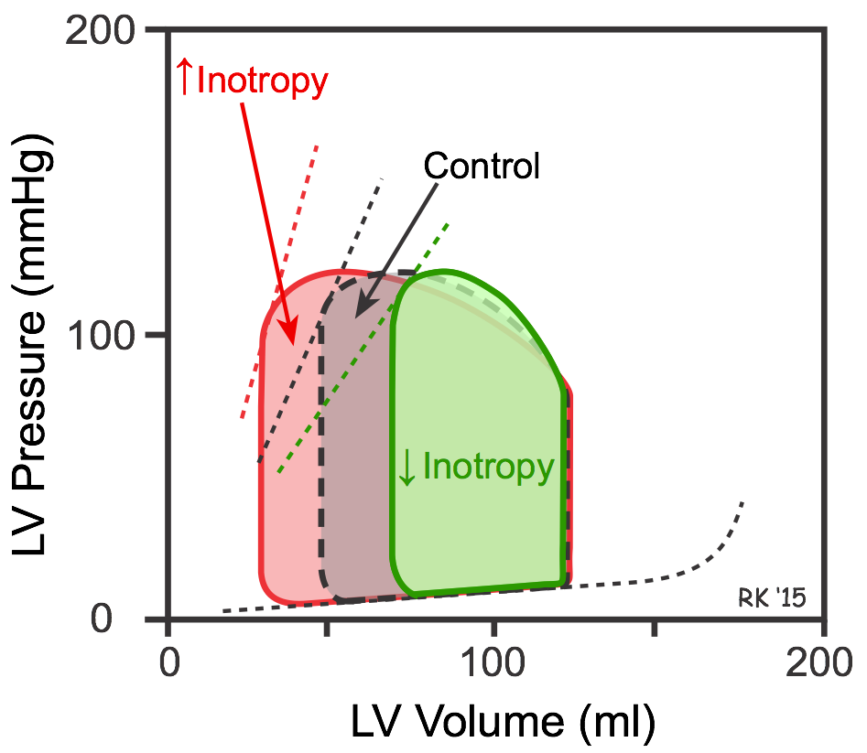
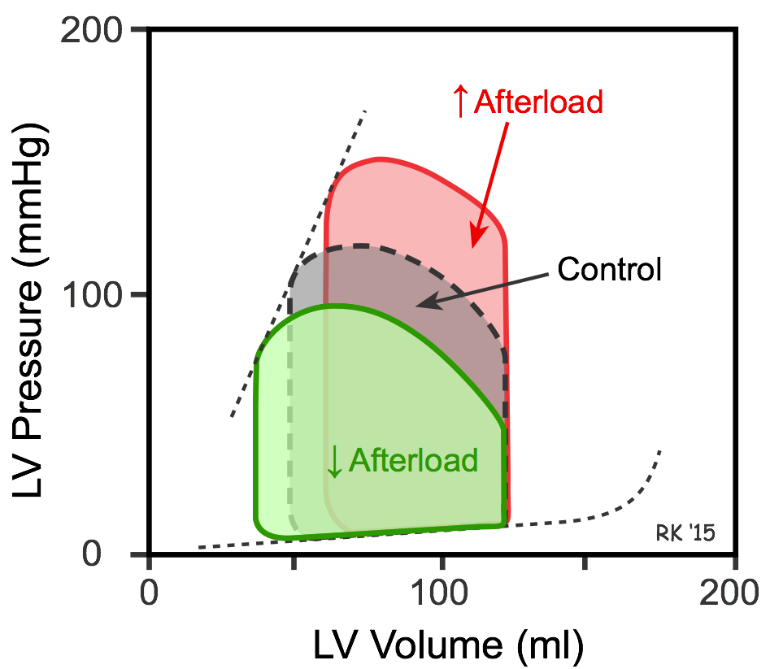

7. What is Fick’s principle of cardiac output measurement?
Given the following information, calculate cardiac output:
Systemic arterial blood oxygen concentration = 200 mL/L
Pulmonary arterial blood oxygen concentration = 140 mL/L
Total body oxygen consumption = 600 mL/min

Fick’s principle is one of the most accurate methods of measuring cardiac output. This principle using the whole body oxygen consumption rate, the oxygen concentration in arterial blood, and the oxygen concentration in mixed venous blood.

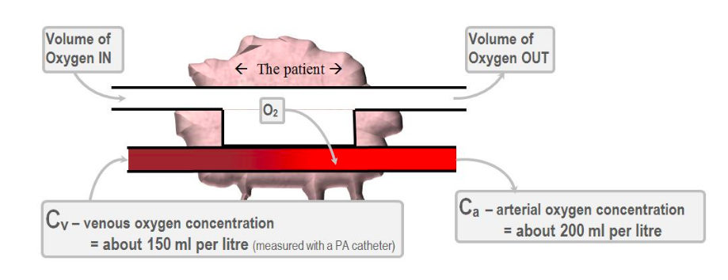
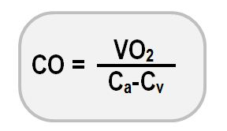

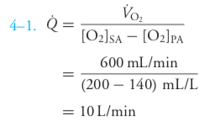

8. Fill in the blanks.

