Vomiting, Ileus, Current Literature Carissa Tong
Vomiting

- Vomiting (Emesis) defined as the forceful expulsion of content from the stomach and intestine, a defense mechanism
- The emetic center is located within the reticular formation of the medulla oblongata of the brainstem
  - In close proximity to the nucleus tractus solitarius (NTS) of the vagus nerve and the chemoreceptor trigger zone (CRTZ)
  - Different receptors present: adrenergic, 5HT-1, NK-1
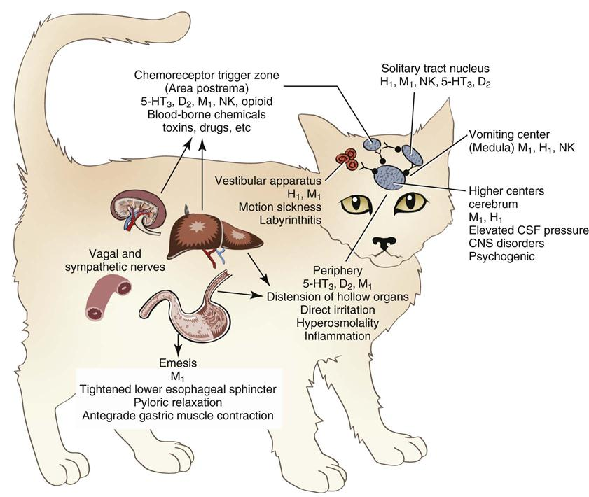
(From Boothe DM: Gastrointestinal pharmacology. In Small animal clinical pharmacology and therapeutics, Philadelphia, 2012, WB Saunders, Figure 19-2.
- Peripheral sensory receptors
  - Release of serotonin (5-HT) and substance P from enterochromaffin cells (present in canine gastric and duodenal mucosa) stimulate vagal afferents via 5-HT3 + NK-1 receptors
- Chemoreceptor trigger zone (CRTZ)
  - In the area postrema, which is located on the dorsal surface of the medulla oblongata adjacent to the caudal end of the 4th ventricle
  - Lacks BBB therefore responsive to circulating emetogens
  - Receptors include dopamine, histamine, peptide YY
    - Cats appears to lack histamine and dopamine receptors in their CRTZ
- Vestibular System
  - Vestibular nuclei (CN VIII) located in the brainstem
  - Mechanism of motion sickness is poorly understood
  - Receptors include histamine (H1) and ACh muscarinic receptor
- Higher Centers - cerebral cortex, limbic system
  - Direct stimulation via inflammatory disease
  - Psychogenic stimulation via fear, stress etc.
  - Traumatic stimulation via TBI, increased intracranial pressure
Causes of Vomiting
- Primary GI: dietary indiscretion, mechanical obstruction, gastritis/gastric ulceration, endoparasites, infectious gastroenteritis, inflammatory bowel disease
- Secondary GI: endocrinopathies (e.g. hypoadrenocorticism, hypoparathyroidism), uremia, hepatobiliary disease, pancreatitis, urogenital disease (e.g. pyometra), vestibular disease, toxins/chemicals/chemotherapy, pericardial effusion reported
- Drugs: apomorphine (canine), alpha 2 agonists (feline), prostaglandins etc.
Vomiting/Emetic Reflex
- Can be triggered peripherally and centrally by the emetic center.
- Efferent nerves: vagal and phrenic nerves, parasympathetic nerves to the salivary glands, somatic motor nerve to abdominal muscles
- 3 phases:
Complications
- Nausea and loss of appetite, which overtime can lead to malnutrition
- Persistent vomiting can cause loss of GI fluid and electrolytes, leading to dehydration, hypovolemia, acid-base and electrolyte disturbances
- Aspiration pneumonia
Clinical Assessment
- Distinguishing between vomiting and regurgitation is important as etiology different
- Signalment may help narrow down differentials
Diagnostic Approach
- Acute gastritis is a misnomer that is commonly used in acute, self-limiting emesis. Has no basis as gastric inflammation not often proved by histopathology
- In the UK, a study showed at 95% of dogs with emesis do not present to a veterinarian
Treatments
- Fluid and electrolyte therapy to correct dehydration, acid-base and electrolyte disturbances
- Giving anti-emetic may run the risk of masking significant clinical signs, delay in diagnosis, could be harmful if it is a prokinetic when there is a foreign body obstruction
Antiemetics
- Ideal antiemetic: prevent both central & peripheral stimuli, minimal cardiovascular effect, wide therapeutic index, minimal CNS side effects, absent prokinetic effect
- Neurokinin-1 (NK-1) receptor antagonists: Maropitant
- Blocks action of substance P in the CNS as well as peripheral NK-1 receptor in GIT
- Dose: 1mg/kg SQ, IV or 2mg/kg PO q24hr
- Metabolism:
  - Extensive 1st pass metabolism in the liver
  - Higher bioavailability when given SQ (90%) compared to oral (23-37%)
  - Oral bioavailability not affected by feeding
- Adverse effect:
  - Pain on injection
  - Bone marrow hypoplasia when administered to puppies < 11 weeks old
- Use:
  - Dog: vomiting secondary to motion sickness or spontaneous illness, and nausea associated with chemotherapy (doxorubicin, cisplatinum)
  - Cats: motion sickness, xylazine-induced emesis in cats
- Thought to have many other effects – anti-inflammatory, neuroprotectant, hepatoprotectant – though yet to be proven
- Appear to reduce visceral pain in cats and dogs and can reduce M.A.C. of sevoflurane
- 5-HT 3 Receptor Antagonists
- Ondansetron, granisetron, dolasetron were developed to alleviate chemotherapy-associated nausea in people
- MoA: competitive blockers of serotonin (5-HT 3) receptors found peripherally (intestinal vagal afferent) and centrally (in CRTZ, and medullary vomiting center)
  - Ondansetron: inhibit emesis in low and high dose, but enhances emesis at intermediate dosages
- Ondansetron has been anecdotally reportedly to stop vomiting effectively in patients not responding to metoclopramide or promazine treatment
- Dolasteron reported to have excellent oral bioavailability
- Dose:
  - Ondansetron 0.1-1mg/kg IV q8-12h
  - Dolasetron 0.6-1mg/kg SQ, IV, PO q12-24h
  - The antiemetic effects of drugs linger after drug disappears from the blood, therefore only need to be given q8-24h
- Metabolism
  - Ondansetron: hepatic metabolism
  - Dolasetron: metabolized into active fraction (hydrodolasetron), eliminated via hepatic P450 enzymes
  - Eliminated in the urine
- Dolasetron reported to cause QT prolongation in humans, but unsure in vet med
- Rare adverse effect but constipation and diarrhea reported in humans
- Ondansetron reported to decrease efficacy of tramadol
- Dolasetron + metoclopramide effective for chemotherapy-induced nausea that is resistant to other antiemetics
- Metoclopramide
- Antidopaminergic and 5-HT3 receptor antagonist = potent blocker of CRTZ
- Antiemetic dose: 0.1-0.5mg/kg IV, SQ, PO q8hr
  - Higher dose for gastric prokinetic action
- Often inadequate as a sole antiemetic for patient with strong stimulus to vomit (e.g. severe pancreatitis, renal failure)
- Effectiveness can be improved as a CRI
- IV solution is light sensitive
- Care in using Metoclopramide in patient with decreased GFR as it is excreted by the kidneys
- Promazine Derivatives
- Broad-spectrum, inexpensive, centrally acting antiemetic
- MoA: antidopaminergic and antihistamine effects that block CRTZ, high dose blocks MVC
  - Also have anticholinergic, antispasmodic, and a-adrenergic blocking effects
- Chlorpromazine, prochlorperazine, and acepromazine most commonly used
- Dose:
  - Chlorpromazine: 0.1-0.5 mg/kg IV, SQ, IM q6-8h
  - Prochlorperazine 0.1-0.5mg/kg IV, IM, SQ, q8-12h
  - Antiemetic dose <<< sedative dose
- Adverse effect: sedation, increased intracranial pressure, alter heart rate (brady- or tachycardia)
- Metabolized by the liver – care in patient with advanced hepatic insufficiency
- Anticholinergic Agents : Aminopentamide
- Dose: 0.01-0.03 mg/kg IM, SQ, PO q8-12h
- MoA: block the cholinergic receptors in the brain involved in the VC and upper GIT via vagus nerve (muscarinic receptors)
- Less effective than metoclopramide, inferior to 5-HT3 and NK-1 antagonists
- Other anticholinergics – e.g. atropine, propantheline, glycopyrrolate – less effective antiemetics
- Caution in patient with glaucoma, cardiomyopathy, tachyarrthymias, hypotension, MG, or gastroesophageal reflux
- Peripherally acting antiemetics
- Drugs that sooth inflamed mucosal lesion (e.g. bismuth subsalicylate, barium sulfate) or relieve dyspepsia (e.g. antacid) can be used to alleviate vomiting
- Typically, much less effective than other drugs that have been discussed

Chemotherapy induced emesis
- Nausea and vomiting are the most common complications of chemotherapy
- Causes:
1) Location of tumour – gastrointestinal tract, liver, pancreas
2) Paraneoplastic syndrome
3) Treatment (sx, radiation, chemotherapy)
- 3 types of vomiting
  - Anticipated vomiting – rare in pets, corresponds to a Pavlov-like type of reflex. Tx: tx with antiemetic before chemotherapy
  - Acute vomiting (w/in first 24 hrs of tx) – caused by central or peripheral stimulation, predominant mode of action of cytotoxic drugs
  - Delayed vomiting (1-5 days after tx) – complex & multifactorial, may be due to reduction in intestinal motility or to alteration of the intestinal mucosa and its release of hormones, or accumulation of metabolites of cytotoxic agents
Type of V+ | Cytotoxic drug
Severe | Cisplatin, dacarbazine, streptozotocin, actinomycin
Moderate | Cyclophosphamide, doxorubicin, methotrexate, carboplatin, mitoxantrone, llosfamide
Mild | L-asparaginase, docetaxel, 5-Fluorouracil, thiotepa, paclitaxel, vinblastine, vinorelbine
Minimal | Bleomycin, busulfan, chlorambucil, hydroxyurea, vincristine, interferon

Gastroprotectants
- Primary indication is to heal existing gastric ulcers and erosions, and is poorly effective at preventing ulceration when the cause persists
- Causes of gastrointestinal ulceration and erosions (GUE) include:
  - Stress (an event causing hypoperfusion or anoxia at the gastric mucosa)
  - Drug therapy (NSAID, corticosteroids)
  - Marked hyperacidity (e.g. gastrinoma, MCT)
  - Liver failure
  - Chronic foreign body
  - Masses
- Gastroprotectants have no effects on the vomiting center and are not antiemetics; however, they have ant antidyspeptic effect that could lessen nausea
- Histamine-2 Receptor Antagonists (H2Ras)
- Cimetidine, ranitidine, famotidine (nizatidine, lafutidine)
- MoA: competitively and reversibly inhibit the H2 receptor on the basolateral membrane of the parietal cell, blocking acid secretion
- Onset of action: immediate
- Potency: Famotidine > nizatidine > cimetidine and ranitidine
  - However, potency does not equate efficacy
- Cimetidine’s absorption is delayed by food
- Metabolism:
  - Cimetidine and ranitidine metabolized by the liver
  - Famotidine, ranitidine and cimetidine undergo substantial 1st pass hepatic metabolism, but not nizatidine
  - Famotidine and nizatidine excreted unchanged in the urine
  - Dosage reduction recommended due to extensive renal tubular secretion
- Interactions:
  - Cimetidine markedly inhibits the hepatic cytochrome P-450 enzymes
    - Ranitidine, nizatidine, and famotidine bind CYP450 with less avidity
  - Cimetidine decrease metabolism of theophylline, metronidazole, lidocaine and many others
  - Cimetidine decreases hepatic blood flow 20%
- Lafutidine (new H2RA) has additional MoA of nitric-oxide mediated and histamine-independent mechanism
  - Has mucosal protective action that is mediated by capsaicin-sensitive sensory nerves
    - Capsaicin-sensitive sensory nerves protect GI mucosa via stimulation of calcitonin gene-related receptor (vasodilator) which ultimate modulated mucosal blood flow (NO formation) and mucus secretion (incr HCO3- secretion)
  - Shown to be more effective than lansoprazole in inhibiting gastric acid in one study
  - Has mild intestinal protective activity
- Adverse effects
  - Uncommon w/ cimetidine, more so with ranitidine and famotidine
  - Apathy, nausea/vomiting, CNS aberrations, cytopenias
  - Hemolytic anemia reported in cats following IV famotidine, suspect due to benzyl alcohol preservative
- Cimetidine can be used to decrease metabolism of Acetaminophen toxicity due to inhibition of hepatic P-450.
- Repeat administration can lead to tolerance
Cimetidine | 5-01mg/kg IV, IM, SQ, PO q6-h
Ranitidine | Dogs: 0.5-2mg/kg IV, or 1-4mg/kg PO q8-12h  Cats: 2.5mg/kg IV or 3.5mg/kg PO q8-12h
Famotidine | 0.5-1mg/kg IV, IM, SQ, PO q12-24h
Nizatidine | 2.5-5 mg/kg PO q12h

- Protein Pump Inhibitors (PPIs)
- Omeprazole, lansoprazole, pantoprazole, esomeprazole, dexlanoprazole
- MoA: irreversibly inhibit hydrogen-potassium adenosine triphosphate on the luminal side of the parietal cell, stopping secretion of H+ into the gastric lumen
- Lansoprazole, esomeprazole and pantoprazole can be given IV
- Reaches 30% of maximal effect in 24 hr, then maximal acid suppression occurs 2-5 days
- Omeprazole is a prodrug, therefore made in enteric-coated granules to allow for duodenal absorption
- Metabolism:
  - Administer Omeprazole 1 hour prior to feeding as food reduces absorption
  - Undergoes 1st pass hepatic metabolism, and the rest if selectively sequestered in the acidic environment of parietal cell where it is transformed to the active form
- Irreversible proton pump inhibition, progressive intracellular acidification, and drug accumulation are why PPIs are more potent than H2RAs
- Interactions:
  - Omeprazole and esomeprazole inhibit hepatic cytochrome P450 enzymes
  - Altered bioavailability via pH change: ketoconazole, digoxin, iron salts, ampicillin esters
  - Altered metabolism via P450 inhibition: cyclosporine, diazepam, phenytoin, warfarin, theophylline, propranolol, Clopidogrel
- Adverse effects:
  - Rare overall
  - Hypersensitivity rx reported in humans
  - Omeprazole may cause diarrhea, dose-dependent inhibition of CNS fluid
- Pantoprazole have strong activity vs Giardia and Trichomonas in vitro

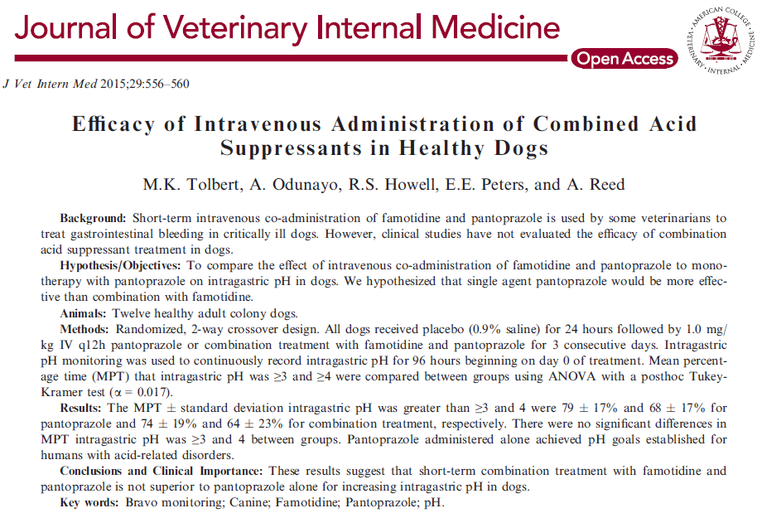
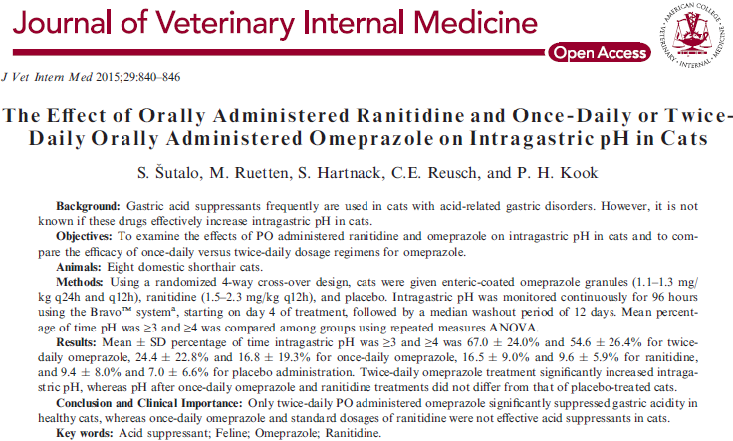

- Current Literature:
  - In dogs, pantoprazole IV alone was superior to combination of famotidine plus pantoprazole. Same study also suggested to use PPI q12hr rather than q24hr (Tolbert et al. 2015)
  - In cats, documented increase in gastric pH after 4-7 days of 1.1-1.3mg/kg Omeprazole PO q12hr (Šutalo et al. 2015)
Dosages:
Omeprazole | 1-2 mg/kg PO q12h
Pantoprazole | 1mg/kg IV q12h
Esomeprazole | 0.5-1mg/kg IV q24h
Lansoprazole | 1mg/kg IV q24h

- PPI and connection to AKI
- Sucralfate
- Sucrose octasulfate and aluminum hydroxide
- Orally administered and locally acting
- When drug encounters pH <3-4, AlOH disassociates from sucrose octasulfate to form a viscous, paste-like negatively charged substance which binds to the positively charged epithelial cells
  - Remains for 6 hours
  - Acidic environment needed to initiate biotransformation, but drug is active in alkaline environment as well
- MoA:
  - Serves as physical barrier
  - Inhibits pepsin molecules, stimulates prostaglandin release (resulting in increased mucus and HCO₃⁻secretion), and increases mucosal blood flow
  - Increases mucus and HCO3- secretion through nonprostaglandin mediated pathways
  - Stimulates epidermal growth factor and cell renewal.
- Interaction:
  - Can decrease absorption of other drugs (e.g. fluoroquinolones, aminophylline, theophylline, tetracyclines, ketoconazole, phenytoin, digoxin, levothyroxine, cimetidine, ranitidine and amitriptyline)
  - Do not give with enteral feedings
- Adverse effect minimal, except for constipation
- Historically, not use in preventing stress-related mucosal disease (SRMD). However, a recent ex vivo study demonstrated that Sucralfate was effective at restoring defects in gastric barrier induced by acid and accelerated repair of tissue, which suggest that Sucralfate may be useful in SRMD (Hill et a. 2018)
- Prostaglandin Analogs – Misoprostol
- A prostaglandin E1 analog with both antacid and mucosal protective properties
- Developed to prevent ulceration caused by NSAIDs
- MoA:
  - Stimulates secretion of mucus and HCO3, increases gastric blood flow
  - Acts on parietal cells to inhibit both nocturnal acid secretion and secretions in response to food, pentagastrin, and histamine
  - Can enhance colonic motility
- Metabolism:
  - Rapidly absorbed w/ food
  - 1st pass metabolism in liver -> active form
  - Short half life give 2-3 times daily
- Adverse effect: diarrhea, uterine contraction (can result in abortion)
- Antacids – administer to neutralize gastric acid

Potential complications of increased gastric pH
- As gastric acid is a defense mechanism in preventing many infectious agents gaining access to the intestinal tract, increasing gastric pH may cause an increased risk of infection
- In critically ill humans, it was been shown that acid suppression therapy is associated with increased risk of bacterial pneumonia following an aspiration event

Gastrointestinal dysmotility disorders (GIDM)
- Common complication in critically ill people
- Most common disorders seen in small animal patients include esophageal dysmotility, delayed gastric emptying, function intestinal obstruction (i.e. ileus), and colonic motility abnormalities
- Many risk factors, e.g. mechanical ventilation, electrolyte derangements, diabetic gastroneuropathy, drugs, hypoxemia, sepsis, shock, trauma, SIRS, MODS
4 main types of dysmotilities:
- Esophageal dysmotility usually secondary to development of gastroesophageal reflux – change in esophageal motor activity and decreases in the LES pressure result in regurgitation of gastric content, esophagitis, and subsequent aspiration
- Delayed gastric emptying is a functional disorder caused by defects in the myenteric neuronal and gastric smooth muscle, which leads to impaired emptying of digesta from stomach
  - Pathophysiology not fully understood in humans and in small animal patients
  - Theories include “pump failure” (primary motor dysfunction) and “excessive feedback” (release of neuroendocrine peptides that inhibit afferent neurons)
- Ileus characterized by lack of borborygmi, accumulation of gas and fluid in the bowel, with subsequent abdominal distension, and decreased advancement of GI contents
  - Multifactorial, may include
    - Loss of synchronized coordination and dysfunction peristalsis
    - Decreased motor activity in muscularis portion of GIT
    - Disturbance in the interdigestive motility pattern (MMCs)
    - Secondary to drugs (e.g. opioids)
- Colonic dysmotility includes constipation, megacolon, or decreased colonic tone
Opioids-related bowel dysfunction
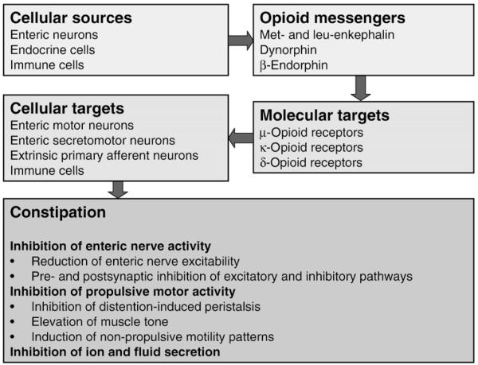
(https://www.ncbi.nlm.nih.gov/pmc/articles/PMC3163293/)
- Opioids receptors (μ-, κ- and δ-subtype) are found in GI enteric neurons and endocrine cells
  - In the human gut, μ-opioid receptors are present on myenteric and submucosal neurons and on immune cells in the lamina propria
- Have been shown to inhibit GI transmit by reducing acetylcholine (ACh) release and altering neuronal excitability
- It can also increase smooth muscle activity whilst inhibiting coordinated propulsive peristalsis, resulting in disordered non-propulsive contractile activity
- In humans, opioid-induced constipation (OIC) is being studied.
Clinical Manifestation
- Hypomotility results in food bolus stasis and disruption of normal absorptive function of GIT
- Negative consequences:
  - Aspiration pneumonia
  - Reflux esophagitis
  - Bacterial overgrowth of gut bacterial translocation
  - Abdominal distension increased intraabdominal pressure
  - Fluid sequestration nutrient/water/electrolytes losses, hypovolemia
  - Delayed delivery of nutrition
- Clinical signs: anorexia, abdominal pain, abdominal distension, nausea, vomiting, and increased gastric residual volume
Diagnostics
- Contrast radiography (e.g. barium study) aid assessment of GI motility
- Ultrasound allows noninvasive, qualitative and semiquantitative assessment of delayed gastric emptying and ileus
  - Main disadvantage incl. subjectivity, lack of consensus on reference ranges
- Gastric residual volume (GRV) can be used as an indirect measurement of delayed gastric emptying (e.g. via NGT) or ileus
  - Defined as the volume of fluid aspirated from the stomach after a given time period and before each new feeding
    - No defined normal range in veterinary patients
  - Not well evaluated in critically ill veterinary patients.
  - Historically, it was thought that high GRV can result in increased risk of gastric reflux and aspiration pneumonia. This prompt regular suctioning of GRV in practice
  - Recommendation in veterinary medicine suggested that GRV should be checked every 4-8 hours via aspiration of NGT
    - Stop feeding if volume exceeds 8 ml/kg or if GRV exceeds twice the volume of food infused in an hour
  - A clinical review of gastric residual volume in 2013 in Nutrition examined use of GRV in human patients and showed that this practice of regular suctioning appeared unnecessary to guide nutrition
  - Recent retrospective study in JAMA showed that routine GRV monitoring reduced enteral nutritional intake whilst conferring no significant benefit to survival, length of hospitalization, or development of ventilation-associated pneumonia
Treatments
- Early enteral feeding, early ambulation, fluid therapy and multimodal pain management are necessary
Prokinetics
- Dopaminergic receptor (D2) antagonists
- MoA: indirectly increase ACh release from postganglionic cholinergic neurons and promote intestinal smooth-muscle contraction and peristalsis
- Domperidone
  - Peripheral D2 antagonist with a2 and b2 adrenergic receptor antagonistic effects
  - Prokinetic effect:
    - Less efficacious than metoclopramide as a gastric prokinetic
    - May decrease frequency of corporeal, pyloric, and duodenal contraction and deteriorate antropyloroduodenal coordination in the dog
    - Minimal phasic effect on LES
  - Antiemetic effect
    - 12-25x more potent than metoclopramide in attenuating apomorphine-induced emesis
  - Not approved in the US
- Serotonin receptor (5-HT) agonists, antagonists
- 5-HT is released from enterochromaffin cells of the GI mucosa, which activates neural pathways associated w/ secretion, peristalsis, motility and sensation
- Multiple receptor subtypes – 1, 2, 3, 4 and 7 – present in the GIT
  - Motility modulated via 5-HT4: presynaptic release stimulates ACh release from postganglionic cholinergic neurons >> smooth muscle contraction
  - Antiemetic modulated via 5-HT3 (e.g. ondansetron, dolasetron)
- Cisapride
  - Prokinetic agent – direct effect via 5-HT4 agonism of ENS
    - Stimulates distal esophageal peristalsis in species with smooth muscles (i.e. cats, humans)
    - Stimulates gastric emptying, increasing gastroesphageal sphincter pressure, and enhances antropyloroduodenal coordination
    - More potent than metoclopramide in combating delayed gastric emptying
  - 5-HT1 and 3 antagonists – stimulates colonic motility
  - Adverse effect of QT interval prolongation and slowing of cardiac repolarization via blockade of rapid component of delayed rectifier K+ channel is NOT seen in veterinary patients
  - Adverse effect: increased defecation, head pain, abdominal pain, cramping, flatulence
- Metoclopramide
  - A Mixed 5-HT3 antagonist/ 5-HT4 agonist
  - Prokinetic effects via 5-HT4 receptor agonism
    - Improves coordination of gastropyloric small intestinal motor function
    - Shown to potentiate LES tone, decrease fundic receptive relaxation, and increase gastric emptying in veterinary patients
    - No documented effects in distal small intestine or in the colon
  - Short half-life therefore QID administration or CRI preferable
  - Interaction: can enhance bioavailability of cyclosporine
  - Adverse effect: 0.2% risk of developing “extrapyramidal signs” via dopamine antagonist including involuntary muscle spasms, motor restlessness, an inappropriate aggression
    - Tx: anti-histamines, BDZ, beta adrenergic antagonists, or dopamine agonists
- Some novel 5-HT agonists that is under investigation including velusetrag, tegaserod, mosapride, and prucalopride
- Motilin/Ghrelin Receptor agonists
- Motilin is a peptide synthesized by endocrine cells of SI mucosa
  - Has a cyclical increase in plasma level which correlates with their action of upregulating interdigestive MMC (strong peristatic contractions, phase III of MMC)
  - Motilin receptors on cholinergic nerves
- Ghrelin is a peptide produced by parietal cells of the gastric mucosa as endogenous ligand for growth hormone
  - Binds to ghrelin receptor, found on endocrine cells of the gastric mucosa
  - Increases gastric emptying and MMC
- Macrolide antimicrobials can increase GI motility by acting on motilin receptors on the smooth muscles of the GI tract
  - Erythromycin mimics effect of motilin in upper GIT, stimulating motility
    - Dogs: mediated via 5-HT3 cholinergic pathways
    - Cats: mediated via direct stimulation of smooth muscle motilin receptors
    - Shown to lower LES tone, increase antral contractions and gastric emptying, and decrease small intestinal transit time
    - Side effect rare and generally well tolerated
      - High dose can cause QT prolongation, nausea, and inappetence
  - Azithromycin – currently being studied for its prokinetic properties
- Histamine receptor antagonists
- All histamine receptors are present in the GI tract
  - H1 receptor activation causes contractions like muscarinic receptor activation by increasing Ca2+ availability
  - H2 receptor mediates neurogenic contraction via cholinergic and noncholinergic excitatory transmission
  - H3 receptor plays a minor role in GI motility regulation – under study
- Ranitidine/nizatidine are both H2 receptor antagonist used to suppress gastric acid suppression, that also can promote acetylcholinesterase inhibition w/in the ENS to stimulate GI motility
  - Primary action on smooth muscle contraction
  - Prokinetic effects seen with antacid doses
- Opioid receptor antagonists
- Opioid receptors are present throughout the GIT; δ -, κ – and μ -receptors have been identified as having effects on human GI function
  - μ -receptor are widely distributed in the submucosa as well as ileal mucosa
  - δ -, κ receptors found in stomach and proximal colon
- Opioid analgesics can lead to hypomotility results from decreased neurotransmission and inhibition of neuronal firing at both the level of the CNS and of enteric neurons in GIT
- In humans, opioid-induced bowel dysfunction/constipation (OIC) is well documented
  - Opioids delay GI transmit, stimulates non-propulsive motility, segmentation tone and stimulation of pyloric and ileocecal sphincter
  - Stimulates absorption of fluids – via delayed transit increasing time for absorption and stimulating sensory receptors that activate a reflex arc to cause further fluid absorption
- Opioid antagonists have been used to treat OIC
- Naloxone
  - Oral administration shown to increase gastric emptying, as it blocks the opioid action at the intestinal receptor level.
  - Has poor bioavailability and undergo hepatic 1st pass metabolism
  - Dose that reverse GI signs often reverse analgesia so not ideal
- Peripherally restricted mu-opiate receptor antagonists (e.g. alvimopan, methylnaltrexone) have been investigated as they antagonize the inhibitor effects of opioid on gut motility, but doesn’t cross the BBB to antagonize the analgesic effects
  - Alvimopan is approved for FDA use to treat OIC in humans, but not in veterinary medicine yet as it is incredibly expensive ($1000/treatment cycle in humans)

References:
Camilleri M. Opioid-induced constipation: challenges and therapeutic opportunities. Am J Gastroenterol. 2011;106(5):835-842; quiz 843. doi:10.1038/ajg.2011.30

D Silverstein, K Hopper. Small animal critical care medicine (2015). Chapter 161: Gastroprotectants: 851-854

D Silverstein, K Hopper. Small animal critical care medicine (2015). Chapter 162: Antiemetics and Prokinetics. 854-858.

Elwood C, Devauchelle P, Elliott J, et al. Emesis in dogs: a review. Journal of Small Animal Practice. 2010;51(1):4-22. doi:10.1111/j.1748-5827.2009.00820.x

Hill TL, Lascelles BDX, Blikslager AT. Effect of sucralfate on gastric permeability in an ex vivo model of stress-related mucosal disease in dogs. Journal of Veterinary Internal Medicine. 2018;32(2):670-678. doi:10.1111/jvim.15076

Kuppinger DD, Rittler P, Hartl WH, Rüttinger D. Use of gastric residual volume to guide enteral nutrition in critically ill patients: A brief systematic review of clinical studies. Nutrition. 2013;29(9):1075-1079. doi:10.1016/j.nut.2013.01.025

Reignier J et al. Effect of not monitoring residual gastric volume on risk of ventilator-associated pneumonia in adults receiving mechanical ventilation and early enteral feeding: A randomized controlled trial. JAMA 2013 Jan 16; 309:249.

Šutalo S, Ruetten M, Hartnack S, Reusch CE, Kook PH. The Effect of Orally Administered Ranitidine and Once-Daily or Twice-Daily Orally Administered Omeprazole on Intragastric pH in Cats. Journal of Veterinary Internal Medicine. 2015;29(3):840-846. doi:10.1111/jvim.12580

Tolbert MK, Odunayo A, Howell RS, Peters EE, Reed A. Efficacy of Intravenous Administration of Combined Acid Suppressants in Healthy Dogs. Journal of Veterinary Internal Medicine. 2015;29(2):556-560. doi:10.1111/jvim.12555

Whitehead K, Cortes Y, Eirmann L. Gastrointestinal dysmotility disorders in critically ill dogs and cats. Journal of Veterinary Emergency and Critical Care. 2016;26(2):234-253. doi:10.1111/vec.12449

