1. EM vs PM coupling

In smooth muscle, changes in intracellular free Ca²⁺ levels can occur both with and without changes in membrane potential. The processes involved are called electromechanical coupling and pharmacomechanical coupling, respectively.
Electromechanical coupling occurs because the smooth muscle surface membrane contains voltage-operated channels for calcium (the same VOCs that are involved in action potential generation). Membrane depolarization increases the open-state probability of these channels and thus leads to smooth muscle cell contraction and vessel constriction. Conversely, membrane hyperpolarization leads to smooth muscle relaxation and vessel dilation. Because the VOCs for Ca²⁺ are partially activated by the low resting membrane potential of the vascular smooth muscle, changes in resting potential can alter the resting calcium influx rate and therefore the basal contractile state.

With pharmacomechanical coupling, chemical agents (eg, released neurotransmitters) can induce smooth muscle contraction without the need for a change in membrane potential. The combination of a vasoconstrictor agonist (such as norepinephrine) with a specific membrane-bound receptor (such as an α1-adrenergic receptor) initiates events that cause intracellular free Ca²⁺ levels to increase for two reasons. One, the activated receptor may open surface membrane receptor-operated channels for Ca²⁺ that allow Ca²⁺ influx from the extracellular fluid. Two, the activated receptor may induce the formation of an intracellular “second messenger,” inositol trisphosphate (IP3), that opens specific channels that release Ca²⁺ from the intracellular sarcoplasmic reticulum stores. In both processes, the activated receptor first stimulates specific guanosine triphosphate-binding proteins (GTP-binding proteins or G proteins). Such receptor-associated G proteins seem to represent a general first step through which most membrane receptors operate to initiate their particular cascade of events that ultimately lead to specific cellular responses.

2. Control of arteriolar tone
--What is the primary determinant of vascular resistance? Arteriolar diameter.

--Name the categories of factors that influence vascular tone, and provide a brief overview.
Local influences, neural influences, and hormonal influences

Local: a local feedback mechanism exists that automatically operates on arterioles to regulate a tissue’s blood flow in accordance with its metabolic needs. Whenever blood flow and oxygen delivery fall below a tissue’s oxygen demands, the oxygen levels around arterioles fall, the arterioles dilate, and the blood flow through the organ appropriately increases. Local metabolic mechanisms represent by far the most important means of local flow control. By these mechanisms, individual organs are able to regulate their own flow in accordance with their metabolic needs.

Neural: Sympathetic vasoconstrictor nerves release norepinephrine from their terminal structures in amounts generally proportional to their electrical activity. Norepinephrine causes an increase in the tone of arterioles after combining with an α1-adrenergic receptor on smooth muscle cells. Norepinephrine appears to increase vascular tone primarily by pharmacomechanical means. The mechanism involves G-protein linkage of α-adrenergic receptors to phospholipase C and subsequent Ca2+ release from intracellular stores by the action of the second messenger IP3. Sympathetic vasoconstrictor nerves normally have a continual or tonic firing activity. This tonic activity of sympathetic vasoconstrictor nerves makes the normal contractile tone of arterioles considerably greater than their basal tone. The additional component of vascular tone is called neurogenic tone. When the firing rate of sympathetic vasoconstrictor nerves is increased above normal, arterioles constrict and cause organ blood flow to fall below normal. Conversely, vasodilation and increased organ blood flow can be caused by sympathetic vasoconstrictor nerves if their normal tonic activity level is reduced. Thus, an organ’s blood flow can either be reduced below normal or be increased above normal by changes in the sympathetic vasoconstrictor fiber firing rate.

Hormonal: Under normal circumstances, the blood levels of NE/epi are probably not high enough to cause significant cardiovascular effects. However, circulating catecholamines may have cardiovascular effects in situations (such as vigorous exercise or hemorrhagic shock) that involve high activity of the sympathetic nervous system. In general, the cardiovascular effects of high levels of circulating catecholamines parallel the direct effects of sympathetic activation; both epinephrine and norepinephrine can activate cardiac β1-adrenergic receptors to increase the heart rate and myocardial contractility and can activate vascular α-receptors to cause vasoconstriction. Recall that in addition to the α1-receptors that mediate vasoconstriction, arterioles in a few organs also possess β2-adrenergic receptors that mediate vasodilation. Because vascular β2-receptors are more sensitive to epinephrine than are vascular α1-receptors, moderately elevated levels of circulating epinephrine can cause vasodilation, whereas higher levels cause α1-receptor-mediated vasoconstriction. Vascular β2-receptors are not innervated and therefore are not activated by norepinephrine, released from sympathetic vasoconstrictor nerves. Although not thought to be significantly involved in normal vascular control, direct vascular constriction from abnormally high levels of vasopressin may be important in the response to certain disturbances such as severe blood loss through hemorrhage. Although it should not be viewed as a normal regulator of arteriolar tone, direct vasoconstriction from angiotensin II seems to be an important component of the general cardiovascular response to severe blood loss. There is also strong evidence suggesting that direct vascular actions of angiotensin II may be involved in intrarenal mechanisms for controlling kidney function. In addition, angiotensin II may be partially responsible for the abnormal vasoconstriction that accompanies many forms of hypertension.

3. CVP and venous return

Using this normal venous return curve and CO curve, diagram or identify the following situations or points:

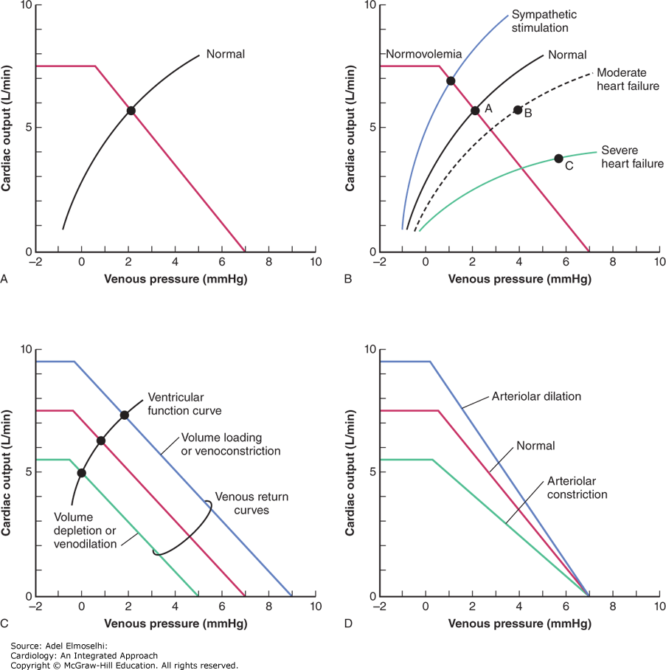

-RA pressure
-Operating point of the heart
-Mean systemic pressure
-VR: Hemorrhage
-CO: Increased cardiac sympathetic tone
-CO: Heart failure
-VR: Hypervolemia
-VR: arteriolar dilation

What is the significance of the flat portion of the venous return curve?
Using the VR curve, explain why a positive fluid balance can have negative effects on cardiac output.

4. Cerebral Blood Flow
Of the three aforementioned categories that regulate arteriolar tone, which is predominant in regulating cerebral blood flow?
Cerebral blood flow is regulated almost entirely by local mechanisms.

Describe the role of CO2 in regulating cerebral blood flow.
The brain as a whole has a nearly constant rate of metabolism that, on a per gram basis, is nearly as high as that of myocardial tissue. Flow through the cerebrum is autoregulated very strongly and is little affected by changes in arterial pressure unless it falls below approximately 60 mmHg. When arterial pressure decreases below 60 mmHg, brain blood flow decreases proportionately. Cerebral blood flow decreases whenever arterial blood PCO2 falls below normal. Conversely, cerebral blood flow increases whenever the partial pressure of carbon dioxide (Pco2) is raised above normal in the arterial blood. This is the normal state of affairs in most tissues, but it plays out importantly when it happens in the brain. For example, the dizziness, confusion, and even fainting that can occur when a person hyperventilates (and “blows off” CO2) are a direct result of cerebral vasoconstriction. It appears that cerebral arterioles respond not to changes in Pco2 but to changes in the extracellular H+ concentration (ie, pH) caused by changes in Pco2. Cerebral arterioles also vasodilate whenever the partial pressure of oxygen (Po2) in arterial blood falls significantly below normal values. However, higher than normal arterial blood Po2, such as that caused by pure oxygen inhalation, produces little decrease in cerebral blood flow.

5. Regulation of arterial pressure: short and long term
What is the most important short-term regulator of arterial blood pressure, and how does it operate?
The arterial baroreceptor reflex is the single most important mechanism providing short-term regulation of arterial pressure.
Sensory receptors, called arterial baroreceptors, are found in abundance in the walls of the aorta and carotid arteries. The receptors themselves are mechanoreceptors that sense arterial pressure indirectly from the degree of stretch of the elastic arterial walls. In general, increased stretch causes an increased action potential generation rate by the arterial baroreceptors. Baroreceptors actually sense not only absolute stretch but also the rate of change of stretch. For this reason, both the mean arterial pressure and the arterial pulse pressure affect baroreceptor firing rate. If arterial pressure remains elevated over a period of several days for some reason, the arterial baroreceptor firing rate will gradually return toward normal. Thus, arterial baroreceptors are said to adapt to long-term changes in arterial pressure. For this reason, the arterial baroreceptor reflex cannot serve as a mechanism for the long-term regulation of arterial pressure.
Consider the various components of the arterial baroreceptor reflex and predict whether the following variables will increase or decrease in response to a rise in arterial pressure.
a. arterial baroreceptor firing rate: inc
b. parasympathetic activity to the heart: inc
c. sympathetic activity to the heart: dec
d. arteriolar tone: dec
e. venous tone : dec
f. peripheral venous pressure : dec
g. total peripheral resistance : dec
h. cardiac output : dec

6. Effects of respiratory activity on CV function
During normal inspiration, which of the following are increased or decreased?
-Pulmonary vascular resistance: decreased
-Right atrial pressure: decreased
-Venous return: increased

7. CV adaptations to shock

What are compensatory processes that are initiated during the shock state:
1. Breathing is rapid and may be shallow, which promotes venous return to the heart by action of the respiratory pump.
2. The release of renin from the kidney as a result of sympathetic stimulation promotes the formation of the hormone, angiotensin II, which is a potent vasoconstrictor and participates in the increase in total peripheral resistance even in mild shock states.
3. The circulating level of vasopressin from the posterior pituitary gland increases and, being a potent vasoconstrictor, contributes to the increase in total peripheral resistance. This hormone is released in response to decreased firing of the cardiopulmonary and arterial baroreceptors.
4. Circulating levels of epinephrine from the adrenal medulla increase in response to sympathetic stimulation and contribute to the vasoconstriction.
5. The increase in arteriolar constriction reduces capillary hydrostatic pressure. Because plasma oncotic pressure has not changed (at least initially), there is a net shift of fluid from the interstitial space into the vascular space.
Glycogenolysis in the liver induced by epinephrine and norepinephrine results in a release of glucose and a rise in blood (and interstitial) glucose levels and, more importantly, a rise in extracellular osmolarity by as many as 20 mOsm. This will induce a shift of fluid from the intracellular space into the extracellular (including intravascular) space.

