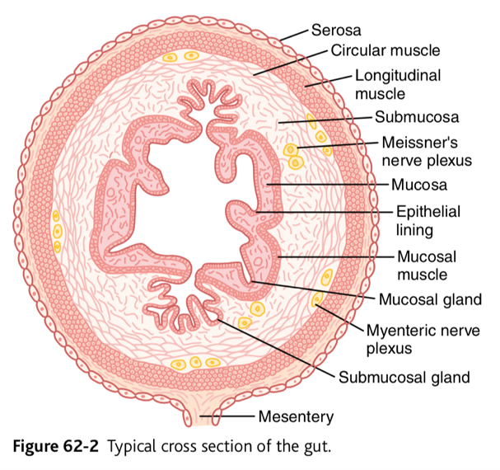
2018

GI Physiology - Guyton

Chapter 62: General Principles
GI Function – Motility, Nervous Control and Blood Circulation

General Principles of GI Motility

Layers from out to in = serosa > longitudinal smooth muscle layer > circular smooth muscle layer > submucosa > mucosa (including mucosal muscle in deep layers)

Smooth Muscle Functions as Syncytium

Muscle fibers are electrically connected through large numbers of GAP JUNCTIONS that allow low-resistance movement of ions.

When an action potential is elicited anywhere within the muscle mass it travels in all directions. The distance it travels depends on the excitability of the muscle – anywhere from a few mm to entire GI tract.

Connections between longitudinal and circular muscle layers so when one is excited the other gets excited too.

Electrical Activity of GI Smooth Muscle

Near continuous slow, intrinsic electrical activity along muscle fibers

Slow waves: slow undulating changes in resting membrane potential. frequency of slow waves determines rhythm of contractions. Interaction among smooth muscle cells and interstitial cells of Cajal (electrical pacemakers). DO NOT CAUSE MUSCLE CONTRATION (except maybe in stomach.) They excite intermittent spike potentials.

Spike potentials: action potentials > happen automatically when resting membrane potential of GI smooth muscle more positive than about -40 mV. The higher the slow wave potential rises the greater the frequency of spike potentials.

Channels allow large numbers of calcium ions to enter plus some sodium (calcium-sodium channels). These channels are slow to open and close > long duration of action potential.

Remember: calcium + calmodulin > myosin activation > contraction

Tonic contraction in some GI smooth muscle

Continuous contraction, not associated with basal electrical rhythm

Last minutes to hours

Can increase or decrease in intensity

Can be caused by:

continuous or repetitive spike potentials. Greater frequency = greater degree of contraction.

Hormones/ other factors that cause continuous partial depolarization without action potential

Continuous entry of calcium into cell not associated with changes in membrane potential

Voltage of resting membrane potential of GI smooth muscle can be made to change to different levels

Factors that cause depolarization (more excitable membrane): stretching of muscle, ACh from parasympathetic nerves, GI hormones

Factors that cause hyperpolarization (less excitable): norepinephrine and epinephrine and sympathetic nerve stimulation (norepinephrine)

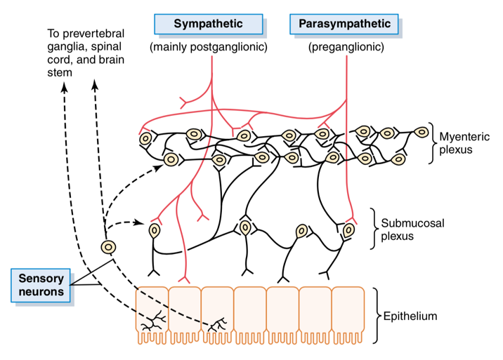
Neural Control of GI Function – Enteric Nervous System

Controls GI movements and secretion

Can function independently of extrinsic nerves

Can be enhanced or inhibited by sympathetic and parasympathetic stimulation

Two plexuses

Myenteric (Auerbach’s) plexus: outer plexus between longitudinal and circular muscle layers

Controls the GI movements

Extends entire length of GI tract.

When stimulated: INCREASES tonic contraction (TONE) of gut wall, INTENSITY and RATE of rhythmical contractions, VELOCITY of conduction of excitatory waves

Some inhibitory fibers as well that secrete inhibitory transmitters (maybe vasoactive intestinal polypeptide) to inhibit sphincter muscles (pyloric sphincter, sphincter of ileocecal valve) that impede movement of food

Submucosal (Meissner’s) plexus: inner plexus in submucosa

Controls GI secretion and local blood flow

LOCAL changes in secretion, absorption, contraction (infolding)

Sensory nerve endings in GI epithelium or gut wall send afferents to:

Both myenteric and submucosal plexuses

Prevertebral ganglia of SNS

Spinal cord

Vagus nerves to brain stem

Neurotransmitters

There’s a bunch: ACh, Norepi, ATP, Serotonin, Dopamine, CCK, Substance P, vasoactive intestinal polypeptide (VIP), Somatostatin, Leu-enkephalin, met-enkephalin, bombesin

ACh: EXCITES GI activity

Norepi/epi: INHIBITS GI activity

Autonomic control of the GI tract

Parasympathetic (increases GI function)

Cranial division to gut supply

A few fibers to mouth a pharynx

Almost everything else is vagus nerves supplying esophagus through first half of large intestine

Sacral division to gut supply

Originate in sacral segments of spinal cord

Pelvic nerves to distal half of large intestine through anus

Sigmoidal, rectal and anal regions better supplied with parasympathetic fibers than other regions (defecation)

Sympathetic Stimulation (inhibits GI function)

Originate in spinal cord segments T5-L2 > sympathetic chains > outlying ganglia (celiac ganglion, mesenteric ganglia etc) > post ganglionic sympathetic nerves > gut

Innervate the whole gut and nerve endings secrete mainly NOREPINEPHRINE >inhibits intestinal tract smooth muscle (excites mucosal muscle) and inhibits neurons of entire enteric nervous system

Afferent Sensory Nerve Fibers from the gut

Afferent sensory nerve fibers in cell bodies of enteric nervous system and some in dorsal root ganglia of spinal cord. Stimulation can lead to excitation or inhibition of gut movement/secretion.

Stimulated by:

Irritation of gut mucosa

Excessive distension

Chemical substances

80% of fibers in vagus nerves are afferent transmitting signals from GI to medulla > vagal reflex signals return to GI

Gastrointestinal reflexes

Those entirely within the gut wall enteric nervous system to control GI secretion, peristalsis, mixing contraction, local inhibitory effects etc.

Those from gut to prevertebral sympathetic ganglia and back to GI: gastrocolic, enterogastric, colonoileal.

Those from the gut to the spinal cord or brain stem and then back to GI to control gastric motor and secretory activity, pain reflexes (inhibition of entire GI), defecation reflexes.

Hormonal Control of GI motility

GI hormones released to portal circulation 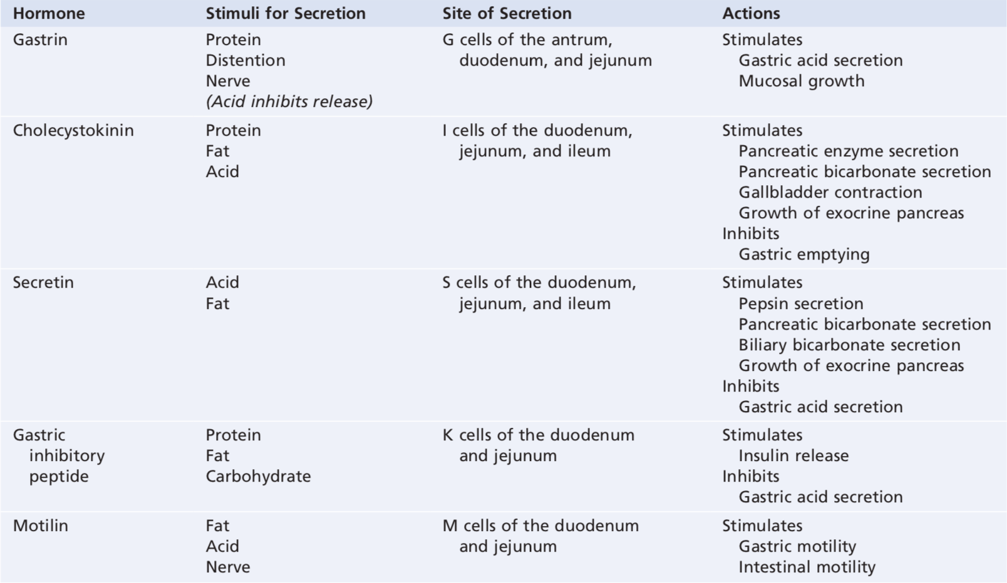

Functional Types of Movements in the GI tract

Propulsive movements

Peristalsis: contractile ring around the gut moves forward. Stimulated by distension of the gut – contractile ring forms 2-3 cm behind the distension. Also stimulated by chemical or physical irritation of epithelial lining in the gut and strong parasympathetic nervous signals.

Depressed or completely blocked if atropine administered and paralyzes the cholinergic nerve endings of myenteric plexus.

Myenteric plexus is polarized in anal direction. Gut relaxes several cm downstream “receptive relaxation = myenteric reflex = peristaltic reflex” allowing food to be propelled more easily toward anus.

Peristaltic reflex + anal direction of movement of peristalsis = “law of the gut”

Mixing movements

Peristalsis against a sphincter

Local intermittent constrictive contractions

GI Blood Flow – Splanchnic Circulation

Splanchnic circulation = blood flow through gut, spleen, pancreas & liver

Blood from gut, spleen and pancreas immediately through liver via portal vein > liver sinusoids > reticuloendothelial cells remove bacteria and particulate matter > hepatic veins away from liver > vena cava

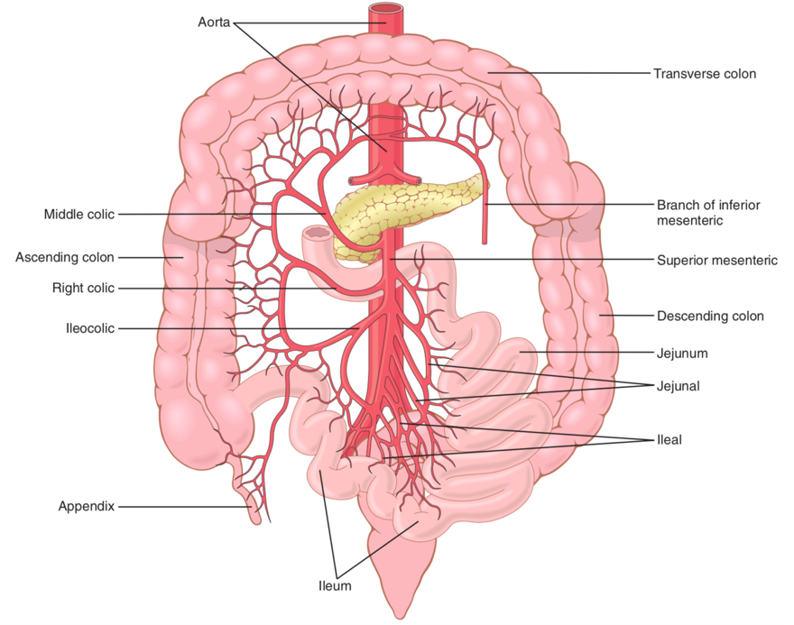
Nonfat water-soluble material to portal blood to reticuloendothelial cells and hepatic cells. ½ - ¾ absorbed, stored and chemically processed.

Fats don’t go to portal blood. Instead absorbed in intestinal lymphatics > thoracic duct > systemic circulation (bypass the liver.)

Blood flow in each area of the GI tract and in each layer of the gut wall is directly related to level of local activity (increases with absorption of nutrients, secretion, motility etc.)

Vasodilator substances released from mucosa (CCK, VIP, gastrin, secretin)

Kinins (kallidin and bradykinin) released into gut wall > powerful vasodilators

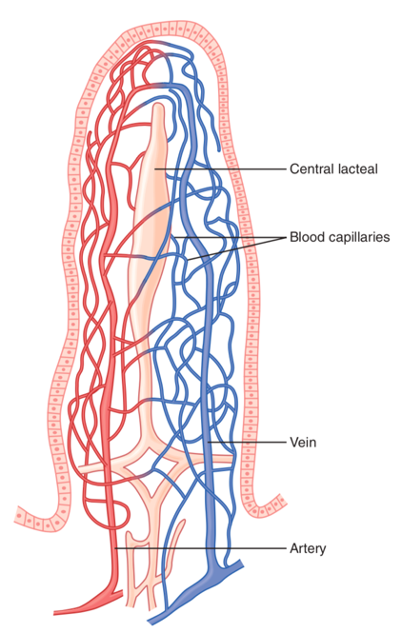
Decreased oxygen concentration in gut wall (as with high metabolic rate) can increase intestinal blood flow 50-100 percent and can increase adenosine fourfold (vasodilator)

Countercurrent blood flow in the villi

Arterial flow into the villus and venous flow out of the villus are in directions opposite to each other and vessels are close > ~ 80% oxygen moves out of arterioles into venules before it reaches tips of the villi.

Normally this isn’t too bad, but in states of circulatory shock the oxygen deficit at the tips of the villi that ischemic death can occur > blunting of villi > intestinal absorptive capacity decreased.

Nervous control of GI blood flow

Parasympathetic nerves to stomach and lower colon increase local blood flow at same time as glandular secretion.

Sympathetic stimulation causes intense vasoconstriction of arterioles in entire GI tract > decreased blood flow. Often followed by autoregulatory escape wherein local metabolic vasodilator mechanisms elicited by ischemia override vasoconstriction and return blood flow to normal. Good for heavy exercise and shock.

Can also cause vasoconstriction of large intestinal and mesenteric veins > decreased volume in veins > more blood in other places that need it.

Chapter 64: Propulsion and mixing of food in the alimentary tract

Ingestion of Food

Mastication

Incisors cut and molars grin, jaw muscles close teeth

Muscles are innervated by motor branch of 5th cranial nerve

Chewing controlled by nuclei in brain stem

Chewing reflex: food in mouth > inhibition of muscles of mastication > lower jaw drops > stretch reflex of jaw muscles > rebound contraction > raises jaw and compresses bolus against lining of mouth > inhibits jaw muscles again > repeat

Why chew?

Break down indigestible cellulose

Increase surface area for digestive enzymes

Prevent excoriation of GI tract

Increase ease with which food is emptied from the stomach

Swallowing (Deglutition)

Voluntary stage: initiates swallowing

Pressure of tongue up and back against palate

Pharyngeal stage/involuntary stage: food from pharynx > esophagus

Food bolus stimulates epithelial swallowing receptor areas around opening of pharynx (esp. tonsillar pillars) > impulses to brain stem (medulla oblongata, tractus solitarius) via sensory portions of trigeminal and glossopharyngeal nerves > medulla and pons initiate (deglutition/swallowing center) motor impulses that travel via 5th, 9th and 10th cranial nerves and superior cervical nerves:

Soft palate pulled up to close posterior nares

Palatopharyngeal folds pulled medially to each other forming the sagittal slit through which food will pass

Vocal cords of larynx strongly approximated and larynx pulled up and anteriorly by neck muscles > epiglottis swings back over opening of larynx & esophageal opening enlarged and pulled up.

At same time upper esophageal sphincter (pharyngoesophageal sphincter) relaxes > food moves to upper esophagus

Upward movement of larynx lifts glottis out of main stream of food flow so food passes to either side

Entire muscular wall of pharynx contracts propelling food by peristalsis into the esophagus

Swallowing center inhibits respiratory center of the medulla allowing swallowing to proceed.

Esophageal stage: from pharynx > stomach

Primary peristalsis: just a continuation of the wave that starts in the pharynx > goes all the way to stomach in 8-10 seconds

Secondary peristalsis: result from distension of esophagus from food that hasn’t made it into stomach. Initiated by:

Intrinsic neural circuits in myenteric nervous system

Reflexes that begin in the pharynx and transmit upwards through vagal afferent fibers to medulla and back to esophagus via glossopharyngeal and vagal efferents.

Striated muscle peristaltic waves controlled by skeletal nerve impulses from glosspharyngeal and vagus nerves

Smooth muscle: vagus nerves and esophageal myenteric nervous system. Interestingly if you cut the vagus nerve to esophagus, the myenteric nerve plexus can cause strong secondary peristalsis all by itself > so even if there is paralysis of brainstem swallowing reflex food fed by tube into esophagus will still pass into stomach.

Receptive Relaxation of the stomach: Esophageal peristalsis initiates a wave of relaxation transmitted through myenteric inhibitory neurons, precedes peristalsis. Entire stomach and some duodenum relaxed.

Lower esophageal sphincter/ gastroesophageal sphincter also relaxes.

Achalasia: LES doesn’t relax

A short portion of esophagus extends into stomach and is caved inward by increased abdominal pressure causing a valve like effect, helping to prevent reflux.

Motor Functions of the Stomach

Storage of large quantities of food until processing

Mixing food with gastric secretions to form a semifluid chime

Slow emptying of chime into SI at a rate suitable for digestions and absorption

Storage functions of the stomach

Food forms concentric circle in orad stomach with new food close to esophageal opening and old food by outer wall. When food stretches stomach a vagovagal reflex to brainstem and back reduces tone in muscular wall to accommodate more food.

Mixing and Propulsion of food in the stomach – basic electrical rhythm of stomach wall

The food lying against the mucosal surface comes into contact with digestive juices secreted by gastric glands

When food is in stomach weak peristaltic constrictor waves called mixing waves start in mid to upper stomach and move to antrum every 15-20 seconds, initiated by basic electrical rhythm (slow waves that occur spontaneously in the stomach wall) more intense closer to antrum providing peristaltic action potential driven constrictor rings that force the antral contents toward pylorus.
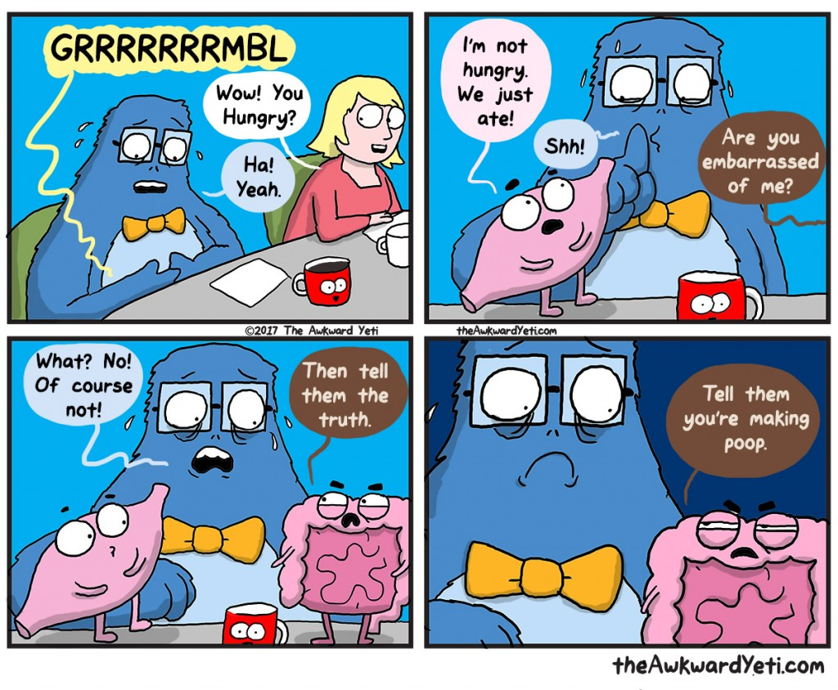This also helps mixing as most antral contents don’t make it through

pylorus but are squeezed up to body of stomach through peristaltic ring (retropulsion).

Once food thoroughly mixed with secretions > chime.

Hunger contractions in body of stomach when stomach empty for several hours or more. Can fuse to cause continuing tetanic contraction lasting 2-3 minutes.

Stomach emptying

“Pyloric Pump”: Intense antral peristaltic contractions midstomach to antrum that cause stomach emptying (several mL of chime with each wave.)

Regulated mainly by the duodenum, and also a little bit by the stomach. Factors that favor emptying:

Increased food volume in the stomach due to myenteric reflexes that increase pyloric pump and decrease pyloric sphincter tone

Stretching of stomach and meat in stomach causes secretion of gastrin from G cells of antral mucosa > gastric juice secretion from stomach glands and mild to moderate stimulation of pyloric pump.

Factors that inhibit emptying (duodenum):

With distension of duodenum, irritation to mucosa, acidity of chime (pH 3.5-4, via secretin and GIP gastric inhibitory peptide), hypo- or hypertonic chyme, and breakdown products of proteins or fats (via CCK): nervous reflexes in duodenal wall travel to stomach to slow or stop emptying via inhibition of pyloric pump and increased sphincter tone:

Enteric nervous system (direct from duodenum to stomach)

Extrinsic nerves to prevertebral sympathetic ganglia and back via inhibitory sympathetic nerve fibers to stomach

Vagus nerves to brain stem to inhibit excitatory signals to stomach

Movements of the Small Intestines

Mixing Contractions (Segmental Contractions)

Chyme distends SI > localized concentric contractions > segmentation of SI > chop up the chime and cause mixing with SI secretions.

Frequency of segmentation determined by slow waves (basic electrical rhythm. Segmentation very weak when enteric nervous system blocked by atropine.

Also helps to propel food.

Propulsive Contractions

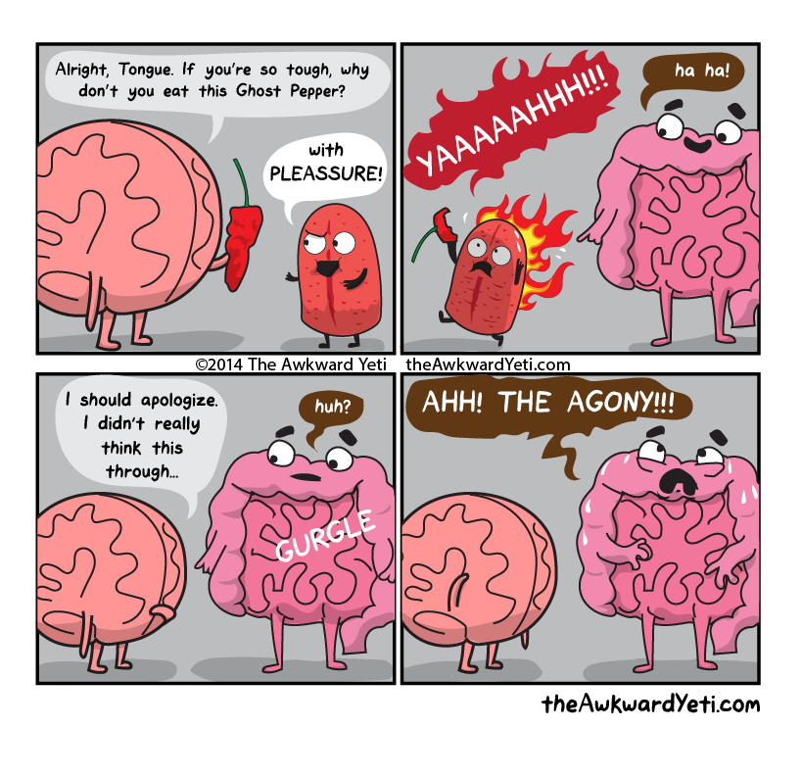Chime is propelled through SI by peristaltic waves: faster in proximal intestine and slower in terminal intestine. Very slow – net movement of SI is 1 cm/min = 3-5 hours for passage of chime from pylorus to ileocecal valve.

Factors that increase peristalsis:

Stretch of duodenal wall by chyme

Gastroenteric reflex (distension of stomach)

Hormones: gastrin, CCK, insulin, motilin, serotonin

Gastroileal reflex

Factors that inhibit peristalsis: Secretin and glucagon

Peristaltic Rush: intense irritation of the intestinal mucosa (severe cases of infectious diarrhea, i.e.) both autonomic nervous system and brain stem and intrinsic myenteric plexus cause powerful peristaltic contraction traveling long distances in SI within minutes sweeping contents into colon and relieving SI of irritative chyme and excessive distension.

Cecum: degree of contraction of ileocecal sphincter and intensity of peristalsis in terminal ileum controlled by reflexes from cecum. When cecum distended, sphincter tone increases and ileal peristalsis inhibited. Irritants in cecum delay emptying.

Movements of the colon:

The colon needs to absorb water and electrolytes from chyme to make solid feces (first 1/2 of colon) and store fecal matter until it is expelled. Colon doesn’t need strong contractions for these functions so is normally sluggish but still has mixing and propulsive movements.

Mixing movements (haustrations): circular constriction in conjunction with longitudinal contracture of teniae coli > cause unstimulated LI to bulge outward into sacs (haustrations). All fecal material gradually exposed to mucosal surface of LI for absorption of fluid and substances.

Propulsive movements: slow but persistent haustral contractions. Takes 8-15 hours to move from ileocecal valve to colon, but mass movements take over a couple times a day:

Mass movement: often in response to gastrocolic and duodenocolic reflexes via autonomic nervous system, constrictive ring in response to distended or irritated (usually transverse) colon > 20+ cm distal to ring lose haustrations and contract as a unit propelling feces en masse > for 30 seconds develops progressively more force then relaxes for 2-3 minutes > another mass movement further along colon. This persists for 10-30 minutes. Eventually feces in rectum > defecation.

Defecation

When mass movement forces feces into rectum the desire to defecate is immediate > reflex contraction of rectum and relaxation of anal sphincters.

Continual dribble of fecal matter through anus is prevented by tonic constriction of an internal anal sphincter (circular smooth muscle) and external anal sphincter) striated voluntary muscle that surrounds internal sphincter and extends distal to it.

External sphincter controlled by pudendal nerve.

Defecation reflexes

Intrinsic reflex (local enteric nervous system in rectal wall): feces distend rectum > afferent signal to myenteric plexus > peristaltic waves in descending colon and rectum > relaxation of internal anal sphincter via INHIBITORY signals from myenteric plexus + voluntary relaxation of external anal sphincter > defecation

This reflex is weak by itself – needs to be fortified by parasympathetic defecation reflex to be effective in causing defecation.

Parasympathetic defecation reflex

Nerve endings in rectum stimulated > signals transmitted to sacral segments of spinal cord and descending colon, sigmoid, rectum and anus via parasympathetic nerve fibers in pelvic nerves > greatly intensified waves & relaxed internal anal sphincter > defecation

Spinal cord signals also cause deep breathing, closure of glottis and contraction of abdominal wall muscles to force fecal contents of colon down.

Also causes pelvis floor to relax downward and pull outward on anal ring to evaginate feces.

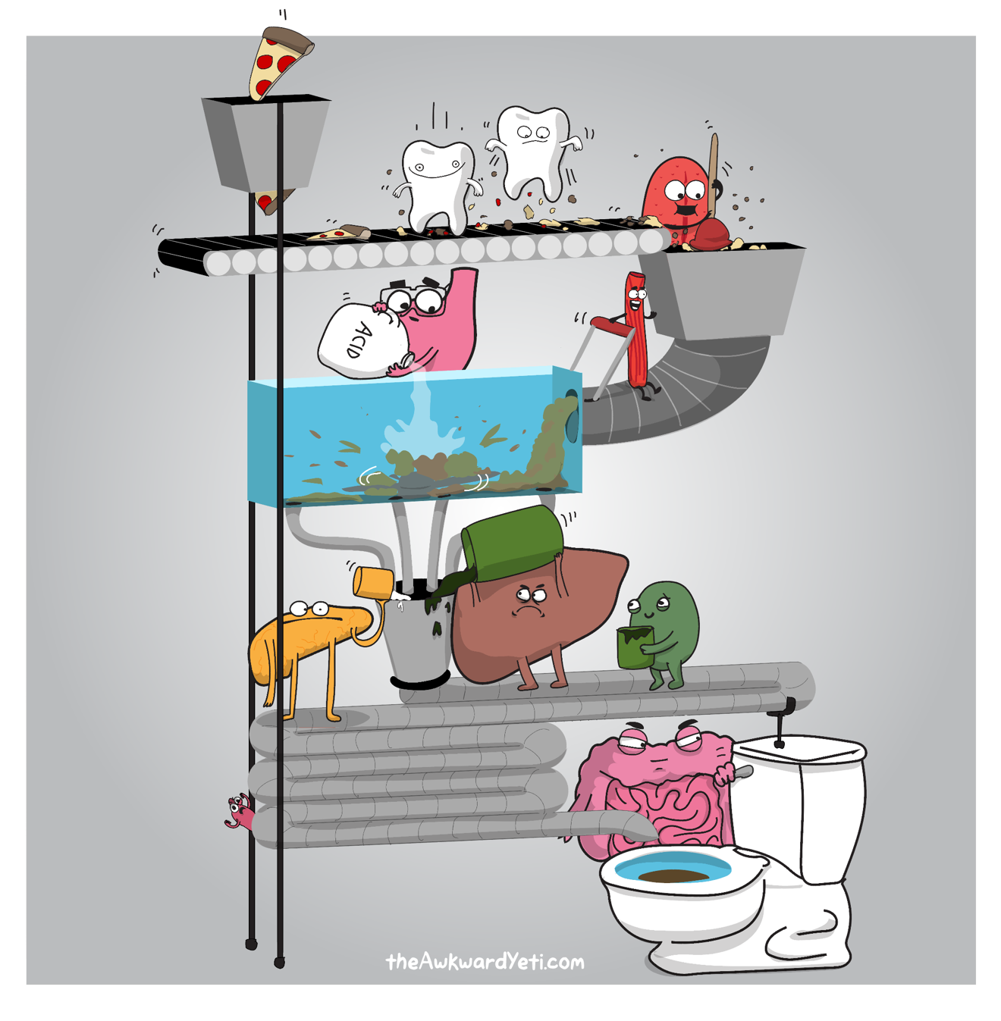When defecation desired can take a deep breath to move diaphragm down and contract abdominal muscles to increase pressure in abdomen > forces fecal contents into rectum to initiate reflexes.

Other reflexes

Peritoneointestinal: irritation of the peritoneum inhibits excitatory enteric nerves > intestinal paralysis

Renointestinal: kidney irritation > inhibits intestinal activity

Vesicointestinal: bladder irritation > inhibits intestinal activity as a result of kidney or bladder irritation.

CHAPTER 65: SECRETORY FUNCTIONS OF THE ALIMENTARY TRACT

General principles of alimentary tract secretion

Single cell mucous glands/mucous cells/goblet cells

Function in response to local irritation of epithelium

Extrude mucous onto epithelial surface

Crypts of Lieberkuhn are invaginations or epithelium into submucosa and contain secretory cells

Tubular glands in the stomach and duodenum secrete acid and pepsinogen (oxyntic glands)

Glands associated with salivary tract: salivary glands, pancreas and liver that provide secretions for digestion and emulsification

Acinous glands (salivary glands and pancreas): lies outside the GI tract but ducts lead into the alimentary tract

Basic mechanisms of stimulation of the alimentary tract glands

Contact of food with the epithelium stimulates secretion of glands in that region and adjacent regions via contact with surface glandular cells and via enteric nervous system (tactile, chemical irritation, distension > mucous cells and deep glands)

Parasympathetic stimulation increases alimentary tract glandular secretion rate, especially in the upper portion of the GI tract (salivary, esophageal, gastric, Brunner’s (duodenal) glands and pancreas) and some distal large intestine.

Sympathetic stimulation has a dual effect on the alimentary tract glandular secretion rate: slight increase in secretion by some local glands BUT ALSO constriction of blood vessels that supply glands. So by itself it slightly increases secretion, but if already have parasympathetic stimulation additional stimulation by sympathetic nervous system will reduce secretion due to vasoconstriction.

Regulation of glandular secretion by hormones

Food in lumen > release of hormones from GI mucosa > absorbed into blood and carried to glands > stimulate secretion

Basic mechanism of secretion by glandular cells

Nutrients needed for formation of secretion transported in blood to glandular cell.

Mitochondria in glandular cell use oxidative energy to form ATP

ATP and substrates used to synthesize organic secretory substances in the ER and Golgi complex. Ribosomes are responsible for secreted proteins.

Within about 20 minutes secretory material travel from ER to Golgi vesicles.

In the Golgi the materials are added to, concentrated, discharged into cytoplasm in secretory vesicles

Vesicles remain stored until hormones cause them to be extruded: hormone bind receptor > cell signaling > increases cell membrane permeability to calcium ions > calcium enters cell > vesicles fuse with apical cell membrane > apical cell membrane breaks open. And empties vesicles to exterior (exocytosis) (too deep)

Nervous stimulation causes water and salts to pass through the glandular cells in great profusion

Lubricating and protective properties of mucus

Mucus: water, electrolytes and glycoproteins (polysaccharides and protein)

Adheres tightly to food and particles and spreads a film over surfaces

Coats wall of gut and prevents contact of food with mucosa

Low resistance for slippage so particles can slide along epithelium

Causes fecal particles to adhere to one another

Resistant to digestion by GI enzymes

Amphoteric: can buffer small amounts of acids or alkalies

Contains moderate bicarb to neutralize acids

Secretion of Saliva

Principal glands of salivation are the parotid, submandibular and sublingual glands. There are also buccal glands.

Two major types of secretion: serous (ptyalin and alpha-amylase to digest starches) and mucus (mucin for lubrication and protection)

Parotid secrete serous

Submandibular and sublingual secrete serous and mucus

Buccal glands secrete mucus

Secretion of ions in saliva

Saliva contains lots of potassium and bicarbonate, but not much Cl or Na

Acini secrete primary secretion (ptyalin and mucin and ions) through ducts > Na ions are actively reabsorbed from salivary ducts & K is secreted in exchange for Na > Na ion concentration of saliva reduced and K increased > excess Na reabsorption relative to K secretion leads to electronegativitiy -70 mV in salivary ducts > Cl ions reabsorbed passively > Cl concentration low in saliva.

Bicarbonate ions are secreted by ductal epithelium into lumen of duct (passive in exchange for Cl and active)

Na and K concentration in saliva ~ 15 mE/L (much lower than plasma) and K ~ 30 mEq/L and HCO3- 50-70mEq/L (much greater than plasma)

During maximal salivation the salivary ionic concentrations change considerably because the rate of formation of primary secretion by acini can increase as much as 20 fold > flows through ducts too rapidly for ductal reconditioning (so high Cl and Na and lower K than in normal secretions)

Saliva is important for oral hygiene

Helps wash away bacteria and food particles

Contains factors that destroy bacteria > thiocyanate ions, proteolytic enzymes and lysozyme.

Contains antibodies to destroy bacteria

Nervous regulation of secretion

Salivary glands are controlled by parasympathetic nervous signals all the way from the superior and inferior salivatory nuclei in the brain stem (medulla and pons)

Stimulated by taste and tactile stimuli from tongue, mouth and pharynx

Also stimulated by input from appetite area of brain

Occurs in response to reflexes originating in the stomach and upper small intestines (nausea, irritation) > saliva helps dilute/neutralize irritating substances)

Sympathetic stimulation can increase slightly

Blood supply also effects as nutrients needed from blood for salivation. Activated salivary glands secrete kallikrein > cleaves alpha2-globulin to make bradykinin > vasodilator

Esophageal secretions

Entirely mucous > lubrication for swallowing

Simple mucous glands along length and at ends compound mucous glands (to protects against excoriation and gastric juices/reflux.)

Gastric Secretion

Characteristics of gastric secretions

Tubular glands: oxyntic (gastric/acid-forming) glands and pyloric glands

Oxyntic secrete: hydrochloric acid, pepsinogen, intrinsic factor, mucus

Body and fundus of stomach (proximal 80%)

Made of 3 types of cells: mucous neck cells > mucus, peptic (chief) cells > pepsinogen, parietal (oxyntic) cell > hydrochloric acid and intrinsic factor

Parietal cells stimulated > secrete acid solution with 160 mmol/L hydrochloric acid (pH 0.8: [H+]3x arterial blood) > bicarbonate ions diffuse into blood at the same time

HCl formed at villus like projections inside canaliculi

H+-K+-ATPase 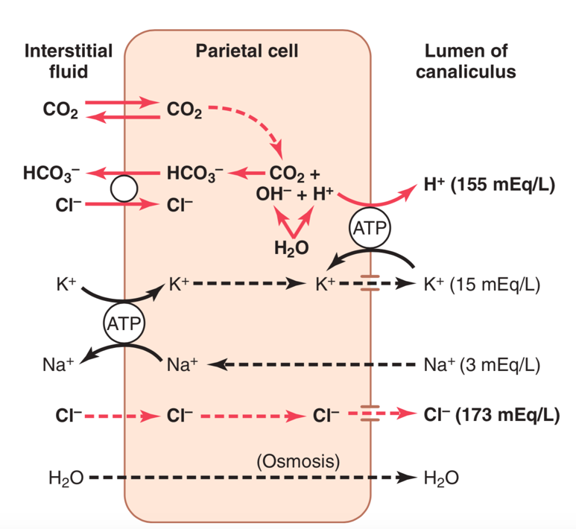

Pyloric secrete: mucus (protect pyloric mucosa from stomach acid) and gastrin

Antral portion of stomach (distal 20%)

Gastric secretion stimulated by acetylcholine, gastrin and histamine

ACh > pepsinogen via peptic cells, hydrochloric acid and intrinsic factor (needed for absorption of B12 in the ileum) by parietal cells and mucous by mucus cells

Pepsinogen by itself no digestive activity

Pepsinogen + Hydrochloric acid > pepsin (active at pH 1.8-3.5, no effect at pH>5)

When acid producing parietal cells of stomach destroyed (chronic gastritis) > achlorhydria (lack of stomach acid secretion) + pernicious anemia (RBCs can’t mature without B12)

Gastrin & Histamine > acid via parietal cells

Pyloric glands – secretion of mucus and gastrin

Similar to oxyntic glands but contain few peptic cells and no parietal cells (so, mostly mucous cells) > pepsinogen + mucous + gastrin

Surface mucous cells

Secrete lots of viscid mucous that coats stomach in think (1mm) layer

Alkaline mucus to protect stomach wall from acid secretion

Stimulation of gastric acid secretion

Parietal cells of the oxyntic glands are the only cells that secrete hydrochloric acid

Parietal cells work closely with enterochromaffin-like cells (ECL cells) which secrete histamine. ECL cells live deep in the oxyntic glands. The rate of formation and secretion of hydrochloric acid by parietal cells is directly related to the amount of histamine secreted by the ECL cells. In turn the ECL cells are stimulated to secrete histamine by gastrin (which is made in antrum of stomach in response to protein digestion)

Gastric is secreted by gastrin cells (G cells) in the pyloric glands in the distal end of the stomach.

Histamine works to stimulate gastric hydrochloric acid secretion.

Pepsinogen is secreted by peptic cells in the oxyntic glands in response to:

ACh released from vagus nerves or gastric enteric nervous plexus

Acid in the stomach (via enteric nervous reflexes)

Phases of gastric secretion

Cephalic phase: sight, smell, thought or taste of food. Greater appetite = more intense stimulation. ~ 30% of gastric secretion associated with eating a meal.

Gastric phase: food enters stomach and excites vagovagal reflexes, local enteric reflexes and gastrin mechanism > all cause secretion of gastric juice for several hours. ~60% of gastric secretion associated with eating a meal.

Intestinal phase: food in upper SI (duodenum) causes stomach secretion due to small amounts of gastrin released by duodenal mucosa. ~ 10% of gastric secretion associated with eating a meal.

Inhibition of gastric secretion by other intestinal factors

Intestinal chyme stimulates gastric secretin early in intestinal phase but inhibits at other times:

Food in intestine > reverse enterogastric reflex via myenteric nervous system and extrinsic sympathetic and vagus nerves > inhibits stomach secretion. Initiated by:

Distension of small bowel

Acid in upper intestine

Protein breakdown products

Irritation of mucosa

Acid, fat, protein breakdown products, hyperosmotic or hypoosmotic fluids, irritation in upper SI > release of intestinal hormones (like secretin) > important for control of pancreatic secretion. Other hormones that can inhibit gastric secretion = glucose-dependant insulinotropic peptide (GIP), VIP, somatostatin.

Why inhibit gastric secretion? Slow passage of chyme from stomach when SI filled or overactive.

Gastric secretion during the interdigestive period: few mLs each hour, nonoxyntic (mucus, little bit of pepsin, almost no acid.)

Pancreatic Secretion

Pancreatic digestive enzymes for digesting all major food types:

Proteins: trypsin (most abundant), chymotrypsin, carboxypolypeptidase

Carbohydrates: amylase

Fats: pancreatic lipase, cholesterol esterase, phospholipase

Also contains lots of bicarbonate ions to neutralize the acidity of the chyme emptied from stomach to duodenum.

When first synthesized in pancreatic cells the digestive enzymes are in inactive form (trypsinogen, chymotrypsinogen and procarboxypolypeptidase > activated when secreted into intestinal tract.

Enterokinase secreted when chyme contacts intestinal mucosa > activates trypsinogen

Trypsinogen also autocatalytically activated by already formed trypsin

Trypsin activates chymotrypsinogen > trypsin

Secretion of trypsin inhibitor prevents digestion of the pancreas

The same cells that secrete proteolytic enzymes into acini simultaneously secrete trypsin inhibitor

Trypsin inhibitor is formed in the cytoplasm of the glandular cells

Trypsin inhibitor prevents activation of trypsin both inside the secretory cells and in the acini and ducts of the pancreas. It also prevents activation of other enzymes by trypsin (by inhibiting trypsin activation.)

When pancreas damaged or duct blocked large amounts of pancreatic secretion pool > effect of trypsin inhibitor overwhelmed > pancreatic secretions activated > can digest entire pancreas within a few hours > acute pancreatitis

Secretion of Bicarbonate Ions

Bicarbonate and water are secreted by epithelial cells of ductules and ducts leading from acini

When pancreas stimulated to make lots of pancreatic juice > lots of bicarb into juice > neutralize stomach acidity

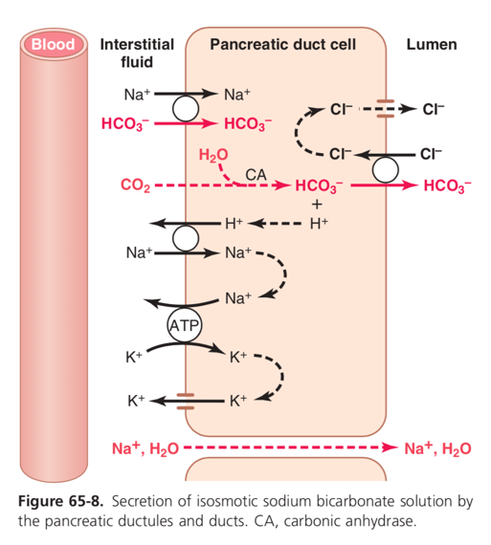
CO2 into cell > CO2 + HCO3- via carbonic anhydrase > H2CO3 (carbonic acid) > HCO3- + H+

More HCO3 via cotransport with Na+, HCO3 exchanged for Cl- by secondary active transport > Na to pancreatic duct lumen.

Cl- back to lumen via chloride channels

H+ exchanged for Na through basolateral membrane of cell

Overall movement of Na and bicarbonate from blood to lumen of duct > osmotic pressure gradient > osmosis of water into pancreatic duct > isosmotic bicarbonate solution

Regulation of pancreatic secretion

Stimuli for pancreatic secretion

ACh: released from parasympathetic vagus nerve endings and cholinergic nerves in enteric nervous system

Stimulated acinar cells of pancreas > lots of digestive enzymes and small amount of water and electrolytes. Enzymes stuck in acini and ducts until fluid secretion washes them into duodenum.

CCK: secreted by duodenal and upper jejunal mucosa when food enters the SI

Stimulated acinar cells of pancreas > lots of digestive enzymes and small amount of water and electrolytes. Enzymes stuck in acini and ducts until fluid secretion washes them into duodenum.

Secretin: secreted by duodenal and upper jejunal mucosa when highly acidic food enters SI

Lots of water and sodium bicarbonate.

When all different stimuli at once total secretion is greater than the sum of each separately (multiplicative effect)

Phases: cephalic, gastric and intestinal

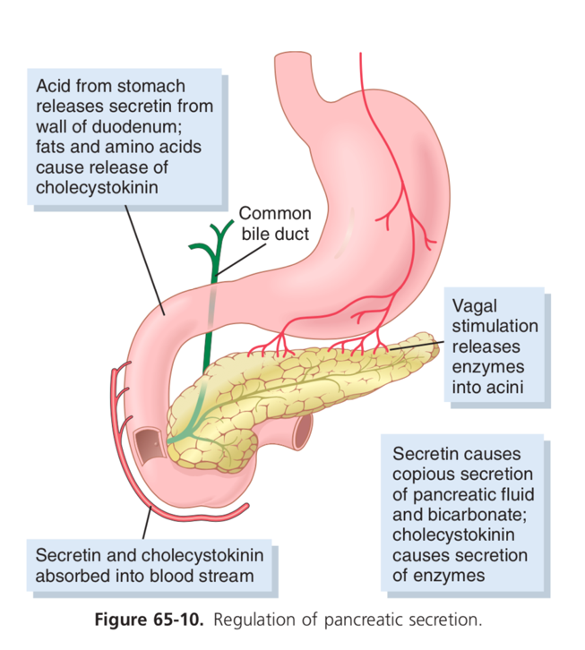
Cephalic: same signals that cause secretion in stomach cause ACh release by vagal nerve endings in pancreas > moderate amount of enzymes secreted (~20% total secretion post meal). Little flow through ducts due to small amount water and electrolytes.

Gastric: continued nervous stimulation (5-10% total). Still little fluid secretion so most does not reach duodenum.

Intestinal: chyme leaves the stomach and enters SI > copious pancreatic secretion in response to secretin.

Hydrochloric acid and chyme with pH < 4.5-5.0 enters duodenum

Duodenal mucosal release of secretin > blood > pancreatic secretion of bicarbonate (up to 145 mEq/L) and low concentration Cl-.

Secretin release from S cells increases greatly when pH <3.0

In the duodenum: HCl + NaHCO3 NaCl + H2CO3 NaCl + H2O + CO2

CO2 expelled via lungs

NaCl in duodenum

Bicarbonate provides the optimal pH for pancreatic enzyme action (~ 8.0)

CCK

Food (especially protein breakdown products likeproteoses and peptones and LCFAs in chyme) in upper SI causes CCK release from I cells from mucosa of duodenum and upper jejunum > blood > pancreatic digestive enzyme secretion by acinar cells of pancreas (70-80% pancreatic digestive enzyme secretion after a meal)

Bile secretion by the liver

Functions of bile

Fat digestion and absorption

Bile acids help emulsify large fat particles of food into many minute particles so lipase enzymes can work on surface

Bile acids in aid in absorption of the digested fat end products through the intestinal mucosal membrane

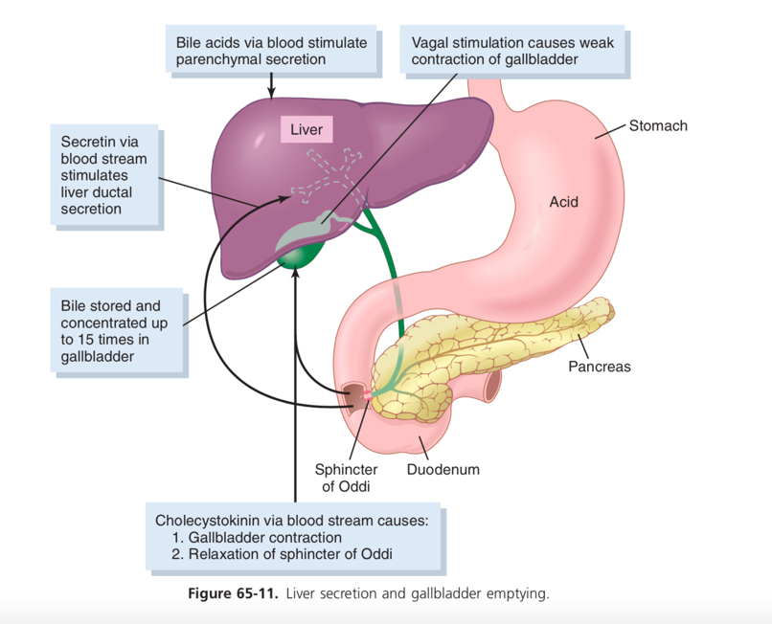
Excretion of several important waste products from the blood including bilirubin (end product of hemoglobin destruction) and cholesterol

Anatomy of bile secretion

Secreted in 2 stages:

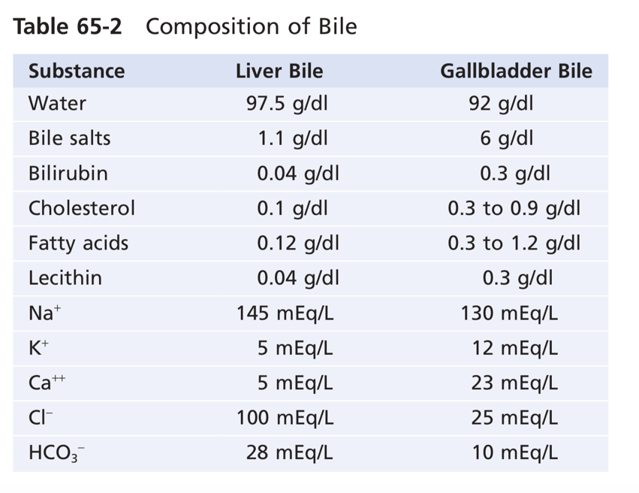
Hepatocytes secrete large amounts of bile acids, cholesterol and organic constituents into bile canaliculi between hepatic cells

Canaliculi > terminal bile ducts > hepatic duct > common bile duct > duodenum OR gallbladder (via cystic duct). In gallbladder for minutes to hours.

Sodium and bicarbonate watery secretion from epithelial cells that line the ductules and ducts. Stimulated by secretin. Can increase quantity of bile by 100%.

Storing and concentrating bile in the gallbladder

Bile secreted continuously by liver cells

Stored in gallbladder until it is needed in duodenum

Water, Na, Cl and other small electrolytes continually absorbed through gallbladder mucosa, concentrating the remaining bile constituents that contain bile salts, cholesterol, lecithin and bilirubin

Most absorption caused by active Na transport; water and electrolytes follow

Composition of bile

Bile salts account for ½ total solutes in bile

Also bilirubin, cholesterol, lecithin, and electrolytes

Water and electrolytes (except calcium) reabsorbed

Everything else (bile salts, lipids like cholesterol and lecithin) become concentrated in gallbladder bile

CCK stimulated gallbladder emptying

Food hits upper GI (especially when fatty foods hit duodenum) > gallbladder begins to empty via rhythmical contractions of gallbladder wall and relaxation of sphincter of Oddi (at exit of common bile duct into duodenum)

Stimulated by CCK and ACh-secreting nerve fibers from vagi and intestinal enteric nervous system

When fat present in meal gallbladder can empty in 1 hour

Function of bile salts in fat digestion and absorption

Cholesterol from diet or made by liver cells is precursor to bile salts.

Cholesterol > cholic acid or chenodeoxycholic acid > combine with glycine and taurine > glycol- and tauro-conjugated bile acids > sodium salts of these acids secreted into bile

Functions in intestinal tract

Detergent action on fat particles (emulsifying/detergent function)

Help in absorption of fatty acids, monoglycerides, cholesterol and other lipids by forming micelles > lipids to intestinal mucosa where they are absorbed into blood.

Enterohepatic circulation of bile salts

94% bile salts reabsorbed into the blood from SI

½ by diffusion in early SI

½ by active transport in distal ileum

Then to portal blood and back to liver > absorbed almost entirely back into hepatic cells > resecreted into bile

94% bile salts recirculated into bile. On average 17 times through circuit before being carried out in feces.

Rate of bile salt secretion actively controlled by availability or lack of bile salts in enterohepatic recirculation, More bile salts > more secretion.

Role of secretin in controlling bile secretion

Causes NaHCO3 rich water secretion by epithelial cells of bile ductules and ducts (not increased secretion by liver parenchymal cells)

Liver secretion of cholesterol and gallstone formation

Bile salts form in hepatic cells from cholesterol in blood plasma

1-2 grams of cholesterol removed from plasma and secreted into bile each day

Cholesterol insoluble in water BUT forms micelles with bile salts and lechitin > keep cholesterol in solution

Cholesterol can precipitate in gallbladder > cholesterol gallstones. Amount of cholesterol in bile determined partly by quantity of fat in diet (liver cells make cholesterol from fat metabolism).

Absorptive characteristics of gallbladder changed by inflammation > excessive absorption of water and bile salts > leaves behind cholesterol > precipitation > many small crystals of cholesterol on surface of inflamed mucosa > then produces large gallstones.

Secretions of the Small Intestines

Secretion of mucus by Brunner’s glands in the duodenum

Brunner’s glands: compound mucous glands in wall of duodenum between pylorus of stomach and duodenal papilla

Secrete large amounts of alkaline mucus in response to:

Tactile or irritating stimulation duodenal mucosa

Vagal stimulation

GI hormones (secretin)

Secretions from Brunner’s glands protect duodenal wall from digestion by highly acidic gastric juice from stomach and neutralize HCl (via bicarbonate ions)

Inhibited by sympathetic stimulation (can leave duodenal bulb unprotected in excitable people and can predispose to peptic ulcers in ~ 50% of people with these ulcers.)

Secretion of intestinal digestive juices by the crypts of lieberkuhn

Entire surface of the SI between intestinal villi.

Surfaces of crypts and villi covered by two types of cells

Moderate number of goblet cells (mucus secretion) to protect intestinal surfaces

Large number of enterocytes (water and electrolyte secretion in crypts and reabsorption in villi – along with end products of digestion)

Mechanism of secretion

Active secretion of chloride ions into crypts

Active secretion of bicarbonate ions

Both of the above cause electrical drag of positively charged sodium through membrane and into fluid. All of this leads to osmotic movement of water.

Digestive enzymes in SI secretion

Almost no enzymes in secretion

Enterocytes of mucosa have enzymes that digest during absorption through epithelium

Peptidases, sucrase, maltase, isomaltase, lactase intestinal lipase

Life cycle of intestinal epithelial cell is 5 days – allows for rapid repair of excoriations in mucosa.

Regulation of SI secretion – local stimuli

Enteric nervous reflexes due to tactile or irritative stimuli from chyme in SI

Secretion of mucus in LI

Crypts of Lieberkuhn, but NO VILLI

Almost no digestive enzymes, epithelial cells secrete mucus with moderate bicarbonate

Mucus secretion also caused by pelvic nerve (parasympathetic nerve stimulation

Protects intestinal wall from irritation and provides medium for holding feces together, protection from bacteria and acids.

Diarrhea caused by excess secretion of water and electrolytes in response to irritation

Irritation of LI > mucosa secreted lots of water and electrolytes > dilutes irritating factors > rapid movement of feces > diarrhea

Chapter 65: Digestion and Absorption in the gastrointestinal tract

Digestion of the various foods by hydrolysis

Hydrolysis of carbohydrates

Polysaccharides, Disaccharides (combination of monosaccharides from which a hydrogen ion has been removed from one and a hydroxyl ion has been removed from the other > condensation)

To digest carbohydrates you reverse this process (hydrolysis) > return H+ and OH- to polysaccharides > monosaccharides. This is facilitated by digestive enzymes.

Hydrolysis of fats:

Triglycerides: 3 fatty acids + glycerol via condensation (3 H2O removed)

Reverse (hydrolysis): return 3 H2O to triglyceride splitting fatty acids away from glycerol

Hydrolysis of proteins:

Amino acids joined by peptide linkages (OH- removed from one amino acid and H+ removed from the next)

Reverse (hydrolysis) again for digestion

Digestion of Carbohydrates

3 major sources of carbs sucrose, lactose, starches

Minor sources of carbs: amylose, glycogen, alcohol, lactic acid, pyruvic acid, pectins, dextrins, carbohydrate derivatives in meats

Cellulose: carb that can’t be digested

Digestion of carbs in the mouth and stomach

Mouth: Parotid glands secrete ptyalin (an alpha amylase) in saliva > hydrolyzes starch into disaccharide maltose and small polymers of glucose (~5% hydrolysis of starches in mouth)

Stomach: continued digestion for up to one hour before mixed with stomach secretions, which inactivate amylase (pH < 4.0) (30-40% hydrolysis of starches)

Digestion of carbs in the small intestine

Pancreatic amylase: more powerful than saliva amylase. 15-30 minutes after chyme empties from the stomach into duodenum and mixes with pancreatic juice > all carbs digested to maltose or other small glucose polymers before leaving duodenum/upper jejunum

Intestinal Epithelial Enzymes: four enzymes in enterocytes lining SI microvilli brush border are lactase, sucrase, maltase and alpha-dextrinase.

Lactose > galactose and glucose

Sucrose > fructose and glucose

Maltose/small glucose polymers > multiple molecules of glucose

All of these products are water soluble and absorbed immediately into the portal blood.

Glucose > 80% of final carb digestion products

Galactose and fructose ≤ 10%

Digestion of Proteins

Digestion of proteins in the stomach

Pepsin in the stomach

Most active at 2.0-3.0 inactive at pH > 5.0. so for this enzyme to work the stomach contents must be acidic.

Pepsin can digest collagen (found in meat)

Pepsin provides 10-20 percent of total protein digestion to convert protein to proteoses, peptones, few polypeptides

Pancreatic Proteolytic Enzymes

Most protein digestion in upper SI, duodenum and jejunum due to pancreatic secretion

SI: trypsin, chymotrypsin, carboxypolypeptidase and proelastase

Trypsin and chymotrypsin > small polypeptides

Carboxypolypeptidase > cleaves off amino acids from carboxyl end

Proelastase converted to elastase > digests elastin fibers

Only a few proteins digested all the way to amino acids, most stay dipeptides and tripeptides.

Digestion of Peptides in SI – more than you need

Enterocytes that line the villi of the small intestine, in duodenum and jejunum peptidases in microvilli protrude through membranes where they come into contact with intestinal fluids

Aminopolypeptidase and dipeptidases split large polypeptides into tripeptides and dipeptides and amino acids > these are transported through microvillar membrane to interior of enterocyte

Other peptidasesinside enterocyte digest all to amino acids than pass through other side of enterocyte and into the blood

99% of the final protein digestive products that are absorbed are individual amino acids

Digestion of Fats

Neutral fat (triglycerides), phospholipids, cholesterol (sterol), cholesterol esters

Digestion of fats in the stomach

Lingual lipase from lingual glands in the mouth and swallowed in saliva (<10%)

Digestion of fats in the intestine

Emulsification by bile acids and lecithin

Physically break the fat globules into small sizes so water soluble enzymes can act on the surface.

Agitation in stomach to mix fat with products of stomach digestion

Bile in duodenum

Bile doesn’t contain any digestive enzymes but does contain bile salts and the phospholipid lecithin

Polar parts of bile salts and lechitin are soluble in water and the rest is soluble in fat > decreases interfacial tension of the fat > allows nonmiscible fluid to be broken up into tiny particles with agitation

Each time the diameter of a fat globule decreases, the surface area increases

Triglycerides are digested by pancreatic lipase *** most important enzyme for digestion of triglycerides ***.

End products of fat digestions are free fatty acids

Triglycerides > FFAs and 2-monoglycerides via pancreatic lipase

Bile salts form micelles that accelerate fat digestion

Hydrolysis is reversible so accumulation of monoglycerides and FFAs blocks further digestion

Bile salts remove monoglycerides and FFAs from fat globules by the formation of micelles (small spherical cylindrical globules 3-6 nanometers in diameter composed of 20-40 molecules of bile salt.)

Each bile salt is made of a fat soluble sterol nucleus and water soluble polar group > small fat globule in the middle and polar groups outside that allow it to dissolve in water > monoglycerides and FFAs ferried to brush border of intestinal epithelial cells fat absorbed into blood

Bile salts released back into the chyme

Digestion of cholesterol esters and phospholipids

Cholesterol in diet in form of cholesterol esters (free cholesterol + fatty acid)

Cholesterol esters and phospholipids hydrolyzed by lipases in pancreatic secretion (cholesterol ester hydrolase and phospholipase A2)

Bile salts do the same ferrying thing by making micelles

Basic principals of GI absorption

Total quantity of fluid absorbed by intestines = ingested fluid + GI secretions.

Almost all absorbed in SI

Folds of Kerckring (valvulae conniventes), villi and microvilli increase mucosal absorptive surface area by 1000 fold

Folds of kerckring extend circularly around intestine especially developed in duodenum and jejunum

Villi increases by another 10 fold

Brush border with microvilli increases surface area another 20 fold

Total increase about 1000 fold

Anatomical stuff

Advantageous arrangement of vascular system for absorption of fluid and material into portal blood

Central lacteal lymph vessel for absorption into the lymph

Small pinocytic vesicles (pinched off portions of infolded enterocyte membrane forming vesicles of absorbed fluids)

Actin filaments from epithelial cell body to microvilli for continuous movement of microvilli

Absorption from SI

Water transported through intestinal membrane by diffusion

Chyme to plasma: when chyme dilute enough.

Plasma to chyme: when hyperosmotic solutions travel from stomach to duodenum. Water travels to cyme to make it isosmotic to plasma.

Sodium actively transported through intestinal membrane

Intestinal secretions lost (diarrhea), sodium reserves can be depleted to lethal levels within hours

Active transport for Na absorption requires ATP

Active transport of Na trough basolateral membrane reduced [Na+] inside cell (~50 mEq/L)

Na+ chyme 142mEq/L, NA moves from chyme into epithelial cells

Na+ also co-transported via Na+-glucose cotransporter, Na+-amino acid cotransporters and Na+-H+ exchanger

Secondary active absorption of glucose and amino acids powered by active Na+-K+-ATPase pump in basolateral membrane

Osmosis of water via transcellular and paracellular (through tight junctions between apical borders of epithelial cells) spaces

Aldosterone enhances Na+ absorption. Conserves NaCl and H2O when dehydrated

Absorption of chloride ions in SI

Upper SI chloride ion absorption is rapid and by diffusion

Brush border membrane chloride-bicarbonate exchanger

Chloride exits cell on basolateral side by chloride channels

Absorption of bicarbonate ions in duodenum and jejunum

Lots of bicarb secreted into duodenum in pancreatic secretion and bile. Absorption occurs:

Na+ absorbed > H+ secreted into lumen in exchange

H+ + HCO3- > H2CO3 > H20 + CO2

Water remains as chyme in intestines

CO2 absorbed into blood and expired through lungs

Secretion of bicarbonate ions in ileum and LI

Epithelial cells on surface of the villi in the ileum and in LI secrete HCO3- in exchange for absorption of Cl-> alkaline bicarbonate ions > neutralize acid products formed by bacteria in LI

Epithelial cells secrete NaCl and H2O into intestinal lumen which is reabsorbed by other epithelial cells. Some toxins of choleral and other bacteria cause secretion that far outweighs reabsorption

Cholera toxin > epithelial cells > formation of cAMP > open Cl channels > Cl to intestinal crypts > activates Na+ pump to pump Na+ into crypts > extreme osmosis of water.

Active absorption of calcium, iron , potassium, magnesium and phosphate.

Calcium actively absorbed from duodenum. Controlled by parathyroid hormone and vitamin D. activated vitamin D enhances calcium absorptions.

Iron ions are absorbed from SI

K, Mg2+,phosphate, and others absorbed via SI. Monovalent easier than bivalent.

Absorption of nutrients

Carbohydrates are mainly absorbed as monosaccharides

Most abundant absorbed monosaccharide is glucose (>80% carbs absorbed)

Without sodium transport cant absorb glucose (co transport)

Na+ is actively transported through basolateral membrane of intestinal epithelial cells into blood (Na inside cells decreases). Then Na moves from intestinal lumen across brush border by secondary active transport. Transport protein needs Na+ and glucose.

Glucose then uses other transporter proteins to move across basolateral membrane into blood

The remaining 20% is galactose and fructose

Galactose pretty much the same as glucose

Fructose via facilitated diffusion but not co-transported with Na

Also lots of fructose becomes phosphorylated converting it to glucose

Absorption of proteins as dipeptides, tripeptides and amino acids

Sodium co-transport

Absorption of fat

Monoglycerides and diglycerides diffuse out of micelles into interior of epithelial cells (lipids soluble in membrane) > smooth ER > form new triglycerides > released as chylomicrons through base of epithelial cell > thoracic lymph duct > blood

Direct absorption of FAs into portal blood (short and medium chain fatty acids only)

SCFAs more water soluble and not reconverted into triglycerides by the ER > diffusion of SCFAs directly into capillary blood of intestinal villi

Absorption in LI: Formation of Feces

Absorbing colon = proximal ½

Storage colon = distal ½

LI can absorb a lot of Na, and the potential generated leads to absorption of Cl too

Tight junctions tighter than in SI > more efficient reabsorption due to higher gradient. Even better with aldosterone.

LI secretes bicarbonate in exchange for chloride

Absorption of Na and Cl > osmotic gradient > absorption of water

Bacteria in the colon digest cellulose > some extra calories

Also vitamin K, B12, thiamine, riboflavin and gases like CO2, hydrogen and methane.

Brown color of feces due to stercobilin and urobilin

Odiferous products include indole, skatole, mercaptans, hydrogen sulfide

Google ecc confluence cornell

